EXPLORING WORD REPRESENTATIONS:
FROM TRADITIONAL WORD EMBEDDINGS TO TRANSFORMERS
24ADI306 – DEEP LEARNING | SELF-LEARNING ASSIGNMENT
Department of Artificial Intelligence and Data Science | Kumaraguru College of Technology
Student: Midhun P 24BAD069

1. Introduction
This report presents the experiments actually implemented and executed in the submitted Jupyter notebook. The work progresses from sparse traditional representations to static predictive embeddings, pretrained GloVe/FastText representations, a trainable TensorFlow/Keras embedding layer, and contextual BERT representations. The experiments use a compact agriculture and technology corpus and evaluate semantic similarity, out-of-vocabulary behavior and embedding visualization.
The assignment requires implementation, experimentation, visualization and comparative analysis. The actual notebook includes TF-IDF, Word2Vec Skip-gram, FastText, TensorFlow/Keras Embedding, BERT, PCA, t-SNE, GloVe and TensorFlow Embedding Projector export.

2. Dataset
The notebook uses 12 agriculture/technology sentences covering farmers, crops, soil, sensors, agriculture, artificial intelligence, machine learning, disease detection, irrigation and automation. The preprocessing tokenizes the text using lowercase alphabetic tokens.
The resulting vocabulary contains 63 unique tokens for the One-Hot/BoW/TF-IDF and Word2Vec experiments.

3. Traditional Text Representations

3.1 One-Hot Encoding
One-Hot Encoding represents each vocabulary word with a binary vector containing one active position. In the executed notebook, the vocabulary size is 63, so each word receives a 63-dimensional sparse binary vector. This representation is simple but does not express semantic similarity between words.

3.2 Bag of Words
Bag of Words represents each document using word counts. The executed BoW matrix has 12 documents and 63 vocabulary features. Word order and contextual meaning are not represented.

3.3 TF-IDF
TF-IDF assigns a weight to each term according to its frequency in a document and its inverse document frequency across the corpus. The executed notebook reports a TF-IDF matrix shape of (12, 63).

Method | Actual result from notebook | Main limitation
One-Hot | 63-dimensional vocabulary | Sparse; no semantic relationship
Bag of Words | 12 × 63 matrix | Ignores word order/context
TF-IDF | 12 × 63 matrix | Still sparse/non-contextual

4. Word2Vec – Skip-gram
The notebook trains Gensim Word2Vec with Skip-gram (sg=1), vector_size=50, window=3, min_count=1, workers=4, epochs=100 and seed=42. The trained vocabulary contains 63 words.
The following are the actual cosine-similarity outputs recorded in the executed notebook.
Query | Top-5 words | Cosine similarities
farmers | can; crop; protect; detection; and | 0.847143; 0.797925; 0.747282; 0.744270; 0.738896
crop | can; and; diseases; farmers; in | 0.836446; 0.824977; 0.803209; 0.797925; 0.793470
soil | crop; and; protect; can; models | 0.757407; 0.695426; 0.688678; 0.678973; 0.667740
machine | reduces; monitor; protect; improve; crops | 0.696176; 0.692804; 0.674194; 0.656413; 0.624034
agriculture | protect; monitor; and; technology; can | 0.747254; 0.713636; 0.697559; 0.692850; 0.681346
An earlier Word2Vec query for 'farmer' returned no result because the exact singular token 'farmer' is not present in the trained vocabulary; the corpus contains 'farmers'. This is a useful demonstration of vocabulary dependence in standard Word2Vec.

5. FastText
FastText is trained with the same 50-dimensional vector size, context window of 3, Skip-gram objective, 100 epochs and seed 42. Its character/subword representation enables vector construction for unseen word forms.
Query | Top-5 words | Cosine similarities
farmers | improves; machines; production; agriculture; detection | 0.949753; 0.948538; 0.947343; 0.947109; 0.947050
crop | crops; detection; agriculture; agricultural; production | 0.948012; 0.935379; 0.932115; 0.928742; 0.924468
agriculture | agricultural; production; improves; detection; productivity | 0.980396; 0.980141; 0.972502; 0.972007; 0.966599
For the explicit OOV test, the notebook used the word 'farmerslike'. Word2Vec reported False for vocabulary membership, while FastText successfully generated a 50-dimensional vector. The first ten values printed by the notebook were: [0.0000, -0.0062, 0.0014, -0.0015, 0.0119, 0.0165, 0.0014, 0.0033, -0.0027, 0.0126].
This experiment directly demonstrates the practical OOV advantage of FastText over a strict Word2Vec vocabulary lookup.

6. GloVe
The notebook additionally loads the pretrained GloVe 'glove-wiki-gigaword-50' model using Gensim. The model was successfully downloaded and loaded, and similarity queries were executed.
Query | Top-5 words | Cosine similarities
farmer | farm; rancher; worker; laborer; farmers | 0.758406; 0.747619; 0.728792; 0.689187; 0.687790
agriculture | agricultural; forestry; farming; husbandry; fisheries | 0.911012; 0.832632; 0.786742; 0.745263; 0.745192
soil | soils; moisture; water; surface; vegetation | 0.778491; 0.753407; 0.745132; 0.744827; 0.726686
Because this GloVe model is pretrained on a large external corpus, its semantic neighborhoods differ from the small agriculture-specific Word2Vec corpus. This provides a useful comparison between corpus-specific and pretrained representations.

7. TensorFlow/Keras Neural Embedding
The notebook uses a Keras Tokenizer, padded integer sequences, a trainable Embedding layer, GlobalAveragePooling1D and two Dense layers. The embedding dimension is 32. The executed embedding matrix has shape (65, 32), meaning 65 token indices are represented by 32-dimensional trainable vectors.
The model uses a simple binary target indicating whether a document contains the word 'technology'. This experiment demonstrates how an embedding layer can be learned jointly with a downstream neural classification task.
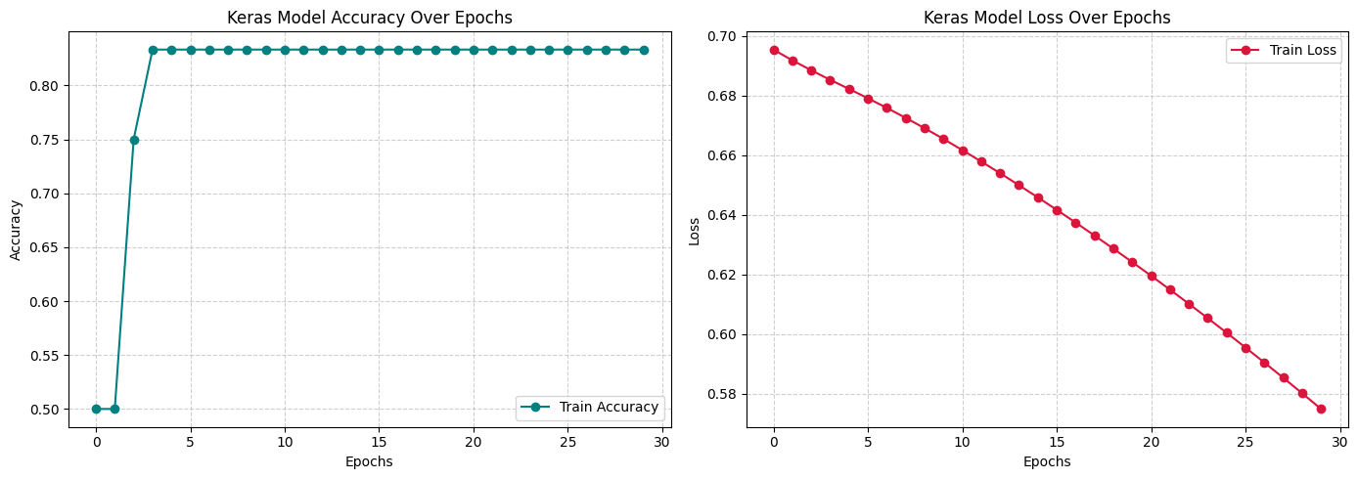
Figure 1. Actual Keras training/embedding-related output generated by the submitted notebook.
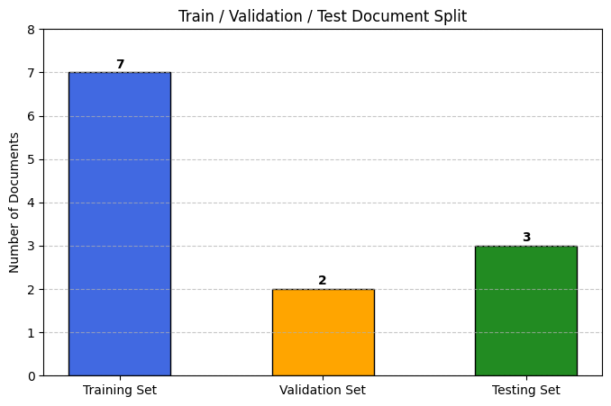
Figure 2. Actual model-training result generated by the submitted notebook.

8. BERT Contextual Embeddings
The notebook loads the pretrained 'bert-base-uncased' model and extracts the contextual representation of the word 'bank' in two sentences:
1. I went to the bank to deposit money.
2. We sat on the bank of the river.
The token sequences were successfully identified, with 'bank' appearing as a token in both contexts. The cosine similarity between the two contextual BERT vectors was 0.5062.
The moderate similarity, together with the change in surrounding context, illustrates that BERT does not assign one fixed vector to a word independent of its sentence. The financial and geographical meanings of 'bank' are represented using their respective contexts.

9. Embedding Visualization

9.1 PCA
The Word2Vec vocabulary subset used for visualization includes agriculture-related and technology-related terms. PCA reduced the 50-dimensional Word2Vec vectors to two dimensions. The first two principal components explain 17.70% and 11.21% of the variance respectively, for a combined 28.91%.
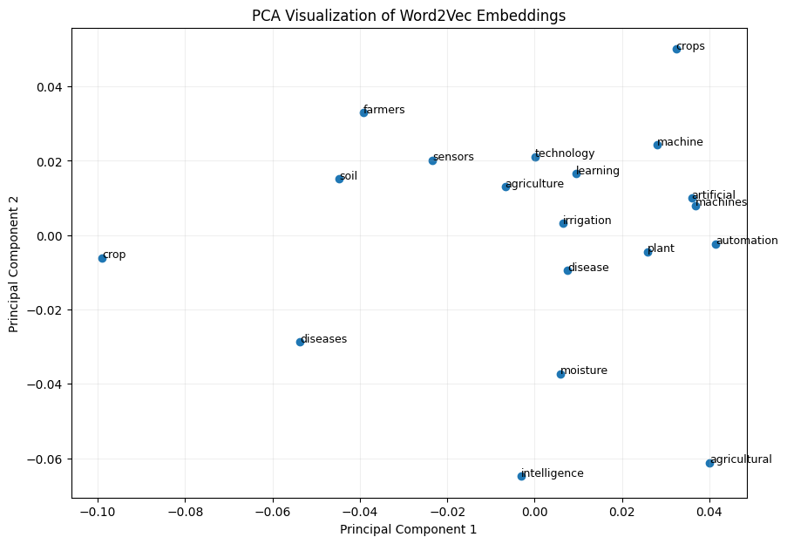
Figure 3. Actual PCA visualization of Word2Vec embeddings from the executed notebook.

9.2 t-SNE
The notebook also applies t-SNE with a data-dependent perplexity, PCA initialization and fixed random seed. The resulting plot is useful for inspecting local neighborhoods. Because t-SNE is a nonlinear projection, visual distances should be interpreted qualitatively.
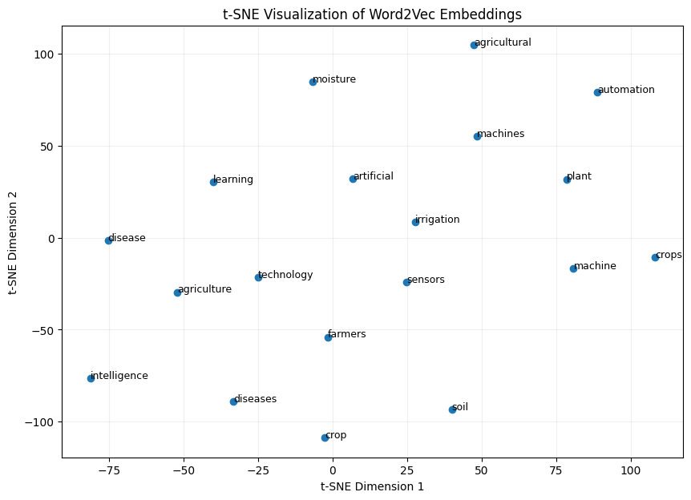
Figure 4. Actual t-SNE visualization of Word2Vec embeddings from the executed notebook.

9.3 TensorFlow Embedding Projector
The notebook exports 'vectors.tsv' and 'metadata.tsv' for use with the TensorFlow Embedding Projector. These files can be loaded into the Projector to interactively inspect high-dimensional embeddings and semantic clusters.

10. Comparative Analysis
Technique | Representation | Contextual | OOV/rare words | Computational cost
One-Hot | Sparse binary | No | Poor | Low
BoW | Sparse counts | No | Poor | Low
TF-IDF | Sparse weighted | No | Limited | Low
Word2Vec | 50-D dense static vectors | No | Limited; exact vocabulary | Medium
GloVe | 50-D pretrained dense vectors | No | Vocabulary dependent | Medium
FastText | 50-D subword-aware vectors | No | Better; demonstrated OOV vector | Medium
Keras Embedding | 32-D trainable vectors | Not inherently contextual | Tokenizer dependent | Medium
BERT | Contextual Transformer vectors | Yes | Subword tokenization | High
The executed results show that Word2Vec, FastText and GloVe produce dense static representations, while BERT produces contextual representations. FastText was particularly useful for the explicit OOV experiment, where Word2Vec could not find 'farmerslike' but FastText generated a vector. BERT required substantially more resources but captured context-sensitive meaning.

11. Key Findings
- The corpus contains 63 unique tokens for the primary traditional and Word2Vec experiments.
- TF-IDF produced a 12 × 63 document-term matrix.
- Word2Vec Skip-gram produced 50-dimensional word vectors.
- FastText produced 50-dimensional vectors and successfully generated an OOV vector for 'farmerslike'.
- The Keras Embedding matrix had shape 65 × 32.
- BERT produced a cosine similarity of 0.5062 between the two contextual representations of 'bank'.
- PCA explained 28.91% of variance through its first two components.
- The notebook exported vectors.tsv and metadata.tsv for TensorFlow Embedding Projector.

12. Conclusion
The actual experiments demonstrate the progression from sparse, frequency-based representations to dense static embeddings and finally contextual Transformer representations. Traditional methods such as TF-IDF are simple and efficient but do not directly capture contextual meaning. Word2Vec learns corpus-specific semantic relationships, while GloVe provides pretrained global semantic structure. FastText improves handling of rare and unseen forms through subword information. The Keras Embedding layer demonstrates trainable neural representations, and BERT provides context-dependent representations, as shown by the two different contexts for 'bank'. PCA, t-SNE and TensorFlow Embedding Projector provide complementary ways to inspect the learned embedding space.

13. References
- Gensim documentation – Word2Vec, FastText and pretrained GloVe embeddings.
- Hugging Face Transformers documentation – BERT.
- TensorFlow/Keras documentation – Embedding layer.
- TensorFlow Embedding Projector documentation.
- Scikit-learn documentation – TfidfVectorizer, PCA and t-SNE.
- 24ADI306 Deep Learning Self-Learning Assignment 1, Kumaraguru College of Technology.

