**Report for Nick Eubank**

**Estimate the Impact of Opioid Control Policies**

Grey Team (Nick Carroll, Jiaxin Ying, Emmanuel Ruhamyankaka, Song Young Oh)

**Motivation**

For more than 30 years, the United States has suffered a widespread crisis of opioid addiction and overdose deaths. As a result, there have been significant policy efforts to address the opioid crisis. Led by the White House's Office of National Drug Control Policy [1], federal agencies such as the Drug Enforcement Agency (DEA), the Centers for Disease Control and Prevention (CDC), the Department of Health and Social Services (DHSS), and the National Institutes of Health (NIH) have led multiple initiatives to combat opioid addiction [2]. But beyond the efforts at the federal level, there have been several state-level policy initiatives instituted throughout the US.

The Texas Medical Board adopted regulations regarding treating pain with controlled substances in 2007. Similarly, the Florida legislature also required pain clinics that treat pain with controlled substances to register with the state starting in 2010. Additionally, the Washington Department of Health adopted a rule regulating the prescription of opioids for pain treatment in 2012.

Understanding the impact of these state-level drug policies on public health allows policymakers to implement best practices and update ineffective policies. These regulations intend to reduce opioid abuse; however, they have the possibility of unintended effects by limiting legal access to drugs for addicts.

This analysis aims to assess the causal effects of opioid drug prescription regulations implemented in these three states (Texas, Florida, and Washington) in the early 2000s (2007, 2010, and 2012 respectively). Specifically, this analysis assessed the impact of the regulations on the volume of opioid shipments and drug overdose deaths.

**Policies Under Investigation:**

1. Texas (2007): The Texas Medical Board adopted regulations about treating pain with controlled substances. The guidelines included performing a patient evaluation before prescribing opioids, obtaining informed consent from the patient for opioid treatment, conducting periodic reviews of the opioid treatment, and maintaining a complete medical record of the patient's treatment.
2. Florida (2010): The state legislature of Florida implemented several amendments to the laws and guidelines governing the prescription of opioids. These modifications included the need for pain clinics to register with the state, the execution of pain clinic raids across the state, the ban on doctors distributing restricted narcotics out of their offices, and tighter controls on drug wholesalers.
3. Washington (2012): The Washington Department of Health adopted a new regulatory rule regarding the prescription of opioids. This rule instituted periodic reviews and mandatory consultations for patients on higher doses of opioids.

**Motivation for Research Design**

This analysis was designed to answer the following two research questions.

1. For Texas: What is the effect of policy change on overdose opioid deaths from 2003-2015?
2. For Florida and Washington: What is the policy change’s effect on opioid shipments and overdose deaths from 2003-2015?

Two approaches were used in this analysis to draw inferences on the causal effects of these three policies. First, the trends of opioid shipments and overdose deaths, both prior to and after institution of the policies, were compared for each jurisdiction in question. This analysis provides information as to how much, if at all, the trends of opioid shipments and overdose deaths were able to be reduced after the policies were implemented. However, even if the trends were able to be dramatically reduced, this does not, in itself, support that the policies themselves caused the reduction in trends. To limit the possibilities of confounding variables which are actually causing a reduction in the trends, this analysis selected control states for each jurisdiction in question, and compared the changes in trend between the jurisdiction in question and its control states, around the time of the policy. Control states were selected to be substantially similar to the jurisdictions in question, except without these policy changes; therefore, making an inherent assumption, that if the policies were not implemented, their trends in the analyzed quantities would have been more similar to the trends in the control states.

**Details of the Data**

In the analysis, three datasets were used to examine the effectiveness of opioid control policies implemented in Texas, Florida, and Washington.

1. Opioid Drug Shipment Data: This dataset provided by The Washington Post details drug transactions reported to the Drug Enforcement Administration between pharmaceutical suppliers and pharmacies between 2006 to 2014. This dataset includes DEA reporter information for the supplier, pharmacy information, and sale information, including the drug, quantity, and sale date.
2. Vital Statistics Mortality Data: The US Underlying Cause of Death statistics include quantities of deaths each year, broken down by each county, and includes the cause of death as qualified by drug or alcohol induced.
3. US Census Population Data: The US Census population estimate dataset includes jurisdictional coding information, population estimates for each year, population change estimates (including births and deaths), along with several other estimates which aren’t relevant to this analysis.

Aside from these three main datasets used for the analysis, two other smaller datasets were taken from Wikipedia to ensure the data interacted appropriately. First, a table of state abbreviations [3] was used because the Opioid Drug Shipment Data stored the US state information as the US state abbreviation, but the US Census Data stored the US state information as the name of the US state. Therefore, using this table ensured that the two datasets mapped to each other accordingly. Second, a table which listed the number of subdivisions (counties) for each state [4] was used to ensure that all the counties were accounted for in the analysis.

**Methods**

To understand the impact of these policies on opioid shipments and overdose deaths, a linear regression of average annualized opioid shipments per capita and overdose deaths per capita was calculated and plotted for each impacted jurisdiction. Two plots were made for each jurisdiction, for each variable analyzed: one which compared the linear trend before policy implementation against the linear trend after the policy implementation and one which compared these linear trends against the linear trends for their control group.

To calculate the linear regressions for average annualized opioid shipments per capita, the opioid drug shipment data was filtered for the buyer’s county, the transaction date, and the quantity of drug along with its conversion factor (opioids are sold in pills, but they are reported in grams and not all pills have the same strength, so the conversion factor is used to compare relative strength/appropriate dose). Once the data was filtered, the units were converted to the appropriate “morphine milligram equivalent” units, and the quantities within a given county and year were calculated. Then, the census population estimates were used to calculate the total opioids shipped per capita to each county for each year. Next, the opioids shipped per capita were averaged over all the counties to provide a single average per capita estimate of opioids shipped per capita for the state for each year. Finally, the data was split into the periods before and after policy implementation, and linear regression trend lines and confidence intervals were calculated for each.

It is important to note that not all counties had records of any opioids shipped. These counties that had no record of opioids shipped in a given year were considered to have zero opioids shipped per capita in that year. These counties which had zero opioids shipped per capita in a given year were then included in the average calculation to ensure a reduction in bias. This bias would particularly impact the data if there were years on one side of the policy implementation which the county had zero shipments, but on the other side of the policy implementation, the county had non-zero shipments. The average over the counties would be substantially less if the zeros were included than if they were excluded. This would, therefore, overstate or understate the change in trend, depending on which side of the policy change the zero value shipments occurred.

Similarly, the mortality data was filtered for drug-induced deaths to calculate the linear regressions for average annualized overdose deaths per capita. The census data was used to calculate each county's drug-induced deaths per capita. Then, the drug-induced deaths were averaged over all the counties for each year's average drug-induced death ratio per capita. And finally, the data was split into the periods before and after policy implementation, and linear regression trend lines, along with confidence intervals, were calculated for each.

**Comparison States**

For this causal inference analysis, the trends of each jurisdiction which implemented a policy were compared against the averages of three states for their control group. Each control group’s three states were selected based on their similarity to the treated state. The metrics used to define “similarity” were population size and opioid dispensing rate. This assumes similar population sizes account for similar social structures and increases the likelihood that those jurisdictions have similar demographics and trends. Additionally, an equivalent level of opioid dispensing rates assumes similarity with respect to opioid use prior to policy intervention. Population size was analyzed from World Population Review [5], and the opioid dispensing rate was analyzed from the Centers for Disease Control and Prevention [6]. Table 1 shows the states with the most “similarity” with their treated state. The metric used to select the control states was a sum of the difference in these two metrics. Based on this analysis, Florida’s comparison states were Michigan, North Carolina, and Ohio. Texas’s analysis used Pennsylvania, Virginia, and Massachusetts as its control states, and Washington’s analysis was compared against Missouri, Georgia, and Arizona.

*Table 1: Selection of Comparison States by Comparing Population Size and Opioid Dispensing Rate*

|  |  |  |  |  |  |  |
| --- | --- | --- | --- | --- | --- | --- |
| **Treated State** | **Control**  **States** | **2022**  **Population**  **Ranking** | **2006**  **Dispensing**  **Rate** | **Population**  **Ranking Diff.**  **(A)** | **Dispensing**  **Rate Diff.**  **(B)** | **Total Diff.**  **(A+B)** |
| Florida | Michigan | 10 | 80.2 | 7 | 0.5 | 7.5 |
| North Carolina | 9 | 85.2 | 6 | 5.5 | 11.5 |
| Ohio | 7 | 87.7 | 4 | 8.0 | 12.0 |
| Pennsylvania | 5 | 69.5 | 2 | 10.2 | 12.2 |
| Missouri | 18 | 80.5 | 15 | 0.8 | 15.8 |
| Texas | Pennsylvania | 5 | 69.5 | 3 | 2.7 | 5.7 |
| Virginia | 12 | 67.2 | 10 | 0.4 | 10.4 |
| Massachusetts | 15 | 66.0 | 13 | 0.8 | 13.8 |
| Illinois | 6 | 55.6 | 4 | 11.2 | 15.2 |
| Arizona | 14 | 74.3 | 12 | 7.5 | 19.5 |
| Washington | Missouri | 18 | 80.5 | 5 | 0.3 | 5.3 |
| Georgia | 8 | 79.8 | 5 | 1.0 | 6.0 |
| Arizona | 14 | 74.3 | 1 | 6.5 | 7.5 |
| North Carolina | 9 | 85.2 | 4 | 4.4 | 8.4 |
| Ohio | 7 | 87.7 | 6 | 6.9 | 12.9 |

**Summary Statistics**

**Mortality Ratio of Opioid Overdose**

The mortality dataset includes 385 counties. The average number of county fatalities were 47.85, with a standard deviation of 70.08. At the county level, Aransas County in Texas and 28 other states had the lowest mean number of deaths which is 10, while Maricopa County had the highest mean number of deaths, 571. At the state level, the maximum number of deaths was 706 and 10 was the lowest number of deaths across the years. Normalized to the population level, Dickenson County in VA had the highest death ratio of 64.82 per 100,000 people, while Hidalgo County in Texas had the lowest death ratio of 2.31 per 100,000 people. The graph below compares the general trend in death ratios between the control states with no policy and the policy-implemented states. Overall, we observe a substantial rise in death ratios for states without policies compared to states with policies.

*Figure 1: Shows a general trend of death ratios per 100,000 persons*

*between states who had a policy compared to states who didn’t.*

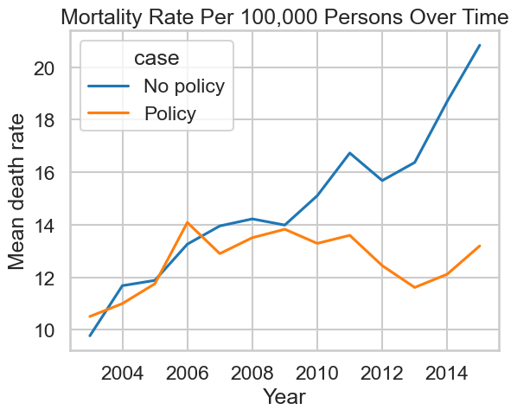

**Opioids Shipments Rate**

There are 67 counties in Florida with a mean opioid per capita of 495.12 and a standard deviation of 313.9. For Washington state, there are 39 counties with a mean opioid shipment per capita of about 369.8. The Opioids per capita for Washington did not seem to change significantly before and after the policy was enacted. See the graph below.

*Fig 2a: Opioid shipment per capita for Washington state in comparison to the control states that had no policy*

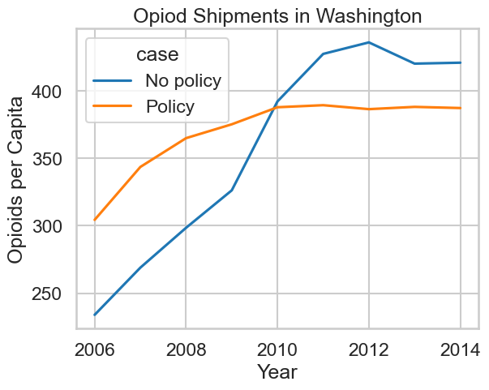

On the other hand, opioid shipments for Florida seemed to reverse after the 2010 policy. Below is a table showing the mean, median, min and Max Opioids per Capita for Florida.

*Table 2: Showing summary statistics of opioid shipment per capita in Florida*

|  |  |  |  |  |  |
| --- | --- | --- | --- | --- | --- |
| State | Policy | Mean | Median | Min | Max |
| Controls | Post | 418.36 | 382.16 | 54.65 | 1721.50 |
|  | Pre | 325.31 | 287.26 | 41.79 | 1612.74 |
| Florida | Post | 533.20 | 456.50 | 71.36 | 2279.13 |
|  | Pre | 446.96 | 388.74 | 78.45 | 1749.64 |

Looking at the table above, it appears as though the mean opioid shipment per capita increased slightly after the policy was implemented. It is possible this can be attributed to the opioid shipments peaking at the beginning of 2010 when news of the policy was announced. However, looking at the graph of average opioid shipments per capita for Florida in Fig3 below, we can see a clear trend of a decrease in the average number of opioids shipped per capita after 2010.

**Rate of Opioid Shipment** **Analysis**

The hypothesis is that the trend in average annual per capita opioid shipments and overdose deaths is lower in the states where regulations were implemented, when compared against the same jurisdiction before implementation, and against jurisdictions where no new policies were implemented. To analyze the validity of this hypothesis, it is expected that the trend for each of these quantities should be substantially less after the policies were implemented than before, and that the trend should be significantly less for the treated states when compared to their control groups. Otherwise, this hypothesis will be rejected if the quantities’ trends continues at a rate similar to the control group.

**Effect of regulation policy on opioid shipments**

**Florida**

Below is the plot comparing the trend of the average annual per capita opioid shipments in Florida before and after policy implementation. Before the policy went into effect in January 2010, the trend of average per capita opioid shipments in Florida was positive, increasing at approximately 100 per year. After 2010, the trend turned negative, decreasing to about 100 per year. This substantial change in trend supports the hypothesis that the policy reduced the number of opioids shipped to Florida.

*Fig 3: This chart depicts the linear regression of the average opioids per capita shipped to Florida in morphine milligram equivalents, both before and after their policy implementation. The blue line represents the linear regression line, and the blue shade represents its confidence interval.*

The plot below compares the trend of the average annual per capita opioid shipments for Florida against Florida’s control states, both before and after policy implementation. When comparing these two trends, Florida’s trend after the policy was implemented was substantially less than their control states’, and had a much more significant reduction in trend than their control states, when compared to before the policy implementation. This substantial trend reduction, compared to the control states, also supports the hypothesis that the policy reduced the number of opioids shipped to Florida. Therefore, concerning the reduction of opioids distributed to Florida, this suggests that Florida’s policy has been effective.

*Fig 4: This chart depicts the linear regression of the average opioids per capita shipped to Florida and its control states, in morphine milligram equivalents, both before and after Florida’s policy implementation. The blue line represents the linear regression line for Florida, and the blue shade represents its confidence interval. The orange line represents the linear regression line for Florida’s control states, and the orange shade represents its confidence interval.*

**Washington**

Below is the plot comparing the trend of the average annual per capita opioid shipments before and after policy implementation in Washington. Before the policy was enacted in January 2012, the trend of average per capita opioid shipments in Washington was positive, increasing at a rate of approximately 20 per year. After 2012, the trend appears flat. While the trend has reduced when comparing the period before and after policy implementation, this reduction seems moderate. This moderate reduction in trend warrants further analysis before supporting the hypothesis that the policy reduced the number of opioids shipped to Washington.

Fig 5: *This chart depicts the linear regression of the average opioids per capita shipped to Washington in morphine milligram equivalents, both before and after their policy implementation. The blue line represents the linear regression line, and the blue shade represents its confidence interval.*

The plot below compares the trend of the average annual per capita opioid shipments for Washington against Washington’s control states, both before and after policy implementation. When comparing these two trends, Washington’s trend after the policy was implemented was less negative than their control states’, and had a much smaller reduction in trend than their control states, when comparing against before the policy implementation. Compared to the control states, this limited reduction in trend does not support the hypothesis that the policy reduced the number of opioids shipped to Washington. Therefore, concerning the reduction of opioids distributed to Washington, this suggests that Washington’s policy was ineffective.

*Fig 6. This chart depicts the linear regression of the average opioids per capita shipped to Washington and its control states, in morphine milligram equivalents, both before and after Washington’s policy implementation. The blue line represents the linear regression line for Washington, and the blue shade represents its confidence interval. The orange line represents the linear regression line for Washington’s control states, and the orange shade represents its confidence interval.*

**Effect of regulation policy on the mortality ratio of opioid overdose**

**Florida**

Below are the plots comparing the trends of the average annual per 100000 drug-induced deaths in Florida and its control states before and after policy implementation in Florida. Before the policy went into effect in February 2010, the trend of average per 100000 drug-induced deaths in Florida was positive, increasing at a rate of approximately 0.75 per year. After 2010, the trend turned negative, decreasing to about 0.5 per year. This substantial change in trend supports the hypothesis that the policy reduced the quantity of drug-induced deaths in Florida. When comparing Florida’s trend against its control group, Florida’s trend after the policy was implemented was substantially less than their control states’ and had a reduction in trend when compared to an increase in trend in their control states’, when compared to before the policy implementation.

*Figure 7: After the regulation policy was effective in Florida in February 2010, the chart presents the averages of the mortality ratio of opioid overdose per 100000 from the raw data for states in each county between the pre-policy (before 2009) and post-policy periods (after 2010). The treatment state is Florida, and its control states include Michigan (MI), North Carolina (NC), and Ohio (OH). The solid lines that represent the averages of the mortality ratio are local polynomial fits (bandwidth = 2), and the blue shadow parts indicate the 95% confidence intervals.*

After Florida implemented the regulation policy for opioid drugs in 2010, it is evident that the mortality ratio of opioid overdose has a decreasing tendency based on the left graph. Also, the right graph indicates the comparison between FL and its control states (MI, OH, NC) without implementing policies. The mortality ratio of opioid overdose in these control states continues to increase after 2010. Based on the left graph, without implementing the regulation policy for opioid drugs, the average mortality ratio per 100000 opioid overdoses rose from 12 year by year since 2003 and peaked at about 16.75 in 2009. After Florida implemented the regulation policy for opioid drugs in 2010, the mortality ratio per 100000 people of an opioid overdose in FL dropped immediately to about 15.75 in 2010, and it continued to keep a downward tendency from 2010. This might not happen if the regulation policy was not implemented. Moreover, according to difference-in-difference analysis, the average mortality ratio per 100000 people opioid overdose for the three comparison states was about two lower than the average mortality ratio of Florida from 2003 to 2009 while all of them held increasing tendencies of the mortality ratio of opioid overdose. However, the three comparison states still had an upward mortality ratio trend after 2010, and this tendency is the same as before 2010. Furthermore, the variations of drug overdose deaths between pre and post-policy periods among Florida and its control states have increased since 2010. In 2015, the average mortality ratio per 100000 persons of an opioid overdose for the three comparison states was about 7.5 higher than the average mortality ratio of Florida. In general, the mortality ratio per 100000 in control states increased from about 15 in 2010 to approximately 21.5 in 2015, while the mortality ratio per 100000 persons of opioid overdose in Florida decreased from 2010 at about 16 to about 14 in 2015. Therefore, we conclude that the policy of opioid regulations had a positive impact on reducing the mortality ratio of opioid overdose in Florida.

**Texas**

Below are the plots comparing the trends of the average annual per 100000 drug-induced deaths in Texas and its control states before and after policy implementation in Texas. Before the policy went into effect in January 2007, the trend of average per 100000 drug-induced deaths in Texas was positive, increasing at a rate of approximately 1.25 per year. After 2007, the trend turned negative, decreasing to about 1.3 per year. This substantial change in trend supports the hypothesis that the policy reduced the quantity of drug-induced deaths in Texas. When comparing Texas’s trend against its control group, Texas’s trend after the policy was implemented was substantially less than their control states’ and had a reduction in trend when compared to an increase in trend in their control states’, when compared to before the policy implementation.

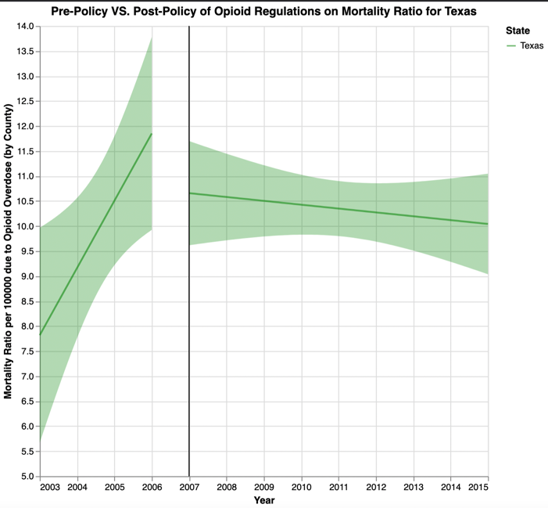

*Figure 8: After the regulation policy was effective in Texas in January 2007, the chart presents the averages of the mortality ratio of opioid overdose per 100000 from the raw data for states in each county between the pre-policy (before 2006) and post-policy periods (after 2007). The treatment state is Texas, and its control states include Pennsylvania (PA), Massachusetts (MA), and Virginia (VA). The solid lines that represent the averages of the mortality ratio are local polynomial fits (bandwidth = 2), and the green shadow parts indicate the 95% confidence intervals.*

After Texas implemented the regulation policy for opioid drugs in 2007, it is obvious that the mortality ratio of opioid overdose has a relatively decreasing tendency based on the left graph. Also, the right graph indicates the comparison between TX and its control states (MA, PA, VA) without implementing policies. The mortality ratio of opioid overdose in these control states continues to increase after 2007. Based on the left graph, without implementing the regulation policy for opioid drugs, the average mortality ratio per 100000 of opioid overdose had an increasing trend from about eight, year by year, since 2003 and peaked at about 12 in 2006. After implementing the regulation policy for opioid drugs in 2007 in TX, the mortality ratio per 100000 of opioid overdose in TX dropped immediately to about 10.7 in 2007. It continued to keep a downward trend from 2007. This might not have happened if the regulation policy had not been implemented. Moreover, according to difference-in-difference analysis, the average mortality ratio per 100000 for the three comparison states is three higher than the average mortality ratio per 100000 in Texas from 2003 to 2006, while all of them held increasing tendencies of the mortality ratio per 100000 of opioid overdose. Nevertheless, the three comparison states still had an upward mortality ratio trend after 2007; this tendency is the same as before 2007. Moreover, the variations of drug overdose deaths between pre and post-policy periods among Texas and its control states have increased since 2007. In 2015, the average mortality ratio per 100000 of opioid overdose for the three comparison states was about nine higher than the average mortality ratio of Texas. In general, the mortality ratio per 100000 in control states increased from about 13 in 2007 to about 19.3 in 2015, while the mortality ratio per 100000 of opioid overdose in Texas decreased from 2007 about 11 to about 10 in 20. Hence, although such a degree of decline is not large, we conclude that the policy of opioid regulations had a positive impact on decreasing the mortality ratio of opioid overdose in Texas.

**Washington**

***Below are the plots comparing the trends of the average annual per 100000 drug-induced deaths in Washington and its control states before and after policy implementation. Before the policy went into effect in January 2012, the trend of average per 100000 drug-induced deaths in Washington was positive, increasing at a rate of approximately 0.25 per year. After 2012, the trend was still positive but with a lower slope, rising at a rate of roughly 0.07 per year. Consequently, this change in trend does not support the hypothesis that the policy reduced the quantity of drug-induced deaths in Washington.

*Figure 9: After the regulation policy was effective in Washington in January 2012, the chart presents the averages of the mortality ratio of opioid overdose per 100000 from the raw data for states in each county between the pre-policy (before 2011) and post-policy periods (after 2012). The treatment state is Washington, and its control states include Missouri (MO), Georgia (GA), and Arizona (AZ). The solid lines that represent the averages of the mortality ratio are local polynomial fits (bandwidth = 2), and the red shadow parts indicate the 95% confidence intervals.*

After Washington implemented the regulation policy for opioid drugs in 2012, the mortality ratio per 100000 of opioid overdose still had a decreasing, but lesser degree tendency based on the left graph. Also, the right graph indicates the comparison between WA and its control states (MO, GA, AZ) without implementing policies. The mortality ratio per 100000 of opioid overdose in these control states continued to increase after 2007. Based on the left graph, without implementing the regulation policy for opioid drugs, the average mortality ratio per 100000 opioid overdoses had an increasing trend from about 12.25 year by year since 2003 and peaked at approximately 14.25 in 2011. However, after implementing the regulation policy for opioid drugs in 2012 at WA, the mortality ratio of opioid overdose in WA did not drop. It continued to keep an upward, but lesser degree tendency from 2012. Furthermore, according to difference-in-difference analysis, the slope of the average mortality ratio for the three comparison states was more significant than that of Washington from 2003 to 2011, while all of them held increasing tendencies of the mortality ratio per 100000 of opioid overdose. The three comparison states still had an upward trend of mortality ratio after 2012, and this trend is the same as before 2012. In general, the mortality ratio in control states increased from about 15.5 in 2012 to approximately 16.5 in 2015, and the mortality ratio per 100000 of opioid overdose in Washington also rose from 2012 at about 13.8 to about 14 in 2015. Therefore, although the mortality ratio per 100000 of opioid overdose in Washington was lower than other control states on average after implementing the policy because Washington still had a rising trend of mortality ratio of opioid overdose after 2012, we conclude that the policy of opioid regulations did not have a positive impact on decreasing the mortality ratio of opioid overdose in Washington.

**Interpretation of the Analysis**

Based on this analysis, Florida and Texas implemented policies that reduced drug-induced deaths, and Florida’s approach was able to limit the number of opioids shipped to the state. With appropriate data, a similar analysis would be able to confirm if Texas could limit opioids shipped to the state. Conversely, based on this analysis, the policy that Washington implemented in 2012 was unable to substantially reduce the quantity of opioids shipped to the state or the drug-induced deaths in the state.

**Limitations**

First, to protect personal privacy, if the number of people in a given category (i.e. one county/year/cause of death category) is less than 10, the US Vital Statistics agency will not record such data. Hence, the actual values of total deaths of opioid overdose will be higher than the data we used in this case, so the actual average mortality ratios of opioid overdose per capita will also be higher than the mortality ratios we calculated. Second, since the U.S. census is conducted every ten years, the population data for all years except for 2010, which is determined, are estimated rather than statistical. In addition, there are numerous ways that the population from census inquiry goes wrong, including non-response, measurement, inaccurate statistical unit definitions, and even the investigators' prejudice [3]. Therefore, the actual population may differ from the data we used here, but we can't get the most realistic data, so these analyses may not fully reflect the real situation. Third, our control states were selected based on similar population sizes and opioid dispense rates. Still, we did not consider other similar factors, such as income and education levels, so our analysis may be somewhat one-sided. Lastly, most states have generally enacted multiple opioid control policies as the opioid crisis has evolved for decades. For example, many states implemented some combination of naloxone laws, Good Samaritan laws, and medical marijuana laws during 2015-2017. In addition to pre-existing prescription drug monitoring program (PDMP) laws, by 2017, most states had implemented at least 3 of these four categories of policies [4]. Therefore, it will be unreasonable to put too much emphasis on specific time points, namely the years 2007 (Texas), 2010 (Florida), and 2012 (Washington). For the same reason, it is almost impossible to identify perfect comparison states which were not impacted by the policy of interest at all. These factors serve to complicate the accurate evaluation of opioid policy effectiveness. In general, despite key takeaways from this analysis, extracting causal information from drug policy analysis is still challenging. Many states have enacted multiple opioid control policies as the opioid crisis has evolved over the decades. For example, several states implemented a combination of naloxone laws, Good Samaritan laws, and medical marijuana laws during 2015-2017. Furthermore, in addition to pre-existing prescription drug monitoring program (PDMP) laws, by 2017, most states had implemented at least 3 of these four categories of policies [7]. Therefore, it is challenging to ascertain appropriate control groups and ensure all confounding variables are accounted for. These factors complicate valid inferences on the causal effects of opioid control policies.

**Conclusion**

Based on the above analysis, the regulation policy of Florida was successful, it played an important role in dramatically lowering the average rate of opioid shipments per capita and significantly reversing the general upward trend in the average mortality ratio of opioid overdose per capita. While we did not analyze the effects of Texas's regulation policy on opioid shipments and only focused on researching the effects of Texas's regulation policy on the mortality ratio of opioid overdose, it was still obvious that Texas was also able to implement effective policies to reduce the average mortality ratio of opioid overdose per capita. However, compared with Florida, the effect of Texas's regulation policy in this respect was not as evident as that of Florida's policy. In general, although both states had reduced the mortality ratio of opioid overdose after implementing their policies, Florida's mortality ratio was greatly reduced, while the rate reduction of the mortality ratio of opioid overdose in Texas was not a huge degree. Conversely, Washington’s policy in 2012 is relatively ineffective at combating the opioid epidemic because the regulation policy of Washington did not result in declining trends of the average rate of opioid shipments per capita and the average mortality ratio of opioid overdose per capita. To conclude, in order to ensure the effective control of opioid shipments and deaths of opioid overdose, other states should follow Florida’s policies which had been shown to have significant effects on reducing both the average rate of opioid shipments and the death ratio of opioid overdose per capita.

**References**

[1] "National drug control budget (2021)." [Online]. Available: https://www.whitehouse.gov/wp-content/uploads/2021/05/National-Drug-Control-Budget-FY-2022-Funding-Highlights.pdf

[2] C.D. Soelberg, R.E. Brown, D.Du Vivier, J.E. Meyer, and B.K. Ramachandran, "The us opioid crisis - current federal and state legal issues," Anesthesia and Analgesia, vol.125, no.5, p.1675-1681, 2017.

[3] ”List of U.S. states by traditional abbreviation” <https://simple.wikipedia.org/wiki/List_of_U.S._states_by_traditional_abbreviation>

[4] “County (United States)” <https://en.wikipedia.org/wiki/County_(United_States)#:~:text=The%20average%20number%20of%20counties,the%20254%20counties%20of%20Texas>

[5] Available: <https://worldpopulationreview.com/states>

[6] Available: <https://www.cdc.gov/drugoverdose/rxrate-maps/state2020.html>

[7] Griffin, B.A., Schuler, M.S., Pane, J. et al. Methodological considerations for estimating policy effects in the context of co-occurring policies. Health Serv Outcomes Res Method (2022).