**Report for Policymakers**

**Estimate the Impact of Opioid Control Policies**

Grey Team (Nick Carroll, Jiaxin Ying, Emmanuel Ruhamyankaka, Song Young Oh)

**Motivation**

For more than 30 years, the United States has suffered a widespread crisis of opioid addiction and overdose deaths. As a result, there have been significant policy efforts to address the opioid crisis. Led by the White House's Office of National Drug Control Policy [1], federal agencies such as the Drug Enforcement Agency (DEA), the Centers for Disease Control and Prevention (CDC), the Department of Health and Social Services (DHSS), and the National Institutes of Health (NIH) have taken several initiatives to combat it [2].

In addition to these efforts at the federal level, there has been enforcement of state-level opioid control policies in various parts of the US. For instance, the Texas Medical Board adopted regulations with regards to treating pain with controlled substances in 2007. The Florida legislature also began to require that pain clinics treating pain with controlled substances register with the state since 2010, and the Washington Department of Health adopted a rule regulating the prescribing of opioids for pain treatment in 2012.

Evaluating the impact of these state-level policies on public health outcomes matters in health policy. It is because their geographic and temporal variation in policy adoption can offer an insight into better understanding about the policy effects. In this project, the effects of opioid drug prescription regulations enforced in three states (Texas, Florida, Washington) will be examined by focusing on their effects on 1) the volume of opioids shipment and 2) drug overdose deaths.

Furthermore, two approaches will be mainly used in the analysis. The first approach is pre-post comparison which focuses on difference between pre-policy and post-policy outcomes. The other one is a difference-in-difference method which compares the changes in outcomes over time between a state with a policy change and other states without the policy change.

**Overview of the Data**

In this analysis, three kinds of datasets will be used to examine the effectiveness of opioid control policies implemented in Texas, Florida, and Washington.

1. Opioid Drug Shipment Data: Provided by the Washington Post, this dataset offers county-level information about drug transactions from 2006 to 2014 that are sourced by the Drug Enforcement Administration's database which tracks the path of every single pain pill sold in the United States. The dataset has records mainly about oxycodone and hydrocodone pills, which are known to consist of three-quarters of the total opioid shipments to pharmacies in the country.
2. Vital Statistics Mortality Data: This dataset, provided by the US Vital Statistics, contains data on every drug overdose death in the US from 2003 to 2015, and it also includes county-level information.
3. US Population Data: This dataset has population estimates for each county in the US from 2000 to 2020.

**Pre-post and Difference-in-difference Analysis**

The project hypothesis is that the average annual percent change in per capita opioid quantities sold and overdose deaths is lower in the states where regulations were implemented when compared against the same jurisdiction prior to implementation and against jurisdictions where no new policies were implemented. To analyze this change, both a "Pre-Post Comparison" and "Difference-in-Difference Comparison" analysis will be utilized. To analyze the validity of the hypothesis, it is expected that the hypothesis is reasonable if the average annual percent change in per capita opioid quantities sold and opioid-drug-overdose deaths should be substantially less after the policies were placed than before the polices were introduced for each jurisdiction. Otherwise, the hypothesis will be rejected if the opioid-drug-overdose deaths per capita or the opioid quantities sold per capita continue to increase or basically keep constant after the regulation policy change.

For the three states (Florida, Washington, and Texas) that introduced opioid regulation policies, we choose three states as comparison states for them because they have similar population sizes and opioid dispense rates. The control states for Florida are Michigan (MI), North Carolina (NC), Ohio (OH), and the control states for Washington are Missouri (MO), Georgia (GA), Arizona (AZ), and the control states for Texas are Pennsylvania (PA), Virginia (VA), Massachusetts (MA). These control states did not implement the same policies to regulate opioid drugs, so we assume that an increase in opioid-drug-overdose deaths per capita or opioid quantities sold per capita is due to the state did not introduce policies to regulate opioid drugs.

**Effect of regulation policy on opioid shipments (to be added)**

**Florida**

**Texas**

**Washington**

**Effect of regulation policy on the mortality rate of opioid overdose**

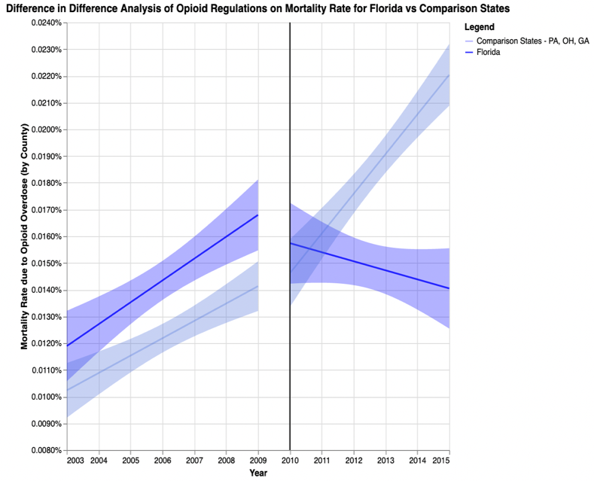

*Figure 1: Chart of the mortality rate of opioid-drug overdose between the pre-policy and post-policy periods, the regulation policy was effective in Florida in February 2010.*

After Florida implement the regulation policy for opioid drugs in 2020, it is obvious that the mortality rate of opioid-drug overdose has a decreasing tendency based on the left graph. Also, the right graph indicates the comparison between FL and its control states (PA, OH, GA) without implementing policies. It is evident that the mortality rate of opioid-drug overdose in these control states continues to hold an increasing trend after 2010. Based on the left graph, without implementing the regulation policy for opioid drugs, the average mortality rate of opioid-drug overdose had a rising trend from 0.012% year by year since 2003 and peaked at about 0.017% in 2009. After Florida implemented the regulation policy for opioid drugs in 2010, the mortality rate of opioid-drug overdose in FL dropped immediately to about 0.016% in 2010 and it continued to keep a downward tendency from 2010. This might not happen if the regulation policy was not implemented. Moreover, according to difference-in-difference analysis, the average mortality rate of opioid-drug overdose for the three comparison states was lower than the average mortality rate of Florida from 2003 to 2009 while all of them held increasing tendencies of the mortality rate of opioid-drug overdose. However, the three comparison states still had an upward trend of mortality rate after 2010, this tendency is the same as before 2010. In general, the mortality rate in control states increased from about 0.015% in 2010 to about 0.022% in 2015, while the mortality rate of opioid-drug overdose in Florida decreased from 2010 at about 0.016% to about 0.014% in 2015. Therefore, we conclude that the policy of opioid regulations had a positive impact on decreasing the mortality rate of opioid-drug overdose in Florida.

**Texas**

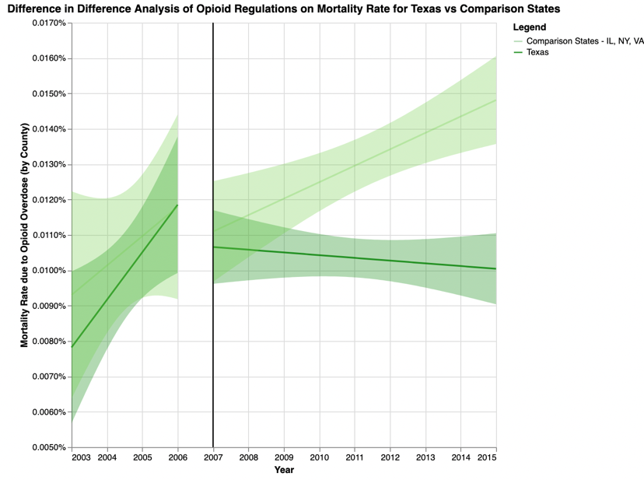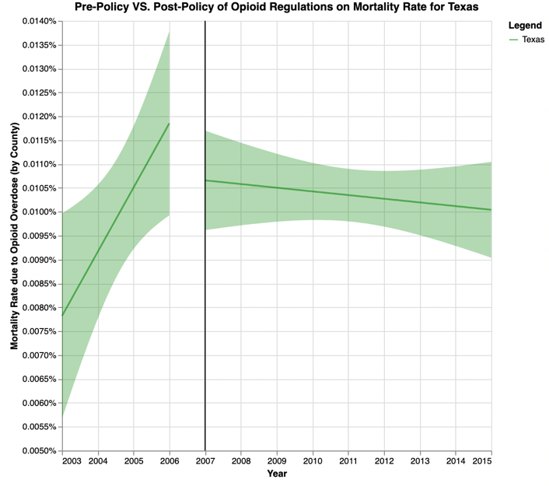*Figure 2: Chart of the mortality rate of opioid-drug overdose between the pre-policy and post-policy periods, the regulation policy was effective in Texas in January 2007.*

After Texas implement the regulation policy for opioid drugs in 2007, it is obvious that the mortality rate of opioid-drug overdose has a relatively decreasing tendency based on the left graph. Also, the right graph indicates the comparison between TX and its control states (IL, NY, VA) without implementing policies. It is obvious that the mortality rate of opioid-drug overdose in these control states continues to hold an increasing trend after 2007. Based on the left graph, without implementing the regulation policy for opioid drugs, the average mortality rate of opioid-drug overdose had an increasing trend from about 0.008% year by year since 2003 and peaked at about 0.012% in 2006. After implementing the regulation policy for opioid drugs in 2007 at TX, the mortality rate of opioid-drug overdose in TX dropped immediately to about 0.0105% in 2007 and it continued to keep a downward tendency from 2007. This might not happen if the regulation policy was not implemented. Moreover, according to difference-in-difference analysis, the average mortality rate for the three comparison states had similar values as the average mortality rate of Texas from 2003 to 2006 while all of them held increasing tendencies of the mortality rate of opioid-drug overdose. Nevertheless, the three comparison states still had an upward trend of mortality rate after 2007, this tendency is the same as before 2007. In general, the mortality rate in control states increased from about 0.011% in 2007 to about 0.015% in 2015, while the mortality rate of opioid-drug overdose in Texas decreased from 2007 at about 0.011% to about 0.010% in 2015. Therefore, although such a degree of decline is not large, we conclude that the policy of opioid regulations had a positive impact on decreasing the mortality rate of opioid-drug overdose in Texas.

**Washington**

*Figure 3: Chart of the mortality rate of opioid-drug overdose between the pre-policy and post-policy periods, the regulation policy was effective in Washington in January 2012.*

After Washington implement the regulation policy for opioid drugs in 2012, the mortality rate of opioid-drug overdose still had a decreasing, but lesser degree tendency based on the left graph. Also, the right graph indicates the comparison between WA and its control states (AZ, MD, WI) without implementing policies. It is obvious that the mortality rate of opioid-drug overdose in these control states continues to hold an increasing trend after 2007. Based on the left graph, without implementing the regulation policy for opioid drugs, the average mortality rate of opioid-drug overdose had an increasing trend from about 0.0125% year by year since 2003 and peaked at about 0.0145% in 2011. However, after implementing the regulation policy for opioid drugs in 2012 at WA, the mortality rate of opioid-drug overdose in WA did not drop, it continued to keep an upward, but lesser degree tendency from 2012. Furthermore, according to difference-in-difference analysis, the average mortality rate for the three comparison states were lower than the average mortality rate of Washington from 2003 to 2011 while all of them held increasing tendencies of the mortality rate of opioid-drug overdose. The three comparison states still had an upward trend of mortality rate after 2012, this tendency is the same as before 2007. In general, the mortality rate in control states increased from about 0.015% in 2012 to about 0.017% in 2015, and the mortality rate of opioid-drug overdose in Washington also rose from 2012 at about 0.0138% to about 0.014% in 2015. Therefore, although the mortality rates of opioid-drug overdose in Washington were lower than other control states on average after implementing the policy; because Washington still had a rising trend of mortality rates of opioid-drug overdose after 2012, we conclude that the policy of opioid regulations did not have a positive impact on decreasing the mortality rate of opioid-drug overdose in Washington.

**Interpretation of the Analysis**

The two main strengths of this analysis are that when evaluating the impacts of the regulation policy of opioid drugs in three states (FL, TX, WA), we use the pre-post comparison and the difference in difference analysis. First, to determine whether the regulation policies of opioid drugs had a positive impact on drug overdose deaths or opioid shipments, the pre-post comparison is about focusing on examining changes over time for each policy-implemented state. If the policies had no effect, after introducing the policies, the plots would depict an ongoing rise or relatively constant tendencies in opioid shipments and overdose deaths. If the policy had a positive influence, after implementing the policies, the plots would indicate a gradual decline trend in opioid shipments and drug overdose deaths. Second, a difference-in-difference analysis is used for exploring whether there were greater variations in opioid shipments or drug overdose deaths between pre- and post-policy periods in each state that had adopted the regulation policy of opioids than in other states that had not. Specifically, we compare the policy-implemented states with states which did not have related policies by choosing three control states based on similar population sizes and opioid dispense rates for each treatment state. Finally, we evaluate the impacts of regulatory policy by recalling a pre-post analysis so that comparing the tendencies of average mortality rates with related control states.

**Limitations**

First, in order to protect personal privacy, if the number of people in a given category (i.e. one county/year/cause of death category) is less than 10, the US Vital Statistics agency will not record such data. Hence, the true values of total deaths of opioid-drug overdose will be higher than the data we used in this case, so the real average mortality rates of opioid-drug overdose per capita will also be higher than the mortality rates we calculated. Second, since the U.S. census is conducted every ten years, the population data for all years except for 2010, which is determined, are estimated rather than statistical. In addition, there are numerous ways that the population from census inquiry goes wrong, including non-response, measurement, inaccurate statistical unit definitions, and even the investigators' own prejudice [3]. Therefore, the true population may be different from the data we used here, but we can't get the most realistic data, so these analyses may not fully reflect the real situation. Third, our control states were selected based on similar population sizes and opioid dispense rates, but we did not take into account other similar factors such as income and education levels, so our analysis may be somewhat one-sided. Last but not least, most states have generally enacted multiple opioid control policies as the opioid crisis has evolved for decades. For example, many states implemented some combination of naloxone laws, Good Samaritan laws, and medical marijuana laws during 2015-2017. In addition to pre-existing prescription drug monitoring program (PDMP) laws, by 2017 the majority of states had implemented at least 3 of these 4 categories of policies [4]. Therefore, it will be unreasonable to put too much emphasis on specific timepoints, namely the year of 2007 (Texas), 2010 (Florida), 2012 (Washington). For the same reason, it is almost impossible to identify perfect comparison states which were not impacted by the policy of interest at all. These factors serve to complicate accurate evaluation of opioid policy effectiveness.

**Conclusion (to be added)**

**References**

[1] "National drug control budget (2021)." [Online]. Available: https://www.whitehouse.gov/wp-content/uploads/2021/05/National-Drug-Control-Budget-FY-2022-Funding-Highlights.pdf

[2] C.D. Soelberg, R.E. Brown, D.Du Vivier, J.E. Meyer, and B.K. Ramachandran, "The us opioid crisis - current federal and state legal issues," Anesthesia and Analgesia, vol.125, no.5, p.1675-1681, 2017.

[3] "Demerits of a Census Investigation (2022)." [Online]. Available: <https://www.toppr.com/guides/business-economics-cs/descriptive-statistics/census/#Demerits_of_a_Census_Investigation>

[4] Griffin, B.A., Schuler, M.S., Pane, J. et al. Methodological considerations for estimating policy effects in the context of co-occurring policies. Health Serv Outcomes Res Method (2022).