**Estimate the Impact of Opioid Control Policies**

**(Report for Policy Maker)**

White Team

Chenxi Rong, Xiaoquan Liu, Fabian Schmid, Zhanyi Lin

November 29, 2022

**Motivation**

Opioids are a class of drugs that include prescription opioids (natural and semi-synthetic opioids and methadone), heroin, and synthetic opioids other than methadone (primarily fentanyl) that derive from, or mimic, natural substances found in the opium poppy plant and work in the brain to produce a variety of effects, including pain relief. Opioid drugs include prescription pain medicine and illegal drugs. Some people may experience euphoria, a joyful sensation of well-being, from opioids, whether they are legally prescribed or not. Opioids don't always generate euphoria, but for those who do, there's a chance they'll be used again and again because of how they feel. Therefore, even with a doctor's supervision, using opioids can pose risks. A person's tolerance and dependency to prescription drugs can develop over time, necessitating greater and more frequent dosages, finally leading to addiction and the person's turning to illegal markets in order to maintain their addiction, and subsequently causing death.

According to the Centers for Disease Control and Prevention (CDC), the number of drug overdose deaths has quintupled since 1999, and the rise in opioid overdose deaths can be outlined in three distinct waves: the first wave in the 1990s with increased prescribing of opioids, the second wave in 2010 with heroin, and the third wave in 2013 with synthetic opioids like fentanyl. In order to fight the opioid overdose epidemic, policymakers have made policy interventions to limit the over prescription of opioids. Texas regulations with regard to treating pain with controlled substances went into effect in January 2007. Florida’s legislature became effective in 2010, and a series of changes related to drug prescription took place in the following years. Washington regulated the prescribing requirements of opioids for pain treatment in January 2012, which included periodic patient reviews, milligram thresholds, strict documentation guidelines, and consultations with pain management experts.

For all three of these policy changes, we performed both pre-post analysis and difference-in-difference analysis to understand the effect of opioid drug regulations on both the amount of opioid shipments and drug overdose deaths. For pre-post analysis, we will demonstrate the trend of overdose deaths and opioid shipments over years. If policy had gone into effect, our plots would show a difference between how things were in each state right before the policy went into effect and right after the policy went into effect.

However, to further valid our analysis of causation between opioid drug regulations and both the amount of opioids shipments and drug overdose deaths, we need to eliminate the effect of confounders. For example, the US Customs Service managed to dramatically reduce the importation of fentanyl into the United States at the same time Florida’s policy went into effect, which would likely reduce the number of overdose deaths throughout the United States. If we were just to use pre-post analysis to bring a conclusion by comparing Florida in 2009 to Florida in 2011, we would wrongly attribute the decline in the amount of shipments and overdose deaths to Florida’s policy change. With difference-in-difference analysis, we used the observed outcomes of people who were exposed to drug regulations (i.e., data from Texas, Florida, and Washington) and people who were not exposed to drug regulations (i.e., for each of those states, we picked three states as comparison states) both before and after the policy went into effect to evaluate the impact of opioid control policies.

**Data**

We used drug overdose death data from the US Vital Statistics records, prescription opioid drug shipments from the Washington Post, FIPS codes based on a file from the US Census, and US census population data. The data sets were merged based on the county FIPS codes and the year. FIPS codes are already included in the population data set and the US Vital Statistics records. Besides that, the raw data was aggregated at the county-year level so that the data was available for our preferred unit of observation.

**Analysis --- Pre-post and Difference-in-difference Analysis**

**Florida**

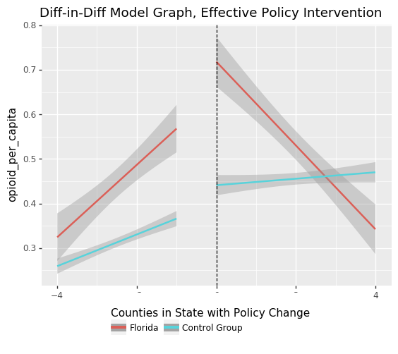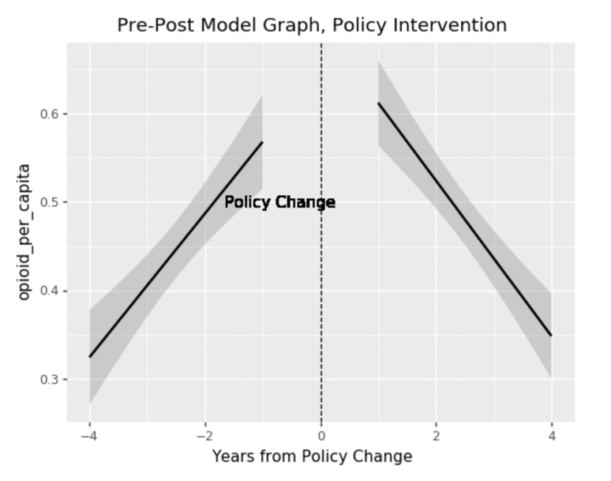[Opioid Shipment]

From the output of the pre-post graph, we can see the slope of regression model of prescriptions opioid shipment per capita. The slope of opioid shipment amount per capita was positive before the policy became effective, but changed to negative after the date the policy became effect. This means that the opioid shipment per capita increased year by year before the policy change and started to decrease annually after the policy effective date. Therefore, we may conclude that the policy is effective in Florida according to pre-post analysis.

For the different-in-different analysis, we selected Georgia, North Carolina, and South Carolina since those three states are close to Florida and have similar weather. From the output, we can see that the slope of control groups is still positive but the slope of Florida opioid shipment converts to negative. Therefore, we may conclude that the decrease of the opioid per capita in Florida after 2010 is because of the policy, which means the policy is effective.

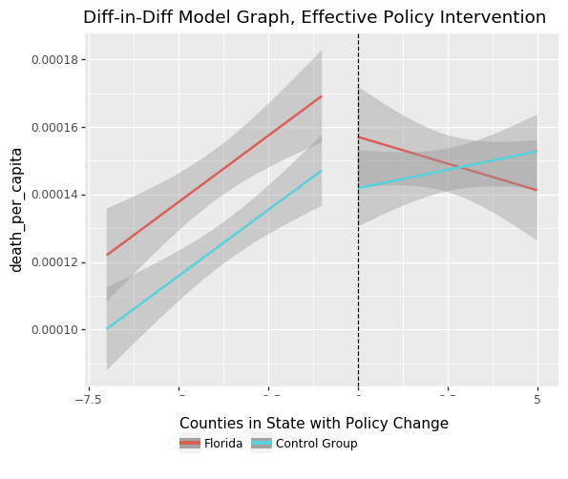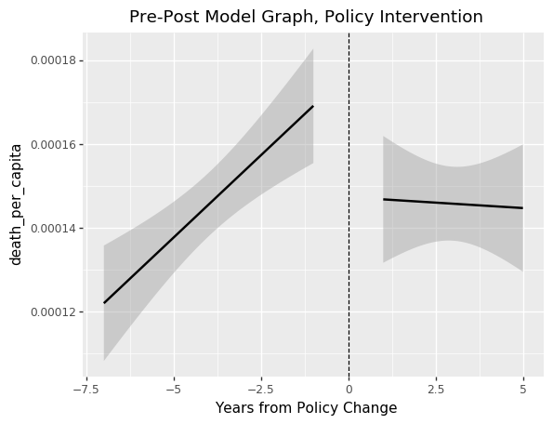[Overdose Death]

From the output of the pre-post graph, we can see the slope of regression model of the overdose deaths per capita. The slope was positive before the policy became effective, but changed to negative after the date the policy became effective. This means that the overdose deaths per capita increased year by year before the policy change and started to decrease annually after the policy effective date. Therefore, we may conclude that the policy is effective in Florida according to pre-post analysis. Combining the output from the difference-in-difference analysis, we can see that the slope of control groups is still positive but the slope of Florida overdose deaths per capita converts to negative. Therefore, we may conclude that the decrease of the overdose deaths per capita in Florida after 2010 is because of the policy, which means the policy is effective.

**Texas**

[Opioid Shipment]

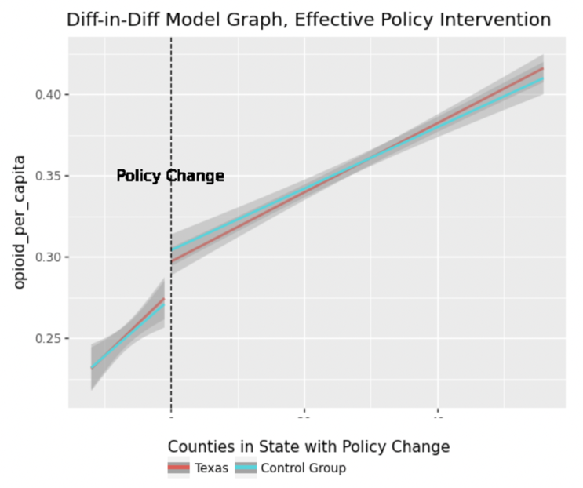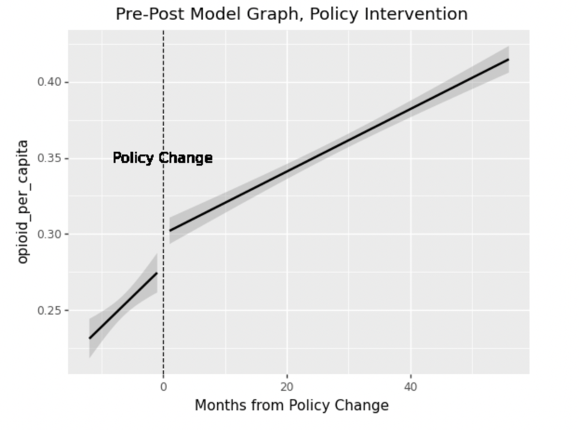Since our shipment data only runs from 2006, meaning we only have one year of data on either side of the policy change, we analyzed opioid shipment data by month instead of by year.

In the left part of the pre-post chart, the slope is sharper than the right's, which means the prescription opioid shipment amount per capita increased year by year in Texas before January 2007. After the policy became effective in January 2007, the trend is still increasing, but the gradient is smaller in the right part. Therefore, we may conclude that the policy restricted the opioid shipment amount.

For the difference-in-difference analysis, we selected Arkansas, Oklahoma, and New Mexico as control groups since those three states are close to Texas. Compared to the control group, even though the amount of opioid shipment per capita in Texas is lower after January 2007, the trend is similar in Texas and control groups, and it seems that the control group experienced a sharper decrease. Therefore, we cannot conclude whether the control policy was successful in controlling the opioid shipments in Texas.

[Overdose Death]

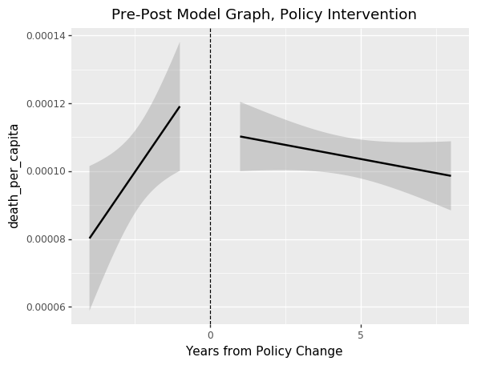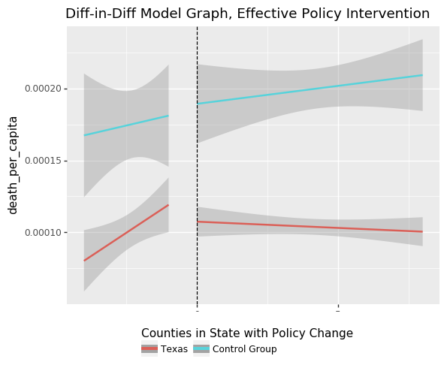From the output of the pre-post graph, we can tell the slope for overdose deaths per capita was positive before the policy became effective, but changed to negative after the date the policy became effective. This means that the overdose death per capita increased year by year before the policy change and started to decrease annually after the policy’s effective date. Therefore, we may conclude that the policy is effective in Texas according to pre-post analysis. Combining the output from the difference-in-difference analysis, we can see that the slope of control groups is still positive, but the slope of Texas overdose deaths per capita converts to negative. Therefore, we may conclude that the decrease in overdose deaths per capita in Texas after 2007 is because of the policy, which means the policy is effective.

**Washington**

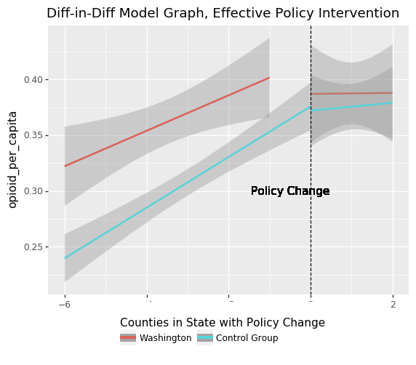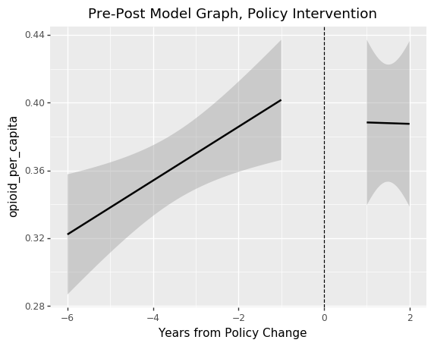[Opioid Shipment]

From the pre-post output, we can find that the slope of prescription opioid shipments amount was positive before the date of policy being effective and became negative after 2012 in which year the policy became effective. Even though the gradient indicates that the decreasing speed is not high, but the overall trend is totally different from the previous years. Hence, we conclude that the policy has positive influence on prescription opioid shipment amount restriction.

For the difference-in-difference analysis, we selected Oregon, Idaho, and Montana as control groups since those three states are close to Texas. From the output, we can see the gradient change is similar for Washington and states in control groups. Hence, we cannot conclude the policy is the only factor which deceased the prescription opioid shipment amount per capita.

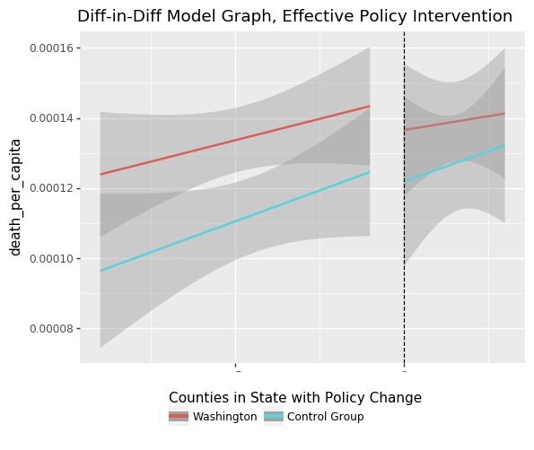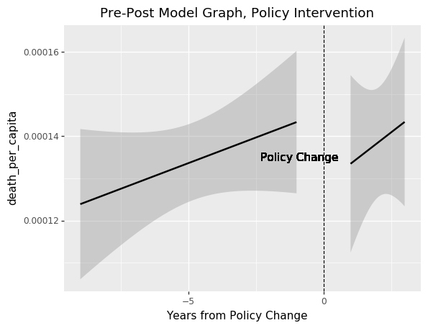[Overdose Death]

From the output of the pre-post graph, we can tell the slope for overdose deaths per capita was both positive before and after the policy became effective. Though at the beginning of the policy became effective, the overdose death per capita became lower, the overdose death per capita still increased year by year after the policy’s effective date. Combining the output from the difference-in-difference analysis, we can see that the trends for both Washington and states in the control group are the same before and after the policy became effective. Therefore, we cannot conclude whether the control policy was successfully in controlling the overdose death in Washington.

**Limitation**

The first limitation of our analysis is that since the US census population data is published once every decade, the population data except for 2010, are estimated. The exact population could be different from the data we used in our analysis. Also, since we used monthly opioid shipment data instead of yearly data but used yearly populations instead of monthly populations at the same time to analyze the effect of policy on opioid shipment in Texas, our analysis may not fully reflect the real situation. However, we assume that population won’t change dramatically, hence, the trend should be the same. Thirdly, in difference-in-difference analysis, we selected states in the control group mainly based on distance and only selected three states as comparison states for every one of those states that had drug control policies. However, factors like population sizes, opioid dispensing rates, and economic conditions should also be taken into account. In addition, these comparison states may also have had some regulatory guidelines that are not implemented by the law but also impacted both the shipment and overdose deaths of opioids.

**Conclusion**

Based on the graphs of our pre-post and difference-in-difference analyses, Florida’s drug policy was effective in decreasing the prescription opioid shipment amount as well as the overdose deaths. The drug policy of taxes was not successful in controlling opioid shipments, but it did reduce overdose deaths.However, Washington's drug policy was not successful in both controlling the opioid shipments and decreasing the overdose deaths.

By comparing policies in the three states, we can learn that since there were a series of changes in Florida that strictly prohibited physician dispensing of drugs and penalized it by arrest, seizure of assets, and clinic closure, strict policies combined with the practical implementation of penalties make the policy have the desired effect. However, policies in both Texas and Washington were mainly focused on performing patient evaluation and consulting, obtaining patients' consent, and making dose recommendations. Those policies seem too moderate to be effective, and in the meantime, no severe penalty was provided. Furthermore, policies in Florida focused on cutting off the source of prescription opioids, which reduced opioid dispensing to the greatest extent possible. In a word, the problem's root cause should be considered when making policies, and strict rules that are well-applied can assist in producing the intended effects.