**The Effect of Caucuses on US Primary Elections**

IDS 690: Unifying Data Science II  
Anna Berman, Kate Coulter, Shota Takeshima

**Topic**

In the US presidential voting system, a preliminary round of voting takes place in which voters select a part nominee. The winner of this first election then goes on to run in the general election against the nominees of the other parties. This first round of voting can take place in two very different formats, a primary or a caucus. In primary elections, voters go to polls and cast ballots for their preferred candidate for their party in the general election. In caucuses, on the other hand, voters gather locally to openly debate and decide which candidate to support.

As Caitlin Jewitt put it during an NPR interview, “proponents of caucuses often say that it is deliberative democracy at its finest. It is the chance for people to show up and talk to their neighbors about politics, have informed conversation, talk to representatives from the campaigns and be persuaded” (Cornish 2020). Because caucuses are a more participatory form of elections, proponents of caucuses often believe they make voters feel that they have a voice and that leads to increased voter turnout. Conversely, proponents of primaries retain that caucuses are time consuming and thus less available to all voters. If caucus voters are required to spend hours talking about the candidates and standing in a gymnasium waiting for all people in the room to be counted, perhaps hiring a babysitter to stay home with their kids, that may very well be enough to prevent many from attending.

**Project Questions**

         Do primaries result in higher voter turnout compared to caucus elections?

**Ideal Experiment**

Ideally, we would have each state conduct a primary election. We would then erase their memories and have each state conduct a caucus. We would then be able to observe differences in voter turnout rates with state fixed effects.

**Study Context**

         With the capability to conduct our ideal experiment, we will turn to voter records from presidential candidate primary and caucus elections as well as records of which format of election each state utilized.

**Project Design**

Several states switched from caucuses to primary for the 2020 presidential nominee election including Colorado, Maine, Washington, Minnesota, Kansas, Idaho, Hawaii, and Nebraska. Our design will group states that made the switch from caucuses to primaries in the 2020 election and those that did not, but that had similar changes in voter turnout between 2012 and 2016. We will then do a difference in difference analysis between 2016 and 2020 democratic elections to assess the effect of election format on voter turnout.

**Model Results**

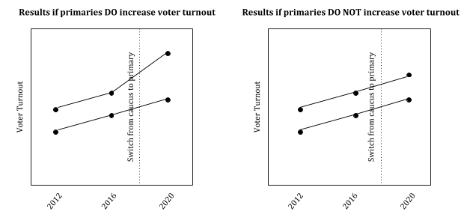

**Final Variables Required**

The variables we need for this project are state aggregate measures of voter turnout for each year’s primary presidential election for the chosen years of study.

**Data Sources**

We are able to obtain voter turnout records as well as records of whether the election was a primary or a caucus from electprojec.org. Fortunately we have these records from each primary from 2000 to 2020. We plan to restrict our analysis to the 2016 and 2020 democratic elections. Based on Nathaniel Rakich’s preliminary analysis with FiveThirtyEight, we believe the best source for this data can be taken from the United States Elections Project (Rakich 2020). Further using this advice, at least for now we plan to use the voting records for 2012, 2016 and 2020 primary elections grouping the states Minnesota, Idaho and Colorado as our case studies as each of these states held caucus style primaries in 2016 and then switched to a primary election state-run system for 2020. Further, each of these states is believed to have fully accounted for these voter turnout numbers so while it would be ideal to have each state that switched between systems, for now it is our opinion that in order to best determine as accurate a causal influence as possible we focus on these three states.

As previously mentioned, our data source for this project is the United States Election Project, specifically their Voter Turnout Data project which has state level information for the two election years we are considering. This data is freely available from their website, has been downloaded and uploaded to our GitHub repository as of Sunday, March 22 and as it is updated by the project will be manually updated by us to ensure we use the most current information available for our final model (United States Election Project 2020).

**References**

Cornish, A. (Host). (2020, February 5) Caucuses Or Primaries? Why States Might Pick One Or The Other. [Radio broadcast episode]. https://www.npr.org/2020/02/05/803183343/caucuses-or-primaries-why-states-might-pick-one-or-the-other

Rakich, N. (2020, March 12). Historic Turnout In 2020? Not so Far. Retrieved from https://fivethirtyeight.com/features/historic-turnout-in-2020-not-so-far/

United States Elections Project. (Retrieved 2020, March 22). Voter Turnout Data. http://www.electproject.org/home/voter-turnout/voter-turnout-data