**The Effect of Caucuses on US Primary Elections**

IDS 690: Unifying Data Science II  
Anna Berman, Kate Coulter, Shota Takeshima

**Topic**

In the US presidential voting system, a preliminary round of voting takes place in which voters select a party nominee. The winner of this first election then goes on to run in the general election against the nominees of the other parties. This first round of voting can take place in two very different formats, a primary or a caucus. In primary elections, voters go to polls and cast ballots for their preferred candidate for their party in the general election. In caucuses, on the other hand, voters gather locally to openly debate and decide which candidate to support.

As Caitlin Jewitt put it during an NPR interview, “proponents of caucuses often say that it is deliberative democracy at its finest. It is the chance for people to show up and talk to their neighbors about politics, have informed conversation, talk to representatives from the campaigns and be persuaded” (Cornish 2020). Because caucuses are a more participatory form of elections, proponents of caucuses often believe they make voters feel that they have a voice and that leads to increased voter turnout. Conversely, proponents of primaries retain that caucuses are time consuming and thus less available to all voters. If caucus voters are required to spend hours talking about the candidates and standing in a gymnasium waiting for all people in the room to be counted, perhaps hiring a babysitter to stay home with their kids, that may very well be enough to prevent many from attending.

**Project Questions**

         Do primaries result in higher voter turnout compared to caucus elections?

**Ideal Experiment**

Ideally, we would randomly assign each state to have either a primary election or a caucus and compare the differences in turnout between groups.

**Study Context**

         With the capability to conduct our ideal experiment, we will turn to voter records from presidential candidate primary and caucus elections as well as records of which format of election each state utilized.

**Project Design**

Several states switched from caucuses to primary for the 2020 presidential nominee election including Colorado, Maine, Washington, Minnesota, Kansas, Idaho, Hawaii, and Nebraska. Our design will group states that made the switch from caucuses to primaries in the 2020 election and those that did not, but that had similar changes in voter turnout between 2012 and 2016. We will then do a difference in difference analysis between 2016 and 2020 democratic elections to assess the effect of election format on voter turnout. We will control for state’s political makeup and demographics such as race.

Building upon this initial analysis, we also plan to complete a second case study analysis examining one county in a state that made the switch from caucuses to primaries in the 2020 election. This analysis will assess the impact of election format on various demographic groups such as African Americans or Millennials using a pre-post approach. Ideally, this analysis will shed light onto the differing effects of election format on these unique groups of potential voters. Completion of this phase is contingent on our ability to locate and access voter data for the selected county in both 2016 and 2020.

**Model Results**

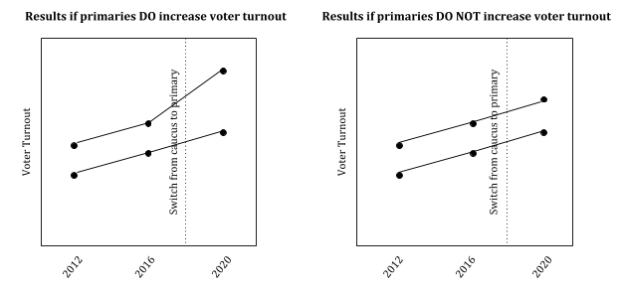

**Final Variables Required**

The variables we need for this project are state aggregate measures of voter turnout for each year’s primary presidential election for the chosen years of study. Additionally, we would like to include controls for state’s political makeup and percentage of white residents.

**Data Sources**

We are able to obtain voter turnout records as well as records of whether the election was a primary or a caucus from electprojec.org. Fortunately, these records include all US primaries from 2000 to 2020. This data is freely available and has been uploaded to our GitHub repository as of Sunday, March 22 (United States Election Project 2020). Manually updates will be done to ensure we use the most current information available for our final model.

We plan to restrict our analysis to the 2012, 2016 and 2020 democratic elections. Based on Nathaniel Rakich’s preliminary analysis with FiveThirtyEight, we believe the best source for this data can be taken from the United States Elections Project (Rakich 2020). We plan to use the voting records for 2012, 2016 and 2020 primary elections grouping the states Minnesota, Idaho and Colorado as each of these states made the switch from caucus to primary elections in 2020. Furthermore, each of these states is believed to have reliable voter turnout numbers. While it would be ideal to include all states that switched between systems, for the sake of accurate estimates we will restrict our focus to these three states.

In regards to the second phase of our analysis, we have not yet identified a potential data source as we hope our choice of county will be affected by the first stage of our analysis. We believe we will be able to obtain the data from a county or state government website.

*Data Limitations*

It should be noted that several US 2020 primaries have been impacted or delayed due to the spread of COVID-19. We will exclude all states that have delayed their elections. Moreover, the three states for which we have complete data are states with a large majority (83% or higher) of white residents. This is certainly a limitation in our analysis, as our conclusions may not generalize to more diverse states. We hope this limitation will be addressed in the second phase of our analysis by more closely examining the effects of election format on different minority groups.

**References**

Cornish, A. (Host). (2020, February 5) Caucuses Or Primaries? Why States Might Pick One Or The Other. [Radio broadcast episode]. https://www.npr.org/2020/02/05/803183343/caucuses-or-primaries-why-states-might-pick-one-or-the-other

Rakich, N. (2020, March 12). Historic Turnout In 2020? Not so Far. Retrieved from https://fivethirtyeight.com/features/historic-turnout-in-2020-not-so-far/

United States Elections Project. (Retrieved 2020, March 22). Voter Turnout Data. http://www.electproject.org/home/voter-turnout/voter-turnout-data