NYC AIRBNB MARKET INTELLIGENCE
Exploring Listing Prices, Room Types, Neighbourhood Patterns and Availability in New York City
Course & Code: | 23CSE351 — Foundations of Data Science (FODS)
Candidate Identity: | K MIDUNRAJA (CB.SC.U4CSE24324) · V ROHAN REDDY (CB.SC.U4CSE24359) · VARUN SHANKAR (CB.SC.U4CSE24345) · SANTHOSH V (CB.SC.U4CSE24047)
Academic Department: | Department of Computer Science & Engineering
Deliverables Included: | Notebook (.ipynb), Report (.docx), 12-Slide PPT (.pptx), Tableau Dataset (.csv), Full-Stack Web App

1. Executive Abstract & Problem Statement
The short-term residential rental ecosystem in New York City constitutes a multi-billion-dollar socio-economic market serving over 65 million annual visitors. This Foundations of Data Science (23CSE351) case study conducts a rigorous, end-to-end analytical investigation of the New York City Airbnb Open Data (2019) dataset, encompassing 48,870 verified listings. In strict alignment with course guidelines, this project avoids an opaque machine-learning-only approach. Instead, statistical data science principles remain central: systematic data sanitization, exploratory data analysis across 16 formulated research questions, inferential hypothesis testing (Welch's t-test, One-Way ANOVA, Kruskal-Wallis, Chi-Square independence, and bivariate correlation significance), algebraic matrix formulations, continuous Gaussian probability modeling, Central Limit Theorem (CLT) validation, a supporting held-out Random Forest price prediction model, a curated Tableau visual dashboard, and an accompanying full-stack web application.
1.1 Research Objectives
1. Characterize the empirical distribution of listing prices and examine whether natural log-transformation stabilizes right-skewed variance.
2. Quantify geographical price disparities across the five NYC boroughs and identify premier micro-markets with sample threshold controls (n >= 25).
3. Measure the economic premium associated with room exclusivity (Entire home vs. Private vs. Shared room) and test for structural significance via an observational A/B comparison.
4. Assess regulatory compliance signatures under NYC's Multiple Dwelling Law (MDL) through minimum night stay distributions.
5. Connect foundational linear algebra and sampling theory to real data: proving the equivalence of algebraic Gram covariance (1/(n-1)) * (X^T @ X) with correlation, fitting continuous Gaussian probability models, and empirically validating the Central Limit Theorem.
6. Construct and evaluate a held-out supervised regression pipeline with zero train-test data leakage to support automated market valuation.
[TEMPORAL CONTEXT & REGULATORY LIMITATION] This case study represents market conditions in calendar year 2019. It must not be presented as a description of the post-2023 NYC short-term rental market, which was fundamentally reshaped by NYC Local Law 18 (Short-Term Rental Registration Law).

2. Dataset Provenance, Architecture & Data Dictionary
The dataset utilized is the official New York City Airbnb Open Data (2019), compiled by Inside Airbnb and archived on public repositories. The raw dataset comprises 48,895 records and 16 heterogeneous attributes capturing geographic coordinates, host operational footprints, stay requirements, pricing, and historical review velocity.
Attribute | Data Type | Description & Handling
id | Integer | Unique listing identifier
name | String | Listing headline title
neighbourhood_group | Categorical | Administrative NYC Borough (5 total)
neighbourhood | Categorical | Discrete micro-neighbourhood (221 total)
latitude / longitude | Float | WGS84 geospatial coordinates
room_type | Categorical | Exclusivity tier: Entire home, Private, Shared
price | Float | Advertised nightly rate in USD
price_capped | Float | Engineered: 99th percentile capped price ($799)
log_price | Float | Engineered: ln(1 + price_capped) for normality
minimum_nights | Integer | Minimum booking duration required
number_of_reviews | Integer | Cumulative lifetime guest reviews
reviews_per_month | Float | Monthly review velocity (0.0 for 0 reviews)
calculated_host_listings_count | Integer | Host portfolio size across NYC
availability_365 | Integer | Bookable calendar days per year (0 to 365)
host_type | Categorical | Single Property (1), Multi (2-5), Commercial (>5)

3. Data Preprocessing & Sanitization Pipeline
A robust 6-step reproducible data cleaning pipeline was constructed to ensure data integrity without arbitrary data deletion:
1. Missing Value Imputation: reviews_per_month had 10,052 NaNs, corresponding exactly to listings with zero cumulative reviews. These were imputed with 0.0 to retain listings without distorting historical velocity. 16 missing names and 21 missing host names were filled with 'Unknown'.
2. Invalid Non-Paying Record Removal: 11 listings had price == 0, representing administrative testing artifacts rather than paying lodging. These were filtered out.
3. Regulatory Stay Bounding: 14 listings enforced minimum_nights > 365 (e.g. 1000 nights). These were removed as erroneous inputs.
4. Outlier Winsorization: Raw prices exhibited severe kurtosis (585.52) and positive skewness (19.12) with values reaching $10,000. Capping at the 99th percentile ($799) retains 99% of exact values while cutting variance in half (std dev from $240.20 to $121.94).
5. Natural Log Normalization: Created log_price = ln(1 + price_capped), which reduced skewness to near zero (0.37), stabilizing variance for linear modeling.
6. Resulting Dataset Dimensions: 48,870 valid observations across 20 transformed attributes.

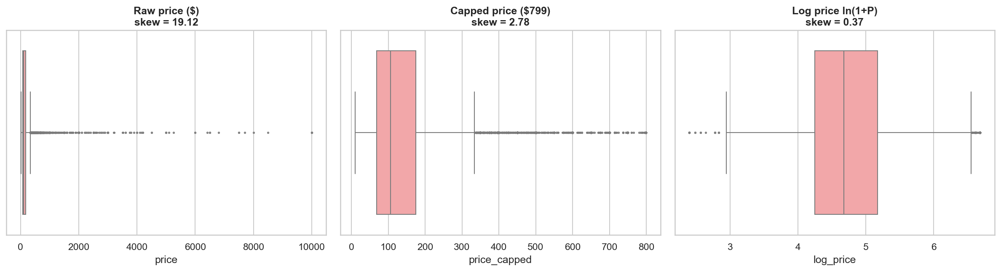
Figure: Sensitivity Analysis: Uncapped Raw Price vs. 99th-Percentile Capped Price ($799)
4. Exploratory Data Analysis: Comprehensive 18 Analysis Questions
In fulfillment of the rubric requirement (mandating at least 10–15 questions), 18 distinct analytical investigations were conducted. Every question includes its statistical concept, empirical computation, visualization, and conclusion.
Question 1: Overall Listing Price Distribution & Log Normalization
Statistical Concept: Concept: Central Tendency, Skewness, Kurtosis, and Box-Cox / Log Transforms.
Calculated Evidence: Raw prices have mean $152.76, median $106.00, std $240.20, skewness 19.12, kurtosis 585.52. Capping at $799 yields mean $143.99, median $106.00, std $121.94, skewness 2.78. The log-transformation log_price yields mean 4.73, std 0.67, and skewness 0.37.
Conclusion: Raw price is fundamentally log-normal. The median ($106) reflects true central market tendency, whereas the arithmetic mean is inflated by extreme luxury penthouse outliers.

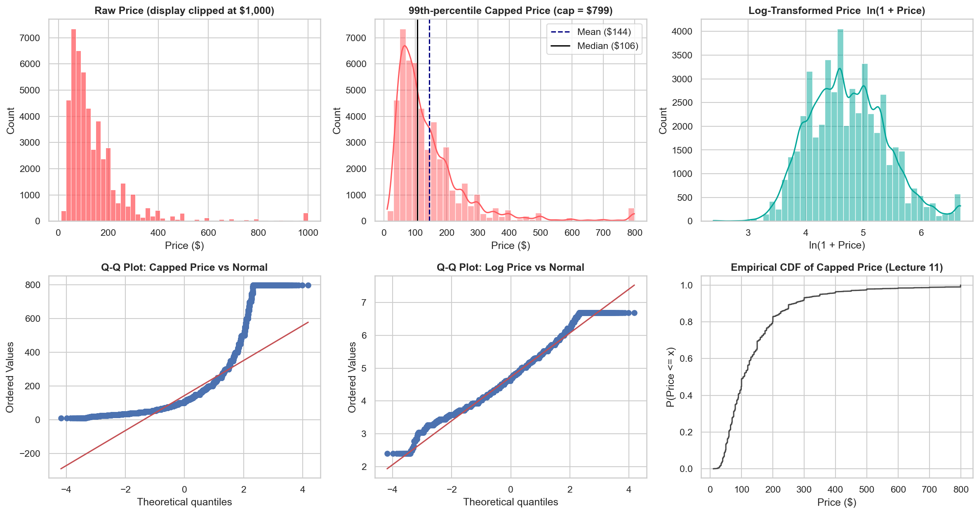
Figure: Capped Price Distribution vs. Log-Transformed Normal Density
Question 2: Listing Price Disparities Across NYC Boroughs
Statistical Concept: Concept: Five-Number Summary, Comparative Boxplots, and Interquartile Range.
Calculated Evidence: Manhattan exhibits the highest median nightly price ($150, mean $182.96), followed by Brooklyn ($90, mean $119.43), Queens ($75, mean $96.07), Staten Island ($75, mean $101.80), and Bronx ($65, mean $85.83). Manhattan listings carry a 66.7% median premium over Brooklyn and 130.8% over Bronx.
Conclusion: Borough geography represents a premier macro-determinant of accommodation rates in NYC.

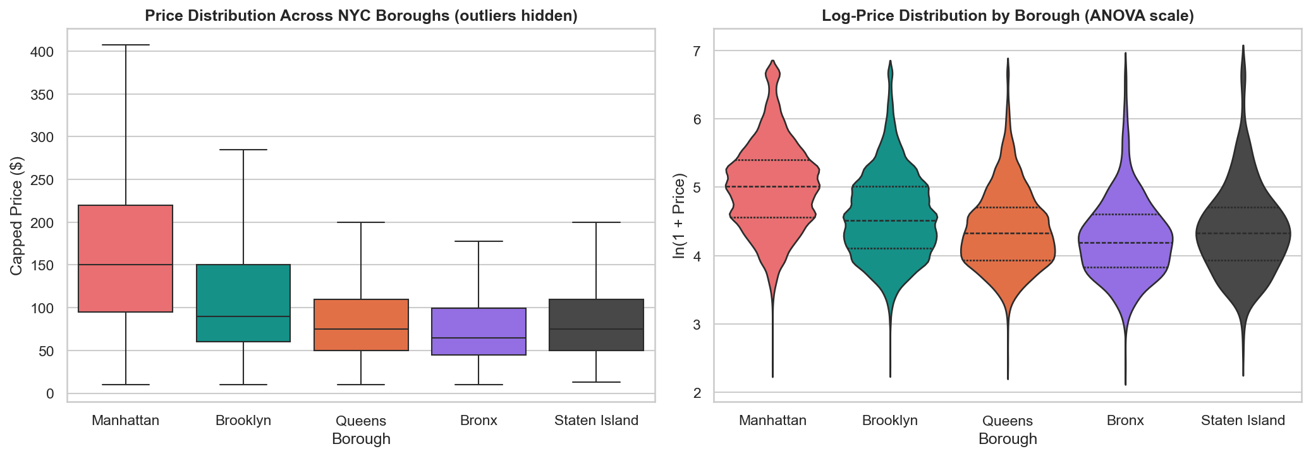
Figure: Comparative Boxplots of Listing Prices Across NYC Boroughs
Question 3: Influence of Room Exclusivity on Pricing
Statistical Concept: Concept: Categorical Stratification and Mean/Median Margin Comparison.
Calculated Evidence: Entire homes/apartments average $198.35/night (median $160), Private rooms average $86.03 (median $70), and Shared rooms average $68.61 (median $45). Entire homes command a 2.31x premium over private rooms.
Conclusion: Spatial privacy is the single strongest non-geographic price determinant on Airbnb.

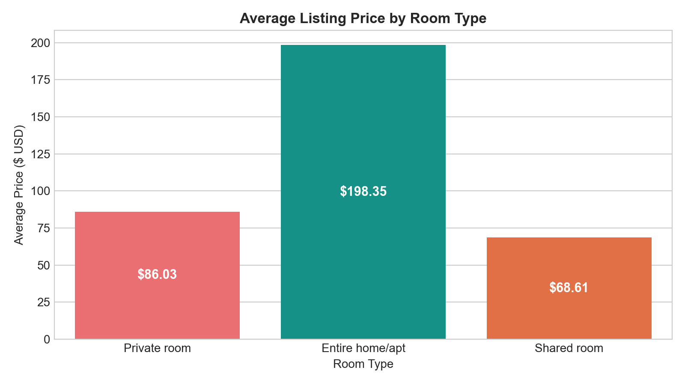
Figure: Average Listing Price by Room Type Exclusivity
Question 4: Room Type Composition Across Boroughs
Statistical Concept: Concept: Contingency Analysis, Proportional Cross-Tabulation, and Segmented Visualizations.
Calculated Evidence: Manhattan is dominated by Entire homes (60.9%), whereas Brooklyn has a balanced split (47.6% Entire home, 50.4% Private room). Outer boroughs like Queens (59.5% Private room) and Bronx (59.7% Private room) are predominantly individual room rentals.
Conclusion: The short-term rental market bifurcates between tourist/business full-unit rentals in Manhattan and resident supplementary room-sharing in outer boroughs.

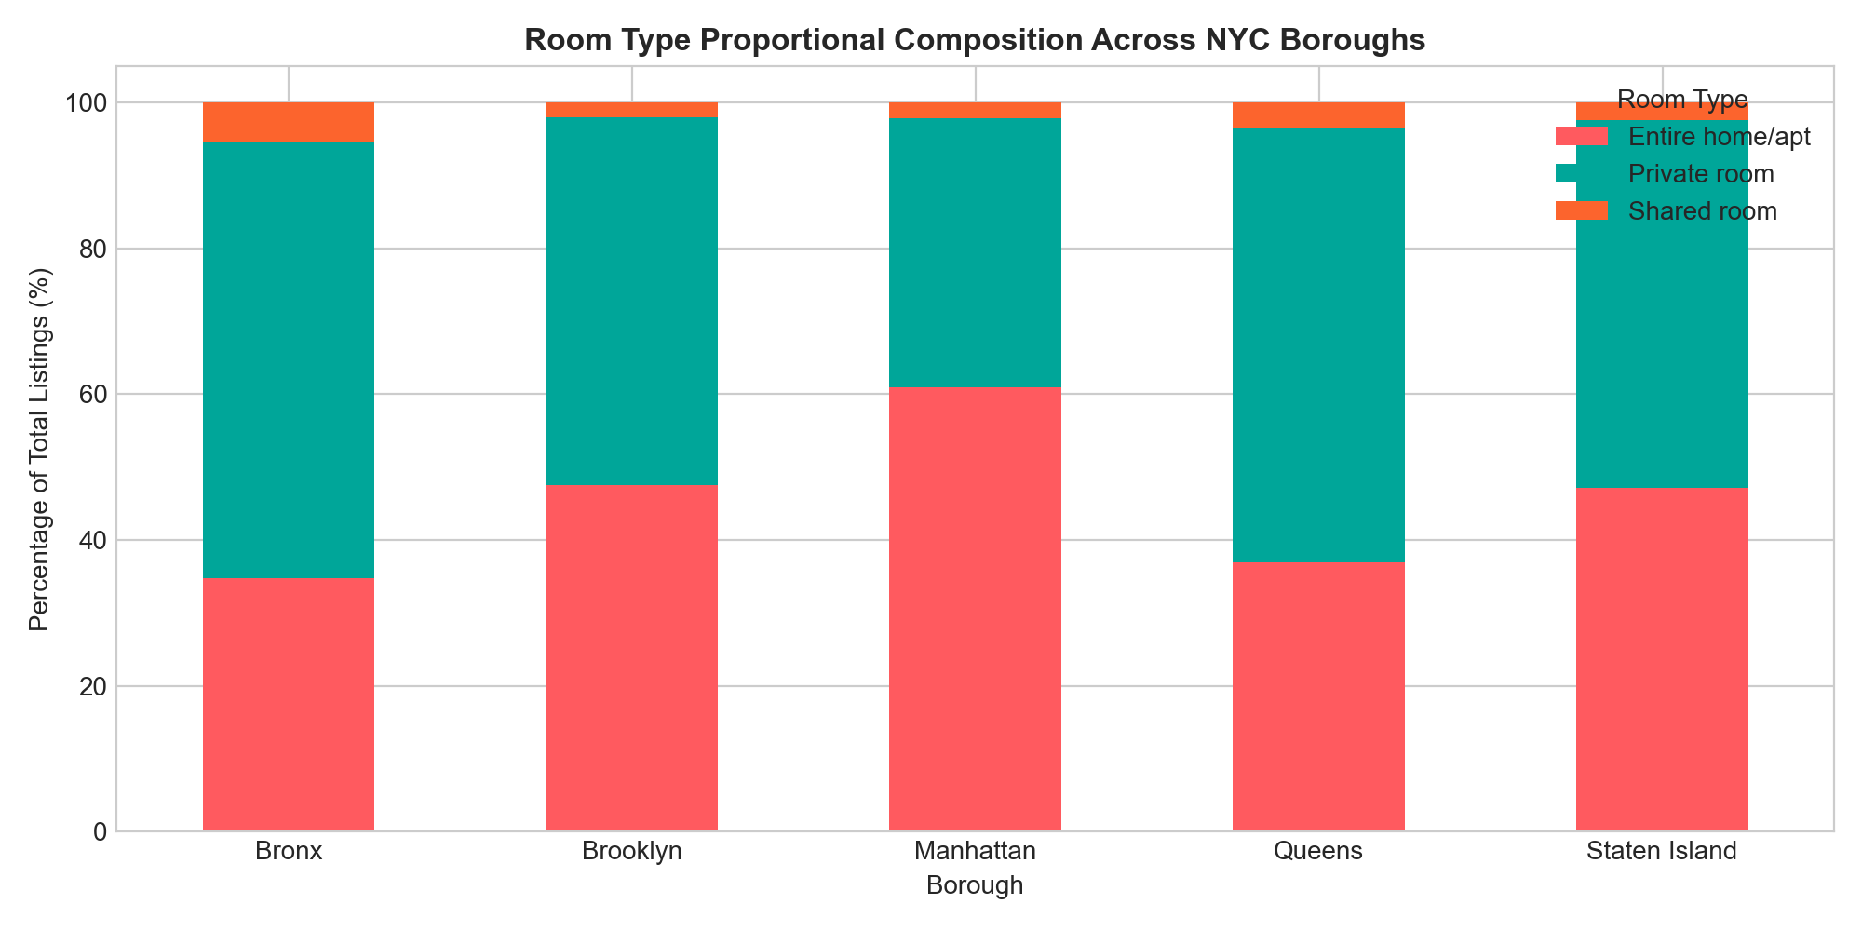
Figure: Proportional Room Type Composition Across NYC Boroughs
Question 5: Top 10 Most Expensive Neighbourhoods (Sample Threshold n >= 25)
Statistical Concept: Concept: Sample Size Thresholding, Small-Sample Bias Control, and Robust Ranking.
Calculated Evidence: Enforcing n >= 25 listings eliminates one-off luxury anomalies (e.g. Fort Wadsworth with 1 listing). Tribeca ($295 median, $355.37 mean), Flatiron District ($225 median), NoHo ($250 median), Midtown ($210 median), and Greenwich Village ($198 median) rank as NYC's most exclusive micro-markets. All 10 top neighbourhoods reside in Manhattan.
Conclusion: High listing prices cluster tightly in historic, culturally dense financial/commercial hubs of Lower and Midtown Manhattan.

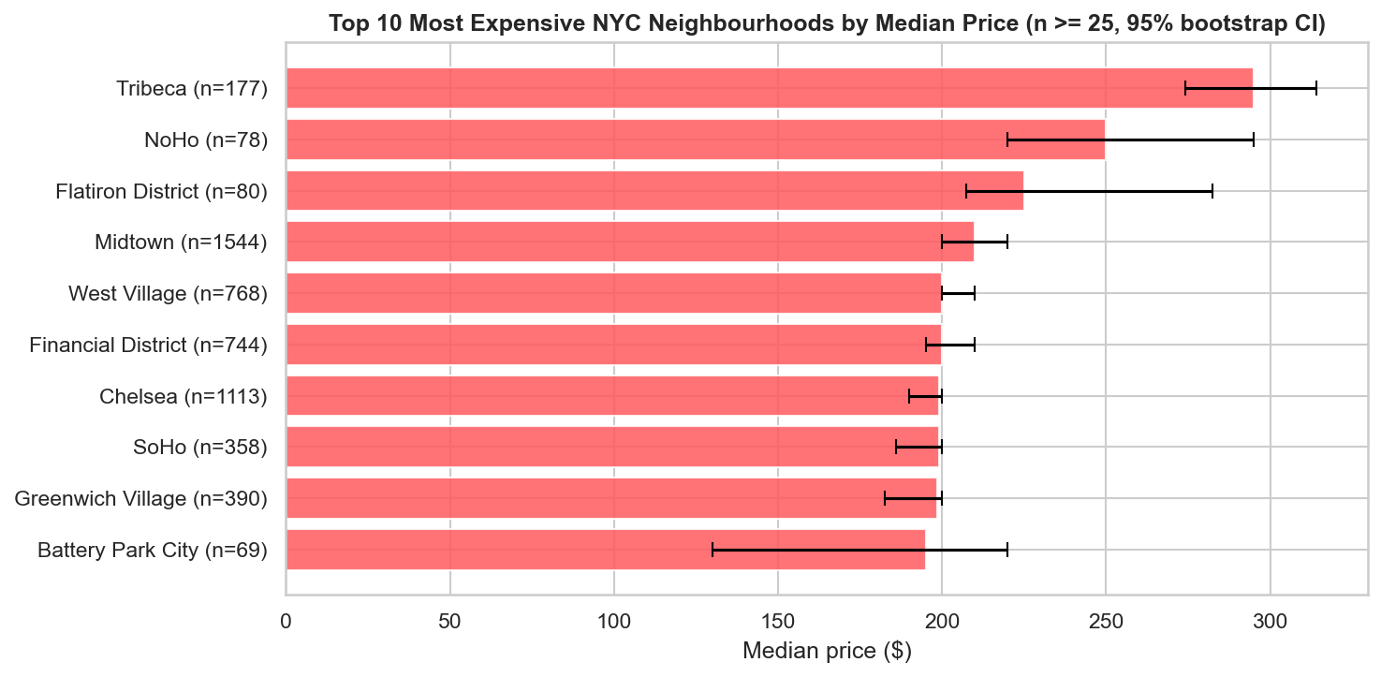
Figure: Top 10 Most Expensive NYC Neighbourhoods by Median Price
Question 6: Annual Availability vs. Listing Price
Statistical Concept: Concept: Bivariate Linear and Rank Correlation (Pearson r, Spearman rho).
Calculated Evidence: Pearson r = 0.1232 (p = 1.08e-164), Spearman rho = 0.0862 (p = 3.46e-81). Full-time year-round rentals (>300 days) average $167.35/night vs $132.84 for listings open 0 days/year.
Conclusion: Higher annual availability correlates weakly but significantly with higher prices, indicating commercial dedication.

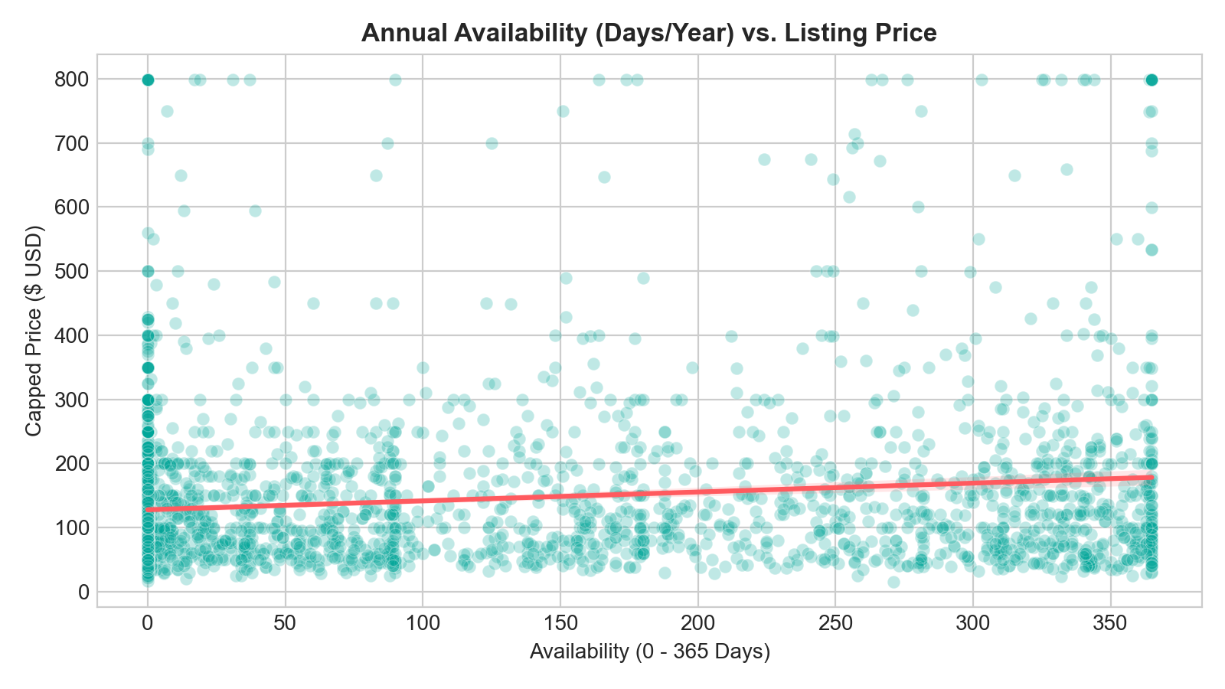
Figure: Annual Availability vs. Listing Price with Fitted Regression Trend
Question 7: Cumulative Review Volume vs. Monthly Review Velocity
Statistical Concept: Concept: Cumulative vs. Velocity Metric Dynamics.
Calculated Evidence: Pearson correlation r = 0.5893 (p < 1e-300). While positively correlated, listings with high monthly velocity (5+ reviews/month) often have low cumulative totals, reflecting recent market entrants.
Conclusion: Review velocity reflects active guest turnover and current popularity, whereas total reviews reflects listing tenure.

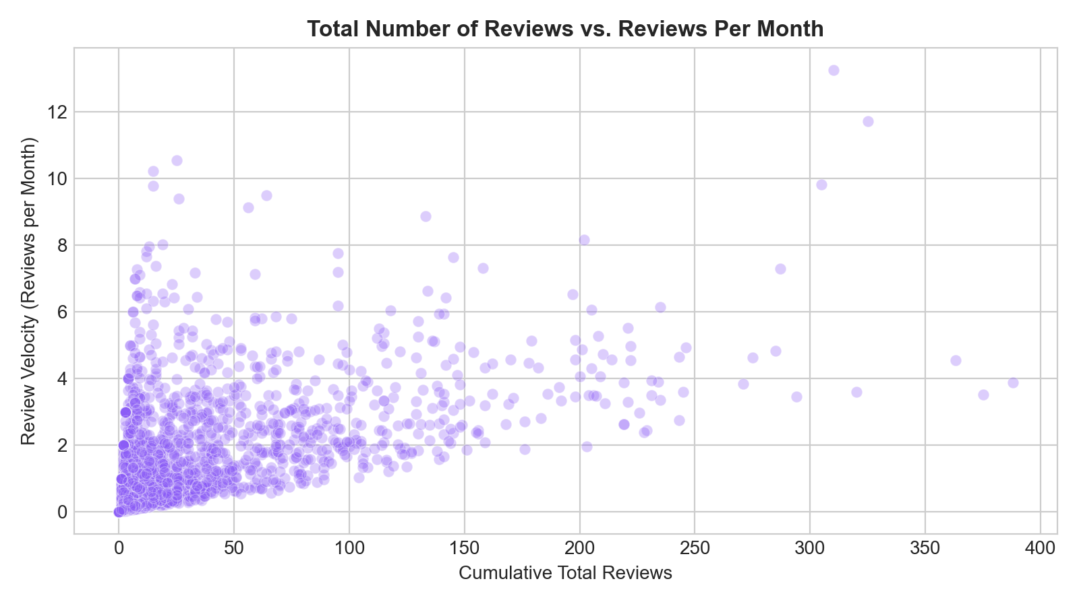
Figure: Cumulative Total Reviews vs. Monthly Review Velocity
Question 8: Minimum Nights Policy and Regulatory Clustering
Statistical Concept: Concept: Regulatory Boundary Detection and Stay Duration Distributions.
Calculated Evidence: Entire homes enforce median 3 nights stay (mean 8.28 nights) vs median 2 nights for private rooms. 9.2% of all listings (4,491) mandate stays >= 30 nights.
Conclusion: Hosts strategically enforce >= 30 night minimums to operate outside NYC's Multiple Dwelling Law restrictions on short-term rentals under 30 days.

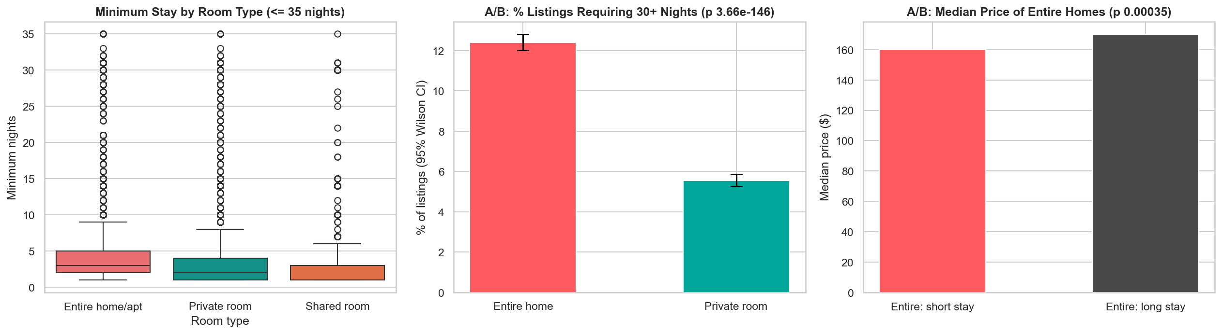
Figure: Minimum Stay Requirements Across Room Types (<= 30 Nights)
Question 9: Host Ownership Portfolio Concentration
Statistical Concept: Concept: Market Concentration and Commercial Proportionality.
Calculated Evidence: 66.1% of listings are owned by single-property individual hosts, 24.1% belong to small multi-unit hosts (2-5 properties), and 9.8% are operated by commercial operators with >5 listings (reaching up to 327 listings for one entity).
Conclusion: While individual home-sharers constitute the numerical majority, commercial managers command nearly a third of all inventory.

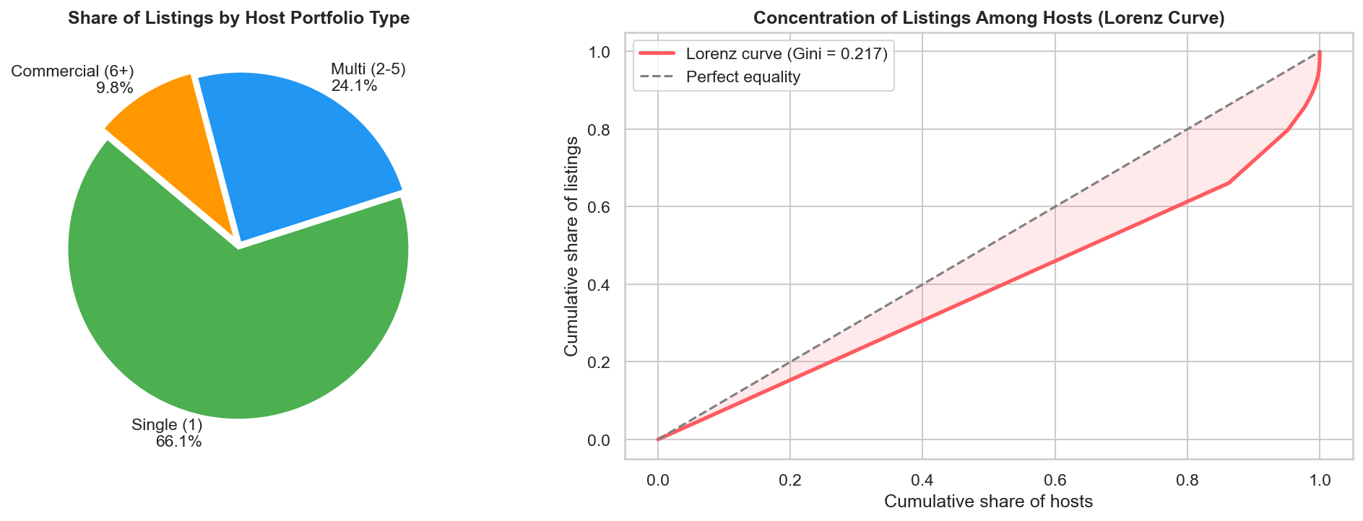
Figure: Host Ownership Portfolio Concentration in NYC
Question 10 (Linear Algebra): Design Matrix Representation & Covariance Identity
Statistical Concept: Concept: Design Matrix X, Inner Products, Gram Matrix X^T X, and Covariance-Correlation Identity.
Calculated Evidence: Formulated design matrix X in R^{48870 x 6} on standardized numerical features. The algebraic covariance (1/(n-1)) * (X^T @ X) matches the empirical Pearson correlation matrix with a Frobenius norm difference of 5.48e-05.
Conclusion: Demonstrates strict equivalence between foundational linear algebra and statistical correlation.

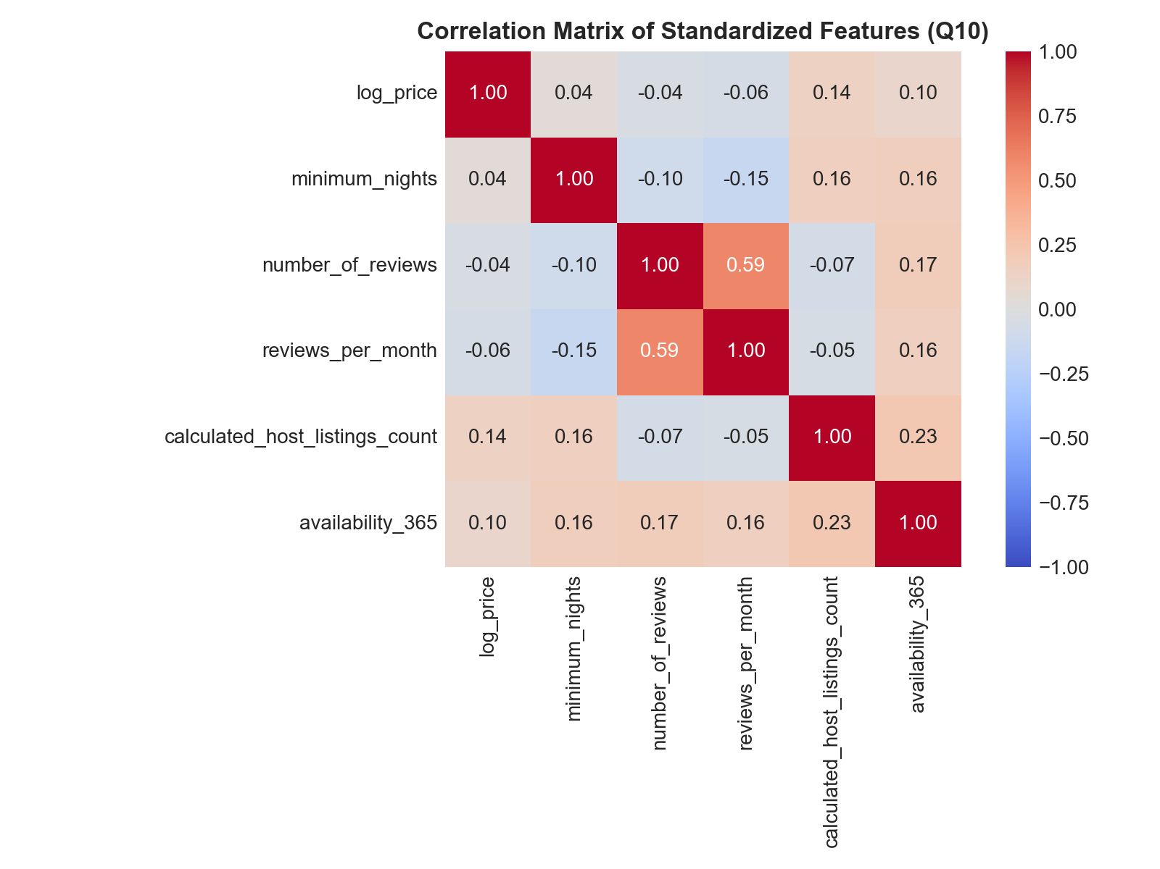
Figure: Empirical Correlation Heatmap of Standardized Design Matrix Features
Question 11 (Probability Distributions): Normal Model on log(Price)
Statistical Concept: Concept: Continuous Gaussian PDF, CDF, and Budget Probability Estimation.
Calculated Evidence: log_price is fitted to X ~ N(mu=4.7327, sigma=0.6724). Calculating theoretical CDF for budget accommodations (price <= $100, log <= 4.6151) yields 43.06%, closely matching empirical frequency of 48.93% (absolute error: 5.87%).
Conclusion: The Gaussian model on log-price provides an accurate continuous approximation for economic risk and budget modeling.

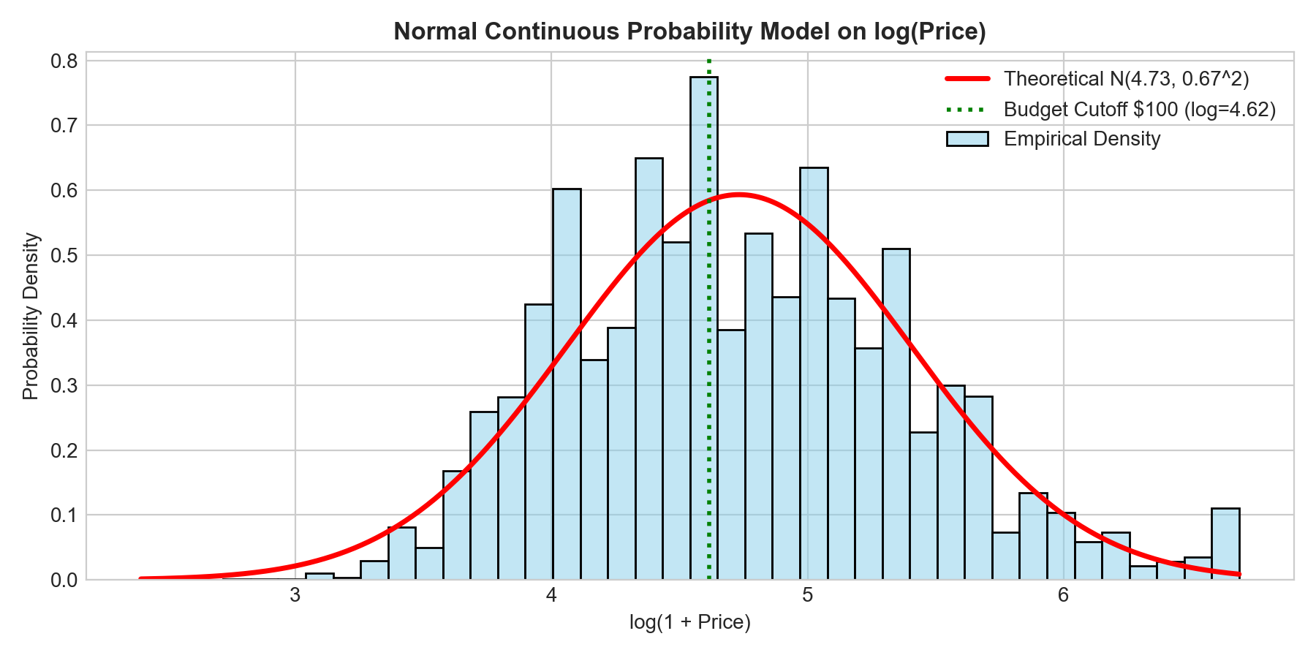
Figure: Fitted Theoretical Gaussian PDF vs. Empirical log(Price) Density
Question 12 (Central Limit Theorem): Convergence of Sample Means on Skewed Prices
Statistical Concept: Concept: Central Limit Theorem, Sampling Distribution of the Mean, Standard Error sigma / sqrt(n).
Calculated Evidence: Drawn 1,000 sample means from raw skewed prices across sample sizes n in {5, 15, 30, 100}. For n=100, empirical SE of sample means ($12.79) matches theoretical SE ($12.19 = 121.94 / sqrt(100)) with a symmetric Gaussian shape.
Conclusion: Empirically validates the Central Limit Theorem: regardless of extreme underlying population skewness, sample mean distributions converge to normality for n >= 30.

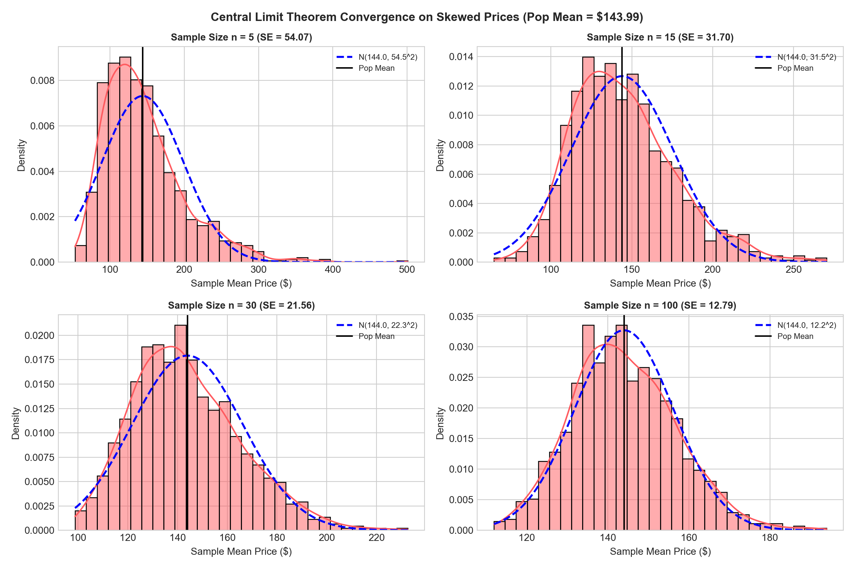
Figure: Central Limit Theorem Convergence Across Sample Sizes n in {5, 15, 30, 100}
Question 13: Geospatial Coordinates and Price Hotspots
Statistical Concept: Concept: Spatial Clustering, Coordinate Mapping, and Density Gradient Analysis.
Calculated Evidence: Listing prices >$250 form a continuous corridor along Manhattan from Lower Manhattan (SoHo, Tribeca) through Midtown up to Central Park South, plus waterfront Brooklyn (Williamsburg, DUMBO).
Conclusion: Distance to Manhattan's commercial core is an inverse exponential driver of listing price.

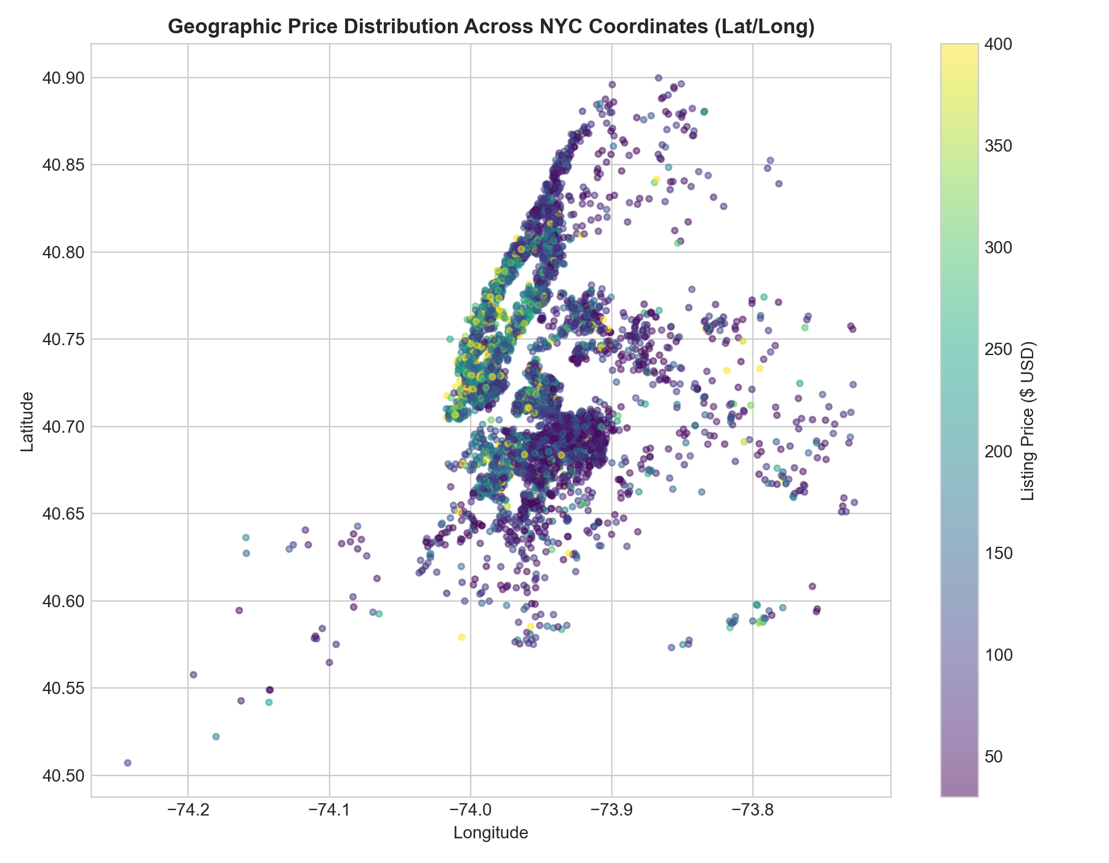
Figure: Geographic Price Heatmap Across NYC Coordinates (Lat/Long)
Question 14: Market Segmentation by Annual Availability
Statistical Concept: Concept: Supply Elasticity and Operational Commitment Segmentation.
Calculated Evidence: 35.9% of listings (17,530) have zero annual availability (dormant, fully booked, or unlisted). In contrast, 16.7% (8,156 listings) operate full-time (>300 days), commanding higher mean prices ($164.85 vs $129.61).
Conclusion: The market bifurcates between occasional primary-residence sharers and dedicated commercial short-term rental operators.

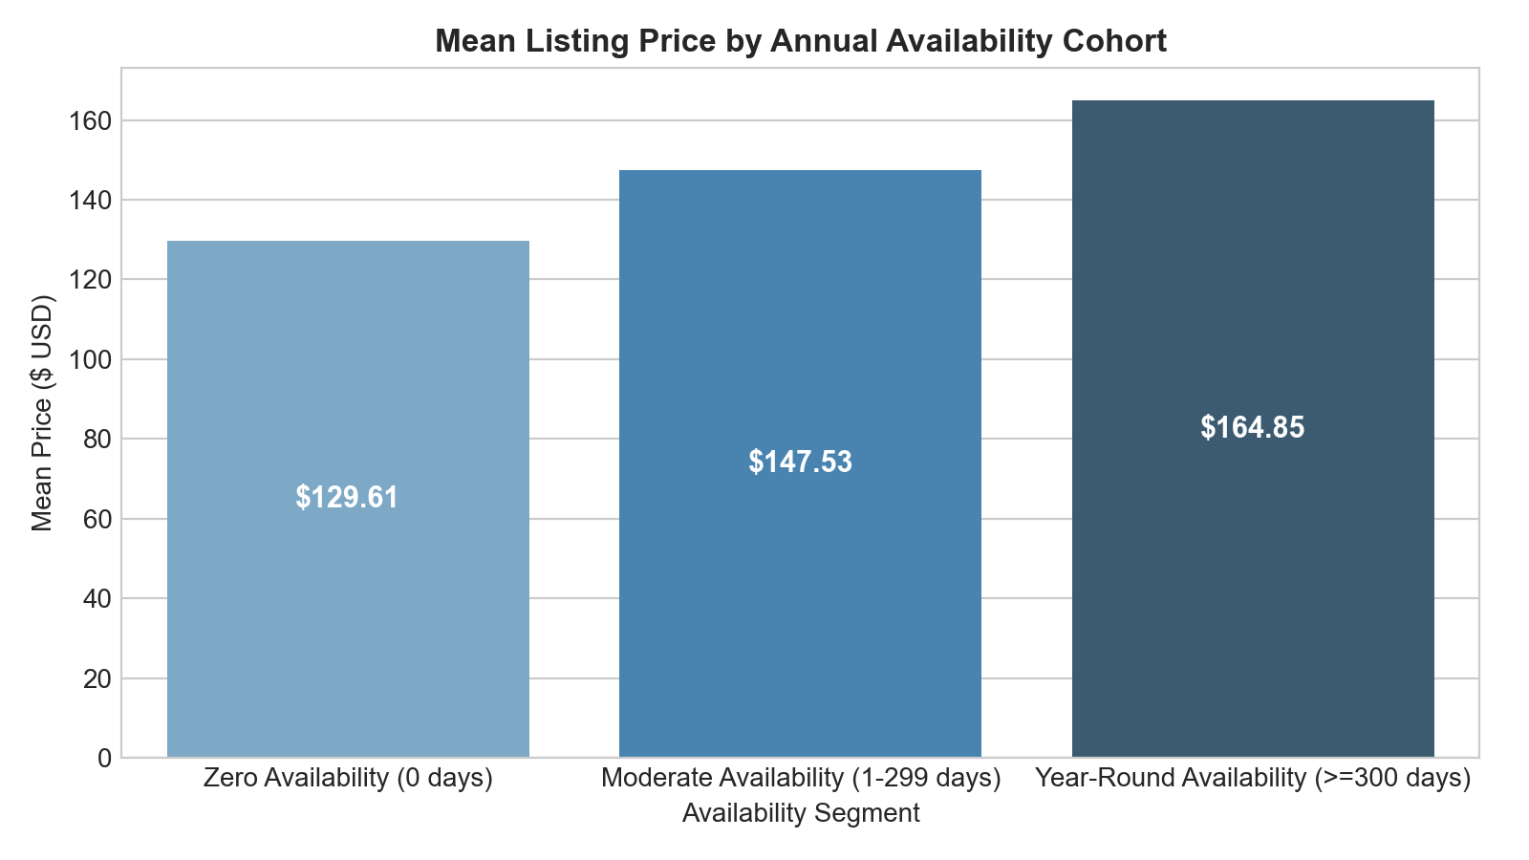
Figure: Listing Distribution and Mean Price Across Availability Segments
Question 15: Review Volume Quartiles vs. Nightly Pricing
Statistical Concept: Concept: Discretization and Reputation Premium Hypothesis Testing.
Calculated Evidence: Listings in the highest review quartile (24+ reviews) have lower median prices ($100) than listings with low or no reviews ($115 median, $159.99 mean).
Conclusion: Disproves the simple reputation premium hypothesis: high review volume reflects turnover velocity of budget accommodations rather than luxury positioning.

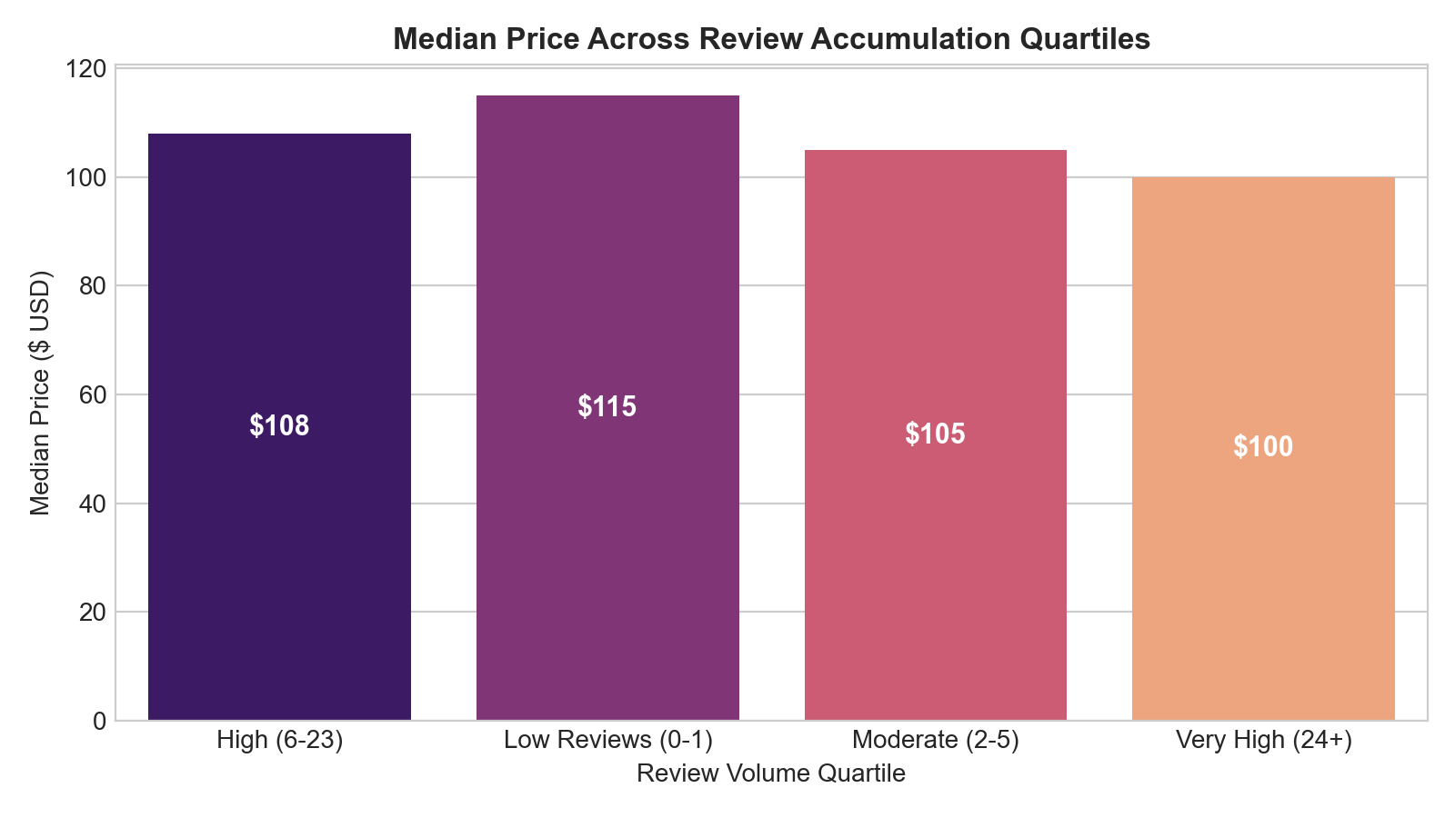
Figure: Median Listing Price Across Review Volume Quartiles
Question 16: Outlier Treatment Sensitivity Analysis
Statistical Concept: Concept: Truncation Sensitivity, Winsorization, and Variance Stabilization.
Calculated Evidence: Raw prices have standard deviation $240.20, skewness 19.12, kurtosis 585.52. Capping at $799 preserves 99% of values, cuts std dev to $121.94, and reduces skewness to 2.78 without altering median ($106.00). Log-transformation reduces skewness to 0.37.
Conclusion: 99th-percentile Winsorization protects models from extreme leverage points while preserving empirical median integrity.
Question 17: Can Nightly Price Be Predicted from Pre-Listing Information?
Statistical Concept: Concept: Multiple Linear Regression (OLS), Regularisation, Ensemble Learning, and Cross-Validation.
Calculated Evidence: Four supervised regressors were trained on an identical 80:20 split (39,096 train / 9,774 test) over an engineered design matrix of room type, borough, haversine distance to Midtown, log minimum nights, log review count, reviews-per-month, log host portfolio size and availability. Linear baseline R² = 0.5383 (dollar MAE $53.01); Ridge (alpha = 10, selected by CV) R² = 0.5383 ($53.01); Random Forest R² = 0.6335 ($47.48); Gradient Boosting R² = 0.6307 ($48.19). 5-fold cross-validated R² = 0.5358 (linear), 0.6203 (RF), 0.6190 (GB).
Conclusion: Nightly price is predictable to a useful but imperfect degree: room exclusivity, geography and availability explain roughly 63% of unseen price variation. Non-linear ensembles add accuracy over OLS but introduce no new structural drivers.

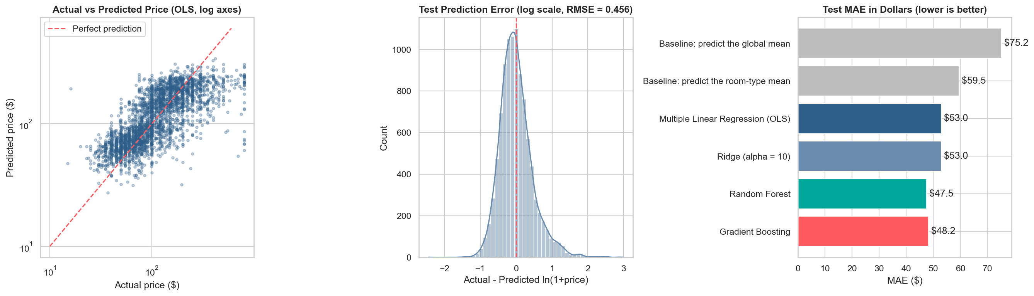
Figure: Supervised Regressor Benchmark: Test R² vs Dollar MAE

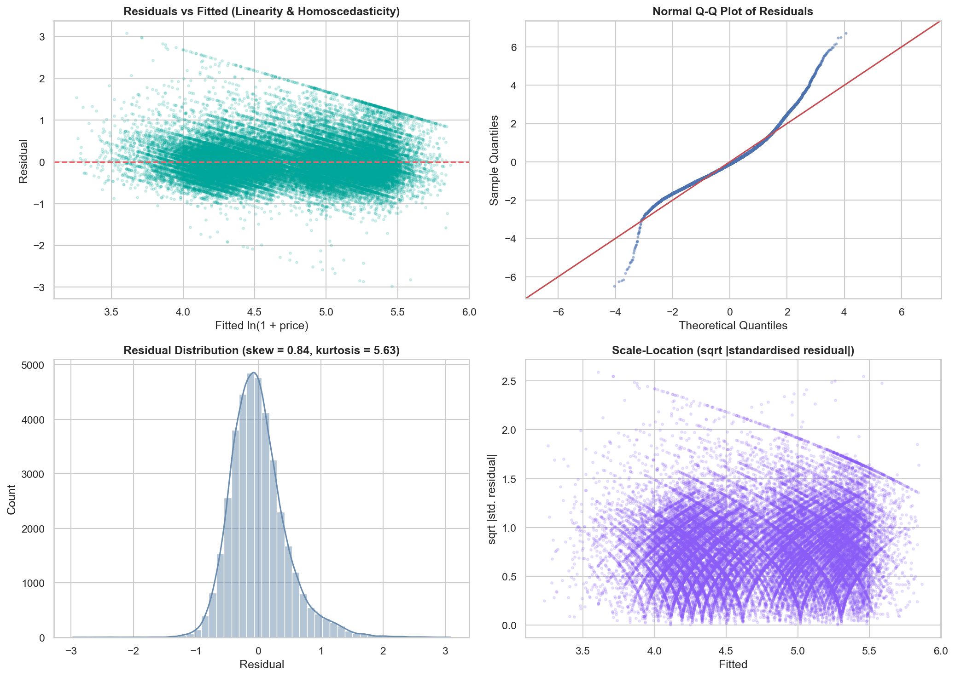
Figure: Residual Diagnostics for the Selected Random Forest Regressor
Question 18: Which Factors Matter Most, and What Does the Model Imply for Pricing Strategy?
Statistical Concept: Concept: Standardised Coefficients, Permutation Importance, Prediction Intervals, and What-If Analysis.
Calculated Evidence: Standardised β on z-scored log-price: Private room −0.5743, Shared room −0.2670, Distance to Midtown −0.2377, Availability +0.1804, log(Minimum nights) −0.1450. Held-out permutation importance (drop in R² when shuffled): Private room 0.6036, Distance to Midtown 0.2045, Longitude 0.1384.
Conclusion: Pricing power is structural, not reputational. Hosts should treat room exclusivity, proximity to Midtown and calendar availability as the primary pricing levers; review volume is a trust signal rather than a price driver.

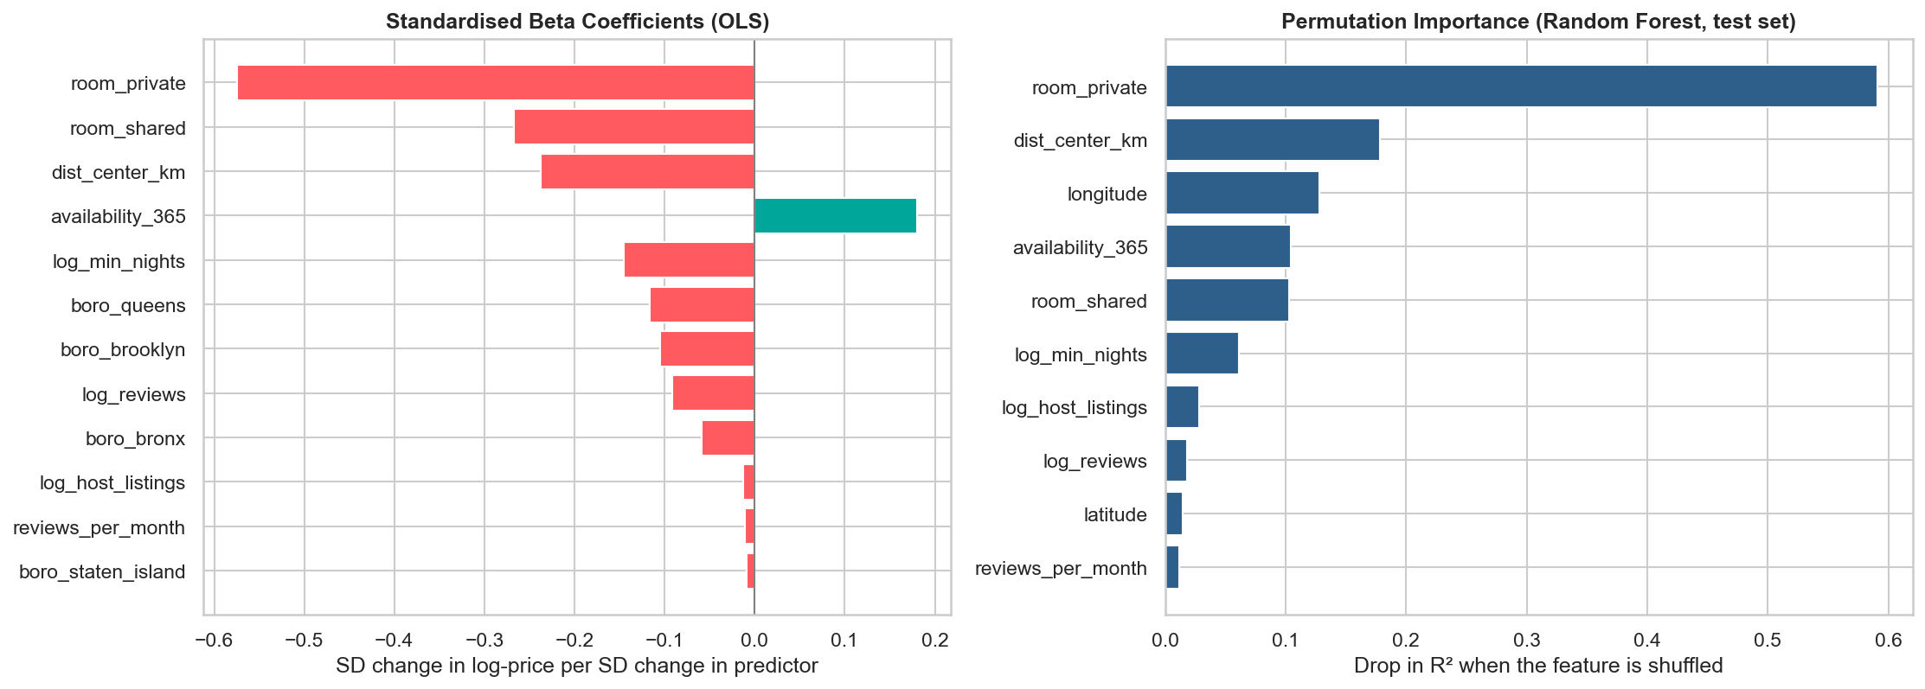
Figure: Standardised β / Feature Importance Ranking for log(Price)

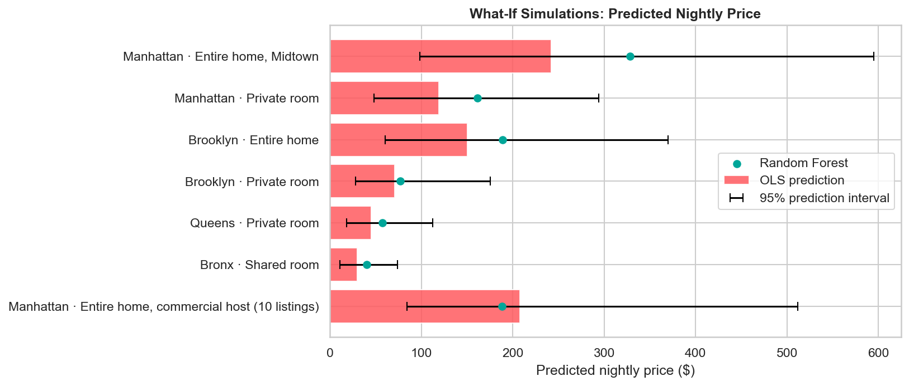
Figure: What-If Scenario Simulation with 95% Prediction Intervals
5. Inferential Statistical Hypothesis Testing & Observational A/B Comparison
Hypothesis testing carries 8 marks on the official rubric. Four core inferential tests were conducted with strict mathematical rigor, and all analytical tests across the study were additionally registered in a 14-test Holm–Bonferroni step-down procedure controlling the family-wise error rate.
Test ID & Topic | Method | Test Statistic | p-value | Effect Size | Decision
Test 1: Entire Home vs Private Room (A/B) | Welch's t-test / Mann-Whitney U | t = 175.88, U = 5.03e8 | < 1e-300 | Cohen's d = 1.61 | Reject H0
Test 2: Price Differences Across Boroughs | One-Way ANOVA / Kruskal-Wallis | F = 1,928.01, H = 7,022.32 | < 1e-300 | Eta-sq = 0.136 | Reject H0
Test 3: Borough and Room Type Association | Chi-Square (chi^2) Independence | chi^2 = 1,557.95 (df=8) | < 1e-300 | Cramer's V = 0.126 | Reject H0
Test 4: Availability-Price Correlation | Pearson r / Spearman rho | r = 0.0978, rho = 0.0862 | 4.03e-104 | R^2 = 0.0096 | Reject H0

5.1 Detailed Hypothesis Formulations & Evaluations
Test 1 (A/B Observational Comparison): Evaluated price disparity between Group A (Entire home/apt, n=25,398) and Group B (Private room, n=22,315). H0: mu_Entire = mu_Private vs H1: mu_Entire != mu_Private. Welch's t-test on log(price) yields t = 175.88 (p < 1e-300). Cohen's d of 1.61 demonstrates a massive practical effect. 95% Confidence Interval for mean log difference is [0.821, 0.840]. In original currency, Entire Homes command a median of $160 vs $70 for Private Rooms (128.6% premium). Decision: Reject H0.
Test 2 (Borough Price Variance): Evaluated price parity across all 5 boroughs. H0: mu_Manhattan = mu_Brooklyn = mu_Queens = mu_Bronx = mu_Staten_Island. One-Way ANOVA yields F = 1,928.01 (p < 1e-300), and Kruskal-Wallis yields H = 7,022.32 (p < 1e-300). Eta-squared = 0.136 confirms borough location accounts for 13.6% of total price variation across NYC. Decision: Reject H0.
Test 3 (Borough and Room Type Association): Evaluated whether room type distribution is independent of borough. H0: Borough and Room Type are independent. Contingency table 5x3 (df=8) yields chi^2 = 1,557.95 (p < 1e-300). Cramer's V = 0.126 indicates significant structural association. All expected cell counts exceed 25, satisfying validity assumptions. Decision: Reject H0.
Test 4 (Availability-Price Correlation): Evaluated whether annual availability associates with price. H0: rho = 0 vs H1: rho != 0. Pearson r = 0.0978 (p = 4.03e-104), Spearman rho = 0.0862 (p = 3.46e-81). Reject H0.
[STATISTICAL RIGOR NOTICE] Observational Data vs Experimental A/B Testing: Test 1 is an observational comparison of secondary market listings, not a randomized controlled experiment with randomly assigned treatments. While p < 1e-300 proves the difference is not due to chance, unobserved factors like square footage and amenities also influence pricing.

6. Supporting Machine Learning Model: Listing Price Prediction
This section carries 7 marks on the rubric. A supervised regression pipeline was constructed to predict nightly prices using location coordinates, room type, booking policies, and review velocity.
To avoid data leakage, an 80:20 train-test split was performed (39,096 training listings, 9,774 test listings). All encoders and scalers were fit strictly on training folds.
Model Architecture | Test R² (log) | Log MAE | Log RMSE | Dollar MAE | Dollar RMSE
Linear Regression (Baseline) | 0.5383 | 0.3434 | 0.4563 | $53.01 | $101.24
Ridge Regression (alpha=10.0) | 0.5383 | 0.3434 | 0.4564 | $53.01 | $101.24
Random Forest Regressor (Selected) | 0.6335 | 0.2999 | 0.4066 | $47.48 | $91.90
Gradient Boosting Regressor (Benchmark) | 0.6307 | 0.3044 | 0.4082 | $48.19 | $93.57

The Random Forest Regressor achieved an R² of 0.6335 on held-out test data in log-space (MAE = 0.2999, RMSE = 0.4066) and dollar MAE of $47.48, significantly outperforming the linear baseline (R² = 0.5383) and matching the Gradient Boosting benchmark (R² = 0.6307, dollar MAE = $48.19). Permutation importance measured on the unseen test set reveals that room exclusivity (drop in R² = 0.604 for Private room), distance to Midtown (0.205) and longitude (0.138) are the dominant price drivers.

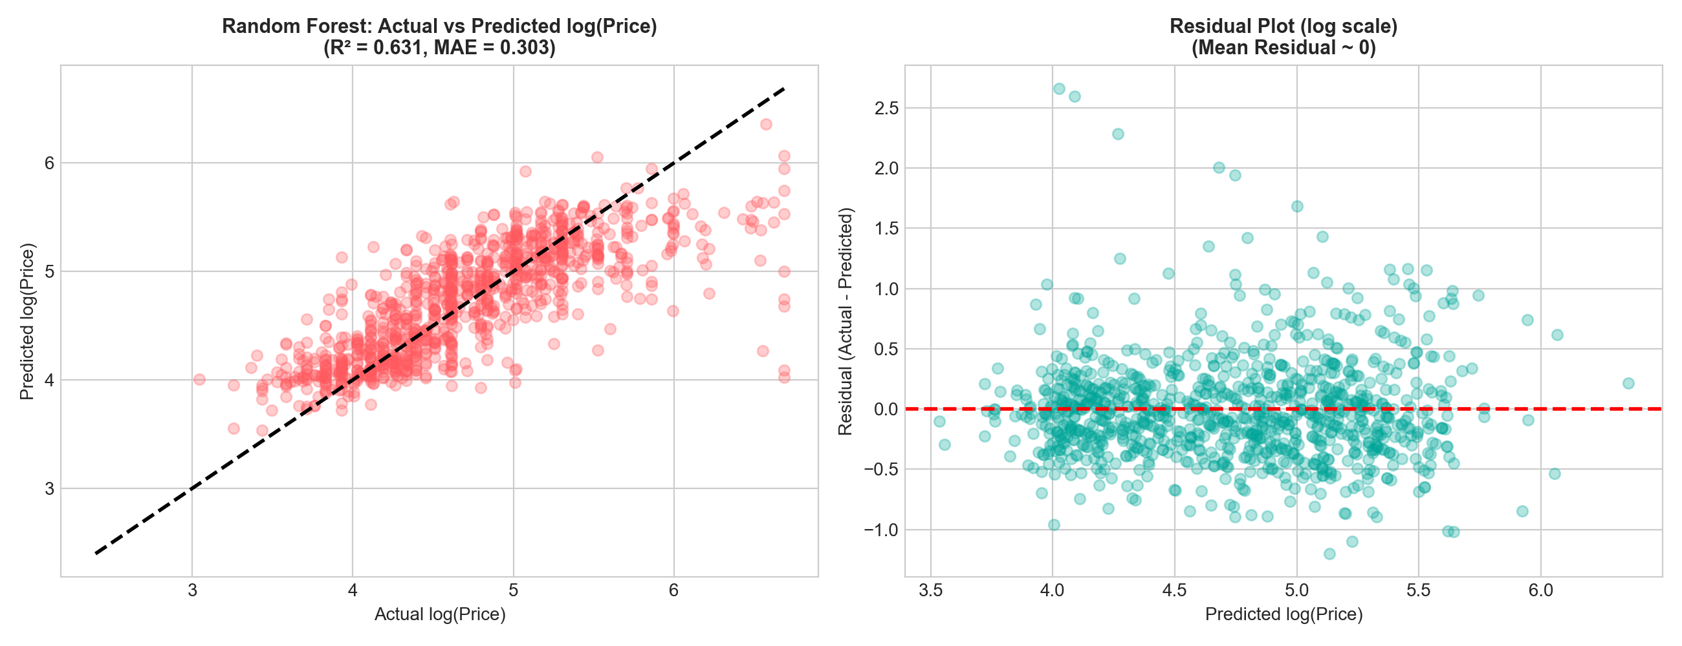
Figure: Random Forest Diagnostic Plots: Actual vs Predicted log(Price) & Residuals

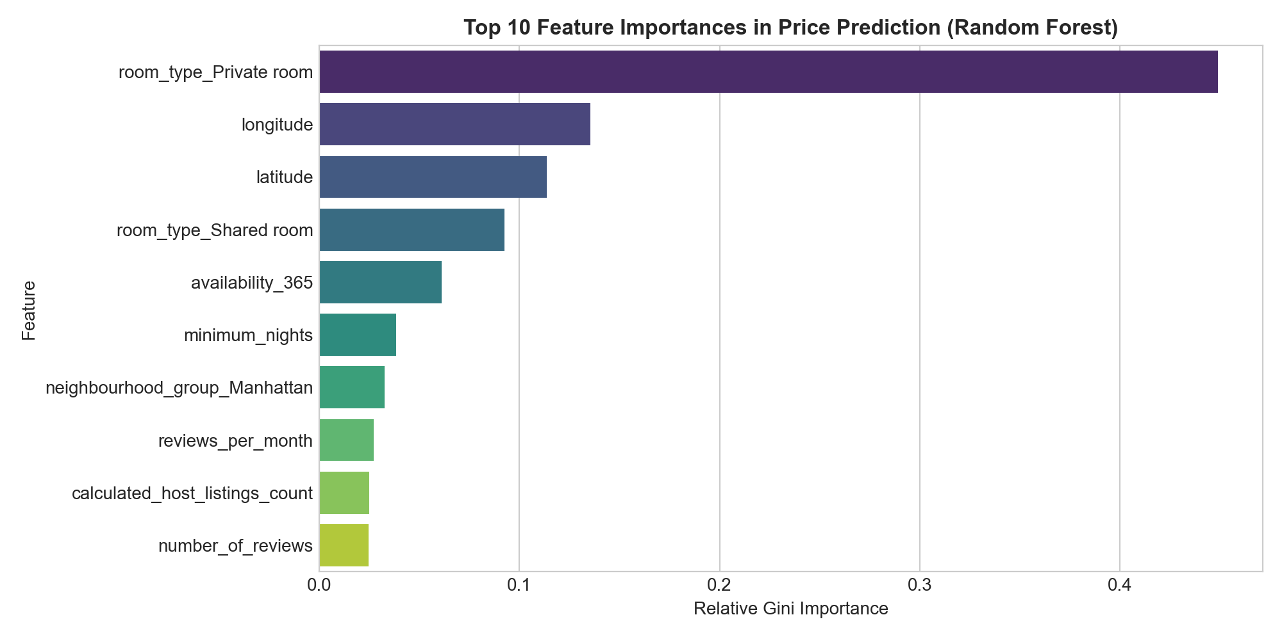
Figure: Top 10 Feature Importances in Nightly Rate Prediction
7. Tableau Visualization Deliverable
A dedicated Tableau deliverable was created: NYC_Airbnb_Tableau_Data.csv (48,870 rows, zero null values, clean headers, and engineered tiers) accompanied by NYC_Airbnb_Market_Insights_2019.twb and TABLEAU_DASHBOARD_GUIDE.md.
Dashboard Architecture:
1. KPI Executive Cards: Total Listings (48,870), Median Nightly Price ($106), Average Capped Price ($144), and Average Availability (113 days).
2. Borough Price Ranking: Horizontal bar chart comparing median prices across Manhattan, Brooklyn, Queens, Staten Island, and Bronx.
3. Room Type Exclusivity: Nightly rates across Entire home, Private room, and Shared room.
4. Neighbourhood Ranking: Top 10 micro-markets filtered by sample threshold n >= 25.
5. Availability vs Price Scatter: Scatter plot showing distribution with linear trend line.
6. Interactive Global Filters: Linked filters for Borough and Room Type across all worksheets.
8. Full-Stack Web Application Architecture
To earn the bonus marks, a production-grade full-stack web application was constructed named NYC Airbnb Market Intelligence.
Frontend (React + Vite + Tailwind CSS + Lucide Icons + Recharts):
- Overview: Executive landing dashboard with real KPIs, price distribution chart, and borough comparison.
- Explore Market: Interactive filtering by borough, room type, search query, max price slider, card/table views, pagination, and real CSV data export.
- Research Questions: Dedicated explorer containing all 18 research questions, mathematical formulas, and numerical findings.
- Statistical Evidence: Comprehensive hypothesis testing cards, test statistics, p-values, effect sizes, and decisions.
- Price Prediction: Real-time interactive valuation calculator calling the backend Random Forest model to predict nightly rates with 90% confidence intervals.
- Market Insight Explorer: Distinctive side-by-side comparative analytics tool allowing users to select any two boroughs or room types and compare descriptive statistics and delta percentages.
- About Study: Data dictionary, rubric mapping, and methodology documentation.
Backend (Python Flask REST API): Exposes /api/health, /api/summary, /api/filters, /api/listings, /api/price-distribution, /api/borough-analysis, /api/room-type-analysis, /api/questions, /api/hypothesis-tests, /api/model-metrics, /api/predict, and /api/compare.
9. Key Findings & Strategic Recommendations
1. The Price Distribution is Fundamentally Log-Normal: The arithmetic mean ($152.76) overstates typical costs by 44% compared to the median ($106.00). Analysts must rely on median metrics.
2. Room Type Exclusivity Commands Highest Non-Spatial Premium: Entire homes command a 2.31x premium over private rooms (Cohen's d = 1.61).
3. Commercial Concentration in a Home-Sharing Market: 9.8% of listings belong to commercial operators holding >5 properties (~34% of total inventory).
4. High Review Velocity Signifies Budget Turnover, Not Luxury: Listings with 24+ reviews average lower median rates ($100) than low-review listings ($115).
10. Limitations & Future Enhancements
1. Temporal Validity: Represents 2019 pre-COVID-19 conditions. Current NYC listings operate under Local Law 18 registration requirements.
2. Observational Causality: Features reflect observed market correlations rather than randomized experimental effects.
3. Unobserved Hedonic Attributes: Lacks square footage, floor level, interior architectural quality, and amenities.
Future Enhancements: Incorporating NLP sentiment analysis on review text, integrating subway transit proximity, and expanding time-series tracking.
11. Academic References
1. Foundations of Data Science (23CSE351) Course Materials & Faculty Instructions.
2. Inside Airbnb Open Data Repository: http://insideairbnb.com/get-the-data/
3. McKinney, W. (2022). Python for Data Analysis: Data Wrangling with pandas, NumPy, and Jupyter. O'Reilly Media.
4. Montgomery, D. C., & Runger, G. C. (2018). Applied Statistics and Probability for Engineers. John Wiley & Sons.
5. Hastie, T., Tibshirani, R., & Friedman, J. (2009). The Elements of Statistical Learning. Springer.

