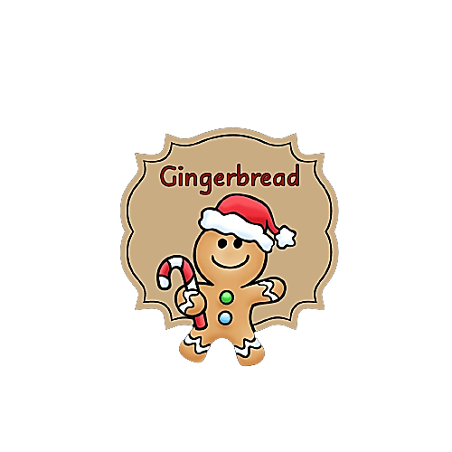

***Documentation***

Contents

1. About us 2

2. Used technologies 2

3. Summary 3

4. Conclusions 3

|  |  |  |
| --- | --- | --- |
| Name | Role | Class |
| **Filipa Popova** | Scrum Trainer | 9B |
| **Nikoleta Ruseva** | Front-End Developer | 9A |
| **Mariq Koleva** | Back-End Developer | 9V |
| **Mariela Dimova** | QA Engineer | 9G |

# About us

# Used technologies

* Visual Studio 2022
* GitHub
* Git
* Microsoft Teams
* Word
* PowerPoint
* Excel
* C++

# Summary

|  |  |
| --- | --- |
| Goals | Our game was created to diversify people's daily life. Also, a great way for young children to develop their vocabulary, recognize letters and make words on their own. |
| WHAT IS OUR PRODUCT? | The essence of this project was to create a C++ game based on wordplay. The game has 3 levels: easy, advanced and extreme. In the different levels the length of the word you need to guess is different and the difficulty increases with each level. You have 5 tries to guess the word that is given. |
| MAIN STAGES IN PROJECT IMPLEMENTATION | Communication is top notch and was done through MS Teams and live meetings we did every week. Roles and tasks are distributed in such a way that each member of the team feels comfortable and can complete their tasks. |
| REALIZATION | We used:  Visual Studio 2022  Teams – for communication  GitHub – for collaboration  Word и PowerPoint – for documentation  C++ - for the game |

# Conclusions

Our game currently meets all requirements. It presents a game based on Wordplay, having three levels of difficulty, and designed for all ages.