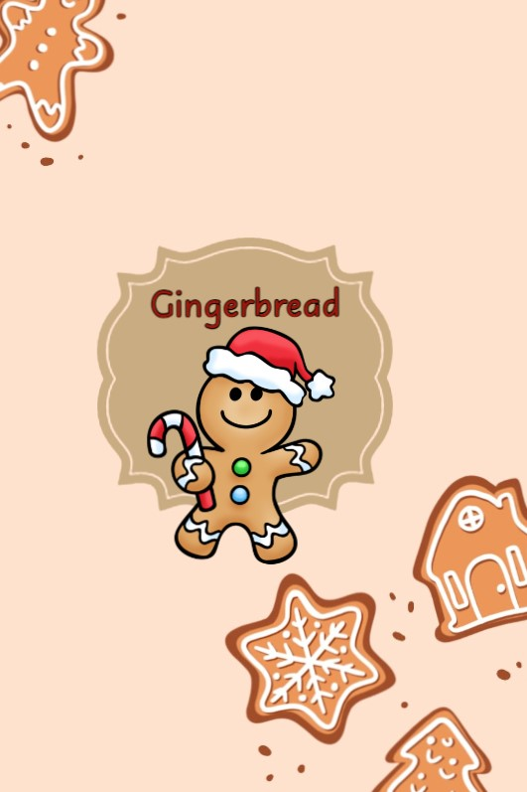

**Documentation**

**Content**

1. **Content** 2
2. **Team Members** 3
3. **Summary** 3
4. **Platforms used** 4
5. **Conclusion** 4

**Team Members**

|  |  |  |
| --- | --- | --- |
| Name | Role | Class |
| **Filipa Popova** | Scrum Trainer | 9B |
| **Nikoleta Ruseva** | Front-End Developer | 9A |
| **Mariq Koleva** | Back-End Developer | 9V |
| **Mariela Dimova** | QA Engineer | 9G |

**Summary**

|  |  |
| --- | --- |
| **Goals** | Our game was created to diversify people's daily life. Also a great way for young children to develop their vocabulary, recognize letters and make words on their own. |
| **WHAT IS OUR PRODUCT?** | The essence of this project was to create a C++ game based on wordplay. The game has 3 levels: easy, advanced and extreme. In the different levels the length of the word you need to guess is different and the difficulty increases with each level. You have 5 tries to guess the word that is given. |
| **MAIN STAGES IN PROJECT IMPLEMENTATION** | Communication is top notch and was done through MS Teams, OneDrive and live meetings we did every week. Roles and tasks are distributed in such a way that each member of the team feels comfortable and can complete their tasks. |
| **REALIZATION** | We used:  Visual Studio 2022  Teams – for communication  GitHub – for collaboration  Word и PowerPoint – for documentation  C++ - for the game |

**Platforms used**

* *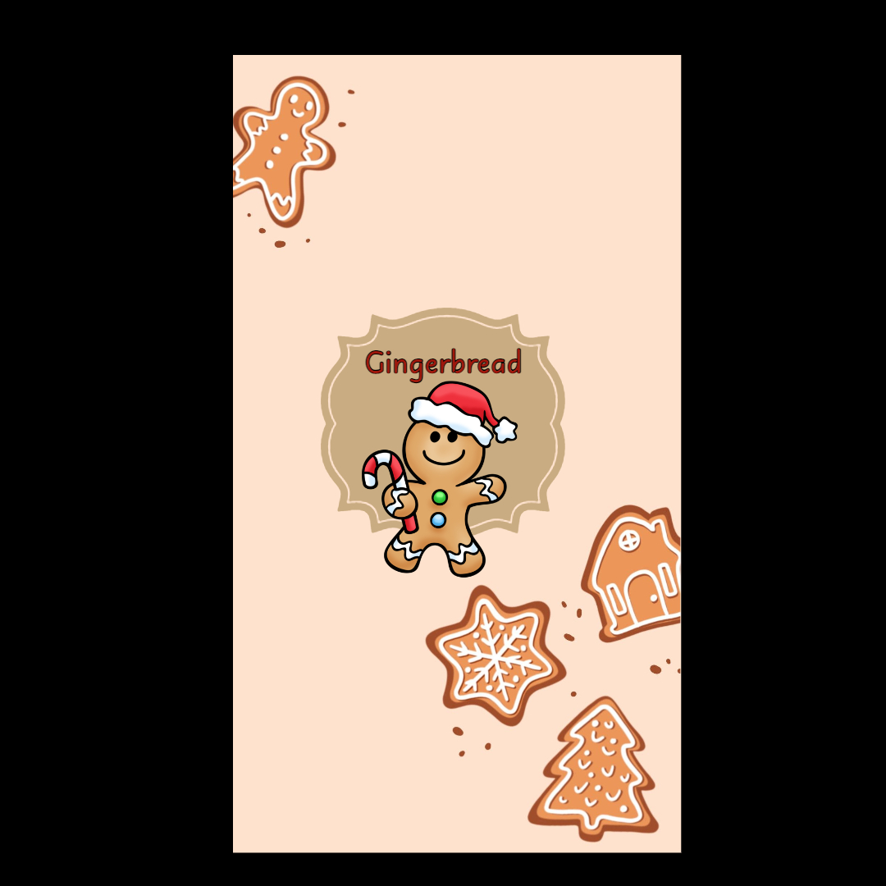Visual Studio 2022*
* *GitHub*
* *Git*
* *Microsoft Teams*
* *Microsoft Word*
* *Microsoft PowerPoint*
* *Microsoft Excel*
* *Adobe Illustator*
* *C++*

**Conclusion**

Our game currently meets all requirements. It presents a game based on Wordplay, having three levels of difficulty and designed for all ages.