**Report:-**

**Twitter Sentimental Analysis of Pfizer Vaccine**



Himanish Mishra (2020A1R123)

**DEPARTMENT OF COMPUTER SCIENCE AND ENGINEERING MIET(Autonomous), JAMMU**

**Contents**

* **Problem Statement**
* **Things Covered In Analysis**
* **Tech Stack**
* **Workflow**
* **Demonstration**

**Problem Statement**

* When a user wishes to voice his view on a trending topic on social media, we apply sentiment analysis to try to determine the sentiment score of that given opinion.
* Twitter is the most popular microblogging social media site, with over a billion users. Nearly 145 million people use the site on a daily basis.
* In today's world, the user tweets utilizing Hashtags, emojis, and punctuation make it difficult to examine the data and Create sentiment scores of tweets. For this project, Tweets of PFIZER VACCINE are used for sentiment analysis.

**Things Covered In Analysis**

* Tweets Preprocessing and Cleaning/Data Cleaning
* Visualization from Tweets
* Extracting Features from Cleaned Tweets from TfizerVectorizer
* Model Building: Sentiment Analysis

1. Logistic Regression
2. Support Vector Machine
3. Random Forest
4. XGBoost

**Tech Stack**

1. Numpy
2. Pandas
3. Matplotlib
4. Vader Sentiment Analyzer
5. Machine Learning Model

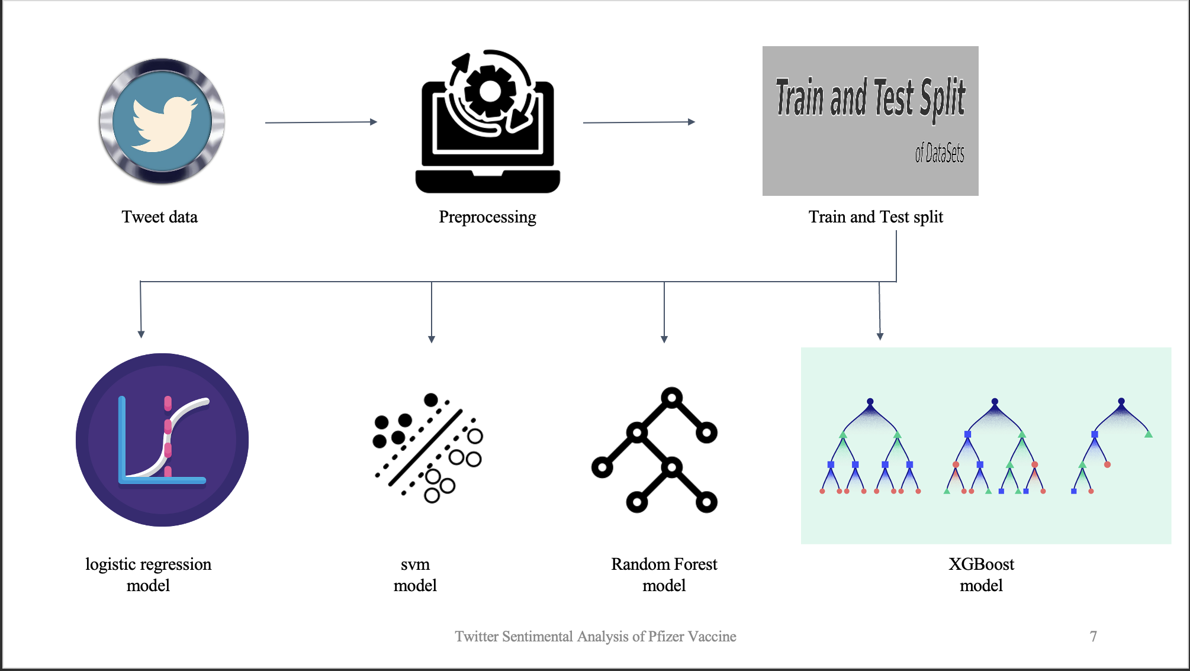 **WORKFLOW**

