**COMPUTER NETWORK PROJECT REPORT**

**ON**

**DYNAMIC HOST CONFIGURATION PROTOCOL**

**SUBMITTED BY**

Khushboo Raina(2020A1r004)

Sparsh Sudan(2020A1R007)

Aryan Verma(2020A1r031)

Dhruv Gupta(2020A1r032)

Muskan Raina(2020A1r033)

**SUBMITTED TO**

**CSE DEPARTMENT**

**Model Institute of Engineering and Technology (Autonomous)**

**Jammu, India**

**2022**

**CONTENTS**

|  |  |
| --- | --- |
| 1 | Introduction to Cisco Packet Tracer |
| 2 | Introduction to Protocols |
| 3 | Introduction to DHCP |
| 4 | Project Implementation |
| 5 | References |

**SUBMITTED TO**

**CSE DEPARTMENT**

**Model Institute of Engineering and Technology (Autonomous)**

**Jammu, India**

**2022**

**Introduction to Cisco Packet Tracer**

**Cisco Packet Tracer** is a [cross-platform](https://en.wikipedia.org/wiki/Cross-platform) visual [simulation](https://en.wikipedia.org/wiki/Simulation) tool designed by [Cisco Systems](https://en.wikipedia.org/wiki/Cisco_Systems) that allows users to create [network topologies](https://en.wikipedia.org/wiki/Network_topologies) and imitate modern [computer networks](https://en.wikipedia.org/wiki/Computer_networks). The software allows users to simulate the configuration of Cisco routers and switches using a simulated command line interface. Packet Tracer makes use of a [drag and drop](https://en.wikipedia.org/wiki/Drag_and_drop) user interface, allowing users to add and remove simulated network devices as they see fit. The software is mainly focused towards Cisco Networking Academy students as an educational tool for helping them learn fundamental [CCNA](https://en.wikipedia.org/wiki/CCNA) concepts. Previously students enrolled in a CCNA Academy program could freely download and use the tool free of charge for educational use.

Packet Tracer can be run on Linux, Microsoft Windows, and macOS. Similar [Android](https://en.wikipedia.org/wiki/Android_(operating_system)) and [iOS](https://en.wikipedia.org/wiki/IOS) apps are also available. Packet Tracer allows users to create simulated network topologies by dragging and dropping routers, switches and various other types of network devices. A physical connection between devices is represented by a 'cable' item. Packet Tracer supports an array of simulated [Application Layer protocols](https://en.wikipedia.org/wiki/Application_Layer), as well as basic routing with [RIP](https://en.wikipedia.org/wiki/Routing_Information_Protocol), [OSPF](https://en.wikipedia.org/wiki/OSPF), [EIGRP](https://en.wikipedia.org/wiki/EIGRP), [BGP](https://en.wikipedia.org/wiki/BGP), to the extents required by the current [CCNA](https://en.wikipedia.org/wiki/CCNA) curriculum.

**Role in Education**

Packet Tracer allows students to design complex and large networks, which is often not feasible with physical hardware, due to costs. Packet Tracer is commonly used by Net Acad students, since it is available to them for free. However, due to functional limitations, it is intended by Cisco to be used only as a learning aid, not a replacement for Cisco [routers](https://en.wikipedia.org/wiki/Router_(computing)) and [switches](https://en.wikipedia.org/wiki/Network_switch). The application itself only has a small number of features found within the actual hardware running a current [Cisco IOS](https://en.wikipedia.org/wiki/Cisco_IOS) version. Thus, Packet Tracer is unsuitable for modelling production networks. It has a limited command set, meaning it is not possible to practice all of the IOS commands that might be required.

**Interface of Cisco Packet Tracer**

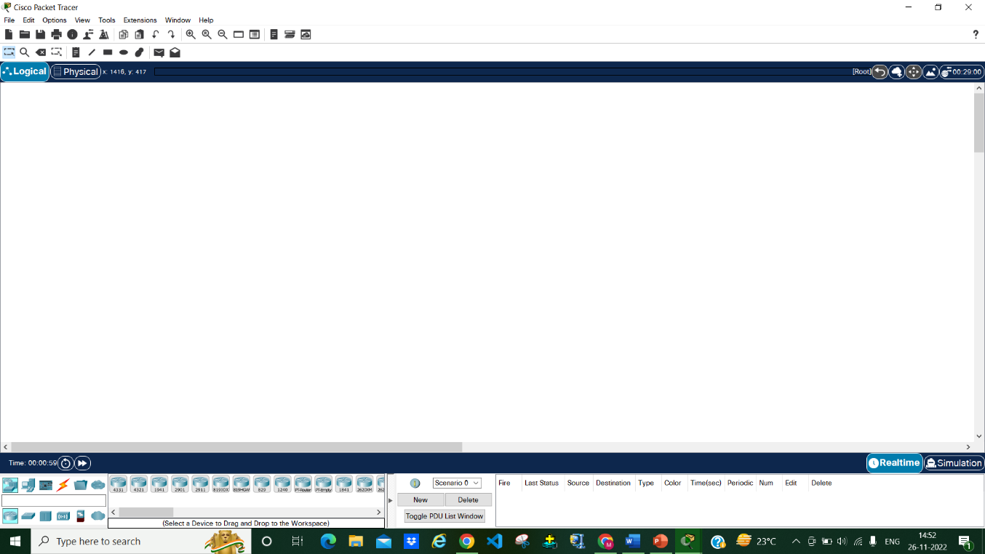

**Introduction to Protocols**

A **communication protocol** is a system of rules that allows two or more entities of a [communications system](https://en.wikipedia.org/wiki/Communications_system) to transmit [information](https://en.wikipedia.org/wiki/Information) via any kind of variation of a physical quantity. The protocol defines the rules, syntax, semantics and synchronization of communication and possible error recovery methods. Protocols may be implemented by [hardware](https://en.wikipedia.org/wiki/Computer_hardware), [software](https://en.wikipedia.org/wiki/Software), or a combination of both.

In order for computers to exchange information, there must be a preexisting agreement as to how the information will be structured and how each side will send and receive it. Without a protocol, a transmitting computer, for example, could be sending its data in 8-bit packets while the receiving computer might expect the data in 16-bit packets.

Protocols are established by international or industrywide organizations. Perhaps the most important computer protocol is OSI (Open Systems Interconnection), a set of guidelines for implementing networking communications between computers. Among the most important sets of Internet protocols are TCP/IP (Transmission Control Protocol/Internet Protocol), HTTPS (Secure Hypertext Transmission Protocol), SMTP (Simple Mail Transfer Protocol), and DNS (Domain Name System).

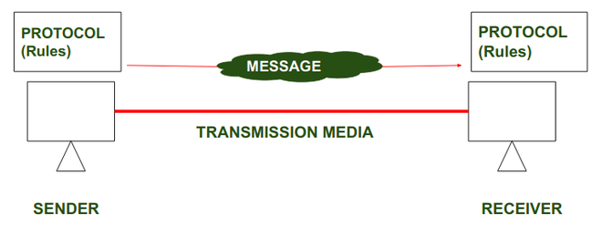

**Introduction to DHCP**

Dynamic Host Configuration Protocol (DHCP) is a client/server protocol that automatically provides an Internet Protocol (IP) host with its IP address and other related configuration information such as the subnet mask and default gateway. DHCP is an application layer protocol.

DHCP server provides the client with at least this basic information:

* **IP Address**
* **Subnet Mask**
* **Default Gateway**

Other information can be provided as well, such as Domain Name Service (DNS) server addresses and Windows Internet Name Service (WINS) server addresses. The system administrator configures the DHCP server with the options that are parsed out to the client.

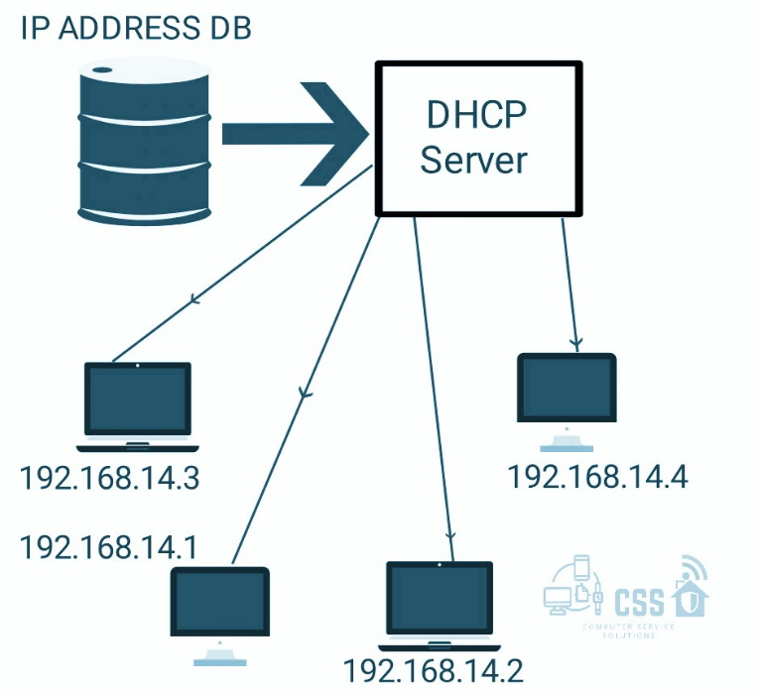

**Why use DHCP?**

Every device on a TCP/IP-based network must have a unique unicast IP address to access the network and its resources. Without DHCP, IP addresses for new computers or computers that are moved from one subnet to another must be configured manually; IP addresses for computers that are removed from the network must be manually reclaimed.

With DHCP, this entire process is automated and managed centrally. The DHCP server maintains a pool of IP addresses and leases an address to any DHCP-enabled client when it starts up on the network. Because the IP addresses are dynamic (leased) rather than static (permanently assigned), addresses no longer in use are automatically returned to the pool for reallocation.

The network administrator establishes DHCP servers that maintain TCP/IP configuration information and provide address configuration to DHCP-enabled clients in the form of a lease offer. The DHCP server stores the configuration information in a database that includes:

* Valid TCP/IP configuration parameters for all clients on the network.
* Valid IP addresses, maintained in a pool for assignment to clients, as well as excluded addresses.
* Reserved IP addresses associated with particular DHCP clients. This allows consistent assignment of a single IP address to a single DHCP client.
* The lease duration, or the length of time for which the IP address can be used before a lease renewal is required.

A DHCP-enabled client, upon accepting a lease offer, receives:

* A valid IP address for the subnet to which it is connecting.
* Requested DHCP options, which are additional parameters that a DHCP server is configured to assign to clients. Some examples of DHCP options are Router (default gateway), DNS Servers, and DNS Domain Name

## Benefits of DHCP

DHCP provides the following benefits.

* **Reliable IP address configuration**. DHCP minimizes configuration errors caused by manual IP address configuration, such as typographical errors, or address conflicts caused by the assignment of an IP address to more than one computer at the same time.
* **Reduced network administration**. DHCP includes the following features to reduce network administration:
  + Centralized and automated TCP/IP configuration.
  + The ability to define TCP/IP configurations from a central location.
  + The ability to assign a full range of additional TCP/IP configuration values by means of DHCP options.
  + The efficient handling of IP address changes for clients that must be updated frequently, such as those for portable devices that move to different locations on a wireless network.
  + The forwarding of initial DHCP messages by using a DHCP relay agent, which eliminates the need for a DHCP server on every subnet.

## Working of DHCP

## DHCP works on DORA process

## D - Discover

## O - Offer

## R - Request

## A - Acknowledgement

## ****1.**** DHCP discover message –  This is a first message generated in the communication process between server and client. This message is generated by Client host in order to discover if there is any DHCP server/servers are present in a network or not. This message is broadcasted to all devices present in a network to find the DHCP server. This message is 342 or 576 bytes long

## 

**2. DHCP offer message-**    
The server will respond to host in this message specifying the unleased IP address and other TCP configuration information. This message is broadcasted by server. Size of message is 342 bytes. If there are more than one DHCP servers present in the network then client host will accept the first DHCP OFFER message it receives. Also a server ID is specified in the packet in order to identify the server.

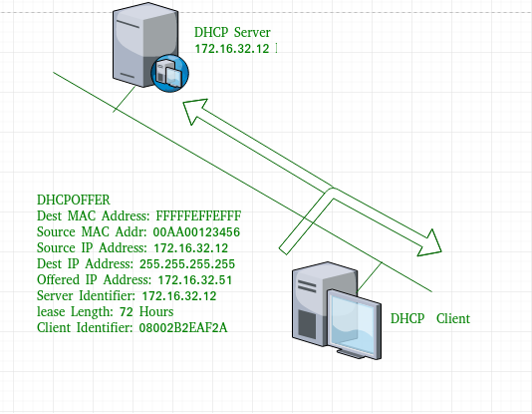

**3. DHCP request message–**   
When a client receives a offer message, it responds by broadcasting a DHCP request message. The client will produce a gratuitous ARP in order to find if there is any other host present in the network with same IP address. If there is no reply by other host, then there is no host with same TCP configuration in the network and the message is broadcasted to server showing the acceptance of IP address. A Client ID is also added in this message.

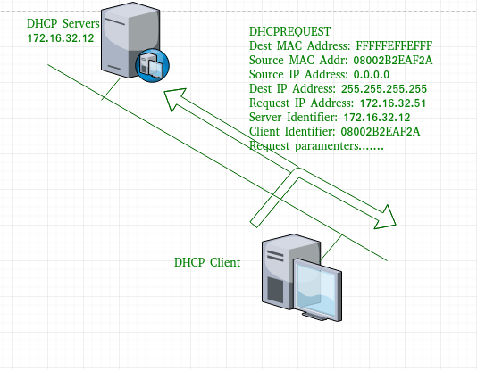

**4. DHCP acknowledgement message–**   
In response to the request message received, the server will make an entry with specified client ID and bind the IP address offered with lease time. Now, the client will have the IP address provided by server.

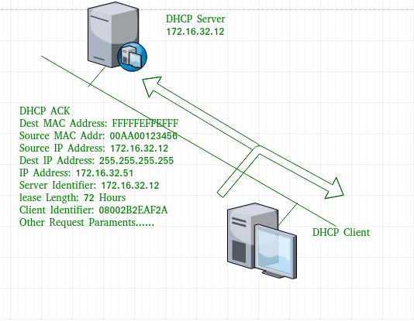

**PROJECT IMPLEMENTATION**

## Implementation of DHCP Using Cisco Packet Tracer

## Step 1: First we setup a network for implementation of DHCP in cisco packet tracer. we use router, then we will use devices we can take device as a laptop or a pc, then we require switch, we also require a server. and at the last we require automatic connections to connect the devices.

## Step 2: As we know we are using DHCP so we are not ip addresses manually to the devices we are giving ip addresses through CLI(command line interface) Then we go to the CLI of router then we use command to implement the project

## Step 3: After giving all the commands we will check whether each and every device has got its individual ip addresses or not. Then we click on the pc go to ip configuration it is not static we have used DHCP it will show DHCP request successful.

## Step 4: We try to ping devices from the router

## SCREENSHOT OF OUR PROJECT

## 

**REFERENCES**

1. <https://learn.microsoft.com/en-us/windows-server/networking/technologies/dhcp/dhcp-top>
2. <https://en.wikipedia.org/wiki/Packet_Tracer>
3. <https://www.britannica.com/technology/protocol-computer-science>
4. <https://www.geeksforgeeks.org/dynamic-host-configuration-protocol-dhcp/>
5. <https://www.google.com/url?sa=i&url=https%3A%2F%2Fwww.geeksforgeeks.org%2Fprotocol-and-standard-in-computer-networks%2F&psig=AOvVaw3KaGrS2FpdOwjqKrmnhXzG&ust=1669641373126000&source=images&cd=vfe&ved=0CBEQjhxqFwoTCPjPuIG5zvsCFQAAAAAdAAAAABAD>
6. <https://www.google.com/url?sa=i&url=https%3A%2F%2Fwww.computerservicesolutions.in%2Fdhcp-protocol-complete-process-attack-and-security-everything-you-need-to-know%2F&psig=AOvVaw0qO3aqjpRETFQWkwhMzvys&ust=1669641312427000&source=images&cd=vfe&ved=0CBEQjhxqFwoTCPDqheG4zvsCFQAAAAAdAAAAABBy>
7. <https://en.wikipedia.org/wiki/Communication_protocol>
8. <https://learn.microsoft.com/en-us/windows-server/troubleshoot/dynamic-host-configuration-protocol-basics?source=recommendations>