User Manual
Respiratory Motion Simulator

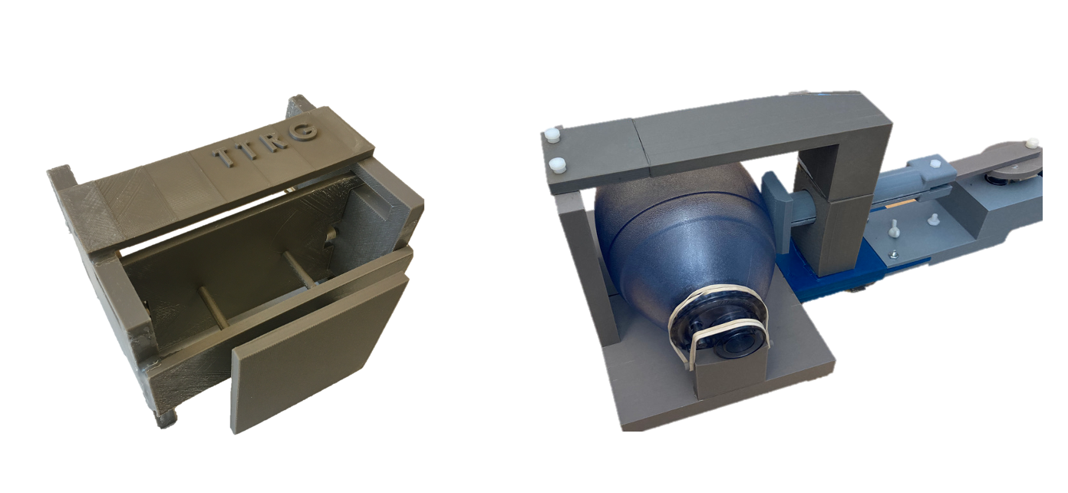

University of California, San Francisco
Thermal Therapy Research Group

Updated 03/19/2022

Table of Contents
1. Overview of mechanisms 2
2. List of components 4
3. Assembly order 6
• Motion Actuator 6
• Motion Phantom 7
4. Testing results 8

Contact:
Kisoo Kim, Ph.D.
University of California, San Francisco
Email: ki-soo.kim@ucsf.edu

- Overview of mechanisms
Outside the MRI suite, a DC motor of 16 rpm is connected to a motion actuator, which increases or decreases the pressure inside the BVM. The BVM is coupled via Tygon tubing to the compressible bag in the motion phantom in the MRI scanner. Various levels of inflation or deflation of the BVM cause cyclical motion of tissue-mimicking phantom in the MRI scanner to simulate the shift of abdominal organs due to respiratory motion. The motor controller allowed adjusting the speed of the DC motor in the range of 8-16 cycles per minute.

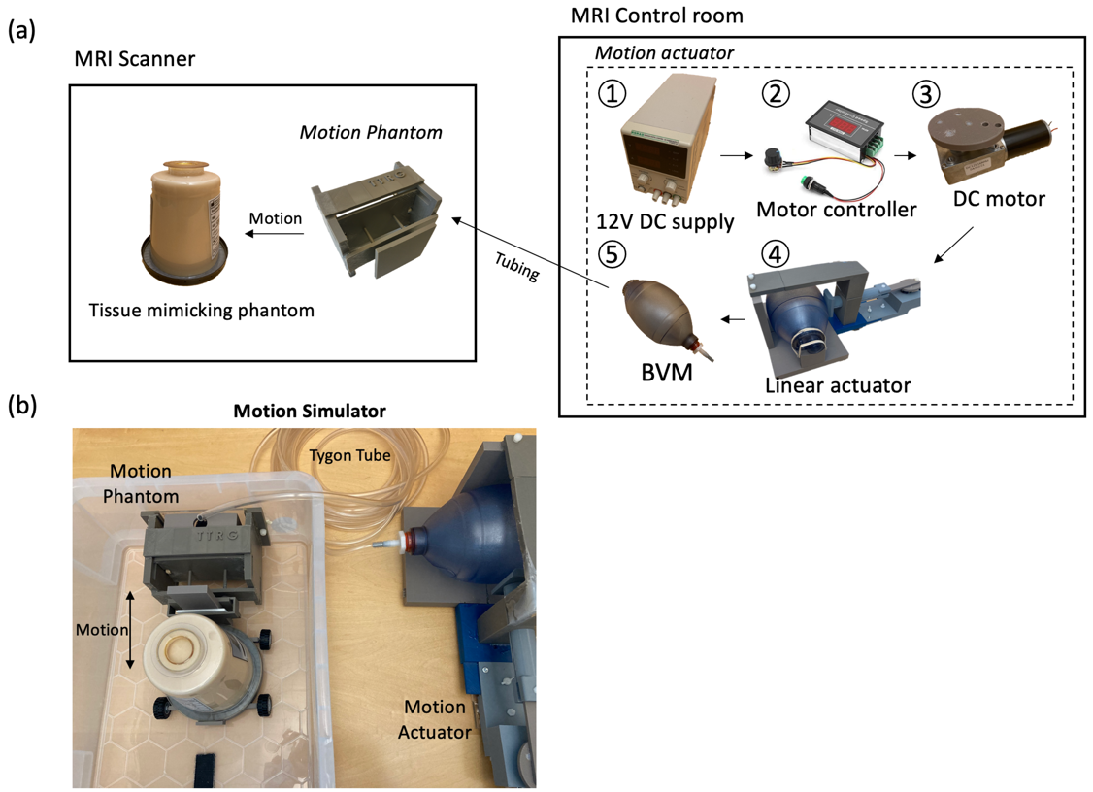
Designed respiratory motion simulator. (a) A schematic diagram and (b) a photo of the phantom and actuator.

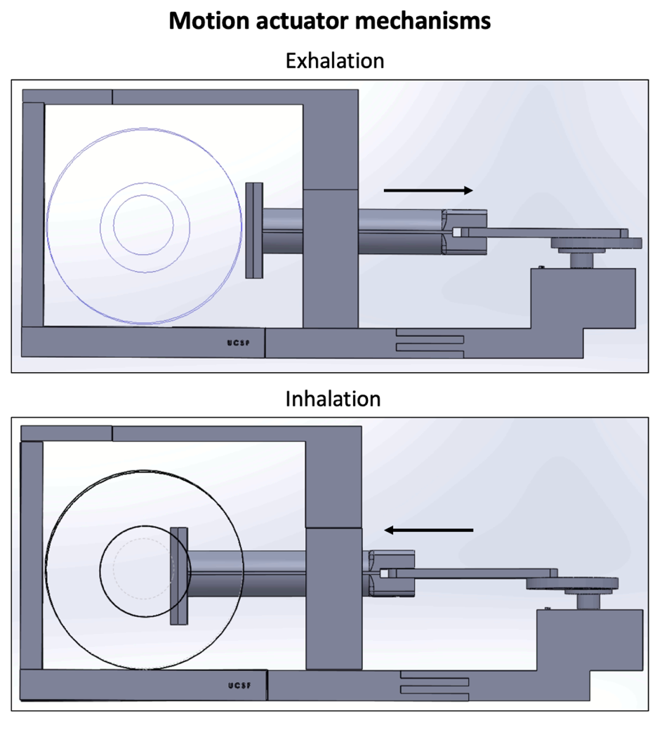
The motion actuator was constructed of a DC motor, 3D-printed linear actuator, and the BVM. The linear actuator was connected to the DC motor to convert the motor rotation into linear motion. The motion of the actuator controlled the level of inflation or deflation of the BVM.

- List of components

Name | Info |  | Cost
DC Power Supply | Korad Technology KD3005D, DC Linear Power Supply |  | $85
DC motor | Brand: Bringsmart (Amazon), 12V-16 rpm, gear motor 70kg$∙$cm |  | $30
DC motor speed controller | Brand: Vikye (Amazon), 6-60V, 30A PWM motor controller |  | $15
8 mm Flange shaft coupling motor connector | Brand: Magic&shell, Thread size: M4, Material: Metal |  | $11
Bag Valve Mask (BVM) | Brand: NEcommerce (currently not available)  Package Dimensions: ‎ 25.65 x 17.78 x 11.43 cm; 454 g, volume 1.8 L |  | <$50
Reservoir bag for the BVM | Brand: NEcommerce (currently not available) |  | <$50
Tygon Tubing | Brand: Masterflex, 15ft |  | <$26
3D printer | Zortrax-M200 Plus |  | -
3D printing material | Acrylonitrile Butadiene Styrene (ABS) |  | $21/1kg
Epoxy Glue | Brand: Gorilla Glue Epoxy |  | $11
Motion Actuator |  |  | Weight
Motor connector coupling wheel (MCW) | 3D-printed |  | 12 g
Connecting Rod | 3D-printed |  | 10 g
Piston | 3D-printed |  | 53 g
Piston holder (a) | 3D-printed |  | 83 g
Piston holder (b) | 3D-printed |  | 110 g
Piston holder (c) | 3D-printed |  | 24 g
Bumper | 3D-printed |  | 15 g
Actuator (a) | 3D-printed |  | 170 g
Actuator (b) | 3D-printed |  | 122 g
BVM stander | 3D-printed |  | 16 g
BVM holder (a) | 3D-printed |  | 227 g
BVM holder (b) | 3D-printed |  | 227 g
Motion Phantom
Part (a) | 3D-printed |  | 50 g
Part (b) | 3D-printed |  | 50 g
Part (c) | 3D-printed |  | 21 g
Part (d) | 3D-printed |  | 22 g
Pusher (a) | 3D-printed |  | 38 g
Pusher (b) | 3D-printed |  | 25 g
Back cover | 3D-printed |  | 39 g
Bag box | 3D-printed |  | 75 g
Total amount |  | (Total 3D printing materials 1.4 kg x $21) + $ 228 = $ 257

Motion actuator components

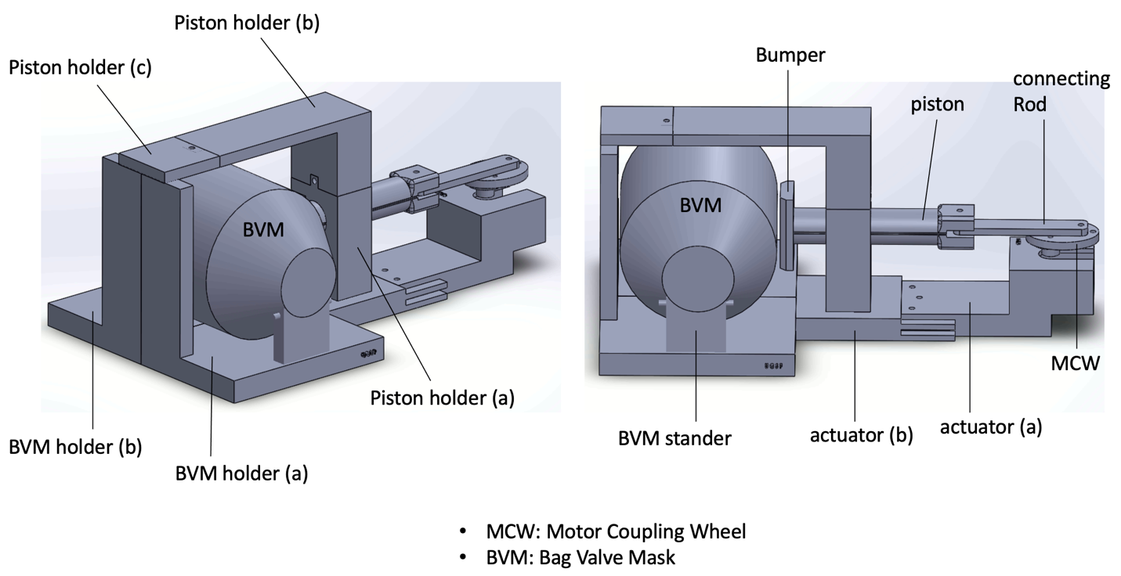

Motion Phantom components

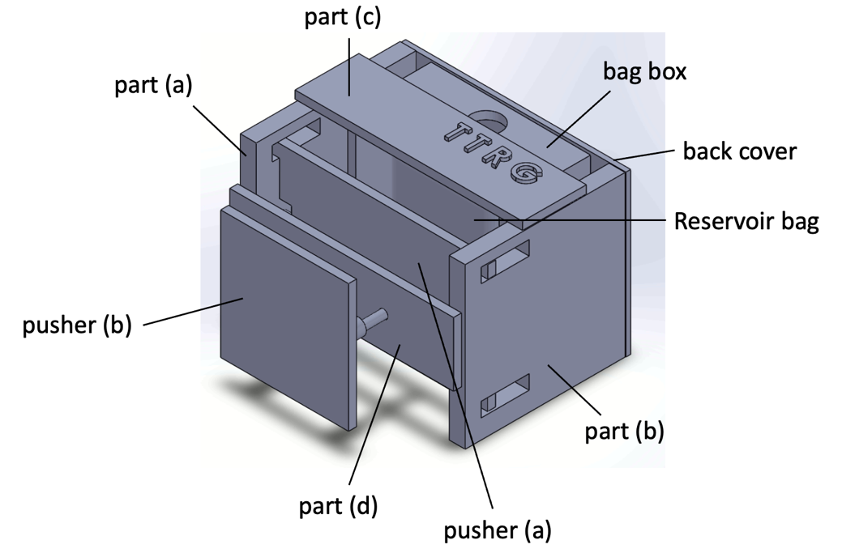

*Part (d) (modified 03/10/2022): This model has been updated to have a chamfer for a more stable movement.

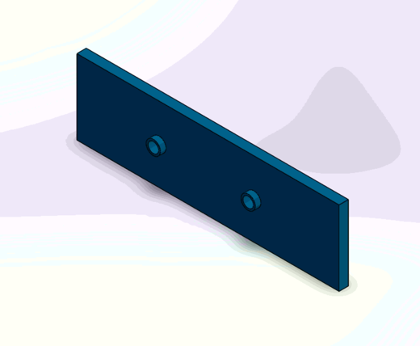

- Assembly order

- Motion Actuator

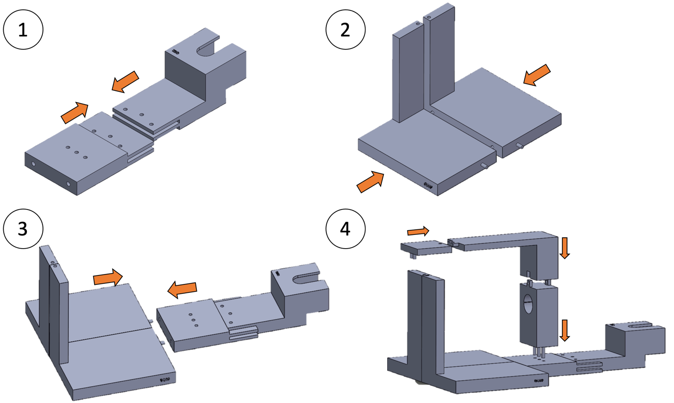

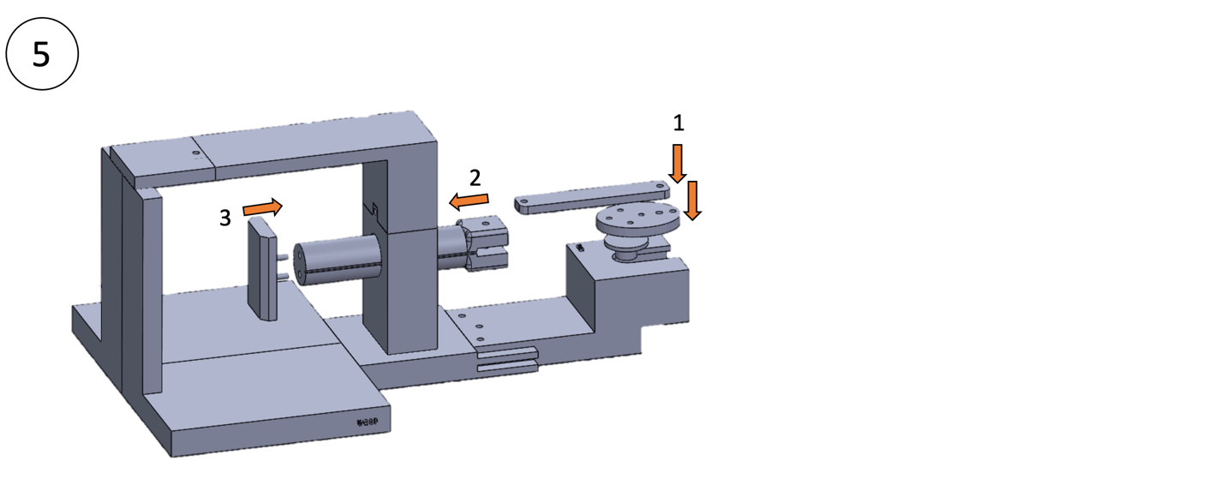

After assembled, bars of 10 mm, 20 mm, and 29 mm need to be used to fix the components. Please print and prepare bars at the steps: Step 1: 3 bars - 20 mm, Step 4: 2 bars - 10 mm, Step 5: 1 bar-29 mm, 1 bar-10 mm (Do not use epoxy)
Epoxy gluing needs to fix the components with the bars. Epoxy glue has been chosen due to high bond strength, non-magnetic, and water resistance.

- Motion Phantom

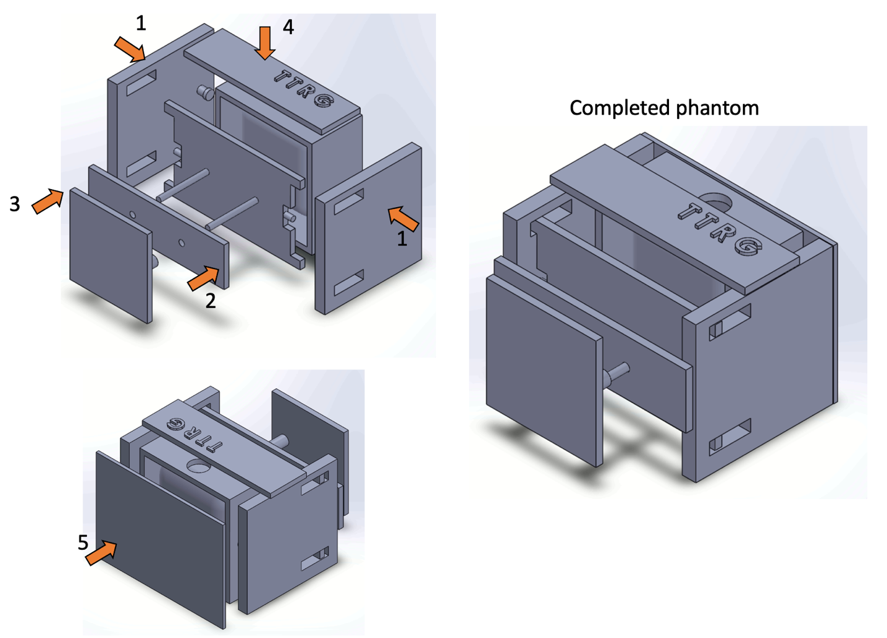
Epoxy gluing needs to fix the components with the bars. Epoxy glue has been chosen due to high bond strength, non-magnetic, and water resistance.

- Testing results

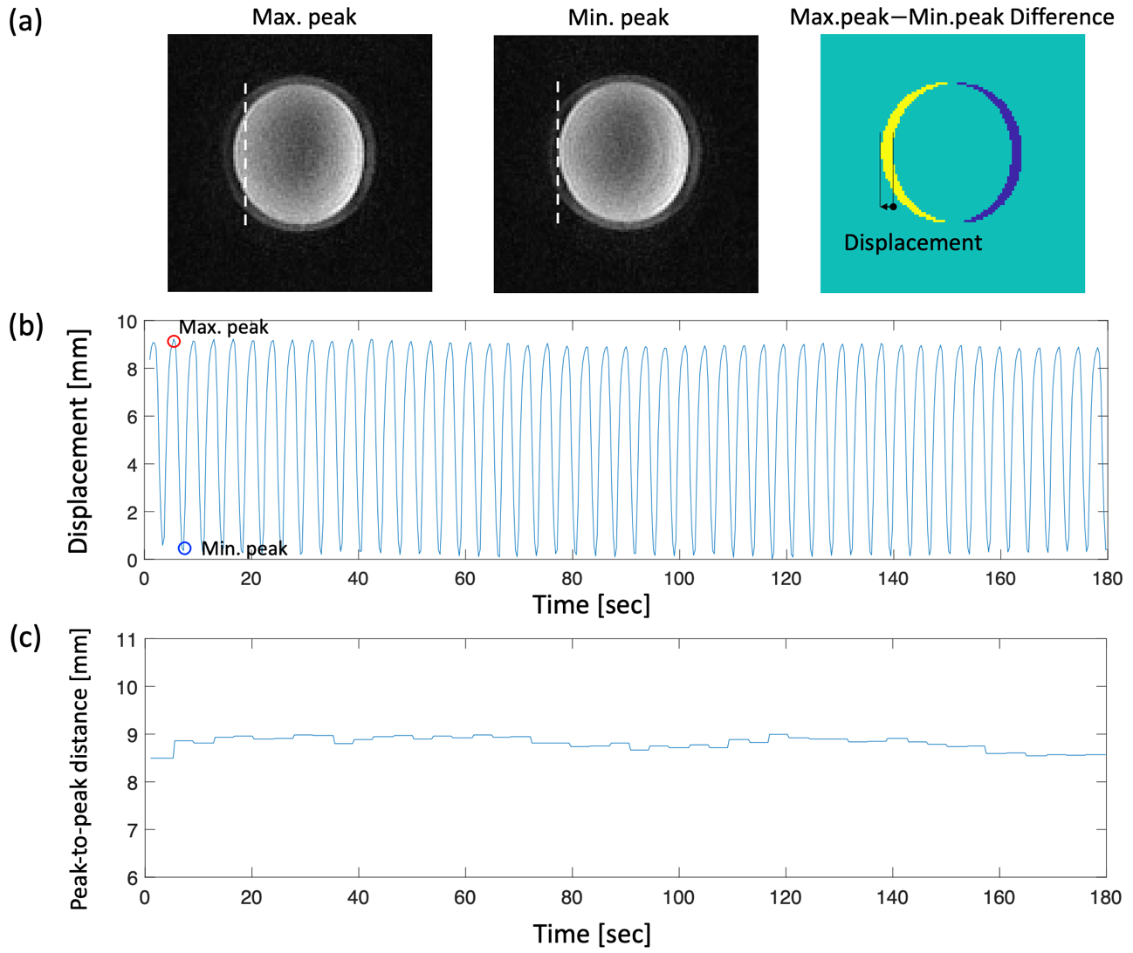
Displacements of the phantom with 1.65 L volume of the BVM. MR magnitude images (a, left, center) are shown on the coronal plane and white dashed lines indicate the original position of the phantom. (b) The displacement profile shows consistent and stable motions for 3 mins. Red and blue circles mean the maximum and minimum peaks of the navigator positions, respectively, corresponding to the magnitude images on the top. (c) Distances between the peak-to-peak displacements for 3 mins are plotted to evaluate the consistency of movement.

Table 1. Averaged distance between the peak-to-peak displacements for 3 mins, according to the volume of the BVM at 16 breaths/min.
Volume of BVM (L)  /Additional plastic thickness (mm) | Averaged Distance (mm)
1.75 L/10 mm | 5.0$±$0.1
1.7/30 mm | 7.0$±$0.1
1.65/35 mm | 8.8$±$0.1

The motion simulator allows various respiratory rates in the range of 8-16 cycles per min, while averaged distances are similar and only dependent on volume of BVM.

