Lab Report
Computational Techniques & Natural Language Processing Lab
Experiment 1 — Data Analysis & Visualization
Experiment 2 — Basic Text Preprocessing
Prepared: August 2026

Contents
1. Experiment 1: Data Analysis
1.1 Average Salary by Department
1.2 Employee Count by Department
1.3 Gender Distribution
1.4 Salary Distribution
1.5 Experience vs Salary
1.6 Top 10 Highest-Paid Employees
1.7 Highest Salary per Department
1.8 Employees Above Average Salary
1.9 Average Experience per Department
1.10 Age Distribution
2. Experiment 2: Basic Text Preprocessing
2.1 Cleaning: Case, Punctuation, Numbers, Whitespace
2.2 Word & Sentence Tokenization
2.3 Stop-word Removal
3. Summary & Conclusion

Experiment 1: Data Analysis
This experiment analyzes an employee dataset (100 records) covering department, salary, gender, age and years of experience, using pandas for data manipulation and matplotlib for visualization.

1.1 Average Salary by Department
Objective: Read the employee dataset and display the average salary of each department using a bar chart.
avg_salary = df.groupby('Department')['Salary'].mean()
plt.figure(figsize=(8, 5))
avg_salary.plot(kind='bar', color='skyblue', edgecolor='black')
plt.title('Average Salary by Department')
plt.xlabel('Department')
plt.ylabel('Average Salary')
plt.show()
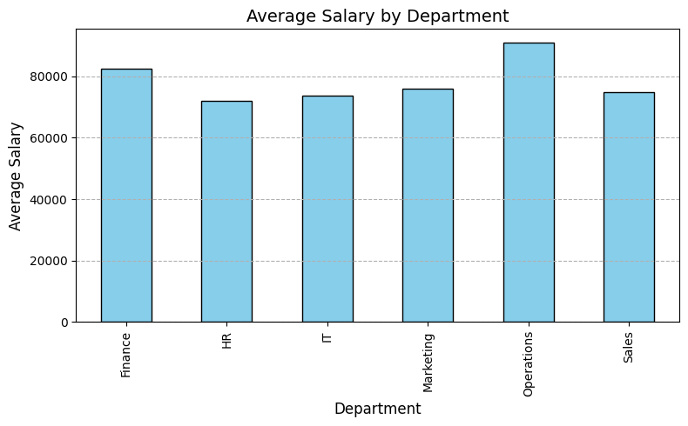
Figure 1.1: Average salary by department

1.2 Employee Count by Department
Objective: Display the number of employees working in each department.
Number of employees per department:
Department
HR 21
Marketing 20
IT 18
Operations 16
Sales 13
Finance 12
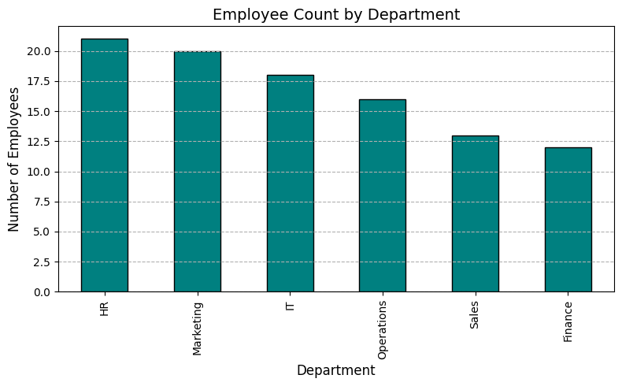
Figure 1.2: Employee headcount by department

1.3 Gender Distribution
Objective: Display the percentage of male and female employees using a pie chart.
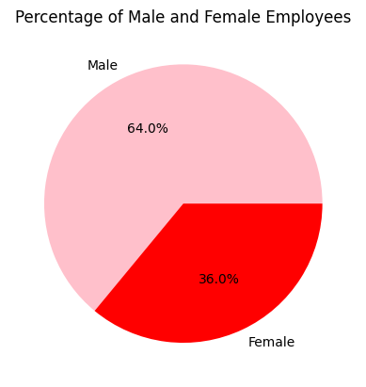
Figure 1.3: Gender split (male vs. female)

1.4 Salary Distribution
Objective: Draw a histogram showing salary distribution.
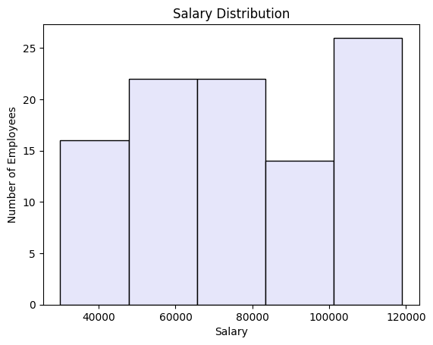
Figure 1.4: Salary distribution histogram

1.5 Experience vs Salary
Objective: Draw a scatter plot showing the relationship between experience and salary.
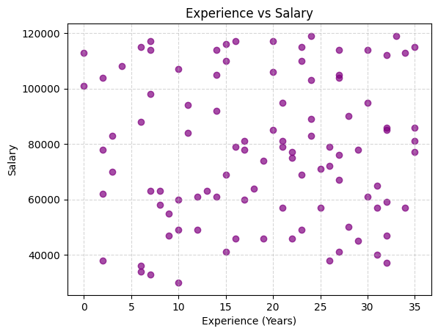
Figure 1.5: Scatter plot — years of experience vs. salary
Observation: There is no strong linear trend visible between years of experience and salary in this dataset, suggesting salary is influenced by factors beyond tenure alone (e.g. department, role level).

1.6 Top 10 Highest-Paid Employees
Objective: Display the top 10 employees with the highest salary.
Employee ID | Name | Department | Salary
E086 | Omar86 | Marketing | 119,000
E088 | Diana88 | Marketing | 119,000
E015 | Ishan15 | Operations | 117,000
E023 | Rahul23 | Finance | 117,000
E059 | Neha59 | IT | 117,000
E049 | Charlie49 | IT | 116,000
E032 | George32 | Operations | 115,000
E056 | Sneha56 | Operations | 115,000
E065 | Bob65 | Finance | 115,000
E010 | Vikram10 | IT | 114,000

1.7 Highest Salary per Department
Objective: Find the highest salary in every department.
Department | Highest Salary
Finance | 117,000
HR | 113,000
IT | 117,000
Marketing | 119,000
Operations | 117,000
Sales | 114,000

1.8 Employees Above Average Salary
Objective: Display employees whose salary is greater than the overall average salary.
Overall Average Salary: 77,760.00
54 of the 100 employees earn above this average.
A representative sample of these employees is shown below (full list available in the notebook output):
Employee ID | Name | Department | Salary
E002 | Diana2 | Operations | 105,000
E004 | Neha4 | HR | 113,000
E008 | Neha8 | Finance | 98,000
E009 | Mohan9 | HR | 110,000
E010 | Vikram10 | IT | 114,000
E015 | Ishan15 | Operations | 117,000
E023 | Rahul23 | Finance | 117,000
E059 | Neha59 | IT | 117,000
E086 | Omar86 | Marketing | 119,000
E088 | Diana88 | Marketing | 119,000

1.9 Average Experience per Department
Objective: Calculate the average years of experience in each department.
Department | Avg. Experience (Years)
Finance | 11.17
HR | 19.81
IT | 18.39
Marketing | 21.90
Operations | 16.88
Sales | 23.85

Observation: Sales has the most experienced workforce on average (~23.9 years), while Finance has the least (~11.2 years).

1.10 Age Distribution
Objective: Display the distribution of employee ages using a histogram.
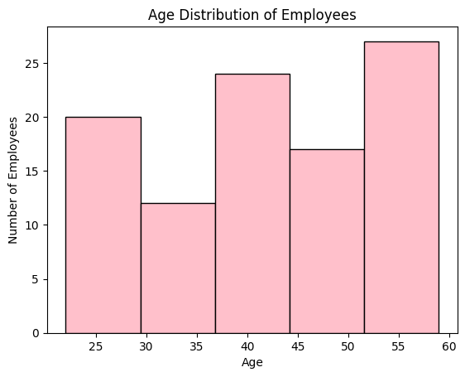
Figure 1.6: Age distribution of employees

Experiment 2: Basic Text Preprocessing
This experiment implements the core preprocessing steps used in Natural Language Processing (NLP) pipelines: text cleaning, tokenization (using three different approaches), and stop-word removal.

2.1 Text Cleaning (Case, Punctuation, Numbers, Whitespace)
Objective: Convert text to lowercase, remove punctuation, remove numbers, and remove extra whitespace, while reporting counts for each type of change.
uppercase_count = sum(1 for c in text if c.isupper())
text_lower = text.lower()
found_puncts = set(c for c in text_lower if c in string.punctuation)
text_no_punct = text_lower.translate(str.maketrans("", "", string.punctuation))
digits_count = sum(1 for c in text_no_punct if c.isdigit())
text_no_nums = "".join(c for c in text_no_punct if not c.isdigit())
extra_spaces = len(text_no_nums) - len(" ".join(text_no_nums.split()))
cleaned_text = " ".join(text_no_nums.split())
Result
Uppercase letters count: 32
Unique punctuation types found: 6 {'.', '+', ')', '!', ',', '('}
Digits count: 13
Extra whitespace count: 12
Cleaned Text (excerpt)
natural language processing nlp is a branch of artificial intelligence it helps
computers understand and process human language in nlp is used in many
applications such as chatbots machine translation sentiment analysis and text
summarization text preprocessing is an important step in nlp...

2.2 Word & Sentence Tokenization
Objective: Perform word and sentence tokenization on a given text using three approaches — plain Python (regex), NLTK, and spaCy — and compare the results.
Approach A — Without NLTK / spaCy (regex-based)
words = re.findall(r"\w+", text)
sentences = [s.strip() for s in re.split(r"[.!?]+", text) if s.strip()]
Words (94 tokens): ['Natural', 'Language', 'Processing', 'NLP', 'is', 'a',
'fascinating', 'field', 'of', 'Artificial', 'Intelligence', 'It', ...]
Sentences (9): ['Natural Language Processing (NLP) is a fascinating field of
Artificial Intelligence', 'It enables computers to understand human
language', ...]
Note: The regex approach strips punctuation entirely and treats "NLP" and its surrounding parentheses as plain word boundaries — it is fast but linguistically naive.
Approach B — Using NLTK
from nltk.tokenize import sent_tokenize, word_tokenize
words = word_tokenize(text)
sentences = sent_tokenize(text)
Words: ['Natural', 'Language', 'Processing', '(', 'NLP', ')', 'is', 'a',
'fascinating', 'field', 'of', 'Artificial', 'Intelligence', '.', ...]
Sentences (9): ['Natural Language Processing (NLP) is a fascinating field of
Artificial Intelligence.', 'It enables computers to understand human
language.', ...]
Note: NLTK preserves punctuation as separate tokens (e.g. '(', ')', '.') and correctly keeps "real-world" as a single hyphenated token.
Approach C — Using spaCy
nlp = spacy.load("en_core_web_sm")
doc = nlp(text)
words = [token.text for token in doc]
sentences = [sent.text.strip() for sent in doc.sents]
Words: ['Natural', 'Language', 'Processing', '(', 'NLP', ')', 'is', 'a',
'fascinating', 'field', 'of', 'Artificial', 'Intelligence', '.', ...]
Sentences (9): matches NLTK's sentence split, but spaCy splits "real-world"
into 'real', '-', 'world' as three separate tokens.
Comparison
Method | Punctuation kept as tokens? | Hyphenated words | Speed / Setup
Regex (no library) | No — stripped | Merged (e.g. 'real', 'world' split by \w+) | Fastest, no dependencies
NLTK | Yes | Kept as one token ('real-world') | Fast, needs punkt data
spaCy | Yes | Split into 3 tokens ('real','-','world') | Slower, needs language model

2.3 Stop-word Removal
Objective: Tokenize text and remove commonly occurring stop words (e.g. is, the, a, an, in, of, and, to), displaying original tokens, the detected stop words, and the filtered tokens.
tokens = word_tokenize(text)
stop_words = set(stopwords.words("english"))
removed_stopwords = [w for w in tokens if w.lower() in stop_words]
filtered_tokens = [w for w in tokens if w.lower() not in stop_words]
Detected Stop Words
{'of', 'for', 'the', 'A', 'by', 'some', 'can', 'a', 'are', 'with', 'these',
'is', 'such', 'as', 'to', 'that', 'on', 'this', 'The', 'It', 'an', 'from',
'it', 'in', 'and'} (25 unique stop words)
Filtered Tokens (excerpt)
['Natural', 'Language', 'Processing', 'important', 'field', 'Artificial',
'Intelligence', '.', 'used', 'many', 'applications', 'chatbots', ',',
'machine', 'translation', ',', 'sentiment', 'analysis', ',', 'text',
'summarization', '.', 'main', 'purpose', 'NLP', 'enable', 'computers',
'understand', 'process', 'human', 'language', '.', ...]
Observation: Removing stop words shortens the token stream considerably while preserving the content-bearing words (nouns, verbs, domain terms), which is the goal of this step before downstream tasks such as keyword extraction or classification.

Summary & Conclusion
Experiment 1 demonstrated exploratory data analysis and visualization on tabular (employee) data using pandas and matplotlib: computing group-wise aggregates (mean, max), ranking records, filtering by threshold, and presenting results through bar charts, a pie chart, a histogram, and a scatter plot. Marketing recorded the highest maximum salary (119,000), while Sales employees have the highest average tenure.
Experiment 2 covered the foundational steps of an NLP preprocessing pipeline: text cleaning (case normalization, punctuation/number/whitespace removal), tokenization compared across three implementations (regex, NLTK, spaCy), and stop-word removal. The comparison showed that library-based tokenizers (NLTK, spaCy) handle punctuation and hyphenation more faithfully than a naive regex approach, which matters for any downstream NLP task.
Together, the two experiments cover complementary skills: structured data analysis/visualization and unstructured text preprocessing, both of which are common early steps in a data science or NLP workflow.

