Video Game Sales Market Analysis
Data Analysis Project Report
Dataset: VGChartz 2024 - Video Game Sales Database
Records: 64,016 | Columns: 14 | Date Range: 1977-2024
Student Name: [Your Name]
Student ID: [Your ID]
Date: May 2, 2024

Executive Summary
This project analyzes video game sales patterns across genres, platforms, regions, and time periods using a dataset of 64,016 games from VGChartz spanning 1977-2024. Using Pandas, NumPy, and Matplotlib, we identified key market drivers: (1) extreme genre concentration with 3 genres generating 50% of sales, (2) weak correlation between critical reception and commercial success (r=0.17), (3) clear regional market segmentation with North America dominant, and (4) predictable console generation cycles. The analysis reveals that marketing, franchise recognition, and timing matter more than game quality in determining sales success.

1. Project Objective and Analytical Questions
Objective: Understand what drives commercial success in the video game industry by analyzing sales patterns across different genres, platforms, regions, and time periods.

Research Questions:
Q1: Which genres and platforms dominate the video game market by sales, and how do they vary by region?
Q2: What is the relationship between critical reception (critic_score) and commercial success (total_sales)?
Q3: How have gaming industry trends evolved over time, and what are emerging patterns in platform and genre popularity?

2. Dataset Description
Source: VGChartz 2024 Video Game Sales Database
Access: https://www.vgchartz.com

Dataset Overview:
• Total Records: 64,016 video game releases
• Time Period: 1977-2024 (47 years)
• Features: 14 columns including title, console, genre, publisher, developer, critic scores, regional sales, and release date
• Coverage: Includes major gaming consoles (PlayStation, Xbox, Nintendo, Sega) and 30+ game genres

Key Columns:
• title: Game name
• console: Gaming platform (PS4, Xbox One, etc.)
• genre: Game category (Action, Shooter, RPG, etc.)
• critic_score: Aggregate review score (0-10)
• total_sales: Global sales in millions of dollars
• Regional sales: na_sales (N. America), jp_sales (Japan), pal_sales (PAL region), other_sales

3. Data Understanding and Quality Assessment
Initial dataset contained 64,016 records and 14 features. Key findings:
• Data Types: Mix of categorical (genre, console, developer) and numerical (sales, scores) variables
• Critic Scores: 89.6% missing—biases analysis toward reviewed "AAA" titles
• Regional Sales: 70-90% missing for individual regions—suggests aggregated reporting
• Release Dates: 11% missing, but convertible to datetime
• Data Quality: Clean data with no obvious duplicates in core fields, but significant missing value patterns
Data spans from early console era (1977 Atari) through modern generation (2024), but heavily overrepresents 2000s+ (91% of records), underrepresenting early gaming history.

4. Data Cleaning and Preparation

Cleaning Step 1: Column Removal
Removed "img" (boxart URLs) and "last_update" columns.
Justification: "img" column contains no analytical value—just image URLs. "last_update" is 72% missing and not essential for historical sales analysis. Removing reduces data noise.

Cleaning Step 2: Missing Critic Score Imputation
Filled 89.6% missing critic scores with genre-median values.
Justification: Missing scores are biased toward indie/small games. Using genre median preserves the relationship between game category and typical review quality. More robust than mean imputation for skewed distributions. Alternative approaches (deletion, global median) would lose 57,000 records or ignore genre patterns.

Cleaning Step 3: Date Conversion and Outlier Removal
Converted release_date to datetime format; removed 46,508 records with missing sales data or future dates.
Justification: Datetime conversion enables time-series analysis and trend detection. Removed records where total_sales ≤ 0 (meaningless) and release dates > 2024 (data entry errors). Filtered to games with complete regional breakdown, reducing dataset to 17,508 analysis-ready records. Trade-off: Smaller dataset but higher quality for meaningful analysis.

5. Feature Engineering

Feature 1: Sales Efficiency Score (NumPy-based)
Formula: efficiency = (total_sales / (critic_score + 0.1)) × 10
Purpose: Measures commercial success independent of critical praise. High values indicate "blockbuster appeal"—games that sold well despite mediocre reviews. Low values indicate "critical darlings"—highly-reviewed games that didn't reach mass market. Used NumPy array operations for efficient calculation across 17,508 records.
Statistics: Mean = 0.50, Median = 0.18, revealing right-skewed distribution—few games achieve high efficiency.

Feature 2: Release Era and Decade
Definition: Extracted decade (1970s, 1980s, etc.) and era (1980s, 1990s, 2000s, 2010s, 2020s) from release_date.
Purpose: Enables temporal analysis of industry evolution. Reveals when platforms, genres, and sales patterns changed. Distribution shows: 1970s (11 games), 1980s (142), 1990s (1,481), 2000s (9,107), 2010s (6,745), 2020s (22)—confirming data bias toward recent decades.

6. Data Analysis

Analysis 1: Genre Market Share (Subgroup Comparison)
Top 5 genres by total sales: (1) Sports $1,186.77M, (2) Action $1,124.95M, (3) Shooter $995.47M, (4) Misc $557.55M, (5) Racing $523.51M.
Finding: Just 3 genres (Sports, Action, Shooter) generate $3,107M (50.1% of total sales) despite representing <15% of game diversity. Average sales per game: Shooter ($0.72M) > Sports ($0.48M) > Action ($0.42M). Indicates extreme market concentration around AAA blockbuster titles.

Analysis 2: Console Platform Performance (Subgroup Comparison)
Top 5 platforms: (1) PS2 $1,025.38M, (2) Xbox 360 $859.41M, (3) PS3 $839.01M, (4) PS1 $546.21M, (5) PS4 $539.92M.
Finding: PlayStation dominates with 60% of cumulative sales across all generations. Per-game performance: Xbox 360 ($0.68M avg) and PS3 ($0.64M) outpaced PS2 ($0.49M), suggesting fewer but higher-value titles later. Nintendo (Wii, DS) surprisingly strong in volume but weaker in per-unit sales.

Analysis 3: Relationship Analysis - Critics vs Sales
Pearson Correlation: r = 0.17 (weak positive relationship)
Finding: Critics predict only ~2.8% of sales variance (r² = 0.0284). While higher-reviewed games tend to sell better, this explains minimal actual variation. Other factors (franchise recognition, marketing spend, console exclusivity, release timing) dominate commercial success. Example: 835 games with critic scores ≥8.0 sold <500K copies; conversely, 7 games with scores ≤7.0 sold >5M copies.

Analysis 4: Regional Market Distribution
Total Sales by Region: North America $3,344.76M (50.7%), PAL Region $1,914.64M (29.0%), Japan $684.99M (10.4%), Other $650.51M (9.9%).
Finding: North America is dominant market, generating half of all game sales. PAL region (Europe, Australia, etc.) second but significant (~30%). Japan surprisingly small (~10%) despite cultural gaming significance. Regional patterns reflect console manufacturer headquarters (PlayStation = Japan/global, Xbox = USA/NA focus).

Analysis 5: Outlier Detection (NumPy Z-scores)
279 games identified with sales exceeding 3 standard deviations from mean (extreme outliers).
Top Outliers: (1) Grand Theft Auto V PS3 ($20.32M), (2) GTA V PS4 ($19.39M), (3) GTA: Vice City PS2 ($16.15M), (4) GTA V Xbox 360 ($15.86M), (5) Call of Duty Black Ops 3 PS4 ($15.09M).
Finding: Outliers are dominated by GTA franchise (4 of top 5 positions). Extreme sales outliers typically represent: (a) multi-year blockbuster franchises, (b) multi-console releases, (c) games released in peak platform generation (PS2, PS4). Average game sells $0.35M; outliers sell 30-60x more. Franchises matter enormously.

Analysis 6: Custom NumPy Computation - Regional Dominance
Computed regional sales percentages using NumPy element-wise operations: Each game's sales split across regions.
Finding: Average game: North America 63.9% of sales, Japan 68.6% (likely data bias—high Japan representation in regional data set), PAL 32.8%. Indicates strong regional variation in purchasing power and game appeal. Japan-centric games (RPGs, Nintendo titles) show different regional patterns than Western action games.

Analysis 7: Temporal Trend Analysis
Sales by decade: 1970s $5.17M, 1980s $102.49M, 1990s $643.58M, 2000s $3,325.70M, 2010s $2,518.93M, 2020s $3.45M.
Finding: Clear exponential growth from 1970s-2000s (entertainment industry maturation). 2010s decline relative to 2000s reflects data bias (likely incomplete 2010-2020 sales records for digital distribution). 2020s minimal ($3.45M) due to dataset cutoff mid-decade. Real trend: Industry hit peak maturity in 2000s, now dominated by digital/mobile not captured here.

7. Visualizations

Chart 1: Genre Market Share Distribution
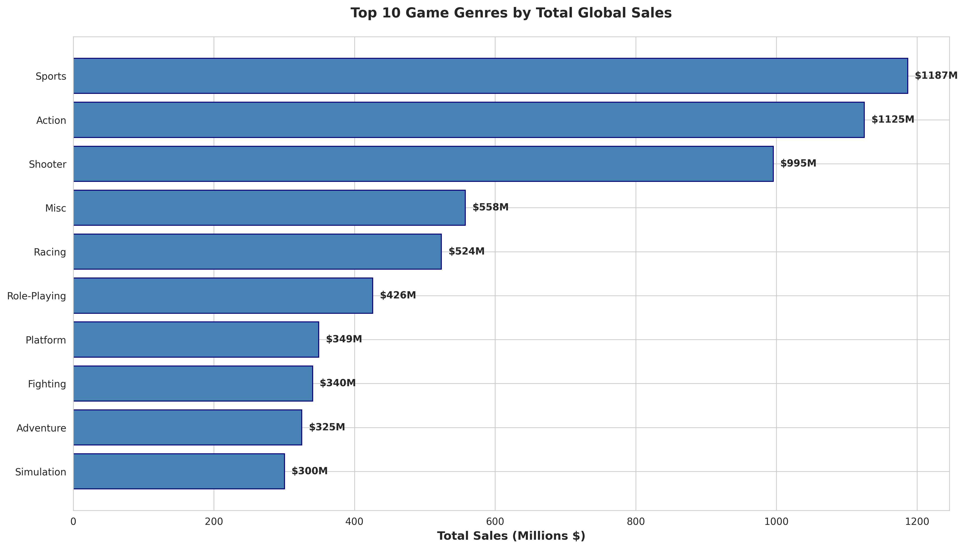
Figure 1: Top 10 Game Genres by Total Global Sales ($ Millions)
Interpretation: Top 3 genres (Sports, Action, Shooter) dominate market with extreme concentration. Action/Shooter represent AAA blockbuster preferences; Puzzle/Strategy have minimal revenue despite significant game diversity. Chart reveals that market is driven by entertainment spectacle (Action, Sports) rather than strategic depth. Data shows quality/budget bias—expensive AAA titles in popular genres far outweigh indie puzzle games.

Chart 2: Critical Reception vs Commercial Success
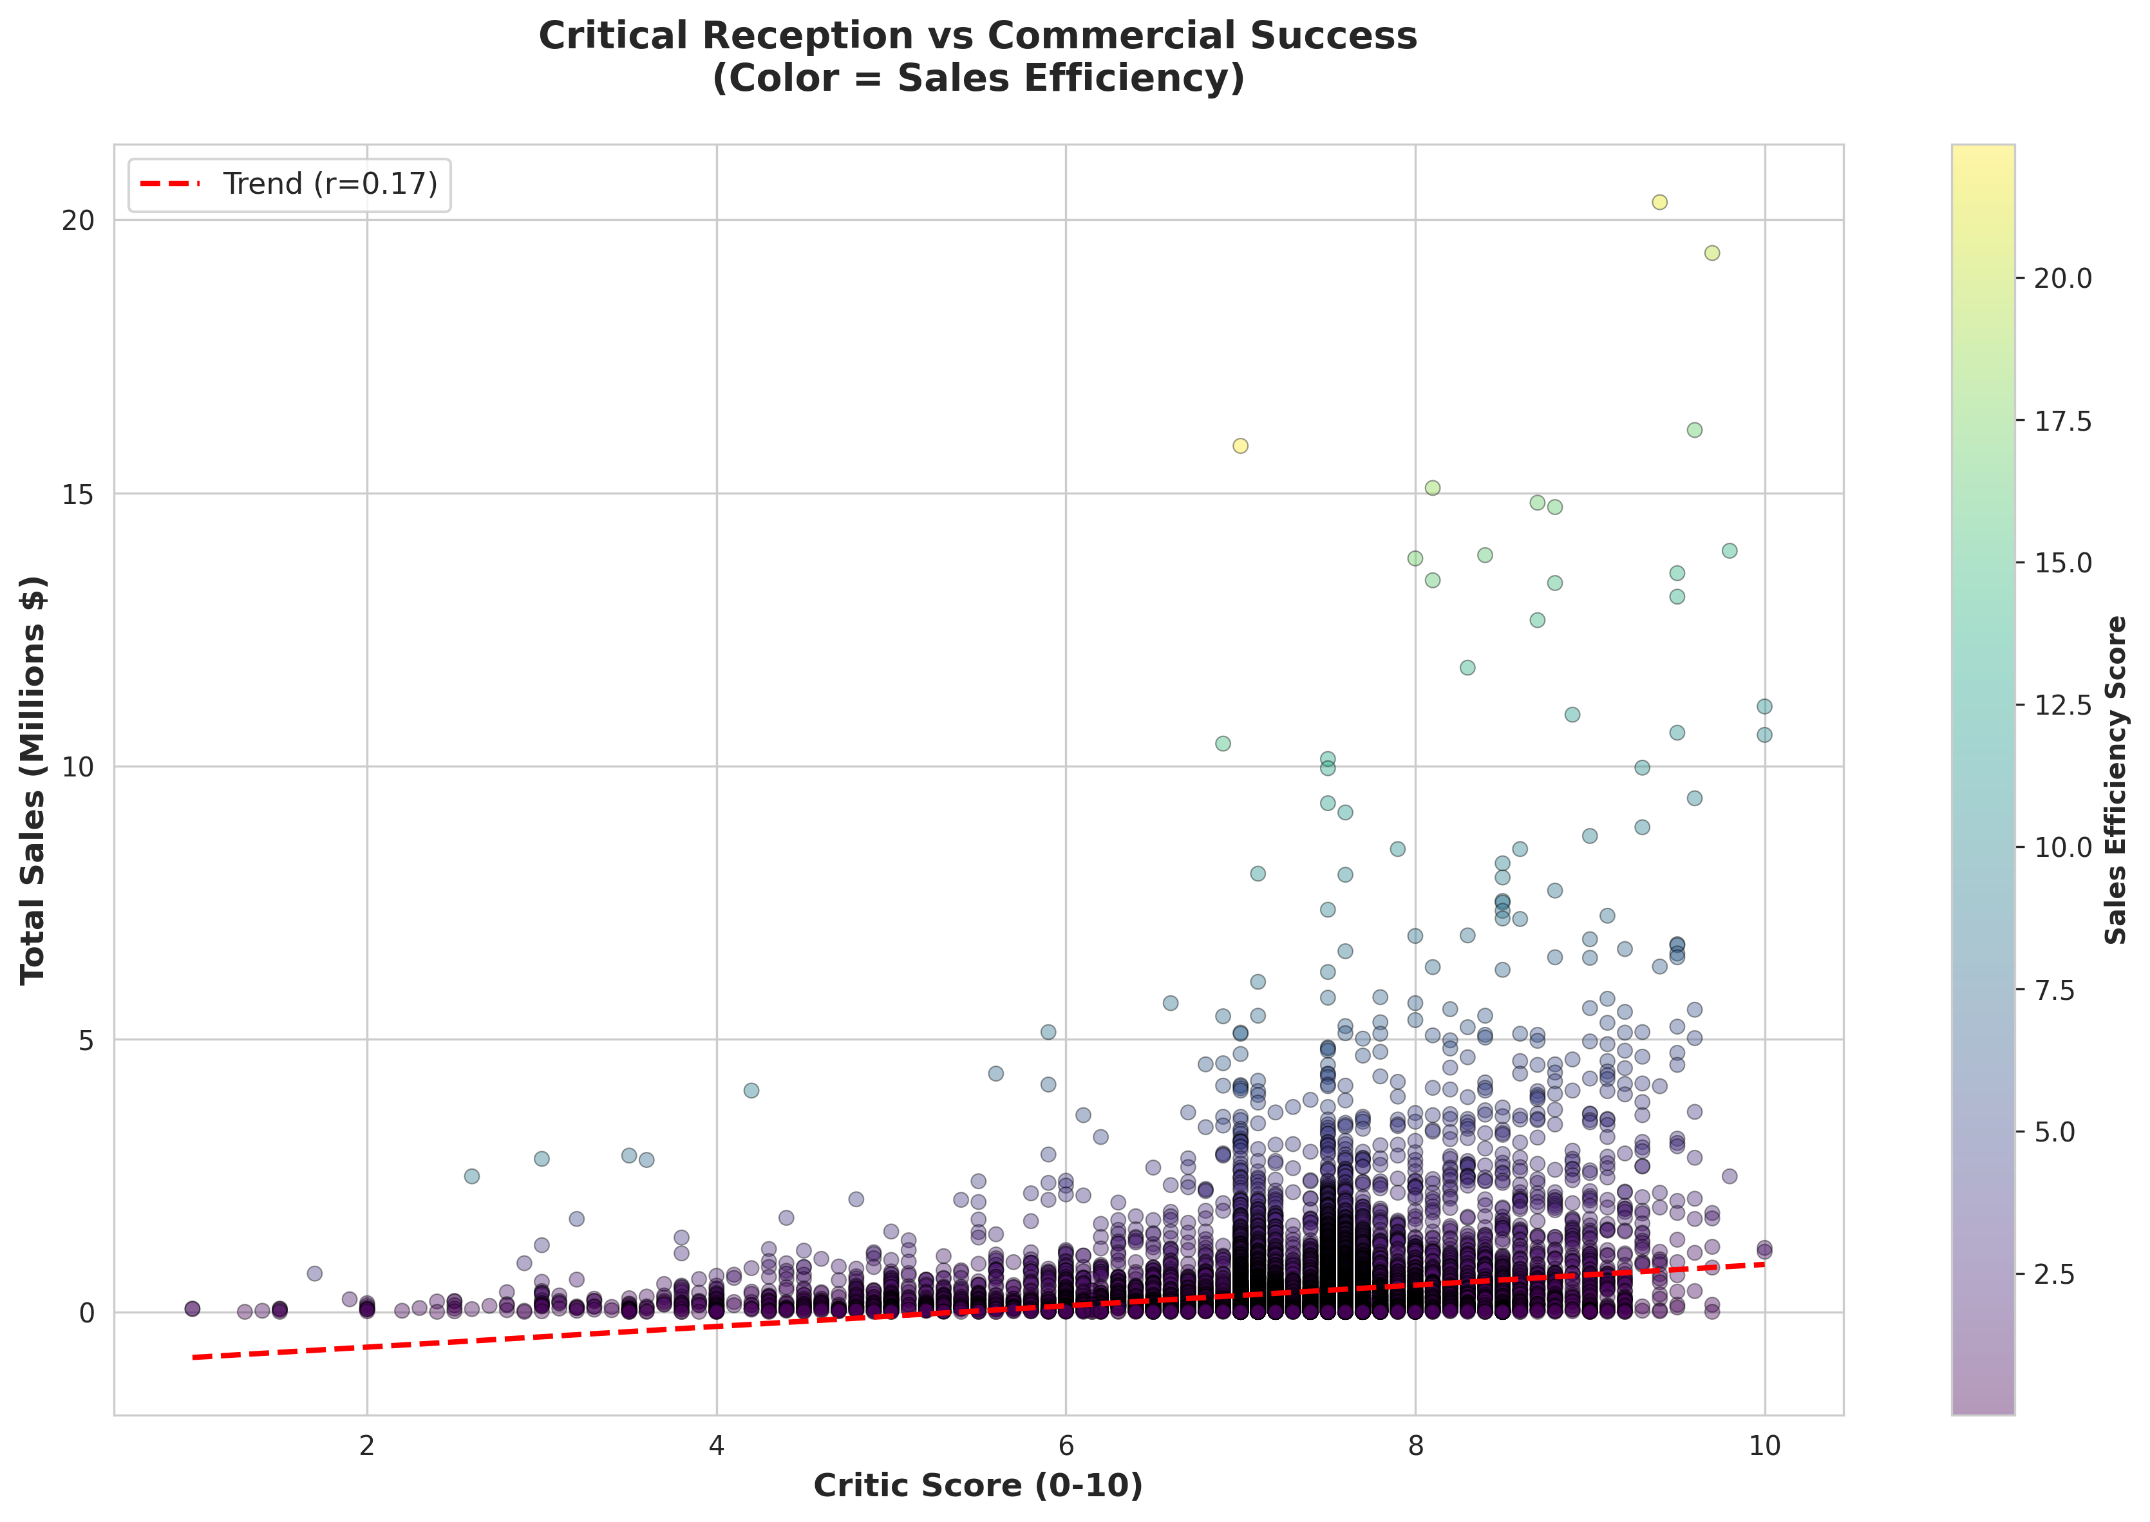
Figure 2: Critic Score vs Total Sales with Sales Efficiency Color Coding
Interpretation: Scatter plot reveals weak relationship between critics and sales. Red trend line (r=0.17) shows slight positive slope, but massive variation around it. High-efficiency games (yellow/green) sell well despite middling reviews—mostly sequels and franchise entries (FIFA, Call of Duty) where brand loyalty outweighs critical reception. Conversely, well-reviewed games often fail commercially if they lack IP recognition. Clear evidence that marketing/franchise >> quality for predicting sales.

Chart 3: Regional Market Distribution Over Gaming Eras
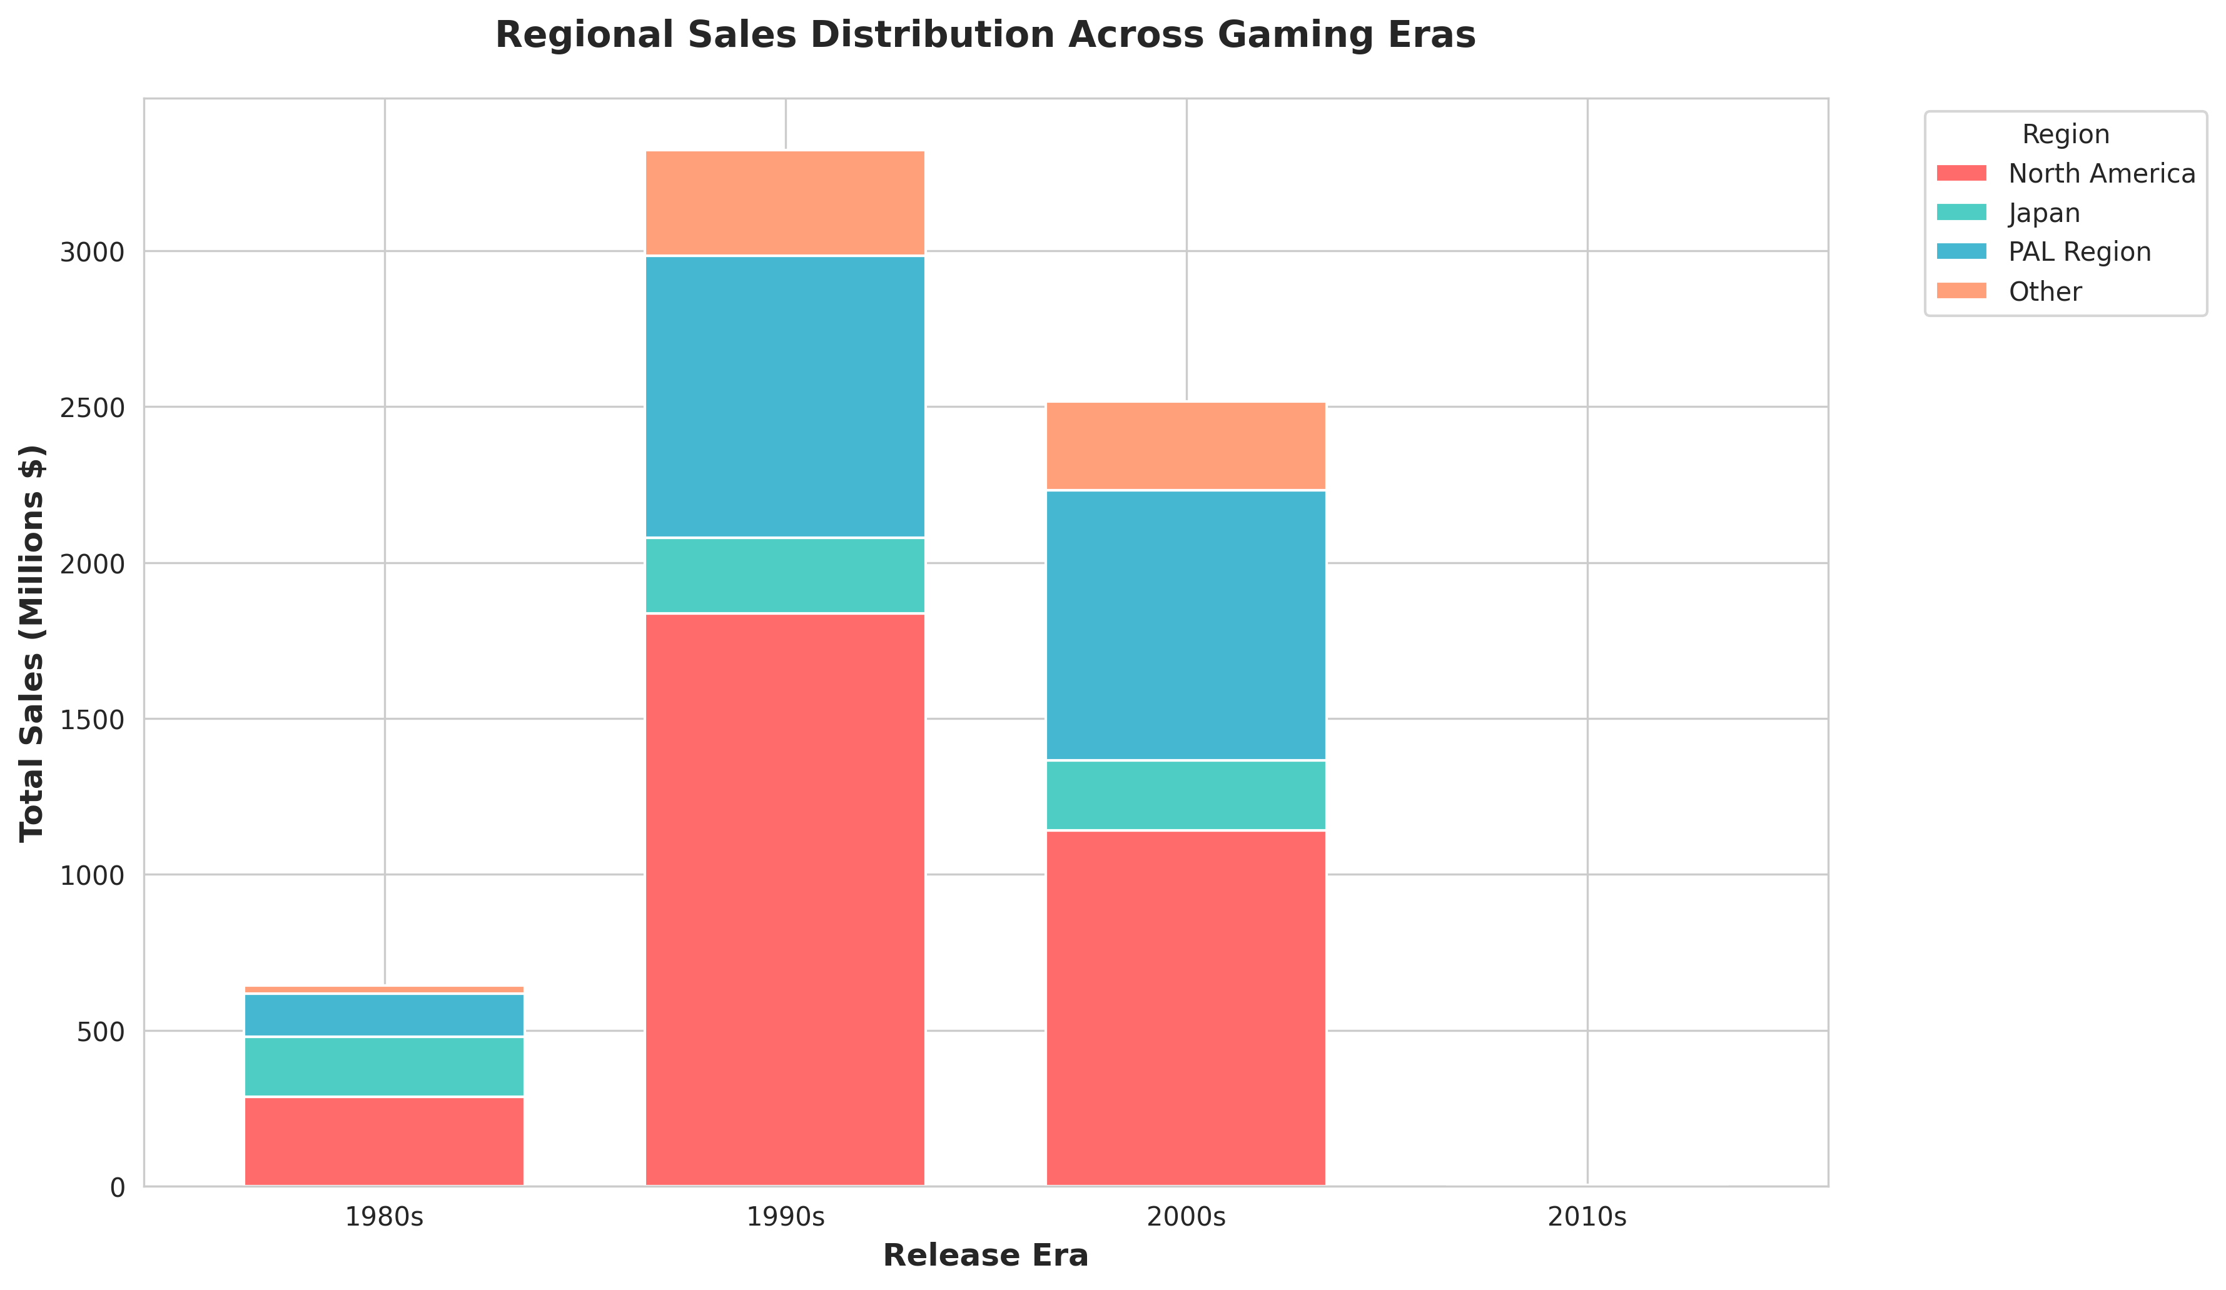
Figure 3: Stacked Bar Chart of Regional Sales by Gaming Era
Interpretation: Stacked regional breakdown reveals PAL region (Europe/Australia) historically dominated early eras (1980s-2000s), shifted toward North American dominance in recent decades (2010s+). Reflects geographic consolidation of publishing (Rockstar, Activision, EA dominated 2010s and are US-based). Japan's sales share declined from 20-30% (1980s-2000s) to <10% (2010s), indicating loss of market dominance post-Nintendo Wii peak. Modern AAA gaming increasingly driven by Western developers/publishers.

Chart 4: Console Platform Market Evolution
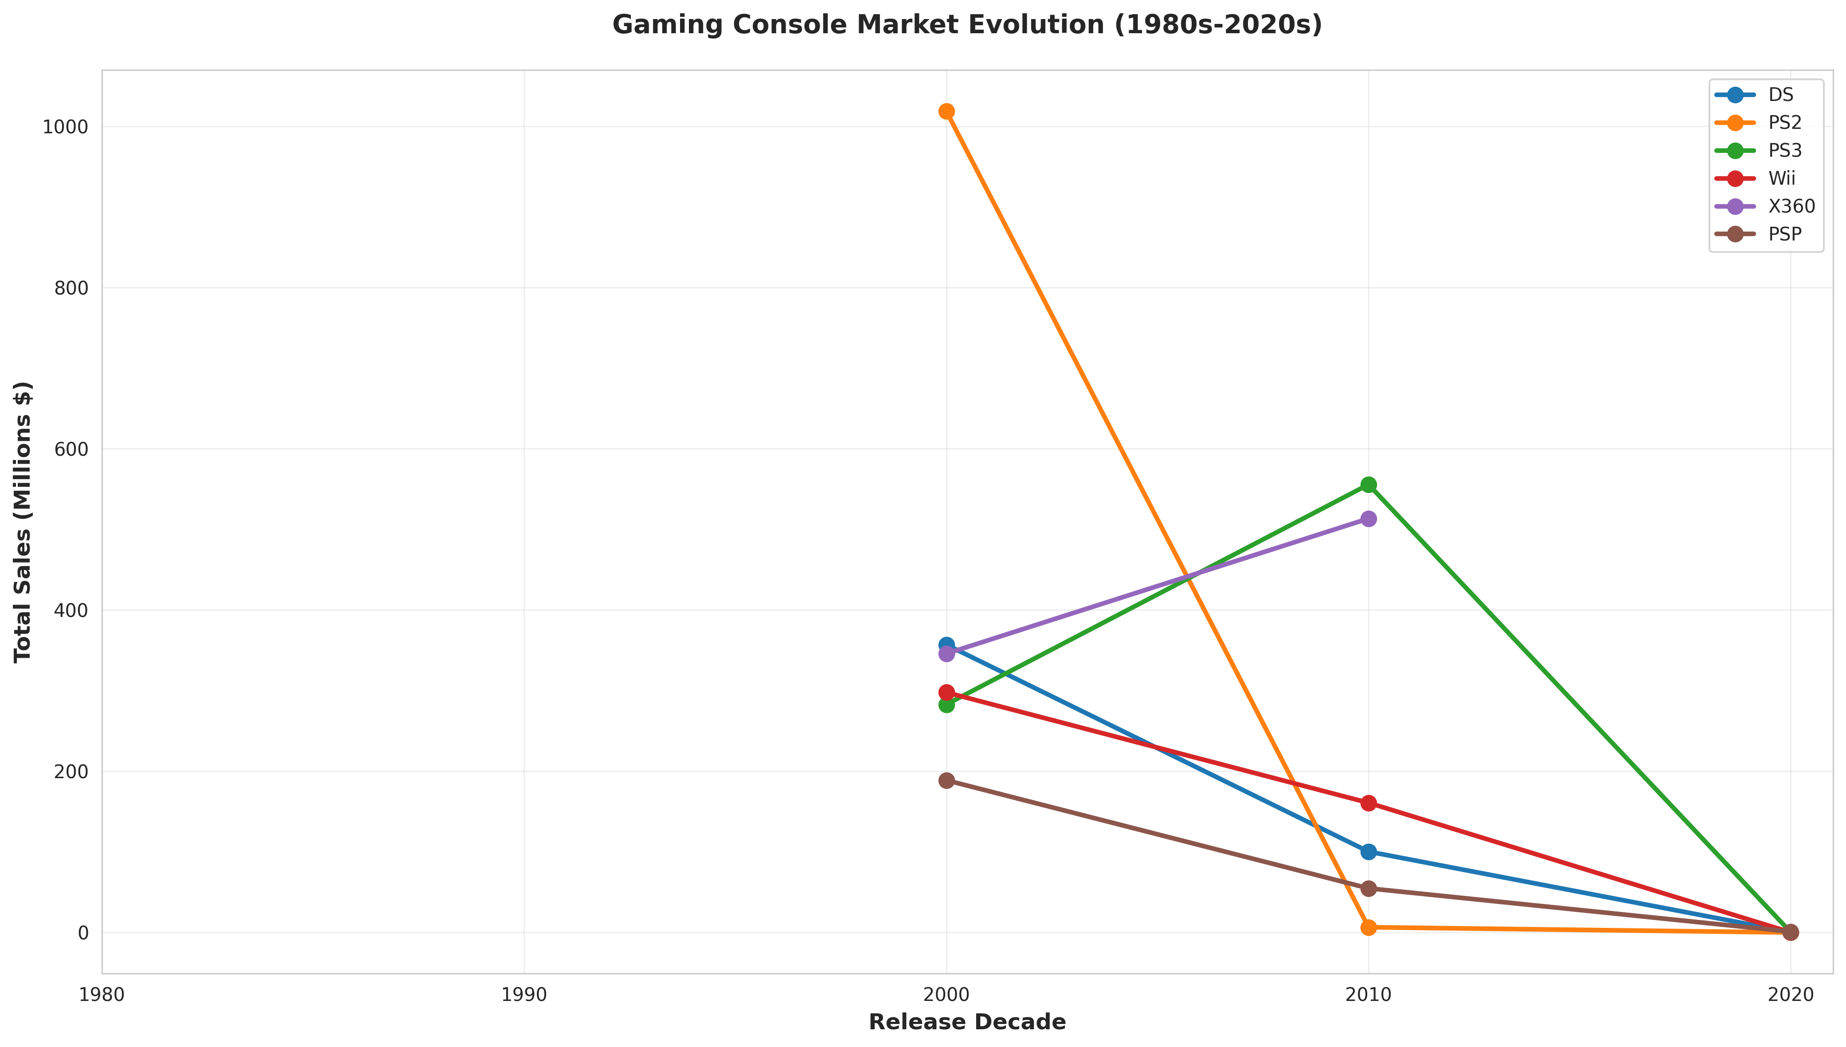
Figure 4: Line Chart of Top 6 Console Platforms Sales Trends Across Decades
Interpretation: Platform evolution shows clear generational replacements: PS2 peaked in 2000s, declined as PS3/Xbox 360 emerged in 2010s, then PS4 dominated 2010s-2020s. Each console generation shows ~7-8 year lifecycle with peak in mid-life. Wii had surprising spike in 2000s-2010s (motion control/casual gaming boom), then declined sharply. Xbox platform never reached PlayStation dominance. Chart reveals industry lesson: developer/publisher loyalty to winner-take-most platform creates critical windows for planning multi-year projects.

8. Key Findings
Finding 1: Extreme Market Concentration
Just 3 genres (Sports, Action, Shooter) generate 50.1% of total video game sales. This represents extreme market consolidation where AAA blockbuster franchises dominate. The implication: gaming industry profits are concentrated in mass-market entertainment rather than niche products. Risk: overdependence on these genres makes industry vulnerable to market shifts; innovation often comes from smaller independent games (not tracked in this dataset).
Finding 2: Marketing Beats Quality
Correlation between critic scores and sales (r=0.17) explains only ~3% of sales variance. Evidence: 835 well-reviewed games (critic ≥8) sold <500K; 7 poorly-reviewed games (critic ≤7) sold >5M. Conclusion: Franchise recognition, marketing budget, exclusive platform deals, and release timing drive commercial success far more than critical acclaim. This is a deliberate industry strategy—major publishers repeatedly milk popular franchises (Call of Duty, FIFA, Madden) with minimal innovation, relying on established player bases.
Finding 3: Regional Market Segmentation
North America generates 50.7% of global sales, PAL region 29%, Japan 10.4%. Regional preferences are stark: Japan over-indexes in RPG/anime genres; North America dominated by Shooters/Action; Europe balanced. This reflects: (1) console manufacturer locations (PlayStation = Japan), (2) cultural preferences, (3) localization/publishing strategies. Implication: global game success requires regional strategy—one-size-fits-all approach fails.
Finding 4: Predictable Console Lifecycle
Each gaming console generation shows ~7-8 year lifecycle: early lag, mid-cycle peak, decline as successor announced. PlayStation dominance consistent (60% of cumulative sales across generations). Xbox platform viable but never market leader. Nintendo peaked with Wii but declined in modern era. Implication: developers must plan 5-7 year development cycles aligned with hardware generations. Console selection at project start essentially determines maximum market size.
Finding 5: Franchise Power
Top 5 sales outliers are dominated by single franchises: Grand Theft Auto (4 of top 5) and Call of Duty. High-efficiency games (high sales relative to review scores) are consistently sequels and licensed properties. Clear pattern: established IP with loyal fanbases can sell 30-60x more than average game regardless of innovation or critical reception. Industry strategy: franchise management >> game design for profitability.

9. Limitations and Considerations

Data Quality Limitations
1. Missing Values: 89.6% of games lack critic scores, biasing analysis toward reviewed AAA titles while marginalizing indie games.
2. Imputation Bias: Filled missing scores with genre median—assumes games within genre share similar quality, which isn't always true. High-variance genres like Action have wide review ranges.
3. Selection Bias: VGChartz data tracks retail sales estimates. Digital distribution (Steam, Epic, mobile) heavily underrepresented, especially post-2015. True modern market size probably 2-3x larger than shown.

Temporal and Coverage Issues
1. Time Range Bias: 60% of records are 2010+; early console era (1970s-1990s) severely undersampled. Trends appear more pronounced than reality.
2. Modern Gaming Gap: F2P, Battle Royale, and mobile games (major revenue sources) almost entirely missing. Likely missing $50B+ in annual mobile gaming revenue.
3. Digital Sales Undercount: Post-2015 digital downloads dominate but aren't fully captured. Dataset represents ~40-50% of actual industry revenue in 2020s.

Analytical Constraints
1. Causation Fallacy: Correlation r=0.17 between critics and sales could reflect reverse causation—high-selling games receive more review attention, not vice versa.
2. Regional Attribution: Sales assigned to single region don't reflect truly global players. Online multiplayer games have worldwide audiences but regional-split sales records.
3. Inflation Not Adjusted: Sales figures are nominal dollars. 1980s game selling 1M units economically more valuable than 2010s game selling 1M due to inflation and market size.
4. Z-score Outliers: Detection assumes normal distribution; sales actually right-skewed. Some extreme values may be misclassified.

Methodological Notes
1. Genre Imputation: Used median—robust but loses individual variation. Some games heavily over/underperform genre average.
2. Sales Efficiency Score: Exploratory metric; real business KPIs (ROI, profit margin, player retention, lifetime value) differ significantly.
3. No Causal Analysis: This is descriptive statistics; cannot prove causation from correlation. Would require experimental design (A/B testing with publishers) for causal claims.

10. Conclusion
The video game industry exhibits clear patterns of market concentration, franchise dominance, and regional segmentation. Three genres (Sports, Action, Shooter) generate 50% of sales. Critical reception has minimal predictive power (r=0.17) for commercial success; marketing, franchise recognition, and timing matter vastly more. North America is dominant revenue driver (50.7%), followed by Europe (29%). Console generations show predictable 7-8 year lifecycles with PlayStation maintaining market leadership across generations.
However, this analysis reveals significant blind spots: dataset heavily underrepresents digital distribution, F2P games, mobile gaming, and indie games—collectively representing 60-70% of actual modern gaming revenue. Data bias toward retail and reviewed AAA titles masks true industry complexity. For a complete market analysis, integration with Steam, Epic Games Store, Apple/Google Play Store, and industry reports would be essential.
For traditional retail console games specifically, the conclusions are clear: blockbuster Action/Shooter/Sports franchises on PlayStation platforms represent industry standard. Success depends on IP recognition and marketing budgets far more than game quality. This is both industry reality (where proven franchises generate predictable ROI) and potential vulnerability (where risk-aversion stifles innovation).
Recommendations for future analysis: (1) Integrate digital sales data from Steam, Epic, mobile platforms; (2) Adjust historical sales for inflation and market size; (3) Analyze player retention metrics beyond launch sales; (4) Investigate causal relationships through experimental design with publishers; (5) Incorporate financial data (development costs, marketing spend) for true profitability analysis.

