HOW TO HOST THE ECG2VCG WEBSITE ON CPANEL
- Log into cPanel and onto the Home page

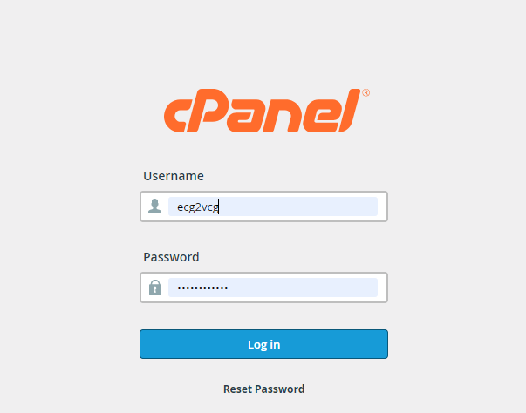
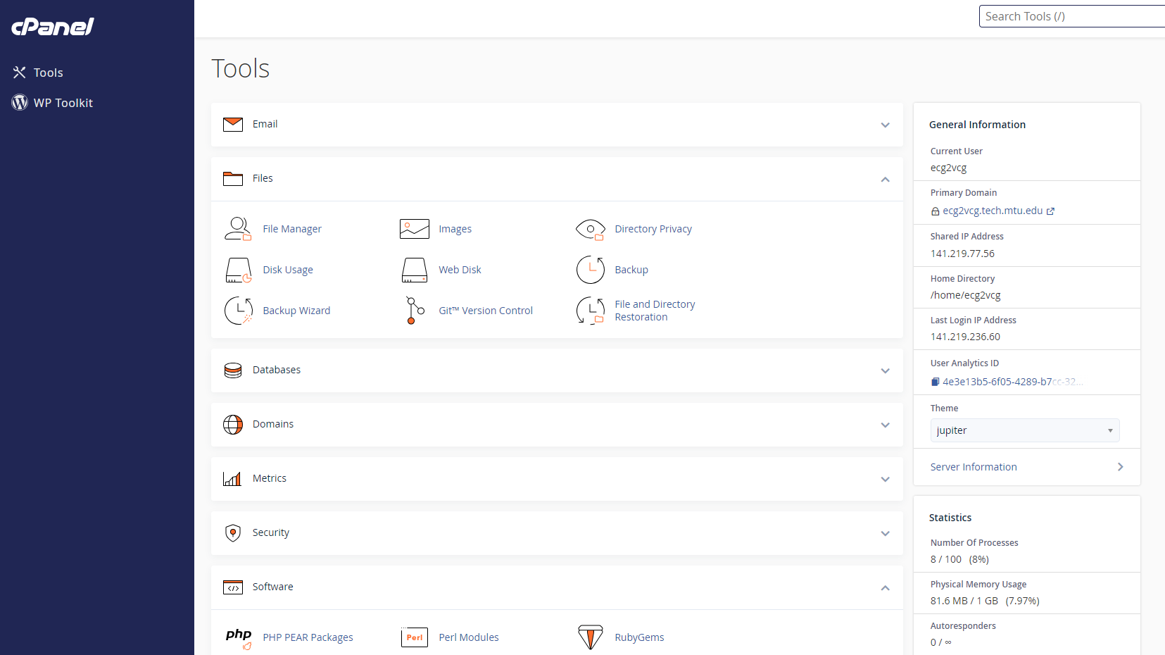

- To upload the ecg2vcg project files, click on “File Manager”. On the file manager page that opens, click on “Upload”.

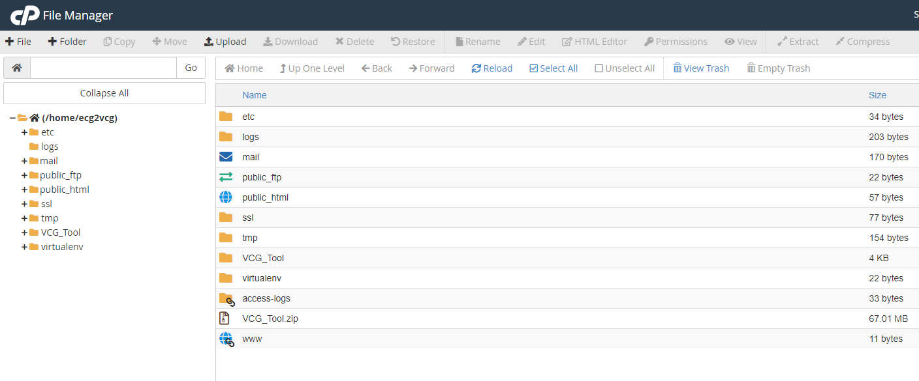
- To extract the zipped project files, right-click on the uploaded zipped file and select “Extract”.

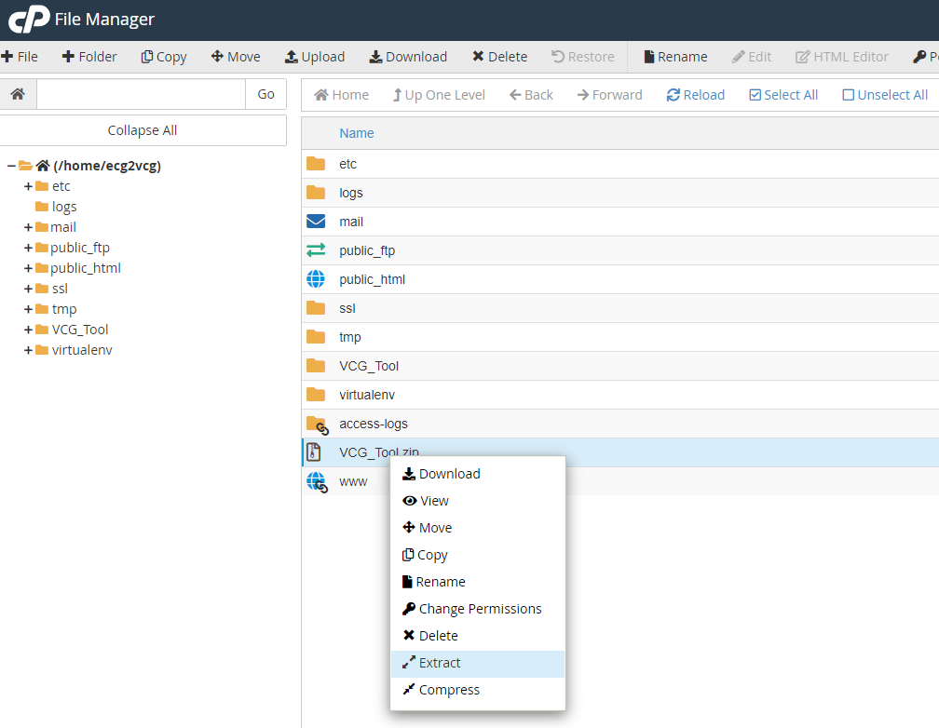

- Navigate back to the Home page. Under the “Software” section, click on “Setup Python App”. On the page that opens, click on “CREATE APPLICATION”.

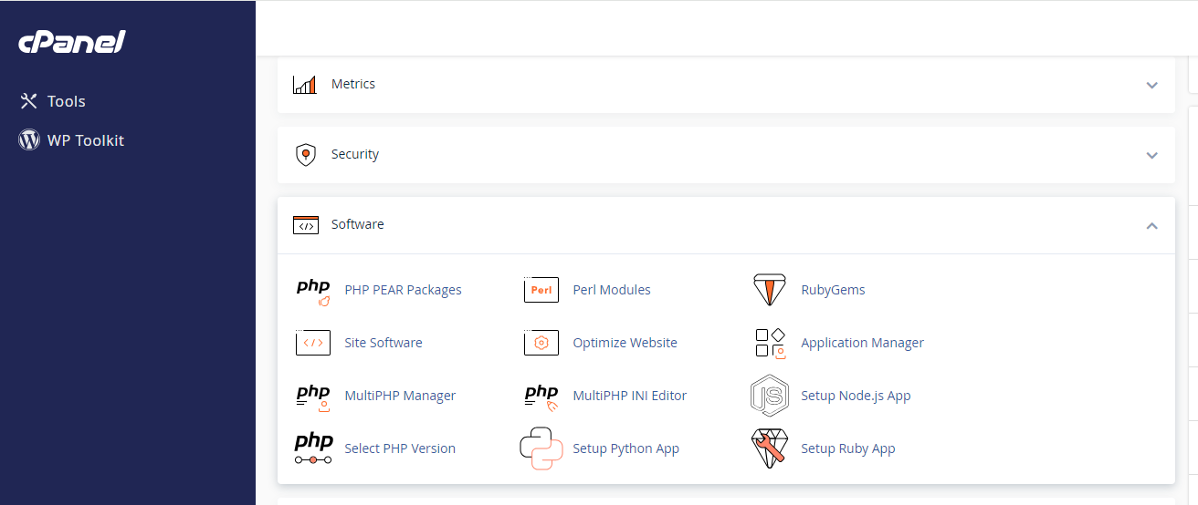

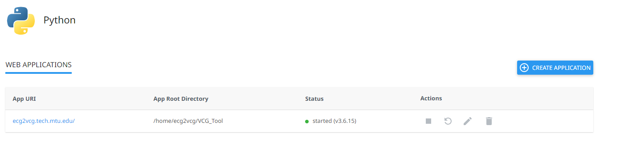
- Select a Python version that suits your application (or the latest version). The “Application root” should be the name of the directory that contains the project files (‘VCG_Tool’ in this case). The “Application URL” is automatically generated. Choose a name for the log file in the “Passenger log file” section. Leave “Application startup file” and “Application Entry point” blank. Then click on “CREATE”.
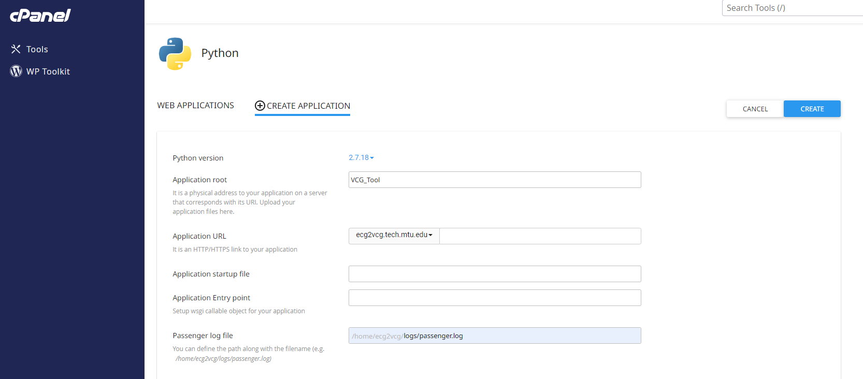
- After creating the application, a command is provided, at the top part of the screen, for creating and activating a virtual environment. Click on this command to copy it.
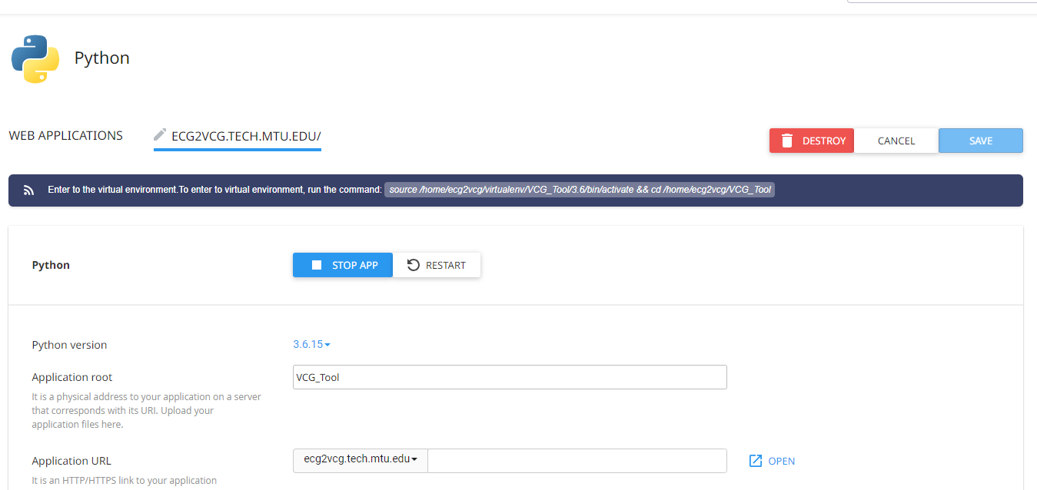

- To open a terminal, go to the Home screen. Under the “Advanced” section, click on “Terminal”. Paste the command from Step 6 in this terminal and hit “Enter”.
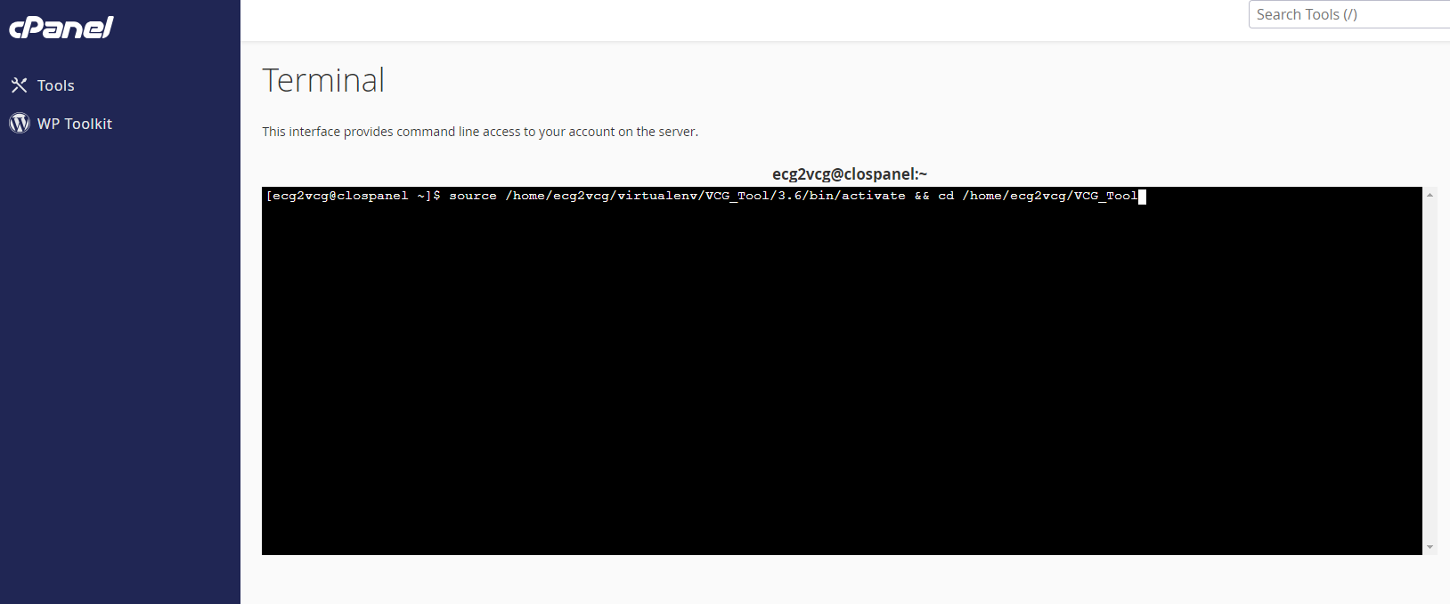
- Then install all the dependencies contained in the “requirements.txt” file. To do this, run the following command: pip install -r requirements.txt.
- Go to the “File Manager”. In the VCG_Tool Directory, locate the “passenger_wsgi.py” file. Right-click on this file and select “Edit”.
- Replace the content of this file with the following code: from djangoProject.wsgi import application.
- Navigate to /home/ecg2vcg/VCG_Tool/djangoProject/. Open the “settings.py” file and make the settings for “ALLOWED_HOSTS” and set up a “STATIC_ROOT” directory. Save and close this file.
- Go back to the terminal and run this command: python manage.py collectstatic.
- Restart your python application and access your website using the assigned URL.

