Results feedback — the arm layer generalises, and two defects it exposed
To: senior
Date: 5 November 2026
Project: Motion Studio (intent → draft → observation → measured edit → preview)
Scope: results since the geometric arm-raise note of 2 November. No new model
was introduced; this round asks whether the geometric layer holds up on actions
other than walking, and what it breaks when it does.

1. Short version
The arm raise was built and verified on walking clips. That risked being a
one-clip trick, so this round moved it onto ten other carriers (turn, bow, sit,
wave, run, walk-back, and the new kick / jump / punch / pick-up / stand-up
clips) and mixed it with tempo and dataset-join edits.
The result is that the operator holds: on every carrier the frame count is
preserved and the measured arm_raise_ratio is exactly the requested height
(1.8 for high, 2.6 for overhead) regardless of what the body underneath is
doing, and the 33-case battery shows on five carriers that only the requested
elbow and wrist move. An arm revise costs 9–12 s in every case, against ~12 min
for the MLD rebuild it replaced.
Two real defects surfaced, both in the planner, not the geometry:
- a turn clip's own rotation was being deleted by an inherited yaw_spin forbid;
- an arm-raise plan could omit the geometric module, so the arm silently did
not move while the plan looked valid and the score stayed high.
Both are fixed and covered by the battery below.
battery | cases | passed | time per case
cross-action (8 generate + 10 arm revise) | 18 | 18 | 3.4–3.6 s / 8.7–11.8 s
mixed action battery (generate, arm, tempo, dataset join) | 11 | 11 | 3.2–12.8 s
arm-raise regression (parser / geometry / end to end) | 33 | 33 | —
page replay, one session, no refresh | 5 | 5 | 5–25 s

Artifacts: outputs/tests/more_actions_20261105/,
outputs/tests/actions_20261105/ (each case has a before/after GIF, a
single-view GIF and an analysis card), replay log in
outputs/session/prompt_logs/20261105-multi-action/log.json.

2. New actions generated
Each prompt went through the same session entry point the page calls. The
generate path is still the four stages (draft → observe → edit only a named
fault → preview); nothing here calls diffusion or MLD.
prompt | source | T | score | M2T caption after | time
a person kicks with their right leg | 000017 | 62 | 100 | a person kick something with their right foot | 3.5 s
a person punches with their right hand | 006257 | 41 | 100 | a person throw something with their right hand | 3.5 s
a person jumps up and lands | 011684 | 52 | 100 | a person jump forward once | 3.4 s
a person turns around 180 degrees | M009648 | 100 | 100 | a person walk forward turn to the right and pick up an object with their left hand | 3.5 s
a person stands up from a chair | 000703 | 100 | 100 | a person walk forward and sit on something | 3.5 s
a person picks up an item from the floor | 009969 | 100 | 100 | a person pick up an object with both hand and place it on the ground | 3.6 s
a person raises both hands and waves | 003858 | 100 | 100 | a person raise their arm to their chest multiple time | 3.5 s
a person walks backward | 002396 | 100 | 100 | a person walk forward and kick with their left foot | 3.4 s

The retrieval side is fine — the right caption family is hit every time. The
captioner is the weak link. Three of the eight captions are close enough to use
as feedback (kick, punch, pick-up), two are partly right (jump is described as
one jump, the turn picks up a spurious "pick up an object"), and three are
wrong in a way that matters:
- stand-up → "walk forward and sit on something" (the opposite of the prompt);
- backward walk → "walk forward and kick with their left foot";
- both-hands wave → "raise their arm to their chest multiple time" (right
gesture, wrong height).
That is half the captions unusable for anything that closes the loop. I have
not changed the captioner this round.

3. The arm layer on other carriers
Ten revises of the form "raise … arm …" against the seven carriers plus run and
bow. The interesting column is ratio: it is the requested height and nothing
else, so the geometry is driving it, not the source clip.
carrier | prompt | T before → after | ratio | score | time
kick | raise the right arm high | 62 → 62 | 1.80 | 100 | 8.7 s
punch | raise the right arm high | 41 → 41 | 1.80 | 100 | 9.3 s
jump | raise the right arm high | 52 → 52 | 1.80 | 100 | 11.8 s
turn | raise the right arm high | 100 → 100 | 1.80 | 100 | 9.2 s
stand up | raise the right arm high | 100 → 100 | 1.80 | 100 | 9.1 s
pick up | raise the right arm high | 100 → 100 | 1.80 | 100 | 9.1 s
wave (both) | raise the right arm high | 100 → 100 | 1.80 | 100 | 9.2 s
walk back | raise the right arm high | 100 → 100 | 1.80 | 100 | 10.7 s
run | raise both arms overhead | 84 → 84 | 2.60 | 100 | 10.1 s
bow | raise both arms overhead | 100 → 100 | 2.60 | 100 | 9.0 s

Frame count is untouched in all ten, which is the property that makes the
operator safe to stack: an arm edit cannot eat the descent of a sit or the
landing of a jump. The jump case is the one worth looking at, because the clip
moves vertically while the raise is applied — it still holds, only the ramp is
shortened to 13 frames by the reach clamp.
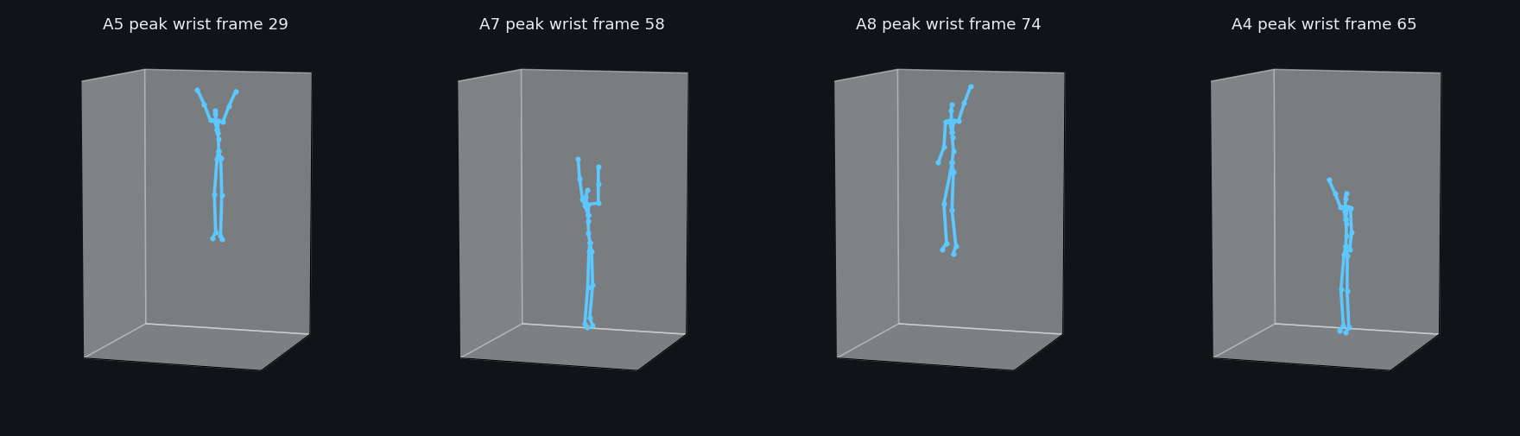
Peak wrist frame for four carriers: bow, wave, walk, turn — the arm reaches the same height on every body
A note on the scores: arm_raise_applied is a hard check, so a 100 here means
the wrist actually rose to the target, not just that the file is finite.

4. Mixed battery, including edits that are not arm raises
Eleven cases: three new actions, five arm raises on new carriers, two tempo
edits, and one real action change.
case | mode | plan | score | T | time
A1 jump | generate | dataset draft | 100 | 52 | 3.2 s
A2 kick | generate | dataset draft | 100 | 62 | 3.2 s
A3 pick up | generate | dataset draft | 100 | 100 | 3.3 s
A4 turn + right arm high | revise | geometric_only | 92 | 120 | 9.3 s
A5 bow + both arms overhead | revise | geometric_only | 100 | 100 | 11.6 s
A6 sit + right arm high | revise | geometric_only | 100 | 152 | 10.0 s
A7 wave + both arms overhead | revise | geometric_only | 92 | 150 | 11.5 s
A8 walk + left arm high | revise | geometric_only | 100 | 100 | 9.3 s
A9 run + slow down | revise | geometric_only | 100 | 105 | 11.1 s
A10 turn + slow down | revise | geometric_only | 92 | 150 | 9.6 s
A11 walk → turn around | revise | dataset join | 100 | 127 | 12.8 s

The three 92s are soft checks, not failures, and both causes are expected:
- A4 / A10 (turn_yaw_large) — the source clip only turns 45.8°, so "want
90° for a full about-face" is honest. What matters is that 45.8° survives
the edit; before the fix in section 5 it was 0.0° and the run failed.
- A7 (wave_one_arm) — "the other arm should stay below 0.75 of the main
one". We asked for both arms, so the check is correct and we are deliberately
violating it.
A11 is the first case in this batch where the body plan itself changes: the
planner split it into turn (attach, dataset) + walk (extend, current) and the
join produced T=127 with yaw 196° and travel 0.76 — a turn, then a walk back,
which is what was asked.
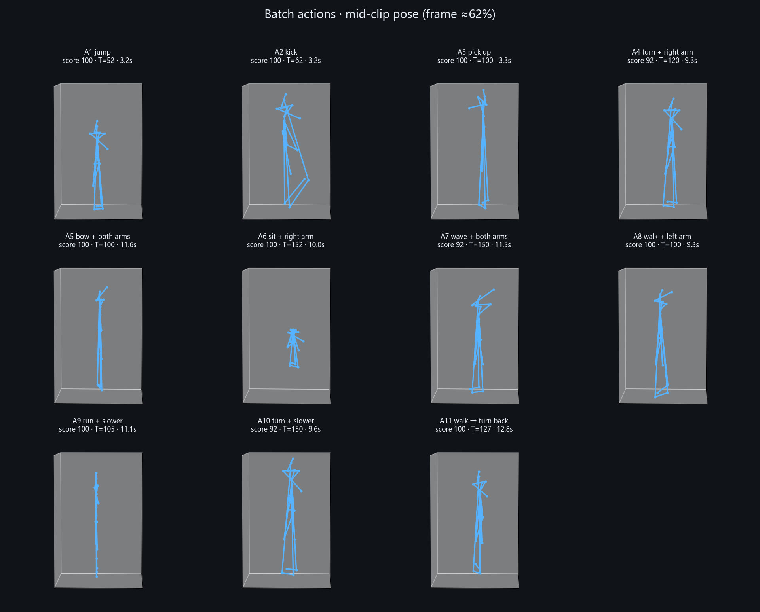
Mid-clip pose for each of the eleven cases, with the score and frame count the gate produced

5. The two defects

5.1 A turn clip's rotation was being deleted
A4 first scored 67 with a hard failure turn_yaw_span: yaw_span=0.0°.
The revise inherited forbid: ["yaw_spin"] from the previous plan. That forbid
is right for a sit or a walk, where a spin is an artefact, but on a turn clip the
yaw is the action, so constraint_postprocess flattened 45.8° → 0.0° and the
gate then failed the clip for not turning. The edit destroyed the thing it was
editing.
Fix in scripts/intent/refine_schema.py: drop yaw_spin from forbid whenever
keep_action starts with turn. A4 and A10 go back to 92 with the rotation
intact.

5.2 An arm-raise plan could omit the geometric module
On carriers with no yaw problem, constraint_postprocess was not added to
modules. The plan then read geometric_only with arm_raise in refine, no
MLD, no diffusion — and nothing that applied the raise. The pipeline looked
successful and the arm did not move. This is exactly the silent-success failure
mode we keep trying to design out.
Fix in scripts/intent/plan_motion_edit.py: if refine.arm_raise is present,
the module is appended unconditionally. The page replay step 5
(raise both arms overhead on the jump clip) is a direct test of that path and
now reports constraint_postprocess handled=['arm_raise'] with a ratio of 1.50
on both sides.
The reason both defects survived the 33-case arm battery is that the battery
always used carriers whose plans already included the geometric module, and it
never edited a turn clip. They were found only by widening the carrier set —
which is the argument for keeping this kind of cross-action battery.

6. Page replay
Five prompts sent from http://127.0.0.1:8787, one at a time, waiting for each
run to finish, no refresh in the middle of a chain:
# | prompt | mode | score | what the agent did
1 | a person turns around 180 degrees | generate | 100 | turn demo clip, T=100, yaw 180°
2 | raise the right arm high | revise | 100 | arm only, T=100, yaw still 180°, ratio 1.8
3 | slow down a bit | revise | 100 | T 100 → 232, speed=['turning'], yaw still 180°
4 | a person jumps up and lands | generate | 100 | dataset draft, T=52
5 | raise both arms overhead | revise | 100 | both sides raised (1.466 / 1.532), T=52

Steps 2 → 3 are the useful pair: a geometric edit followed by a timing edit on
the same clip, with the turn preserved through both. Screenshots of the
reasoning panel and the quality card for each step are in
outputs/tests/actions_20261105/ui/.
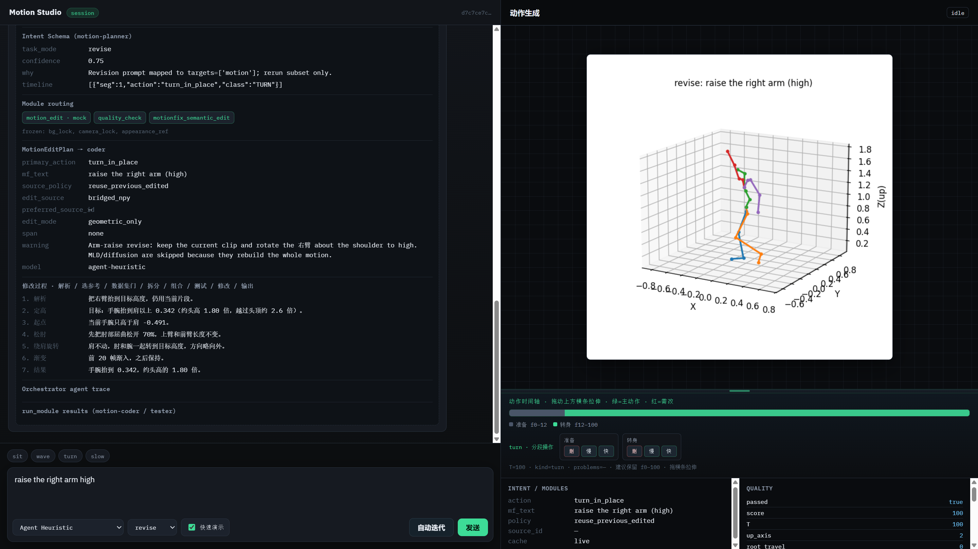
Page replay, step 2: the turn clip after the right arm raises to 1.8, quality card and timeline

7. Open issue: the critique can say "no problems" while the caption is wrong
A11 asked for "turn around and walk back". The clip is correct by measurement
(T=127, yaw 196°, travel 0.76). TM2T described it as "a person walk forward and
wave with their right hand", and the critique line still ended in
Issues: n/a.
The cause is structural: the critique is assembled from the caption plus the
gate's problem list. If the gate is happy, the problem list is empty, so the
critique reads as approval even when the two sentences disagree. Handing that to
the loop controller is worse than handing it nothing, because it argues for
stopping.
Two options, and I would like your call:
- Cheap — always append the rule-based description to the critique when it
disagrees with TM2T on locomotion or arm height (the rule sentence is
reliable on travel, yaw and pelvis drop, and TM2T is reliable on finer
gesture). The disagreement itself becomes the reported problem.
- Proper — score caption agreement as a metric and let the gate fail on
large disagreement. That needs a reference sentence, which for a user prompt
we do not have; it would have to be caption-before vs caption-after, i.e. "the
edit did not change what the motion is", which is a different and possibly
more useful check.
I have not implemented either, because (2) changes what a score means and I did
not want to move it without your agreement.

8. What this does not prove
- Score 100 still means "the hard checks for this action label passed".
Kick, punch, jump and stand-up are not in a label set, so a clip that is
merely moving can score 100. The arm cases are better protected than the
generate cases.
- The captioner is distribution-bound. Three of the eight new-action captions
are wrong in a way that matters (§2). The arm layer avoids this by trusting
arm_raise_ratio over the caption, but that workaround is per-operator and
will not scale to gestures.
- A11 joins two clips; it is not a general action transition. The planner
asked for a dataset turn and an extension of the current walk, and the join
happened to be clean. A harder pair (sit → walk, or turn while carrying the
arm raise) is still a dataset swap or a refusal, not a real compositional
edit.

9. Reproducing
# cross-action battery: 8 generate + 10 arm revise (2 cases per carrier)
python scripts/tests/batch_cross_actions.py
# mixed battery: 11 cases, each with a before/after GIF and an analysis card
python scripts/tests/batch_actions.py --out outputs/tests/actions_20261105
# re-render GIFs and cards from existing runs without re-running the pipeline
python scripts/tests/batch_actions.py --out outputs/tests/actions_20261105 --rerender
# arm-raise regression (parser / geometry / end to end, 33 cases)
python scripts/tests/test_arm_raise.py
Both batteries write results.json and report.md into their output folder and
read every number back from the run's own artifacts, so a rerun either reproduces
the tables in this note or fails visibly.

10. Asks
- Which of the two critique fixes in §7 do you want — the cheap disagreement
line, or the caption-stability check?
- Is half-wrong captioning acceptable for the write-up if it is reported as a
known limit, or should the next step be a better captioner before anything
else?
- For the paper narrative: should the cross-action battery become the
"generalisation" section, with the two planner defects described as the
motivation for the module-presence check? I think that is the stronger story
than presenting 33/33 alone.

