JHU Master of Science in Security Informatics、

入口：

https://applygrad.jhu.edu/apply/?sr=3e5b4d9d-8b0a-4f96-9579-b577c78080f1截止日期：

Fall admission – March 1 by 11:59 PM EST

材料清单

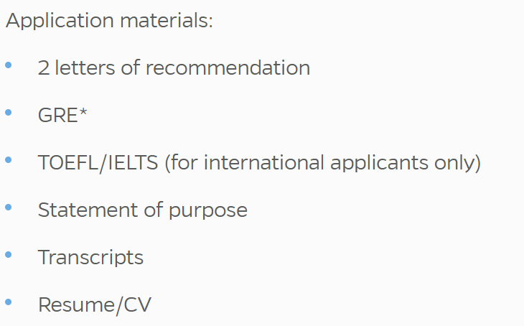

GRE：不要

The Whiting School of Engineering requires GRE General Test scores for applications to all master’s programs. However, the Department of Computer Science does not review the scores nor do they have any impact on the outcome of decisions made during the application review process.

Toefl

Use institution code (C559) to send official TOEFL scores electronically from ETS.

Statement of Purpose

没有具体要求，常规

WUSTL Master of Science in cybersecurity engineering

入口

<https://gradadmit.wustl.edu/apply/?sr=4503835c-76a0-44d8-b086-00f19e2bb810>

截止：March 1

清单

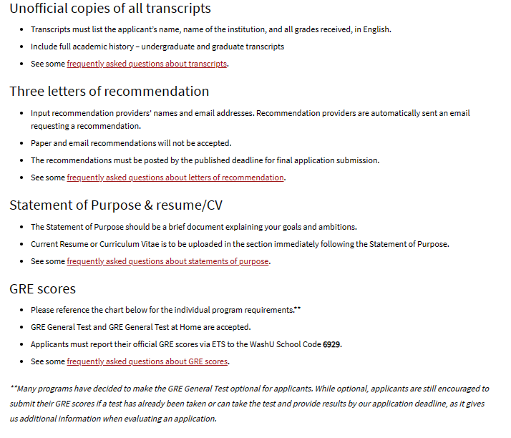

Statement ofPurpose

Statement of Purpose The Statement of Purpose should be a brief document explaining your goals and ambitions.

GRE要求

Applicants must report their official GRE scores via ETS to the WashU School Code 6929.

托福：

Official TOEFL scores should be sent via ETS to the WashU School Code 6929.

usc Master"s in Cyber Security Engineering

入口：

https://usc.liaisoncas.com/applicant-ux/#/login

截止：12.15

清单

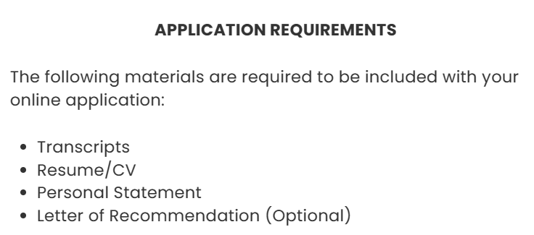

GRE，不要求

Master's & PhD Programs: The GRE is not required for Spring 2024 and Fall 2024 applicants. Scores submitted will not be reviewed.

托福：USC’s institution code is 4852.

个人陈述：没有具体要求，常规写

CMU MSIT-ITM (Information Security Specialisation)

清单

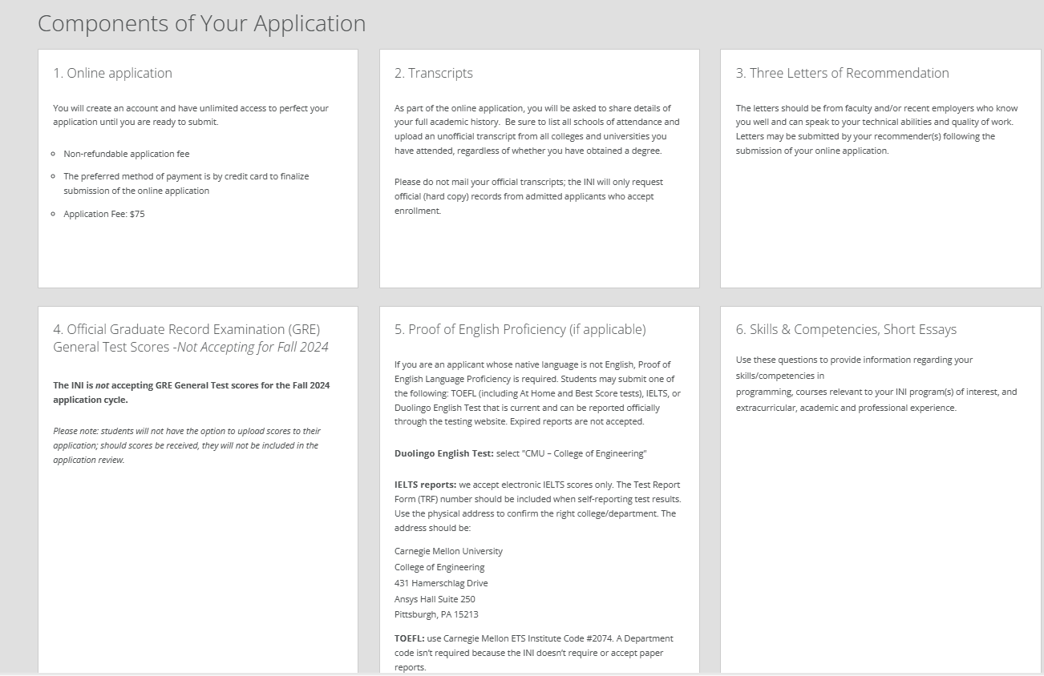

入口：

https://gradadmissions.engineering.cmu.edu/apply/

截止：

Priority Deadline: December 1, 2023

Final Deadline: Jaunuary 15, 2024

GRE，不要

The INI is not accepting GRE General Test scores for the Fall 2024 application cycle.

托福：TOEFL: use Carnegie Mellon ETS Institute Code #2074.

Essays需要开网申进去看具体要求。

Skills & Competencies, Short Essays

Use these questions to provide information regarding your skills/competencies in

programming, courses relevant to your INI program(s) of interest, and extracurricular, academic and professional experience.

VideoESSAY做的时候给你找面经

All applicants are required to submit a 3-minute video response to a random question. This feature allows students to supplement their written essays and permits the admissions committee to “meet” them in a new way. A 60-second preparation time is included before the recording starts. Prepared statements aren’t recommended.

NYU cybersecurity

入口

[https://apply.engineering.nyu.edu/apply/?_gl=1*1gofnot*_ga*MTgxMDk5MDg2OC4xNjU4ODc5MDU2*_ga_2YVHNYZEDV*MTY5NzY4NjMyMC41Mi4xLjE2OTc2ODY1OTAuNDkuMC4w](https://apply.engineering.nyu.edu/apply/?_gl=1*1gofnot*_ga*MTgxMDk5MDg2OC4xNjU4ODc5MDU2*_ga_2YVHNYZEDV*MTY5NzY4NjMyMC41Mi4xLjE2OTc2ODY1OTAuNDkuMC4w)

截止： 12.1/2.15

托福：The NYU Tandon School of Engineering TOEFL institution code is 2668.

Gre: 要求

the GRE test scores must be submitted electronically through ETS (institution code is 2668;

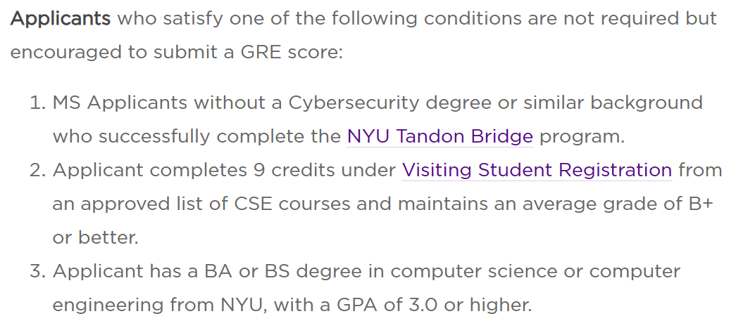

Statement of purpose回答俩问题：

As part of your application, you are expected to provide a response, in written form, to two prompts. A response to both prompts is required. This is an opportunity for you to give us a stronger sense of who you are, as a person. Your essay should be as unique as you are and should be written using your own voice. Include each prompt as the header for each of your two responses. When finished, combine your response to both prompts into one single PDF and upload it to the application. Your total essay upload should be 12 pt, Arial font and no more than two pages, double-spaced, in length.

Prompt 1: Drawing from your previous academic, professional and personal experiences, tell us what attracted you to the program of study you have noted in your application. Be very specific about your past experiences and how they shaped your interests.

Prompt 2: Students often have a wide range of ideas and plans for what they hope to achieve after they receive their graduate degree. Tell us what your 5-year plan is after completing a degree from NYU Tandon.

**ufl Master of Science in Computer Science**

入口

https://www.applyweb.com/uflgrad/index.ftl

截止：

February 1

托福GRE要求

eport your official GRE and TOEFL scores (if applicable) electronically through ETS using school code 5812. A department code is not necessary.

Statement of Purpose

没有额外要求

uci Master of Science in Computer Science

入口

<https://apply.grad.uci.edu/apply/>

截止

All materials as outlined should be submitted before the December 15th deadline.

GRE: Not Required

托福：Please select institution code 4859 to have your official score sent to UCI. No department code is needed.

Statement of purpose

The “statement of purpose” should focus on your academic/research background and interests. The “personal history statement” essay should focus on your personal background and any challenges or obstacles you may have encountered in your academic journey and how you overcame them.

Optional：The “Personal History Statement” essay should focus on your personal background and any challenges or obstacles you may have encountered in your academic journey and how you overcame them.

WISC MS in Data Engineering

入口

https://apply.grad.wisc.edu/Account/Login?ReturnUrl=%2f

截止：

March 15

GRE：Not required.TOEFL：1846

Statement of purpose:没有特殊要求

自申：DUKE MENG cybersecurity

入口

https://applygp.duke.edu/apply/?sr=b94c5749-ebe3-484d-a197-1f7e5aa6735d

截止：1.15/3.15

三个essay（1500字符，含空格）

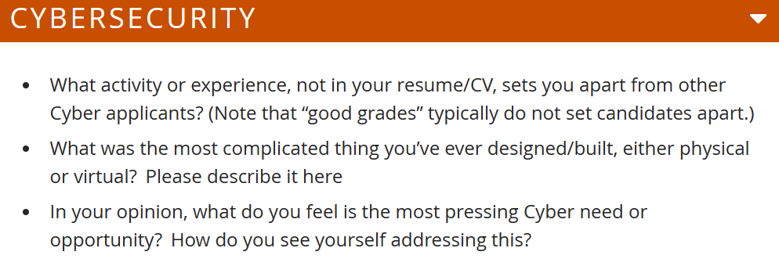

Video

<https://meng.pratt.duke.edu/apply/requirements/video-introduction-interview>

托福：Report official scores to Institution Code 5156 (Duke University). [Note: There is no department code.]

GRE：optional

自申：NTU cybersecurity

截止

31 January

入口

<https://wis.ntu.edu.sg/webexe/owa/coal_main.notice>

GRE：

GRE is not required for MSc programme (by coursework).

个人陈述，常规，没要求，网申和官网都没提这个文书的事 应该是不要

Gatech cybersecurity

Rukou

[gradapp.gatech.edu/apply/](https://gradapp.gatech.edu/apply/)

Information Security

1. S.: February 15

GRE: Admissions to our program are highly competitive and applications of exceptional students may be considered without a GRE score. However, high GRE scores do add to how an application is ranked and we highly recommend that students submit these scores.

文书没有明确要求

NEU \

April 15

Rukou

[https://enroll.northeastern.edu/apply/?_gl=1*1scxf75*_gcl_au*MXTA3NjI4OTc0Mi4xNjkzODc4MTIy](https://enroll.northeastern.edu/apply/?_gl=1*1scxf75*_gcl_au*MXTA3NjI4OTc0Mi4xNjkzODc4MTIy)

文书

Statement of purpose that should include career goals and expected outcomes and benefits from the program

GRE Optional

BU CS cybersecurity concentration

入口

<https://bu-grs.liaisoncas.com/applicant-ux/#/login>

截止

March 15

GRE:

Yes. All applicants must take the GRE General test. The Computer Science subject test is not required.

SOP没有具体要求