Chemistry & Biology project Documentation

**Content**

Assignment2

Team2

Stages of development3

Project description4

Block diagram 5

Functions6

**Assignment**

The topic is: "Chemistry & Biology project". We had to create a game written in C++. The task had to be completed from 07.03.2023 to 03.04.2023. We had to form a team, distribute our roles and everyone’s tasks and make a finished product, which you can read more about in the next sections.

**Team**

|  |  |  |
| --- | --- | --- |
| № | Name and class | Role |
| 1 | Martin Кafedzhiev – 10 A | Scrum trainer |
| 2 | Samuil Shkvarla – 10 A | Back-end developer |
| 3 | Plamen Daylyanov – 10 A | Back-end developer |
| 4 | Elena Keserdzhieva – 10 B | Designer |
| 5 | Ivan Dadakov – 10 A | Designer |

**Stages of development**

|  |  |
| --- | --- |
| № | Stage |
| 1 | **Assembling the team**  We gathered and distributed the roles, so each person can work on the field that he is most competent with. |
| 2 | **Idea**  We decided to make a game. We started thinking of an idea for the game. We decided to make game related mainly to chemistry and the reactions we learn in school. |
| 3 | **The process of creating the product**  Every week there were meetings to discusses the progress and the tasks that are left. We assigned each task to the person that we believed can do it quickly, clearly, and accurately, so the team would be more productive and efficient. |
| 4 | **Polishing the product**  After we finished with the game and the documentation, we fixed some bugs and made the overall user experience a bit more pleasant. |
| 5 | **Presenting the product**  After weeks of hard working and sleepless nights we finished the project and now it is ready to be presented. |

**Project description**

|  |  |
| --- | --- |
| № | Description |
| 1 | **A general idea about the game**  The general idea of the game is that a chemistry scientist tried to become one of the best scientists but during one of his dangerous experiments he made a mistake and the laboratory was destroyed. Now 3 years later you help him to clear his name and he help you to become great chemistry scientist. You can obtain chemical element by buying them for the shop or finding them in the form of junk and purifying them. You task is to make different reactions and get all the elements in the game and unlock achievements. |
| 2 | **How to access the project**  Our repository:  <https://github.com/MIKafedzhiev20/KOH-Project.git>  If you want to install our game, you can navigate towards the "[Release](https://github.com/MIKafedzhiev20/KOH-Project/releases)" tab in GitHub and download the latest version.  To download our project past the following code in your CMD:  git clone https://github.com/MIKafedzhiev20/KOH-Project.git |
| 3 | **Team work**  The main communication platform we used is Microsoft Teams. During the project we stayed in touch with each other. |
| 4 | **Used technologies for our project development**  We used Visual Studio 2022 as our IDE. The game is written in C++ and we used Raylib graphic library. We used GitHub for collaborative work. We used Procreate, Creative Cloud and Pixlr for our visual elements. For our documentation we used Microsoft Word and Doxygen and for our presentation we used Microsoft PowerPoint. |

**Block diagram**

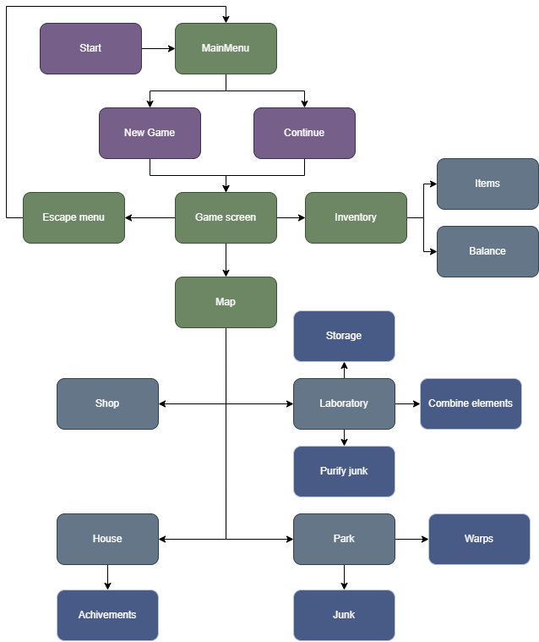

**Functions**

|  |  |  |
| --- | --- | --- |
| Type | Name | Description |
| void | DrawMainMenu | Draws the main menu |
| Vector2 | getCameraPos | Return the camera position |
| void | move | Move the player base on user input |
| void | Draw | Draws the elements of the game |
| void | DrawExtractor | Draws the extractor UI |
| void | DrawLaboratory | Draws the laboratory |
| void | DrawStorage | Draws the storage UI |
| void | DrawTable | Draws the table |
| bool | GameShouldClose | Checks if the window should close |
| void | generateJunk | Generate junk around the map |
| unsigned | getSelectedSlot | Returns the selected slot |
| void | manageInvetory | Manage the inventory slots |
| void | removeItem | Remove item from the inventory |
| void | setSelectedSlot | Sets the selected slot to a new one |
| vector | getItems | Return the items which are in the inventory |
| void | setIsUnlocked | Sets the isUnlocked to true/false |
| void | setPrice | Sets the price to a give one |
| int | getPrice | Returns the isUnlocked value |
| vector | createElement | Creates vector of elements from file |
| bool | getIsPickedUp | Returns whether the items is picked up or not |
| Rectangle | getHitbox | Return the item's hitbox |
| string | getName | Returns the item's name |
| void | setHitbox | Set the item's hitbox |
| void | setType | Sets the items type to a given one |
| string | getRequired1 | Return the first required element |
| string | getRequired2 | Returns the second required element |
| void | setIsObtained | Sets true/false if the reaction is obtained |