**Project Title:**

Design and Simulation of a Simple Traffic Light Controller

**Group Members:**

Mohamed Imad Kasem

Ali Naji

Taha Ramadan

**Testing Results:**

**001 : NS Green**

**010: NS Yellow**

**011: NS red**

**100: EW Green**

**101: EW Yellow**

**110: EW Red**

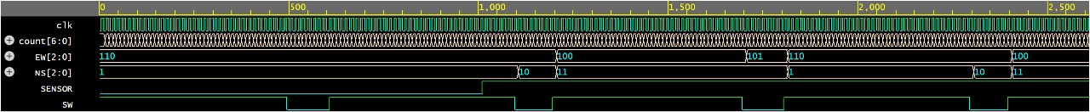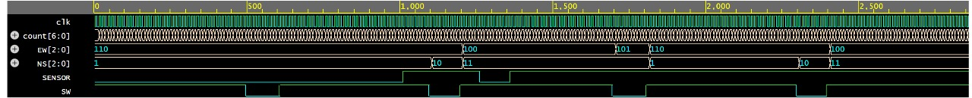

**Codes:**

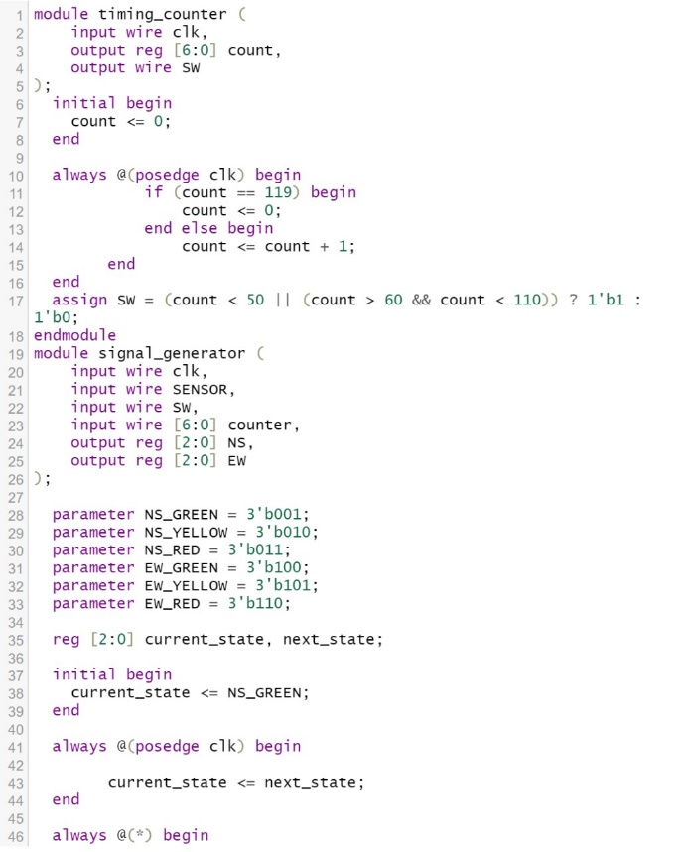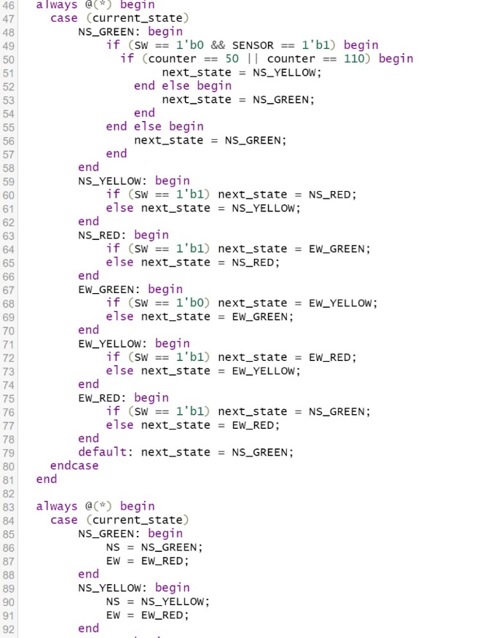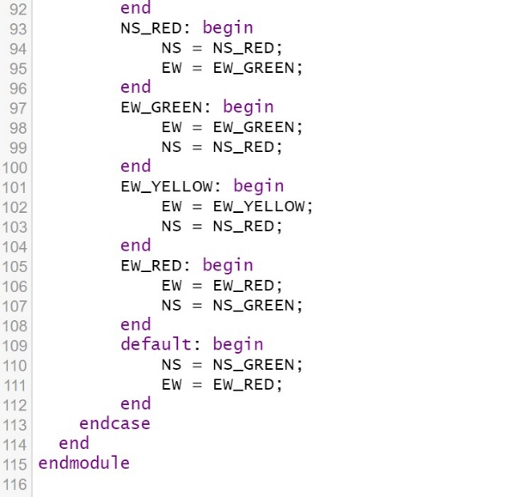

**Testbench:**

