**Project Title:**

8-Bit Arithmetic and Logic Unit (ALU) Design

**Group Members:**

Mohamed Imad Kasem

Ali Naji

Taha Ramadan

**Project Description:**

We would like to design an 8-bit arithmetic and logic unit (ALU) that takes two inputs A and B (two’s complement numbers) each of size 8 bits and that performs the following operations depending on the values of a control signal C (4 bits).

**Testing Results:**

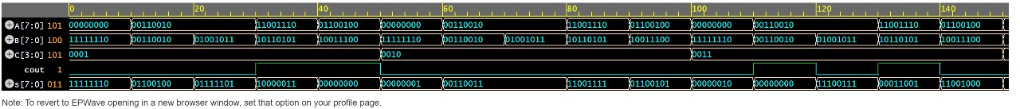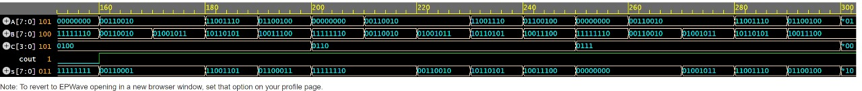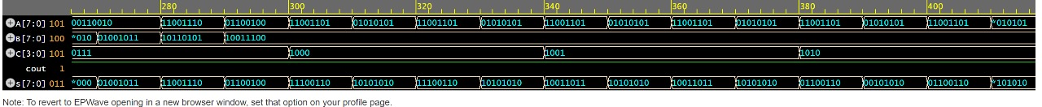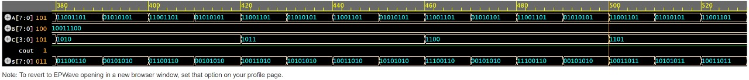

**Codes:**

