**VISVESVARAYA TECHNOLOGICAL UNIVERSITY  
BELGAUM - 590018**

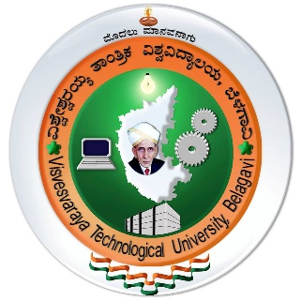

Synopsis Report on

**“Library Management System”**

A Mini **7350251** **7350251** for the partial fulfillment of the requirements for  
**Database Management Laboratory**  
of   
**Bachelor of Engineering**  
in  
**Computer Science**

**Submitted by**

|  |  |  |  |  |  |  |  |  |  |
| --- | --- | --- | --- | --- | --- | --- | --- | --- | --- |
| **Milan Kumar Chaudhary** |  |  | **Nikhil Basur** |  |  |  |  |  |  |
| **1ST16C094** |  |  | **1ST16CS103** |  |  |  |  |  |  |

**Under the Guidance of**  
**Mrs. Sowmya B.  
Assistant Professor, Department of CSE**



DEPARTMENT OF COMPUTER SCIENCE AND ENGINEERING **SAMBHRAM INSTITUE OF TECHNOLOGY  
BENGALURU – 560 097**