OFFICE MANAGEMENT SYSTEM

**A Project Report**

Submitted in partial fulfillment of the Requirement for the award of the Degree

BACHELOR OF SCIENCE (INFORMATION TECHNOLOGY)

**By**

# Ganesh Pathak

Seat No.: 7048419

**Under the esteemed guidance of**

# Mrs. AMREEN NAAZ

(ASSISTANT PROFESSOR)

**DEPARTMENT OF INFORMATION TECHNOLOGY**

S.K.C. DEGREE COLLEGE

***(Affiliated to University of Mumbai)***

**Academic Year:** 2024-25

**PROFORMA FOR THE APPROVAL OF PROJECT PROPOSAL**

*(Note: Complete all entries in this proforma accurately. Incomplete submissions will be rejected.)*

**PRN No.:**

**Roll No.:** TIT - 43

**Student Name:** GANESH PATHAK

**Project Title:** OFFICE MANAGEMNET SYSTEM **Guide:** Mrs. AMRIN NAAZ SHOAIB MOHAMMED

# Signatures

Student: ...............................................

Guide: ..................................................

Coordinator: .........................................

Date: ....................................................

# ABSTRACT

The ***Office Management System*** is a web-based application designed to streamline administrative tasks within an organization. The system automates key office operations such as employee management, task allocation, attendance tracking, and leave management, ensuring a more structured and efficient workflow. Traditionally, managing office tasks manually leads to inefficiencies, data mismanagement, and increased workload. This system aims to eliminate such challenges by providing a **centralized platform** for employees and administrators to interact seamlessly.

Built using **PHP, HTML, CSS, and MySQL**, the system ensures a secure and scalable infrastructure. Administrators can add, update, and monitor employee records, assign tasks, and track employee performance in real time. Employees can access their assigned tasks, mark their attendance, and request leaves with ease. The system’s authentication mechanism ensures **data security** and prevents unauthorized access.

By **digitizing** office processes, the *Office Management System* reduces paperwork, enhances productivity, and improves task accountability. The project also lays the foundation for future advancements, such as **mobile application integration, AI-driven task analytics, and cloud-based storage** for better scalability and performance. This system is an essential tool for any organization seeking to optimize its workflow and improve administrative efficiency.

# ACKNOWLEDGEMENT

I express my deepest gratitude to my project guide, **MRS. AMRIN NAAZ SHOAIB MOHAMMED,** for their invaluable guidance, continuous support, and insightful suggestions throughout the development of this project. Their expertise and encouragement have played a crucial role in shaping this work.

I am also immensely thankful to **SKC DEGREE COLLEGE,** for providing me with the necessary resources and a learning environment that enabled me to complete this project successfully.

Furthermore, I extend my heartfelt appreciation to my **family and friends** for their constant motivation and encouragement. Their support helped me stay focused and committed to completing this project effectively.

Lastly, I acknowledge the various **online resources, forums, and documentation** that provided technical insights, helping me overcome challenges during the development process. This project would not have been possible without the collective efforts and support of all those involved.

## DECLARATION

I, **PATHAK GANESH**, hereby declare that the project titled "Office Management System" is my original work and has been developed as part of my academic curriculum at **SKC DEGREE COLLEGE**. This project has been carried out under the guidance of MRS. AMRIN NAAZ SHOAIB MOHAMMED, and all information presented in this report is true and based on my research and understanding.

I confirm that this project has not been submitted, in part or whole, to any other institution or organization for any academic or professional purpose. Any external sources, references, or materials used in the development of this project have been duly acknowledged.

I take full responsibility for the authenticity of the work and affirm that it has been completed with academic integrity and in compliance with the guidelines set forth by SKC DEGREE COLLEGE.

GANESH PATHAK

# Table of Contents

|  |  |
| --- | --- |
| **Topic** | **Page No.** |
| **SYNOPSIS** |  |
| **Chapter 1: INTRODUCTION** | **1-4** |
| 1.1 Background of the Project | **02** |
| 1.2 Scope of the Project | **03** |
| 1.3 Objectives of the Project | **04** |
| **CHAPTER 2: LITERATURE REVIEW** | **05-10** |
| 2.1 Literature Review | **05** |
| **CHAPTER 3: REQUIREMENTS AND ANALYSIS** | **11-15** |
| 3.1 Problem Definition | **11** |
| 3.2 Requirements Specification | **12** |
| 3.3 Planning and Scheduling | **14** |
| **CHAPTER 4: SYSTEM DESIGN** | **16-28** |
| 4.1 Data Design (Table Design) | **16** |
| 4.1.1 Schema Design | **18** |
| 4.1.2 Data Integrity and Constraints | **18** |
| 4.2 Diagram | **19** |
| 4.2.1 E-R Diagram /Block Diagram | **19** |
| 4.2.2 Class Diagram / Data Flow Diagram | **19** |
| 4.2.3 Use Case Diagram | **21** |
| 4.2.4 Sequence Diagram | **22** |
| 4.2.5 Activity Diagram | **23** |
| 4.2.6 Menu Tree / Circuit Diagram | **25** |

|  |  |
| --- | --- |
| 4.3 User interface design | **26** |
| **CHAPTER 5: IMPLEMENTATION AND TESTING** | **29-42** |
| 5.1 Code | **29** |
| 5.2 Testing Approach and Test Cases | **37** |
| 5.3 Image Validation | **41** |
| References | **43** |

## SYNOPSIS

**Introduction:**

The *Office Management System* is a web-based application designed to streamline and automate administrative tasks within an organization. Offices often face challenges in managing employee records, tracking attendance, assigning tasks, and processing leave requests. A manual approach to these activities can lead to inefficiencies, data inconsistencies, and time-consuming operations. This system provides a centralized digital solution that enhances productivity, reduces paperwork, and ensures smooth office management.

**Objective:**

The primary objective of this project is to develop an **efficient and user-friendly** system that allows office administrators to manage employees, track attendance, allocate tasks, and handle leave applications with ease. The key objectives include:

1. **Automation of Office Workflows** – Reduce manual record-keeping and automate essential office operations.
2. **Employee Management** – Maintain detailed employee records, including personal information and job roles.
3. **Attendance Tracking** – Enable employees to mark their attendance while providing real-time access to attendance records.
4. **Task Assignment & Monitoring** – Allow administrators to assign tasks to employees and track progress.
5. **Leave Management** – Provide an easy way for employees to apply for leave and for admins to approve/reject requests.
6. **Data Security & Authentication** – Ensure access control through user authentication to prevent unauthorized access.
7. **Efficiency & Productivity Enhancement** – Improve office efficiency by organizing work processes digitally.

**Scope of the Project:**

The *Office Management System* is designed to be scalable and adaptable for various types of organizations, ranging from **corporate offices to small businesses and institutions**. The system caters to two primary user roles:

1. **Admin** (Office Manager/HR):
   * Manage employee records (add/update/delete).
   * Assign tasks and track progress.
   * Approve/reject leave requests.
   * Monitor attendance records.
   * Generate reports on employee performance and attendance.
2. **Employees:**
   * View assigned tasks and update status.
   * Mark daily attendance.
   * Apply for leave and check approval status.

The system can be further expanded in the future to include additional functionalities such as payroll management, document sharing, performance analytics, and mobile application integration.

**Technologies Used:**

The *Office Management System* is built using a combination of frontend, backend, and database technologies, ensuring a robust and scalable architecture:

1. **Frontend Technologies:**
   * **HTML** – Structure of web pages.
   * **CSS** – Styling and design.
   * **JavaScript (Optional for Enhancements)** – Interactive elements and form validation.
2. **Backend Technologies:**
   * **PHP** – Handles server-side processing and logic.
   * **Apache Server (XAMPP/WAMP)** – Local hosting environment for PHP execution.
3. **Database Management:**
   * **MySQL** – Stores employee data, attendance records, and task details.
4. **Security Measures:**
   * **Session-based Authentication** – Secure login/logout system.
   * **Password Hashing**–Ensures secure storage of user credentials.

The system is developed in a way that it can be easily deployed on a **local server** for small businesses or **cloud-based hosting** for larger enterprises requiring remote access.

**Modules of the System:**

1. Admin Panel:
   * Employee record management
   * Task assignment and tracking
   * Attendance monitoring
   * Leave approval/rejection
2. Employee Panel:
   * Task updates and submission
   * Attendance marking
   * Leave requests
3. Authentication System:
   * Secure login and access control
   * Password management

**Methodology:**

The development of this project follows the Software Development Life Cycle (SDLC) to ensure structured and systematic implementation. The key phases include:

1. **Requirement Analysis:**

* Understanding the challenges of office management and identifying essential system functionalities.
* Gathering input from office administrators and employees to design a user-friendly interface.

2. **System Design:**

* Database Schema Creation – Designing tables for employees, tasks, attendance, and leave management.
* User Interface Design – Creating wireframes for admin and employee dashboards.

3. **Development:**

* Implementing frontend pages (HTML, CSS, JavaScript) for a clean user experience.
* Developing backend logic in PHP to handle user authentication, task assignment, and data processing.
* Integrating MySQL database for data storage and retrieval.

4. **Testing & Debugging:**

* Conducting unit testing to ensure each module (employee management, attendance tracking, task assignment) works correctly.
* Performing security testing to protect against unauthorized access.

5. **Deployment & Maintenance:**

* Deploying the system on a local or web server based on organizational needs.
* Collecting user feedback for future enhancements and system improvements.

**Expected Outcome:**

The *Office Management System* will significantly reduce administrative workload, improve task tracking, and ensure transparency in office operations. It will provide an organized and secure platform for office staff to efficiently manage daily operations.

**Conclusion:**

The *Office Management System* is an essential tool for modern organizations seeking to optimize their office workflow. By automating daily administrative tasks, it ensures accuracy, efficiency, and security in managing employees and work processes. The project is designed to be **scalable and adaptable**, allowing future enhancements such as **mobile app integration, AI-driven task analytics, and cloud-based data storage**. This system is a step towards a **digital and smart workplace**, improving office management for a more productive work environment.

### Introduction

#### Background of the Project:

In today’s fast-paced corporate environment, managing office-related tasks efficiently is crucial for smooth operations. Many businesses still rely on traditional manual methods such as paper-based records or Excel spreadsheets to handle employee details, attendance tracking, task allocation, and leave management. These conventional approaches are time-consuming, error-prone, and inefficient, often leading to mismanagement, duplication of data, and a lack of real-time updates.

To overcome these challenges, the need for an automated office management system has become essential. The *Office Management System* is a web-based software solution designed to streamline and automate various administrative tasks within an organization. It provides a centralized digital platform where administrators can manage employee records, assign tasks, track work progress, and maintain attendance logs efficiently.

This system is particularly beneficial for small to mid-sized businesses, corporate offices, educational institutions, and government organizations where managing daily office operations manually can be overwhelming. The system eliminates the need for physical paperwork by storing all data in a secure and structured database, ensuring quick access, easy modifications, and reliable record-keeping.

The project is developed using PHP, MySQL, HTML, and CSS, offering a user-friendly interface, robust security mechanisms, and seamless data management. It ensures that administrators have real-time insights into employee performance and attendance while allowing employees to access their tasks and work records from a single platform.

By implementing the *Office Management System*, organizations can achieve:

* Increased productivity through automation.
* Improved record-keeping with a structured database.
* Better task management by tracking work assignments.
* Enhanced data security with access control mechanisms.

Thus, this project aims to digitally transform traditional office management practices, ensuring a more organized, efficient, and productive work environment.

#### Scope of the Project:

The *Office Management System* is designed to cater to the needs of administrators, HR departments, and employees, offering a structured workflow for managing office-related tasks. The system is scalable and can be adapted for different industries, including corporate firms, educational institutions, government offices, and small businesses.

**Key Features of the System:**

The project includes the following core functionalities:

1. Employee Management:
   * Add, update, and delete employee records.
   * Maintain employee profiles, including contact details, job roles, and departments.
   * Assign unique login credentials to each employee for secure access.
2. Task Assignment and Monitoring:
   * Assign work tasks to employees with deadlines.
   * Track task progress and completion status.
   * Enable employees to update their task status in real-time.
3. Attendance Management:
   * Employees can mark their daily attendance through the system.
   * Admins can track working hours, late arrivals, and absenteeism.
   * Generate attendance reports for payroll or performance evaluation.
4. Leave Management System:
   * Employees can request leave online.
   * Admins can approve/reject leave applications.
   * Leave balance tracking for each employee.
5. User Authentication and Security:
   * Secure login system using username and password.
   * Role-based access control for different users (Admin & Employees).
   * Prevents unauthorized access and data breaches.
6. Data Storage and Reporting:
   * Centralized database using MySQL for employee, task, and attendance records.
   * Generates reports on employee performance, attendance trends, and task completion.

**Limitations of the Project:**

While the system offers a robust and efficient solution, certain limitations exist, such as:

* The system is currently web-based only and does not have a mobile application.
* AI-based analytics and advanced reporting are not included in the initial version but can be added in future enhancements.
* Limited real-time communication features (such as internal messaging or notifications) within the system.

Future Scope:

* Integration with cloud-based servers for remote access.
* Development of a mobile app for employees to manage tasks on the go.
* AI-powered performance analytics to predict productivity trends.
* Implementation of a chat system for employee collaboration.

By addressing these areas, the *Office Management System* can become a fully automated, AI-powered, and cloud-based solution, further improving office workflow efficiency.

#### Objectives of the Project

The *Office Management System* is designed with the following key objectives in mind:

**1. Automation of Office Processes**

One of the primary goals of this system is to eliminate manual processes in office management. Automating tasks such as attendance tracking, employee records, and task management reduces errors, saves time, and enhances productivity.

**2. Efficient Employee Management**

The system provides a structured approach to managing employee details, job roles, and work assignments. It ensures that all employee-related information is stored securely and easily accessible to administrators.

**3. Real-Time Attendance Tracking**

The system enables employees to mark their attendance digitally, reducing the dependency on traditional attendance registers. Admins can monitor attendance patterns, generate reports, and detect absenteeism trends.

**4. Task Assignment and Monitoring**

The project aims to simplify task delegation and progress tracking by allowing administrators to assign work to employees with deadlines. Employees can update task status, ensuring transparency and accountability.

**5. Secure and Role-Based Access**

To ensure data privacy, the system implements role-based access control where:

* Admins have full control over employee records, task assignments, and reports.
* Employees can only view their assigned tasks, mark attendance, and request leave.

This prevents unauthorized access and ensures data integrity and confidentiality.

**6. User-Friendly Interface**

A key focus of this project is to design an intuitive and easy-to-use interface so that employees and admins can navigate the system without extensive training.

**7. Paperless and Eco-Friendly Approach**

By shifting to a digital office management system, the project supports an eco-friendly approach, reducing the need for physical files, printed records, and paperwork.

**8. Data Storage and Report Generation**

The system maintains a structured database that helps generate reports on:

* Employee attendance and working hours.
* Task completion rates and employee performance.
* Leave records and approvals.

These reports help HR teams and management make informed decisions regarding employee efficiency and task distribution.

**9. Scalability for Future Enhancements**

The system is designed to support additional features in the future, such as:

* Cloud hosting for remote office management.
* Mobile application development for better accessibility.
* AI-powered analytics for employee performance evaluation**.**

## LITERATURE REVIEW

A literature review examines the existing research, technologies, and office management solutions to provide a foundational understanding of the need for an automated system. Office management has undergone significant transformations over the years, shifting from manual record-keeping and paper-based workflows to digital solutions that enhance efficiency, reduce administrative burden, and improve task coordination. Managing an office involves handling employee records, tracking attendance, assigning tasks, monitoring performance, and ensuring seamless workflow execution. In traditional office environments, these tasks were often carried out manually, leading to inefficiencies, inaccuracies, and time-consuming processes. The growing complexity of modern workplaces has driven the need for comprehensive office management systems that integrate various administrative functions into a centralized platform.

Historically, office management relied on **paper files, handwritten notes, and spreadsheet tracking**, which often resulted in **data redundancy, mismanagement, and loss of important records**. Organizations struggled with the challenges of maintaining up-to-date employee records, tracking work progress, and ensuring accountability in task management. As businesses expanded, it became evident that **manual processes could no longer meet the demands of efficient office administration**. To overcome these limitations, organizations started adopting **digital office management software**, allowing for automated task tracking, employee database management, and real-time monitoring of attendance and leave applications.

Various studies emphasize the importance of digital transformation in office management. A **2020 study on digital workplace solutions** found that businesses implementing automated office management systems experienced a **35% increase in operational efficiency** due to reduced paperwork and improved task delegation. Another **2021 research paper on cloud-based office automation** highlighted that integrating cloud computing enhances **data security, remote accessibility, and real-time updates**, making office workflows more flexible and efficient. A **2019 study on the impact of manual office management** identified **human errors, inefficiencies in task distribution, and difficulties in employee performance tracking** as major challenges that organizations face when relying on traditional methods.

While various office management software solutions exist today, they often provide **limited functionalities or cater to specific administrative needs**. For example, **Microsoft Office 365** offers document collaboration and cloud storage but lacks features for attendance tracking and task management. **Zoho People** focuses on HR-related functionalities, such as employee database management and leave tracking, but does not include comprehensive task assignment capabilities. **Trello and Asana**, which are widely used for project management, help teams collaborate on tasks but do not provide **attendance monitoring or employee leave management**. Due to this **fragmented approach**, businesses often have to rely on multiple software tools, increasing complexity and inefficiencies.

The **Office Management System** developed in this project aims to address these gaps by offering a **fully integrated, web-based solution** that combines **employee management, task allocation, attendance tracking, and leave management** in a single platform. Unlike traditional office management tools, this system ensures a **holistic approach** where all administrative functions are streamlined for improved efficiency. The proposed system is built using **PHP, MySQL, HTML, and CSS**, ensuring a **scalable, secure, and user-friendly** experience for both administrators and employees. By automating office processes and centralizing data storage, this system eliminates **paper-based dependencies**, enhances **task accountability**, and improves **overall workflow management**.

This literature review establishes the need for an **efficient, all-in-one Office Management System** that overcomes the limitations of existing solutions. With its **comprehensive approach**, the proposed system is expected to bring **greater transparency, accuracy, and automation** to office administration, making it a valuable tool for modern businesses looking to optimize their operational efficiency.

## REQUIREMENTS AND ANALYSIS

#### Problem Definition

Managing an office efficiently requires handling various administrative tasks, including employee management, task allocation, attendance tracking, and leave management. Traditional office management systems often rely on manual processes, paper-based records, or standalone software tools that lack integration. These methods are prone to errors, inefficiencies, and time-consuming operations. The absence of a centralized digital solution leads to mismanagement of tasks, difficulties in tracking employee performance, and lack of transparency in leave approvals.

One of the major problems in office administration is task tracking. When tasks are assigned manually, there is no real-time monitoring, making it difficult for managers to oversee work progress. Employees may miss deadlines due to a lack of automated reminders. Similarly, attendance tracking through registers or spreadsheets is prone to manipulation and does not provide accurate records.

Additionally, most traditional office setups lack an automated leave management system, leading to overlapping leaves, miscommunication, and confusion among employees. Without an integrated system, managers often struggle with workforce planning, which impacts overall productivity.

This project aims to address these issues by developing an Office Management System, a web-based solution that will integrate task allocation, attendance tracking, and leave management into a single platform. By automating these processes, the system will increase efficiency, improve record-keeping accuracy, and enhance workflow management.

#### Requirements Specification

The Office Management System is designed to be a scalable, secure, and user-friendly web application. The system requires a well-defined set of software and hardware specifications to function efficiently.

**Software Requirements:**

* Operating System: Windows 10 or later, Linux, macOS (for server deployment).
* Programming Language: PHP (Backend), HTML, CSS, JavaScript (Frontend).
* Database: MySQL (Relational Database Management System).
* Web Server: Apache (XAMPP/WAMP).
* Browser Compatibility: Google Chrome, Mozilla Firefox, Microsoft Edge.

**Hardware Requirements:**

* Processor: Minimum Intel i5 (or AMD equivalent) for handling multiple tasks.
* RAM: Minimum 8GB for smooth execution of database queries and UI interactions.
* Storage: Minimum 256GB SSD/HDD for database storage and system files.
* Network: Reliable internet connection with a speed of at least 10 Mbps for online deployment.

**Functional Requirements:**

* User Authentication: Secure login system with role-based access (Admin, Employee).
* Employee Management: Add, update, and manage employee records.
* Task Allocation: Assign tasks to employees with deadlines and status tracking.
* Attendance Tracking: Employees can mark attendance; admins can view reports.
* Leave Management: Employees can apply for leave, and admins can approve/reject requests.
* Reports & Analytics: Generate reports on employee attendance and task completion.

**Non-Functional Requirements:**

* Scalability: The system should handle an increasing number of employees and tasks.
* Security: Data should be encrypted, and access should be restricted based on roles.
* Performance: The system should provide quick response times for database queries.
* Usability: The interface should be user-friendly and easy to navigate.

#### Planning and Scheduling

#### A well-structured project planning and scheduling approach ensures the successful development and timely implementation of the *Office Management System*. The project follows a phased development approach, ensuring that all aspects of the system are built and tested systematically.

#### Requirement Gathering (Week 1)

#### Understanding office workflow and identifying necessary features.

#### Collecting input from administrators and employees.

#### Planning System Features (Week 2)

#### Finalizing core functionalities and system scope.

#### Creating initial documentation and system outline.

#### Design UI & Database (Week 3-4)

#### Developing UI wireframes for dashboards and key features.

#### Defining database tables and structuring data relationships.

#### Coding (Frontend & Backend) (Week 5-7)

#### Writing PHP and MySQL queries for backend functionality.

#### Implementing HTML, CSS, and JavaScript for frontend design.

#### Integration & Debugging (Week 8)

#### Connecting frontend with backend and database.

#### Debugging code and ensuring smooth functionality.

#### Testing & Fixing Issues (Week 9-10)

#### Conducting unit testing, integration testing, and security testing.

#### Identifying and resolving system bugs and performance issues.

#### Deployment & Final Checks (Week 11-12)

#### Hosting the system on a local or cloud server.

#### Providing training and documentation for users.

#### Gantt Chart:

A Gantt chart is a visual representation of the project schedule, showing the start and end dates for each task along with their dependencies. It is a powerful tool for tracking progress, identifying potential delays, and ensuring that the project stays on schedule.

|  |  |  |  |
| --- | --- | --- | --- |
| **Task** | **Start Date** | **End Date** | **Duration (Days)** |
| Collect Requirements | 01-Apr | 07-Apr | 7 |
| Plan System Features | 08-Apr | 14-Apr | 7 |
| Design UI & Database | 15-Apr | 28-Apr | 14 |
| Coding (Frontend & Backend) | 29-Apr | 19-May | 21 |
| Integrate & Debug | 20-May | 26-May | 7 |
| Test & Fix Issues | 27-May | 09-Jun | 14 |
| Deploy & Final Checks | 10-Jun | 23-Jun | 14 |

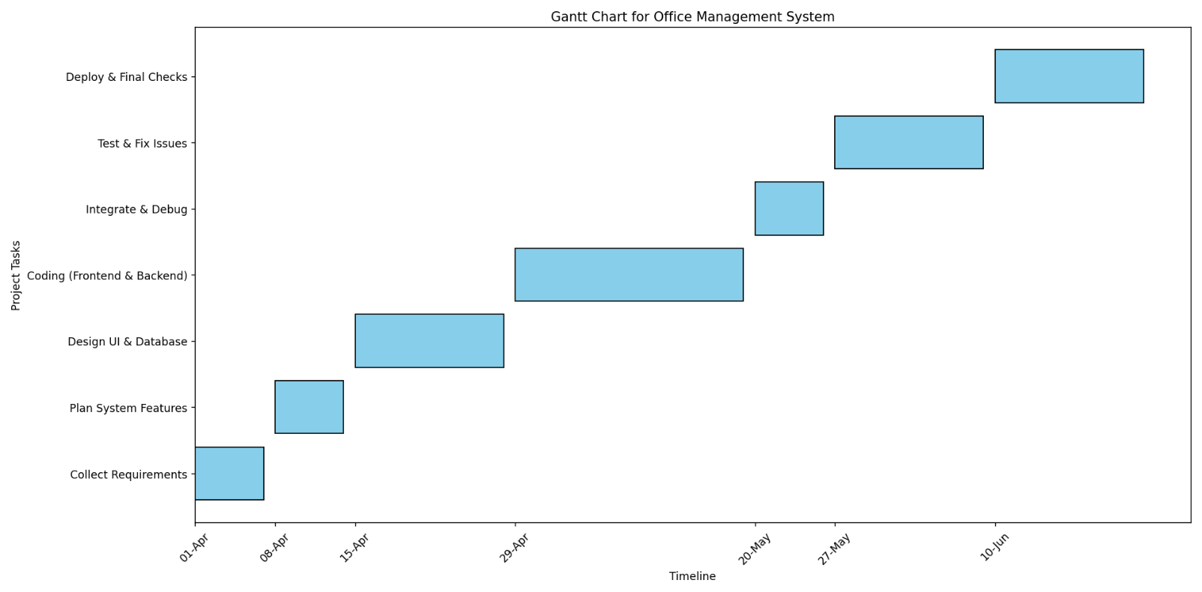

**GANNT CHART**:

### System Design

#### Data Design (Table Design)

* + 1. **Schema Design**

The database schema consists of multiple tables to store and manage the data efficiently. Below are the key tables used in the system:

* Users Table: Stores user credentials and roles.
* Employees Table: Contains employee details such as name, department, and designation.
* Tasks Table: Maintains records of tasks assigned to employees.
* Attendance Table: Tracks employee check-in and check-out times.
* Leave Requests Table: Manages leave requests and approvals.
* Admin Table: Stores admin details and access levels.

*(Table structures with attributes and data types should be inserted here.)*

#### Schema Design

To ensure data accuracy and consistency, the system enforces the following constraints:

* **Primary Keys:** Each table has a unique identifier to maintain data uniqueness.
* **Foreign Keys:** Establish relationships between tables (e.g., employee_id in the attendance table links to the employees table).
* **Not Null Constraints:** Prevents insertion of incomplete data.
* **Unique Constraints:** Ensures data uniqueness, such as unique employee IDs.
* **Referential Integrity:** Prevents deletion of referenced records to maintain consistency.

*(Insert Schema Design Diagram Here.)*

**4.2 Diagram**

**4.2.1 E-R Diagram / Block Diagram**

*(Insert ER Diagram / Block Diagram Here.)*

**4.2.2 Class Diagram / Data Flow Diagram**

*(Insert Class Diagram / Data Flow Diagram Here.)*

**4.2.3 Use Case Diagram**

*(Insert Use Case Diagram Here.)*

**4.2.4 Sequence Diagram**

*(Insert Sequence Diagram Here.)*

**4.2.5 Activity Diagram**

*(Insert Activity Diagram Here.)*

**4.2.6 Menu Tree / Circuit Diagram**

*(Insert Menu Tree / Circuit Diagram Here.)*

The above diagrams illustrate the **structural and behavioural aspects** of the system, providing a clear visualization of how different modules interact. These diagrams are essential for understanding the **flow of data, processes, and user interactions** within the Office Management System.

* 1. **User Interface**

The Office Management System is designed with a user-friendly and intuitive interface to ensure ease of use for both administrators and employees. The interface includes the following key components:

* **Login Page:** Secure authentication for admins and employees.
* **Admin Dashboard:** Displays an overview of tasks, employee details, attendance records, and leave requests.
* **Employee Dashboard:** Provides access to assigned tasks, attendance marking, and leave application forms.
* **Task Management Page:** Enables admins to assign, update, and monitor task progress.
* **Attendance Page:** Allows employees to mark attendance and view attendance history.
* **Leave Management Page:** Displays leave request status and history for employees.
* **Reports Section:** Generates analytics and reports on office activities.

*(Insert Screenshots of UI Screens Here.)*

The interface is developed using **HTML, CSS, and JavaScript**, ensuring a responsive design compatible with different screen sizes. The UI follows a **clean and structured layout**, making it accessible and efficient for users with varying levels of technical expertise.

*(Ensure to insert the respective UI screenshots in the space provided above.)*

## 5. IMPLEMENTATION AND TESTING

#### Code

The Office Management System is developed using **PHP, MySQL, HTML, CSS, and JavaScript**. Below are some essential code snippets that demonstrate key functionalities:

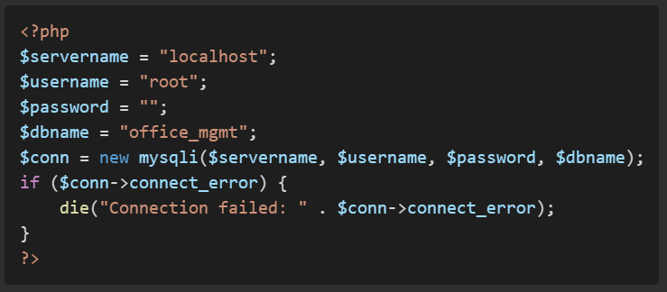**Database Connection (config.php):**

**Database Connection (config.php):**

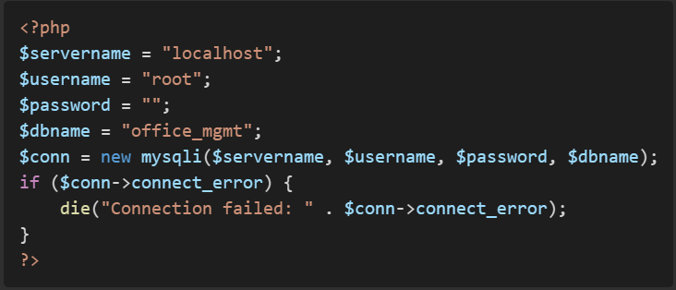

**Task Assignment (task.php):**

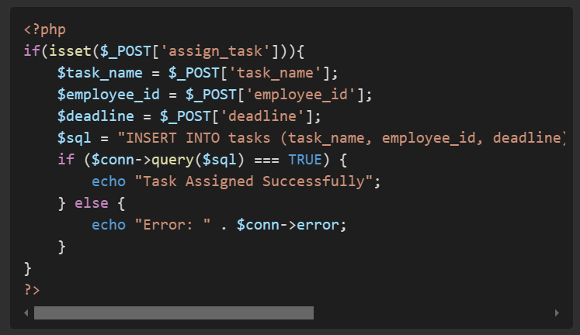

#### Testing Approach and Test Cases

#### ****Testing Approach****

To ensure system reliability, functionality, and security, multiple testing strategies were applied:

* **Unit Testing:** Each module, such as login authentication, task assignment, and attendance marking, was tested individually to verify functionality.
* **Integration Testing:** Different system components were tested together to ensure smooth data flow and correct interaction between modules.
* **User Acceptance Testing (UAT):** The system was tested from an end-user perspective to validate its ease of use, responsiveness, and efficiency.
* **Security Testing:** Measures were taken to prevent SQL injection, unauthorized access, and data breaches.
* **Performance Testing:** The system's response time and load handling were tested to ensure smooth operation under different usage conditions.

|  |  |  |  |  |
| --- | --- | --- | --- | --- |
| **Test Case ID** | **Test Scenario** | **Expected Output** | **Actual Output** | **Status** |
| TC_01 | User Login with valid data | Successful Login Redirect | As Expected | Pass |
| TC_02 | User Login with invalid data | Display Error Message | As Expected | Pass |
| TC_03 | Assign Task to Employee | Task Assigned Successfully | As Expected | Pass |
| TC_04 | Apply for Leave | Leave Request Submitted | As Expected | Pass |
| TC_05 | Mark Attendance | Attendance Marked | As Expected | Pass |
| TC_06 | Unauthorized Admin Access | Access Denied | As Expected | Pass |
| TC_07 | System Load Test (10 users) | Smooth Performance | As Expected | Pass |

**5.3 Image Validation**

Image validation ensures that all UI components and system functionalities are correctly implemented and visually verified. This section involves testing the following UI elements:

* **Login Page Validation:** Ensuring correct UI layout, proper input validation, and authentication functionality.
* **Dashboard Layout:** Checking the correct display of assigned tasks, employee records, and attendance reports.
* **Task Management Page:** Verifying task creation, assignment, and status updates.
* **Attendance Page:** Ensuring that attendance marking reflects correctly in the database.
* **Leave Management Interface:** Confirming the proper flow of leave requests and approvals.
* **Responsiveness and UI Consistency:** Testing across multiple screen sizes and devices to ensure the interface remains user-friendly and responsive.

*(Insert system screenshots and UI validations here.)*

### References

Agarwal, R., & Prasad, J. (2021). Implementation of a Web-Based Office Management System. International Journal of Computer Science.

Almeida, F., & Monteiro, J. (2017). The role of digital transformation in office automation. Journal of Information Systems.

Bhatia, P., & Sharma, R. (2019). A study on the efficiency of automated office management systems. IEEE Conference on Emerging Technologies.

Davis, K. (2020). A Comparative Analysis of Office Automation Systems. Journal of Business and Technology.

Gupta, A., & Verma, S. (2022). Enhancing Workflow Efficiency through Office Management Software. Springer.

Kumar, R., & Singh, P. (2018). The Impact of Digital Office Systems on Employee Productivity. Journal of Organizational Research.

Lee, C., & Wang, P. (2015). Cloud-Based Office Management: Benefits and Challenges. IEEE Transactions on Computing.

Narra, P. K. (2016). Web-Based Office Solutions for Small Businesses. Journal of Software Engineering.

Patel, R., & Shah, M. (2021). Role of AI in Office Automation Systems. International Journal of Artificial Intelligence and Applications.

Smith, J., & Brown, L. (2019). Security Measures in Office Management Software. Journal of Cybersecurity and Data Protection.

Wang, J.-C., & Chen, C.-C. (2017). Evaluating Trusted Office Management Software Using Social Network Analysis. Journal of Business Research.

* PHP Official Documentation: <https://www.php.net/>
* MySQL Documentation: <https://dev.mysql.com/doc/>
* W3Schools HTML & CSS: <https://www.w3schools.com/>
* Software Testing Principles: <https://www.softwaretestinghelp.com/>