Titile: Smart fuel Queue Management System
Name: Mintsenot Bizuayehw
Phone: +251982314943
Email: mintesenotbizuayehw@gmail.com

Date : 3/3/2026
- Abstract
This innovation presents a mobile application (for customers and station officers) and a web-based platform (for station managers) designed for fuel station discovery, electric charging station discovery, and digital queue management, with the objective of optimizing access to fuel and EV charging while reducing congestion. The system integrates real-time geolocation, queue monitoring, charger and fuel availability visibility, digital payment, electronic ticketing, and smart notification technologies into a unified platform.
Users can securely register and authenticate, after which nearby fuel stations or electric charging stations are identified using GPS-based location services. The platform provides dynamic information including queue length, estimated waiting time, service capacity, distance, navigation guidance, station type, and charging-related categories for electric stations. Users are able to remotely select a station, join or reserve a queue position or charging access slot, and complete advance payment through integrated digital payment methods.

Upon successful transaction, the system generates a unique digital access ticket incorporating a QR code and one-time password (OTP) for secure verification at the selected station, while operators monitor fuel service or charging service readiness through connected mobile and web interfaces.

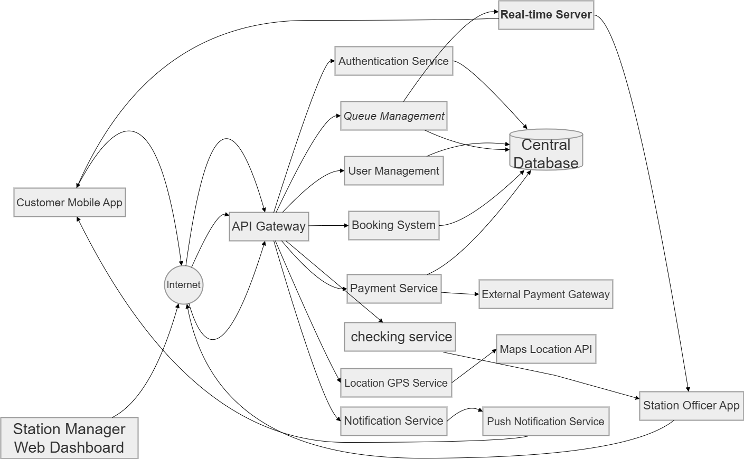
Fig.1

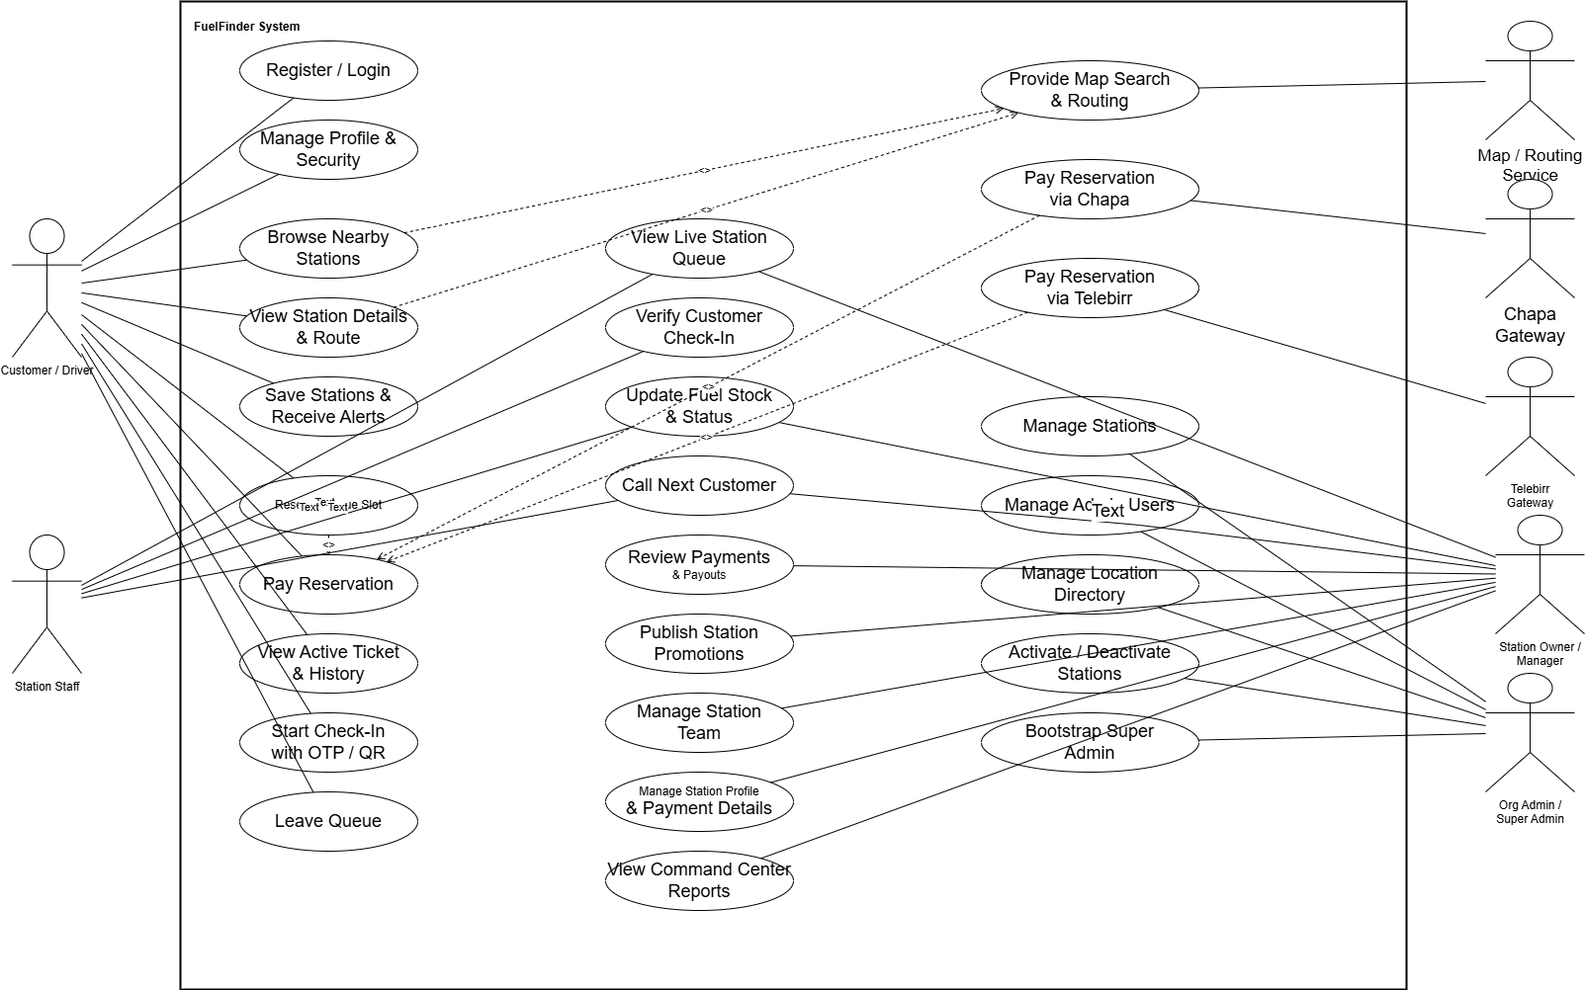

Fig-1

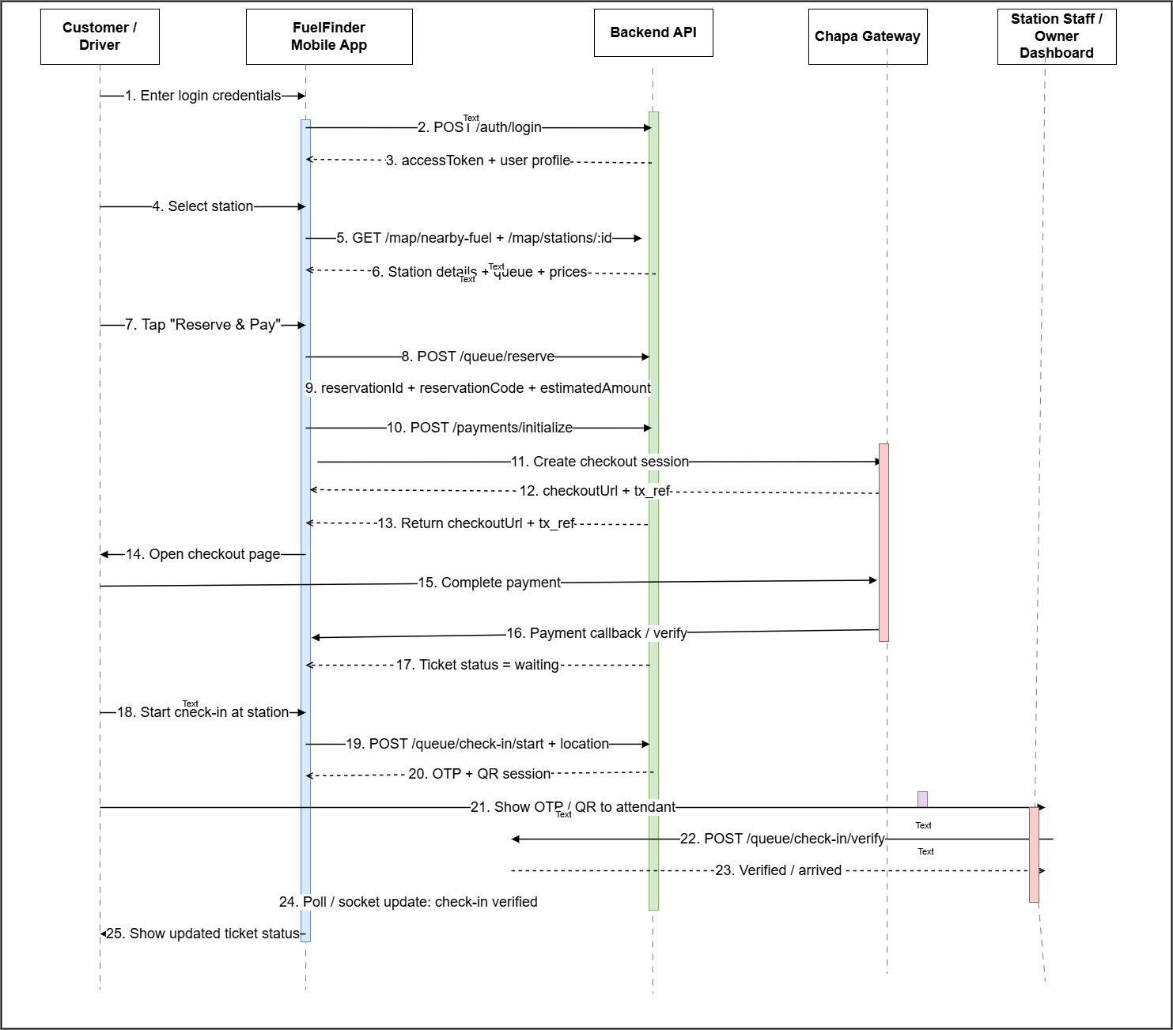

Fig.2
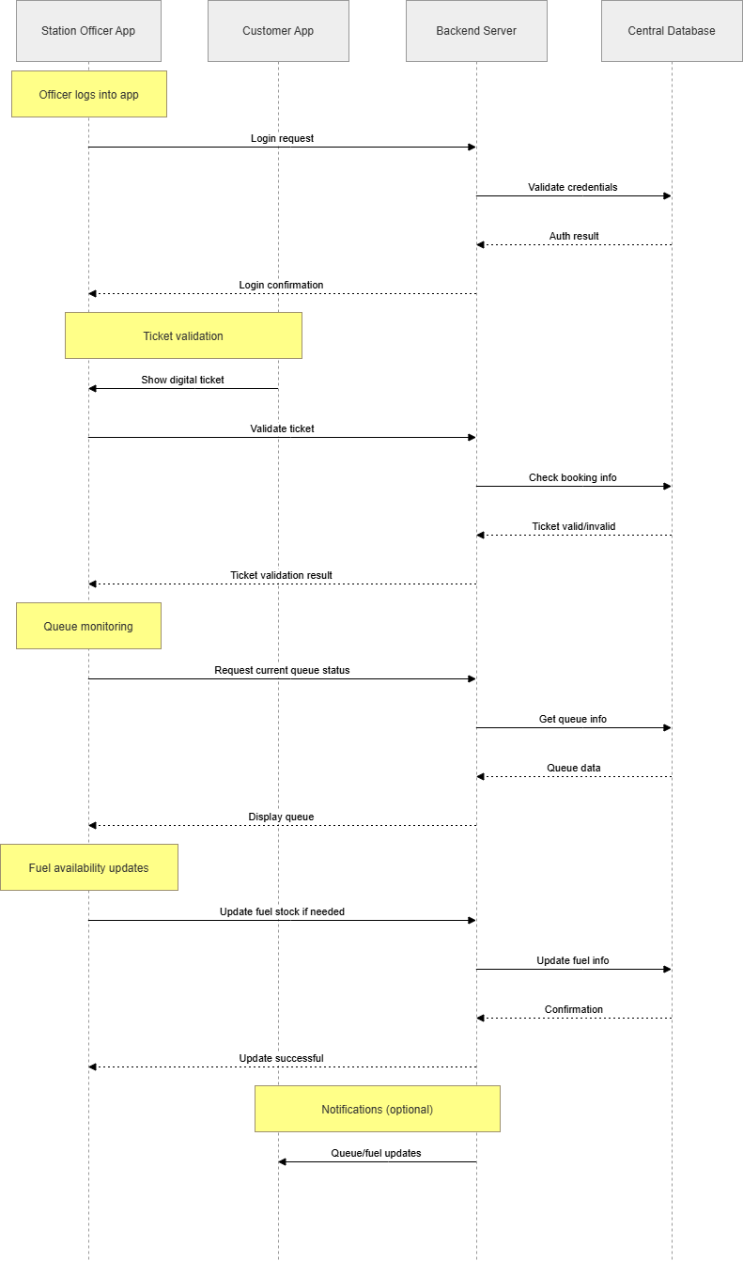
fig. 3

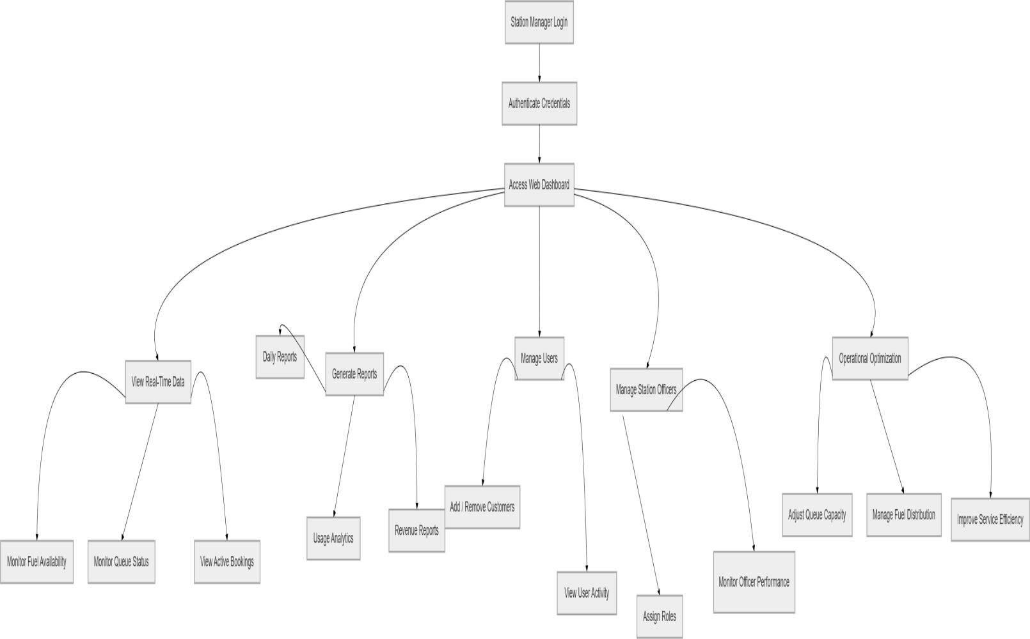

Fig. 4
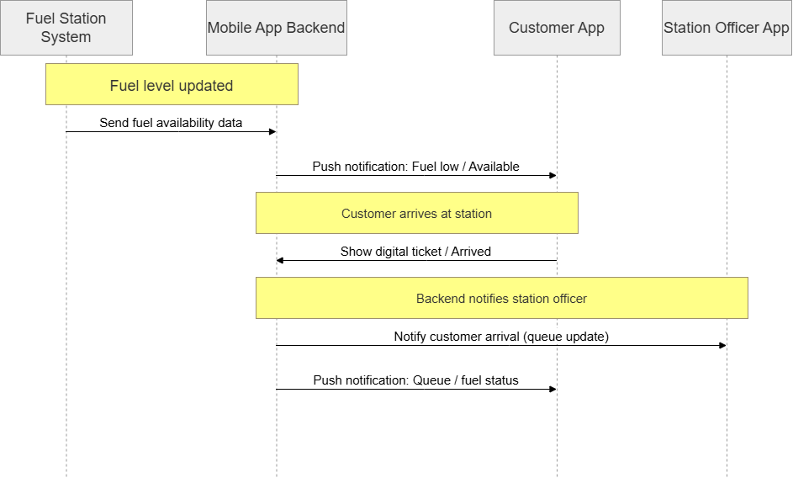Fig.5

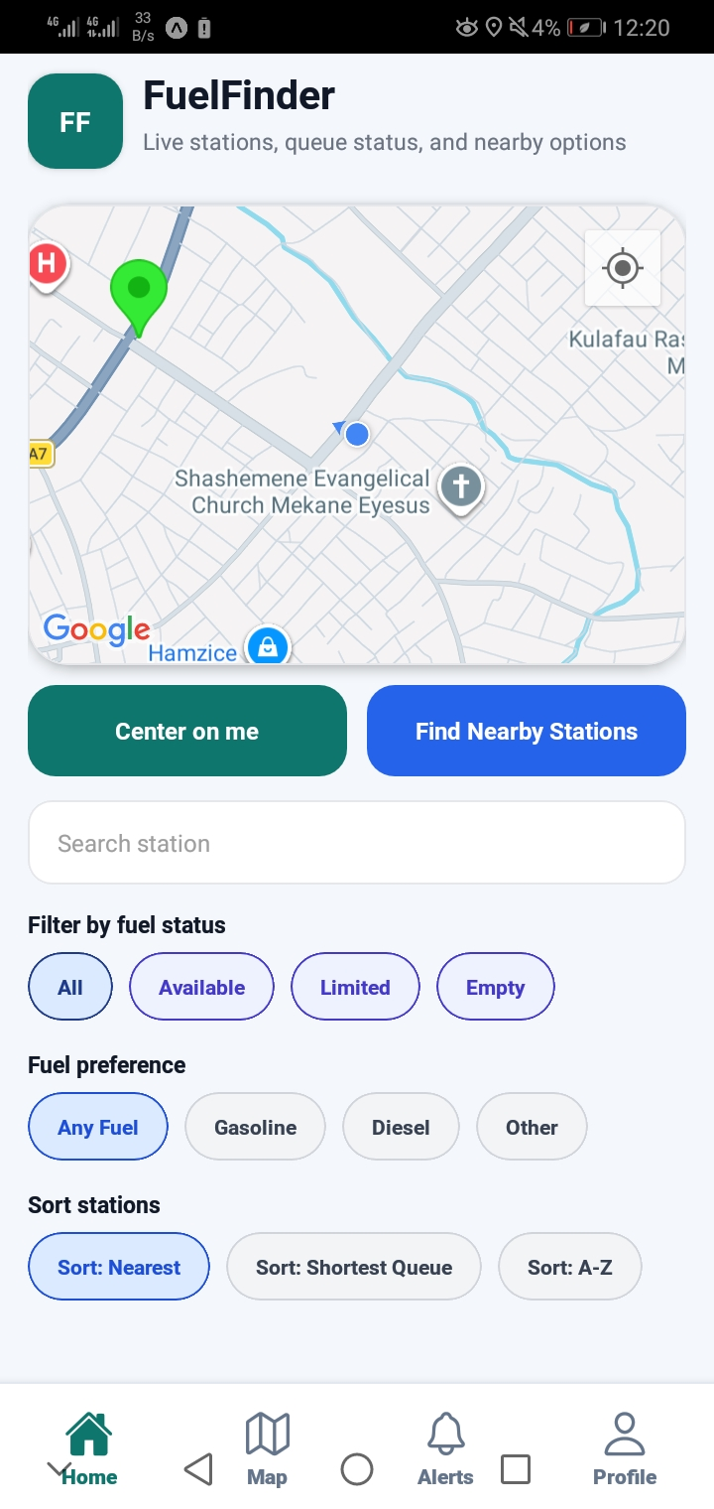

Figure 1 No.1 Customer Mobile Application,

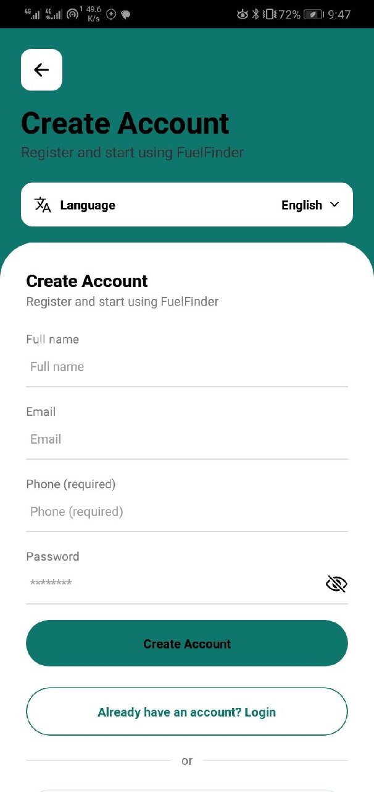
Fig 1 No.2.
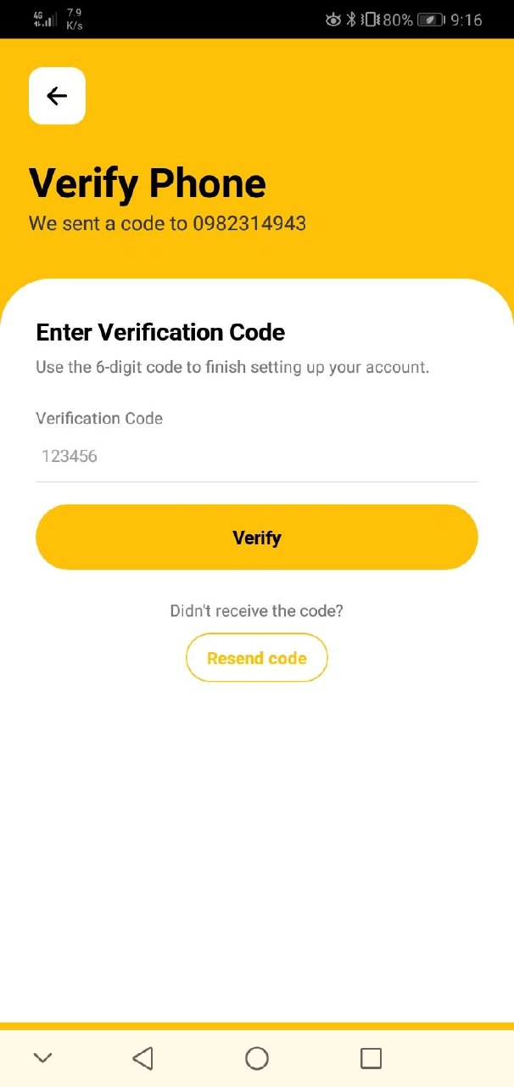

Fig 1 No.2 .1

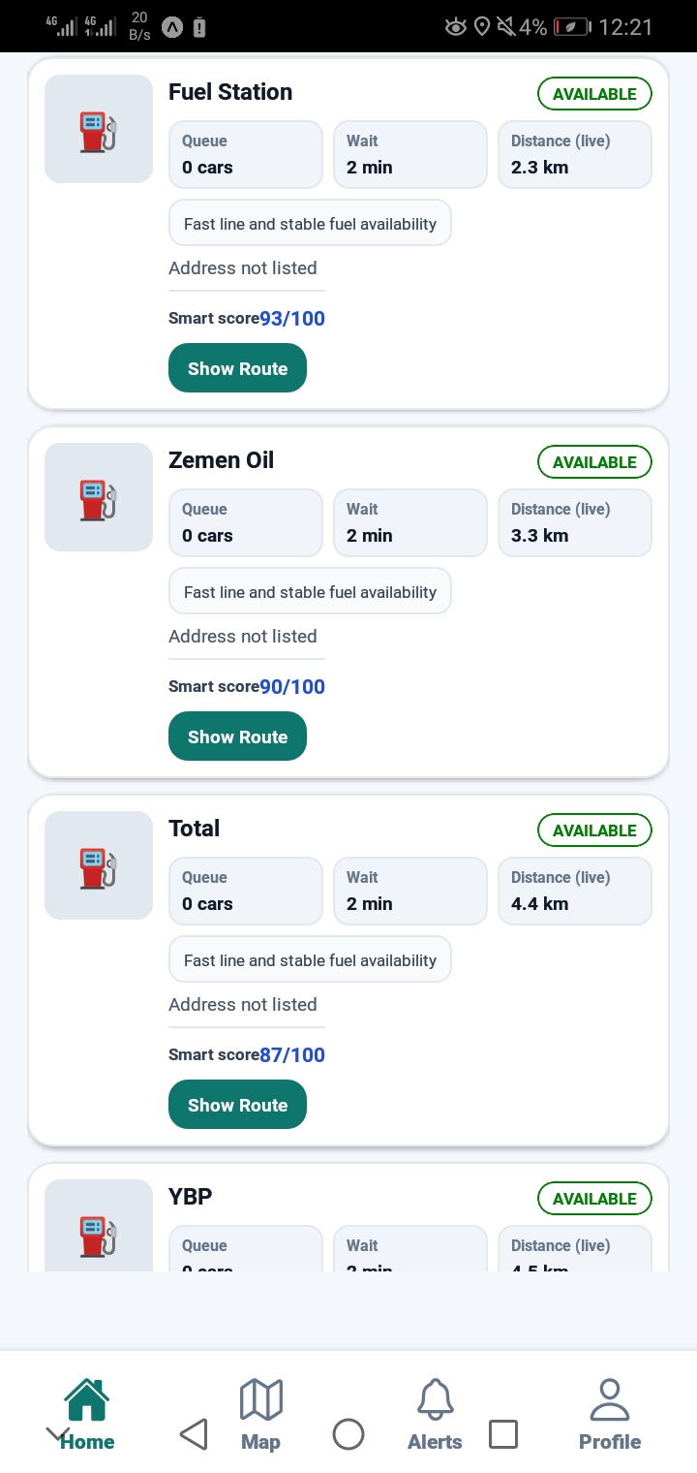
Fig1 No.3

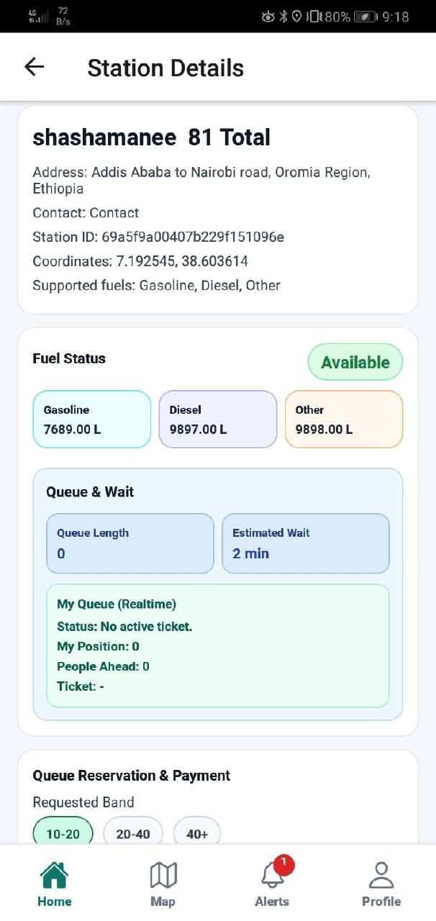

Fig 1 No.4

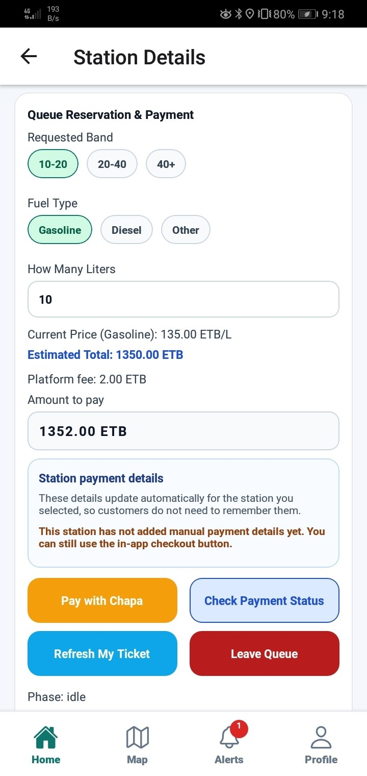
Fig 1 No.5

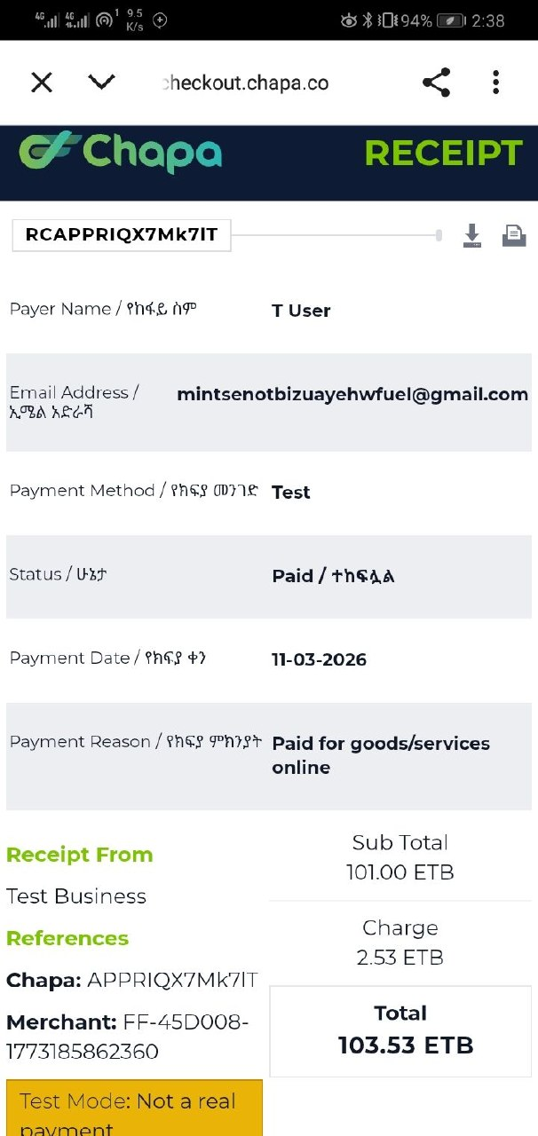
Fig 1 No.6

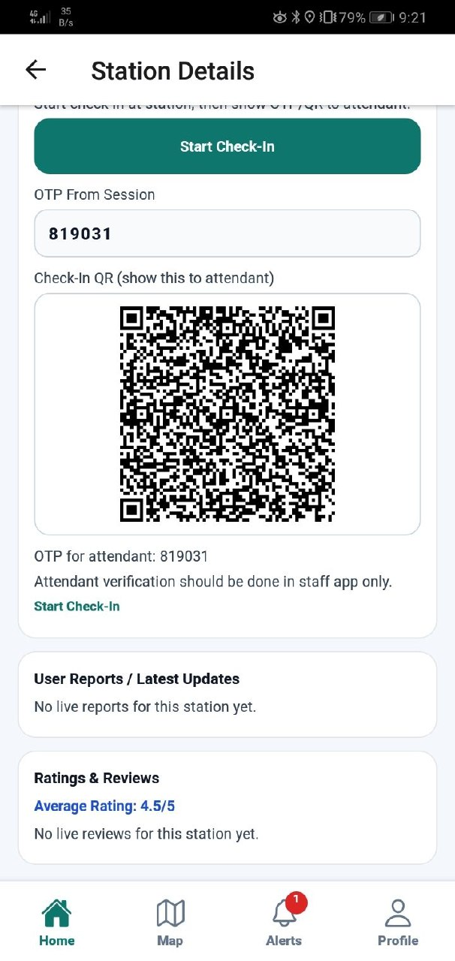
Fig 1 No.7

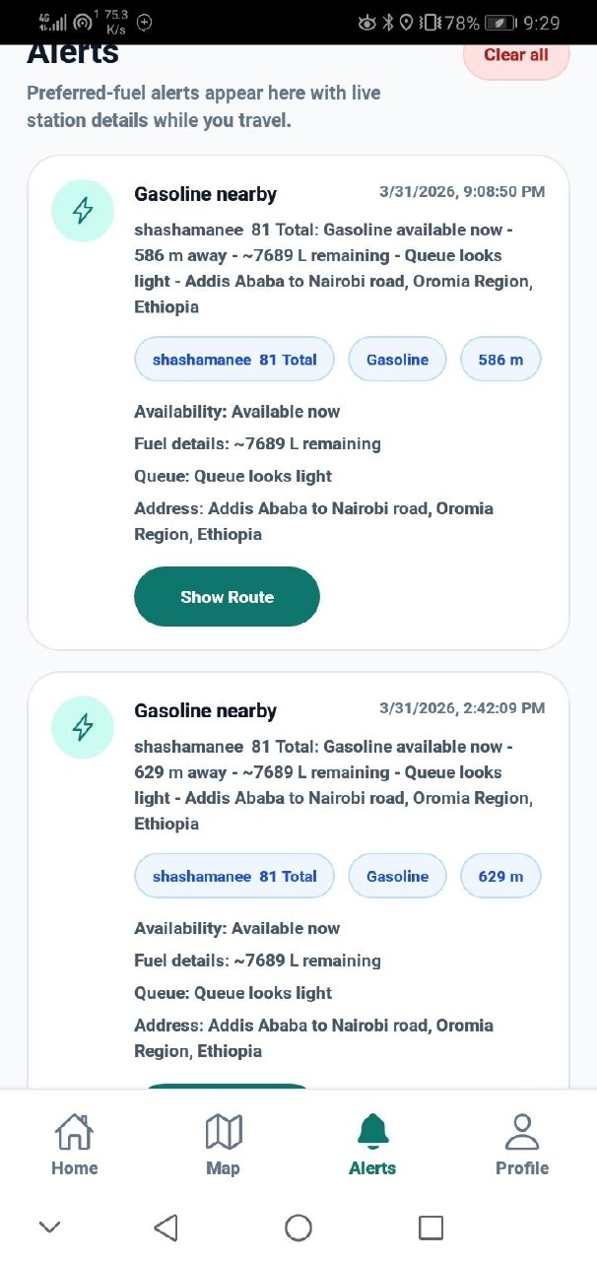

Fig1 No.8

2 Station Officer Mobile Application
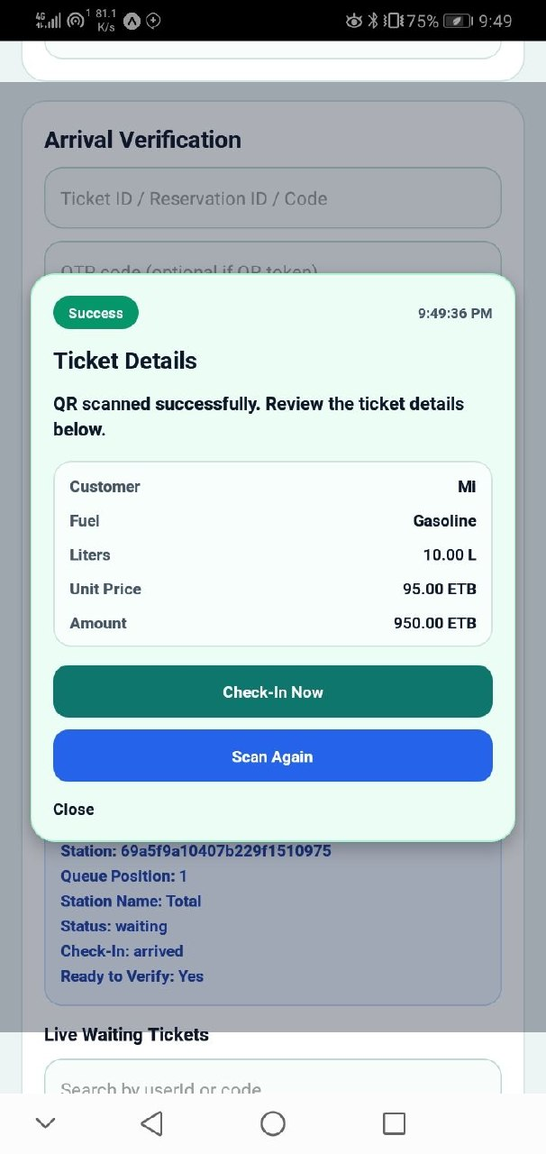

Fig 2 No.1

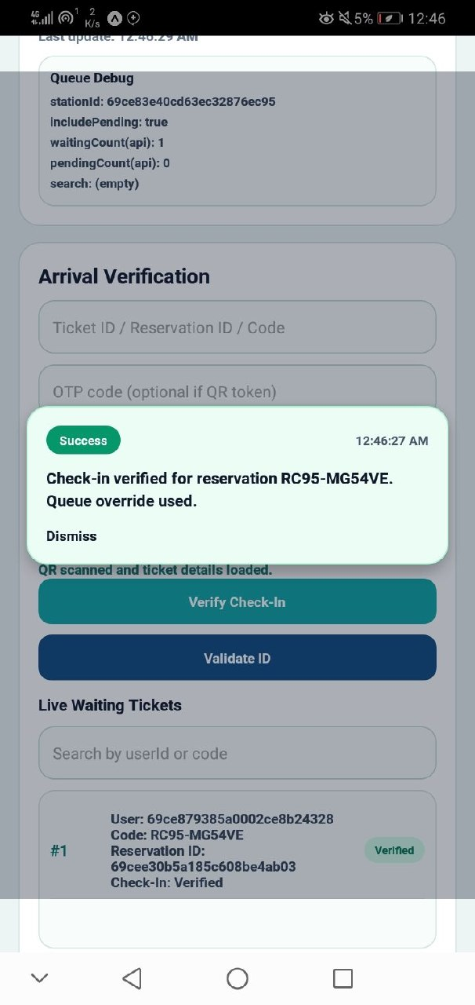

Fig 2 No.2

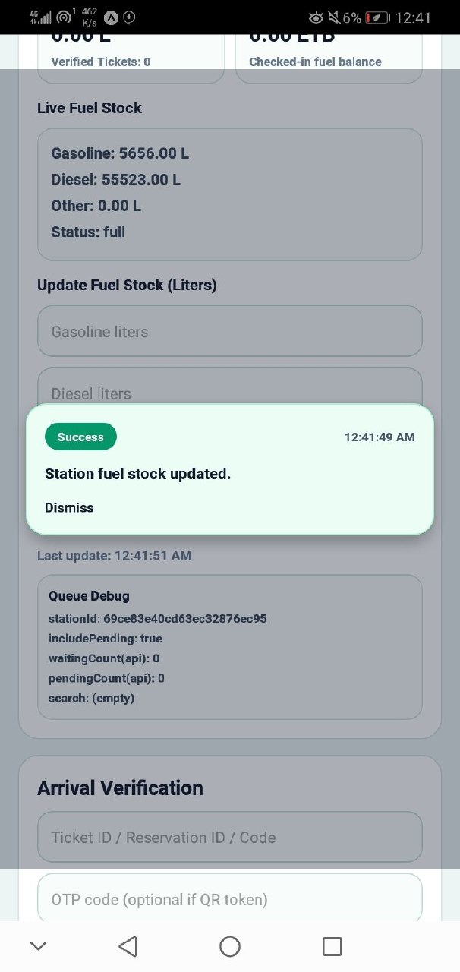

Fig 2 No.3

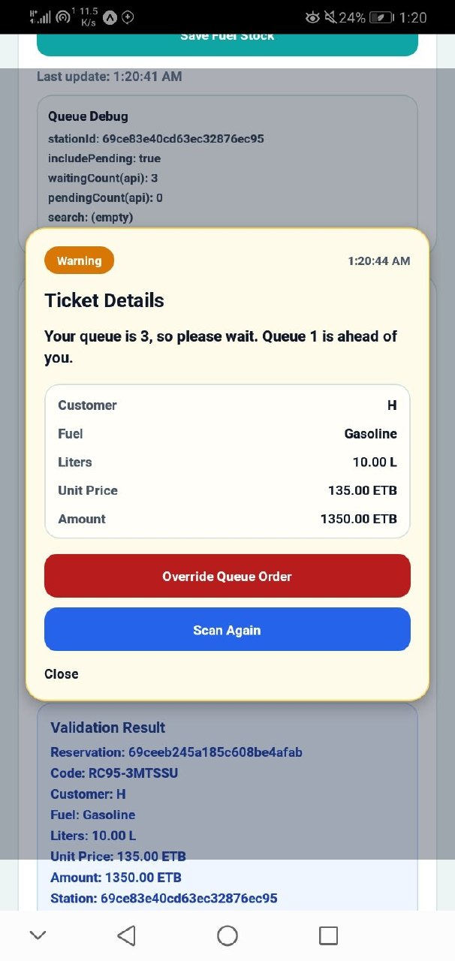

Figure 2 No.4

3 Station Manager Web Dashboard
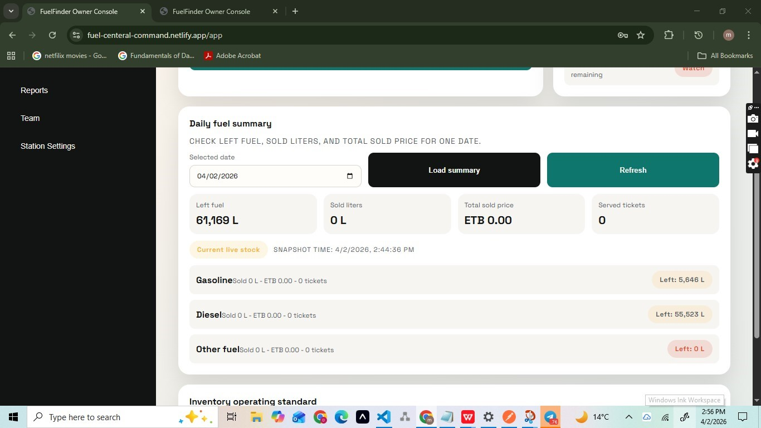

Fig 3 No.1

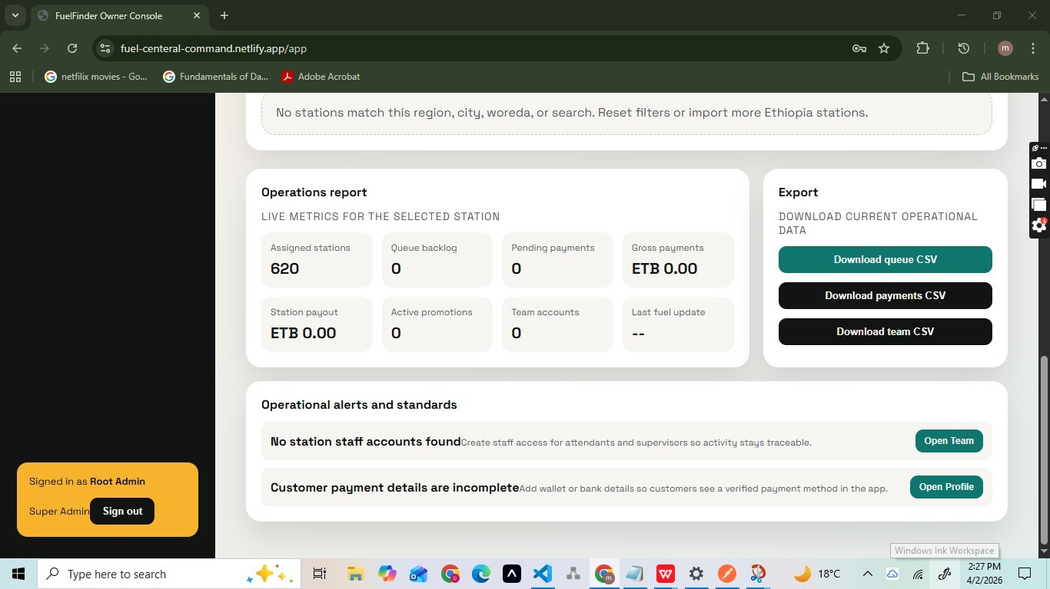

Fig 3 No.2

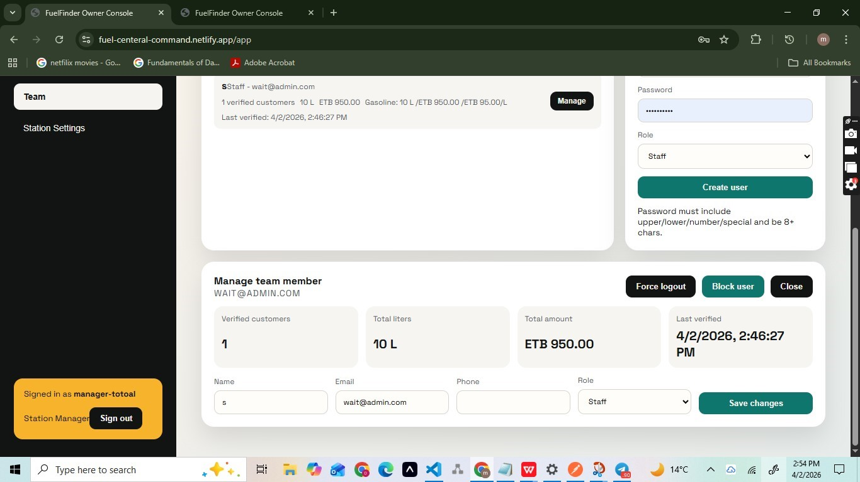

Fig3 No.3

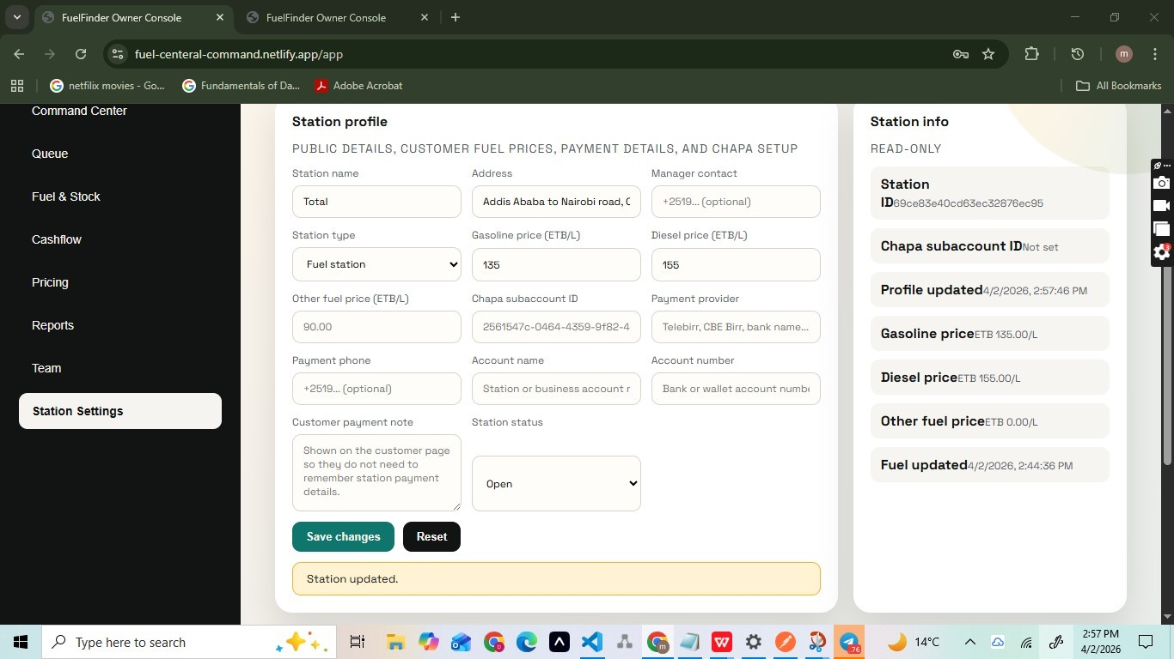

Fig3 No.4

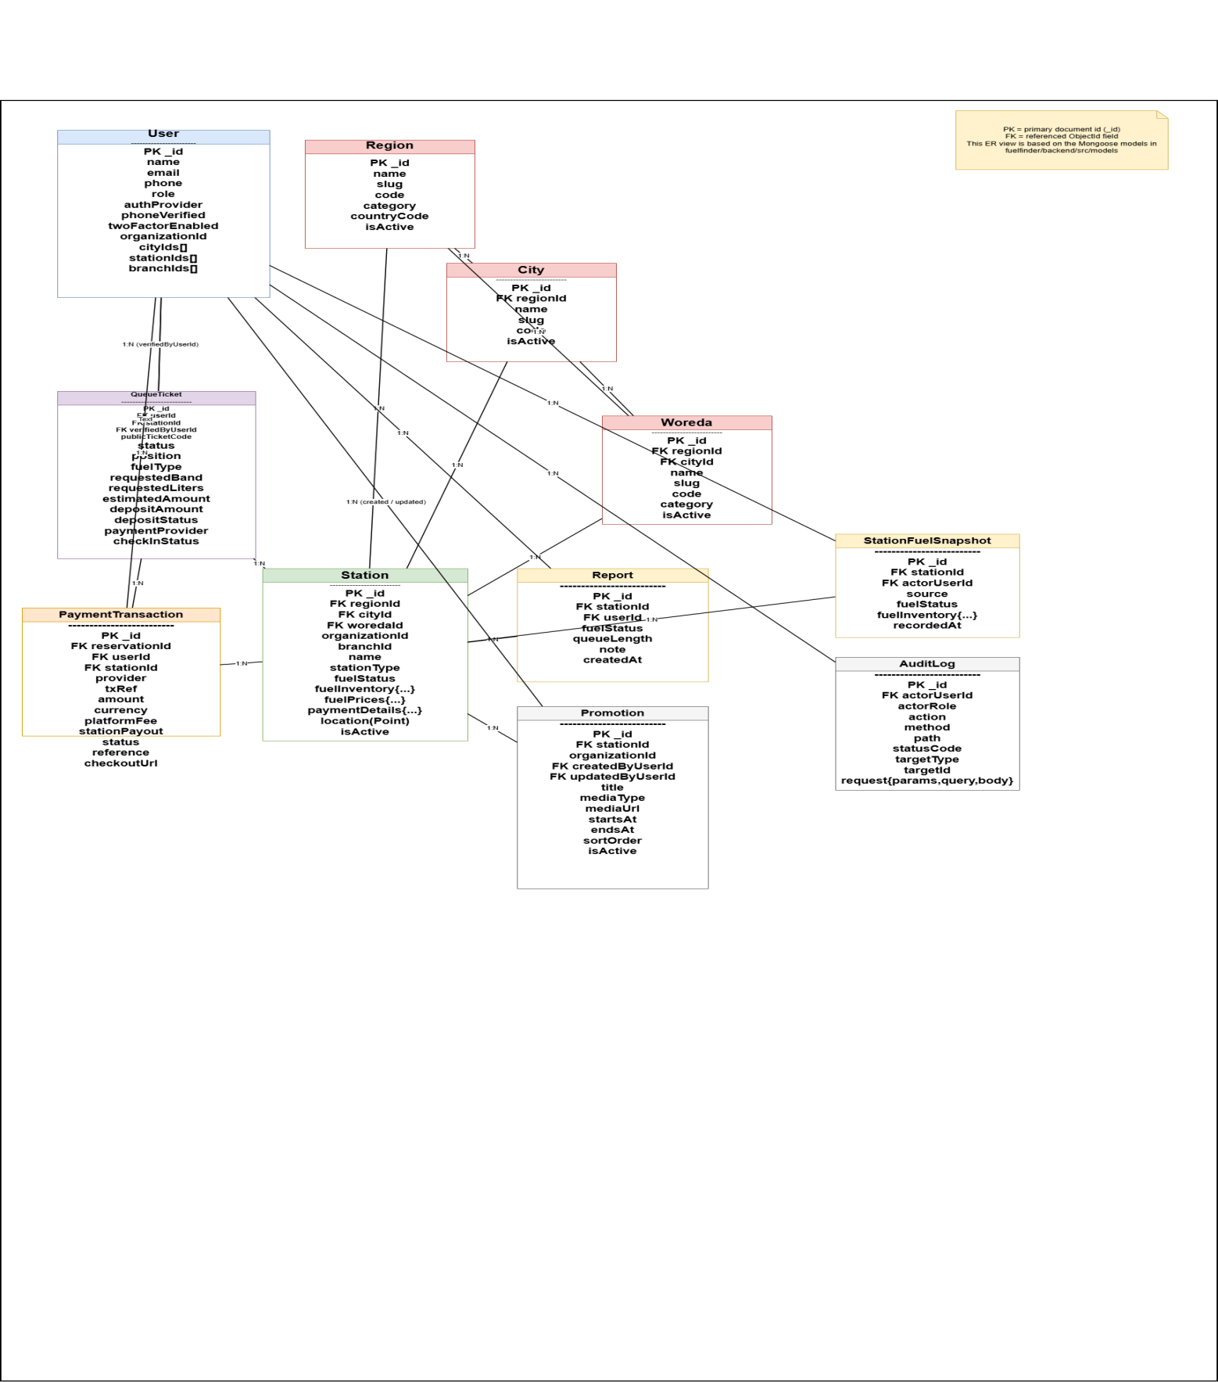

Figure 4 No.1

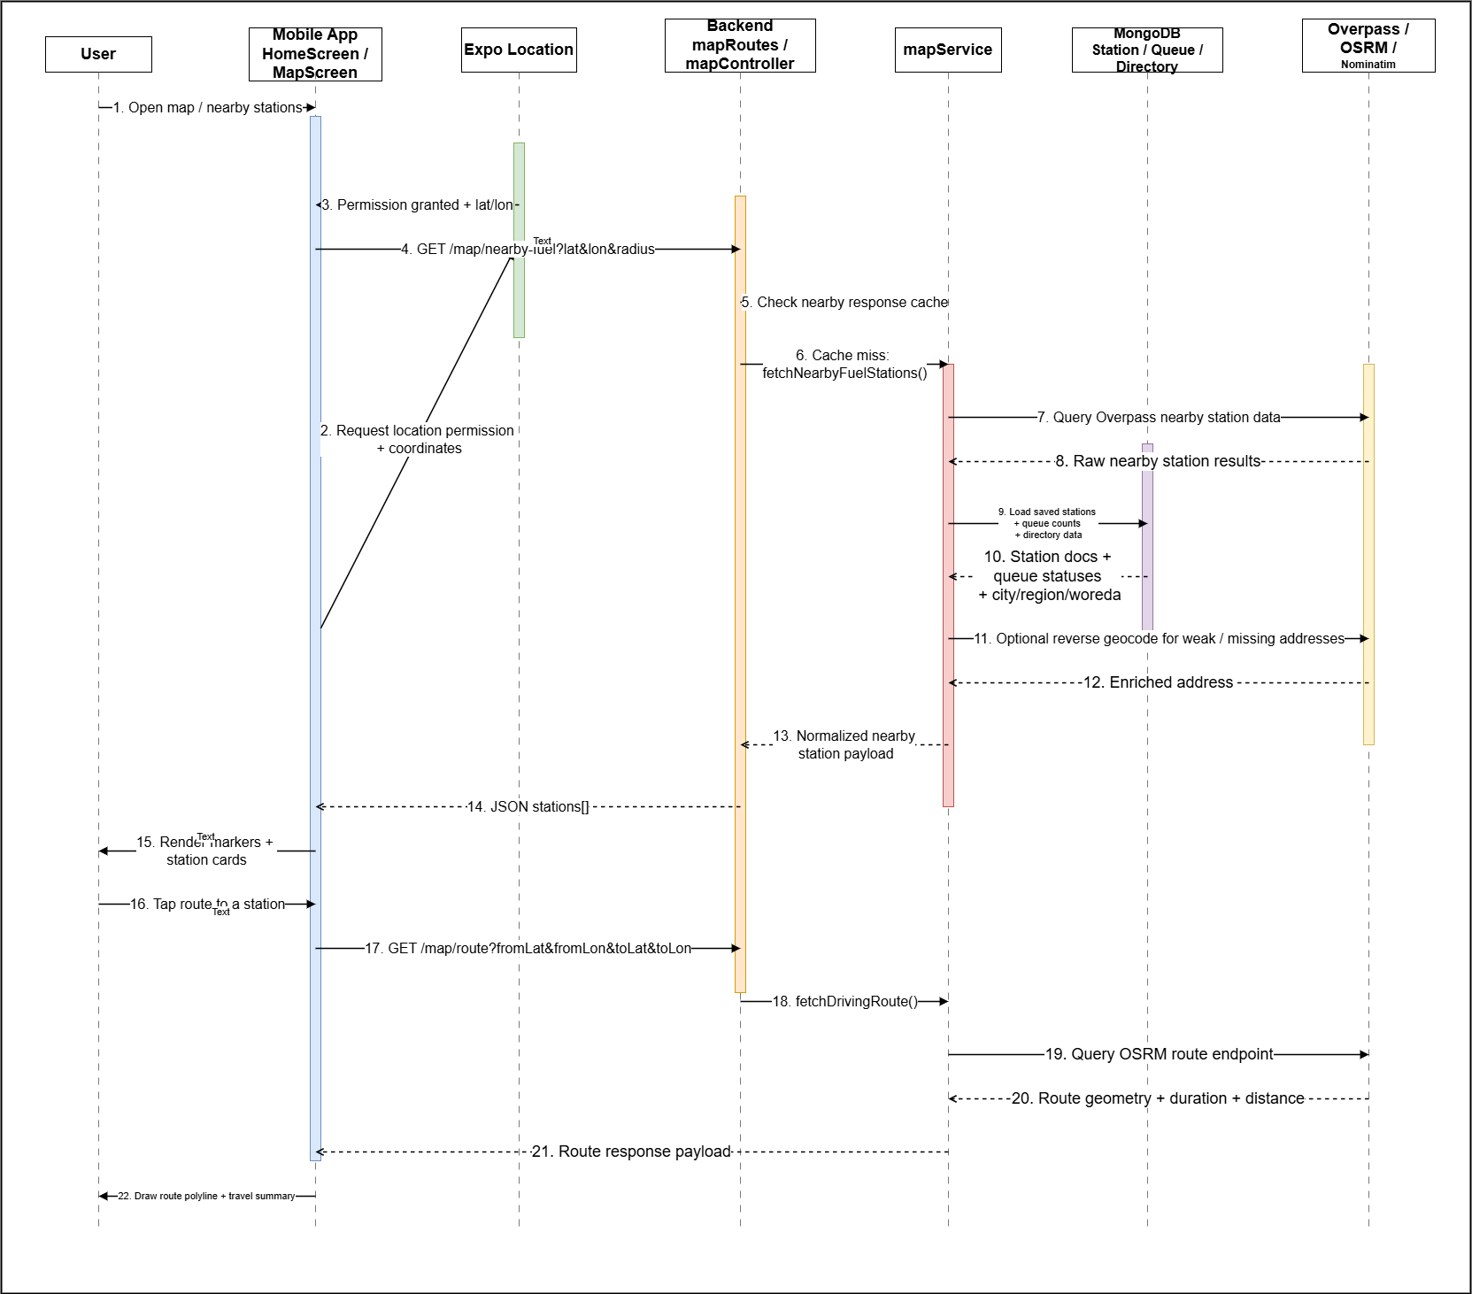
Fig4 No.2
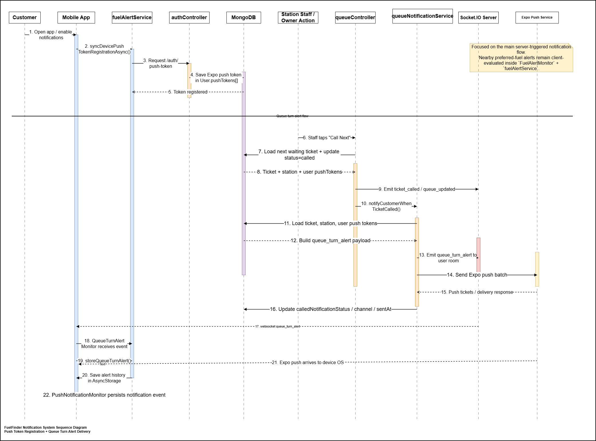
Fig 4 No.3
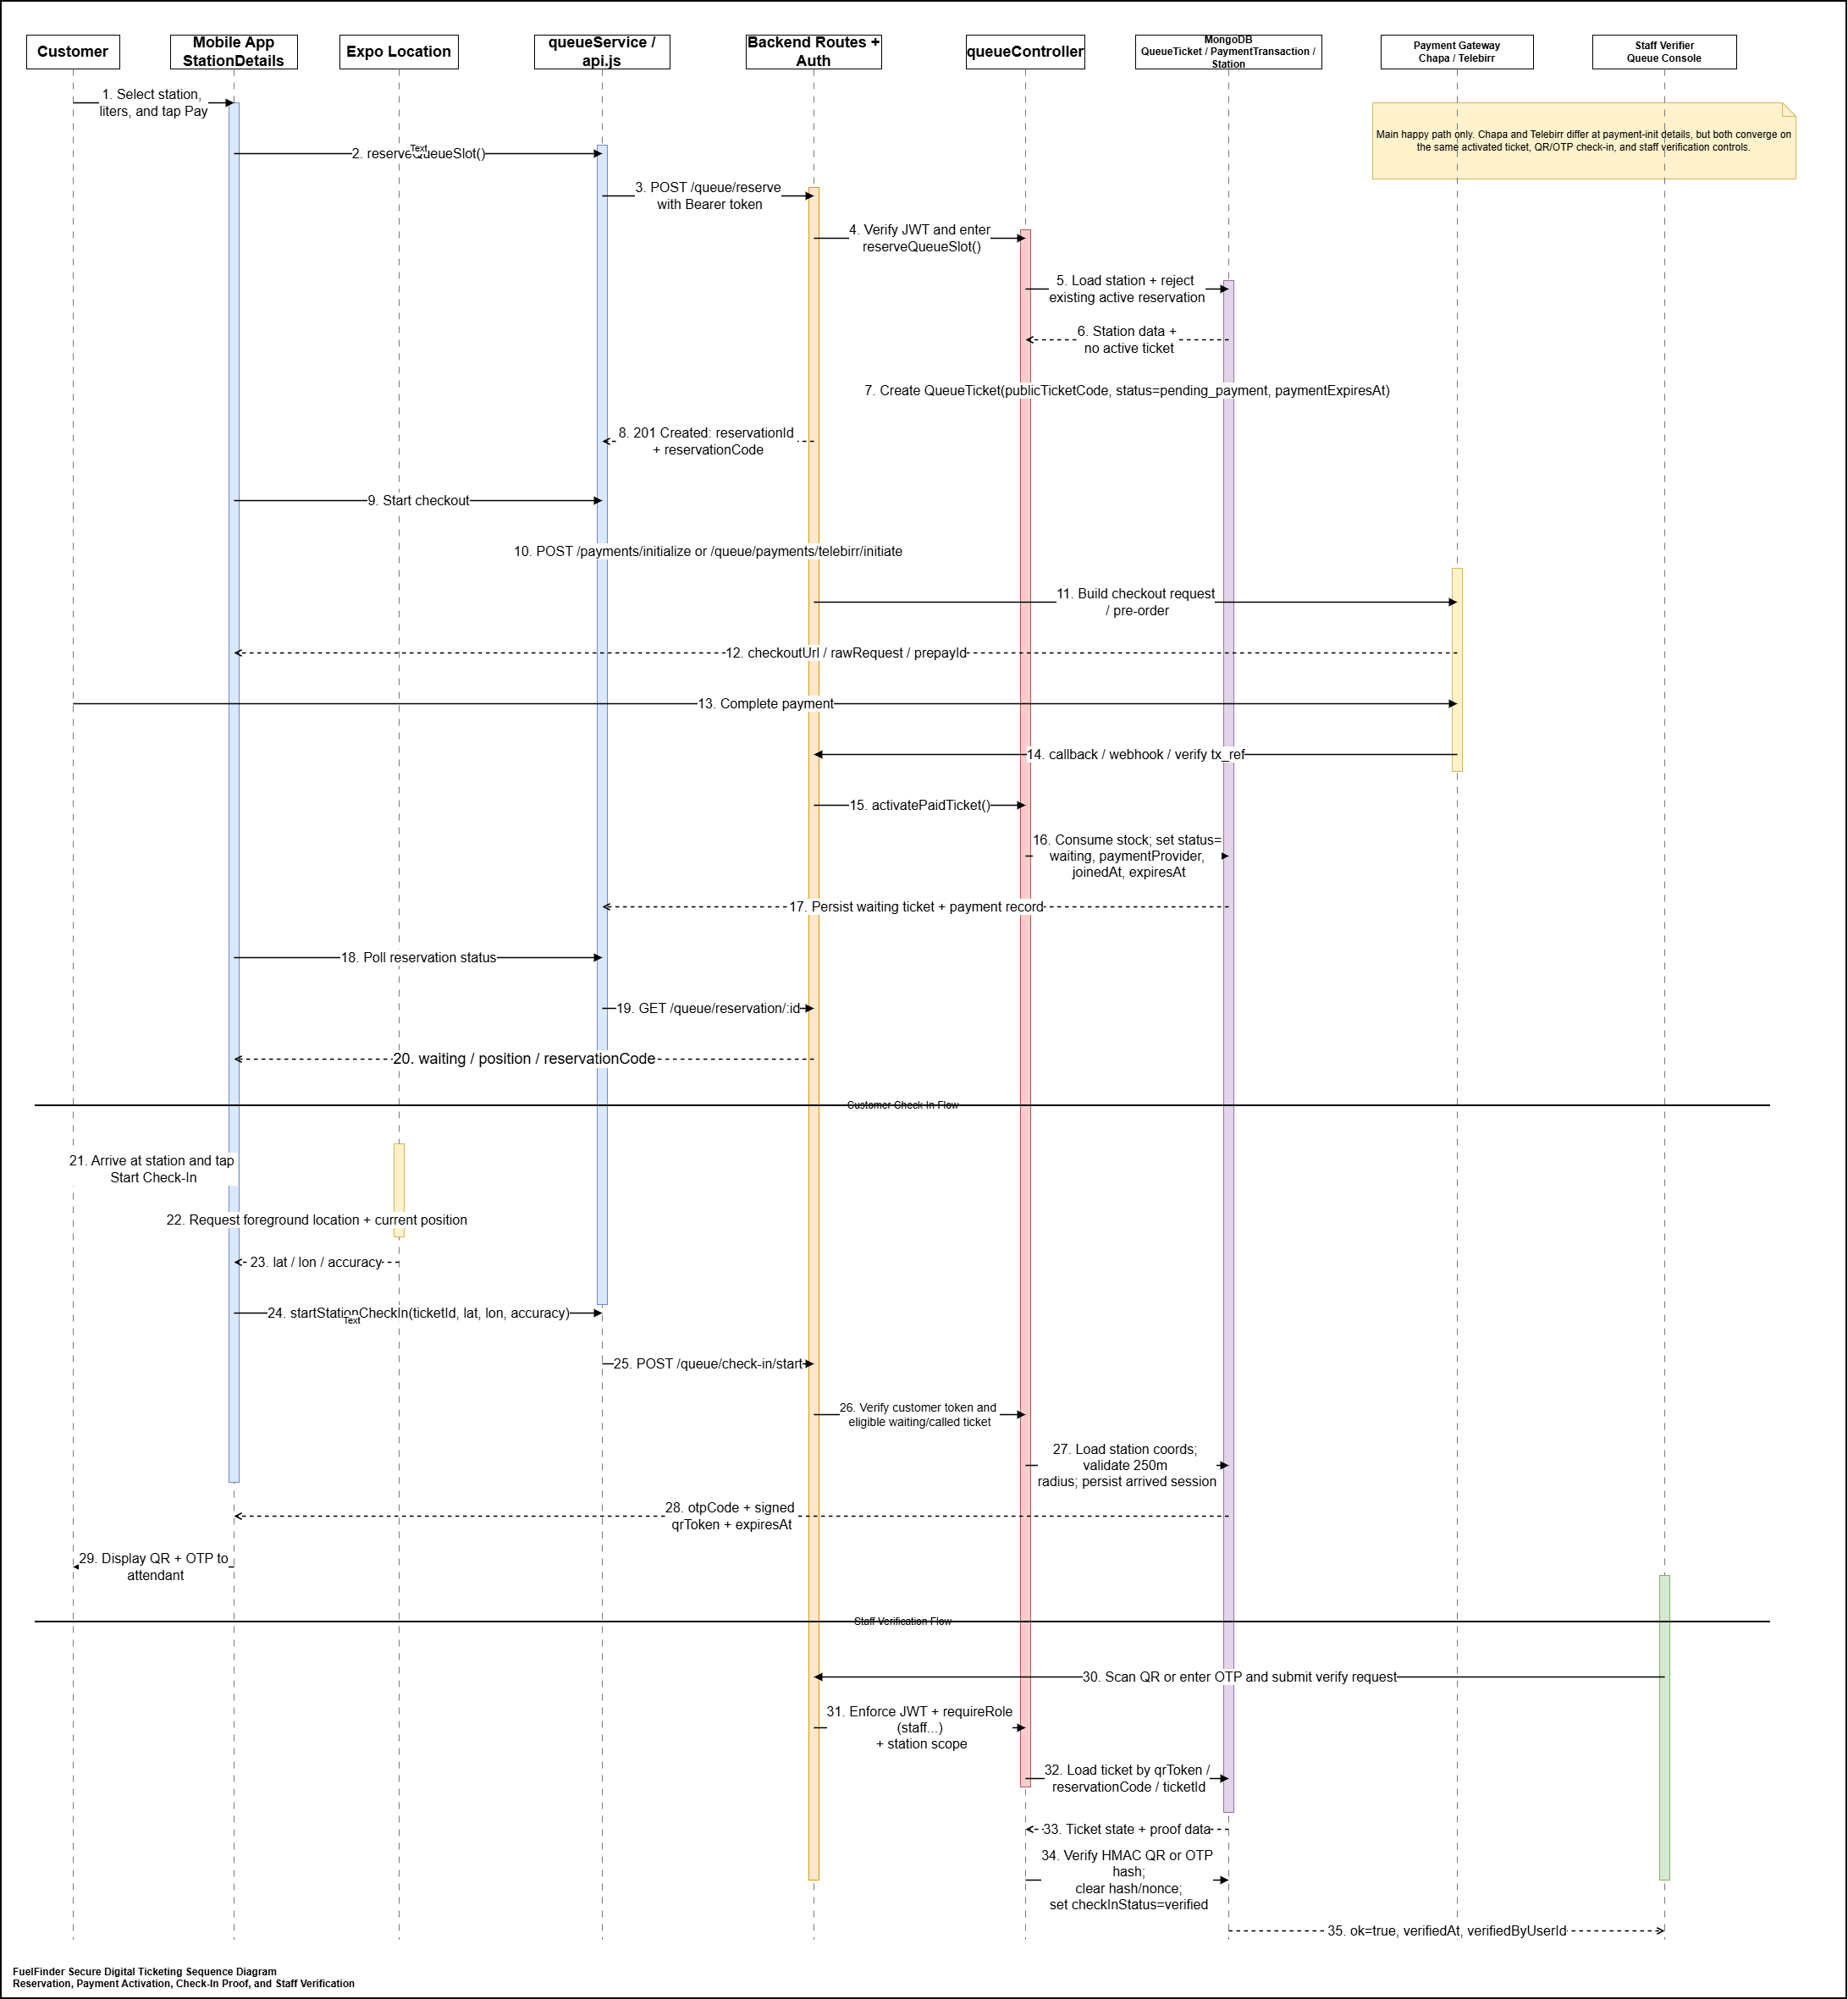 Fig4 No.4
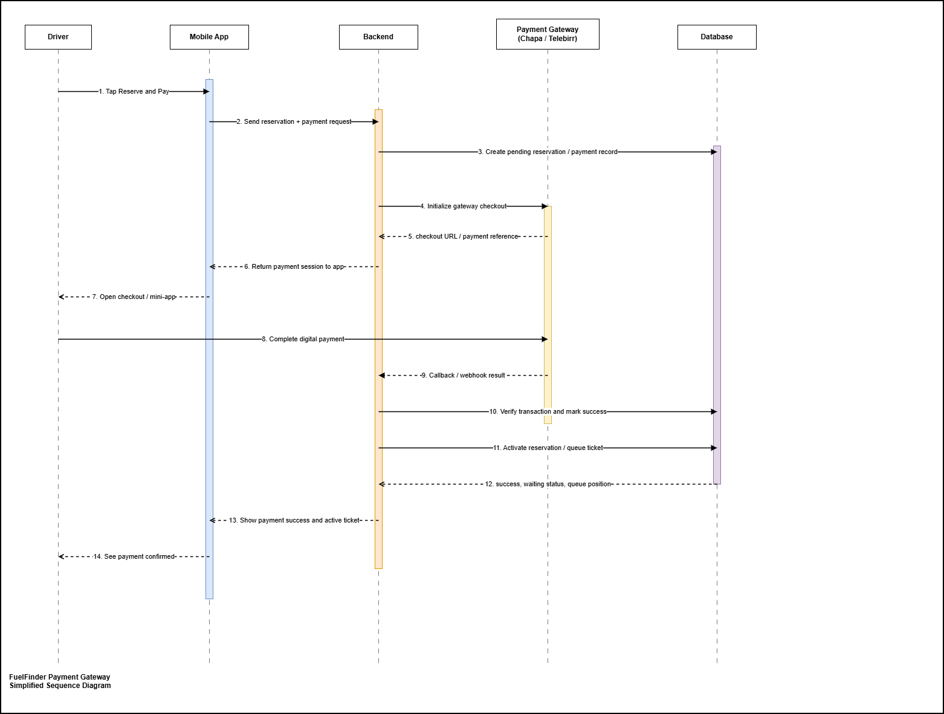
Fig 4 No.5
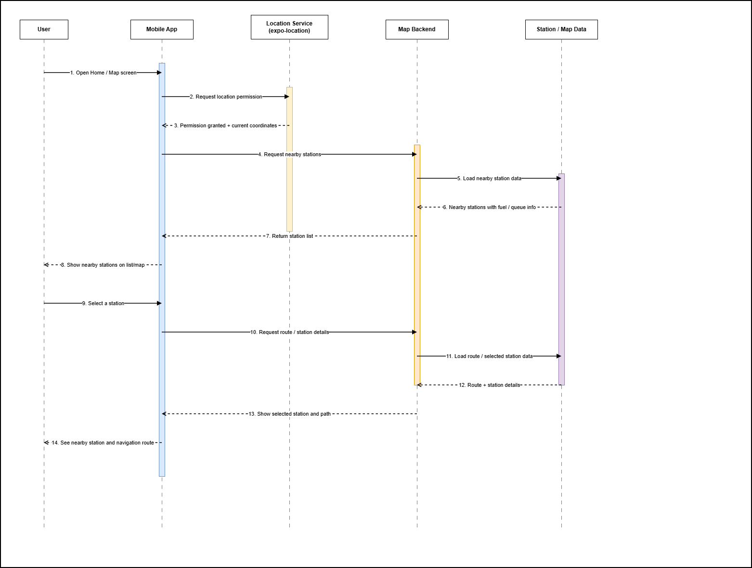
Figure 5 No.1
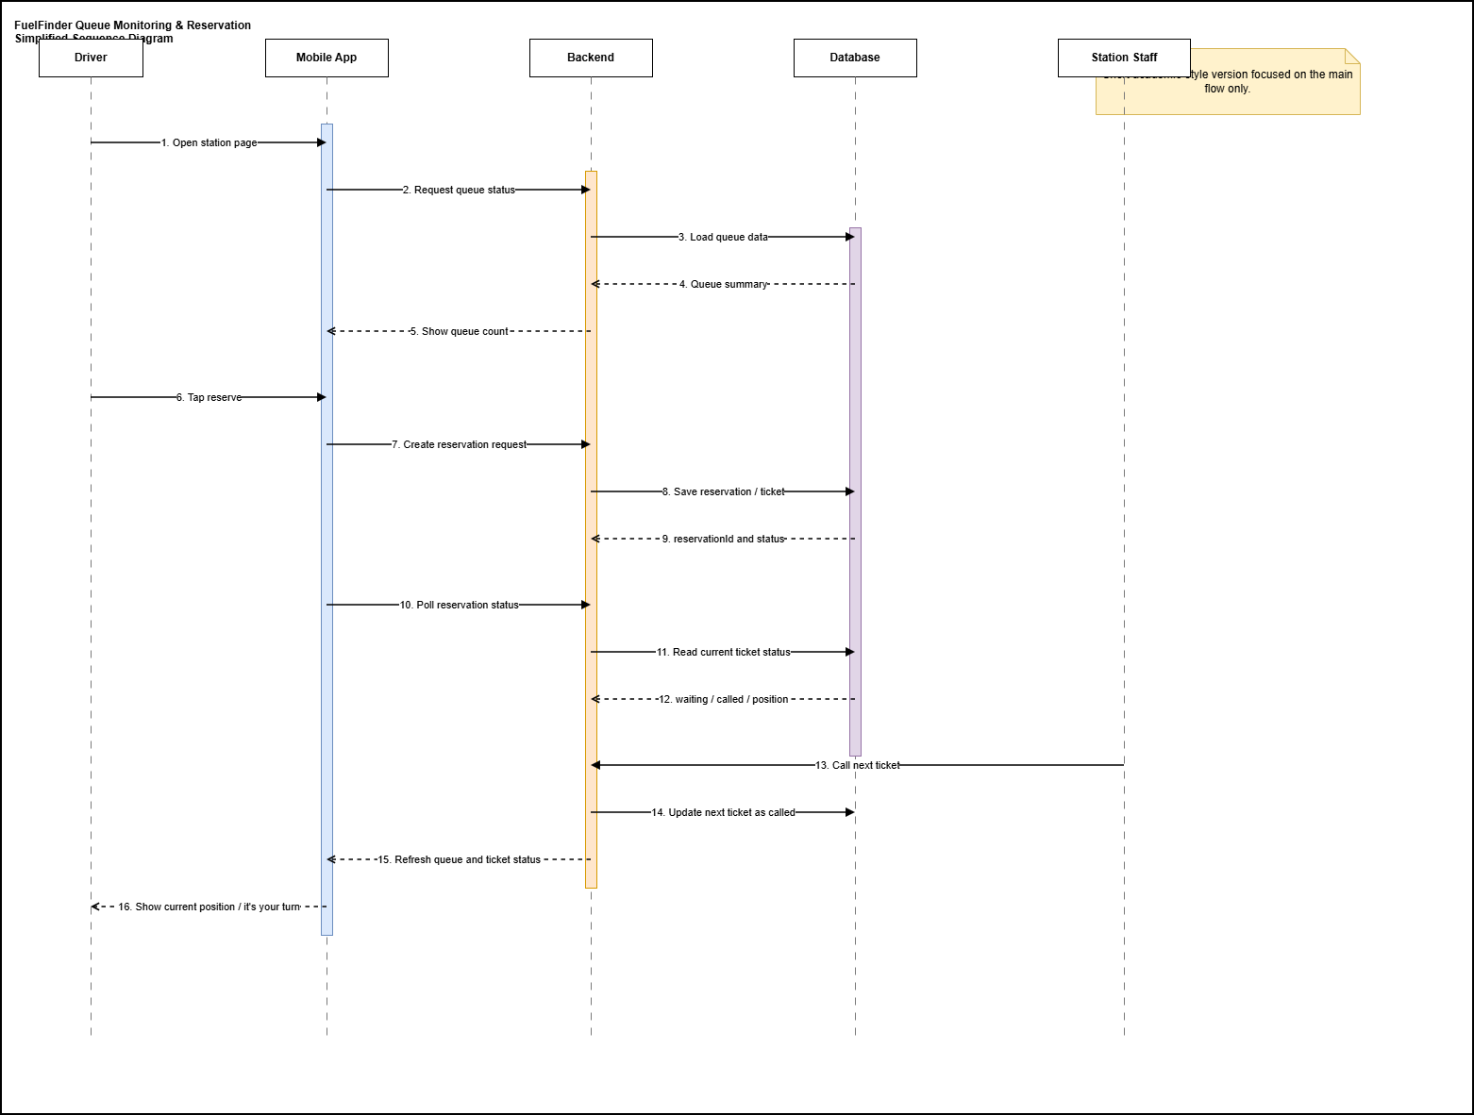
Fig5 No.2
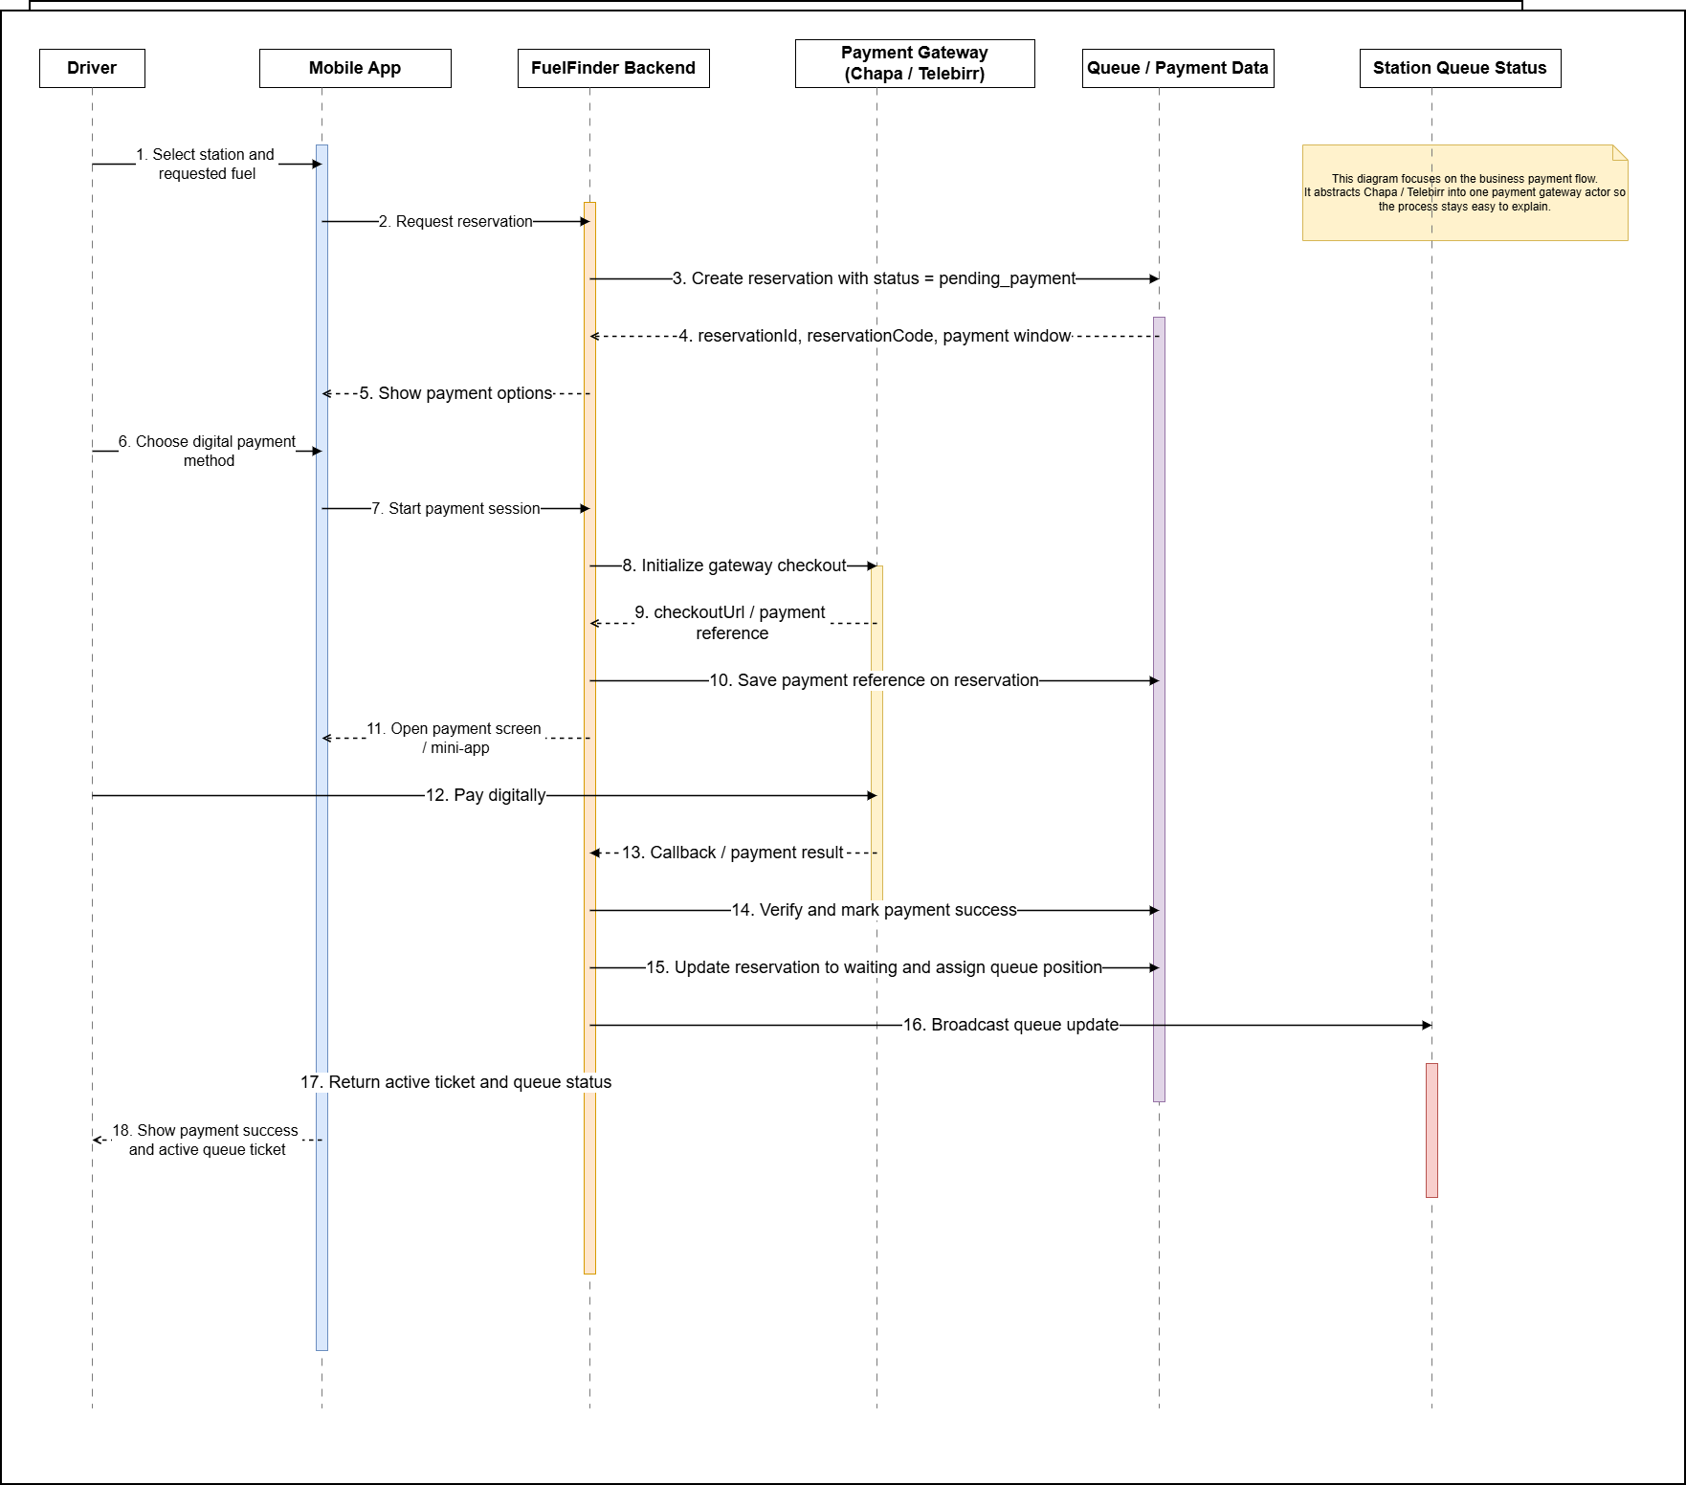

Fig5 No.3

Figure 5 No.4
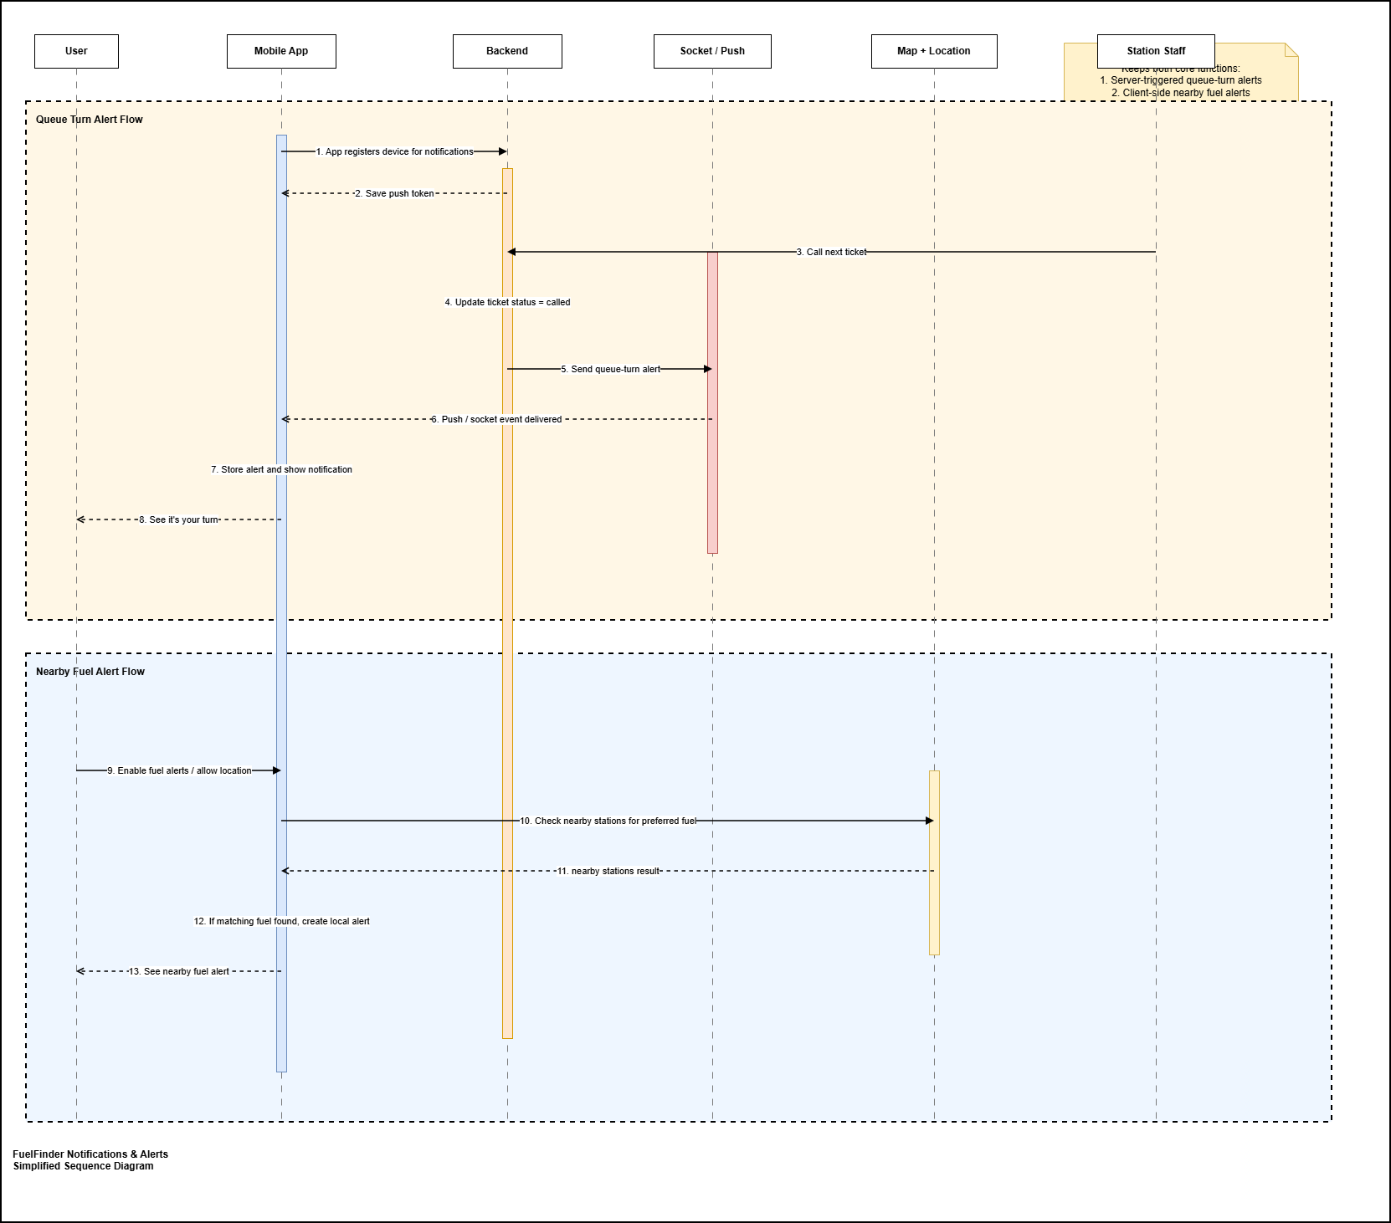
Fig 5 No.5

- BACKGROUND OF THE INNOVATION
Project Background
Fuel-finder was developed in response to a practical and recurring transportation problem: drivers often do not know which fuel stations are open, which stations still have fuel available, how long the queue is, how far the station is, or whether the time and fuel spent reaching that station will be worthwhile. In environments where fuel supply can change quickly and customer demand can surge without warning, this lack of visibility creates wasted trips, long wait times, confusion, traffic pressure around stations, and frustration for drivers
At the beginning, the project idea was not simply to build another map application. The deeper goal was to reduce uncertainty in fuel access by giving users timely, location-aware, and operationally useful information. Instead of forcing people to rely on rumors, phone calls, physical observation, or trial-and-error travel, Fuel-Finder aims to give them a digital way to discover stations, evaluate station conditions, and make better decisions before they commit to a trip.

This means the project sits at the intersection of mobility, location services, queue management, digital payments, and station operations. From the user perspective, the app helps answer a set of real questions:
- Which station near me has fuel?
- How far away is it?
- What is the queue situation there?
- What fuel type is available?
- Can I reserve a place before I arrive?
- Can I pay in advance and reduce waiting time?
- How do I get there quickly and confirm my turn when I arrive?

These questions show why Fuel-Finder is larger than a traditional station directory. A normal directory can list names and coordinates, but it does not solve the operational problem of fuel access under pressure. Fuel-Finder tries to solve that broader problem by combining discovery, queue handling, real-time updates, payments, and check-in into one connected flow.

Problem Context
The background of the app is rooted in the everyday inefficiencies that appear when fuel access is uncertain. In many real-world situations, customers may drive from station to station only to discover that a station is out of stock, temporarily inactive, overcrowded, or serving a fuel type they do not need. This wastes time, increases fuel consumption, causes frustration, and reduces trust in station information. At the same time, station staff may be forced to manage heavy queues manually while also answering repeated questions from customers about stock levels, expected waiting times, and payment procedures.

Fuel-finder addresses this problem by treating fuel access as an information and coordination challenge. The app assumes that the main pain point is not only the physical lack of fuel, but also the lack of reliable visibility around fuel availability, queue movement, and station readiness. By improving visibility, the app aims to improve customer planning, reduce unnecessary travel, support orderly service, and make the overall station experience more predictable.

Product Vision
The long-term vision behind Fuel-Finder is to become a digital coordination platform for fuel station access and station management. In that vision, the platform does not only help a driver find a nearby station. It also helps the station communicate its current operational state to customers, and it helps owners and administrators manage the station more effectively behind the scenes.

This is why the project contains both customer-facing and operator-facing capabilities. On the customer side, the focus is convenience, speed, confidence, and better decision-making. On the station side, the focus is control, operational visibility, staff coordination, payment traceability, and improved service flow. The project therefore reflects a two-sided platform model:
- Customer side: discover stations, view status, compare options, route to stations, reserve queue slots, pay, receive updates, and check in.
- Operator side: manage stations, update fuel stock, observe queue pressure, track payments, manage staff access, maintain station details, and support promotions or operational changes.

Core Business Logic Behind The Platform
The app is built around a simple but powerful operational flow:
1. A customer discovers nearby stations.
2. The system shows useful context such as fuel status, queue length, distance, and route.
3. The customer can reserve a slot or join the queue remotely.
4. Payment can be initiated digitally before or during the queue process.
5. The station can manage the queue and fuel inventory in near real time.
6. The customer checks in when arriving at the station.
7. Staff can validate the customer and move the queue forward.

This flow is important because it reveals the real background of the project: Fuel-finder was designed to reduce friction from end to end, not only at the discovery stage. The system tries to connect the entire journey from search to service completion.

Local And Market Context
A major part of the app's background is its local orientation. The project is clearly adapted to the Ethiopian context rather than being a generic global template. This is visible in several ways:
- support for multiple Ethiopian languages in the mobile experience,
- Ethiopia-specific administrative location structures such as regions, cities, and woredas,
- integration with payment platforms such as Telebirr and Chapa,
- import and enrichment workflows for Ethiopian fuel and electric station datasets,
- handling of ETB-oriented payment and station operations use cases.

This localization matters because transportation and payment behavior are highly context-dependent. An application that works well in one country may fail in another if it ignores local languages, local payment systems, and local geographic structures. Fuel-Finder's background therefore includes not only a technical goal, but also a localization goal: to make the platform usable and relevant in the environment it is intended to serve.

Fuel-finder is designed for several categories of users, and this multi-role design is central to understanding the project background.

Customers are the first and most visible group. They need fast access to trustworthy information about station availability, queue conditions, route options, and payment steps. For them, the app reduces uncertainty and helps them save time.

Station staff and station managers are another important group. They need tools for handling queue progression, fuel status updates, stock awareness, and customer check-in. For them, the platform supports smoother service operations and less manual confusion.

Organization-level admins and super admins represent the management layer. They need visibility across stations, the ability to manage users and permissions, station setup, payment monitoring, location directory data, and overall operational oversight. For them, the platform serves as a control and administration system.

Because these groups have different responsibilities, the project evolved toward role-based access and scoped permissions rather than a single shared interface. That design choice shows maturity in the product background: the platform is intended to operate in a real organizational setting, not only as a single-user demo app.

Evolution Of The Project
The project also has an architectural background worth noting. Earlier planning notes suggest the idea began as a broader startup-style concept for a production-grade system, with emphasis on scalability, monetization readiness, clean architecture, and operational seriousness. As implementation progressed, the technical realization became a React Native mobile application backed by a Node.js/Express and MongoDB backend, with additional owner/admin-facing web interfaces in the wider workspace.

This evolution is significant because it shows that FuelFinder matured from a concept about fuel discovery into a fuller ecosystem:
- a customer mobile application,
- a backend service for authentication, queue management, maps, payments, and realtime communication,
- administrative and owner workflows for station control,
- data import and location management tooling for Ethiopia-focused station records.

In other words, the app did not stay at the level of a prototype map screen. It moved toward an operational platform with live services, roles, data management, and business workflows.

Real-time capability is a core part of the app's background because the fuel access problem is dynamic. A station that has fuel now may not have fuel later. A short queue can quickly become a long one. A customer who reserved a slot needs timely updates. Staff need queue state changes to be reflected quickly. Because of this, the project includes real-time communication and periodic synchronization so that station and queue information can remain useful while conditions change.

Without real-time or near real-time updates, the app would be little more than a static listing system. The presence of queue events, status transitions, reservation states, and live updates shows that the app is intended to support active operations, not just passive browsing.

Payments are included because queue reservation without payment confirmation can create abuse, uncertainty, and operational inconsistency. By integrating digital payment flows, the platform adds commitment to reservations and creates a clearer transaction trail for both customers and station operators. This is especially important in a system where demand pressure can make queue slots valuable and where staff need confidence that reservations are legitimate.

The inclusion of both Telebirr and Chapa indicates that the project is trying to fit into realistic digital payment behaviors rather than treating payment as an afterthought. This broadens the app from a service-information tool into a transaction-enabled platform.
One of the most important things to understand about FuelFinder is that it is not only a consumer convenience app. It is also an operations app. The owner and admin capabilities in the wider workspace show that the project recognizes a basic truth: customer experience at a station depends heavily on what station staff and managers can see and control internally.

For that reason, the platform includes concepts such as:
- fuel stock visibility,
- queue monitoring and advancement,
- payment review,
- station profile management,
- team and role management,
- location directory management,
- promotional and organizational controls.

This makes the app strategically stronger. Instead of relying entirely on customer-side reporting, it creates a path for station-side participation and system-level coordination.

Broader Significance Of The Project
From a software and product perspective, FuelFinder represents an attempt to digitize a fragmented service experience. The app brings together location intelligence, operational visibility, queue discipline, digital payment, role-based administration, and localization into one coordinated platform. That makes it relevant not only as a consumer app, but also as a case study in building software for real-world service bottlenecks.

Its broader significance lies in the fact that it transforms fuel access from an informal, uncertain, and manually coordinated process into a more transparent and manageable digital workflow. Even when supply conditions are imperfect, better information and better coordination can still improve the user experience and the efficiency of station operations.

Field of Innovation
This innovation falls under the field of Information and Communication Technology (ICT), specifically in mobile application systems, location-based services, digital queue management, and smart resource distribution systems. It further relates to real-time communication systems and fuel distribution optimization platforms.
Need for Innovation
Fuel distribution in many urban areas, particularly in Ethiopia, is characterized by long queues, lack of real-time information, inefficient service processes, and congestion at fuel stations.
Users are required to physically visit stations without knowing:
- Fuel availability
- Queue length
- Waiting time
This results in:
- Time loss and inefficiency
- Traffic congestion
- Fuel wastage
- Poor user experience and uncertainty
Additionally, there is no system to notify users when fuel becomes available nearby or fuel station status Available, limited and empty fuel, further reducing operational efficiency.
Outcomes of Prior Innovations (Prior Art)
Existing solutions provide limited capabilities such as:
- Applications for fuel station location and navigation
- Digital payment platforms
However, these systems have key limitations:
- No real-time fuel availability alerts
- No remotely queue reservation systems
- No customer arrival notification to stations
- No integration of queue, payment, and communication features
- Lack of secure digital ticket validation (QR/OTP)
- Not designed for fuel distribution challenges in Ethiopia
Improvements Introduced by Innovation
The proposed innovation introduces several key improvements:
- Real-time queue monitoring and waiting time estimation
- Remote queue reservation without physical presence
- Integration of advance digital payment systems
- Generation of secure digital tickets (QR code and OTP)
- GPS-based fuel station discovery with navigation support
- Fuel availability alerts, notifying users when nearby stations have fuel
- Customer arrival notification system, sending alerts to customer your turn is coming up
- A centralized digital platform connecting users and fuel stations in real time
These enhancements significantly improve efficiency, communication, transparency, and user convenience.
Objective and Summary of the Innovation
Objective:
The primary objective of this innovation is to develop an intelligent and integrated digital system that enhances fuel distribution efficiency, reduces waiting time, and improves communication between users and fuel stations.
Summary
In summary, the background of FuelFinder is the need to solve a real and costly coordination problem around fuel station access and, increasingly, electric vehicle charging access. The app was created to help customers find trustworthy station information quickly, reduce wasted travel and queue uncertainty, support digital reservation and payment, and improve the way stations manage service flow. Over time, it developed into a multi-role platform that combines customer mobility features with backend operational control, localized market relevance, and management workflows for both fuel stations and electric charging stations. For that reason, FuelFinder should be understood not merely as a fuel station finder, but as a comprehensive digital system for fuel access, EV charging discovery, queue management, and station operations.
3. DESCRIPTION OF THE INNOVATION
3.1 Brief Description of Figures
The following figures illustrate the components and workflow of the fuel queue management system described in the abstract:
- Figure 1: Overall system architecture showing the interaction between customers, station officers, station managers, and the central system/database.
- Figure 2: Customer mobile app workflow, including registration, fuel station discovery, queue reservation, digital payment, ticket generation, and notifications.
- Figure 3: Station officer mobile app workflow, including ticket validation, queue monitoring, fuel availability updates,
- Figure 4: Station manager web dashboard, illustrating real-time monitoring, report generation, user and officer management, and operational optimization.
- Figure 5: Notification and alert system flow, showing how fuel availability alerts and customer arrival notifications are sent to relevant users.

Perfect! Then we can make each figure fully detailed, explaining not just what it is, but how it works, its purpose, benefits, and interactions with other components. This is a step beyond a short paragraph — each figure will have a mini-section. Here’s a professional version for all 8 figures:

3.2 Detailed Description

Figure 1 No.1 – Customer Mobile Application
The Customer Mobile Application serves as the primary interface between the user and the fuel station system. It is designed for smartphones and allows users to:
Access a list of nearby fuel stations using GPS.
View real-time queue status, including estimated waiting times.
Make remote queue reservations and digital payments.
Receive notifications regarding fuel availability or queue updates.
The app ensures convenience by centralizing all interactions in one platform. Its intuitive design minimizes user errors and reduces reliance on physical presence at fuel stations.

Figure 1 No.2 – Registration & Authentication
This module ensures secure access to the system. Users must register using their email, phone number, and password, after which they create login credentials. Features include:
Verification via email or SMS to prevent fraudulent access
Secure storage of user data, protecting personal and payment information.
Role-based access control, distinguishing regular users from station staff or managers.
This process guarantees that only authorized users can interact with the system, maintaining system integrity and data privacy.

Figure 1 No.3 – Fuel Station Discovery
The Fuel Station Discovery component allows users to identify nearby fuel stations efficiently. Features include:
GPS-based geolocation to locate the nearest stations.
Real-time updates on fuel availability and station operating hours.
Display of station capacity and queue length for informed decision-making.
Map view with visual indicators for stations with available fuel.
This component reduces wasted trips, optimizes user time, and directs users to stations with available fuel, especially important in areas with inconsistent supply.

Figure 1 No.4 – Queue Monitoring
Queue Monitoring provides a real-time view of station queues. Its detailed functions include:
Displaying current queue length and estimated waiting time for each station.
Monitoring station capacity to prevent overcrowding.
Integration with the mobile app to update users instantly about changes in the queue.
By monitoring queues digitally, this system replaces the manual “physical line” method, reducing congestion and wait times.

Figure 1 No.5 – Remote Queue Reservation
This feature allows users to join a fuel station queue without being physically present. Detailed operations include:
Assigning a virtual position in the queue when a user reserves remotely.
Updating queue status dynamically as other users arrive or cancel.
Sending notifications to the user when their turn approaches.
Remote reservation eliminates the need for early arrival and long physical waiting, improving efficiency for both customers and station staff.

Figure 1 No.6– Digital Payment
The Digital Payment module allows users to pay for fuel in advance. Features include:
Integration with multiple payment methods (mobile money, credit/debit cards).
Secure transaction processing to protect financial data.
Immediate confirmation of payment linked to the queue reservation.
Advance payments reduce delays at the station, prevent disputes, and facilitate smooth operations.

Figure 1 No.7 – Digital Ticket Generation
After payment, the system generates a secure digital ticket containing:
QR code for scanning at the station.
OTP (One-Time Password) for verification.
Timestamp and fuel type details for precise transaction recording.
The ticket acts as proof of reservation and payment, ensuring the user’s turn is secured without manual intervention.

Figure 1 No.8 – Notifications & Alerts
This module keeps users informed throughout the process. Features include:
Fuel availability alerts when nearby stations have stock.
Queue arrival alerts notifying users when it’s their turn.
Optional reminders for reservation expiry or station updates.
Notifications enhance the user experience by ensuring timely arrival, reducing missed turns, and allowing users to plan effectively.

3.2. Detailed Description
The fuel queue management innovation combines multiple technologies and operational processes into a single, integrated platform. Each component is described in detail below:
Figure 1 No.1 Customer Mobile Application, Figure 1 No.2 and No 2.1 Registration & Authentication Users securely register with email and password and phone and create login credentials, Figure 1 No.3 Fuel Station Discovery: GPS-based geolocation identifies nearby fuel stations, Figure 1 No.4 Queue Monitoring: Real-time display of queue length estimated waiting time, and station capacity, Figure 1 No.5 Remote Queue Reservation: Users can join a queue without physically being at the station, Figure 1 No.6 Digital Payment: Integrated payment methods allow advance payment of fuel, Figure 1 No.7 Digital Ticket Generation: After payment, a secure ticket with QR code and OTP is generated, Figure 1 No.8 Notifications & Alerts: Fuel availability alerts when nearby stations have fuel. Arrival alerts to notify customers when the user queue turn is coming up
2 Station Officer Mobile Application

Figure 2 No.1 – Ticket Validation
The Ticket Validation module enables station officers to verify each customer before fuel service is provided. When a customer arrives at the station, the officer scans the QR code generated by the system or enters the OTP (One-Time Password) provided to the user.
This process ensures that:
- Only customers with valid reservations are served.
- Fraudulent or duplicate entries are prevented.
- The correct queue order is maintained.
The validation system is fast and secure, reducing manual checking errors and ensuring transparency in service delivery.

Figure 2 No.2 – Queue Management
The Queue Management feature allows station officers to monitor and control the queue in real time. It provides:
- A live view of the number of customers currently in the queue.
- Estimated waiting time based on service rate and queue length.
- The ability to update or adjust queue status when necessary (e.g., delays or interruptions).
This component replaces manual queue handling, helping officers manage customer flow efficiently and reduce overcrowding at the station.

Figure 2 No.3 – Fuel Availability Updates
This module allows station officers to update the system with the current fuel status at the station. Officers can:
- Input available fuel quantity.
- Indicate fuel shortages or complete depletion.
- Update fuel type availability (e.g., petrol, diesel).
These updates are instantly reflected in the customer mobile application, ensuring users receive accurate and up-to-date information before making reservations or traveling to the station.

Figure 2 No.4 – Customer Arrival Monitoring
The Customer Arrival Monitoring feature helps officers track incoming customers and prepare for service. It includes:
- Notifications when the queue length becomes small or when the next customers are about to arrive.
- Alerts indicating that reserved users are approaching their turn.
- Visibility into expected customer flow within a short time period.
This allows station officers to plan fuel dispensing efficiently, reduce idle time, and maintain a continuous service process without unnecessary delays.

3.4 Station Manager Web Platform – Detailed Description
The Station Manager Web Platform provides administrative control and strategic oversight of the entire fuel queue management system. It enables managers to monitor operations, analyze performance, manage users, and optimize service delivery. Each component is described in detail below:

Figure 3 No.1 – Real-Time Monitoring
The Real-Time Monitoring module allows station managers to observe all system activities as they happen. Through a centralized dashboard, managers can:
- View live queue lengths across one or multiple fuel stations.
- Monitor estimated waiting times for customers.
- Check station status, including operational condition and fuel availability.
- Track customer flow and service progress in real time.
This feature provides full visibility into daily operations, enabling quick decision-making and immediate response to issues such as overcrowding or delays.

Figure 3 No.2 – Operational Reporting
The Operational Reporting component enables managers to generate detailed reports for performance analysis and decision-making. It includes:
- Reports on fuel consumption over specific periods.
- Analysis of queue efficiency, including average waiting time and service rate.
- Identification of peak usage periods and high-demand time slots.
- Historical data tracking for long-term planning and forecasting.
These insights help managers understand system performance and make data-driven improvements to enhance efficiency.

Figure 3 No.3 – User & Staff Management
This module allows managers to control and manage all system users and staff members. Key functions include:
- Adding or removing station officers from the system.
- Managing customer accounts and resolving user-related issues.
- Assigning roles and responsibilities to staff members.
- Controlling access levels to ensure system security.
This ensures that the system operates with proper authorization, accountability, and efficient workforce coordination.

Figure 3 No.4 – Optimization
The Optimization module helps managers improve overall service delivery by adjusting system operations. It allows managers to:
- Reallocate staff based on demand and queue size.
- Adjust queue handling strategies to reduce waiting time.
- Configure notification settings for better customer communication.
- Implement operational changes based on real-time data and reports.
This feature ensures continuous improvement of the system, helping fuel stations operate more efficiently and provide better service to customers.

4 System Integration & Techniques
The innovation uses the following technical components and methods:
- Figure 4 No.1 Central Database: Stores all data including users, queues, payments, and ticket information, Figure 4 No.2 Geo location & Mapping Service: Enables GPS-based station discovery and navigation, Figure 4 No.3 Notification System: Sends real-time alerts for fuel availability and customer arrival, Figure 4 No.4 Secure Digital Ticketing: QR code + OTP ensures safe verification and prevents fraud. Figure 4 No.5 Payment Gateway Integration: Securely handles digital transactions for advance payment, Figure 4 No.6 User Role Management: Differentiates access and tasks for customers, officers, and managers, Real-Time Data Processing: Ensures that all queue, payment, and notification data is updated dynamically.
- Objective of Each Technique

Figure 5 No.1 GPS-based discovery:
For Fuel-Finder, the objective of GPS-based discovery is to use the user’s live location to find nearby fuel stations, compare them using useful operational data, and help the user choose the best station quickly.
In detail, the objective includes:
1.Detect the user’s current position
The app uses the phone’s GPS to know where the driver is at that moment
2. Find nearby fuel stations
Instead of showing all stations, the system focuses on stations close to the user’s location.
3. Improve decision-making
The goal is not only to show a map pin, but to help the user decide:
- which station is closest
- which station has fuel
- which station has a shorter queue
- which station is worth traveling to
4. Reduce wasted time and fuel
Without GPS-based discovery, drivers may travel blindly from one station to another. This feature helps reduce unnecessary movement, fuel waste, and frustration.

5. Support route guidance
After discovering a station, the system can estimate distance, travel time, and route so the user can reach the station more efficiently.
6. Make the app context-aware
GPS allows the app to respond to the user’s actual environment instead of acting like a static station directory.
7. Strengthen the overall service workflow
In FuelFinder, GPS is important because it connects with other parts of the system:
- nearby station discovery
- route calculation
- queue planning
- station selection
- later check-in validation at the station
So the objective is bigger than “get location.”
the same detailed style. Figure 5 No.2 Queue monitoring & reservation: Minimizes physical waiting and congestion.
Figure 5 No.3 Digital payment:
The objective of digital payment in Fuel-Finder is to allow users to pay electronically for reservation-related services before their queue ticket becomes active. It is used to make the payment process faster, more traceable, and more reliable than manual cash-based confirmation.
1. Allow users to pay electronically
The system gives users a digital way to complete payment through supported payment channels instead of depending only on in-person payment.
2. Support reservation confirmation
Payment is tied to reservation processing so that a ticket can move from `pending_payment` to an active state only after successful payment confirmation.
3.Reduce manual handling
Digital payment reduces the need for manual cash tracking, verbal confirmation, or paper-based proof of payment.
4. Improve speed and convenience
Users can complete payment through the app-supported workflow, making the process more convenient and reducing delays in queue access.
5. Create a verifiable transaction trail -Each payment can be linked to transaction references, provider responses, and stored payment records, which improves accountability and auditability.

6. Increase operational trust
Station operators can trust that active reservations are connected to actual payment results rather than uncertain promises or incomplete actions.
7. Support automated workflow transition
Once payment is confirmed, the system can automatically update ticket status, assign queue position, and trigger queue-related updates without requiring manual intervention.

Figure 5 No.4 Digital ticketing (QR + OTP):
The objective of digital ticketing using QR code and OTP in FuelFinder is to provide users with an electronic queue ticket that can be presented and verified during station service. This replaces manual or paper-based ticket handling with a more organized and efficient digital process.
1. Issue tickets electronically
The system gives the user a digital ticket inside the app instead of relying on paper slips or verbal queue confirmation.
2. Make ticket presentation easier
The QR code and OTP provide simple ways for the user to present their ticket when they arrive at the station.
3. Support quick ticket verification
Staff can use the QR code or OTP to identify the customer’s reservation and confirm that the ticket belongs to the current queue process.
4. Reduce confusion in queue handling
Digital ticketing helps users and station staff clearly identify active reservations, ticket codes, and service order.
5. Improve convenience for users
Since the ticket is stored digitally in the app, users can access it more easily without worrying about losing a physical ticket.
6.Connect ticket use to the service workflow
The digital ticket becomes part of the overall queue process, linking reservation, queue status, and station check-in in one flow.

Figure 5 No.5 Notifications & alerts: Improves communication between users and stations, Figure 5 No.6 Administrative dashboard: Supports operational efficiency and decision-making.
n

Claim:
In Ethiopia, fuel stations typically operate manually. Customers arrive at stations, often without knowing fuel availability, and join physical queues. Station officers record fuel dispensing manually, and managers rely on paper logs or spreadsheets.
This system has several problems:
- Long waiting times for customers.
- Congestion and disorder in queues.
- Difficulty tracking fuel consumption and revenue.
- Lack of real-time information for customers and managers.
- No coordination between multiple stations in high-demand areas.
These challenges inspired the creation of a digital, integrated solution to modernize fuel station operations and improve customer experience.

Summary of the Invention
The invention is a computer-implemented fuel station and electric charging station discovery and service-access management system designed specifically for Ethiopia. It integrates:
- A mobile application for customers,
- A mobile application for station officers, and
- A web-based platform for station managers.

The system provides:
- Real-time fuel and electric station information.
- Digital queue management and charging-access coordination that reduce reliance on physical queues.
- Secure payment processing.
- Ticket verification with QR codes and OTPs.
- Notifications about queue status, fuel status, and charger readiness.
- Administrative monitoring and reporting.
- In embodiments supporting electric mobility, users can choose a preferred station type so the application presents a matching fuel-station or electric-station discovery workflow and filtered results.

How the System Works

1. Traditional vs. Improved System
Traditional system (manual):
- Customers arrive at stations without prior knowledge.
- They stand in long physical queues.
- Officers manually track fuel dispensing.
- Managers use paper logs to record fuel sold and revenue.
- No digital coordination exists among customers, officers, and managers.
Improved system (digital):
- Customers use the mobile app to find nearby fuel stations or electric charging stations via GPS geolocation.
- Queue length, estimated waiting time, fuel availability or charger readiness, and distance are displayed.
- Customers can reserve a queue position or charging access slot remotely and pay in advance through secure digital payment.
- A digital ticket with a unique QR code and OTP is issued for verification.
- Officers validate tickets by scanning QR codes and manage queue flow or charging-access flow digitally.
- Managers monitor all stations in real time, track fuel stock or charging availability, and generate reports.
- Customers receive real-time notifications for fuel availability, charger readiness, queue updates, and arrival reminders.
This system reduces congestion, eliminates uncertainty, and improves efficiency while maintaining coordination among all participants across fuel distribution and EV charging services.

Key Features
- GPS-based Station Discovery – Customers can see nearby fuel stations or electric charging stations, current queue length, estimated waiting times, service capacity, distance, and navigation guidance.
- Digital Queue, Charging-Access, and Ticketing – Customers can reserve a queue position or charging access slot and pay in advance. Digital tickets contain QR codes and OTPs for secure verification.
- Notifications – Real-time alerts for:
- Fuel availability,
- Queue status updates,
- Arrival reminders when the customer’s turn is approaching.
- Electric Charging Station Support – The platform can store and surface electric charging stations using station-type filters, charger-readiness indicators, and charging-location categories.
- Charging Station Classification – Electric charging stations can be categorized by connector or socket type, including Type 2, CCS or CCS2, CHAdeMO, Tesla, and Schuko, as well as by free or paid charging and customer or private access conditions.
- Station Officer Interface – Mobile app allows officers to:
- Validate tickets (QR code/OTP),
- Monitor arrivals,
- Manage queues in real time,
- Update fuel availability or charging-service readiness.
- Station Manager Interface – Web platform allows managers to:
- View station performance,
- Monitor queue statistics,
- Track fuel consumption, charger availability, and station readiness,
- Manage user and officer accounts
- Generate operational and financial reports including daily fuel sold, reservation activity, and service throughput.
- Integration – Combines station discovery, queue management, payment processing, ticket verification, notifications, routing, and administrative monitoring into a unified platform.
- Adaptation for Ethiopia – Specifically designed for high-demand, limited-supply fuel stations and emerging EV charging networks, handling physical queues and digital reservations simultaneously.

Claims
- A computer-implemented station discovery and service-access management system for fuel stations and electric charging stations, comprising:
    - A mobile application for customers and station officers, and
    - A web-based platform for station managers, configured to provide real-time fuel and charging station information, queue management services, charging-access coordination, and coordinated interaction among all parties, including digital and physical queues.
- The system of Claim 1, wherein it utilizes GPS-based geolocation to identify nearby fuel stations or electric charging stations and display dynamic data including queue length, estimated waiting time, service capacity, distance, navigation guidance, and station type, allowing customers to select stations efficiently.

- The system of Claim 1, wherein customers can securely register, authenticate, choose a preferred station type, select a fuel station or electric charging station, join or reserve a queue or charging access slot, and pay digitally, generating a secure ticket with a unique QR code and OTP.
- The system of Claim 1, wherein electric charging stations are classified and searchable according to charging-related attributes including connector or socket type, charging access condition, and paid or free charging status.

- The system of Claim 1, wherein real-time notifications and queue updates are sent to users, including fuel availability alerts, charger readiness updates, estimated waiting times, and arrival reminders.

- The system of Claim 1, wherein station officers use a mobile interface to validate tickets, monitor arrivals, manage queue flow, and update fuel availability or charging-station service readiness in real time.

- The system of Claim 1, wherein station managers use a web-based platform to monitor overall fuel and electric station performance, queue statistics, fuel inventory or charger availability, user and officer accounts, and operational and financial reports, such that station discovery, queue management, payment processing, ticket verification, notifications, routing, and administrative monitoring operate as a unified platform adapted for Ethiopia.

  - Abstract yoo bayyate jeechoota 150 YKN Sarara 5 kan hin callee ta’u qaba
  - Background Of The Innovation gadi fageenyaan hala kalaqaakee ibsu qabda
  - Detailed Description suuraalee jiran akkataa lakkoofsan kennameen hojii isaa ibsamu qaba akkaatan ani ani si hojjedhen Footoo kaadii dizayiniidhan ka’u qabaa kanaaf itti yaaditii guutaadhu
  - Claim kankee ta’uusaa kan ibsuu fi kana kalaquuf kan sii kakaasee addaa bafachuun tooftaa itt addaa sii goodhe mirkaneeffachuun mirgii abbumaa akka sii kabajaamuu iffaafii iffaatti yoo baayate 7 kan hin caalee osoo ta’e gaariidha. Etc………………..

