Label agreement and baseline model confidence
PA vs. PR-AUC consistency analysis, baseline_fine138_kfold

1. Purpose
This note documents a consistency check between the inter-dataset label agreement metric (Positive Specific Agreement, PA, between Goodscents and Leffingwell) and the baseline models' per-label PR-AUC on the 138 fine odor labels. The aim is to establish whether PA can be used as an independent signal for setting confidence thresholds on model predictions, and to propose a concrete threshold scheme.

2. Data and method
PA and n_PA (the number of molecules in the Goodscents/Leffingwell intersection for that label) come from the label-consistency notebook. Per-label PR-AUC comes from baseline_fine138_kfold_all_results.csv, aggregated to the best configuration (by mean PR-AUC across 5 folds) per model per label, then further reduced to the single best model per label. Labels were matched by name after stripping the fine_ prefix used in the baseline results file; all 138 labels matched cleanly with no naming discrepancies.
8 of the 138 labels have zero molecules in the Goodscents/Leffingwell intersection (bergamot, cedar, cinnamon, clove, hawthorn, sandalwood, smoky, vetiver), so PA is undefined for them. These are excluded from all PA-based statistics below but remain in the PR-AUC-only threshold analysis (Scenario A).

3. Headline finding: PA and PR-AUC are correlated
Across the 130 labels with a defined PA, PA and baseline PR-AUC are positively and significantly correlated (Spearman rho = 0.396, p = 3.1e-06). Labels where the two source datasets agree more about which molecules carry a given descriptor also tend to be labels the baseline models predict more accurately.
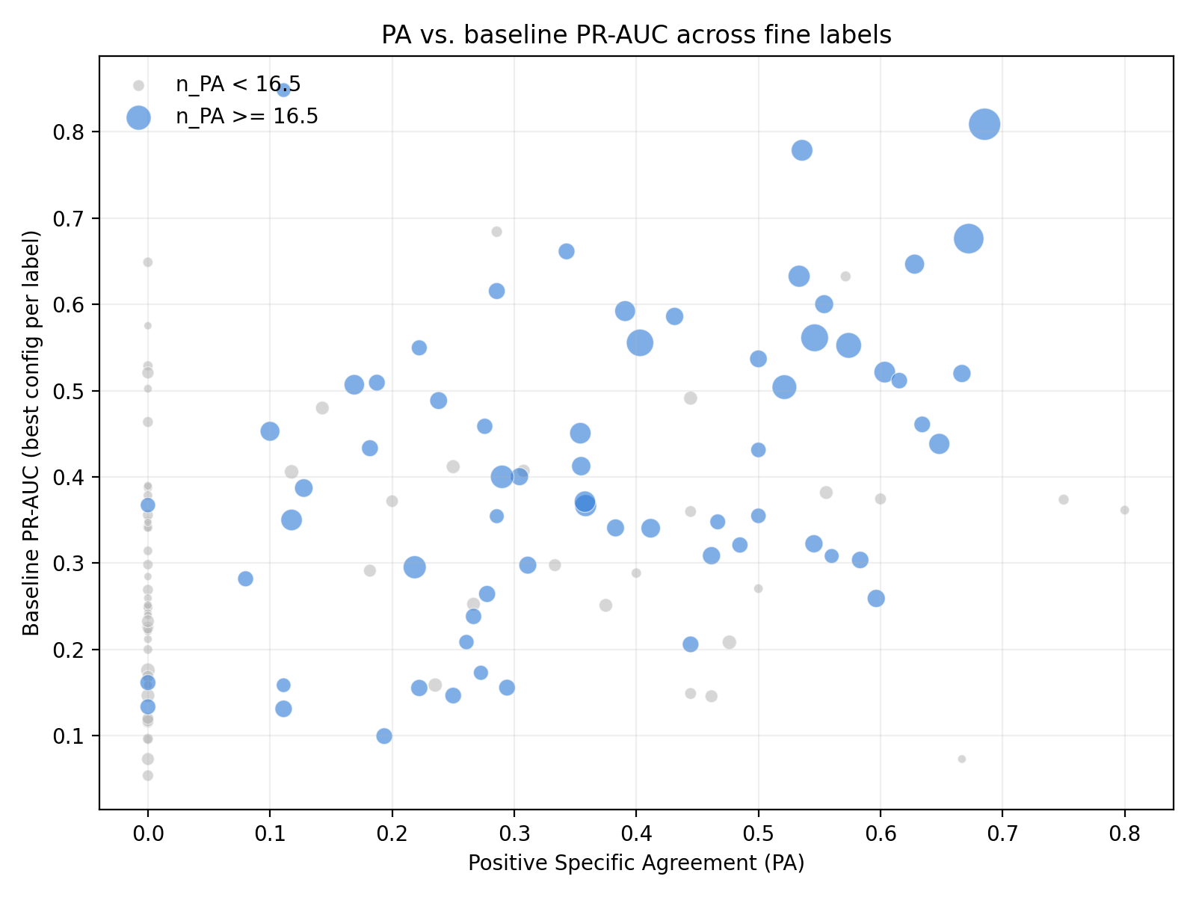

4. Ruling out the small-n confound
Because n_PA is small for most labels (median 16.5, many below 10), a natural concern is that the correlation is an artifact: small n_PA makes PA noisy, and small label counts also tend to make PR-AUC worse, so both could be driven by the same underlying scarcity rather than by any real relationship between agreement and predictability.
This concern does not hold up. n_PA does correlate with both PA and PR-AUC individually, confirming the scarcity effect is real, but the PA-PR-AUC correlation survives controlling for n_PA (partial rho = 0.229, p = 8.8e-03), and it gets stronger, not weaker, when the analysis is restricted to higher-n_PA labels. This is the opposite of what a pure small-sample artifact would produce.
Test | rho | p-value
PA vs PR-AUC, all 130 labels with defined PA | 0.396 | 3.1e-06
n_PA vs PA (reliability check) | 0.592 | 1.3e-13
n_PA vs PR-AUC (scarcity check) | 0.381 | 7.9e-06
PA vs PR-AUC, controlling for n_PA (partial) | 0.229 | 8.8e-03
PA vs PR-AUC, n_PA >= 16.5 (median), n=65 | 0.428 | 3.8e-04
PA vs PR-AUC, n_PA >= 50, n=22 | 0.652 | 1.0e-03

5. Confidence threshold scenarios
Two threshold scenarios are proposed for classifying labels into confidence tiers based on median-split baseline PR-AUC. A 0.0 floor was also considered but is a no-op: the minimum observed PR-AUC across all 138 labels is 0.05, so no label falls below it.
Scenario A - all 138 labels. This is the primary, most inclusive threshold and applies regardless of whether PA is defined for a label.
Scenario B - the high-n_PA subset (n_PA >= 16.5, the median), i.e. the 65 labels where PA is estimated reliably. This is the basis for the PA-consistency claim specifically.
Scenario | Scope | Median PR-AUC | High tier | Low tier
A | All 138 fine labels | 0.350 | 69 labels | 69 labels
B | High-n_PA subset (n_PA >= 16.5), n=65 | 0.400 | 33 labels | 32 labels
For the 65 labels present in both scenarios, the high/low tier assignment agrees 89.2% of the time, indicating the reliable-PA subset behaves consistently with the full population rather than diverging from it.
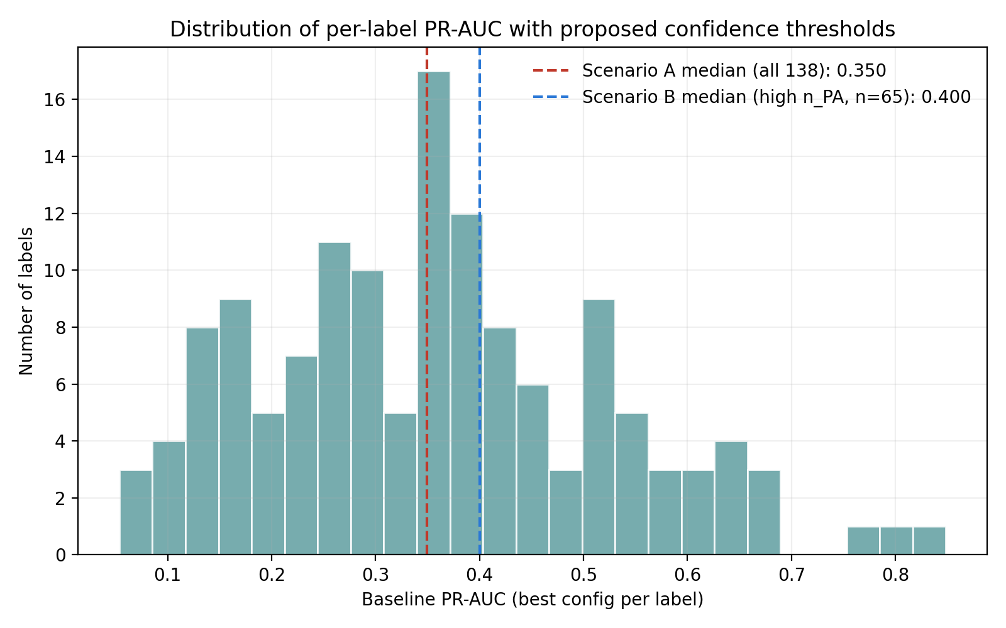

6. Illustrative examples
Highest-PA labels (defined PA, n=130 pool):
Label | PA | n_PA | PR-AUC
chamomile | 0.80 | 3 | 0.361
grapefruit | 0.75 | 5 | 0.374
fruity | 0.69 | 401 | 0.809
green | 0.67 | 318 | 0.676
rose | 0.67 | 40 | 0.520
tea | 0.67 | 2 | 0.073

Zero-PA labels with small n_PA (illustrating the reliability concern for low n_PA, not necessarily genuine disagreement):
Label | PA | n_PA | PR-AUC
almond | 0.00 | 4 | 0.342
amber | 0.00 | 3 | 0.388
anisic | 0.00 | 3 | 0.378
aromatic | 0.00 | 2 | 0.096
black currant | 0.00 | 2 | 0.341
bitter | 0.00 | 2 | 0.212

7. Recommendations for the paper
- Report the PA-PR-AUC correlation as a genuine finding, with the partial correlation and the n_PA-restricted robustness check included as the confound-ruling-out evidence, not left implicit.
- Restrict the PA-reliability claim explicitly to n_PA >= 16.5 (median split of the data itself, not a hand-picked cutoff), and state this restriction plainly as a limitation for the excluded low-n_PA labels.
- Use Scenario A's median (0.350) as the primary PR-AUC confidence threshold covering all 138 labels; cite Scenario B's median (0.400) as corroborating evidence from the subset where PA is trustworthy, and report the 89.2% tier-agreement rate as a consistency check between the two.
- Treat the 8 zero-overlap labels (undefined PA) as a vocabulary-coverage-gap note, consistent with the existing Leffingwell zero-positive-label finding, rather than folding them into the PA analysis as PA = 0.
- Drop the 0.0 PR-AUC floor from the threshold scheme, since it partitions nothing given the observed PR-AUC range (0.05 to 0.85).

8. Reproducibility
All figures and statistics in this report are reproducible from three scripts: plot_pa_per_label.py, plot_pa_vs_prauc_scatter.py, and plot_prauc_threshold_scenarios.py, run against pa_per_label_gs_lw.csv and best_model_per_label.csv. See accompanying files.

