Main structures of multimedia DSP microprocessor
The Multimedia DSP microprocessor that we are about to simulate is 16-bit. It is also an example of RISC (reduced instruction set computer) architecture.
The main structures of the microprocessor that are necessary for functional simulation are
- Program counter (PC), also known as instruction pointer (IP), processor register that indicates where the computer is in its instruction sequence. It is 16 bits wide.
- Register file (RF), an array of processor registers. Register is a small amount of storage available on the microprocessor whose contents can be accessed more quickly than storage available elsewhere. RF consists of 32 general purpose registers (GPRs) r0 – r31. The width of each register is 16 bits.
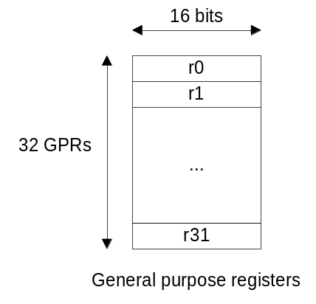
- Flag register (flags), a collection of flag bits. Flag register consists of 4 bits.
N bit is set when the result is negative, Z bit is set when the result is zero, C bit is set when there is a carry out and O bit is set when there is an overflow.
Carry out occurs if the result of operation doesn’t fit in the bit representation of number. Overflow occurs when the result of operation, considering source and destination as signed numbers, can’t be correctly represented as signed number.
Flags are checked before execution of certain instructions (e.g. jump instructions) because their execution depends on the flags combination. Flags are also changed (updated) after execution of certain instructions (e.g. arithmetic instructions).
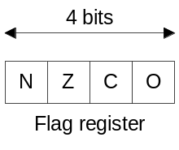
Instruction set (simplified)
Each instruction is encoded in a 32-bit number or instruction word. Instruction words are kept in instruction memory. Each byte of the instruction memory is addressed by PC (16 bits). Therefore the maximum size of instruction memory of our processor is limited to 2¹⁶ bytes (64 kBytes) or 2¹⁴ instruction words (16 kW, kilowords).
There are 4 types of instructions - MOVE, ALU, P_FLOW and SYS.
- MOVE instructions load and store data to/from memory. MOVE instruction word:
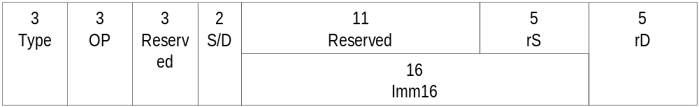
Type field (3 bits) is 000. OP field (operation code, 3 bits) depends on instruction:
  - 001 – BRM instruction (move data between a register and memory);
  - 011 – BRR instruction (move data between registers);
  - 110 – LD instruction (load register or memory with immediate data).
S/D field (2 bits) has several purposes. If instruction is BRM than S/D field specifies source and destination: 00 – source is rS register, destination is memory (rD keeps the memory address); 01 – source is memory (rS keeps the memory address), destination is rD. If instruction is BRR than S/D field is unused. If instruction is LD than S/D filed specifies destination: 00 – destination is rD register; 01 – destination is memory (rD keeps the memory address).
Imm16 field (16 bits) is a value (0x0000 – 0xFFFF).
Syntax:
brm s/d, rS, rD action: rS->m(rD), m(rS)->rD;
brr rS, rD action: rS->rD;
ld s/d, imm16, rD action: imm16->rD, imm16->m(rD).
MOVE instructions don’t read or update the flag register.
- ALU instructions perform arithmetic, logic and shift operations. ALU instruction word:
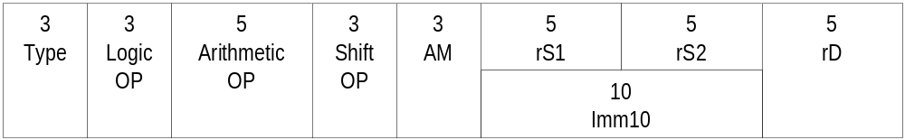
Type field (3 bits) is 001. 3 ALU instructions could be encoded in one instruction word simultaneously. Therefore there are 3 OP fields: logic OP (3 bits) for logic instructions, arithmetic OP (5 bits) for arithmetic and shift OP (3 bits) for shift.
We consider only arithmetic instructions, so logic OP is 000 and shift OP is 000 (NOP instructions). Arithmetic OP depends on instruction:
- 00000 – NOP instruction (no operation);
- 00001 – ADD instruction (arithmetic addition);
- 00010 – SUB instruction (arithmetic subtraction).
AM field (3 bits), or addressing mode, specifies source and destination:
- 000 – register direct (all operand values are in registers)
- 001 – register direct with immediate data (implied addressing: sources are imm10 and rD, destination is rD)
- 010 – register indirect (all operands values are in memory; rS1, rS2, rD keep memory addresses)
- 011 – register indirect with immediate data (implied addressing: sources are imm10 and memory, destination is memory (rD keeps memory address))
Imm10 field (10 bits) is a value (0x000 – 0x3FF).
Syntax:
add am, rS1, (rS2), rD action: rS1+rS2->rD, rS1+rD->rD;
sub am, rS1, (rS2), rD action: rS1-rS2->rD, rS1-rD->rD;
ALU instructions update the flag register.
- P_FLOW instructions change the program flow. P_FLOW instruction word:
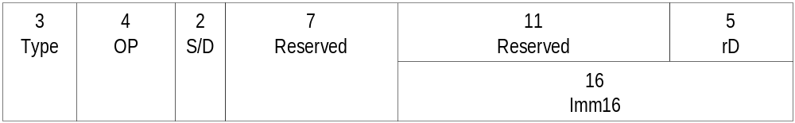
Type field (3 bits) is 101. OP field (4 bits) depends on instruction:
- 0000 – JMP instruction (unconditional branch, or jump)
- 0001 – JGT instruction (conditional jump. Jump if greater than 0)
S/D field specifies destination: 00 – destination is rD; 01 – destination is imm16.
Imm16 field (16 bits) is an address (0x0000 – 0xFFFF).
P_FLOW conditional instructions check the flag register before execution. If combination of flags satisfies the jump condition (N=0 and Z=0 for JGT instruction), PC is updated. Look at condition table at page 33 [1] and description of conditional jumps at page 80 [1].
Syntax:
jmp s/d, dest, where dest is rD or imm16 action: dest->PC;
jgt s/d, dest, where dest is rD or imm16 action: dest->PC.
- SYS instructions implement system operations. SYS instruction word:
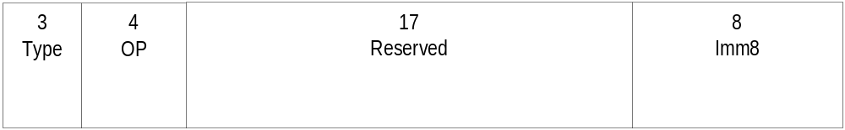
Type field (3 bits) is 110. OP field (4 bits) depends on instruction:
- 0000 – HLT instruction (halt)
- 0001 – INT instruction (call to interrupt procedure)
Imm8 field (8 bits) is an interrupt vector (0x00 – 0xFF).
HLT stops instruction execution. INT instruction generates call to interrupt handler specified in the immediate.
Syntax:
hlt action: stop execution;
int imm8 action: call interrupt handler;
References
- Gnatyuk V, Runesson C. A Multimedia DSP Processor Design. Linköping University, Department of Electrical Engineering, 2004.

