OS Lab 08 - In lab
Task 01 - A
Code:
#include <stdio.h>
#include <stdlib.h>
#include <time.h>

#define sz 10000000

int main() {
float *a, *b, *c;

a = (float*)malloc(sz * sizeof(float));
b = (float*)malloc(sz * sizeof(float));
c = (float*)malloc(sz * sizeof(float));

if (!a || !b || !c) {
printf("mem alloc fail\n");
return 1;
}

for (long i = 0; i < sz; i++) {
a[i] = (float)i;
b[i] = (float)(sz - i);
}

clock_t st = clock();
for (long i = 0; i < sz; i++) {
c[i] = a[i] + b[i];
}
clock_t et = clock();

printf("exec time: %f sec\n", (double)(et - st) / CLOCKS_PER_SEC);

free(a);
free(b);
free(c);

return 0;
}

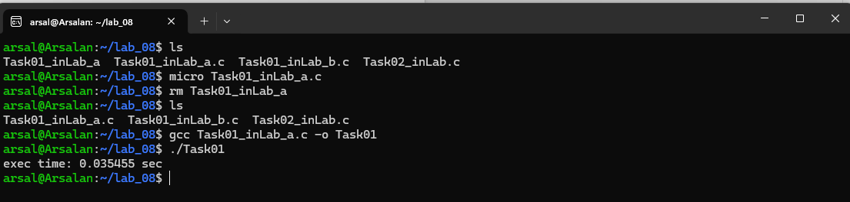

Task 01 - B
Code:
#include <stdio.h>
#include <stdlib.h>
#include <pthread.h>
#include <time.h>

#define sz 10000000
#define th 10

float *a, *b, *c;

typedef struct {
int st;
int en;
} td;

void* add(void* arg) {
td* d = (td*)arg;
for (int i = d->st; i < d->en; i++) {
c[i] = a[i] + b[i];
}
pthread_exit(NULL);
}

int main() {
pthread_t t[th];
td d[th];

a = (float*)malloc(sz * sizeof(float));
b = (float*)malloc(sz * sizeof(float));
c = (float*)malloc(sz * sizeof(float));

if (!a || !b || !c) {
printf("mem alloc fail\n");
return 1;
}

for (long i = 0; i < sz; i++) {
a[i] = (float)i;
b[i] = (float)(sz - i);
}

clock_t st = clock();

int cs = sz / th;
for (int i = 0; i < th; i++) {
d[i].st = i * cs;
d[i].en = (i == th - 1) ? sz : (i + 1) * cs;
pthread_create(&t[i], NULL, add, (void*)&d[i]);
}

for (int i = 0; i < th; i++) {
pthread_join(t[i], NULL);
}

clock_t et = clock();
printf("exec time: %f sec\n", (double)(et - st) / CLOCKS_PER_SEC);

free(a);
free(b);
free(c);

return 0;
}

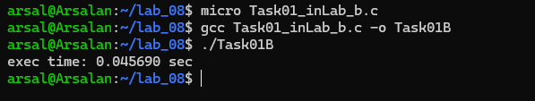

Task 02
Code:

#include <stdio.h>
#include <stdlib.h>
#include <pthread.h>

int *arr, n;
float avg;
int min, max;

void* get_avg(void* arg) {
float sum = 0;
for (int i = 0; i < n; i++)
sum += arr[i];
avg = sum / n;
pthread_exit(NULL);
}

void* get_max(void* arg) {
max = arr[0];
for (int i = 1; i < n; i++)
if (arr[i] > max)
max = arr[i];
pthread_exit(NULL);
}

void* get_min(void* arg) {
min = arr[0];
for (int i = 1; i < n; i++)
if (arr[i] < min)
min = arr[i];
pthread_exit(NULL);
}

int main(int c, char *v[]) {
if (c < 2) {
printf("args req\n");
return 1;
}

n = c - 1;
arr = (int*)malloc(n * sizeof(int));

for (int i = 0; i < n; i++)
arr[i] = atoi(v[i + 1]);

pthread_t t[3];
pthread_create(&t[0], NULL, get_avg, NULL);
pthread_create(&t[1], NULL, get_max, NULL);
pthread_create(&t[2], NULL, get_min, NULL);

for (int i = 0; i < 3; i++)
pthread_join(t[i], NULL);

printf("avg: %.0f\n", avg);
printf("min: %d\n", min);
printf("max: %d\n", max);

free(arr);
return 0;
}

