OS Lab 06
Task 01
Code:
#include <stdio.h>
#include <stdlib.h>
#include <unistd.h>
#include <sys/types.h>
#include <sys/wait.h>

#define fn "data.txt"

int main() {
int p1[2], p2[2];
if (pipe(p1) == -1 || pipe(p2) == -1) {
perror("p");
exit(1);
}

pid_t c1 = fork();

if (c1 == 0) {
close(p1[0]);
FILE *f = fopen(fn, "r");
if (!f) {
perror("f");
exit(1);
}
int n, s = 0;
while (fscanf(f, "%d", &n) == 1) {
s += n;
}
fclose(f);
write(p1[1], &s, sizeof(s));
close(p1[1]);
exit(0);
}

pid_t c2 = fork();

if (c2 == 0) {
close(p2[0]);
FILE *f = fopen(fn, "r");
if (!f) {
perror("f");
exit(1);
}
int n, s = 0, c = 0;
while (fscanf(f, "%d", &n) == 1) {
s += n;
c++;
}
fclose(f);
double a = c ? (double)s / c : 0.0;
write(p2[1], &a, sizeof(a));
close(p2[1]);
exit(0);
}

close(p1[1]);
close(p2[1]);

int s;
double a;

waitpid(c1, NULL, 0);
read(p1[0], &s, sizeof(s));

waitpid(c2, NULL, 0);
read(p2[0], &a, sizeof(a));

close(p1[0]);
close(p2[0]);

printf("Sum: %d\n", s);
printf("Avg: %.2f\n", a);

return 0;
}
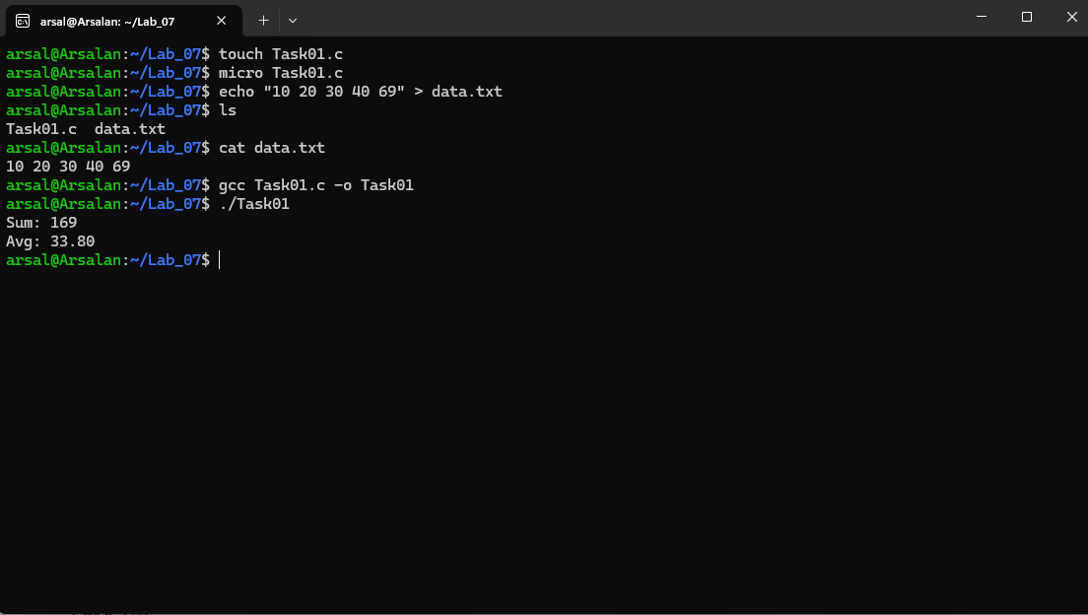

Task 02
Code:

#include <stdio.h>
#include <stdlib.h>
#include <fcntl.h>
#include <unistd.h>

#define fn "input.txt"

int main() {
int fd = open(fn, O_RDONLY);
if (fd == -1) {
perror("o");
exit(1);
}

char buf[1024];
int r, wc = 0, in_word = 0;

while ((r = read(fd, buf, sizeof(buf))) > 0) {
for (int i = 0; i < r; i++) {
if (buf[i] == ' ' || buf[i] == '\n' || buf[i] == '\t') {
in_word = 0;
} else if (!in_word) {
in_word = 1;
wc++;
}
}
}

if (r == -1) {
perror("r");
close(fd);
exit(1);
}

close(fd);
printf("Words: %d\n", wc);

return 0;
}
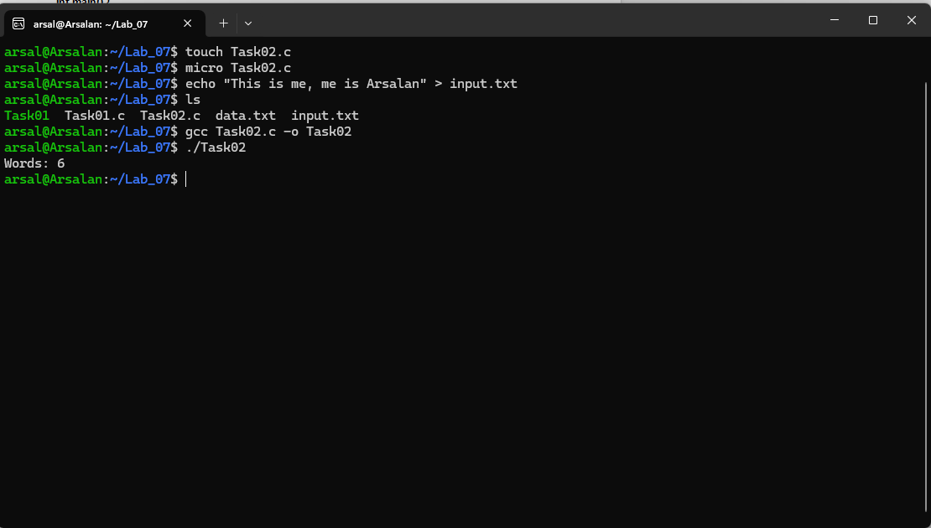

Task 03
Code:
#include<stdio.h>
#include<stdlib.h>
#include<unistd.h>
#include<sys/types.h>
#include<sys/wait.h>

long f(int n){
long r=1;
for(int i=2;i<=n;i++){
r*=i;
}
return r;
}

void fb(int n){
int a=0,b=1,c;
for(int i=0;i<n;i++){
printf("%d ",a);
c=a+b;
a=b;
b=c;
}
printf("\n");
}

void p(int n){
for(int i=2;i<=n;i++){
int x=1;
for(int j=2;j*j<=i;j++){
if(i%j==0){
x=0;
break;
}
}
if(x){
printf("%d ",i);
}
}
printf("\n");
}

int main(int ac,char**av){
if(ac!=4){
printf("u:%s<f><fN><pN>\n",av[0]);
exit(1);
}

int fN=atoi(av[1]),fL=atoi(av[2]),pN=atoi(av[3]);

if(!fork()){
printf("f(%d)=%ld\n",fN,f(fN));
exit(0);
}
if(!fork()){
printf("fb(%d):",fL);
fb(fL);
printf("\n");
exit(0);
}
if(!fork()){
printf("p(%d):",pN);
p(pN);
printf("\n");
exit(0);
}

wait(0);
wait(0);
wait(0);

printf("d\n");
return 0;
}
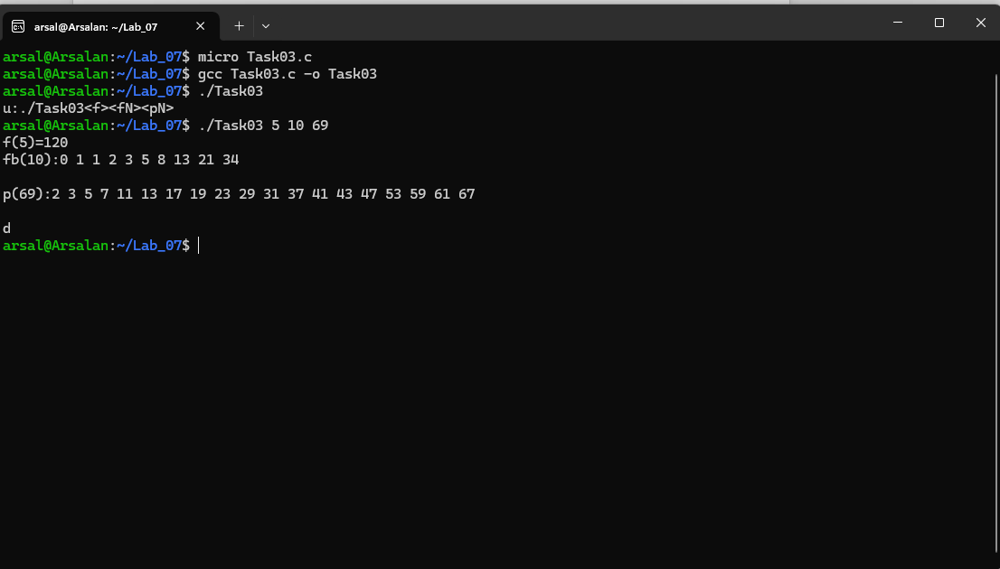
Task 05
Code:
#include<stdio.h>
#include<stdlib.h>
#include<unistd.h>
#include<sys/types.h>
#include<sys/wait.h>

int main(){
int p1,p2,p3;

p1=fork();
if(p1==0){
printf("3rd terminates first\n");
exit(0);
}

p2=fork();
if(p2==0){
waitpid(p1,0,0);
printf("2nd terminates second\n");
exit(0);
}

p3=fork();
if(p3==0){
waitpid(p2,0,0);
printf("1st terminates third\n");
exit(0);
}

waitpid(p3,0,0);
printf("parent terminates last\n");
return 0;
}
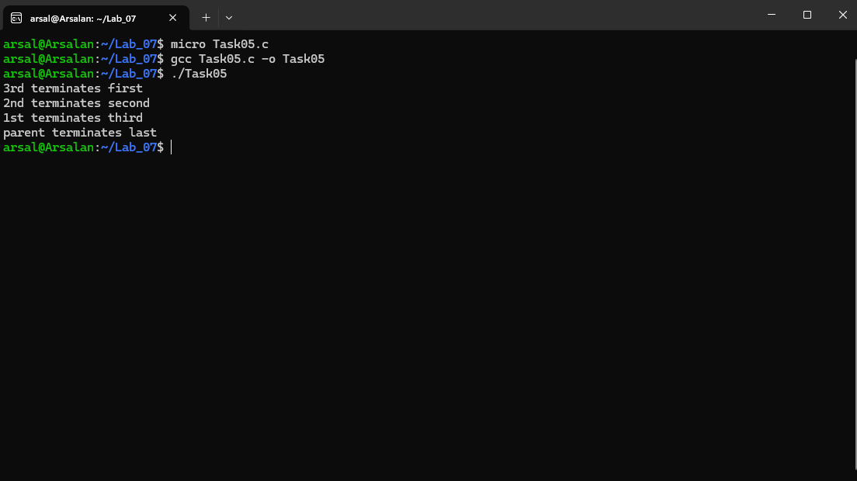
Task 06
Code:
#include<stdio.h>
#include<stdlib.h>
#include<unistd.h>
#include<sys/types.h>
#include<sys/wait.h>
#include<sys/shm.h>
#include<string.h>

#define sz 1024

int main(){
int id=shmget(IPC_PRIVATE,sz,0666|IPC_CREAT);
if(id<0){
exit(1);
}

char *shm=(char*)shmat(id,0,0);
if((long)shm==-1){
exit(1);
}

if(fork()==0){
strcpy(shm,"msg from child");
shmdt(shm);
exit(0);
}

sleep(1);
printf("r:%s\n",shm);

shmdt(shm);
shmctl(id,IPC_RMID,0);

return 0;
}
