SHOP-SCORE
Advanced Customer Lifetime Value (CLV) & Churn Modeling
Domain: Data Analytics & Artificial Intelligence
Project Report

1. Project Overview & Objective
SHOP-SCORE moves retail analytics from traditional demographic segmentation to predictive, AI-driven customer retention. Using supermarket point-of-sale (POS) transactions, the system predicts which customers are about to churn, scores behavioural risk, and forecasts the 12-month Customer Lifetime Value (CLV). The results let business stakeholders control customer acquisition cost (CAC), improve retention and target marketing interventions where they pay back.
Objectives:
- Segment registered members with RFM analysis and assign a retention risk score.
- Detect early signs of churn (falling visit frequency or basket size) before a customer fully leaves.
- Forecast 12-month CLV for existing and newly acquired customers.
- Produce three deliverables: an Executive Retention Dashboard, an Intervention Roster and an Acquisition Budget Strategy Report.

2. Data & Preprocessing
The pipeline accepts a POS CSV (customer_id, date, amount, optional promo_used). Because no proprietary data was supplied, the submitted results use a built-in simulator that generates 100,461 transactions from 4,000 customers over 36 months (Jan 2023 - Dec 2025). The simulator includes heterogeneous visit rates and basket sizes, promotion response, random churn, and a gradual slowdown in visits and basket size before a customer churns, so the models have a realistic early-warning signal to learn.
Cleaning steps: removal of null keys and non-positive amounts, de-duplication, date normalisation and per-customer sorting. All features are built point-in-time (only data up to the snapshot date), which prevents leakage of future information.

3. Methodology

3.1 Behavioural scoring (RFM)
Recency (days since last visit), Frequency (number of visits) and Monetary value (total spend) are converted to 1-5 quintile scores. Rule-based segments are: Champions (R>=4, F>=4), Loyal, New/Promising, At-Risk (R<=2, F>=3), Lost (R=1, F<=2) and Needs Attention. A weighted RFM risk score (0-100) provides a quick rule-based view of retention risk.

3.2 Feature engineering
- Rolling averages of monthly spend (3 and 6 months).
- Standard deviation and mean of days between purchases; recency ratio (recency divided by the customer's usual gap).
- Basket size, basket-size variance (coefficient of variation) and last-90-day basket ratio.
- Frequency and spend trends: last 90 days versus the previous 90 days.
- Response rate to past discounts (share of visits using a promotion).

3.3 Early-warning churn model
Churn is defined as no purchase in the 90 days after the snapshot date. Only customers still active (last visit within 120 days) are modelled, because customers silent for longer are already lapsed and would make the task trivial. Logistic Regression and Random Forest were compared (XGBoost is used automatically if installed); the best model by PR-AUC was selected. The decision threshold is chosen on out-of-fold training predictions so that recall is at least 0.90, which prioritises catching every at-risk customer (few false negatives) over precision.

3.4 12-month CLV forecasting
A Gradient Boosting regressor predicts each active customer's spend over the next 365 days from their behavioural features. For newly acquired customers a separate early-life model uses only the first 60 days of behaviour (visits, spend, basket, days to second visit, promo response) to predict first-year revenue. Both are evaluated with RMSE and MAE against naive baselines.

4. Results

4.1 Churn classifier
Metric | Value
Best model | RandomForest
Decision threshold | 0.258
Recall | 0.888
Precision | 0.583
F1-score | 0.704
ROC-AUC | 0.908
PR-AUC | 0.856
Churn rate among active customers | 31.4%

Model comparison (test set): Logistic Regression ROC-AUC 0.899, Random Forest ROC-AUC 0.908. The recall target of about 0.90 is met at the cost of moderate precision, which is the intended trade-off.

4.2 CLV models
Model | RMSE | MAE | Baseline RMSE | Baseline MAE
12m CLV (existing customers) | 11,268 | 7,456 | 16,213 | 10,021
12m revenue (new customers) | 11,108 | 6,428 | 13,512 | 10,128

Both models beat their baselines (annualised trailing spend for existing customers; cohort mean for new customers). Values are in Rs.

4.3 Customer base health
Indicator | Value
Active customers (last visit within 120 days) | 1,447
Lapsed customers | 2,553
Active customers in High-risk tier | 41.8%
High-value customers (top 25% CLV) in High-risk tier | 7.5%
Average predicted 12m CLV (active) | Rs 10,697
Revenue at risk (churn probability x CLV) | Rs 2,278,791

5. Deliverables

5.1 Executive Retention Dashboard
The dashboard summarises key KPIs, RFM segments, risk tiers, the CLV trend over quarterly snapshots, the churn model precision-recall curve and new-cohort spend versus profit.
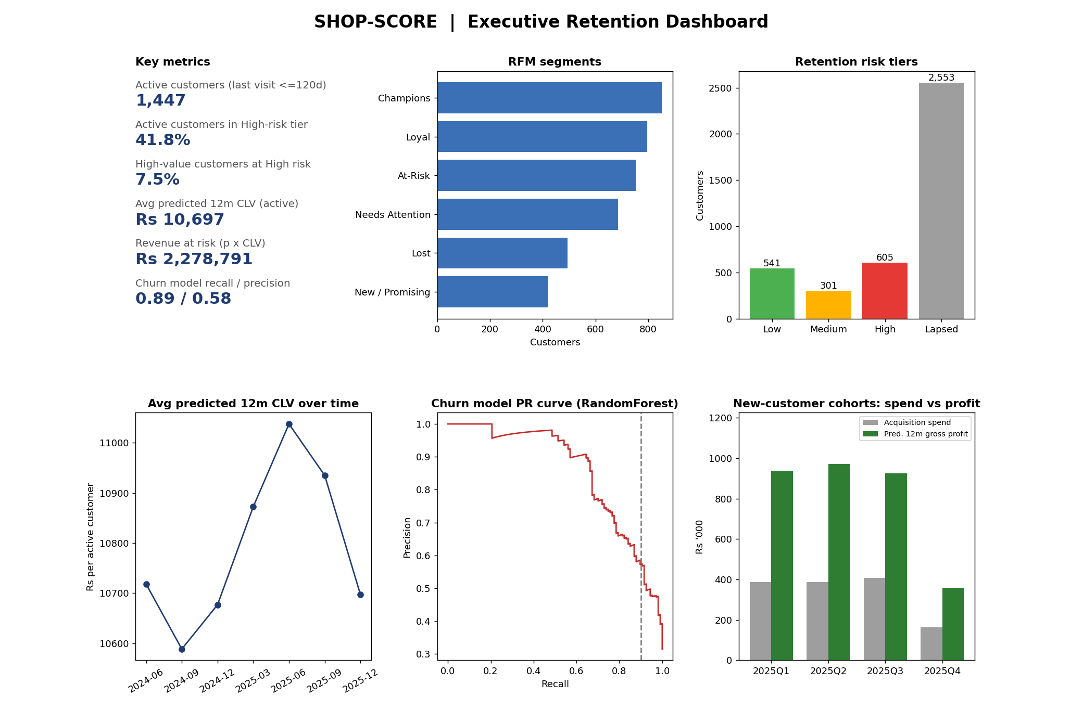

5.2 Intervention Roster (Churn Alerts)
556 active customers are flagged (churn probability at or above the 0.26 threshold). Each row gives the customer ID, segment, churn probability, predicted CLV, recommended discount per visit, a promotion cost cap and a channel (SMS + app coupon for promo-responsive customers, otherwise email). Discount tiers are 5%, 10% and 15% by CLV rank, and the total promotion cost is capped at 10% of the customer's 12-month CLV, so promotion cost can never exceed projected value. The roster covers Rs 1,221,401 of expected revenue at risk for a maximum promotion outlay of Rs 85,706.

5.3 Acquisition Budget Strategy Report
Cohort | New cust. | Avg pred. 12m rev (Rs) | Acq. spend (Rs) | Pred. gross profit (Rs) | ROI % | Max CAC (Rs)
2025Q1 | 323 | 11,607 | 387,600 | 937,267 | 141.8 | 2,902
2025Q2 | 323 | 12,048 | 387,600 | 972,842 | 151.0 | 3,012
2025Q3 | 339 | 10,912 | 406,800 | 924,780 | 127.3 | 2,728
2025Q4 | 136 | 10,563 | 163,200 | 359,132 | 120.1 | 2,641

With an assumed CAC of Rs 1,200 per customer and a 25% gross margin, every 2025 cohort has positive marketing ROI. The break-even CAC (average predicted revenue x margin) is the ceiling that keeps ROI non-negative; Q4 is a partial cohort observed for a short time.

6. Business Recommendations
- Run the intervention roster weekly; start with the highest expected-value-at-risk customers and use the promo cap as a hard rule.
- Protect high-value customers first: a lost high-CLV customer costs far more than a lost average one, so prioritise by expected value at risk.
- Use the break-even CAC per cohort as the upper bound for acquisition budgets and re-run the early-life model each month.
- Monitor recall of the churn model monthly and retrain when it falls below 0.85.

7. Limitations & Future Work
- Results come from simulated data; retrain and re-validate on real POS and loyalty data before deployment.
- Uplift modelling and A/B testing would measure whether discounts truly change behaviour (the save rate is not modelled).
- Probabilistic BG/NBD and Gamma-Gamma models can be added as a benchmark for CLV, together with SHAP explanations for the churn model.
- The gross margin, promotion cap and CAC are assumptions to be replaced by finance-approved figures.

8. Conclusion
SHOP-SCORE delivers an end-to-end, reproducible pipeline that identifies at-risk customers early, values them in monetary terms and links retention and acquisition spending to predicted profit. The single-file implementation, README and outputs allow the project to be run on any POS dataset in the documented format.

