**REPUBLIC OF CAMEROON**

**Piece-Work-Fatherland**

************************

MINISTRY OF HIGHER

EDUCATION

****************************

**VOCATIONAL TRAINING INSTITUTE BESTECHNOLOGY**

**REPUBLIQUE DU CAMEROUN**

**Paix-Travail-Patrie**

************************

MINISTERE DE L’ENSEIGNEMENT SECONDAIRE

****************************

**VOCATIONAL TRAINING INSTITUTE BESTECHNOLOGY**



VOCATIONAL TRAINING INSTITUTE BESTTECHNOLOGY

(**VTIB**)

**DESIGN AND IMPLEMENTATION OF A PORTFOLIO-BUILDING WEB APPLICATION CASE OF PORFOLIOBUILD**

***In partial fulfillment of the requirement for the award of Higher National Diploma (HND) in***

**SOFTWARE ENGINEERING (SWE).**

**WRITTEN AND PRESENTED BY:**

**MALALOUM DJOU MIREILLE**

**VTIB222MUE007**

**Under the supervision of:**

**Academic Supervisor**

**Eng. CHICK JOSEPH TITA**

***Deputy Director Of Training At***

**VTIB**

**Professional Supervisor**

**Mr. CHAMDJOU LOIC**

***Responsible for digital services***

**CHEM INVESTMENT**

**ACADEMIC YEAR**

**2023- 2024**

**APPROVAL**

I, undersigned **Mr. CHICK JOSEPH TITA** hereby acknowledge and certify that this report entitled: “**DESIGN AND IMPLEMENTATION OF A PORTFOLIO-BUILDING APPLICATION CASE OF PORFOLIOBUILD”** is the original work of **MALALOUM DJOU MIREILLE** with matriculation number **VTIB222MUE007** writing after elaborated search in the field.

The responsibility for any errors, omissions, or facts that may be found in the work is that of the researcher. ENG. CHICK JOSEPH TITA's responsibility has been to ensure that the report conforms to international standards and format required by **VTIB** under the tutelage of the MINISTRY OF HIGHER EDUCATION.

I find this copy convincing, and as such fit for the public defense before the competent jury for evaluation, in partial fulfillment of the HIGHER NATIONAL DIPLOMA (HND) in Software Engineering.

**SUPERVISOR:** **Mr. CHICK JOSEPH TITA**

**SIGNATURE:**

**DATE:**

**CERTIFICATION**

This project report entitled **“DESIGN AND IMPLEMENTATION OF A PORTFOLIO-BUILDING APPLICATION CASE OF PORFOLIOBUILD”** by **MALALOUM DJOU MIREILLE** with matricula number **VTIB222MUE007** meets the requirement and regulation governing the awareness of the Higher National Diploma (HND) in Software Engineering. By **VTIB** under the tutelage of the MINISTRY OF HIGHER EDUCATION, hence approved for its contribution to scientific knowledge and literary presentation.

DIRECTOR OF TRAINING:

ENG. BESONG MICHEAL E

**ACADEMIC SUPERVISOR:**

Mr. CHICK JOSEPH TITA

**SIGNATURE:**

**DATE:**

**SIGNATURE:**

**DATE:**

**PRESIDENT OF JURY:**

**SIGNATURE:**

**DATE:**

DEDICATION

**TO MY FAMILY**

**ACKNOWLEDGEMENT**

I would like to express my heartfelt gratitude to all those who have contributed to the successful completion of this portfolio building application.

First and foremost, I extend my sincere appreciation to my supervisors, **Mr. CHICK JOSEPH TITA, Mr BESONG MICHAEL E.**  for their invaluable guidance, support, and encouragement throughout this project. Their expertise and constructive feedback have been instrumental in shaping the application's development and ensuring its alignment with the project's goals.

* I extend my thanks to my beloved mother MACHUCHINE CECILIA for her lot prayer over my life, for all the finance and support to my academic career.
* To my brother MOFFA JOU SEVERIN for all the financial and moral support to my academic career.
* To my sister TSATAT JOU MERLINE FLORE for all the financial and moral support to my academic career.
* To my brother JEAN NORBER for all the financial and moral support to my academic career.
* To my brother JOU ULRICH for all the financial and moral support to my academic career.
* To my classmate for their moral support and all their encouragement throughout the completion of this project.

Lastly, I offer my gratitude to the institution and all individuals who have contributed directly or indirectly to this project's completion. Your support and collaboration have been indispensable. This project would not have been possible without the collective efforts of everyone involved, and for that, I am deeply thankful.

**ABSTRACT**

This report explores the development and implementation of a PORTFOLIO BUILDING APPLICATION designed to assist individuals in creating and showcasing their professional portfolios. The report delves into the methodology, features, and technical aspects of the application, highlighting the significance of user experience (UX) design, security measures, and future developments.

A comparison is drawn between the new portfolio-building application and traditional resume systems to underline the advantages of portfolios, such as enhanced visual representation, comprehensive evidence of skills, and personal branding. Additionally, the report covers the various types of portfolios and their potential disadvantages.

The case study further emphasizes the importance of portfolios in online visibility and their role in convincing employers. Through a systematic system analysis and well-thought-out system design, the application aims to provide a seamless, user-friendly experience, empowering individuals to present their work effectively and stand out in today's competitive professional landscape. For this solution, I used a web server (Apache), a MySQL DBMS, Operating System and I programmed in HTML, CSS, Bootstrap, JS, JQUERY, PHP, and SQL. So, I demonstrate that with security in place, my application was able to help individuals captivate potential employers with their portfolio and my objective was very much attained.

**RESUME**

Ce rapport explore le développement et la mise en œuvre d'une APPLICATION DE CREATION DE PORTFOLIO conçue pour aider les individus à créer et présenter leurs portfolios professionnels. Le rapport examine la méthodologie, les fonctionnalités et les aspects techniques de l'application, mettant en évidence l'importance de la conception de l'expérience utilisateur (UX), les mesures de sécurité et les développements futurs.

Une comparaison est établie entre la nouvelle application de création de portfolio et les systèmes traditionnels de CV pour souligner les avantages des portfolios, tels que la représentation visuelle améliorée, les preuves complètes des compétences et le renforcement de la marque personnelle. De plus, le rapport couvre les différents types de portfolios et leurs éventuels inconvénients.

L'étude de cas souligne également l'importance des portfolios dans la visibilité en ligne et leur rôle dans la persuasion des employeurs. Grâce à une analyse systématique du système et une conception bien réfléchie du système, l'application vise à offrir une expérience fluide et conviviale, permettant aux individus de présenter leur travail de manière efficace et de se démarquer dans le paysage professionnel concurrentiel d'aujourd'hui. Pour cette solution, j’ai utilisé un serveur web (Apache), un SGBD MySQL, un system d’exploitation et j’ai programme en HTML, CSS, Bootstrap, JS, JQUERY, PHP et SQL. Ainsi, j’ai démontré qu’avec la sécurité en place, mon application était en mesure d’aide les individue a attiré des employeur potentiel avec leur portfolio et mon objective a été largement atteint.

**TABLE OF CONTENT**

**LIST OF FIGURES**

**GLOSSARY**

|  |  |
| --- | --- |
| **NAME** | **FULL MEANING** |
| HTML | Hypertext Markup Language |
| **CSS** | Cascading style sheet |
| SQL | Structured Query Language |
| PHP | Hypertext Processor |
| MYSQL | My Structured Query Language |
| PC | Personal Computer |
| URL | Uniform Resource Locator |
| API | Application Programming Interface |
| DBMS | Database Management System |
| MVC | Model-View-Controller |
| JS | JavaScript |
| XAMPP | Cross-Platform, Apache, MySQL, PHP and Perl |
| VTIB | VOCATIONAL TRANING INSTITUTE BESTTECHNOLOGY. |

**GENERAL INTRODUCTION**

**Introduction**

This report is written to introduce and justify the development of a groundbreaking portfolio building application. Its purpose is to address the limitations of traditional resumes, offering a more dynamic and visually compelling platform for individuals to showcase their skills and accomplishments. The report aims to outline the objectives, system analysis, and design considerations, showcasing the potential of this innovative solution to redefine how professionals present themselves in today's competitive landscape.

**PROBLEM STATEMENT**

In the ever-evolving landscape of professional advancement, the traditional methods of presenting one's skills and achievements face challenges in meeting the dynamic expectations of the contemporary workforce. As individuals navigate the competitive job market and seek opportunities to showcase their talents, the limitations of conventional resumes become apparent. This report addresses the need for a transformative solution, recognizing the demand for a more dynamic and visually compelling representation of professional identity.

**PROPOSED SOLUTION**

In response to this, we propose the development and implementation of a cutting-edge portfolio building application. This application aims to revolutionize how individuals construct, personalize, and exhibit their portfolios, providing a platform that transcends the constraints of traditional resumes. By delving into the system analysis, design, and case study, this report seeks to outline the multifaceted advantages and functionalities of the proposed solution. The objectives include exploring the user-centric design, technical robustness, and the application's ability to redefine the professional narrative. Through this comprehensive exploration, we aim to present not just a solution but a paradigm shift in how professionals portray their skills and experiences, addressing the evolving needs of the contemporary job market.

**PLAN**

This report is divided into four chapters. The plan goes as follows, with the details comprised in each chapter.

**Chapter 1:**

This chapter is titled "**Context of the company and internship process**", In this chapter, we will have the location of Chem & Investment group history, vision, values, ty mission, services being carried out in the severally organigram. This will be followed by the course of my two months internship at Chem & Investment group Lid.

**Chapter 2:**

It is titled "Case study of a portfolio building application" and this chapter definite a portfolio, give it important, types, complain it with traditional resumes and it give us the disadvantages.

**Chapter 3:**

It is titled "Design and Implementation" and this chapter briefly explains to us how both the Front and Back-end is design and developed that is it talks about the user feature and user interface and on the back-end i have the Use case diagram, Class diagram, Sequence and the design of the database. We are also going to look at the difference software used.

**Chapter 4:**

This chapter is titled "Results and conclusion "this chapter talks on recommendations of my report, Results tested, Conclusion and References.

**CHAPTER 1: CONTEXT OF THE**

**COMPANY AND INTERNSHIP PROCESS**

We will discuss here a presentation of CHEM INVESTMENT GROUP and its various subsidiaries followed by a presentation of our internship environment and the various activities we have had to carry out.

**GENERAL PRESENTATION OF CHEM INVESTMENT GROUP**

Before starting our study, we must first understand that CHEM Investment Group is a group of several small structures, namely QUEEN’S AFRICA, CHEM INDUSTRY and CHEM DELIVERY.

**IDENTITY OF CHEM INVESTMENT GROUP**

1. **What is CHEM INVESTMENT GROUP?**

 CHEM INVESTMENT GROUP Sarl is a company based in Cameroon, created in 2019 and headquartered in Douala, the economic capital, located in Douala, LOGPOM TRADEX. It specializes in providing services through its various subsidiaries. All of this is thanks to its founder, none other than the businessman **Mr. CHOUMENIE EMMANUEL**.

Furthermore, CHEM INVESTMENT GROUP has set up several products or companies, namely:

1. **QUEEN'S AFRICA**

Queen's is an African luxury cosmetic brand designed by Africans and for Africans. Its aim is to satisfy African women by offering them quality cosmetic products at a reasonable price.

Figure 1.1

1. **CHEM INDUSTRY**

CHEM INDUSTRY is a production and transformation unit for cosmetic products. It is responsible for the transformation and development of Queen's Africa products.

1. **CHEM DELIVERY**

CHEM delivery is a specialized structure in the transport and delivery of QUEEN'S AFRICA products.

Figure 1.2

1. **MISSION AND VISION**
2. **MISSION**

CHEM Investment Group, through its product QUEEN’S, has a mission to satisfy the needs of women in terms of luxury natural cosmetic products, and especially to provide highly effective treatment, capable of correcting various bodily problems that women may encounter in general.

1. **VISION**

Its vision is that of a transformed Africa, capable of succeeding, building, and developing through its youth. Not only that, it challenges itself to thrive with its predominantly young workforce. It hopes to establish other structures in the future, namely: DIGITAL AGENCY, PIG FAME, and NTCI (New Technological Industrial).

**MARKETING MIX**

1. **Activities**

The activities of CHEM INVESTMENT GROUP are as follows:

* Production and transformation of skin cosmetic products
* Marketing of said products for facial, skin, and body care
* Delivery
* Communication on the company's products and services

1. **Products and prices**

We have taken the care to summarize all the prices and products of Queen's Africa. The products are intended for cosmetic use. And the products are high-end, therefore reserved for a category capable of affording Queen's products.

|  |  |  |
| --- | --- | --- |
| PRODUCT PRICES | | |
| PRODUCTS | RETAIL PRICES | WHOLESALE PRICES |
| BODY CREAMS | | |
| LIGHTENING BODY CREAM FOR MIXED SKIN TONE | 15000 XOF | 15% FROM 15 PDTS |
| LIGHTENING BODY CREAM FOR CARAMEL SKIN TONE | 12000 XOF | 15% FROM 15 PDTS |
| NATURAL COMPLEXION BODY CREAM | 10000 XOF | 15% FROM 15 PDTS |
| FACE CREAMS | |  |
| LIGHTENING FACE CREAM FOR MIXED SKIN TONE | 8000 XOF | 15% FROM 15 PDTS |
| LIGHTENING FACE CREAM FOR CARAMEL SKIN TONE | 7000 XOF | 15% FROM 15 PDTS |
| NATURAL COMPLEXION FACE CREAM | 6000 XOF | 15% FROM 15 PDTS |
| BODY SOAPS | | |
| LIGHTENING BODY SOAP FOR MIXED SKIN TONE | 10000 XOF | 15% FROM 15 PDTS |
| LIGHTENING BODY SOAP FOR CARAMEL SKIN TONE | 10000 XOF | 15% FROM 15 PDTS |
| NATURAL COMPLEXION BODY SOAP | 10000 XOF | 15% FROM 15 PDTS |
| FACE SOAPS | | |
| LIGHTENING FACE SOAP | 8000 XOF | 15% FROM 15 PDTS |
| NATURAL FACE SOAP | 7000 XOF | 15% FROM 15 PDTS |
| LIGHTENING SERUM | 7000 XOF | 15% FROM 15 PDTS |
| NON-LIGHTENING REPAIRING CREAMS | | |
| VERGY | 10000 XOF | 15% FROM 15 PDTS |
| LIGHTENING REPAIRING CREAMS | | |
| LIGHTENING REPAIRING CREAM FOR THIGHS |  | 15% FROM 15 PDTS |
| LIGHTENING REPAIRING CREAM FOR ANTI-CHAFING |  | 15% FROM 15 PDTS |
| DARK CIRCLES | 5000 XOF | 15% FROM 15 PDTS |
| DIETARY SUPPLEMENTS |  |  |
| APETAMIN | 8000 XOF | 6000 FROM 3 PDTS |

1. **Distribution**

At CHEM Investment group, the distribution system used is the direct or ultra-short circuit. Indeed, the company has an intermediary that interposes between the producer and the consumer.

CHEM Investment group

Target audience or consumers

CHEM delivery

²

1. **Communication**

Internally, the company uses the following means of communication:

|  |  |  |
| --- | --- | --- |
| **Written** | **Oral** | **Type** |
| Bulletin board | Meetings | Intranet |
| Memorandum | Fixed phone | Internet |

Externally, that is, to communicate with its target audience, it uses the following means:

* Digital communication: social networks (Facebook, Instagram, YouTube, etc.), website, blog.
* Sales promotion
* Advertising on social networks
* Word of mouth

1. **Organizational Structure**

An organizational structure is used to structure a company according to its own objectives (increasing production, securing the future). It creates a general framework for the accomplishment of tasks within the company, as well as a basis for all standard procedures and routines in daily work. Therefore, the organizational structure of CHEM Investment group is represented in the diagram shown in Annex 1.

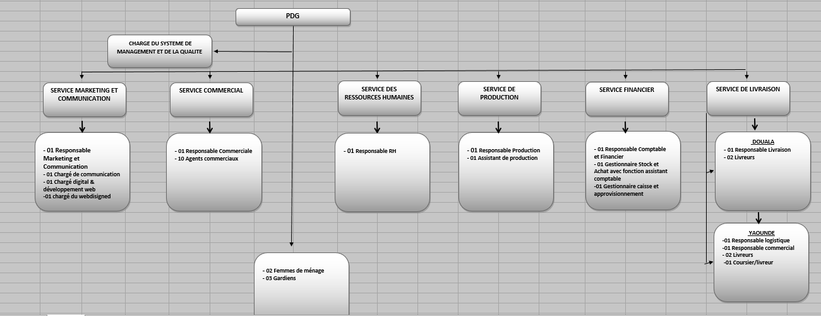Figure 1.3

**INTERNSHIP PROCESS**

**1.3 EXPOSITION OF TASKS PERFORMED**

1. **Environment**

Our internship environment consisted of the work schedule, the rules to be followed within the company, and meetings

* Work Schedule

|  |  |  |  |
| --- | --- | --- | --- |
| DAYS OF THE WEEK | ARRIVAL | BREAK | DEPARTURE |
| Monday | 8AM | 1PM to 3PM | 6PM |
| Tuesday | 8AM | 1PM to 3PM | 6PM |
| Wednesday | 8AM | 1PM to 3PM | 6PM |
| Thursday | 8AM | 1PM to 3PM | 6PM |
| Friday | 8AM | 1PM to 3PM | 6PM |
| Saturday | 8AM | - | 6PM |

* Rules
* Adherence to the dress code
* Requirement to report presence before and after leaving the company
* Prohibition of personal phone use during work
* Non-consumption of tobacco, alcohol, or other drugs during service
* Obligation to respect each collaborator
* Adherence to break schedules
* Non-disclosure of private company information
* Meetings

The meetings were classified as follows:

Monday: General meeting of the executives of each department between 9 AM and 11 AM Tuesday: Meeting of the company's sales team between 9 AM and 11 AM

Wednesday: Meeting of the communication department between 9 AM and 11 AM

1. **Presentation of activities**

Our internship took place from August 07th to September 07th, 2023 at QUEEN’S AFRICA. Here is a summary table of the activities carried out during this period:

|  |  |  |
| --- | --- | --- |
| **DATES** | **ACTIVITES CONDUCTED** | **OBJECTIVES TO ATTAIN** |
| From the 07th to 11/08/2023 | Observation and presentation of the different departments + initiation to the activities and tasks of the company. | Familiarization with the internship environment and its services. |
| From 14th to the 18/08/2023 | Worked on a website called Queens Africa congo. Used UI/UX design principles to make the Queens Africa congo website userfriendly . Added new designs to the homepage with a bit of animation. | Ensure the website is Visually appealing and user-friendly. |
| From 21th to the 25/08/2023 | Practices on network and troubleshooting connection isseus. | Make network to work on the machine of each employer in need of internet connection. |
| Du 13 au 19/06/2023 | Helping employers with dificulties in using Microsoft office software like word, excel just to name a few. | Make the employer to know some tips to better used the software. |
| Du 20 au 26/06/2023 | Creation of a new strategy and writing of internship report. | Prepare internship Report. |

**BENEFITS OF THE INTERNSHIP AND IDENTIFICATION OF THE PROBLEM**

1. **Benefits of the internship**
2. **Personal benefits**

This internship at CHEM INVESTMENT has greatly benefited us personally in that it has allowed us to:

* Overcome my fear of public speaking
* Refine my speaking skills
* Manage my stress
* Improve my ability to articulate
* Improve my gestures during my speeches
* Learn to capture the attention of my target audience

1. **Professional benefits**

Professionally speaking, we say that we have acquired a lot of skills during this internship, namely:

* The creation of a professional action plan
* The management of a digital strategy
* The management of a community on social networks
* Mastery of sales channels
* The writing of an effective script
* The management of speaking skills
* The functioning of advertising on social networks

**CHAPTER 2: CASE STUDY**

**(PORTFOLIO WEB APPLICATION)**

**2.1 DEFINITION**

A portfolio is a curated collection of an individual's work samples, projects, achievements, and skills. It serves as a comprehensive representation of their abilities, expertise, and accomplishments in a specific field or industry.

**2.2 WHY IS A PORTFOLIO IMPORTANT**

Portfolios play a vital role in showcasing an individual's capabilities and achievements to potential employers, clients, or collaborators. They provide tangible evidence of skills, demonstrate practical application, and offer a holistic view of an individual's professional journey. Portfolios allow individuals to present their work in a visually appealing and engaging manner, leaving a lasting impression on the audience.

**2.2.1 online visibility**

In today's digital age, online visibility and impression management are crucial when it comes to job searching and convincing potential employers. Portfolios play a pivotal role in this regard. With a well-crafted online portfolio, individuals can establish a professional online presence, showcase their skills, and provide concrete evidence of their capabilities. Having a portfolio accessible online allows employers to easily find and review an individual's work, even before the interview stage. This online visibility enhances credibility, demonstrates initiative, and gives employers a deeper understanding of an individual's abilities beyond what a traditional resume alone can convey. Portfolios a persuasive tool for individuals to stand out among competitors, leaving a lasting impression and increasing their chances of securing desired employment opportunities.

**2.3 Advantages of a Portfolio over Traditional Resumes**

Compared to traditional resumes, portfolios offer several distinct advantages:

* Visual Showcase: Portfolios provide a visual representation of an individual's work, allowing for a more engaging and impactful presentation compared to the text-based format of resumes.
* Comprehensive Representation: Portfolios offer a holistic view of an individual's skills, projects, and achievements, providing a deeper understanding of their capabilities beyond what a resume can convey.
* Tangible Evidence: Portfolios offer tangible evidence of an individual's work through samples, demonstrating their practical skills and the quality of their work.
* Personal Branding: Portfolios allow individuals to showcase their unique style, personality, and personal brand through design choices and customized presentations.

**2.4 TYPES OF PORTFOLIOS**

Portfolios can take various forms depending on the intended purpose and industry requirements. Some common types include:

1. **Career Portfolios:**

Highlighting an individual's professional achievements, skills, and work experience.

1. **Creative Portfolios:**

Showcasing artistic work, such as graphic design, photography, or writing samples.

1. **Academic Portfolios:**

Documenting academic achievements, research projects, and scholarly work.

1. **Project Portfolios:**

Focusing on specific projects or case studies to demonstrate problem-solving abilities and project management skills.

**2.5 DISADVANTAGE OF PORTFOLIOS**

While portfolios offer numerous benefits, they also have certain disadvantages to consider:

1. **Time and Effort:**

Creating a portfolio requires time, effort, and careful curation of work samples, which may be more extensive compared to preparing a traditional resume.

1. **Subjectivity:**

Evaluating portfolios can be subjective, as the impact of visual elements and personal preferences may influence the perception of an individual's work.

1. **Access and Distribution:**

Portfolios, particularly in physical or non-digital formats, may have limited accessibility and face challenges in reaching a wider audience.

1. **Technical Skills:**

Developing and maintaining a digital portfolio may require technical skills or familiarity with portfolio-building platforms and tools.

1. **Technology Dependent:**

A portfolio is completely dependent on technology and internet, a slight disconnection can make your portfolio unreachable by your employers.

**CHAPTER 3: DESIGN AND IMPLEMENTATION**

**EXISTING SYSTEM:**

Before the introduction of the portfolio-building application, individuals counted on traditional methods to create and showcase their professional skills. These methods often involved creating physical copies of resumes, and certificates, to be presented during job interviews or professional. While this approach served its purpose, it had several limitations such as Limited visual representation, Incomplete picture of abilities, Lack of tangible evidence, Limited space for information, and less captivating.

**Proposed solution**

By utilizing the portfolio-building application, individuals can overcome the constraints of traditional methods, expand their reach, and adaptable representation of skills and achievements, captivating potential employers or clients in a unique way.

**SYSTEM DEVELOPMENT LIFE CYCLE (SDLC)**

The system development life cycle (SDLC) is a framework the development team uses to produce high-quality software in a systematic and cost-effective way. The SDLC methodology is used by both large and small organizations. It is composed of five main phases which are: planning, analyses, design, implementation, and support. We will see how some of these phases were implemented in the development of the system below.

**SYSTEM REQUIREMENT**

When designing a web application (software), there are important steps to follow visualizing the layout and design added in the system also takes into consideration, how users will interact with each page and icon and how the website/App should perform. Hence requirements when building systems are very important. Once the requirements are set, we can initiate the other technical work including system design, development, testing, implementation, and operation. The requirements are of two types. The functional and Non-functional requirements.

* **Functional Requirement**
* **Admin**
* Create, edit, or delete client accounts.
* Delete available templates.
* See all purchases on the system.
* View all registered clients.
* Cancel a purchase
* See client purchase
* See his earnings
* Send Announcements.
* Login.
* Logout.
* **Clients**
* Create an account.
* Pass a purchase.
* See his purchase.
* Customised template
* View announcements
* Login.
* Logout.
* **Visitors**
* Navigate menus
* Create Account
* **Non-Functional Requirements**
* **Security**

User validation will be done using login to ensure that the user is valid and that the user only has access to his or her permission data. Users will only have access through the user interface. Meaning that only authorized users can access the system with a username and password.

* **Performance**

Compared to the old system, the new portfolio-building system offers improved performance, streamlined workflow, enhanced visual presentation, increased accessibility, collaboration, and scalability.

* **Availability**

The system is available to users anytime, anywhere, just need a PC, Phone, and Internet connection. Also, the system works in multiple web browsers like (Chrome, Mozilla, Opera, and Internet Explorer).

* **User Friendliness**

The system has a friendly user interface. The user-friendly feature of the portfolio-building system determines how easy it will be to operate. From the dashboard, the user has the opportunity to choose any function of the system. Hence, they can operate the system without difficulties.

**SYSTEM ANALYSES**

This part contains the analyses of the functional and non-functional requirements using a use-case diagram, and use-case detail. In addition, the interactive behavior of the activities is analyzed using sequence diagrams and static view using class diagrams. To produce a model of the system that is correct, complete, and consistent I need to construct the analyses model which focuses on structuring and formalizing the requirements of the system. The analysis model contains three models: functional, object, and dynamic models. The functional model can be described by the use-case diagrams. Class diagrams describe the object model. Dynamic models can also be described in terms of sequence, state chart, and activity diagrams. For the purpose of this project, I have described the analysis models in terms of the object model, functional model, and dynamic model using classes, use cases, and sequence diagrams.

**SYTEM DESIGN**

The Portfolio-building application incorporates a visually appealing and user-friendly interface. The application will feature a modern and intuitive design, with a clean layout and easy-to-navigate menus. Users will be greeted with a dashboard where they can manage their portfolios. The portfolios will be visually engaging, with the ability to showcase project images, videos, and other multimedia elements. The system design will ensure seamless responsiveness across different devices, enabling users to access and

edit their portfolios on desktops, laptops, tablets, and smartphones. To design the system, I would go through various stages which can be resumed as show in Figure 4. Below.

Implementation

Designing Sequence

Diagram

Designing

Database

Designing Class

Diagram

Designing Use

Case Diagram

Designing

UML Diagram

**FIGURE 3.1:** **system modelling and design**

**3.2.3.1 DESIGNING UML DIAGRAMS**

UML (Unified Modelling Language) is a standard language for specifying, visualizing, constructing, and documenting the artifacts of a system software. There are fourteen (14) diagrams in UML where seven (7) diagrams are all about system behavior and the seven (7) other diagrams point to very technical details like designing databases. These diagrams are activity diagrams, communication diagrams, interaction overview diagrams, sequence diagrams, state diagrams, timing diagrams, use case diagrams, class diagrams, component diagrams, composite structure diagrams, deployment diagrams, object diagrams, package diagrams, and profile diagrams.

**3.2.3.2 TOOL**

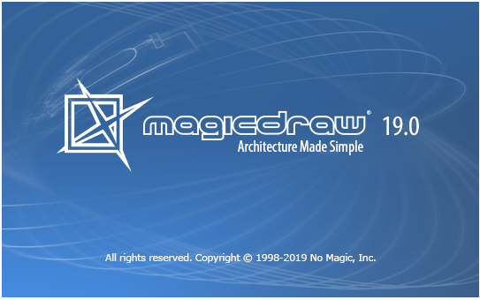For this project, the tool used to design these three diagrams was a software named **Magic Draw** version **19.0**. Which are the use case diagram, sequence diagram, and class diagram.

**3.2.3.3 DESIGN USE CASE DIAGRAMS**

The use case diagram is a dynamic and behavior diagram that models the functionality of a system.

Actor

* **System**

It is illustrated using a rectangle which contain the use cases and relationship. The actors should be place outside the boundaries of the system.

System

System Name

* **Use Case**

They are drawn using ovals. They are labelled with verbs that represent the system’s function.

Use Case

Use Case

* **Relationship**

I illustrate the relationship between actors and use cases, use cases and other use cases using a simple line. An “include” relationship indicates that the use case is needed by another use case to perform a task. An “extend” relationship indicates the alternatives options under a certain use case.

<<include>>

Relationships

<<extend>>

It should be noted that, this part contains the analysis of the functional and non-functional requirements use-case diagram and use-cases details.

With all this knowledge, I am now able to draw my portfolio building system use case diagrams, which resulted as such:

1. 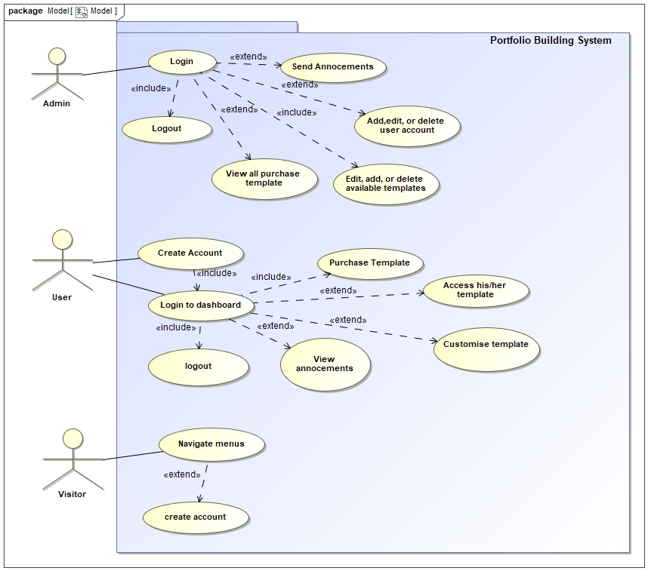**Use Case Diagrams for the Following**

**Figure 3.3: Use case Diagram**

**3.2.3.5 DESIGNING SEQUENCE DIAGRAMS**

This represents the dynamic aspect of a software system. Behavior of a software system can be modelled as interactions or as sequence of state changes.

**Message Arrows**

An arrow from the message caller to the message receiver specifies a message in a message in a sequence diagram. A message can flow in any direction; from left to right, right to left or back to the message caller itself. While you can describe the message being sent from one object to the other on the arrow, with different arrowheads you can indicate the type of message being send or received.

**Synchronous message**

As shown in the activation bars example, a synchronous message is used when the sender waits for the receiver to process the message and return before carrying on with another message. The arrowhead used to indicate this type of message in a solid one, like the one below.

**Activation Bars**

Activation bars is the box place the lifeline. It is used to indicate that an object active (or instantiated) during an interaction between two objects. The length of the rectangle indicates the duration of the object staying active.

**Asynchronous message**

An asynchronous message is used when the message caller does not wait for the receiver to process the message to another object within the system. The arrowhead used to show this type of message is a line arrow like show in the example below.

<< asynchronous message >>

1. **Sequence Diagrams**

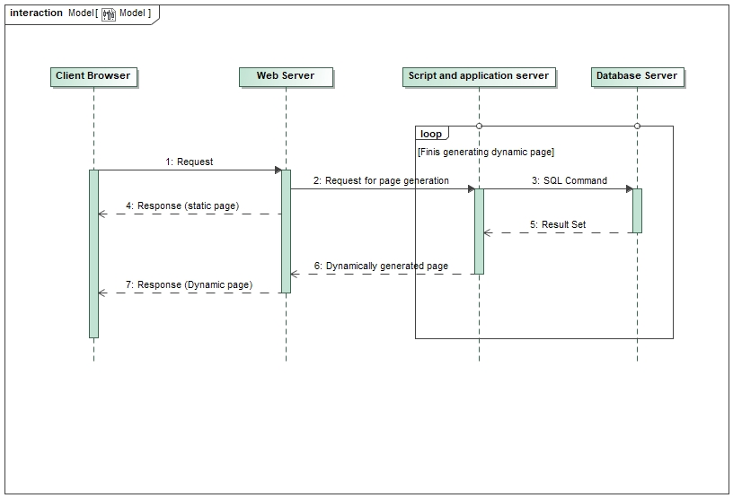

**Figure 3.4 Sequence Diagram**

**3.2.3.6 DESIGNING A CLASS DIAGRAM**

Class diagram is a static diagram and it represent the static view of an application. It describes the attributes and operations of a class and also the constraints imposed on the system. The standard class diagram is composed of three sections which are as follows;

* Upper Section: It contains the name of the class and it is always required, whether we are talking about a classifier or an object.
* Middle Section: It contains the attributes of the class which are used to describe the qualities of the class. It is required when describing a specific instance of a class.

Bottom Section: It includes class operations (methods) which are displayed in list format. The operations describe how a class interacts with the data.

The purpose of designing a class diagram can be seen as follows:

* Describe responsibilities of the system
* It provides an overview of how the application is structured before studying the actual code. This can easily reduce the maintenance time
* Class Diagram Illustrates data models for even very complex information systems.
* Forward and reverse engineering
* Allows drawing detailed charts which highlights code required to be programmed

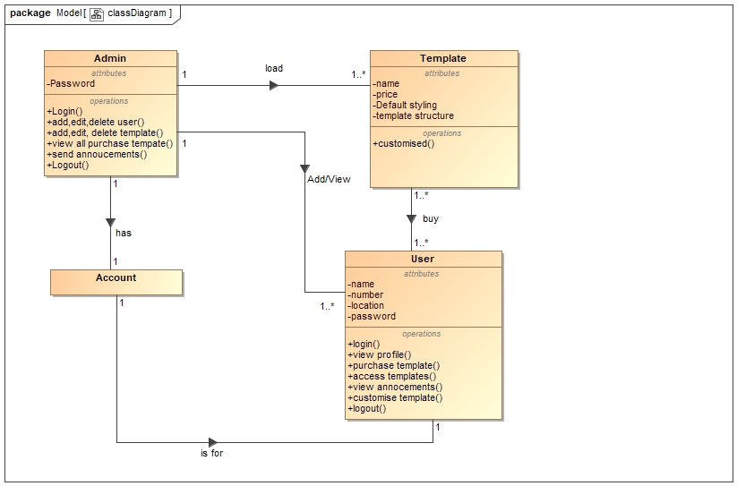

**Figure 3.5: Class Diagram**

**3.3 DATABASE DESIGN**

After designing UML diagrams, the next step I took was to design my HMS was to design the database.

**3.3.1 PERSISTENT DATA MANAGEMENT**

Persistent data management deals with how the persistent data (file, database, etc.) are stored and managed and it outlives a single execution of the system. This allows all the programs that operate on the HMS data to work consistently. Moreover, storing data in a database enables the system to perform complex queries on a large data set.

For complex queries over attributes and large datasets, the XAMPP Server is implemented, which is a Relational Database Management System.

**3.3.2 TOOL**

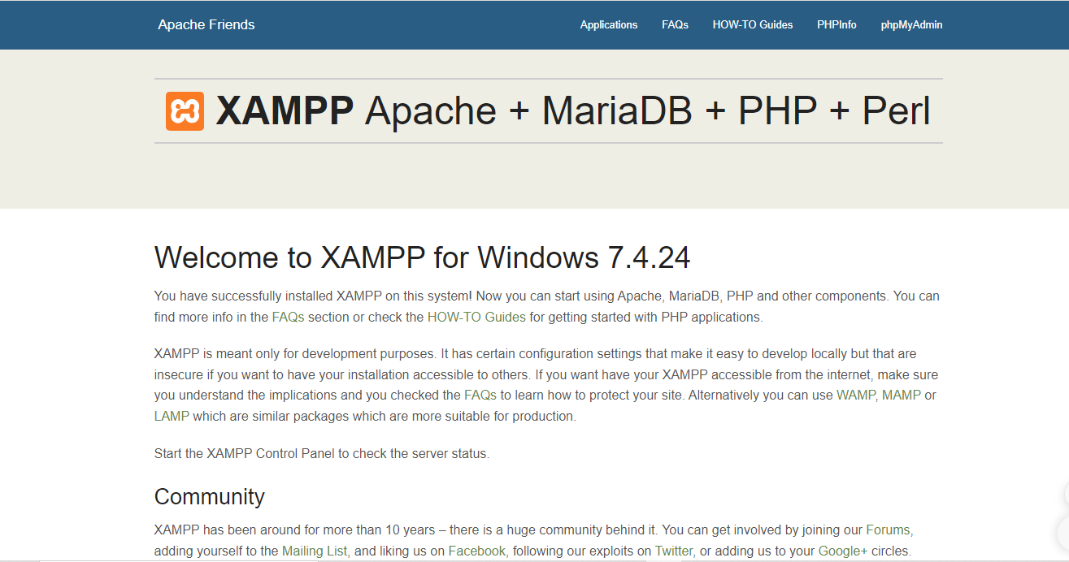The database was designed using PHP & and MySQL in XAMPP, which has the following interfaces.

**Figure 3.6:** **Xampp**

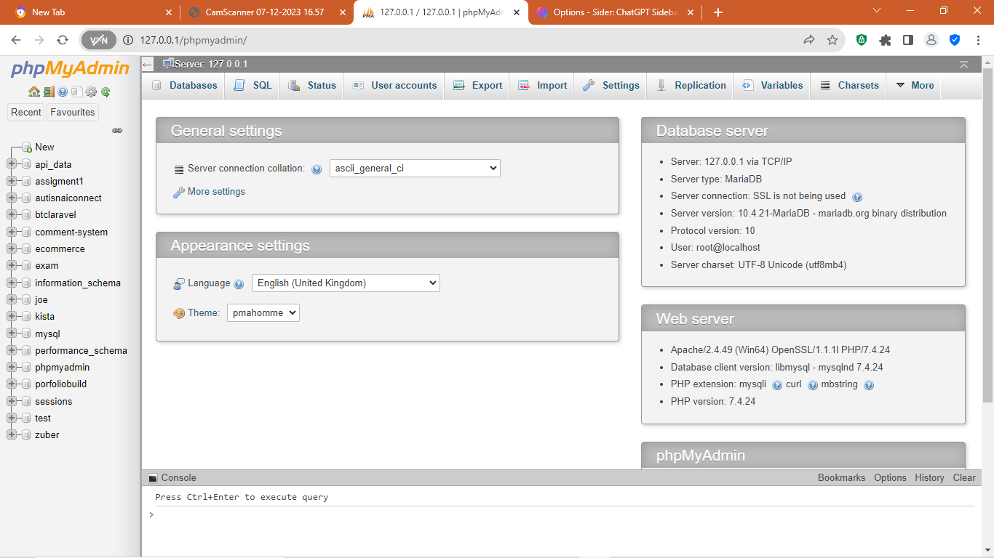 **XAMPP** is an abbreviation cross-platform, Apache, MySQL, PHP and Perl.

I have chosen XAMPP for the following reasons:

* It allows you to build WordPress site offline, on a local web server on your computer.
* It has a high performance
* It is easy to use
* It ensures data security
* It is scalable and flexible
* It is easy to interact with
* It works on Windows, Linux, and Mac -

**3.3.3 DATABASE MODEL**

In order to create an efficient database, we use database models. A database model in SDLC is a conceptual framework describing all activities in a software development project from planning to maintenance.

Software development is a cumbersome activity requiring proper identification of requirements, their implementation, and software deployment. However, the activities do not

end there. After the distribution of the software, proper maintenance has to be provided in a timely manner.

They are varieties of models such as the water fall model, magic box model, v-model, spiral model just to name a few.

**3.4 IMPLEMENTATION**

Below in this heading, I will present the testing part of the system with the front-end brought up by using HTML, CSS, JAVASCRIPT, JQUERY and BOOSTRAP. Followed by the back-end with PHP and MYSQL for database

**3.5 SOFTWARE USED**

For the successful development of the E-market, I made use of the following software

* **XAMPP**: A program/application used to develop databases with a user-friendly interface.
* **MAGIC DRAW**: A software which enable you to draw diagrams.
* **VISUAL STUDIO CODE**: An IDE which was used to write the codes for the Front-end and back-end.
* **CHROME**: A web browser which was used to test the system occasionally.
* **INTERNET**: The World Wide Web served as a reference for my entire work. Thanks to it this work successful.

**CHAPTER 4: RESULT AND DISCUSSION**

* **HOME PAGE**

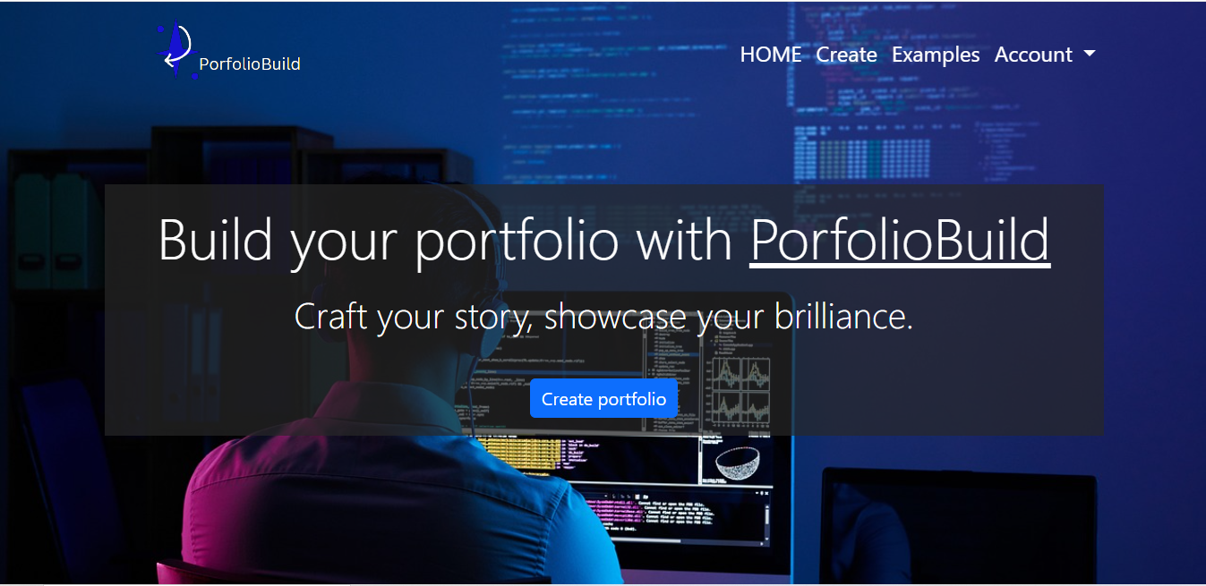This page will simply be welcome page and it will provide the user with a quick view of what he/she can do with the application.