CREATE A WEB APP WITH REACT AND BOOTSRAP

Web App Ideas

1. Create a web app for farmers to ask questions and get answers from fellow farmers

2. Create a web app to help farmers keep track of their daily task

The second idea was chosen due to the limited time for submitting project .

**PROTOTYPE OF WHAT WEBSITE SHOULD LOOK LIKE**

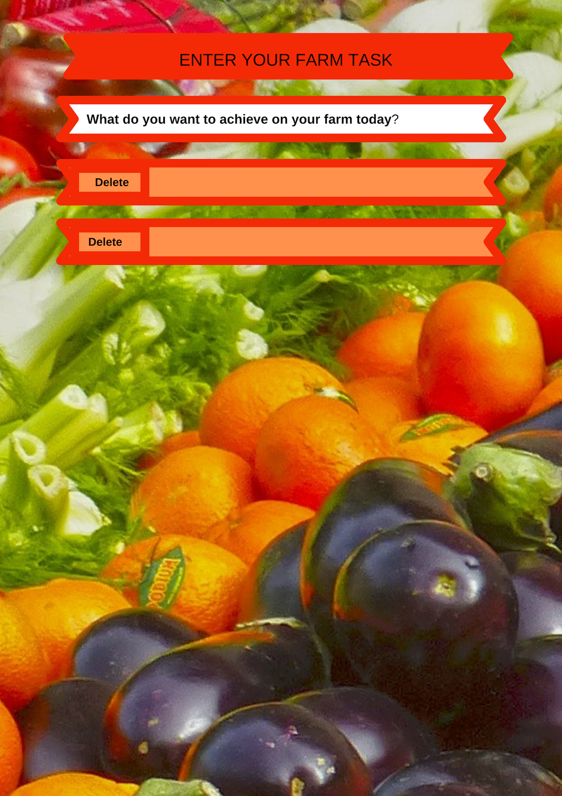

Requirements

* Install node.js to have access to npm
* Install create-react-app
* Install react-bootstrap
* Install react-router

To be able to had create this app I had to read the docs on react and react-bootstrap and freshing up my knowledge on javascript.