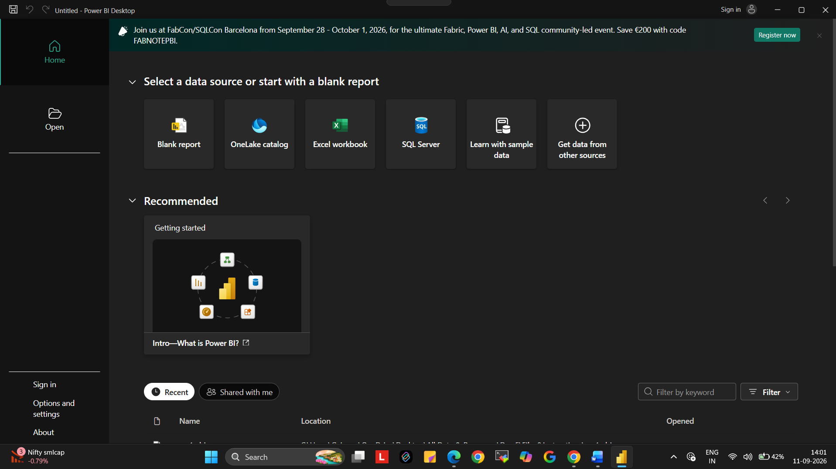
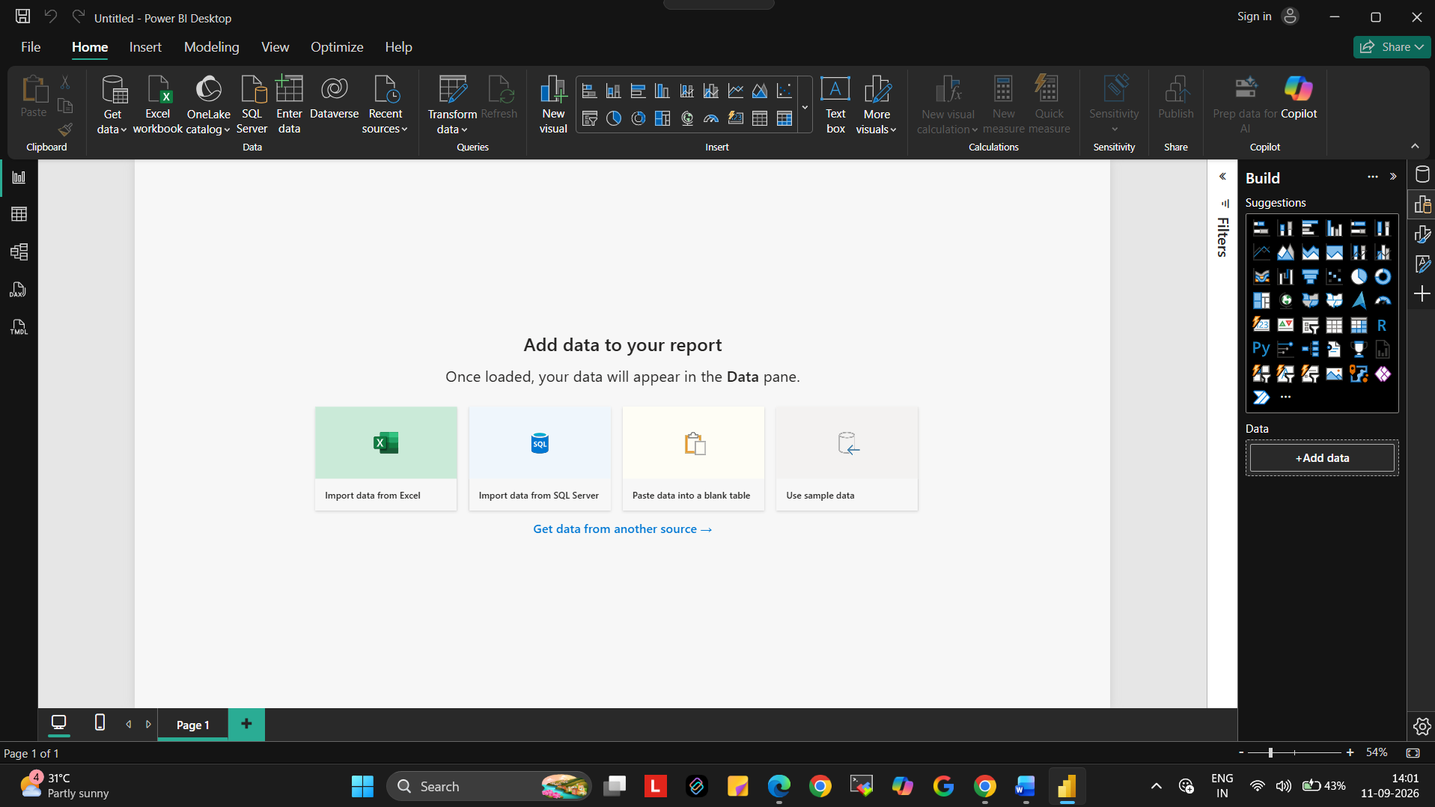
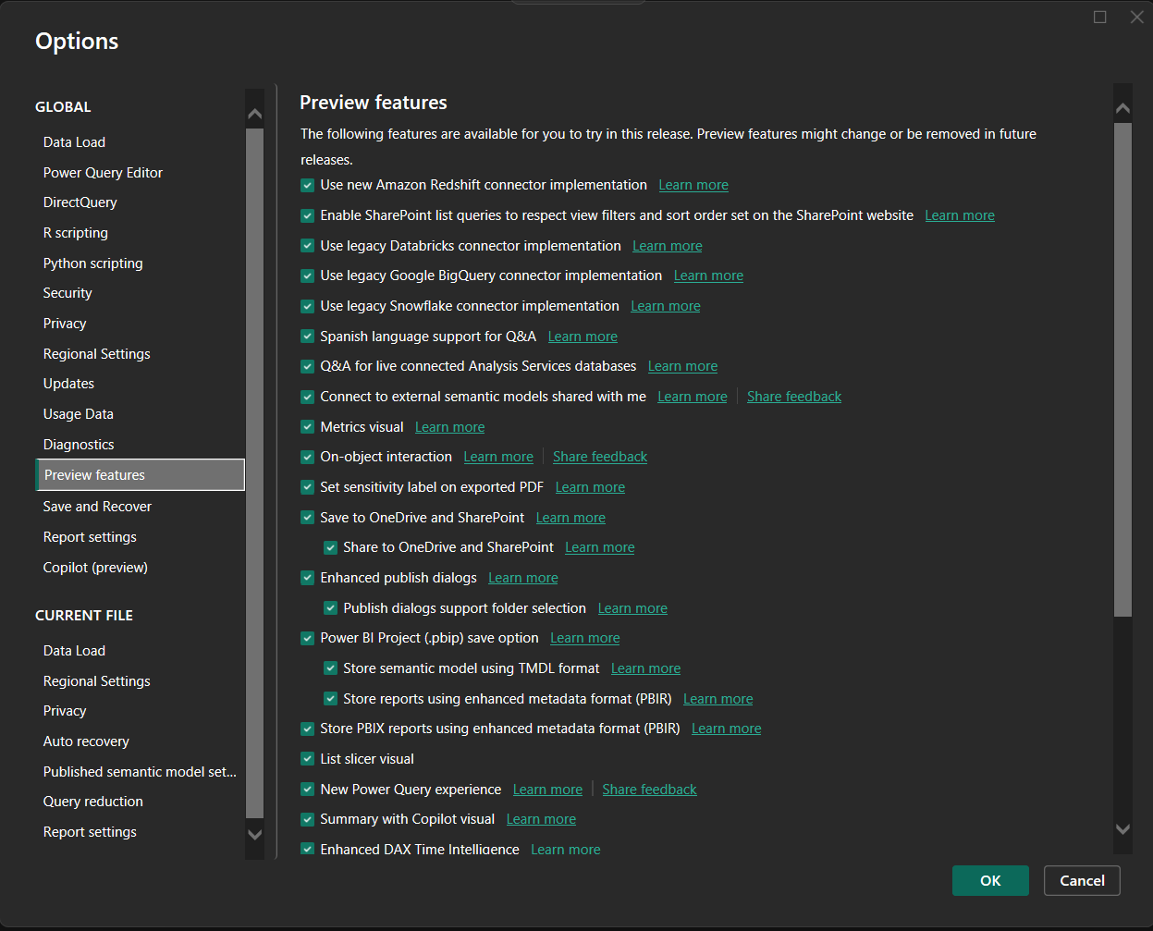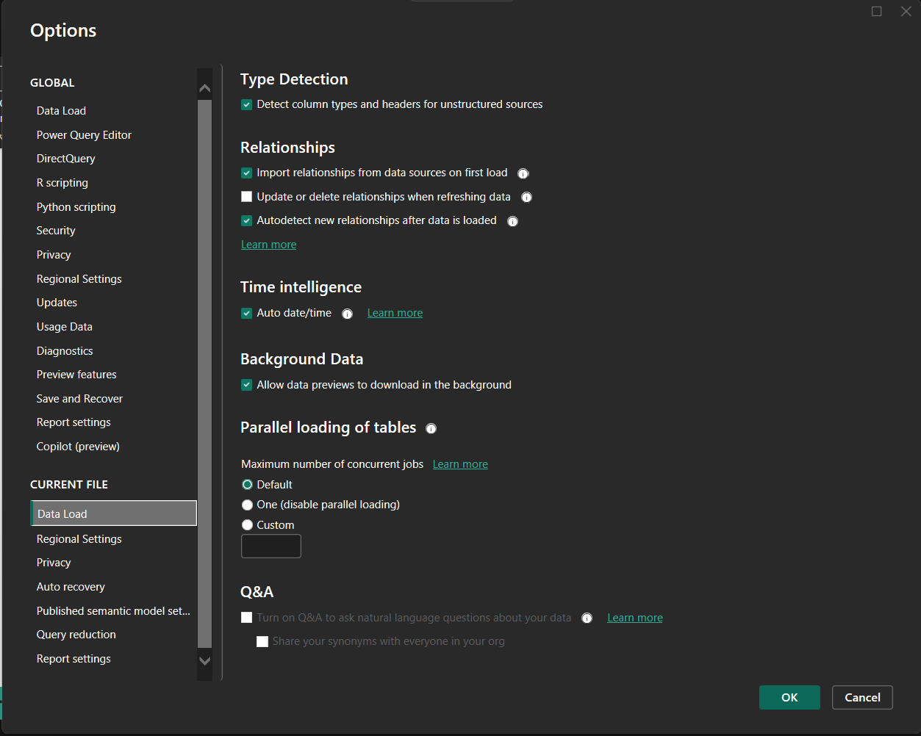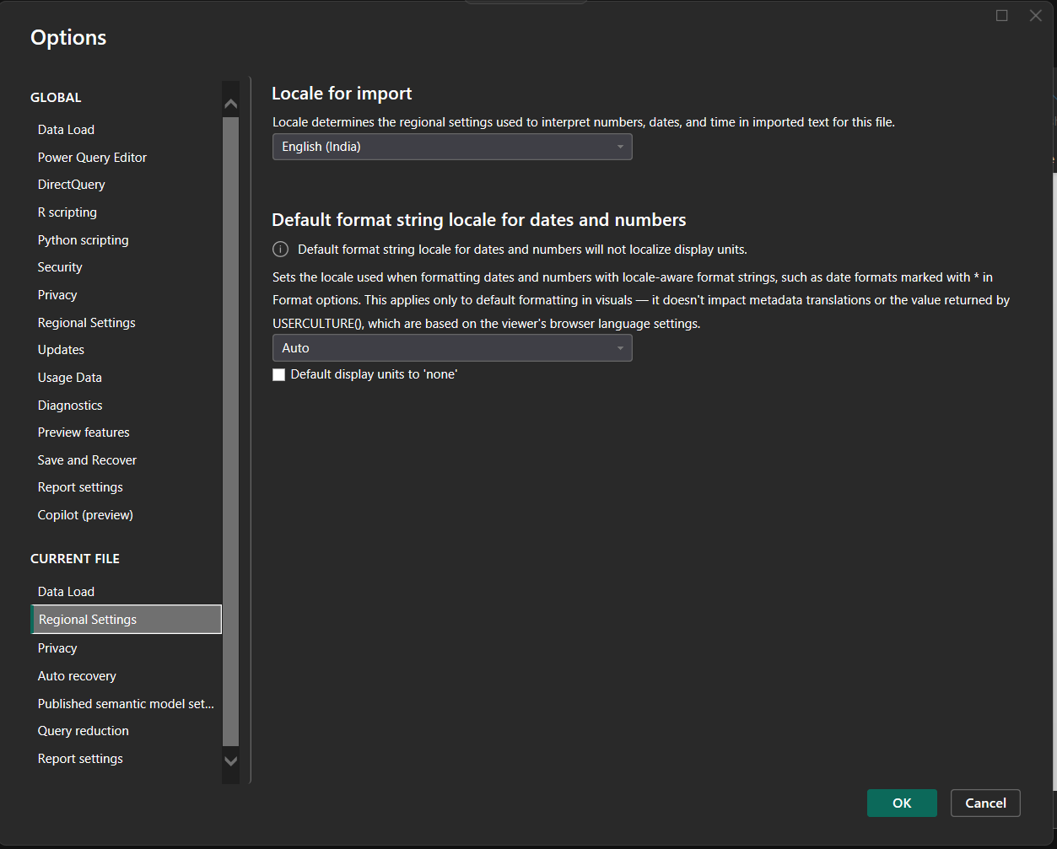

- Why are preview features useful?
ANS: They give you early access to new tools before official release. You can test and learn them safely in development. Your feedback helps Microsoft improve the final version. They let you prepare in advance for upcoming changes.

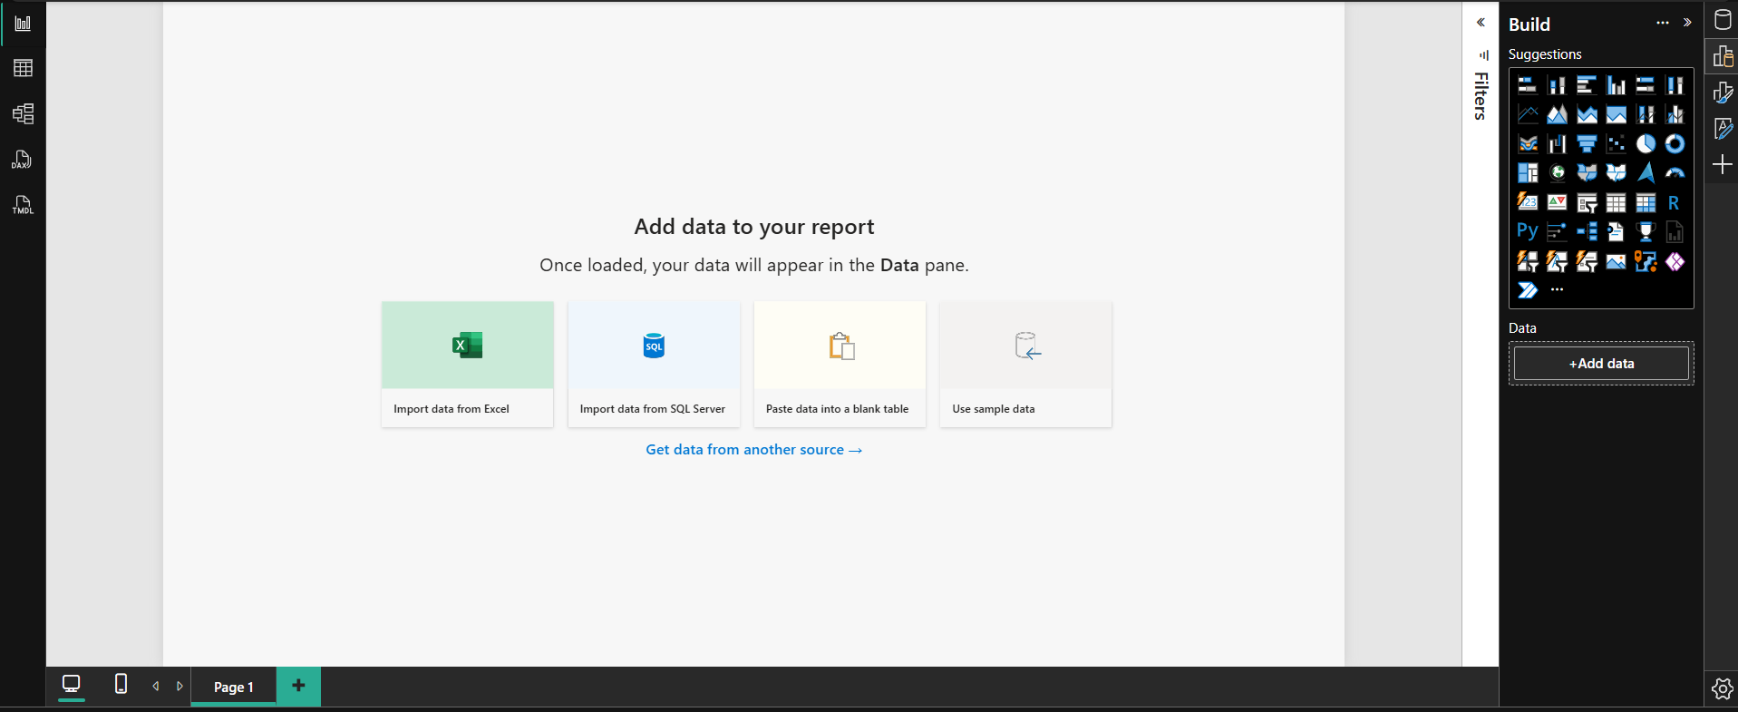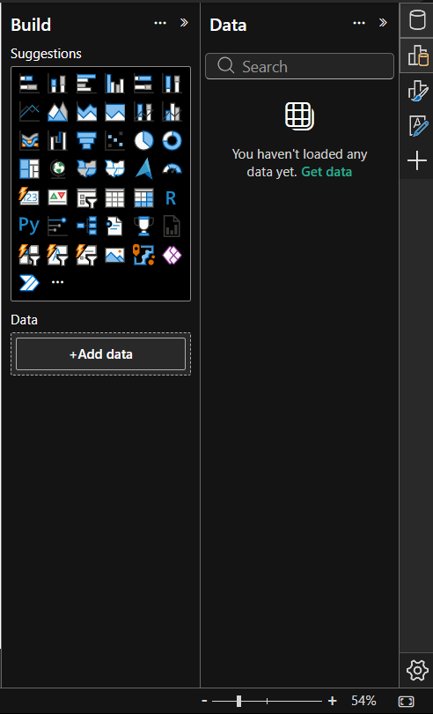

2) Explain the basic purpose of each view and when you might use DAX in a project.
ANS: Purposes of views as follows :-
Report view :- Build interactive dashboard, charts, maps and tables for end-users
Data view :- Inspect, explore and sort the raw rows and columns inside individual tables
Model view :- Manage relationships set up table hierarchies and organise semantic links across multiple tables.

When to use DAX as follows :- DAX is Data analysis expressions is the formula language used to add custom logic calculations and intelligence to your data model. Use DAX when standard Drag and Drop aggregations are not enough.

