# Assessment #4: Design Thinking

## Ethical Design – Prison Cell Challenge

Prepared by: Mashrur Hossain Mishal

### Part 1: Define Your Ethical Stance

Chosen Stance: Rehabilitative (growth and reintegration-focused)  
  
Justification:  
I believe that a prison system should not only serve as a deterrent and a means of justice, but also as an opportunity for reform. The majority of incarcerated individuals will eventually return to society. A rehabilitative design focuses on personal growth, education, psychological healing, and social reintegration. Ethical responsibility demands that we treat prisoners as human beings with the potential to change. By emphasizing rehabilitation, we foster safer communities in the long term and reduce recidivism rates.

### Part 2: Design the Cell

Five Essential Features:  
1. Natural Light and Ventilation: Large, secure windows allow access to natural daylight and fresh air, reducing depression, regulating circadian rhythms, and improving mental health.  
2. Private Restroom and Hygiene Area: A small, enclosed toilet and washbasin area supports personal dignity, hygiene, and a sense of autonomy.  
3. Modular Shelving and Desk: Allows for personal storage and space for study or creative expression. Encourages responsibility and routine.  
4. Digital Learning Terminal (Restricted Access): A secure, monitored computer station that gives access to educational materials, online courses, and mental health resources, promoting intellectual growth and reintegration skills.  
5. Communication Window or Time-Limited Call Access: Allows scheduled, monitored video or voice communication with family members or counselors. Maintains essential social bonds and emotional support.

### Prison Cell Sketch Illustration

Below is the visual sketch of the proposed prison cell layout incorporating all ethical features:

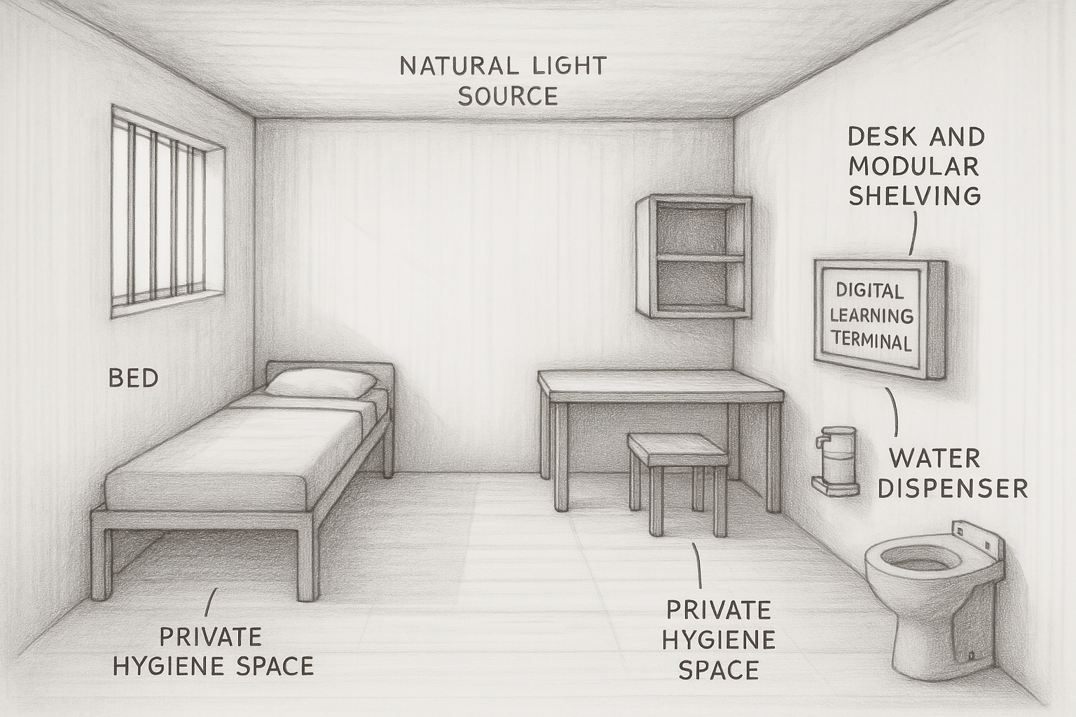

This sketch shows:  
- Bed next to a barred window for natural light and ventilation  
- Desk and shelving for study and storage  
- Digital learning terminal on the wall  
- Intercom/monitor for scheduled communications  
- A separate toilet in a private corner  
- A water dispenser with drinking glass away from the toilet area

### Part 3: Draw the Ethical Line

Feature Refused:  
24/7 Facial Recognition Surveillance  
  
Reason:  
While safety is critical, constant biometric surveillance invades privacy and can cause long-term psychological damage such as paranoia, anxiety, and dehumanization. Incarcerated individuals already face a loss of liberty—perpetual biometric tracking further strips them of dignity. Instead, ethical design should balance supervision with respect for personal boundaries.

### Bonus Reflection (Preferred Version)

Reflection:  
I chose a rehabilitative approach because I believe that people deserve a second chance. Most prisoners will re-enter society someday, and if we want safer communities, we have to give them the tools to grow—emotionally, mentally, and socially.  
  
My design includes natural light, a private hygiene space, a desk with learning materials, and monitored communication access—all meant to promote mental health, dignity, and personal development. But ethical design also means knowing where to draw the line. I refused to include 24/7 facial recognition surveillance because it’s invasive and psychologically harmful.  
  
That said, I recognize that even well-intentioned designs can feel unethical to users who have no choice in the matter. They might see our efforts as controlling or manipulative. That’s why true ethical design requires empathy and ongoing input from the people we’re designing for.  
  
Thank you.