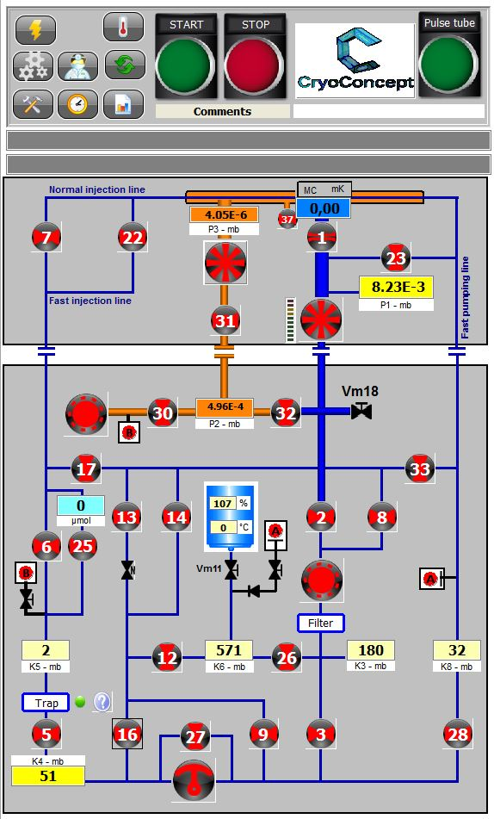

NX20

NX6

After the end of the stop cycle.

**How Put all of the mixture in security in NX20**

1. Close VM11 and VM18
2. Start Primary pump NX20
3. Open V2 V13 V12
4. Wait K6 = 0
5. Close the valve V12 V13 V2
6. Stop the Pump

**How Pump the dilution**

1. Start NX6
2. Open V13
3. Wait P2 1x10-1 Mbar
4. Open V32 V1 V23 V7 V22
5. Start Turbo Hipace 400

**How Test Leak in the pumping circuit**

1. Close all the valves and pump
2. Connect a leak detector on the VM18
3. Start the leak detector
4. Check the leak in the flexible between detector and VM18
5. Open V17
6. Open VM18
7. Start Turbo Hipace 400
8. Test the leak in the injection line (start on the top of V7-V22 and finish in the connection with GHS
9. Close V17
10. Test the leak in the pumping line (start on the top of the V1 and finish in the connection with GHS)
11. Stop the turbo and Close VM18

**Regeneration of the cold trap during a dilution cycle**

**CAUTION never forget to close valve B after regeneration**

**Risk of mixture loss**

1. Close the V1 V23 V7
2. Stop Turbo Hipace 400
3. Close V5
4. Open V17
5. Wait K5 = 0
6. Close V17 V6
7. Start Pump NX6
8. Warm the cold trap (around 50°C)
9. Open Valve B
10. Wait K5 = 0
11. **Close Valve B** (Don’t forget to close this valve you risk to loss mixture)
12. Open V5 V6 V7 V1 V23
13. Start Turbo Hipace 400 when P1 < 10 mb
14. Stop Pump NX6

**Regeneration of the cold trap when fridge is stopped and mixture in safety area NX20 outlet**

**CAUTION never forget to close valve B after regeneration**

**Risk of mixture loss**

1. All pumps and valves stopped
2. Put cold trap at room temperature
3. Control K5 pressure
4. Start Pump NX6
5. Open V31 V32 V17 V6
6. Warm the cold trap (around 50°C)
7. Wait K5 = 0 an P2 < 5 x 10-1
8. Close V17 V6 V32 V30
9. Stop Pump NX6
10. Put the cold trap in the nitrogen tank
11. The cold trap is ready