Evaluating Cost and Supply Chain Trade-offs in Off-site Construction
by
Paige Ruhlman
and
Andrés Vargas Pérez

Submitted May 2026 in Partial Fulfillment of the
Requirements for the Degree of Master of Applied Science in Supply Chain Management
at the Massachusetts Institute of Technology

ABSTRACT

Natural disasters affect millions of homes and individuals each year, posing supply chain challenges for recovery efforts aimed at providing replacement housing. Industrialized, off-site construction offers a practical solution by reducing costs and improving responsiveness. Focusing on cost efficiencies, this capstone examines how varying levels of centralization in the off-site construction supply chain affect total landed cost. Furthermore, it evaluates the trade-off between labor and transportation costs associated with off-site manufacturing and assembly. Applying a top-down, assembly-cost-based model, the capstone team estimated total costs for traditional housing construction and compared them with cost savings from off-site construction. The findings show that in serving high-labor-cost markets, off-site construction can reduce costs by up to 47%. Additionally, the team developed a facility location model to quantify the impact of location-based labor and transportation costs, suggesting facility location and market-allocation decisions to minimize total cost. Results show that locating manufacturing facilities in lower-cost states allows developers in high-labor-cost markets to reduce construction costs and improve profit margins. Stakeholders, including industrialized construction companies, federal agencies, and nonprofits, can reference the models and results to make data-driven decisions to decrease total landed costs. Beyond disaster relief, the capstone’s analysis and insights have broader relevance for advancing housing accessibility and affordable housing initiatives.

Capstone Advisor: Jarrod Goentzel
Title: Director, MIT Humanitarian Supply Chain Lab

Capstone Co-Advisor: Lauren Finegan
Title: Research Engineer
Table of Contents
1 INTRODUCTION 3
1.1 Motivation 3
1.2 Problem Statement and Key Questions 3
1.3 Project Goals and Expected Outcomes 4
2 STATE OF THE PRACTICE 5
2.1 Off-site Construction Supply Chain 5
2.2 Off-site Construction Supply Chain Configurations 5
2.2.1 Off-site Construction Housing Elements 6
2.2.2 Construction Supply Chain Configurations 6
2.2.3 Construction Activity Location 7
2.3 Housing Cost Estimation 7
2.3.1 Estimation Approaches 8
2.3.2 Cost Bases 8
3 METHODOLOGY 9
3.1 Methodology Selection 9
3.2 Data Collection and Preparation 10
3.3 Application of Methodology 12
4 RESULTS AND DISCUSSION 14
4.1 Local and Multi-market Modular 14
4.1.1 Results 14
4.1.2 Discussion 15
4.2 Multi-market Hybrid 15
4.2.1 Results 16
4.2.2 Discussion 16
4.3 Labor and Transportation Costs Trade-off 16
4.3.1 Results 17
4.3.2 Discussion 17
4.4 Limitations and Assumptions 17
5 RECOMMENDATIONS 18
5.1 Stakeholder Recommendations 19
5.2 Future Work 19
REFERENCES 21

1 INTRODUCTION
Natural disasters create significant challenges for the supply chains involved in housing-rebuild efforts. The United Nations (2015) reported that environmental events damaged 87 million homes worldwide from 1995 to 2015. In 2021, disasters affected one in every 10 homes in the United States, representing $57 billion in property damage (Jacobson, 2022). More recently, according to Los Angeles County (2025), the 2025 fires in that area resulted in an estimated $250 billion in economic losses and affected 16,000 structures. The unpredictability of natural disasters drives spikes in demand for housing replacements and complicates standardized government and construction responses.

1.1 Motivation
According to the U.S. Department of Housing and Urban Development (HUD), industrialized construction is a building approach that uses technologies and processes that are typical of industrial manufacturing (Rupnik et al., 2026). While industrialized construction started in the early 1900s, there is renewed interest driven by rising housing costs, unmet housing demand, and technological advances (Conroy et al., 2025).
Off-site construction is a type of industrialized construction that can be effective in disaster relief efforts. The International Code Council (2023) defines off-site construction as the production of building components or structures in a centralized factory setting to improve quality, sustainability, and safety while reducing time and costs compared to traditional on-site construction (commonly referred to as site-built). However, these cost savings create a trade-off, as transporting prefabricated or complete units to the final site introduces logistics costs that must be weighed against the lower construction costs. Off-site construction, compared to traditional on-site, can reduce build times by 20%–50% and lower costs by approximately 20% (International Code Council, 2023). These improvements typically derive from process efficiencies and economies of scale. Bertoni and King (2025), in their Massachusetts Institute of Technology (MIT) capstone, explored different approaches to off-site construction, including varying levels of process centralization and automation. They found that off-site implementation can take as few as 18 months, including design, construction, delivery, and on-site assembly, with construction itself taking as little as five months. In contrast, traditional housing reconstruction efforts can take 3.5 to 5.9 years (Martín et al., 2019). Several key stakeholders, such as industrialized construction companies and federal agencies, question whether specific demand conditions and building context can inform an approach that further reduces costs and improves post-disaster responsiveness.
As the sponsor of this capstone, the Humanitarian Supply Chain Lab (HSCL) seeks to continue research on the supply chain for off-site construction. Part of the Center of Transportation and Logistics (CTL) at MIT, the HSCL focuses on enhancing supply chains to meet human needs. Founded in 2011, it has conducted extensive research on supply chain resilience in pre- and post-natural-disaster situations. The HSCL began partnering with the Federal Emergency Management Agency (FEMA) in 2017 to study post-disaster housing supply chains and off-site construction. According to the lab’s research, there is a limited understanding of the end-to-end supply chain for off-site construction. Thus, it is hard to quantify the cost benefits of economies of scale achieved through centralization at the construction process level. As a result, it is complicated to assess the trade-offs between off-site construction and transportation costs.

1.2 Problem Statement and Key Questions
This project aims to understand and describe the off-site construction supply chain, the value of centralization, and the trade-off between location-specific labor and transportation costs. To achieve the objective, the project analyzes various end-to-end supply chain configurations of manufacturing, assembly, delivery, and installation. A proposed estimation model that calculates the total landed cost for each configuration facilitates sensitivity analysis for varying assumptions regarding scale economies as well as spatial analysis that balances labor and transportation costs. Using traditional, site-built housing construction as the benchmark, the estimation model evaluates two markets: Salt Lake City, Utah, and Los Angeles, California. Industry experts guided the selection of these metropolitan areas to compare and contrast a very large urban market with high labor costs and demand (Los Angeles) with a mid-sized market with lower labor costs and demand (Salt Lake City).
In that context, the questions to be answered include:
- What are the operational differences between off-site construction configurations?
- How can off-site housing construction processes benefit from centralization and economies of scale?
- How does the combination of labor and transportation costs across markets affect the choice of off-site facility location to minimize the cost of serving a market?
Figure 1 outlines the key steps to be pursued throughout the capstone, including preliminary research, parameter identification, and the development of models refined by user feedback.
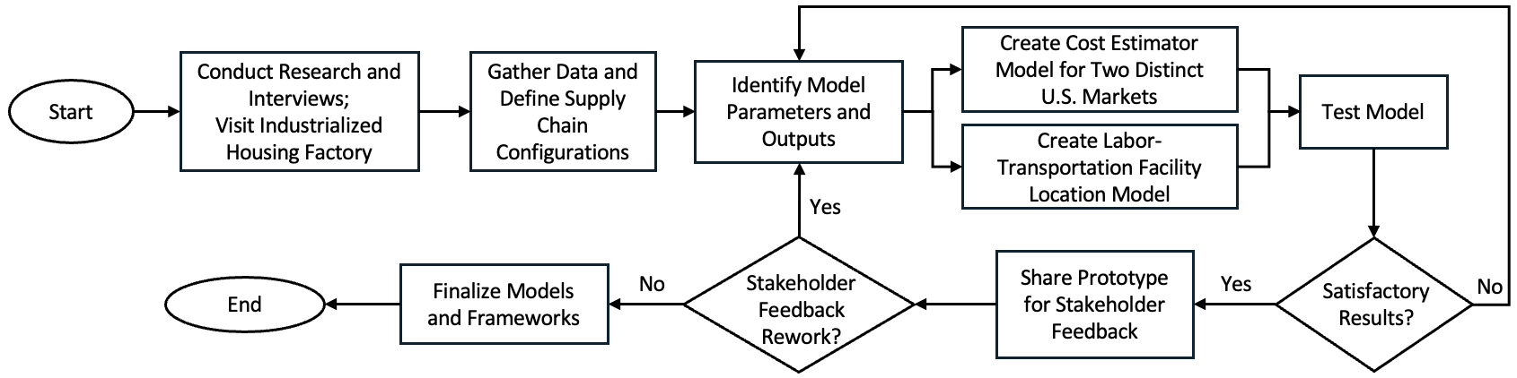
Figure 1. Plan of Work for Capstone Project

1.3 Project Goals and Expected Outcomes
The goal of this project is to provide the HSCL with models to evaluate cost trade-offs between supply chain configurations (defined in Section 2.2) based on input parameters. The models highlight how total costs differ with various configurations and the nature of construction process centralization. Parameters, including material and labor rates, distance to the final homeowner site, and cost per mile, among others, drive the calculation. Results from the calculation also include a side-by-side cost comparison between site-built construction and the off-site configurations, highlighting estimated cost savings.
The deliverables to the project sponsor include:
- A cost estimation model comparing construction configurations that adapts to parameters and supply chain design. It includes a user-adaptable capability to alter the location of each construction activity (see Section 2.2.3) to analyze trade-offs between configurations.
- A facility location model of off-site housing construction isolating location-specific labor and transportation to the demand site. Sensitivity analysis shows how different values of labor and transportation costs impact the off-site facility location strategy to minimize costs.
Stakeholders, including federal agencies, governments, and nonprofit organizations, can use the models to make data-informed decisions to reduce the total cost of housing construction. Furthermore, the breakdown of off-site construction configurations enables deeper visibility into the housing supply chain. Ultimately, the team can share the finalized model as an open-source tool to enable faster decision-making and support affordable housing needs, especially after disasters.

2 STATE OF THE PRACTICE
The central problem of this capstone is understanding the end-to-end supply chain of off-site construction, identifying cost benefits from manufacturing process centralization, and comparing key labor and transportation trade-offs when selecting facility location. To assess the current state of practice, the study examines the supply chain activities of off-site housing, specifically from manufacturing start to final delivery and assembly. It also defines construction supply chain configurations comprised of housing elements, manufacturing strategy, and activity location. Lastly, it explores techniques for estimating cost trade-offs in supply chain configurations, including estimation approaches and cost bases.

2.1 Off-site Construction Supply Chain
Off-site housing construction follows a supply chain flow of sourcing, manufacturing, transportation, and on-site installation. After permit approval, off-site manufacturing starts in parallel with the construction site preparation (e.g., foundations and grading). Manufacturers fabricate housing components, including floors, walls, roofs, mechanical, electrical, and plumbing (MEP) systems, insulation, and finishes, using both assembly-line and job shop approaches (Modular Building Institute, 2022). Depending on the configuration, these components can either be transported directly to the construction site for on-site assembly or assembled at the off-site facility to complete the volumetric housing module before being transported. In either case, inspections take place on these housing elements before leaving the factory to ensure quality compliance. Once the housing module(s) are on-site, installation, including connecting panels or modules and any final interior or exterior finishes, occurs. In off-site construction, 85% to 95% of traditional construction activities can take place in the factory (Zohourian et al., 2025). Moreover, Bertram et al. (2019) estimate a potential 20%–50% time savings relative to site-built construction due to increased facility productivity and the parallel start of site preparation and manufacturing.

2.2 Off-site Construction Supply Chain Configurations
The supply chain configuration for off-site construction includes the elements of a home, the construction strategy, and the location of the construction activity. There are many ways to combine these aspects, and each supply chain design has trade-offs. Figure 2 visualizes the different supply chain configurations examined in this capstone.
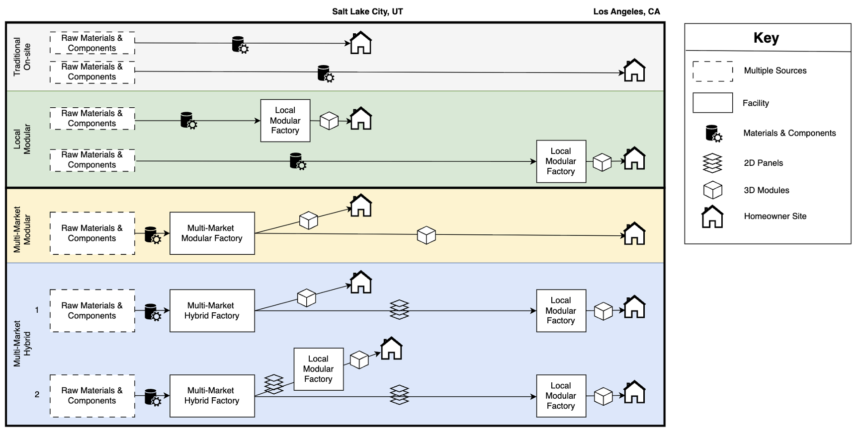
Figure 2. Construction Supply Chain Configurations Evaluated

2.2.1 Off-site Construction Housing Elements
The off-site construction housing elements are (1) raw materials and components, (2) 2D panels, and (3) 3D modules. Each classification is defined below.
- Raw Materials and Components: All raw materials needed to build a home from scratch. These materials can range from small and medium elements (nails, screws, tape, wires, pipes) to larger components (lumber, vertical frames, doors, roofing material). Depending on the configuration, suppliers ship raw materials and components to the construction site or an off-site facility.
- Panels (2D): Two-dimensional panels (floor, wall, roof). Trucks transport these items from the initial facility to a secondary facility or the housing site for assembly. The panelized approach enables easier transportation compared to volumetric shipping and greater housing design flexibility (Bertram et al., 2019).
- Modules (3D): Volumetric modules built in the factory, consisting of panels, building frames, and other structural components. Trucks transport the modules to the housing site for installation. Builders connect many modules to create a modular house, which enables various housing design options. With high standardization, the modular approach can lead to greater productivity and time savings (Bertram et al., 2019).
Some builders use a hybrid combination of 2D panelized and 3D modules. While there can be many hybrid variations, this capstone focuses on 2D panels transported from one facility to be assembled into 3D modules in another, more local facility. The hybrid model leverages the strengths of the individual panelized and module approaches, leading to cost savings if successful (Zohourian et al., 2025).

2.2.2 Construction Supply Chain Configurations
This capstone compares on-site housing construction to three different off-site facility designs: local modular, multi-market modular, and multi-market hybrid.
- Traditional On-site (benchmark): Suppliers send raw materials and components from multiple sources directly to the homeowner’s site. Workers build the house from the ground up, with equipment, workers, and other resources all located on-site.
- Local Modular: Suppliers send raw materials and components to a smaller facility, which produces and delivers the finished module(s) to the local housing site (within 50 miles) for installation.
- Multi-market Modular: Suppliers send raw materials and components to a larger facility, which produces finished module units. Drivers transport the finished units to two markets for installation: local housing sites (50–100 miles) and distant or long-haul housing sites (>100 miles). In this scenario, the square-foot construction cost is the same across similar housing modules, while transportation costs vary by the market served.
- Multi-market Hybrid: Suppliers send raw materials and components to a larger, hybrid facility, which can produce a mix of panelized and finished modules. Drivers transport panels to a secondary, more local facility to assemble into housing modules. From both facilities, housing modules ship to the end user location for installation. This strategy is the least defined and implemented in the industry.

2.2.3 Construction Activity Location
The construction activity location specifies where the respective construction step is executed. Depending on the supply chain configuration, the construction process steps may be located on-site, locally, centrally, or in a hybrid setup. Construction activities in a configuration may take place across multiple locations.
- On-site: In on-site and off-site housing, these process activities are done completely on the homeowner’s site. The entire construction process, using a traditional on-site manufacturing strategy, is on-site. Regardless of supply chain configuration, site work, foundations, and on-site installation are on-site assemblies (see Section 3.3, Table 1 for construction process steps).
- Local: In local modular and hybrid housing configurations, these manufacturing processes are performed at a local factory before the housing unit is transported to the homeowner’s site. The local modular strategy assumes all process steps are performed at the local facility (besides those stated to be on-site above).
- Central: In the multi-market modular configuration, all manufacturing processes are performed at a central factory, after which the housing units are transported to homeowners’ sites in both local and distant markets. The central modular strategy assumes all process steps are performed at the central facility (besides those stated to be on-site above).
- Hybrid: In hybrid off-site configurations, manufacturing processes are performed at a large, hybrid factory that produces components, panels, and housing modules to serve multiple markets. Suppliers ship panels from a hybrid location to a local facility to complete the housing module. Drivers then transport the finished modules directly to the homeowner’s site.
- Hybrid/Local: In hybrid/local off-site configurations, these manufacturing processes are done at both the large, hybrid facility and the smaller, local facility. An example of a hybrid/local construction process is building inspections.

2.3 Housing Cost Estimation
The practice of cost estimation includes approximating the total amount of resources needed for a project. This approach is especially useful during the planning phase, as it can compare the cost and timeline of different project designs and help determine whether a particular design should be implemented (Joubert, 2019). Thus, an estimation model’s accuracy and robustness can lead to the success or failure of a project.
Given that many strategic decisions are based on estimates, the U.S. Government Accountability Office (2020) states that estimates must be comprehensive, well-documented, accurate, and credible. To achieve this, the estimator’s purpose and scope must be clearly defined at the beginning. It is best practice to create a work breakdown structure (WBS) outlining the project’s tasks. Then the estimation approach(es) and cost bases defined below can be identified. When acquiring data, it is important to document all assumptions and sources to ensure model traceability. The estimator should review, test, and present values to experts for feedback to ensure reliability.
The list of estimating approaches and cost bases is extensive, as the methodology applied to each project is unique. This capstone examines three widely used approaches (top-down, bottom-up, expert judgment) and three cost bases (unit cost, assemblies, square foot).

2.3.1 Estimation Approaches
The following estimation approaches are considered in this capstone:
- Top-Down: Typically used for projects in planning stages or those without a detailed breakdown of activities, this approach starts with a high-level approximation of the project costs and resources. This initial estimate is derived by categorizing project tasks into buckets and aggregating. As more details emerge throughout the project’s lifecycle, the estimator updates the approximation (actiTIME, 2021). Thom (2025) describes this method as quick, reducing the amount of data needed, and serving as a first gauge of whether the project should be pursued. Initial top-down estimates can have low accuracy, and the traceability of costs, times, and resources used is unclear.
- Bottom-Up: Thom (2025) explains that this estimation method, the opposite of the top-down technique, begins by using the WBS and dividing the project into independent activities. Estimators approximate costs, times, and resources at this level of granularity and sum them across all activities. Benefits of this approach include detailed visibility into resources needed and quote tracking. Additionally, the precision of bottom-up estimation enables identification of the main cost drivers and bottlenecks in the process (Thom, 2025). The U.S. Government Accountability Office (GAO) says this approach requires a comprehensive WBS, which may be difficult to achieve for projects without an established process. Thus, it can be costly and time-consuming to calculate. If the analysis uses incorrect assumptions and estimates at lower levels, the sum of those costs can lead to inaccuracy (U.S. Government Accountability Office, 2020).
- Expert Judgment: This technique involves obtaining approximations from subject-matter experts (SMEs) in the field based on their insights, expertise, and experience. The SME is a trusted source of information who provides feedback, explanation of data, and estimated values. This approach is helpful when experience in a given field is limited or data gaps exist. Given the professional’s deep knowledge, the approximation may also account for elements of the project beyond the scope of other methods. This method can be subject to bias and limited perspectives because expert judgment relies on human experience and skill (actiTIME, 2021).

2.3.2 Cost Bases
The following cost bases are considered in this capstone:
- Unit Cost: Requiring a detailed list of project resources, unit cost base assigns a cost to each unit of measurement, for example, the cost of a specific material per linear foot. Frequently used in bottom-up estimating, this type of cost base increases visibility into the bill of materials (BOM). Nevertheless, the level of granularity requires time and experience to ensure unit cost accuracy (Quantity Surveying Coach, 2024).
- Assemblies: Segmenting project activities into buckets, an estimator approximates assembly cost bases at an aggregated level rather than by individual units. In construction, common assemblies include floors, walls, roofs, and MEP systems. The top-down estimation method commonly uses this cost base, which pools together many tasks. Assemblies’ costing is quick and can be refined further as more details become available. However, summarized costs at a higher level can lead to under- or over-exaggeration of costs, times, and resources needed (Quantity Surveying Coach, 2024).
- Square Foot: Leveraging existing project data with similar characteristics, the square-foot cost base generates per-area costs. The construction industry commonly uses square-footage approximations during the preliminary phase of a project to reflect industry averages. This method can lead to limited data justification and accuracy, as the estimate is based on an overall square-foot cost rather than material costs. Moreover, it has limited adaptability in assessing the impact of variables and is prone to broad simplifications (Quantity Surveying Coach, 2024).
By examining the process of various supply chain configurations, the team gained insight into the industry's opportunities and risks. Paired with the study of cost methodologies, this research helps identify the most appropriate method(s) for evaluating the cost trade-offs between supply chain configurations.

3 METHODOLOGY
This section describes the team’s approach to answering the sponsor’s key questions outlined in Section 1.2. The methodology description outlines the plan for analyzing the trade-offs and benefits of housing supply chain designs for disaster relief responses.

3.1 Methodology Selection
The team decided to implement a top-down, assembly-cost-based model after understanding the sponsor’s need to compare different construction approaches and centralization levels. This estimation method offers a balance between data-collection time and accuracy compared with other techniques. Results break down at the construction-process level, which provides an initial estimation and reduces the time required to collect data compared to a bottom-up approach (see Section 2.3.1). The analysis distributes the total cost across construction processes based on each activity’s percentage of the overall construction cost. The framework allocates cost values between labor and materials to assess labor’s impact on total construction cost. The study presents the estimates using two units of analysis: a 1,000-square-foot home and a per-square-foot basis, assuming a linear relationship. These provide the flexibility to understand the total construction cost of a house as well as the unit level most commonly used by builders when quoting projects and performing cost analyses.
The estimation model examines the following main supply chain strategies: 1) a traditional on-site model; 2) an off-site factory serving local demand; 3) a multi-market modular factory serving both local and distant markets; and 4) a hybrid approach, in which a centralized facility ships panels to smaller facilities where assembly is performed and delivered to fulfill local demand. These approaches represent varying degrees of centralization and associated transportation costs. The model calculates process-level savings for each configuration based on whether each construction activity occurs on-site or at an off-site facility. Also, it evaluates the traditional on-site and local off-site scenarios from the perspectives of a high-cost market and an average-cost market. The multi-market configuration assumes that a factory located in the average-cost market (Salt Lake City) supplies demand for both the local and the high-cost market (Los Angeles). Transportation requirements in the analysis capture the trade-offs between lower labor costs and shipping houses to the on-site lots.
Additionally, the study presents a model that finds a centralized facility location that offers the lowest network cost based on the trade-offs between labor rates and transportation costs. This model minimizes the cost of meeting housing demand across states located west of the Mississippi River. The population-weighted centroid of each of those states is considered a potential facility location. The model looked to answer two questions, based on each state’s labor rates and the transportation costs associated with off-site construction: 1) Where should a facility be located to service both local and other states’ demand? And 2) For each state in the analysis, should it be serviced out of the central facility or from an in-state facility? This analysis offers insights into the sponsor’s key questions, allowing them to understand the trade-offs between transportation and labor costs in off-site construction.

3.2 Data Collection and Preparation
The data collection process forms the foundation of the estimation model. The model draws information from diverse sources, including the National Association of Home Builders (NAHB), U.S. government labor statistics, and publicly available data. Subject-matter experts refined the values based on their empirical experience. Despite the need for accurate information, the model does not aim to produce the most precise results, but rather to provide a reasonable initial estimate that offers directional guidance for decision makers.
The NAHB provided the primary source of information for this project through its 2024 annual report, Cost of Constructing a Home (Lynch, 2025). Using national averages, the report presents the cost of building a house with traditional construction methods, including a detailed breakdown of construction processes and their percentage contribution to the total cost. These values serve as the baseline for calculating potential savings from centralizing processes. Furthermore, this report provides information on average sales price and other costs, which allows the calculation of profit margins for the evaluated configurations.
To better compare configurations and assess the trade-offs between labor and transportation costs, the team separated the NAHB process-level cost values into labor and material components. Subject-matter experts and publicly available data from real estate advisors suggest a split of approximately 60% for materials and 40% for labor (HomeAdvisor Staff Writer & Robert Tschudi, 2025). While proportions can vary across processes due to specialized labor requirements, this initial estimate enables the team to generalize and prepare a preliminary cost assessment. Further refinements, such as incorporating more SME input, can be made to modify these assumptions for more specific or detailed scenarios.
The study used publicly available data from consulting firms and online cost estimator tools to refine the national averages reported by the NAHB, reflecting the specific markets evaluated: Los Angeles and Salt Lake City. These sources provide insights into regional variations in labor and material costs, enabling the team to scale the national baseline to reflect local construction economics more accurately. This adjustment enables evaluation of the traditional and local off-site scenarios in each market, as well as the multi-market scenario in which a lower-cost region supplies a high-cost market, balancing labor savings and transportation costs.
The team obtained transportation cost estimates for different supply chain configurations and off-site construction housing elements (defined in Section 2.2.1) from SMEs. These experts provided cost per mile estimates for both long-haul and short-haul distances. Transporting 3D volumetric components is more expensive than transporting 2D panels, since modules may require pilot vehicles or police escorts depending on size regulations, which can vary by state. (Note: state variation is not included in the model; see Section 3.3 for all assumptions made and model limitations.) In contrast, 2D panels can be stacked more efficiently to fit standard size limits, which allows a greater number of components to be shipped at once and reduces overall transportation costs and escort requirements.
The team calculated facility costs, treated as fixed costs in the analysis, by using lease rates across each market and estimated throughput levels. For each market, the team researched lease rates for a small local facility and a larger centralized factory, defined as 50,000 and 100,000 square feet, respectively. These sizes reflect the actual facilities currently used by subject-matter experts in off-site construction. The smaller, 50,000-square-foot facility is assumed to service local demand within 50 miles and have an annual throughput of approximately 31,250 square feet of construction, based on estimates of 500–700 square feet of throughput per week provided by industry practitioners. The larger, 100,000-square-foot facility represents a centralized, multi-market operation with double the throughput of a local facility (62,500 square feet per year modular).
Further, the team estimates that the panelized (2D) throughput would be twice as efficient as the volumetric throughput (3D) for hybrid multi-market facilities (see section 3.3 for two hybrid scenarios). For example, if the 100,000-square-foot hybrid facility is producing modules and panels (assuming a 50% split), the panelized square-foot throughput is estimated to be twice as much as the modular square-foot throughput (62,500 square feet per year panelized; 31,250 square feet per year modular). Whereas, if the hybrid facility is producing only panelized elements, the square-foot throughput is estimated to be twice as much as the multi-market modular facility (125,000 square feet per year panelized). The study uses this assumption due to a lack of data from subject-matter experts (see Section 4.4 for other limitations on the multi-market hybrid configuration). Equipment costs, estimated at $1 per square foot of facility space, function as fixed costs. By dividing both the lease and equipment costs by throughput, the team calculated a fixed cost per square foot. This approach allowed the analysis to quantify the fixed cost structure inherent in off-site construction.
The model calculates total time per construction activity using a publicly available average of 210 days to complete a 1,000-square-foot home from site work through completion (Eje, 2026). Using the site-built configuration as the benchmark, the team assigned each construction activity a proportional share of this total project duration derived from Bertoni and King’s 2025 Capstone (these parameters are modifiable in the model). Then, for off-site configurations, the model applies a time-reduction factor for each construction activity relative to the site-built configuration. The team estimates that most construction activities achieve a 20% time savings, based on estimations from consulting and industry reports. Additionally, there is a significant time reduction due to the parallel start of on-site work and housing production. Further, the centralized location of manufacturing enables greater time savings for inspections, as the factory’s processes can be certified as opposed to each individual house in traditional construction. Transportation and on-site installation add time in off-site configurations that do not exist in the site-built configurations. As a result of these calculations, the model has an approximate breakdown of the number of days and hours each construction process requires. It is important to note that the team did not refine the time estimation for deeper analysis due to a scope shift to cost metrics.
To create the facility location model, the team researched labor rates at the U.S. state level and the construction process. The main source of information was the 2024 Bureau of Labor Statistics Occupational Employment and Wage Statistics (BLS OEWS), which provides the average cost per hour of each construction process at the state level (U.S. Bureau of Labor Statistics, 2025). This study required locating the population-weighted centroid of each state to be considered as a potential facility location. The U.S. Census provided this information, as well as annual housing demand by state.

3.3 Application of Methodology
After gathering the necessary data, the model estimates costs for each supply chain design and market scenario, accounting for centralization benefits and transportation costs.
For the traditional on-site model, the analysis allocates the national average values from the NAHB report to construction processes. The model assigns the values to one of the aggregated construction processes shown in Table 1.
Aggregated Construction Processes
- Floor framing  - Floor sheathing  - Interior wall framing  - Interior wall sheathing  - Exterior walls framing  - Exterior wall sheathing  - Roof framing | - Roof sheathing and waterproofing  - Mechanical rough in  - Electrical rough in  - Plumbing rough in  - Insulation drywall  - Mechanical finishing  - Electrical finishing | - Plumbing finishing  - Carpentry  - Floor finishing  - Painting  - Transportation  - Assembly  - Inspections
Table 1. Aggregated Construction Processes
This model adjusts national values to reflect local labor and material costs in the Los Angeles and Salt Lake City markets, based on researched construction costs in these locations. The traditional scenario displays the cost of each process (except for transportation, as construction takes place on-site). The result is an estimation model for on-site construction for each of the two markets and the national average. NAHB provides additional costs, such as financing, marketing, and overhead expenses, which the analysis groups into an “Other Costs” category. Furthermore, the NAHB provides the average selling price for the national average (adjusted for each specific market) to calculate profit per scenario. This information provides a clear summary of the construction costs and profits for traditional housing across three markets.
The study uses the traditional on-site construction costs as the baseline to evaluate the cost benefits of centralization under a local modular configuration. While size can vary, this capstone defines ~50,000 square feet as a “small” local facility, based on field research. For each construction process, a percentage reduction in cost from centralization is applied. The savings assumption is based on professional research indicating that modular off-site construction can generate cost savings of up to 20% (International Code Council, 2023). A savings rate is assigned to each construction activity depending on whether it can be performed in a local modular factory. For example, site work cannot be relocated and therefore receives no savings adjustment.
In contrast, processes such as structural assembly can be centralized to yield efficiency gains. However, modular construction introduces transportation costs absent in the traditional configuration. The model calculates these costs using a per-mile estimate and an assumed 50-mile distance between the local factory and the final site. The adjusted total construction cost is then computed. Holding all other costs and the selling price constant, a new profit level is derived that captures the gains from centralization. Alternatively, by lowering the selling price, these cost efficiencies can be passed on to consumers to improve housing affordability.
The multi-market scenario model assumes that a larger facility located in the average-cost market (Salt Lake City) fulfills both local demand and long-haul demand from the high-cost market (Los Angeles). The team estimates the distance between these cities to be 750 miles. In this configuration, the model calculates the cost benefits from centralization using the same method as in the single-market scenarios. Higher production volumes enable greater savings from process specialization and economies of scale. This provides a cost benefit for both local and distant demand compared to the local modular configuration. Serving the high-cost market requires long-haul transportation, which increases logistics costs. However, lower labor costs in the average-cost region partially offset these transportation expenses, creating a classic labor versus transportation trade-off in supply chain design.
Finally, the study developed a hybrid approach to evaluate the potential benefits of serving both markets from a centralized panel manufacturing facility. Despite many variations in hybrid configurations, this capstone examines two multi-market hybrid manufacturing approaches:
- Hybrid Scenario 1: Suppliers send raw materials and components to a larger, hybrid facility, which produces both panelized and finished module units. To serve the first local market, drivers transport finished modules to the homeowner’s site for installation. To serve the second, distant market, logistics teams transport components and panels long-distance (750 miles) to a local factory. The local factory assembles and completes finished module units, which drivers transport locally (50 miles) to the end customer. In this scenario, both the square-foot construction cost and the transportation cost vary by market.
- Hybrid Scenario 2: Similar to Hybrid Scenario 1; however, a hybrid approach replaces the modular approach to reach the first local market. Specifically, suppliers send raw materials and components to one larger facility, which produces only panelized elements. To serve the first local market, drivers transport components and panels short distances to a smaller local facility. The local factory assembles and completes finished module units, which drivers transport locally (50-100 miles) to the end customer. To serve the second, distant market, logistics teams transport components and panels long-distance (>100 miles) to a local factory. The local factory assembles and completes finished module units, which drivers then transport locally (50-100 miles) to the end customer. In this scenario, both the square-foot housing cost and the transportation cost vary by market served.
Both hybrid scenarios benefit from the lower transportation costs of shipping two-dimensional panels instead of three-dimensional volumetric units over long distances. Additionally, they retain the volume-driven cost efficiencies observed in the multi-market scenario, which leads to cost advantages from the centralization. However, hybrid approaches incorporate higher fixed costs from the addition of local facilities as well as the addition of assembly labor costs in the local, higher-labor-cost market. There is a trade-off between decreased transportation costs and increased fixed and local assembly costs when compared to modular configurations.
This study compares the results for each model (traditional on-site, local modular, multi-market, and hybrid) at the market level using the inputs defined in each scenario. This enables overall construction and process-specific analysis, which provides clear visibility into the potential benefits of off-site construction through centralization. The team presented the results to subject-matter experts for validation. While the model is intended to provide an initial estimate, it includes flexibility to adjust parameters for specific scenarios that key stakeholders may face.
As for the facility location model, the objective is to minimize the cost of meeting housing demand across states west of the Mississippi River. The team evaluates each state’s population-weighted centroid as a potential site for a single central production facility and selects the lowest-cost option. For each state, the model then determines whether it is more cost-effective to build houses locally or supply them from the out-of-state central facility. Annual housing demand comes from the U.S. Census Bureau (2025), and the model restricts potential facility locations to each state’s population-weighted centroid (U.S. Census Bureau, 2021). For all state combinations, the model uses the Haversine formula to calculate the shortest distance between the population-weighted centroids. As the algorithm evaluates each state as a potential facility location, it compares the combined labor rates plus transportation costs from that location against the labor cost in each other state west of the Mississippi River. If the off-site configuration cost (labor + transportation) is lower than the local manufacturing option (labor), the state is assigned to the central facility. The model records the total network cost for this configuration. The process then iterates for all states as the central facility location. Finally, it selects the combination of facility location and service assignments that minimizes total systemwide cost.

4 RESULTS AND DISCUSSION
This section discusses the cost estimation model’s overall results in detail. There are three focus areas: (1) local and multi-market modular, (2) multi-market hybrid, and (3) labor and transportation trade-offs of off-site construction housing. A comparison of cost estimates across supply chain configurations displays the benefits of centralization. For each market, the results highlight the configuration with the highest construction cost savings in green. Additionally, results outline the trade-offs between transportation and labor costs to assess how servicing high-cost demand through an average-cost market facility reduces costs and increases profit. As described in Section 3.3, this study holds other costs and selling prices constant across scenarios to enable a fair comparison. The model presents information on a per-square-foot basis. All models and results can be referenced on the GitHub repository (Ruhlman & Vargas Perez, 2026).

4.1 Local and Multi-market Modular
Separated by market served, the local modular and multi-market modular configurations both transport finished housing modules from the facility to the site. The model output benchmarks the two strategies against site-built construction to highlight the cost efficiencies, referenced in Figure 3.
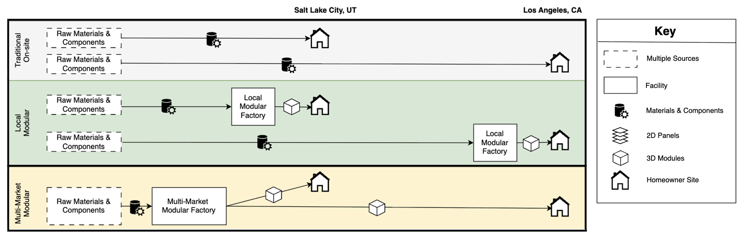
Figure 3. Construction Supply Chain Configurations (On-site and Modular)

4.1.1 Results
As shown in Table 2, centralizing most construction activities reduces total construction costs. For the average-cost market (Salt Lake City), construction costs decrease by 7%, from $150 to less than $140 per square foot. In the high-cost market (Los Angeles), relocating production to a lower-labor-cost region and centralizing construction can lower construction costs by 47%, decreasing from $320 per square foot under traditional construction to $169. The difference in construction cost between the two markets, despite production occurring in the same facility, is driven by unavoidable on-site expenses like site work and foundations. As a result, profit per square foot increases from 11% to 12% for the Salt Lake City market and from 11% to 37% for the Los Angeles market. The labor and transportation trade-offs indicate an opportunity for developers in high-cost markets to perform off-site manufacturing in lower-labor-cost markets.
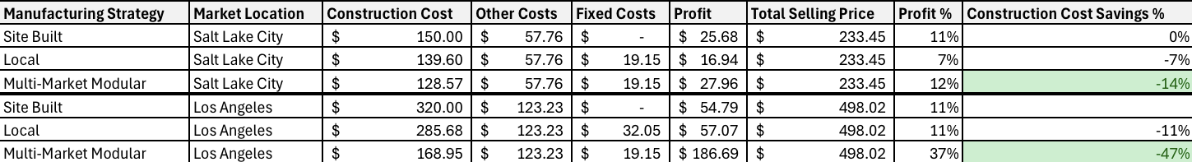
Table 2. Cost Estimation Model Final Results – Local and Multi-market Modular Results

4.1.2 Discussion
Comparing the local and multi-market modular configurations serving Salt Lake City, there is less profit estimated for local, off-site construction. Although the configurations have the same fixed costs (see Section 3.2 for the fixed cost calculation), the increased throughput at the multi-market facility enables greater economies of scale that drive the square-foot construction cost down. The multi-market cost savings more than overcome the additional fixed costs compared to local off-site and traditional construction. This highlights the economies of scale benefits of serving multiple markets. There would be a greater opportunity to offset the fixed costs of a local configuration if throughput increased.
The results presented raise several questions that require further analysis and validation by subject-matter experts. Based on initial estimates, the opportunity to leverage labor costs in low-cost manufacturing markets while servicing high-cost markets may yield higher margins for the construction industry. Additional off-site manufacturing builders must validate these numbers to assess their accuracy. If this validation confirms that the numbers are accurate, it raises the question of why builders have not fully adopted this configuration despite its potential to increase profitability or reduce housing costs.

4.2 Multi-market Hybrid
The capstone analyzes two hybrid scenarios where logistics teams move components between facilities before builders construct and deliver the final housing module to the homeowner’s site (see Figure 4). Research and discussions with industry leaders in off-site construction suggest a limited focus on and implementation of a hybrid approach. The initial findings reveal the cost impact that a hybrid off-site supply chain can have relative to the other configuration models. However, as data volumes and adoption increase in future years, the impact of a hybrid supply chain design will become clearer. Thus, the capstone team analyzed the hybrid scenarios separately from the local and multi-market modular methods to enable a like-for-like comparison.
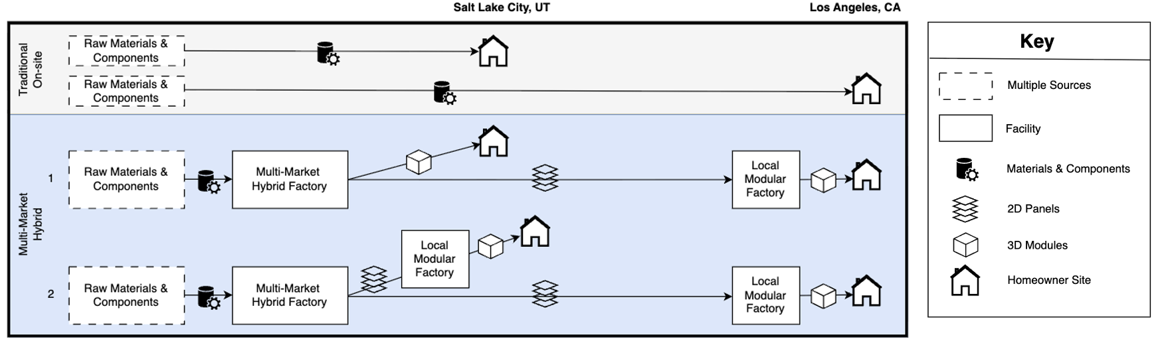
Figure 4. Off-site Construction Supply Chain Configurations (Hybrid)

4.2.1 Results
Table 3 reflects the preliminary results of both multi-market hybrid strategies. Compared to the site-built benchmark, the hybrid scenarios serving the Salt Lake City market have a lower profit margin of 3%–6%. While the construction cost decreased in the off-site hybrid strategy by 10%–13%, it did not offset the higher fixed costs of facility leases and equipment at the current throughput levels. On the other hand, both hybrid scenarios serving the Los Angeles market result in a 31% decrease in construction costs and have double the profit margins as the site-built strategy. The reduction in total construction costs drives this higher margin in Los Angeles and offsets fixed costs. Despite the long-distance transportation from a Salt Lake City facility to a Los Angeles facility, the Utah-specific labor and construction cost savings achieve a much larger margin than manufacturing in Los Angeles.
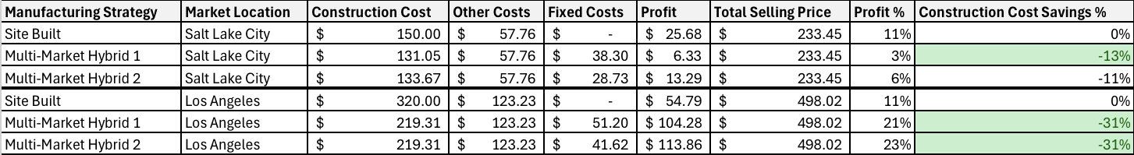
Table 3. Cost Estimation Model Final Results — Hybrid Scenarios

4.2.2 Discussion
The only structural difference between the first and second multi-market hybrid scenarios is the approach to serving the Salt Lake City market. In the Hybrid Scenario 1, a large, hybrid factory serves the market by shipping the finished housing unit. In the Hybrid Scenario 2, a large, hybrid facility ships components and panels to a smaller, local facility, which then completes and ships the finished housing units to the homeowner’s site. Despite the differences between the two hybrid supply chain configurations, total construction costs remain almost the same in the Salt Lake City market. However, Hybrid Scenario 1 splits Salt Lake City facility production between modular units and panels, which results in lower total throughput. In contrast, Hybrid Scenario 2 is fully panelized, leveraging the higher production speed of panels to achieve greater overall throughput (see Section 3.2 for throughput breakdown). As a result, Hybrid Scenario 1 distributes fixed costs over fewer total throughput square feet, leading to a higher fixed cost per square foot compared to Hybrid Scenario 2.
Similar to the local and multi-market modular results, the Los Angeles high-cost market achieves major cost savings when compared to site-built. These savings stem largely from lower labor rates in the average-cost market (Salt Lake City). In contrast to the multi-market modular approach, which transports finished housing units from the factory to the homeowner’s site regardless of distance, the hybrid approach transports panels over longer outbound transportation distances and finished housing modules over shorter, local distances. Generally, transporting larger housing modules incurs higher costs than transporting small- to medium-sized panels. One reason is that, depending on the size and weight of the housing module, oversized trucks and police escorts may be needed. Despite the transportation cost savings compared to purely modular configurations, the multi-market hybrid approach results in higher overall costs due to the added local facility in Los Angeles, which has higher local labor and fixed costs.

4.3 Labor and Transportation Costs Trade-off
Along with the cost estimation model, the capstone team created a facility location model to consider the impact of regional labor and transportation cost differences. Narrowing the scope to states west of the Mississippi River and using a modular off-site construction approach, this project isolates labor and transportation costs in a model to explore the trade-offs. To minimize the cost of off-site housing (location-specific labor cost + transportation cost), the model specifies whether each state should adopt a local, in-state facility or a central, out-of-state facility to satisfy demand. The model uses BLS OEWS 2024 hourly wage data by state and occupation, along with a constant transportation cost.

4.3.1 Results
The results shown in Figure 5 indicate that higher labor costs lead to out-of-state, centralized construction strategies. Keeping state-specific labor costs unchanged among scenarios, the capstone team conducted a sensitivity analysis of the impact of increasing transportation costs ($1–$15 per mile). The model only accounts for state-specific labor and a constant transportation cost; the overall results do not account for any fixed, material, or on-site expenses. Further details about the results of varying transportation costs can be found in GitHub (Ruhlman & Vargas Perez, 2026).
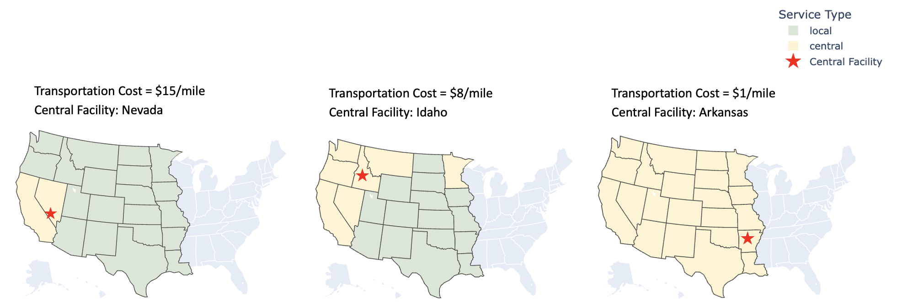
Figure 5. Selected Facility Location Under Varying Transportation Costs

4.3.2 Discussion
Based on field research, $15 per mile represents the average transportation cost of modules. At $15 per mile, the model shows that all states west of the Mississippi River should adopt an in-state local facility strategy except for California (Figure 5, left). Due to the high labor costs in California, it costs less to manufacture and ship housing modules from a central facility in Nevada than to manufacture in California. When the team tested the other extreme, $1 per mile (Figure 5, right), all states showed central manufacturing due to out-of-state labor and transportation costs being less than the costs of manufacturing in-state. At $8 per mile, a central facility in Idaho serves six states, while all other states locally manufacture (Figure 5, middle). In this scenario, all the centrally served states except Minnesota are on the West Coast or border Idaho. Minnesota has the third-highest aggregated labor cost, following California and Washington. When the transportation cost is $8 per mile, it costs less for Minnesota housing demand to be fulfilled from central manufacturing in Idaho than in-state production.
These results suggest that lower transportation costs increase centralization, as the combined out-of-state labor and transportation costs are lower than local labor costs. In contrast, higher transportation costs encourage localized, in-state strategies since out-of-state labor and transportation costs outweigh local labor costs.

4.4 Limitations and Assumptions
The capstone team addressed several limitations while developing the estimation model. The main constraint stems from simplifying the assumptions made to keep the calculations manageable. The model assumes a linear relationship between construction costs and square footage to estimate costs per square foot, where cost per square foot equals total construction cost divided by total square footage. This relationship does not hold in full, as costs behave more like step changes than proportional increases with size. This assumption reflects the fact that the cost per square foot is the unit most often used in subject-matter expert validation.
Another limitation arises from broad assumptions about economies of scale and process-level savings. The model applies a standard savings percentage to many construction processes without detailed technical validation to confirm precise accuracy. This approach was necessary due to the lack of reliable data on process-level savings in off-site construction. Data collection also presented challenges. Publicly available sources often showed wide variation in the components included within each activity’s cost, which prevented direct comparisons. When inconsistencies arose, the team made modifications informed by field research and subject-matter expert input.
While constructing the hybrid supply chain configuration, the team used approximations and assumptions to adjust for additional constraints. First, given the nature of various hybrid strategies, the analysis narrows the scope to two hybrid scenarios, focusing on facility location and housing elements at each site. Even within the two hybrid scenarios, the construction activity location can vary (on-site, hybrid, local, and hybrid/local). Thus, the location of each construction activity is a changeable parameter within the model. Moreover, scarce information and insights into the hybrid configuration, drawn from public data sources and SME discussions, led to more general approximations. For example, the capstone team estimates a hybrid configuration to have higher cost savings per construction activity than a local modular approach; however, the exact value is unavailable. Finally, calculating transportation costs within and between states was challenging due to the many factors affecting each shipment, including dimensions, weight, route distance, road conditions, required police escorts, and interstate permitting. The complex nature of the hybrid scenarios, including various housing elements and construction activity locations, made it difficult to fit the model to each strategy appropriately.
While the facility selection model highlights the trade-offs between the labor and transportation costs, the framework is subject to constraints and relies on some assumptions. The BLS OEWS database reports hourly wage data from 2024, the most recent data available. Due to state aggregated values, the exact hourly wages may differ based on centroid facility placement, and the model’s assumption of labor skill and availability in each location may not be accurate. Thus, the models could be run with more granular BLS OEWS data. Further, the transportation cost is constant in the model, whereas in reality, it will differ depending on multiple factors, including the size and weight of the housing module, interstate permits, the use of oversized trucks, and escorts. To simplify the model, the local strategy assumes zero transportation cost, although in practice, a final-mile delivery cost would still be incurred. Finally, the model positions facility locations at each state’s population-weighted centroid. In real-life implementation, it may be more suitable to locate a facility in a different location to lessen the distance to the consumer.

5 RECOMMENDATIONS
This project examined the off-site construction supply chain to assess the value of centralization and quantify the trade-off between location-specific labor and transportation costs. Using a top-down, assembly-cost-based model, the capstone team approximated the total costs of each off-site strategy (local modular, multi-market modular, and multi-market hybrid). Focusing on two distinct markets (Salt Lake City, Los Angeles), the key findings show that a multi-market modular supply chain configuration yields the highest cost savings for the two markets. With a clear trade-off between location-specific labor and transportation costs from the manufacturing facility to the end user, the team created a cost model that isolates these two factors while holding all other variables constant. In states west of the Mississippi River with higher aggregate labor costs, out-of-state housing construction was more cost-effective, as the combined cost of out-of-state construction and transportation was lower than in-state construction costs.

5.1 Stakeholder Recommendations
The findings of this capstone can help the Humanitarian Supply Chain Lab (HSCL) engage and support decision-making by stakeholders such as federal agencies, governments, and nonprofit organizations. The cost estimation and facility location models provide initial insights that stakeholders can explore more deeply within their own context. Given the many off-site supply chain configurations, there should be a careful examination of cost structure, resources, and demand before implementing an off-site construction strategy. Centralization is most effective in high-cost markets, particularly when housing manufacturing occurs in a lower-cost region. The reduction in construction costs outweighs the transportation expenses. For low-to-average-cost markets, off-site housing approaches should be analyzed closely to ensure the increased transportation and fixed costs are justified with a positive return on investment. Overall, these insights highlight that centralization in off-site construction and facility placement can be strategic levers to achieve economies of scale and reduce costs.
The analysis of off-site construction configurations improves visibility into the off-site housing supply chain and highlights how centralization can drive 13%–47% cost savings. Isolating location-specific labor and transportation costs in the model can help stakeholders reevaluate their supply chain strategy of facility location(s). The model can become an open-source tool to support data-driven analysis for affordable housing. The model’s unique functionality allows users to modify the parameters, which will make it useful for generating context-specific insights.
Beyond the modeling insights, the results show how strategic facility placement can reduce the total cost of housing construction and accessibility in times of disaster. Out-of-state housing facilities enable agencies to start rebuilding efforts more quickly, since they can manufacture in a location that has not been impacted by the disaster. This strategy can also provide more workforce availability and lower labor rates. Extending beyond disaster relief, off-site construction can enable lower overall home costs, leading to more affordable housing. Ultimately, developers can use these insights to strategically locate off-site facilities to expand market reach, reduce costs, and enhance supply chain efficiency.

5.2 Future Work
Off-site construction requires further research to fully realize its potential in disaster relief and affordable housing. Future work should focus on expanding the analysis to better evaluate a hybrid approach that combines elements of centralized and localized production. The current lack of data on hybrid configurations limits the ability to fully model and quantify their cost structure and operational trade-offs. In addition, potential regulatory changes could significantly impact the industry. For example, if government agencies move toward greater federal standardization of housing codes, then the state-by-state variability that currently constrains off-site construction and limits scalability will be reduced. Federal initiatives, such as the Housing for the 21st Century Act (2025), signal a shift in this direction by aiming to streamline regulations, expand financing mechanisms, and support manufactured housing. This bill could create a more favorable environment for the adoption and scaling of off-site construction methods. Further research should also examine the increasing role of automation in off-site facilities, which is rapidly becoming an industry standard. If implemented effectively, automation can enhance cost efficiency, production optimization, and sustainability. Finally, there is a need for a similar analytical framework to quantify time savings across different off-site configurations. The time variability in off-site construction creates a challenge in evaluating savings. Limited data availability prevented a clear assessment of time savings in this study. Construction time is a critical factor in the disaster relief context, and off-site construction has the potential to increase responsiveness, which is especially relevant in these situations.
This capstone provides a structured framework to evaluate key cost trade-offs in off-site construction while also offering insights into supply chain visibility and facility location. Beyond the immediate application, the findings contribute to a broader understanding of how manufacturing-driven approaches can improve efficiency, scalability, and responsiveness in the industry. The proposed methodology can be applied by developers, manufacturers, and supply chain operators seeking to select facility location, production strategy, and distribution networks. Thus, this project is relevant for environments beyond off-site construction, particularly for industries undergoing similar shifts toward industrialized off-site production.

REFERENCES
actiTIME. (2021, November). 6 project estimation techniques: Pros + cons. actiTIME. https://www.actitime.com/project-time-estimation/project-estimation
Bertoni, A., & King, M. (2025). Optimizing housing recovery: Industrialized solutions for post-disaster survivors [Unpublished master’s capstone]. Massachusetts Institute of Technology.
Bertram, N., Fuchs, S., Mischke, J., Palter, R., Strube, G., & Woetzel, J. (2019). Modular construction: From projects to products. McKinsey & Company. https://www.mckinsey.com/capabilities/operations/our-insights/modular-construction-from-projects-to-products
Carlos Martín, Brandi Gilbert, Dan Teles, Brett Theodos, Rebecca Daniels, Tanaya Srini, Nicole DuBois, Ilana Brody, & Christina Plerhoples Stacy. (2019). Housing Recovery and CDBG-DR. https://www.huduser.gov/portal/sites/default/files/pdf/HousingRecovery_CDBG-DR.pdf
Conroy, R., Proussaloglou, E., & Johnson-Grau, C. (2025, October). Altadena prefab housing handbook: A homeowner’s guide to rebuilding with prefab. cityLAB UCLA. https://www.calfund.org/wp-content/uploads/Altadena-Prefab-Handbook-Spreads.pdf
Eje, J. (2026, February 24). Construction cost estimator. Mastt. https://www.mastt.com/blogs/construction-cost-estimator
HomeAdvisor Staff Writer & Robert Tschudi. (2025, June 24). How Much Does Building Your Own Home Cost in 2025? https://www.homeadvisor.com/cost/architects-and-engineers/build-a-house/
Housing for the 21st Century Act, H.R. 6644 (2025). https://docs.house.gov/billsthisweek/20260209/HR%206644.pdf
International Code Council. (2023). Delivering disaster recovery and resilience through off-site construction. https://www.iccsafe.org/wp-content/uploads/23-23003_CORP_Deliv_Dis_Rec_Resil_Off-site_Const_BRO_FINAL_2.pdf
Ivan Rupnik, Ryan E. Smith, & Tyler Schmetterer. (2026). Hud’s past, present, and future role in accelerating U.S. Offsite construction for housing: A comparative study and action plan. https://www.huduser.gov/portal//portal/sites/default/files/pdf/HUDs-Role-Accelerating-Offsite-Construction-For-Housing.pdf
Jacobson, L. (2022, February 17). Natural disasters hit roughly 1 in 10 American homes in 2021. CNBC. https://www.cnbc.com/2022/02/17/natural-disasters-such-as-fires-hurricanes-hit-1-in-10-us-homes-in-2021.html
Joubert, S. (2019, November 11). What is cost estimation in project management? Northeastern University Graduate Programs. https://graduate.northeastern.edu/knowledge-hub/cost-estimation-in-project-management/
Los Angeles County Board of Supervisors. (2025). A pilot self-certification program to expedite post-fire rebuilding (No. 202826). https://file.lacounty.gov/SDSInter/bos/supdocs/202826.pdf
Lynch, E. (2025, January 20). Cost of constructing a home-2024. National Association of Home Builders. https://www.nahb.org/-/media/NAHB/news-and-economics/docs/housing-economics-plus/special-studies/2025/special-study-cost-of-constructing-a-home-2024-january-2025.pdf
Modular Building Institute. (2022, January 28). Inside the modular building process. https://www.modular.org/2022/01/28/inside-the-modular-building-process/
Quantity Surveying Coach. (2024, December 30). Estimating techniques: Unit cost, assemblies, and square feet. Quantity Surveying Coach. https://quantitysurveyingcoach.com/cost-estimating/estimating-techniques-unit-cost-assemblies-and-square-foot/
Ruhlman, P., & Vargas Pérez, A. (2026). eval_off_site_construction. GitHub. https://github.com/MIT-HSCL/eval_off_site_construction
Thom, M. (2025, August 6). Guide to project estimation and estimation techniques. https://galorath.com/estimation/
U.S. Bureau of Labor Statistics. (2025, July 23). Occupational Employment and Wage Statistics. https://www.bls.gov/oes/tables.htm
U.S. Census Bureau. (2021, November 16). Centers of Population. https://www.census.gov/geographies/reference-files/time-series/geo/centers-population.html
U.S. Census Bureau. (2025, May). National, State, and County Housing Unit Totals: 2020-2024. https://www.census.gov/data/datasets/time-series/demo/popest/2020s-total-housing-units.html
U.S. Government Accountability Office (GAO). (2020). Cost estimating and assessment guide (No. GAO-20-195G). https://www.gao.gov/assets/d20195G.pdf
United Nations. (2015, November 23). UN report finds 90 per cent of disasters are weather-related. United Nations Sustainable Development. https://www.un.org/sustainabledevelopment/blog/2015/11/un-report-finds-90-per-cent-of-disasters-are-weather-related/
Zohourian M., Pamidimukkala, A., Kermanshachi, S., & Almaskati, D. (2025). Modular Construction: A Comprehensive Review. Buildings, 15(12), 2020. https://doi.org/10.3390/buildings15122020

The model also compares estimated time savings of off-site configurations which were unable to be sufficiently refined for the purpose of analysis. Section 5.2 Future Work discusses challenges and opportunities to quantify.

