Open data, transparency and   
redistricting in Mexico[1]

**Alejandro Trelles** U. Pittsburgh,

**Micah Altman** MIT,

**Eric Magar** ITAM

**Michael P. McDonald** U. Florida[2]

**Abstract:** The many complaints and protests by citizens generated by the deterioration of the political elite in recent decades are clear evidence, among other things, of the urgent need to strengthen the connections between citizens and their representatives. To this end, the delimitation of the electoral boundaries –also known as redistricting– is key to improve political representation. Given the many technicalities involved in this processes –geographic, statistical, digital, among the most obvious– it is easy to succumb to the temptation of relegating it to specialists and lose sight of its importance for democracy. From our perspective, the use of new technologies, as well as the generation and use of open data, offer an opportunity to strengthen political representation. In this article we discuss Mexico’s redistricting experience, the challenges in terms of transparency, and how certain tools –such as open source software and online mapping tools– have tremendous potential for increasing the levels of transparency, participation, and accountability surrounding boundary delimitation.

***Keywords***: open data, transparency, redistricting, public mapping, open source software, political representation, participation, gerrymandering, minority groups.

Transparency and open government are not preconditions for Democracy (Dahl 1972). But given the pressing need to improve accountability and create closer ties between governments and citizens, open government has become a priority for those seeking to improve governance and build more effective democracies. [3] This research note underscores the centrality of transparency for one specific but fundamental aspect of the electoral realm: the mapping of geo-electoral boundaries, also known also as redistricting (Altman and McDonald 2012). We argue that making public the flow of information used by the electoral management body (EMB) to carry out this technical task fulfills a necessary, but not sufficient, condition for transparency. What remains is to offer *tools* that allow citizens to participate, manipulate, analyze and share the flow of georeferenced, demographic and electoral information used for redistricting. Although there are government data archives whose interpretation does not require specific tools, the information related to the various phases of the redistricting process is not among them.

Drafting the boundaries of majority districts in the country requires information generated by various local and federal government offices. Some of the most important data are supplied by the National Statistics, Geography and Informatics Institute (INEGI), the National Commission for the Development of the Indigenous Population (CDI) and, of course, the National Electoral Institute (INE) which is the EMB in charge of the redistricting process (IFE 2013a). Incredibly enough, even though all this information is public –as are all the relevant agreements and norms– it is not available in an accessible format so that citizens can participate in the process. Those interested in accessing this information must overcome daunting barriers to obtain, process and interpret the data. For example, people do not have access to the automated map generated by the authorities for every state, nor to the counterproposals made by the political parties involved in the redistricting process. Comparing these maps to the final proposal would enable anyone interested in the process to quantify the extent to which changes introduced by political parties alter the electoral geography. The optimization algorithm, the software used to generate and evaluate the plans, and the information needed to analyze the political effect of the different changes in the local and federal cartography are all unavailable as well. These blank spaces create opacity and significantly limit the accountability of the whole process. If citizens have no access to the maps that were taken into account by the authorities or the software used to evaluate them (or, at least, to the complete methodology), they cannot directly verify whether regulations and agreements on the redistricting process were followed.

Furthermore, the EMB has not created information mechanisms that take into account the interests of minority citizens or communities. The clearest example of this in Mexico is the indigenous population. Although the Constitution obliges authorities at all levels to guarantee the participation and rights of indigenous peoples, the redistricting effort looks only at the relative size of this group in each municipality (also known as *municipios*, the lowest elected offices, similar to counties in the U.S.) –not the differences among the country’s more than 50 ethnic communities and groups. By denying the indigenous population a voice in the process –or the possibility of reviewing the proposed scenarios– the INE geographers risk overlooking key information for complying with the second article of the Constitution. For example, ancestral differences among indigenous communities located in the same municipality could be considered by the EMB and affect the shape of electoral boundaries (Sonnleitner 2013a).

The research note is structured as follows: in the first section we briefly describe Mexico’s experience with redistricting. In the second we list a series of necessary characteristics for introducing an open-data policy to redistricting. In the third we discuss the challenges Mexico faces in transparency, civic participation and accountability. In the fourth section we explain why open-source software has a considerable potential to increase participation, transparency and accountability surrounding redistricting processes. Finally, we discuss the use of open data in redistricting processes, its effect on citizens’ perceptions and trust, and the agenda of pending research in the field.

**I. Redistricting in Mexico: progress and limitations**

According to Handley and Grofman (2008), redistricting is “the process by which lines on maps get drawn partitioning a territory into a set of discrete electoral constituencies from which one or more representatives are to be elected” (p. 3). This process is fundamental for democracy, because it outlines the physical space of political representation, where the bond between legislators and citizens is established.

The mixed-member electoral system of Mexico’s legislatures combines two principles of representation: majority in single-member districts and proportional representation in plurality districts (Shugart and Wattenberg 2001). The lower house of Mexico’s congress —the *Cámara de Diputados*— is composed of 300 districts of the first type, which elect three-fifths of the house, and five districts of the second –known as *circunscripciones plurinominales–* where the other 200 members are elected*.* The same logic applies to the 32 local legislatures, whose numbers and proportions vary from one state legislature to another (Balkin and Orta 2004). Our note addresses only the case of majority districts (Palacios Mora and Tirado Cervantes 2009 provide an evaluation of the proportional representation districts).

In order to balance demographic changes among districts, Mexico renewed its congressional maps for the 1997 (replacing the map that had been in use since 1979) and 2006 federal elections (Trelles and Martinez 2012; Lujambio and Vives 2008; Magar et al. 2015). The IFE (the Federal Electoral Institute, predecessor of the INE),[4] which drew up both maps, also completed a third redistricting process in 2013, on time and as planned, for the 2015 federal election. But amid doubts and tensions over an electoral reform being hammered out at the same time –and which would be adopted some months later– the EMB’s executive board decided at the last minute to put off adopting the new district map.

With some technical differences, the 2013 redistricting effort followed the same process as the previous ones (Trelles et al. 2015). It can be summed up in four phases (see Chart 1). The process begins with the distribution of 300 districts among the states and Mexico City depending on the relative populations from the most recent census. Next, a Technical Committee appointed by the EMB’s executive board –*­el Consejo General del INE–* develops and implements an optimization algorithm that automatically produces a preliminary map for each state. Each proposal is then submitted for two subsequent rounds of reviews by the parties. Acceptance of suggested modifications depend on how capable they are of improving the value associated to the score function –produced by the optimization algorithm– by which the maps are evaluated. The process ends when the Technical Committee selects a final proposal and submits it for the approval of the EMB’s executive board.[5]

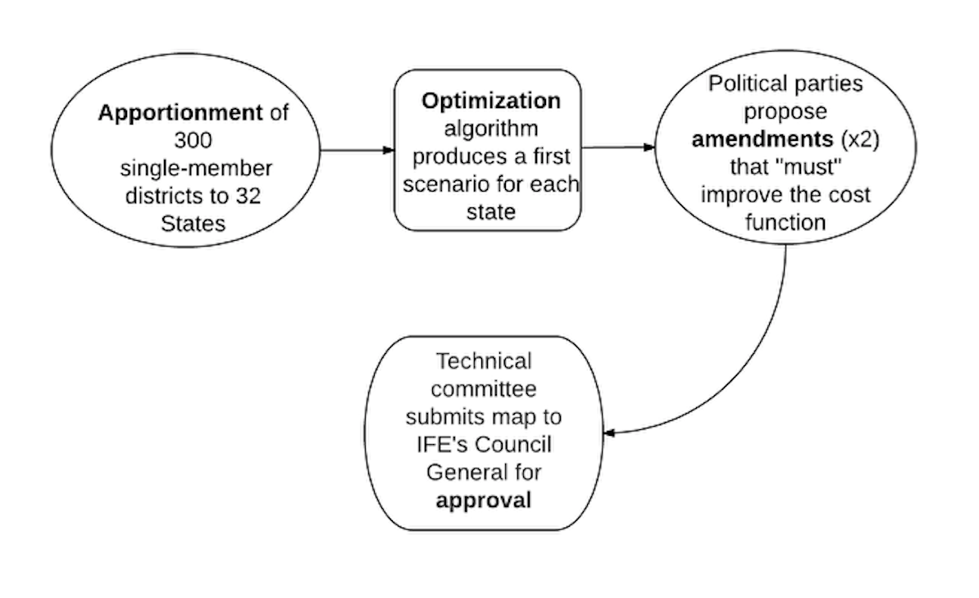**Chart 1. The redistricting process in Mexico**

Source: Chart prepared by the authors.

In the academic sphere, important contributions have been made to the study of Mexico’s electoral geography. Authors like Martínez Assad (1990), Molinar (1990) and Emmerich (1993) analyze how changes in the electoral geography have affected electoral results and the balance of power in the country. Gómez Tagle and Valdés (2000) and Isla (2007) point to the connections between socioeconomic traits in the population, its geographic distribution, and citizens’ voting preferences. Along the same lines, Sonnleitner (2013b) stresses the social, collective and territorial characteristics of voting patterns in Mexico. Sonnleitner (2001, 2013a) and González (2008) argue that despite regulatory changes in the last two decades, Mexico’s indigenous population remains politically unrepresented, because of redistricting processes carried out with no regard to differences, or even antagonisms, between geographically proximate indigenous communities.[6]

This literature offers detailed and interesting descriptions of the territorial breakdown of the vote, but has not undertaken an in-depth discussion of issues like the *criteria* used by the EMB for boundary delimitation (like López 2006 or López and Soto 2008), the optimization models used by the electoral board (as in Rincón García et al. 2015) or parties’ intervention with the redistricting authority (as in Trelles et al. 2015). There is fertile ground for ongoing analysis of the intersection between technical, regulatory and methodological aspects in redistricting, as well as the political impact these various dimensions have on the generation of electoral maps. We believe the availability of analyzable information is a prerequisite –which is still far from being a reality– for pursuing this line of research.

The systematic study of boundary delimitation criteria becomes of primordial importance in light of partisan gerrymandering. This means the practice, more or less surreptitious but widespread in the world, of designing districts to benefit one or more identifiable groups, such as parties, incumbents or racial groups (Cox and Kata 2002; Jackman 1994; Johnston 2002; Magar et al. 2015; Otero 2003).[7] Partisan participation in the redistricting process is well documented, but to be able to evaluate the degree in which parties are able to affect electoral maps we need to know more about their incentives, their strategies, and the ways they interact with the EMB. In studying redistricting in Northern Ireland, Rossiter, Johnston and Pattie (1998) argue that the neutrality of independent electoral commissions does not deter political parties from trying to influence their decisions to safeguard their own interests, and they present evidence that, to a large extent, they succeed. For these authors, the degree of partisan influence in redistricting depends on three factors: a) the clarity of regulatory criteria; b) the profile of the members of the organization in charge of drawing the map; and c) the dynamics between that organization and political parties. The discussion contained in this note yields another two factors: d) the transparency and accessibility of all information on the redistricting process, and e) the existence of means of communication –and verification– between the public and the organization in charge of boundary delimitation.

Mexico is no exception when it comes to partisan influence in electoral regulation. In the same way to Rossiter et al. (1998), Estévez, Magar and Rosas (2008) argue that IFE’s impartiality does not stem from the independence of its board members, but rather the system of party checks and balances within the institution. They describe the IFE as a collegiate body whose members are carefully selected with expectations that they will conduct themselves in accordance with the interests of the parties that appointed them in the *Cámara de Diputados* (the lower house of Congress). In addition to this, a substantial portion of the EMB executive board’s decisions —including redistricting— can only be audited by the parties. And although it is fundamental that parties keep an eye on the regulator and on each other in their influence over redistricting, opening this process to other more diverse social agents is highly desirable as a way to improve representation. We elaborate on the concept of participation later on in this paper. But first, we show that the conditions are not yet in place for agents without direct presence in the board to track, evaluate or, much less, participate in the redistricting process.

**II. Transparency, accountability and civic participation**

Admittedly, Mexico’s EMB has made a tremendous effort and has achieved a great deal in working toward an open data policy. The almost twenty years during which that body has been gradually opening up information on electoral processes, and on the various aspects of electoral regulation, are evident with a simple visit to its webpage.[8] In terms of redistricting, almost all the cartographic inputs are available online (INE 2015b, 2015c) only on an *ex post* basis and once the process has concluded. Incredibly enough, because of the nature of redistricting, and the technical complexities it entails, the efforts made so far to open up the information and make this process more transparent have been insufficient.

Boundary delimitation requires a formidable volume of information. Among the most relevant are demographic figures of various kinds, the location of geographic features throughout the national territory, or the digitalized geography. It is very difficult, if not impossible, to evaluate a decision if we cannot replicate the process by which it was taken (Smith 2015). Table 1 lists seven major aspects we consider necessary and sufficient to replicate the redistricting process. It includes data bases, miscellaneous cartography, the mathematical formulas used, the existing laws and regulations, the party maps and alterations, the electoral results, and the specialized software.[9] Thirty-six public agencies are responsible for producing and distributing it.

**Table 1. Availability of information for redistricting**



Source: Table prepared by the authors.

Some of the information is from sources outside the electoral board, like INEGI’s census data. The estimations of traveling time on the roads and highways within each district comes from the Ministry of Communications and Transportation (SCT); the location and concentration of indigenous population is prepared by the CDI. Another substantial portion of the information comes from the INE itself, like the description of the optimization algorithms (see Magar et al. 2015 for a critical discussion of the automated redistricting process), the applicable laws and regulations, or the cartography of the country’s geographical blocks (*secciones electorales,* the basic redistricting units, equivalent to census tracts in the US). Finally, each one of the 32 local EMB’s –known as Local Public Organisms (*Organismos Públicos Locales*, or OPLES after the 2014 electoral reform)– concentrates information on the various legal and administrative criteria applicable to that state. Although redistricting processes do not formally include the analysis of previous election results in any of its stages by the Technical Committee or the EMB’s executive board, we assume that party modifications are made primarily on this basis, so votes are key information for evaluating the maps proposed by the various parties.

As the table also indicates, not all the information is available in accessible formats. There is some data that, despite being declassified by the board, is hard to come by.[10] There are various types of specialized software for processing part of the information. For example, analyzing the information requires a data program for manipulating georeferenced data in GIS format. There are many options available, both commercial and open-source (Wikipedia lists a dozen under “geographic information systems”). It also requires a copy of the system developed by the board specifically for redistricting. This software performs various tasks: prepares proposed maps with a combinatorial optimization algorithms (known as simulated annealing or honeycomb optimization); allows for the selection of “seed sections” as a starting point for the automated redistricting process; or calculates measures for evaluating different scenarios using quantitative indicators. Finally, if interaction with a third party is required (whether the electoral board, a political party or an external individual) there must be a platform to “socialize” the proposals and receive comments and changes.

Making the missing information available to the public will clearly help making redistricting processes more transparent. But given the nature of the redistricting process and its various phases, it is not enough in and of itself. The electoral board must also make a significant effort to harmonize and integrate the information so that it is easier to use. Below we describe three conditions for ensuring that transparency and open data translate into effective accountability (Smith 2015, Ferreira da Cruza et al. 2015).[11] The conditions are ordered from least to most demanding, and can be understood as three stages: the higher the stage the redistricting guidelines reach, the greater the probability that transparency will translate into effective accountability.

***Condition 1. Open data***. This entails operating the redistricting process in a totally transparent manner, giving the public continuous access (preferably online and in real time) to agreements, proposed maps, deliberations, and observations made to the maps. To this end, the data used and the records generated by the redistricting process itself must be declassified. Any analysis conducted –or vetted– by the board should be accessible. The same applies for specialized software: the public should be able to use it freely or operate it remotely (preferably from the cloud) at the same time the electoral board is redistricting. As can be seen in the institutional report on the 2005 federal redistricting process (IFE 2005), the electoral board has made significant efforts to meet this first condition (open data). But the real time availability, description and access mechanisms to information are still very limited.

***Condition 2. Replicability***. This requires developing and offering a catalog of the universe of data used in redistricting. The data should be free, unrestricted as to use, and structured so that they are readable simply and automatically using digital equipment. In terms of existing technology, it is possible to offer one-click access to the set of relevant information or the various subsets of that information. All the data must be structured and linked with the rest in order to be cross-referenced and easily analyzed. Meeting this condition would mean the redistricting process, and all of its results, could be fully replicated. This means anyone could replicate the process, which would enhance public trust in the authority and enable participants to rule out, at the outset, improper manipulation of electoral boundaries.

***Condition 3. Participation***. This means creating mechanisms to make interaction between the EMB and the public during the redistricting process both possible and likely. One possible mechanism would be to adopt a user-friendly open source interface. This would make it easier for any interested party, even non-specialists, to formulate legal counter-proposals on the electoral boundaries as a basis for evaluating other proposals on the table.[12] A platform like this would allow for easy comparison of various maps using both the formal criteria applied by the EMB and the political consequences of the various proposed plans. Because the software is free, it could be copied, studied, modified and redistributed in order to check, among other things, that the optimization process is carried out according to legal criteria.

To sum up, we believe that enhancing the transparency of redistricting processes and building information access tools that allow and encourage civic participation would have considerable benefits for better redistricting, but would also help consolidate our still-young democracy.

**III. Signs of opacity**

In this section we use three concrete examples to illustrate why it is important to meet the conditions of open data, replicability and participation. These examples point to some of the areas in which the existing open data policy is insufficient to ensure accountability.

***Example 1: The subnational level***. We have already discussed some of the problems and challenges of federal-level redistricting. But the shortcomings we detected pale in comparison to the local redistricting effort in most states. Before INE became responsible for redistricting local districts in the 32 states (with the 2014 electoral reform), most states failed even to meet the open data condition, the most basic of our list. In the majority of states, the task of drawing up local district boundaries fell exclusively to local electoral boards, although in some cases the legislative branch of the state played a central role in that process (Trelles and Martínez 2007; López and Soto 2008; Lujambio and Vives 2008). Today, it is still extremely difficult to obtain information about the adoption of local districts. Even obtaining the local electoral district maps is challenging. Photographic images of local districts are available in many states on the local EMB’s websites, but the digitalized files —such as the shapefiles— that enable the maps to be analyzed on a basic level, are unavailable.[13] Without that information, it is virtually impossible to gauge the degree of arbitrariness of the technical, regulatory and methodological criteria applied in each local redistricting process, or to document the extent to which the process has been politicized.

This was largely the reason why major parties agreed, as part of the 2014 electoral reform, that local redistricting –as well as electoral regulation in general– should be left in the hands of a single EMB at the national level. Because every state has its own legal framework and socio-demographic conditions, INE began a dialogue with the Local Public Organisms (OPLES), which are subdivisions of the board that replaced the state level EMB’s, to reduce the tensions arising from the mismatch between local interests and the constitutional regulatory framework. The INE began work on redrawing electoral boundaries for the local congresses early in 2015.[14]

Another area of opacity that has not been addressed from an academic standpoint is the political effect of using different methods and technical criteria for redistricting at the federal and local level.[15] In other words, in the past the EMB has not systematically used the same criteria and methods to redraw electoral boundaries at the federal level, and now that it is responsible for boundary delimitation at the local level as well, it has not used the same criteria for redrawing local legislative districts. For local redistricting the INE has decided use a different optimization method than what it used in the federal process, and to take into account fewer components.[16] For local processes, in contrast to the 2005 and 2013 federal redistricting processes, it chose to use not four but only two components in the optimization algorithm: population balance and geometric compactness (INE 2015, Trelles et al. 2015). The population component was assigned twice the weight of compactness in the cost function.

The INE has not justified these changes, either technically or in terms of the regulation, and given the lack of local-level information available, it is almost impossible to weigh the political impact the various decisions by the electoral board had on the electoral maps of each state. At the same time, the ambiguity in the selection of criteria and the lack of efforts to raise public awareness about the redistricting process pose tremendous challenges in terms of transparency. Why have the algorithms, components of the model, and weighting changed if the redistricting laws have not been modified in the past few years? How do these changes affect the configuration of local legislatures? Has any party (or parties) benefited systematically from these changes? Why are the criteria, their weighting, and methodology for redistricting local congresses different from those used in previous federal redistricting processes? What has been the political effect of the malapportionment induced by the differing criteria adopted in local boundary delimitation? It is hard to answer these and other questions based on the information available.

***Example 2: partisan influence***. Political parties have played an active role in formulating observations and counterproposals for drawing up federal electoral districts since 1996. Because the condition of replicability has not been met, it is much harder to evaluate the effects of the interaction between the parties and the electoral board on the configuration of electoral boundaries. In the most recent federal redistricting process held before the 2015 federal election (which was drawn up according to schedule but was never adopted), Leonardo Valdés –then President of the EMB’s executive board– emphasized parties’ active participation during the boundary delimitation process:

“The enormous participation by political party representatives with the National Surveillance Commission and Local Surveillance Commissions has already been accurately described: in effect, there are more than 540 observations presented by these representatives during the boundary delimitation process, and in many cases observations improved the proposed district plans according to the established rules. In all such cases, the Technical Committee accepted these recommendations and incorporated them into the scenarios, particularly in the Third Scenario which is today being considered by this General Council.” (IFE 2013b).

In effect, the parties presented more than twice as many counterproposals as in the 1996 and 2005 redistricting processes; 236 were included to the first scenario, which was generated by an automated combinatorial optimization process, of which 157 were formulated in the Local Surveillance Commissions and 79 in the EMB’s National Surveillance Commission. The counterproposals served as an input for generating the second scenario, and the parties formulated 308 new counterproposals, of which 139 were local and 79 national. On average, the seven parties represented in the IFE presented 75 counterproposals each (Trelles et al. 2015).

What changes did the parties propose? What interests lay behind the counterproposals? How different were the proposals from the automated scenario? Which were accepted and which rejected? Were legal and regulatory criteria followed systematically? Which party proposed more scenarios, and what were the implications? Was the original value associated to the cost function improved? Did the board evaluate all counterproposals with the same criteria? What party submitted the most successful (accepted) proposals? And, in more general terms, did the parties’ intervention introduce any bias in the districts? Unfortunately, with the information available to the public, no citizen, organization or stakeholder can answer these questions. Replicating and evaluating the different scenarios requires not only the IFE/INE software, but also access to the operationalization of the optimization algorithm, the elements used to calibrate the model, the random selection of a seed –*sección electoral–* as a starting point for automated optimization, the various runs that were conducted to determine the first scenario, and each of the 544 counterproposals submitted by the parties. Without a serious effort to meet the open data and replicability conditions, the proposed maps cannot be properly evaluated.

***Example 3: indigenous representation and the absence of participation mechanisms***. Authors like Sonnleitner (2013a) have pointed out the jarring contrast between the electoral board’s initial effort to draw indigenous-majority districts, and the perennial lack of representation for Mexico’s indigenous population in political life. Meeting the condition of participation would contribute tremendously to closing this gap.

The 2001 constitutional reform forced the electoral authorities to include indigenous population for the first time in the federal redistricting process facing the 2006 election.[17] Although this was the first significant attempt to include this minority community, there are many aspects that can still be improved to strengthen political participation by these groups in public life. Grouping indigenous people together ­–as the board does– by census count during redistricting, without taking into account differences across indigenous communities or encouraging their participation, does not guarantee these groups have access to political representation or that they are able to build or strengthen the ties with their political representative.[18]

There has been little debate over how the representation of the indigenous population might be improved through redistricting, and we believe there are viable alternatives for addressing this need. A first step would be to recognize that including minority groups has various levels and possibilities. As shown in Chart 2, a first level of participation is reached when the regulatory framework recognizes the need to safeguard the representation and participation of certain groups. In Mexico, this happened with the 2001 constitutional reform. The second level of participation is indirect inclusion. This happens, for example, when the board takes into account only the total number of inhabitants that were reported to speak an indigenous language, but does not take into account any other socio-demographic factor or a direct consultative mechanism with the communities to obtain additional information. The third level refers to the degree in which the population belonging to a minority group is aware that its rights are safeguarded in order to guarantee their political representation and participation. The fourth level requires mechanisms for people to participate and communicate their needs to the electoral board. The fifth level is reached when the electoral board develops mechanisms for formally incorporating the opinions and needs of minority groups into the redistricting processes.

**Chart 2. Levels of participation in the redistricting process**

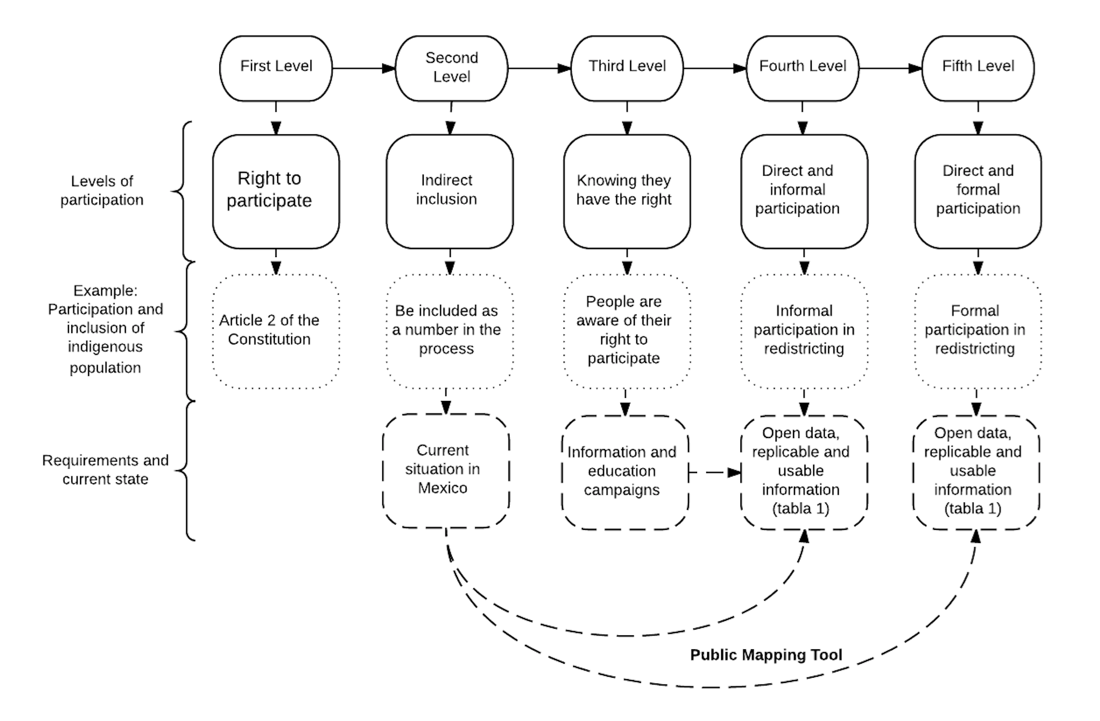

Source: Chart prepared by the authors.

By this standard, Mexico is right now at the most basic levels of participation. First, the regulatory framework guarantees certain groups’ right to representation; second, there is a mechanism for indirectly including the indigenous population.[19] But to move on from these initial levels of participation (indirect inclusion) to direct participation (the fourth and fifth levels), an intervention is required, which would include: a) education campaigns to ensure the people are informed and aware that their right to representation is safeguarded and that they can participate in these processes, and b) the mechanisms and tools needed for citizens to participate. [20] In the following paragraphs we will describe how open-source software and web-based mapping technology offer a possible solution for making the redistricting process transparent and enabling the public to participate in that process.

**IV. The use of open source software and public mapping platforms as a possible solution**

New information technologies have brought the ability to meet the conditions of open data, replicability and participation within our grasp.[21] We conclude this research note by introducing *District Builder*, a public mapping web based platform that has tremendous potential for overcoming the limitations and problems encountered in federal and local redistricting processes. *District Builder* offers a way to replicate any boundary delimitation exercise and a mechanism for citizens to participate openly in these processes.[22]

The platform operates from the cloud, eliminating the need for users to acquire or install new software on their personal computers. *District Builder* can be hosted on the server of the electoral board, an academic institution, a non-governmental organization, or even by renting a space on one of the many available commercial services (i.e. Amazon Cloud). Users have one-click access to all the information involved in the redistricting process (which meets the *open data condition*), have a user-friendly tool to replicate, evaluate, compare and create electoral districts (which meets the *replicability condition*), and can formulate suggestions and observations to the electoral board (which meets the *participation condition).*

Users can create districts departing from a totally blank scenario, or they can visualize and edit existing federal and local maps preconfigured in the system. The public may also be given access to the electoral maps of previous years, to conduct comparisons or analyze the political effect that historical changes have had in the country’s electoral cartography —the platform is highly versatile. This type of system also enables users to share information, store their proposals, and download all files in easily accessible formats that are readable by any digitalized geographic information system (GIS). Furthermore, the platform has the potential to become an extremely effective tool during INE’s redistricting processes —both federal and local—, which involve many phases and participants, to reduce the existing communication gap between the public and electoral authorities, meeting the three conditions that guarantee accountability and making possible a transition to a public participation that is both direct and inclusive.

**Figure 1. Sample screen shot from home page of District Builder**

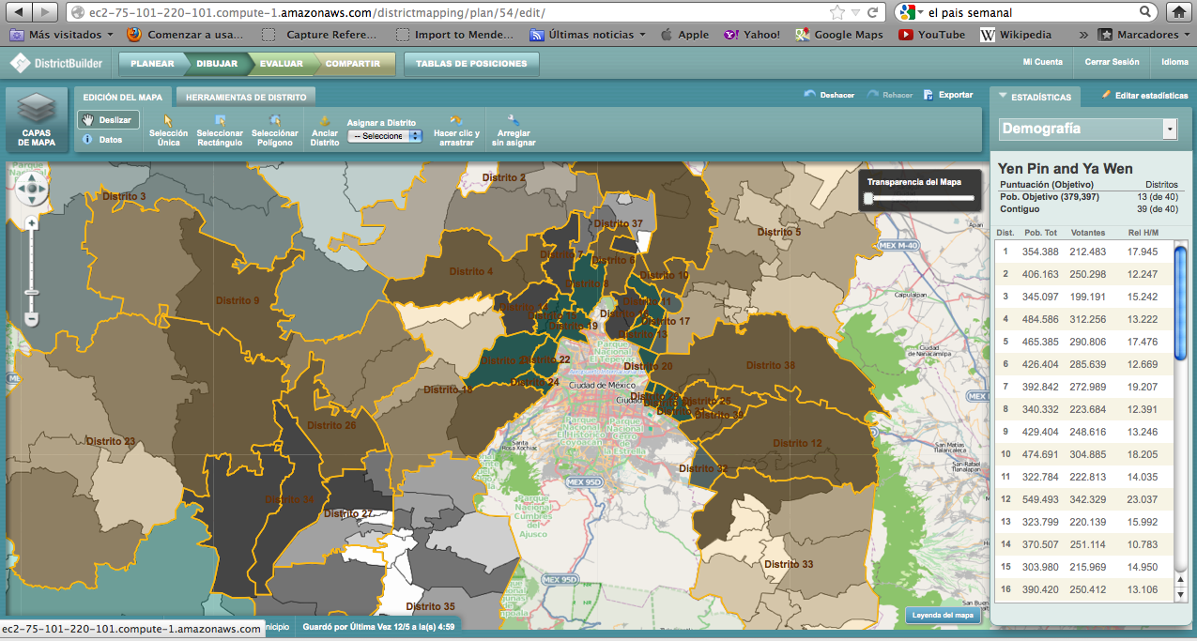

**Source**: Figure prepared by authors. **Note**: The image shows the web interface for the platform, with a view of the 40 electoral districts of the State of Mexico and its sub-divisions at the municipal level (with the most densely populated municipalities shown in darker colors).  At the top of the screen are the tools for editing and analyzing the map.  On the right hand side there is a calculation tool with the values associated to the number of inhabitants, number of voters, and gender ratios in each district.

Figures 1 and 2 show a screen shot of the electoral cartography of the State of Mexico in District Builder. Both represent, on different scales, the portion of the state that borders on northern Mexico City. Figure 1 shows the borders of some federal districts with municipal subdivisions. Figure 2 shows the same district division, but with subdivisions at the level of *sección electoral*. The platform changes the map layers from municipalities to *secciones* automatically when zooming in with the mouse (similar to the way the Google Maps interface works).

**Figure 2. Screen shot of electoral cartography of Mexico State at the *sección* level in District Builder**

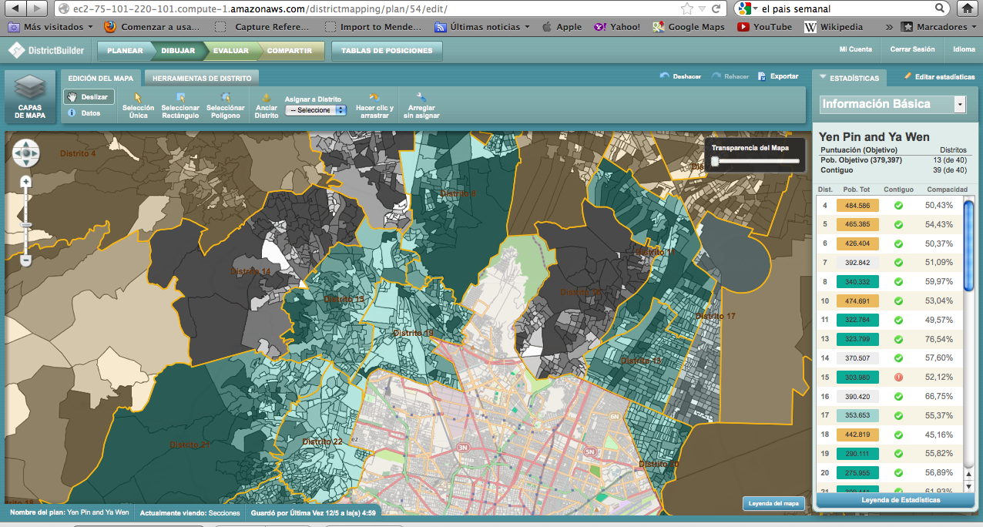

**Source**: Figure prepared by authors. **Note**: The image shows the web interface for the platform, with a zoom-in view of the 40 electoral districts of the State of Mexico and its sub-divisions at the *sección electoral* level (with the most densely populated of these shown in darker colors).  At the top of the screen are the tools for editing and analyzing the map.  On the right hand side there is a calculation tool with the values associated to population, contiguity, and compactness

In both images we can see, to the right of the screen, a calculator with the values associated to the map evaluation criteria that have been incorporated into the system. The platform allows for the incorporation of data on any variable at the *sección* level. In Figure 1, for example, the calculator reports total population, registered voters and the ratio of men to women in each district on the map. Figure 2 shows the population, with an indicator of contiguity and geometric compactness index for each district. All the socio-demographic information associated with the census results (number of inhabitants, income, education, gender, age); the values associated to the components used in the redistricting process (like percentage of indigenous population, geographic contiguity and continuity, geometric compactness and inter-municipal travel times); the previous electoral results (including any indicator of electoral competitiveness); or indicators generated by other institutions (crimes, kidnapping, extortion) can be viewed in this space.

To modify the map, the platform allows the user to select a redistricting unit or *sección electoral* (or group of them) and manually drag them from one district to another. The system automatically updates the new district boundaries, recalculates the values for the data the user is interested in, and displays them in the calculator. With this, any user can conduct geo-spatial analysis, modify maps and evaluate the effects of these changes without the need of a mapping specialization background. The platform also permits scenarios to be published and shared: it saves all changes made on the server and generates a link so the user can share the map through e-mail or social media. With this, various users can interact, work as a team,, and formally submit their proposals to the electoral board in order to safeguard the interests of certain communities or groups. If, for example, a map that is being proposed by the electoral board is splitting a specific territory into two districts, or if it would place it in the same district with another rival –and more numerous– community, the platform would allow any user to communicate this situation to the EMB, so it can make an informed decision *before* adopting the map,.

The platform also allows users to select a group of variables and export them to a database for analysis with whatever tool the user prefers. The calculator that shows the figures has the potential to substantially increase the level of transparency surrounding the process, because users must undertake a dialogue (especially with the authority in charge of redistricting) objectively and based on quantitative values. *District Builder* makes it possible, among many other things, to measure the political effect of counterproposals submitted by political parties during the boundary delimitation process.

Finally, the platform allows users to check whether their district plan meets the legal criteria. The tool filters each plan, checks that it complies with restrictions (for example, the population deviation in each district is limited to certain percentage) and ranks the plan alongside district plans proposed by other users (including plans suggested by political parties and the first scenario produced by the automated process). This classification is public, based on criteria established *a priori* by the electoral board, and enables the redistricting effort to meet the conditions necessary for the fifth level of participation —direct and formal— described in Chart 2.

To sum up, this type of tool opens a window of opportunity for any citizen to take part in the redistricting process, communicate his or her needs and interests and, at the same time, gives the electoral board more information through crowdsourcing, as well as tool for evaluating and comparing counterproposals using objective, automated criteria. In other words, public mapping platforms are a possible solution for ensuring that *transparency* translates into effective *accountability* and for transitioning from the most basic to the highest levels of civic participation.

**V. Conclusions**

Although redistricting in Mexico has not been highly politicized in the past, it cannot be said to be a transparent process, or free of political tensions in the short and long term. Looking ahead to the 2018 election, for example, it is not clear what optimization method, criteria or weighting the INE will use to redraw the boundaries of 300 federal districts. The districts that will be used in the 2018 election will, for the first time, be the battleground where elected representatives will try to build closer ties with the electorate in order to stay in office for up to three consecutive periods. In theory, these districts will serve to reelect legislators in subsequent elections, in 2021, 2024 and 2027.

The absence of legislative reelection in the past, and the centrality of political parties in the Mexican electoral system, explains –in part– the absence of conflict and politization around the redistricting processes to date. For many years, Mexican legislators have cultivated loyalties with the party leadership, but not with their constituents; Mexican voters in turn, lacking a bond with their legislators, vote mainly along party lines, not to punish or reward the individual performance of their district representative (Dworak 2003, Godoy 2007). Starting in 2018, however, legislators can be expected to try to build a more ambitious electoral connection with citizens in order to retain their seat for subsequent terms, and to show more interest in the changes that the electoral geography will go through approximately every decade.

The new normative framework allowing legislative reelection, as well as the political effect of adopting different methodologies and criteria for redistricting, are fertile ground for new research. It is also key to make redistricting a more transparent process and offer new mechanisms that allow the public to be informed and participate in the process. This will help generate new paths of communication —so far non-existent— between citizens, their representatives, political parties and the authority.

The Mexican regulatory framework, from the Constitution to the regulations and bylaws of public institutions, already recognize access to public information as a basic right (INE 2015a). In other words, there is a broad-based acceptance among the institutions of the Mexican State regarding the transcendence of having effective systems for accessing public information, and an explicit recognition of the importance of generating and making socially useful information available to citizens. The new online mapping technologies and open-source software offer that possibility. For the first time, Mexico can meet international open-government standards and transition from a society in which information is public because the laws make it so, to one in which information is transparent, available, and usable by any interested party.

# **Bibliography**

Altman Micah and Michael P. McDonald (2010), “The Promise and Perils of Computers in Redistricting.” *Duke Journal of Constitutional Law and Public Policy*, 5:69–159. In: <http://informatics.mit.edu/publications/promise-and-perils-computers-redistricting> [April 10, 2015].

________ (2011), “Technology for Public Participation in Redistricting.” In Moncrief, Gary F. *Reapportionment and Redistricting in the West*, New York: Lexington Books Press.

________ (2012), “Redistricting Principles for the Twenty-First Century.” *Case Western Reserve Law Review,* 62, no. 4: 1179-1204.

________ (2014), “How Independent Commissions Could Use the Internet and Open Software to Maximize Transparency and Public Engagement in Redistricting.” *Scholars Strategy Network.* In:

[ssn_key_findings_altman_and_mcdonald_on_redistricting_reform_at_internet_scale.pdf](http://openscholar.mit.edu/sites/default/files/dept/files/ssn_key_findings_altman_and_mcdonald_on_redistricting_reform_at_internet_scale.pdf) [10 March 2015].

Altman Micah and Michael P. McDonald (2014a), “Public Participation GIS: The Case of Redistricting.” Proceedings of the 47th *Annual Hawaii International Conference on Systems Sciences*. In: http://papers.ssrn.com/sol3/papers.cfm?abstract_id=2321870. [3 March 2015].

Altman Micah, Thomas E., Mann, Michael P. McDonald and Norman. J. Ornstein (2010), “Principles for Transparency and Public Participation in Redistricting.” *Brookings Institution*. In: <http://www.brookings.edu/research/opinions/2010/06/17-redistricting-statement> [9 March 2015].

Balkin, Robert and Sara Berenice Orta Flores (2004), *El poder legislativo estatal en México: análisis y diagnóstico* [State legislative power in Mexico: Analysis and diagnosis]. Mexico City: SUNY, ITAM, CIDE and Universidad Anáhuac.

Cox, Gary W. and Jonathan N. Katz, (2002), *Elbridge Gerry's Salamander: The Electoral Consequences of the Reapportionment Revolution*, Cambridge University Press.

Dahl, Robert (1972), *Polyarchy*, New Haven: Yale University Press.

Dworak, Fernando (2003), *El legislador a examen: el debate sobre la reelección legislativa en México* [The legislator under examination: the debate on legislative reelection in Mexico]. Mexico City: Fondo de Cultura Económica.

Estévez, Federico, Eric Magar and Guillermo Rosas (2008), “Partisanship in non-partisan electoral agencies and democratic compliance: Evidence from Mexico's Federal Electoral Institute.” *Electoral Studies*, *27*(2), 257-271.

Emmerich, Gustavo Ernesto, Cord. (1993), *Votos y Mapas. Estudios sobre Geografía Electoral en México.* [Votes and Maps: Studies of Electoral Geography in Mexico].Toluca: Universidad Autónoma del Estado de México*.*

Ferreira da Cruza, Nuno, António F. Tavares, Rui Cunha Marques, Susana Jorge, and Luís de Sousa (2015), “Measuring Local Government Transparency.” *Public Management Review*, Volume 18, Issue 6, pp. 1-28.

Godoy Rueda, Luis Fernando (2007), “Reelección en la Cámara de Diputados 1917-1933: Federalismo y ambición política” [Reelection in the Chamber of Deputies 1917-1933: Federalism and political ambition]. Undergraduate thesis. Mexico City: Instituto Tecnológico Autónomo de México.

Gómez Tagle, Silvia and María Eugenia Valdés (2000), *La Geografía del Poder y las Elecciones en México* [The Geography of Power and Elections in Mexico]. Mexico City: Instituto Federal Electoral - Plaza y Valdés.

Galván, J. A. G. (2008), “La redistritación electoral y la participación política de los pueblos indígenas en México, balance y perspectivas (2006-2009) [Electoral redistricting and political participation of indigenous population in Mexico: Balance and prospects, 2006-2009]. *Boletín Mexicano de Derecho Comparado*, (121), 173-211.

Grofman, Bernard, W. Koetzle and T. Brunell (1997), “An integrated Perspective on the three potential sources of partisan bias: malapportionment, turnout Differences, and the geographic distribution of party vote shares.” *Electoral Studies* 16(4):457–70.

Handley, Lisa., & Grofman, Bernard Eds. (2008), *Redistricting in Comparative Perspective*. Oxford: Oxford University Press.

Instituto Federal Electoral (2005), *Distritación 2004-2005: Camino para la democracia* [Districting 2004-2005: Path to democracy]. México DF: IFE.

________ (2013), *Acuerdo del Consejo General del Instituto Federal Electoral por el que se aprueba el presupuesto del Instituto Federal Electoral para el ejercicio fiscal del año 2013* [Resolution of the Council General of the Federal Electoral Institute approving the budget of the Federal Electoral Institute for fiscal year 2013]. CG12/2013, pg. 142. Mexico City. In: http://www2.ine.mx/docs/IFE-v2/DEA/DEA-PresupuestoInformes/DEA-PresupuestoIFE/PresupuestoIFE-docs/2013/CG12_2013_ppt_2013.pdf [5 March 2015].

________ (2013a), *Acuerdo del Consejo General del Instituto Federal Electoral por el que se aprueba la propuesta de criterios que se utilizarán para formular los estudios y proyectos para la división del territorio nacional en trescientos distritos electorales uninominales federales, a propuesta de la Junta General Ejecutiva* [Resolution of the Council General of the Federal Electoral Institute approving the proposed criteria to be used in formulating studies and projects for the division of the national territory into three hundred single-member federal districts, at the proposal of the General Executive Board]. CG50/2013. Mexico City. In: http://www.ine.mx/docs/IFE-v2/DERFE/DERFE-CNV/2013/Redistritacion/CGe60213ap4.pdf [5 March 2015].

________ (2013b), Intervención del Consejero Presidente, Dr. Leonardo Valdés Zurita, en la Sesión del Consejo General del IFE para aprobar los trabajos de redistritación. IFE: Versión estenográfica de la sesión extraordinaria del Consejo General del Instituto Federal Electoral. [Presentation by Chairman Leonardo Valdés Zurita in the Meeting of the Council General of the IFE to approve the restricting work. IFE: Stenographic version of the extraordinary meeting of the Council General of the Federal Electoral Institute.] Mexico City, 28 October 2013. <http://www.ine.mx/archivos3/portal/historico/contenido/estenograficas/2013/10/42ced4b4598ba310VgnVCM1000000c68000aRCRD.html>[5 March 2015].

Instituto Nacional Electoral (2015), “Modelo Matemático y Algoritmos” [Mathematical Model and Algorithms]. In: *Notas sobre el proceso de Redistritación, 2013.* Mexico City: Registro Federal de Electores.

________ (2015a), Reglamento del Instituto Nacional Electoral en materia de Transparencia y Acceso a la Información Pública. [Regulations of the National Electoral institute with regard to Transparency and Access to Public Information]. At http://norma.ine.mx/documents/27912/276852/2014_Regto_Transparencia.pdf/8dffabb3-fed9-421a-80f9-2b9ebff9d879 [15 March 2015].

________ (2015b), Sistema de Información Geográfica Electoral [Geographic-Electoral Information System]. En http://cartografia.ife.org.mx/ [12 de diciembre de 2015].

________ (2015c), Productos cartográficos básicos. En http://www.ine.mx/archivos3/portal/historico/contenido/Geografia_Electoral_y_Cartografia/ [12 de diciembre de 2015].

Islas Colín, Alfredo (2007), *Elecciones y geografía electoral en México* [Elections and electoral geography in Mexico]. Mexico City: Instituto Electoral del Distrito Federal- Miguel Ángel Porrúa.

Jackman, Simon (1994), “Measuring electoral bias: Australia, 1949–93.” *British Journal of Political Science*, *24*(03), 319-357.

Johnston, Ronald J. (2002), “Manipulating maps and winning elections: measuring the impact of malapportionment and gerrymandering.” *Political Geography*, *21*(1), 1-31.

Johnston, R., Rossiter, D., and Pattie, C. (1999), “Integrating and decomposing the sources of partisan bias: Brookes' method and the impact of redistricting in Great Britain.” *Electoral studies*, *18*(3), 367-378.

López Levi, Liliana (2006), “Redistritación electoral en México: logros pasados y retos futuros” [Electoral redistricting in Mexico. Past achievements and future challenges].  *Investigaciones geográficas*, (61), 99-113.

López Levi, Liliana and Soto Reyes Garmendia, E. (2008), “Federalismo y redistritación electoral en México” [Federalism and electoral redistricting in Mexico]. *Política y cultura*, (29), 125-147.

Lujambio, Alonso and Horacio Vives Segl. (2008), “From politics to technicalities: Mexican redistricting in historical perspective.” In: Handley, Lisa and Bernard Grofman Eds., *Redistricting in Comparative Perspective*, Oxford: Oxford University Press.

Magar, Eric, Alejandro Trelles, Micah Altman, and Michael McDonald (2015), “Measuring malapportionment, gerrymander, and turnout effects in multi-party systems.” Typescript, ITAM.

Martínez Assad, Carlos R. (1990), *Balance y perspectivas de los estudios regionales en México* [Balance and prospects of regional studies in Mexico]. Mexico City: Miguel Angel Porrua, 1990.

Molinar Horcasitas, Juan (1990), "Geografía electoral"[Electoral geography]. en Martínez Assad, Carlos Coord., *Balance y perspectivas de los estudios regionales en México*, Mexico City: CIIH-UNAM/Editorial Porrúa.

Otero, Jimena. (2003), “Gerrymandering en México? La geografía política federal, 1994-1997” [Federal political geography, 1994-1997]. Undergraduate thesis. Mexico City: Instituto Tecnológico Autónomo de México.

Owen, G., & Grofman, B. (1988), “Optimal partisan gerrymandering.” *Political Geography Quarterly*, *7*(1), 5-22.

Palacios Mora, Celia and Eruviel Tirado Cervantes (2009), “Circunscripciones electorales plurinominales: configuración geográfica y equilibrio poblacional. 1977-2007” [Plurality *circunscripciones electorales*: geographical configuration and population balance, 1997-2007]. *Investigaciones Geográficas*, Boletín del Instituto de Geografía, UNAM, 69: 102-115.

Presidencia de la República (2015), Decreto por el que se establece la regulación en materia de Datos Abiertos [Decree establishing regulation in the matter of Open Data]. *Mexico City: Diario Oficial de la Federación. 20 February 2015. In:* http://www.dof.gob.mx/nota_detalle.php?codigo=5382838&fecha=20/02/2015 [18 March 2015].

Robinson, David G. and Yu, Harlan and Zeller, William P. and Felten, Edward W. (2009), “Government Data and the Invisible Hand” Fall 2009. *Yale Journal of Law & Technology*, Vol. 11, p. 160. At SSRN:http://ssrn.com/abstract=1138083 [24 March, 2015]

Rossiter, D. J., Johnston, R. J., & Pattie, C. J. (1998), “The Partisan Impacts of Non‐Partisan Redistricting: Northern Ireland 1993–95.” *Transactions of the Institute of British Geographers*, *23*(4), 455-480.

Rincón-García, E. A., Gutiérrez-Andrade, M. Á., de-los-Cobos-Silva, S. G., Lara-Velázquez, P., Mora-Gutiérrez, R. A., & Ponsich, A (2015), “ABC, A Viable Algorithm for the Political Districting Problem.” In *Scientific Methods for the Treatment of Uncertainty in Social Sciences* (pp. 269-278), Springer International Publishing.

Shugart, Matthew and Martin P. Wattenberg, eds (2001), *Mixed-Member Electoral Systems: The Best of Both Worlds?* Oxford: Oxford University Press.

Smith, Heidi Jane (2015), “Accountability as a public administration process.” ITAM, Working Paper.

Sonnleitner, Willibald (2001), *Los indígenas y la democratización electoral. Una década de cambio político entre los tzotziles y tzeltales de Los Altos de Chiapas (1988-2000)* [Indigenous peoples and electoral democratization: A decade of political change among the Tzotzil and Tzeltal people of Los Altos de Chiapas, 1988-2000]. Mexico City: El Colegio de México-Instituto Federal Electoral).

________ (2013a), *La representación legislativa de los indígenas en México: De la representatividad descriptiva a una representación de mejor calidad*. [Legislative representation of indigenous people in Mexico: From descriptive representation to a better quality representation]. Mexico City: Tribunal Electoral del Poder Judicial de la Federación. Available at: <http://portal.te.gob.mx/sites/default/files/32_representacion.pdf> [25 de junio de 2015].

________ (2013b), “Explorando las dimensiones territoriales del comportamiento político: reflexiones teórico-metodológicas sobre la geografía electoral, la cartografía exploratoria y los enfoques espaciales del voto” [Exploring the territorial dimensions of political behavior: Theoretic-methodological reflections on electoral geography, exploratory cartography and spatial voting focuses]. *Estudios Sociológicos*, 97-142.

Trelles and Martínez (2007), “Fronteras electorales. Aportaciones del modelo de redistritación mexicano al Estado de California” [Electoral borders: Contributions of the Mexican redistricting model to the State of California]. Undergraduate thesis. Mexico City: Instituto Tecnológico Autónomo de México.

________ (2012), “Fronteras Electorales. Lecciones de la redistritación en México para California.” *Política y Gobierno.* Mexico City: CIDE. Vol. XIX. No. 2.

Trelles, Alejandro, Micah Altman, Eric Magar and Michael McDonald (2015), “Transparency, Automated Redistricting, and Partisan Strategic Interaction: The Case of Mexico” Paper presented at the Electoral Integrity Workshop, San Francisco, CA. September 2015.

Tribunal Electoral del Poder Judicial de la Federación (TEPJF). 2015. Jurisprudencia 37/2015. México Cit..

Wonderlich, John (2010), “Ten Principles For Opening up Government Information.” Washington, DC: Sunlight Foundation. August 11, 2010. In: <http://sunlightfoundation.com/policy/documents/ten-open-data-principles>. [18 March 2015].

**Online appendix. Open data and public information needed to make redistricting processes transparent[23]**

In this document, we list and describe the data and information generated with public resources by various public-sector institutions in Mexico, which must be open, up to date, and available to the public in order to *make the redistricting processes in Mexico transparent*.

**Ministry of Communications and Transportation (Secretaría de Comunicaciones y Transportes, SCT)**

* Database with distances and travel times across Mexican states and the municipal highway system.

**National Commission for the Development of Indigenous Peoples (Comisión Nacional para el Desarrollo de los Pueblos Indígenas, CDI)**

* Database with the concentration of indigenous population in Mexico at the state and municipal level.

**National Statistics and Geography Institute (Instituto Nacional de Estadística y Geografía, INEGI)**

* Database with administrative cartography at a national, state and municipal level
* Database with administrative cartography and geographic features at the national, state and municipal level.

**INEGI-INE**

* Database with census information on geo-electoral scales (*secciones electorales*) at the state and municipal level.

**National Electoral Institute (INE)**

**I. Information, regulations and procedures**

* Regulations, technical and legal criteria, procedures, operating rules and agreements for the redistricting process at the federal level, which has been regulated by the IFE since 1990 (1997, 2004 and 2013) and by the INE starting in 2015.
* Information generated by the IFE in the federal redistricting processes of 1997, 2004 and 2013, and information generated by the INE in the federal and local districting processes, generated starting in 2015.
* Information on models and mathematical formulas, as well as the inclusion and weighting of different variables (criteria) in those models or formulas (also known as the cost function or objective function).
  + Mathematical used to work towards circular districts (the closest to an irregular polygon) and avoid generating irregular forms.
  + Deterministic mathematical algorithm that impartially identifies processes for preserving municipal integrity throughout the space of possibilities, known as the “municipal integrity preservation process.”
  + Formulas, weighting and calibration constants for all federal estates.
* Information produced from the process of interaction between political parties and the electoral board during redistricting processes.

**II. Databases**

**Data linked to the redistricting process**

* Data generated by the IFE in federal redistricting processes of 1997, 2004 and 2013, and databases generated by the INE in the federal and local districting processes starting in 2015. Specifically, the data bases for operationalizing the components of the federal and local redistricting models (travel times, geographic continuity indigenous population at the *sección* and municipal level, number of municipalities that were separated to avoid being part of the combinatory optimization), such as:
  + Table of inter-sectional or inter-municipal neighborhoods that the Districting System uses to detect geographic continuity in the districts to be defined.
  + Grouping table of municipalities and/or *secciones* (which by nature are composed of disconnected territories) as a single geographic unit (or as independent geographic units) because of their size, population and territorial location.
  + Cartographic bases with areas, perimeters, neighborhoods and coordinates of centroids/rectangles that contain *secciones*.
  + Table of inter-sectional or inter-municipal travel times for each of the 32 federal states, which serve as an input for the Districting System.
* Current electoral cartography at the national, state, municipal, district and *sección* level.
* Electoral data.
* Database with the number of voters, electoral results and electoral turnout at the state, municipal, district and *sección* level.

**III. Software**

* Districting Software (or redistricting system) designed by the IFE/INE and used to operationalize the combinatorial optimization algorithms (simulated annealing, honeycomb optimization).
* Indicator Platform (indicator system) developed by the IFE/INE to evaluate the various proposals generated by the redistricting system, the technical committee, and the political parties.
* Source code for the Districting System.

1. We are grateful for the comments and suggestions of the anonymous reviewers. We are also indebted to the *Colegio de México* Center for International Studies for organizing a discussion table in Mexico City (October 2015). We would like to acknowledge the National Electoral Institute (INE) Cartography Department for sharing with us its experience in redistricting processes since 1996. Eric Magar wishes to thank the *Asociación Mexicana de Cultura A.C.* and the *Sistema Nacional de Investigadores* (SNI) for their support in developing this paper. The data for the note and a technical appendix will be available online after the work is published. Article translated from Spanish by Susana Guardado y del Castro. Article received on April 10, 2015 and accepted for publication on January 26, 2016.
2. **Alejandro Trelles**, [lat44@pitt.edu](mailto:lat44@pitt.edu), is a doctoral candidate in political science at the University of Pittsburgh, 4600 Wesley W. Posvar Hall, Pittsburgh, PA, 15260. phone +1(412)9790715. **Micah Altman**, escience@mit.edu, is director of research in the program on information science at the Massachusetts. Institute of Technology (MIT), E25-131, 77 Massachusetts Ave, Cambridge, Massachusetts, 02139. Phone: +1(585)4664224. **Eric Magar**, emagar@itam.mx, is a full-time professor of political science at the Instituto Tecnológico Autónomo de México (ITAM), Río Hondo 1, Progreso Tizapán, México, D.F., 01000. Phone: +52(55)56284079. **Michael P. McDonald**, michael.mcdonald@ufl.edu, is associate professor of political science at the University of Florida, 234 Anderson Hall, Gainesville, Florida, 32611. Phone: +1(352)3920262.
3. See, for example, the mission of the Open Government Partnership at <http://www.opengovpartnership.org>.
4. With the 2014 electoral reform, the Federal Electoral Institute (IFE) became the National Electoral Institute (INE), reflecting its newly acquired administrative authority for both federal and subnational elections. In the text we use both IFE and INE, as well as “the electoral management body (EMB),” “the independent board,” or simply “the board,” to refer to the institution in charge of managing elections and boundary delimitation.
5. After the 2014 electoral reform, the INE also became responsible for redistricting the states and Mexico City for sub-national elections.
6. The 2005 redistricting created for the first time 28 districts that group together contiguous municipalities with high concentrations of indigenous inhabitants (Trelles and Martínez 2007). Notably absent was any discussion of whether the indigenous-non indigenous dichotomy is a sufficient, or even necessary, condition to safeguard the political representation and interests of indigenous inhabitants.
7. More information about the different types of bias —and their measurements— in redistricting can be found in the work of Owen and Grofman (1988), Johnston, Rossiter and Pattie (1999), Johnston (2002) and Magar, Trelles, Altman and McDonald (2015).
8. Available at: http://www.ine.mx, http://cartografia.ife.org.mx/ and

   http://www.ine.mx/archivos3/portal/historico/contenido/Geografia_Electoral_y_Cartografia/.
9. The items in the table are drawn from a reading of the legal framework and various agreements of IFE’s General Council during the redistricting process, as well as interviews with technical personal and political parties. A description of the components of each line is available in the online appendix.
10. One of the authors was formally involved in the federal redistricting effort of 2004-2005 and has served as advisor to the General Council of the IFE. This gave us access to the various phases and information used in the redistricting process.
11. By *transparency* we are referring to the ongoing effort to de-classify and facilitate the distribution of data and information on regulatory decisions and their processes. By *accountability* we mean that decisions and the process are verifiable and fully replicable by external participants, such as journalists, researchers or stakeholders (Wonderlich 2010, Altman et al. 2010). When the decision and its process are simple, transparency may be sufficient to ensure accountability. One example is the award of research fellowships: it is sufficient, in principle, to publish the rules governing the process, the candidates’ applications, the documents attached to each application and the list of winners, so that anyone can evaluate whether the final selection was based on the candidates’ professional merits. But when dealing with more complex decisions and/or processes, transparency is not sufficient.
12. Geographic information systems (GIS software) available on the market, such as Arc GIS, tend to involve a steep learning curve that discourages its use by novices or non-specialists in cartographic analysis.
13. In the State of Mexico, for example, local districts have not been updated in almost two decades (since 1996) because of political wrangling between the incumbent party (which has a legislative majority) and the opposition parties. The local electoral cartography of that state is available only in PDF format, but the digitalized cartographic files that would enable this information to be replicated or analyzed are not available. See, for example: http://www.ieem.org.mx/numeralia/msd/msd01.html (last viewed in December 2015).
14. In 2015, the INE approved local redistricting in fifteen states: Aguascalientes, Baja California, Coahuila, Chihuahua, Durango, Hidalgo, Nayarit, Oaxaca, Puebla, Quintana Roo, Sinaloa, Tamaulipas, Tlaxcala, Veracruz and Zacatecas. In 2016 the electoral maps of 300 majority districts at the federal level will be redrawn, and at the local level the other 19 states. In all these cases there is little information available on the phases, criteria, methodology, party participation or regional concerns in the local redistricting processes.
15. The electoral authority used a “heuristic” model in 1996 and a combinatory optimization algorithm known as “simulated annealing” for the federal redistricting processes of 2004 and 2013 (Trelles and Martínez 2007), but for the local processes it decided to change the algorithm and use the search method known as “honeycomb optimization.”
16. In 2004, the “simulated annealing” optimization heuristic was used, with four input parameters weighted as follows (relative weight in parenthesis): population balance (.4), geometric compactness (.3), municipal integrity (.2), and traveling time across districts (.1). In 2013, the electoral authority decided to use the same optimization method with the same four components, but changed the weighting —or hierarchy— of the components: population balance (.4), municipal integrity (.3), travel time (.2), and geometric compactness (.1). In contrast, in the local redistricting effort by INE starting in 2015, it decided to use a different optimization method, called “honeycomb” (or beehive) optimization, and to include only two components. Municipal geography, concentration of indigenous population, and the criteria liked to travel time between municipal seats were not part of the optimization process.
17. Transitory Article Three of the Constitution, amended in August 14, 2001, states: “To establish the territorial boundaries of single-member electoral districts, the board must take into account, when feasible, the location of indigenous communities and groups, in order to encourage their political participation.” The Second Article of the Constitution stipulates that “indigenous communities and groups must be recognized in state constitutions and laws, which must take into account … ethno-linguistic and physical settlement criteria…elect according to their own rules, procedures and traditional practices, their authorities or representatives to exercise their own forms of internal governance, guaranteeing that indigenous men and women enjoy and exercise their right to vote and hold office under equal conditions; and to access and hold public office and elected positions to which they have been elected or appointed, in a framework of respect for the federal pact and the sovereignty of the states … To elect, in municipalities with a majority indigenous population, representatives to the municipal councils… The state constitutions and laws must recognize and regulate these rights in the municipalities in order to strengthen political participation and representation in accordance with their traditions and internal rules.”
18. Since 2005, minority federal districts were created out of areas that had more than a minimum proportion of indigenous population (usually 40 percent).
19. In November of 2015 Mexico’s Electoral Tribunal (TEPJF) ruled on this matter and established that the EMB needs to organize public forums to evaluate the needs and differences across indigenous communities during redistricting processes. Starting 2016, the EMB began exploring new consultative mechanisms to attend the ruling of the court (See TSEPJF Jurisprudence 37/2015 and http://www.ine.mx/archivos3/portal/historico/recursos/IFE-v2/DS/DS-CG/DS-SesionesCG/CG-acuerdos/2016/02_Febrero/CGor201602-26/CGor201602-26_ap_14_a1.pdf).
20. These interventions do not necessarily have to come from government or bureaucratic institutions. Civil society or academic institutions, for example, can play a central role in generating information campaigns and participation mechanisms (Altman and McDonald 2014a).
21. The emergence and use of online mapping tools in the United States has given citizens direct access to the redistricting process and enabled authorities to effectively identify community interests. Civic participation has given the authorities a much wider range of options for exploring, comparing and evaluating scenarios in a process characterized by high levels of politicization and which, only a few years ago, was open only to small circle of politicians and technocrats. The US experience shows that citizen-drafted plans tend to have less party bias and generate more competitive scenarios than those proposed by legislators (Altman et al. 2010; Altman and McDonald 2010, 2011, 2012, 2014). For more information about the public mapping project in the US, see: http://www.publicmapping.org/ and http://informatics.mit.edu/publications/topic/gis.
22. The authors of this text adapted District Builder for Mexico State and have introduced the platform in various national and international forums, including the international redistricting seminars organized by the INE in 2012 and 2013. For more information on District Builder and the Public Mapping Project see: http://en.wikipedia.org/wiki/DistrictBuilder;<http://www.azavea.com/products/districtbuilder/>; and <http://digital.colmex.mx/index.php/la-plataforma-publica-de-mapeo-y-la-democracia-en-mexico>.
23. Upon publication, we will publish a data file with the appendix online.