Prepared by:

**Poplin Working Group**

**MITA Reference Architecture**

Service Definition: Data Service Taxonomy

Initial Draft

Version 0.1

January 11, 2018

Record of Changes

| Version | Date | Author / Owner | Description of Change |
| --- | --- | --- | --- |
| 0.1 | 1/11/2018 | Dwayne Carter | Initial draft |
|  |  |  |  |
|  |  |  |  |

Table of Contents

1. Introduction 1

2. Purpose 1

3. Scope 1

4. Data Services Overview 1

4.1 MITA Metamodel 2

4.1.1 Business Architecture Components 3

4.1.2 Information Architecture Components 3

4.1.3 Technical Architecture Components 3

4.2 MITA Metamodel with Data Services 3

4.2.1 Updated Information Architecture Components 4

5. Data Management vs. Data Processing 5

5.1 Data Management 5

5.2 Data Processing 5

6. Data Service Areas 6

6.1 Data Processing Service Area 6

6.1.1 Data Collection Service Classification 9

6.1.2 Data Validation Service Classification 9

6.1.3 Data Transformation Service Classification 10

6.1.4 Data Storage Service Classification 11

6.1.5 Data Aggregation Service Classification 12

6.1.6 Data Analysis Service Category 13

6.1.7 Data Presentation Service Classification 15

6.1.8 Data Distribution Service Classification 15

7. Using the Data Service Functions 16

7.1 Business Architecture Support 16

7.2 Information Architecture Support 17

7.2.1 Reuse Opportunity Identification 17

7.2.2 Target Schema Development 17

7.2.3 Data Flow Development 18

7.2.4 Standardize Data Processing 18

7.3 Technical Architecture Support 19

7.3.1 Classifying Legacy Systems/Applications 19

7.3.2 Identifying Data Services 19

7.3.3 Data Service Capability Identification 20

# Introduction

No enterprise can escape the need to manage data. Enterprises large and small must manage data to survive. One of the biggest differences between enterprises that are successful and those that are not, is their ability to effectively manage and use data. One common misunderstanding is that the management of data is purely a function of technology. This often leads to business staff delegating all responsibility for the management of data to technical staff. Although technology often plays a major role in the management of data, it is not purely a function of technology. Data is a critical enterprise asset, that should be managed as such. Technology can help support the management of data but with or without technology, data must be managed.

# Purpose

The MITA 3.0 framework provides extensive guidance for State Medicaid Agencies to develop Business and Technical Services. Although the Information Architecture provides guidance on managing data, it lacks any discussion or guidance on the development of Data Services. The introduction of Data Services into the MITA framework will help provide additional opportunities for State Medicaid Agencies to collaborate and share both internally as well as with the vendor community. The purpose of this paper is to provide guidance for State Medicaid Agencies to develop Data Services that are aligned to the MITA 3.0 framework.

# Scope

Like Business and Technical Services, Data Services should be considered a part of the Technical Architecture. The process for developing a Data Service is very similar to the process for developing Business and Technical Services. The primary difference with Data Services is the functional taxonomy that helps with the initial planning and design. Business Services are driven by Business Processes and their associated Business Capabilities. Technical Services are driven by Technical Functions and their associated Technical Capabilities. The scope of this paper will focus on the following:

* + - Establish a standard definition for Data Service
    - Introduce Data Service into the MITA 3.0 Metamodel
    - Establish a functional taxonomy for classifying Data Services
    - Identify benefits and uses of the functional taxonomy
    - Identify next steps for expanding Data Services

# Data Services Overview

Data Services are component-driven technical outlines that leverage a common standardized vocabulary to allow intrastate and interstate agencies, federal partners and health care stakeholders to leverage collaboration. Data Services are organized in a hierarchical fashion from groupings of Data Service Areas and Data Service Categories.

Data Service

A Data Service represents a Data Transaction that has been automated by technology. It is a software component that executes a generic Data Processing capability. It has a defined interface for its invocation, performs a defined Data Processing Function that corresponds to the capability and returns defined results.

## MITA Metamodel

The MITA framework represents an Enterprise Architecture for State Medicaid Agencies. A critical component of developing an Enterprise Architecture is the development of an Architectural Metamodel. The Architectural Metamodel describes the critical components that are actively managed by an enterprise, while it identifies the relationships between those components. This Metamodel helps ensures that an enterprise is accurately developing models, designs and plans that is in the best interest of the entire Enterprise. The following diagram identifies a high-level metamodel that describes the current relationships in the MITA Framework for Business and Technical Services.

Figure 1 - MITA Metamodel

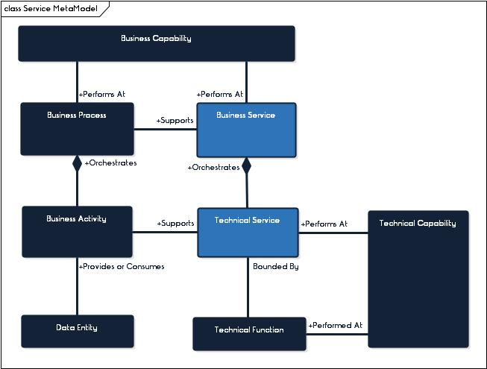

### Business Architecture Components

* **Business Process –** The business process represents a process that is performed by a State Medicaid Agency to help meet its goals, objectives, and performance measures. Each business process is comprised of a set of smaller business activities that are performed to support the business process. The business process defines the orchestration of how and when these smaller business activities are performed.
* **Business Activity –** The business activity represents an individual step within a business process. Each activity performed, produces a meaningful result that supports a business process.
* **Business Capability –** A Business Capability is the competence of an individual, organization or system to perform a business process.
* **Business Service –** A Business Service is a software component that executes a business process or function at a specific capability level. It includes a defined interface for its invocation, performs a defined function that corresponds to the capability, and returns defined results.[1] Business activities associated with processing data produce, manipulate and consume Data.

### Information Architecture Components

* **Data Entity –** A Data Entity represents an encapsulation of data that is recognized by the business as a thing. It is a collection of data that can represent any data set that an Enterprise manages. Types of Data Entities include Data Stores, Master Data, Transaction Sets, etc. Data Entities are consumed by and/or produced by business activities. As an example. the business activity for “Receive Business Relationship Request” is a consumer for the “Business Relationship Request” Data Entity.

### Technical Architecture Components

* **Technical Functions –** Technical Functions are generic technical support activities. They are used to drive Technical Capabilities and define Technical Services.
* **Technical Service -** A Technical Service as a piece of software that executes a generic IT capability. It has a defined interface for its invocation, performs a defined function that corresponds to the capability, and returns defined results. [2]
* **Technical Capabilities –** A Technical Capability is the competence of an individual, organization or system to perform a technical function.

## MITA Metamodel with Data Services

To incorporate Data Services into the MITA Framework, it is important to include the Data Service as well as its associated components into the MITA Metamodel. The following diagram identifies how Data Services are introduced into the MITA Metamodel.

Figure 2 - MITA Metamodel w/Data Services

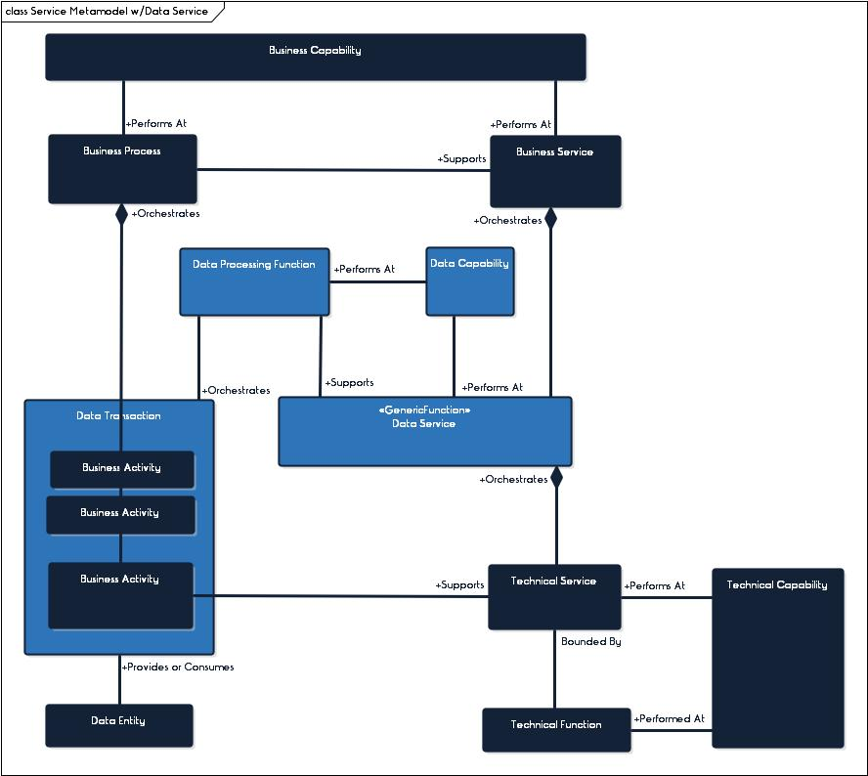

### Updated Information Architecture Components

* + - **Data Processing Function -** Data Processing represents activities that are responsible for collecting and manipulating data, as well as converting that data into meaningful information that is used to support business goals and objectives. Data Processing activities are generic and can be used to support a variety of different business processes.
    - **Data Transaction –** A Data Transaction refers to a collection of business activities that perform data processing functions. A Data Transaction is a Data processing function that has been adopted to support a specific Business Process.. In addition, Data Transactions also meet the following:
* Includes a collection of related data processing related activities
* Can be modeled and used as a sub-process within a business process
* Can be reused as a sub-process within many different business processes
* Cannot be considered complete until all activities within the Transaction are complete
  + - **Data Services -** A Data Service represents a Data Transaction that has been automated by technology. It is a software component that executes a generic Data Processing capability. Data Services have defined interfaces for their invocation, and can perform a defined Data Processing Function that corresponds to the capability and returns defined results.
    - **Data Capability –** A Data Capability is the competence of an individual, organization or system to perform a Data Processing Capability.

# Data Management vs. Data Processing

Data is the representations of facts about the world.[3] Those facts are then interpreted by people and technology. The use of data enables an organization to fulfill its mission, to meet its goals and objectives. As technology has advanced, the amount of data available for an organization to use has substantially increased. With this increase in available data, the importance of appropriately managing data has never been so important.

## Data Management

Data Management refers to the performance of processes and activities associated with managing data as a valuable enterprise asset. Data Management activities are focused on establishing strategies, policies, processes, performance, etc. that guide activities associated with processing data through its lifecycle. The MITA framework provides guidelines for the development and control of a Data Management Strategy, as well as a set of associated capabilities. Like other Business Areas in MITA, Data Management should be included in the framework as a Business Area with a defined set of categories and processes. Recommended guidance has been developed in *the Expanding the MITA 3.0 Framework: Data Management Business Processes.* The Data Management Business Area is aligned to the best practices established by the Data Management Association (DAMA) and contains the following Business Categories:

* + - Data Governance
    - Data Modeling & Design
    - Data Architecture
    - Data Security
    - Data Storage Management
    - Data Integration & Interoperability
    - Metadata Management
    - Data Quality Management
    - Reference Data Management
    - Data Warehouse & Business Intelligence
    - Data Analytics & Science

## Data Processing

Data Processing is facilitated and governed by Data Management. It refers to the collection and manipulation of data to produce meaningful information that is then delivered and distributed for business use. Data Processing activities cross all Data Management Business Categories. Data Management is a high-level grouping that encompasses data processing. In addition to Data Processing activities, it also includes activities that establish the infrastructure for data processing. That includes activities such as establishing data standards, models, policies, etc. Data Processing activities are focused on the following:

* + - Bringing data into an organization
    - Ensuring that data meets the needs of the organization
    - Changing the data to meet the needs of an organization
    - Storing and retaining the data for an organization to use
    - Producing information to help support better understanding and decision making
    - Reporting the data to organization stakeholders

# Data Service Areas

Like Business and Technical Services, Data Services could be defined at various levels of granularity. Each service is driven by taxonomies that have three (3) levels of granularity. The Business Service has Business Service Areas, Categories and Processes. The Technical Service has Technical Service Areas, Categories and functions. To ensure alignment, Data services will also be defined at three (3) levels of granularity which include the following:

* + - **Tier 1: Data Service Areas** represent the highest-level of granularity used to describe a Data Service Function.
    - **Tier 2: Data Service Category** represents an additional classification or grouping of Data Service Functions.
    - **Tier 3: Data Service Function** represents the lowest-level for describing a Data Service Function.

Figure 3 Service Function Hierarchy

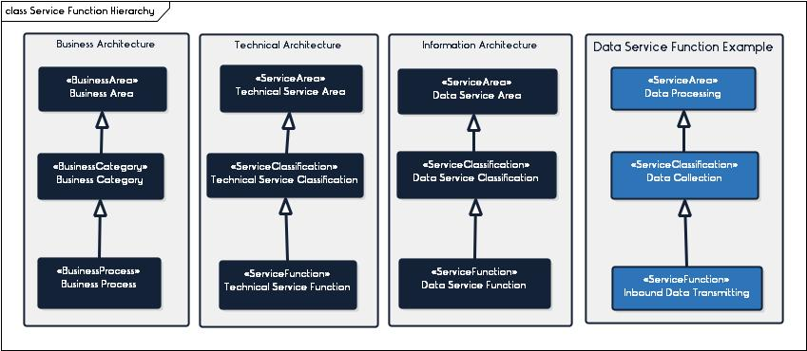

## Data Processing Service Area

The Data Processing Service Area is focused on identifying the generic data processing functions that are performed by individuals or technology. Each data processing function can be aligned to a single or group of business activities that are performed to support a business process. The Data Processing Service Area has eight (8) functional categories that are aligned to the Data Processing Lifecyle.

Figure 4 – Data Processing Cycles

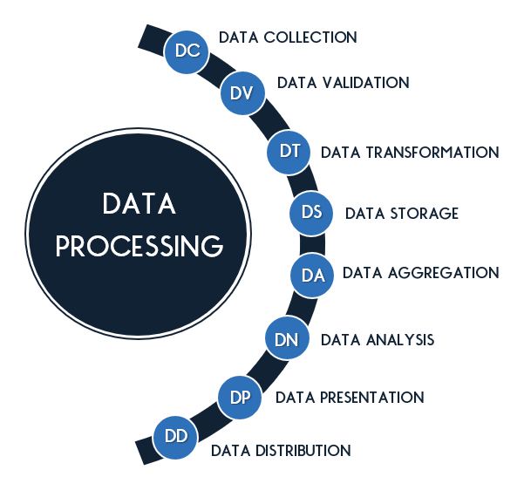

### Data Collection Service Classification

The Data Collection Service Classification is focused on bringing data into an organization. All functions in this category play a role in receiving data and successfully bringing data into an organization for use.

Figure 5 Data Collection Service Classification

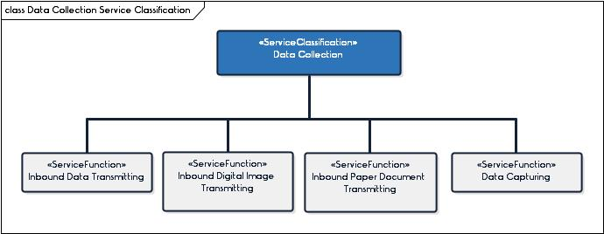

Table 1 – Data Collection Service Functions

| ID | Service Function | Service Classification | Service Function Description |
| --- | --- | --- | --- |
| DC-01 | Data Capturing | Data Collection | Data Capturing is a function for capturing machine readable text. The capturing can happen manually through data entry or converting a digital image into machine readable text. |
| DC-02 | Inbound Data Transmitting | Data Collection | Inbound Data Transmitting is a function for receiving inbound electronic data that has been transmitted from data trading partners. |
| DC-03 | Inbound Digital Image Transmitting | Data Collection | Inbound Digital Image Transmitting is a function for receiving inbound electronic digital images that have been transmitted from data trading partners. |
| DC-04 | Inbound Paper Document Transmitting | Data Collection | Inbound Paper Document Transmitting is a function for receiving paper documents that have been transmitted from data trading partners. |

### Data Validation Service Classification

The Data Validation Service Classification is focused on validating the quality of data. All functions in this category play a role in validating that data sets, records, and elements meet minimum quality and authorization requirements and rules.

Figure 6 Data Validation Service Classification

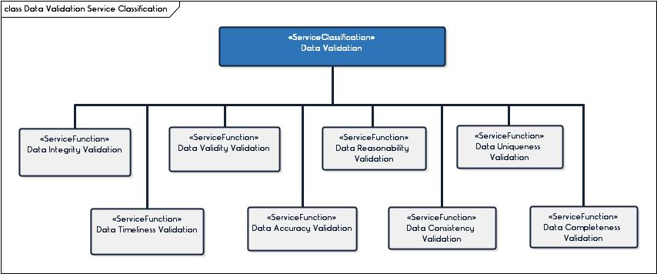

Table 2 – Data Validation Service Functions

| ID | Service Function | Service Classification | Service Function Description |
| --- | --- | --- | --- |
| DV-01 | Data Accuracy Validation | Data Validation | Data Accuracy Validation is a function for validating that the data correctly represents ‘real life’ |
| DV-02 | Data Completeness Validation | Data Validation | Data Completeness Validation is a function for validating that all required data is present. |
| DV-03 | Data Consistency Validation | Data Validation | Data Consistency Validation is a function for validating that data is represented consistently within, between and across data sets. |
| DV-04 | Data Integrity Validation | Data Validation | Data Integrity Validation is a function for validating that data is aligned to the expected structure |
| DV-05 | Data Reasonability Validation | Data Validation | Data Reasonability Validation is a function for validating that data and data patterns meet expectation. |
| DV-06 | Data Timeliness Validation | Data Validation | Data Timeliness Validation is a function for validating that the timing associated with the data meets expectations and needs |
| DV-07 | Data Uniqueness Validation | Data Validation | Data Uniqueness Validation is a function for validating that no entry in the data exists more than once and there are no duplicates |
| DV-08 | Data Validity Validation | Data Validation | Data Validity Validation is a function for validating that the data is consistent with expected reference data values and/or codes |

### Data Transformation Service Classification

The Data Transforming Service Classification is focused on changing data. This includes semantic, structural, or other changes to help improve the use and/or quality of the data.

Figure 7 Data Transformation Service Classification

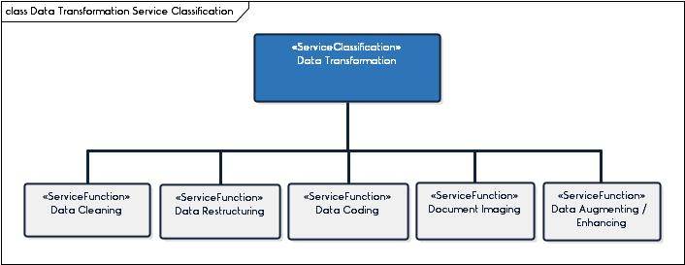

Table 3 – Data Transformation Service Functions

| ID | Service Function | Service Classification | Service Function Description |
| --- | --- | --- | --- |
| DT-01 | Data Augmenting/ Enhancing | Data Transformation | Data Augmenting is a function for adding to the data such as demographic data, time/date data, etc to enhance the data. |
| DT-02 | Data Cleaning | Data Transformation | Data Cleaning is a function for improving the data through activities such as replacing data, de-duplicating data, removing data, etc. |
| DT-03 | Data Coding | Data Transformation | Data Coding is a function for adding reference data to help classify and standardize data. |
| DT-04 | Data Restructuring | Data Transformation | Data Restructuring is a function for changing the structure of data to match the target |
| DT-05 | Document Imaging | Data Transformation | Document Imaging is a function for scanning and converting paper documents into Digital Images |

### Data Storage Service Classification

The Data Storage Service Classification is focused on the storage of data. This includes storing a variety of different types of data including transaction data, analytical data, metadata, master data, etc.

Figure 8 Data Storage Service Classification

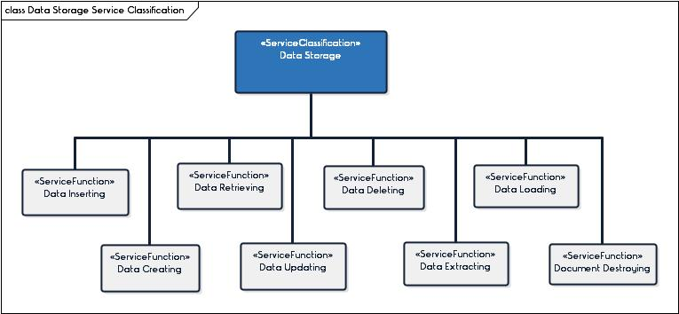

Table 4 – Data Storage Service Functions

| ID | Service Function | Service Classification | Service Function Description |
| --- | --- | --- | --- |
| DS-01 | Data Creating | Data Storage | Data Creation is a function for creating data in a data store. This includes the creation of a Data Store (i.e. Data File), Data Objects, etc. |
| DS-02 | Data Deleting | Data Storage | Data Deleting is a function for deleting and removing data from a data store. |
| DS-03 | Data Extracting | Data Storage | Data Extracting is a function for gathering and removing data from a data store. |
| DS-04 | Data Inserting | Data Storage | Data Inserting is a function for inserting data into an existing data store. |
| DS-05 | Data Loading | Data Storage | Data Loading is a function for gathering and inserting batches of data into a data store. |
| DS-06 | Data Retrieving | Data Storage | Data Retrieving is a function for searching, finding and reading data in an existing data store. |
| DC-07 | Data Updating | Data Storage | Data Updating is a function for updating data. |
| DC-08 | Document Destroying | Data Storage | Document Destroying is a function for destroying paper Documents. |

### Data Aggregation Service Classification

The Data Aggregaation Service Classification is focused on bringing data together to support data analysis. This includes the development of different views of the data based on user needs.

Figure 9 Data Aggregation Service Classification

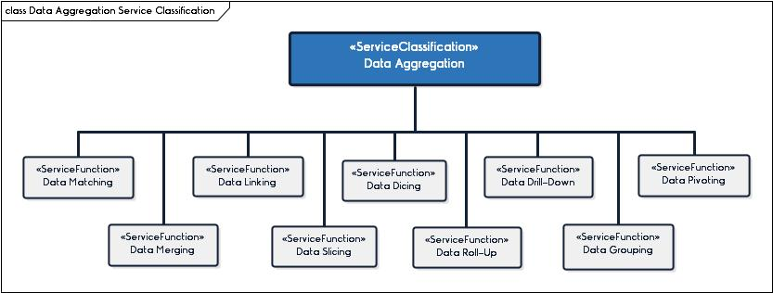

Table 5 – Data Aggregation Service Functions

| ID | Service Function | Service Classification | Service Function Description |
| --- | --- | --- | --- |
| DA-01 | Data Dicing | Data Aggregation | Data Dicing is like Data Slicing except it is viewing data from a different perspective. Data Slicing views are looking within a dimension, Data Dicing looks at data across dimensions. |
| DA-02 | Data Drill-Down | Data Aggregation | Data Drill-Down is the opposite of Data Roll-Up. It is a function for creating sub-total views of data based on aggregating from higher summary levels of data. |
| DA-03 | Data Grouping | Data Aggregation | Data Grouping is a function for grouping together data to provide group summary views. |
| DA-04 | Data Linking | Data Aggregation | Data Linking is a function for linking different records that have an association with each other. |
| DA-05 | Data Matching | Data Aggregation | Data Matching is an activity that uses matching rules to identify matching data records. |
| DA-06 | Data Merging | Data Aggregation | Data Merging is a function for merging different data records that are similar into one comprehensive record. |
| DA-07 | Data Pivoting | Data Aggregation | Data Pivoting is a function for aggregating data into a summary view. It identifies patterns in the data based on user defined calculations such as averaging, frequency, etc. |
| DA-08 | Data Roll-Up | Data Aggregation | Data Roll-up is a function for creating grand total views of data based on aggregating from lower levels of data. |
| DA-09 | Data Slicing | Data Aggregation | Data Slicing is a function for viewing a slice of data, stored in a dimensional data store. The function provides a special filter to view a specific value in a dimension. |

### Data Analysis Service Category

The Data Analysis Service Classification is focused on turning raw data into meaningful information that helps improve decision making.

Figure 10 Data Analysis Service Classification

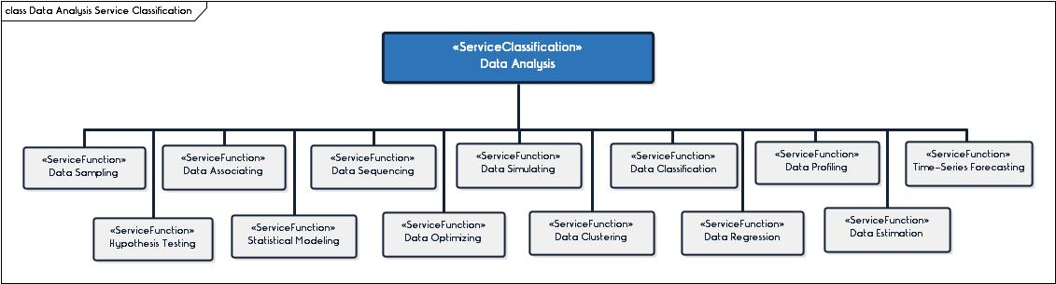

Table 6 – Data Analysis Service Functions

| ID | Service Function | Service Classification | Service Function Description |
| --- | --- | --- | --- |
| DN-01 | Data Profiling | Data Analysis | Data Profiling is a function for gathering descriptive statistics about data that can help detect anomalies about the data. |
| DN-02 | Data Associating | Data Analysis | Data Associating is a function for identifying data within a data set that frequently appear together and appear to have an association. |
| DN-03 | Data Classification | Data Analysis | Data Classification is a function for identifying patterns by assigning items to classification groupings to predict how other similar items will be classified or grouped. |
| DN-04 | Data Clustering | Data Analysis | Data Clustering is a function for finding natural groups of data within a data set. |
| DN-05 | Data Estimation | Data Analysis | Data Estimation is a function for using sample data and statistical models to identify estimates about a larger population. |
| DN-06 | Data Optimizing | Data Analysis | Data Optimization is a function for prescribing data to achieve the best possible outcome. |
| DN-07 | Data Regression | Data Analysis | Data Regression is a function for estimating the relationships among variables. |
| DN-08 | Data Sampling | Data Analysis | Data Sampling is a function for identifying a data set that is representative of a larger population. The sample is used to find trends or patterns that can be used to describe the associated larger population. |
| DN-09 | Data Sequencing | Data Analysis | Data Sequencing is a function for finding sequence patterns in each data set. |
| DN-10 | Data Simulating | Data Analysis | Data Simulating is a function for using statistical models to simulate the real world and make predictions. |
| DN-11 | Hypothesis Testing | Data Analysis | Hypothesis testing is a function for testing whether your statistical findings are valid and significant. |
| DN-12 | Statistical Modeling | Data Analysis | Statistical Modeling is a function for developing models from a data sample that can be generalized to a larger population. There are several different types of Statistical Modeling including predictive models, regression models, etc. |
| DN-13 | Time-Series Forecasting | Data Analysis | Time-Series Forecasting is a function for forecasting future events based on assessing past events that include a timing component. |

### Data Presentation Service Classification

This Data Presentation Service Classification is focused on converting data into a format that can be presented to stakeholders.

Figure 11 Data Presentation Service Classification

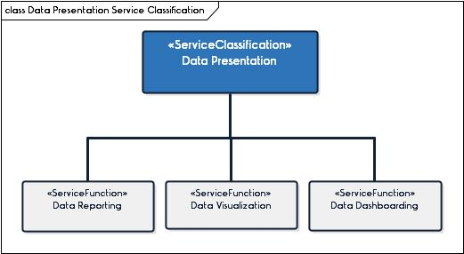

Table 7 – Data Presentation Service Functions

| ID | Service Function | Service Classification | Service Function Description |
| --- | --- | --- | --- |
| DP-01 | Data Dashboarding | Data Presentation | Data Dashboarding is a function for designing and generating dashboards |
| DP-02 | Data Reporting | Data Presentation | Data Reporting is a function for designing and generating data reports. |
| DP-03 | Data Visualization | Data Presentation | Data Visualization is a function for designing and generating data visualizations. |

### Data Distribution Service Classification

The Data Distribution Service Classification is focused on distributing data out of an organization. All functions in this category play a role in sending data and successfully delivering it out of an organization for use.

Figure 12 Data Distribution Service Classification

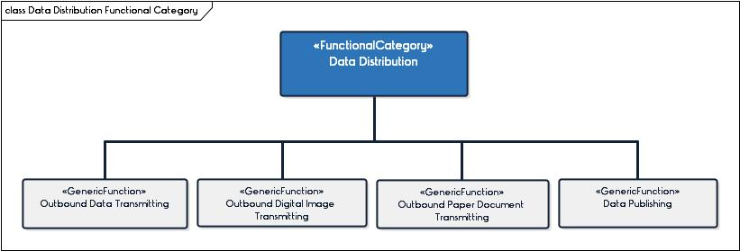

Table 8 – Data Distribution Service Functions

| ID | Service Function | Service Classification | Service Function Description |
| --- | --- | --- | --- |
| DD-01 | Outbound Data Transmitting | Data Distribution | Outbound Data Transmitting is a function for sending outbound electronic data to data trading partners. |
| DD-02 | Outbound Digital Image Transmitting | Data Distribution | Outbound Digital Image Transmitting is a function for sending outbound electronic digital images to data trading partners. |
| DD-03 | Outbound Paper Document Transmitting | Data Distribution | Outbound Paper Document Transmitting is a function for sending paper documents to data trading partners. |
| DD-04 | Data Publishing | Data Distribution | Data Publishing is a function for distributing data to a group of subscribers that have subscribed to receive the publication. |

# Using the Data Service Functions

The Data Service Functional Hierarchy can be used to assist the State Medicaid Agency in a variety of different ways while supporting the Business, Information and Technical Architecture.

## Business Architecture Support

The Data Service Functional Hierarchy can be used within the Business Architecture to support Business Process Modeling. Each business process identified by MITA includes a set of steps or activities that are performed to support that business process. Within each process, there are a number of these activities that can be grouped as a single transaction. Business Process Modeling Notation (BPMN) identifies a transaction as a specialized sub-process that requires all activities within the sub-process to be complete before the transaction is considered complete. The Data Service Functional Hierarchy can be used to define the Data Transactions within a business process. Each activity in a business process that is associated with processing data (i.e. sending, receiving, retrieving, etc.) should be classified as a Data Transaction using the Data Service Functional Hierarchy. The following table identifies a list of possible Data Transactions using the Data Service Functional Hierarchy.

Table 9 – Data Transaction Table

| Function | Business Process | Business Activity | Transaction |
| --- | --- | --- | --- |
| Inbound Data Submission | Establish Business Relationship | Receive request for business relationship from partner. | Business Relationship Request Submission |
| Inbound Data Submission | Process Claim | Receive claim submission or claim adjustment information. | Health Care Claim Submission |
| Inbound Data Submission | Process Encounter | Receive claim submission or claim adjustment information. | Health Care Claim Submission |
| Inbound Paper Document Submission | Establish Business Relationship | Receive request for business relationship from partner. | Business Relationship Request Paper Document Submission |

## Information Architecture Support

The Data Service Functional Hierarchy can be used to support the Information Architecture in many ways, including the following:

### Reuse Opportunity Identification

The use of the Data Service Functional Hierarchy to define Data Transactions will provide a mechanism for State Medicaid Agencies to easily identify internal reuse opportunities. There are many Data Transactions, such as “Provider NPI Validation,” that are used by a variety of different business processes, departments, and units. Often, this is being handled differently by each one. The modeling of the Data Transaction will provide a tool for identifying collaboration opportunities. It also provides a tool for identifying plans to increase the overall enterprise maturity for managing data.

### Target Schema Development

Each Data Transaction identified will also be associated with a “Transaction Set” Data Entity. This can then be used to identify if there is an existing structure or transaction standard. It also provides a common vocabulary to work with internal, intrastate, interstate and regional partners to establish standards. The identification and standardization of these Transaction Data Set Schemas can be leveraged to increase interoperability, decrease time for data exchange mapping and support capability maturity.

Table 10 – Data Transaction Set Table

|  |  |  |  |
| --- | --- | --- | --- |
| Function | Transaction | Transaction Set | Standard |
| Inbound Data Submission | Business Relationship Request Submission | Business Relationship Request | N/A |
| Inbound Data Submission | Health Care Claim Submission | Health Care Claim | ASC X12 837 Health Care Claim |
| Inbound Data Submission | Health Care Claim Submission | Health Care Claim | ASC X12 837 Health Care Claim |
| Inbound Paper Document Submission | Business Relationship Request Paper Document Submission | Business Relationship Request | N/A |

### Data Flow Development

Once a Data Transaction has been identified, a Data Flow that supports that transaction can be developed. The Data Flow helps identify data sources, targets, transmission and needs. It provides a data view for each business process that can be used to support capability maturity.

Table 11 – Data Transaction Source/Target Table

|  |  |  |  |
| --- | --- | --- | --- |
| Function | Transaction | Source | Target |
| Inbound Data Submission | Business Relationship Request Submission | Business Relationship Applicant | Inbound |
| Inbound Data Submission | Health Care Claim Submission | Provider | Inbound |
| Inbound Data Submission | Health Care Claim Submission | Provider | Inbound |
| Inbound Paper Document Submission | Business Relationship Request Paper Document Submission | Any Stakeholder | Inbound |

### Standardize Data Processing

The Data Service Functional Hierarchy can be used standardize the functions that dictate how each business process performs these functions. It also allows for the ability to easily define and perform audits to ensure data is being processed as expected across the enterprise.

Table 12 – Data Processing Transaction Model – Inbound Data Submission Example

|  |  |
| --- | --- |
| Inbound Data Transmitting | |
| Item | Details |
| Description | The Inbound Data Transmitting is a generic Data Processing Transaction for receiving inbound electronic data. This transaction should be used as a template to develop Data Services for receiving electronic data from data trading partners. |
| Transaction Naming | “Data Entity” Submission |
| Example | **Business Process:** Establish Business Relationship  **Process Step:** 1. START: Receive request for business relationship from partner.  **Data Service:** Business Relationship Request Submission |
| Trigger | Trading Partner Submits “Data Entity” |
| Data Entity Type | Transaction Data Entity |
| Result | Data Received and Accepted |
| Steps/Activities | 1. **Alert:** New Data File Received  2. Log Data File Receipt with Transaction Status set to Initiated  3. Validate Data File Syntax as Correct  4. Validate Data File Syntax as Complete  5. Validate Data File as Authentic**  6.**Alert:** Validation Status Set to Passed  7. Transform Data to Target Schema**  8. Store Transaction Data**  9. **Alert:** Transaction Data Created / Transaction Data Inserted  10. Update Data Transaction Status to Complete |
| Performance Measures |  |

Table 13 – Data Processing Transaction Model – Outbound Data Delivery Example

|  |  |
| --- | --- |
| Outbound Data Transmitting | |
| Item | Details |
| Description | The Outbound Data Transmitting is a generic Data Processing Transaction for sending outbound electronic data. This transaction should be used as a template to develop Data Services for sending outbound data to trading partners. |
| Transaction Naming | **“Data Entity” Distribution** |
| Example | **Business Process:** Inquire Contractor Information  **Process Step:** 8. END: Send contract verification response to requestor.  **Data Service:** Contract Verification Response Delivery |
| Trigger | Data Ready for Delivery |
| Result | Data Sent and Accepted by Trading Partner |
| Steps/Activities | 1. **Alert:** Data Ready for Delivery  2. Discover Data Source**  3. Export Data**  4. Transform Data to Target Schema**  5. **Alert:** Transformation Status Set to Complete  6. Transmit Data File to Partner  7 Change Transaction Status to Transmitted  8. Receive Acknowledgement Receipt  9. **Alert:** Acknowledgement Receipt Submission Transaction Status set to Complete  10. Change Transaction Status to Delivered |
| Performance Measures |  |

## Technical Architecture Support

The Data Service Service Classificationcan be used to support the Technical Architecture in many ways, including the following:

### Classifying Legacy Systems/Applications

The Data Service Classification can be used by the Technical Architecture as reference data for classifying data processing functionality provided by current systems and applications. It will allow the Technical Architecture team to have a common vocabulary when discussing data processing technology.

### Identifying Data Services

The Data Service Classification can be used by the Technical Architecture as reference data for classifying future Data Services, as well as identifying enterprise-wide requirements for those services. It can also significantly decrease the time for design if the business and information architecture teams have also used the Data Service Classification to define Data Transactions and Transaction Set Schemas.

### Data Service Capability Identification

The Data Service Functional Hierarchy can be used to develop Information Capabilities that are closely aligned with the processing of data. It will alleviate confusion with the current capability model which does not easily connect to specific business processes such as MITA Business and Technical capabilities. It also allows for more detailed Data-related capabilities.

Table 14 – Data Service Capability Matrix Example

|  | Level 1 | Level 2 | Level 3 | Level 4 | Level |
| --- | --- | --- | --- | --- | --- |
| Data Processing | | | | | |
| Data Collection | | | | | |
| Conceptual Data Model | No CDM Developed. | SMA has identified inbound data transactions needed to support the SMA and have developed Conceptual Data Models for each. | SMA has identified inbound data transactions that that are common across the intrastate and developed Conceptual Data Models for each. | SMA has identified inbound data transactions that that are common across the regional and developed Conceptual Data Models for each. | SMA has identified inbound data transactions that are common across the nation and developed Conceptual Data Models for each. |
| Data Standards | The agency uses non-standard structure data standards. | SMA has established internal structural and vocabulary data standards for each transaction including state-specific and Health Insurance Portability and Accountability Act of 1996 (HIPAA) data standards. | SMA has established partnerships and shared intrastate structural data standards for common intrastate transactions. | SMA has established partnerships and shared region structural data standards for common intrastate transactions. | SMA has established partnerships and shared national structural data standards for common intrastate transactions. |
| Logical Data Model | No LDM Developed | SMA has developed Logical Data Model schemas for all inbound data transaction sets. | SMA has developed Logical Data Model schemas and mappings across intrastate trading partners for all inbound data transaction sets. | SMA has developed Logical Data Model schemas and mappings across regional trading partners for all inbound data transaction sets. | SMA has developed Logical Data Model schemas and mappings across national trading partners for all inbound data transaction sets. |

1. Chapter II – Business Services
2. Chapter II – Technical Services
3. DAMA