Table of Contents

1 Introduction 2

2 Business Process Models 2

Determine Provider Eligibility Business Process Model 2

Enroll Provider Business Process Model 3

Disenroll Provider Business Process Model 5

Inquire Provider Information Business Process Model 6

3 Object/Resource Diagrams 9

Determine Provider Eligibility Object/Resource Diagram 9

Enroll Provider Object/Resource Diagram 10

Disenroll Provider Object/Resource Diagram 11

Inquire Provider Information Object/Resource Diagram 12

4 Object/Resource Descriptions 13

5 API Definitions 13

Determime Provider Eligibility API Definitions 13

Enroll Provider API Definitions 13

Disenroll Provider API Definitions 13

Inquire Provider Information API Definitions 13

# Introduction

The Poplin Provider Enrollment Reference Architecture (RA) defines a comprehensive, reusable, open-source technical architecture to support the Medicaid Information Technology Architecture’s (MITA) Provider Enrollment business category.

The Provider Enrollment RA provides standard definitions for application services that can be used to combine provider enrollment business processes into a set of standard objects packaged in a single module. This Provider Enrollment module may be leveraged across State Medicaid Agencies (SMA) to implement commutable, interoperable Medicaid Management Information Systems (MMIS). The development of modular RAs across MITA business categories progresses modular design, reinforces the Medicaid Enterprise commitment to the Seven Standards and Conditions, and supports the technical evolution of SMAs.[1]

The MITA Provider Enrollment business category falls under the Eligibility and Enrollment Management MITA business area and is composed of four MITA business processes:

* EE05 Determine Provider Eligibility
* EE06 Enroll Provider
* EE07 Disenroll Provider
* EE08 Inquire Provider Information[2]

Therefore, the Provider Enrollment RA is broken down into four equivalent Business Process Models each accompanied by an Object Model, Resource Definitions, and Application Programming Interface (API) Definitions.

# Business Process Models

## Determine Provider Eligibility Business Process Model

The MITA Determine Provider Eligibility (EE05) business process is used to collect information through a provider application for enrolling, re-enrolling, or revalidating a Medicaid service provider. The business process determines a providers eligibility through a configurable set of validations and screening with internal and external entities. The EE05 business process also triggers downstream MITA business processes including: EE06 Enroll Provider, EE07 Disenroll Provider, PM02 Manage Provider Communication, and FM07 Manage Accounts Receivable Funds. Furthermore, this business process also provides the data necessary for the MITA Provider Management business category. Figure 1 depicts the EE05 Determine Provider Eligibility business process model according to MITA.



## Enroll Provider Business Process Model

The MITA Enroll Provider (EE06) business process is used for enrolling providers in a State Medicaid program. Successfully enrolled Medicaid providers may begin or continue rendering services to Medicaid beneficiaries. The EE06 business process can be triggered through several other MITA business processes. An obvious trigger for the process comes from EE05 Determine Provider Eligibility as providers must be enrolled in Medicaid in order to provide services once eligibility is determined. Other MITA business processes triggering EE06 include: Manage Performance Measures (PL05) – for providers who must complete revalidation or State-determined periodic review – and Award Contract (CO06) – for providers such as Managed Care Organizations which have gained a new or continuing contract with the SMA. Furthermore, an example of an environmental trigger for the EE06 business process would be the receipt of enrollment or disenrollment information for the provider from another SMA or CHIP.

The EE06 business process primarily accomplishes three business needs – determination of contracting parameters, program assignment, and establishment of rates. As such, the Enroll Provider business process is not a complex process; but, rather, serves as a gateway to subsequent MITA business processes. Inherently, many MITA business processes are triggered or “alerted” via EE06, these include: Manage Contractor Payment (FM09), Manage Contract (CO07), Perform Provider Outreach (PM03), Manage Provider and Contractor Communication (PM02 and CO02), and Manage Provider and Contractor Information (PM01 and CO01). Figure 2 depicts the EE06 Enroll Provider business process model according to MITA.



## Disenroll Provider Business Process Model

The MITA Disenroll Provider (EE07) business process is used for disenrolling providers from a State Medicaid program. Similar to the EE06 Enroll Provider business process, the EE07 Disenroll Provider business process can be triggered through several other MITA business processes. Also similar to EE06, the inherent trigger for this business process comes from EE05 Determine Provider Eligibility in order to disenroll providers from Medicaid if a provider’s eligibility determination is unsuccessful. The EE07 business process can also be triggered through other MITA business processes such as: PE03 Manage Compliance Incident Information, PM01 Manage Provider Information, CO01 Manage Contractor Information, PE04 Determine Adverse Action Incident, and CO08 Close Out Contract. Addtionally, there are some external environmental factors which can initiate the Disenroll Provider business process – these include: information received of provider’s death, retirement, or disability; notification of provider sanction from federal or state credentialing entity; or, request for disenrollment from State insurance affordability program. Once the primary goal to disenroll a Medicaid provide is completed via the EE07 business process, subsequent MITA business processes are triggered. Again, similar to the EE06 Enroll Provider business process, EE07 Disenroll Provider is not a complex process; but, rather, serves as a gateway to subsequent MITA business processes. Figure 3 depicts the EE07 Disenroll Provider business process model according to MITA.



Figure 3. EE07 Disenroll Provider Business Process Model[3]

## Inquire Provider Information Business Process Model

The MITA Inquire Provider Information (EE08) business process model is a more simple process model than the three previous models discussed in this document. The business process consists primarily of the system/State receiving a provider verification request and the system/State sending a response back to the requesting system/entity/individual. Interestingly, there are no MITA business processes that trigger this process nor are there any MITA business processes that this process triggers. The provider information shared as a result of the successful completion of this business process is data received through the completion of the three previously defined business processes. For example, according to MITA, shared provider information may include:

* Provider demographics
* Provider network
* Contract information
  + Type
  + Specialty
  + Enrolled Program
  + Jurisdiction
  + Payment Information
* Provider taxonomy
* Service Location Information
  + Category of Service
  + Services
  + Limitations
  + Business Arrangement

Figure 4 depicts the EE08 Inquire Provider Information business process model according to MITA.



Figure 4. EE08 Inquire Provider Information Business Process Model[4]

# Object/Resource Diagrams

## Determine Provider Eligibility Object/Resource Diagram

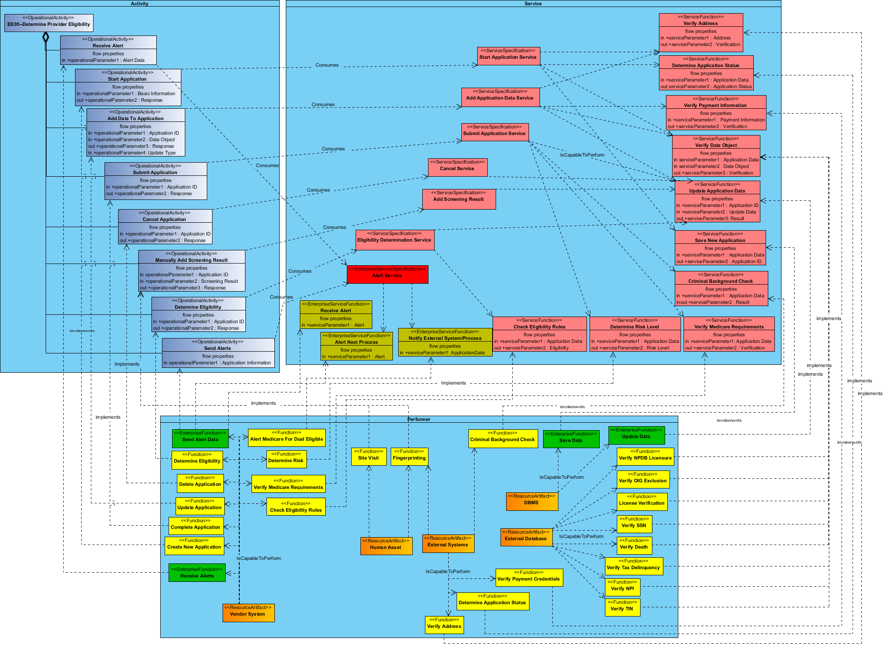

Figure 5. Determine Provider Eligibility Object/Resource Diagram

## Enroll Provider Object/Resource Diagram

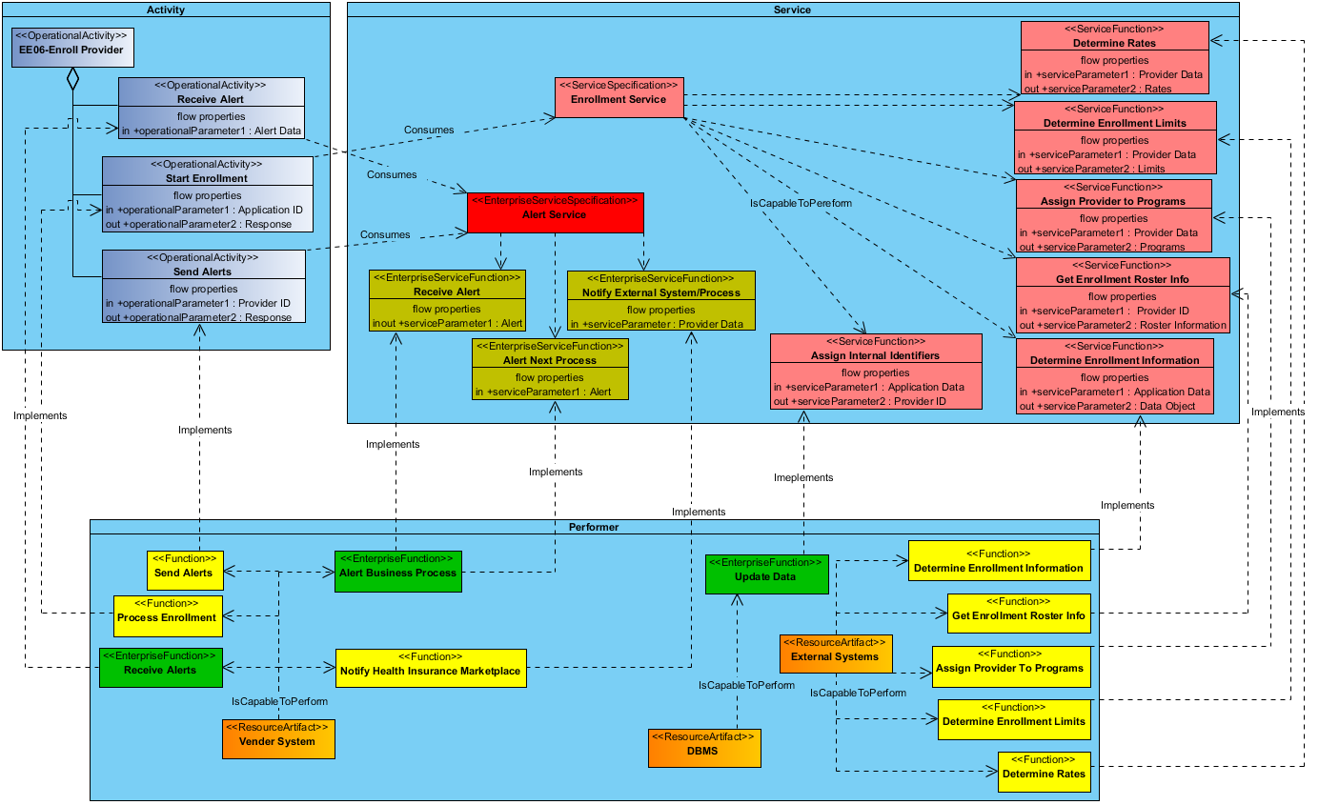

Figure 6. Enroll Provider Object/Resource Diagram

## Disenroll Provider Object/Resource Diagram

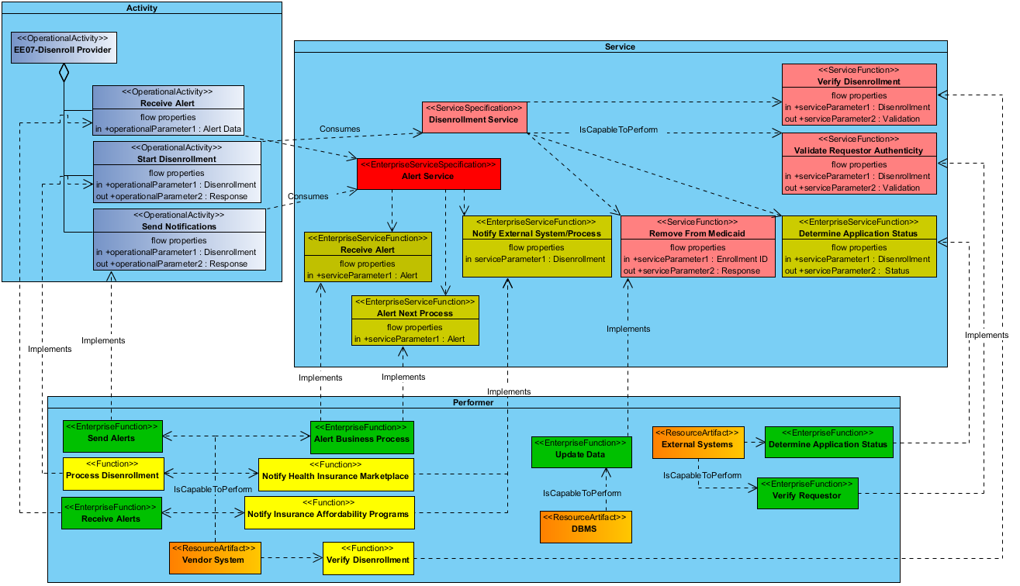

Figure 7. Determine Provider Eligibility Object/Resource Diagram

## Inquire Provider Information Object/Resource Diagram

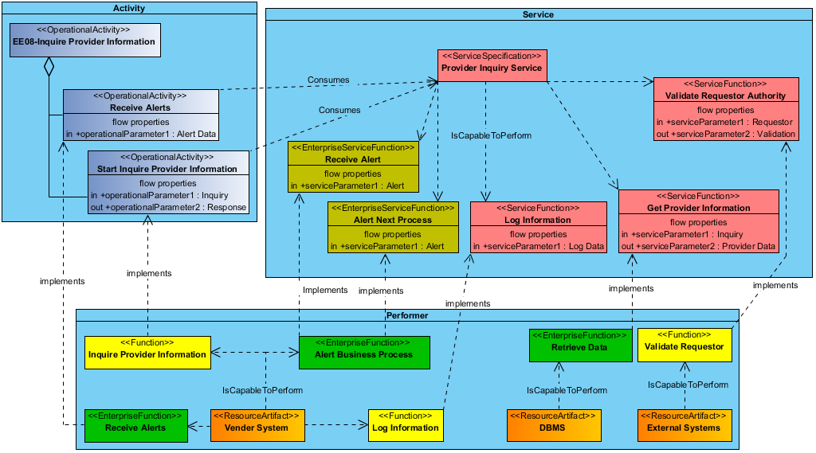

Figure 8. Inquire Provider Information Object/Resource Diagram

# Object/Resource Descriptions

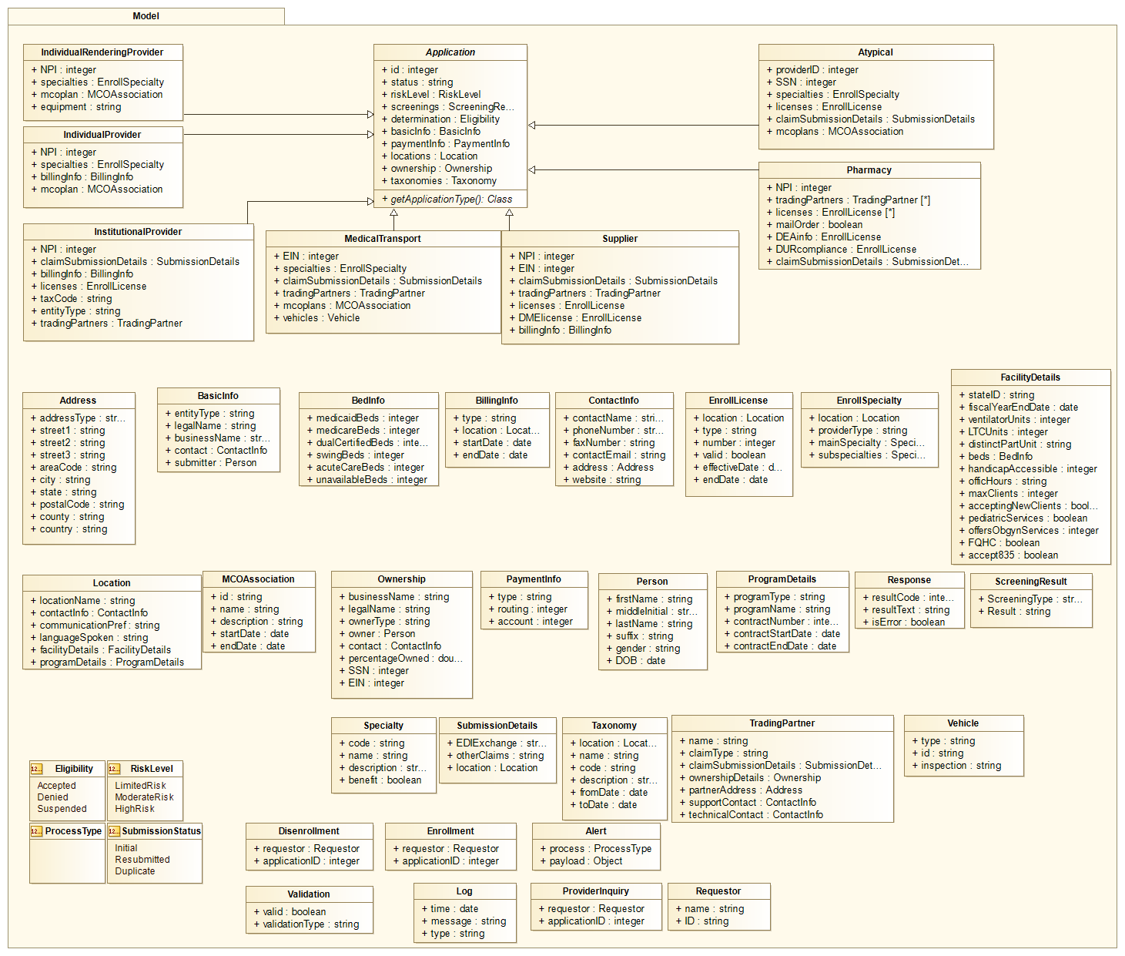

Figure 9. Provider Enrollment Class Model Diagram

# API Definitions

## Determime Provider Eligibility API Definitions

## Enroll Provider API Definitions

## Disenroll Provider API Definitions

## Inquire Provider Information API Definitions

1. (MITA Governance Board Poplin Working Group)
2. <https://www.medicaid.gov/medicaid-chip-program-information/by-topics/data-and-systems/downloads/parti_appendixc_bpm_draft_jun2013.pdf>
3. <https://www.medicaid.gov/medicaid-chip-program-information/by-topics/data-and-systems/downloads/parti_appendixc_bpm_draft_jun2013.pdf>
4. <https://www.medicaid.gov/medicaid-chip-program-information/by-topics/data-and-systems/downloads/parti_appendixc_bpm_draft_jun2013.pdf>