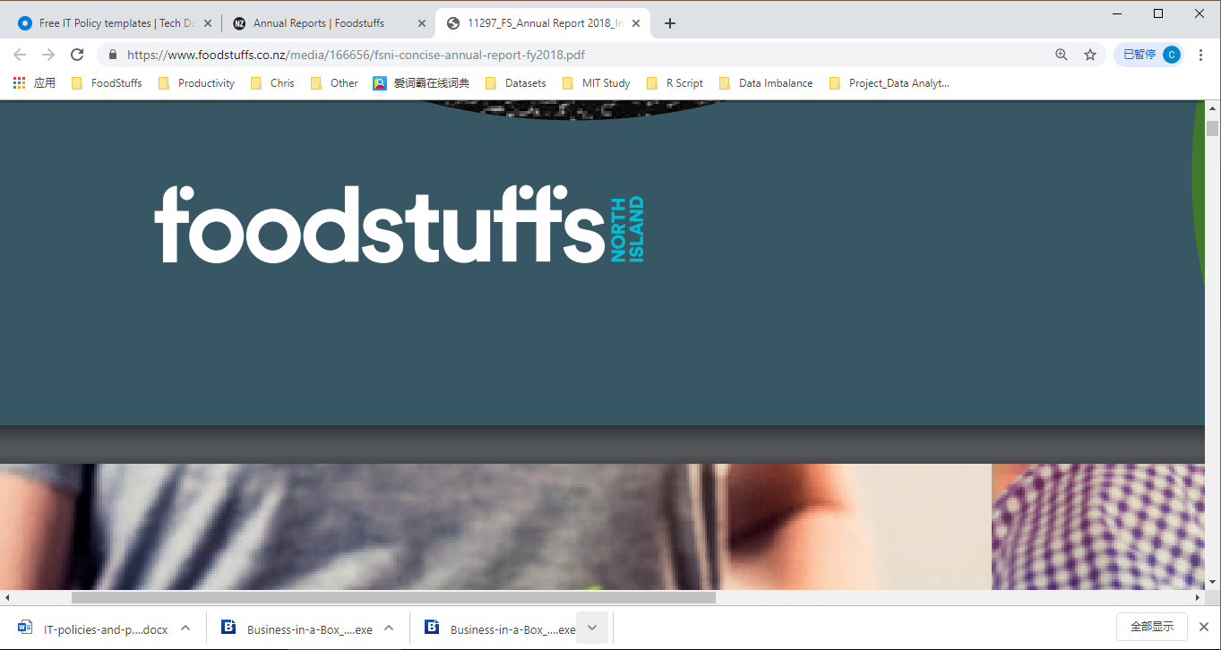

2019

ICT Portfolio for Foodstuffs -North Island

*supermarket in newzealand*

**Team F - Qixiang, Melvina, Sergei, Tanapol, Yun**

Contents

1. About Foodstuffs (North Island) 3

1.1 Vision/Purpose 4

1.2 Mission 4

1.3 Goals 4

1.4 Objectives 4

1.5 Values 5

1.6 Key Business Functions 5

1.7 Organisational Structure 6

1.8 Summary 8

2. ICT Infrastructure 8

2.1 Introduction 8

2.2 Hardware 9

2.3 Software 9

2.4 Current ICT Organisational Structure 12

2.5 Summary 12

3. Strategic Plan Analysis 13

3.1 Introduction 13

3.2 ICT SWOT Analysis 14

3.3 ICT PEST Analysis 17

3.4 ICT Balanced Scorecard 20

3.5 Gartner Quadrant Analysis 25

3.6 Enterprise Architecture – Zachman 28

3.7 Summary 29

*4.* ICT Strategy – *Foodstuffs* 30

5. ICT Infrastructure 30

5.1 Introduction 30

5.2 Proposed ICT Organisational Structure 30

5.3 Roles of Key ICT managers 38

6. Description of Individual Roles in the Team 38

**Executive Summary**

In this portfolio, we introduced the origin, background and ICT infrastructures of Foodstuffs. Then we analyzed and assessed the ICT infrastructures performance with analysis methods (SWOT, PEST, Balanced Scorecard, and Quadrant Analysis) to offer a strategic plan to Foodstuffs - North Island. Foodstuffs, as one of the largest grocery distributor organizations, has the nation-leading ICT technology no matter in the hardware or the software aspects, and that is the reason why they can keep themselves competitive among all the opponents. In the process of searching for information and analyzing the information, we found that ICT techniques play a crucial role to help Foodstuffs achieving their goals more efficient in each department. Foodstuffs has the top Data producing system in New Zealand which makes them manage their daily data easier. Conversely, they need to improve their customer analytics technology to understand what people want most, then, they may have more chance to keep their current customers and attract potential customers. Besides, they have to keep their ICT technologies and staffs’ knowledge up to date to steady their leading position. Furthermore, we also compared Foodstuffs with another major supplier company in New Zealand(Woolworths) in data platform they use and get a result that the system which Foodstuffs used has advantages in revealing hidden trends and finding answers, but it lacks better-integrated visualization tools and native integration with other IBM products.org So we advise them to fix this by using data visualization tools as soon as possible.

So, in a word, although Foodstuffs’ ICT technique has various advantages than other companies in New Zealand and they do perform well, there still are many inadequacies if they adjust and improve them, Foodstuffs would be more competitive in the marketing competition.

# About Foodstuffs (North Island)

Foodstuffs is the largest grocery distributor organization that is owned and operated as a kiwi organization in New Zealand. Foodstuffs distributes grocery’s to supermarkets such as PAK'nSAVE, New world, Four Square etc., and also to private label brands such as Value, Pams etc. and Foodservice Brands such as Gilmour’s, Trent’s Wholesale Ltd etc.

Foodstuffs was funded in 1922 in Auckland then over time it started to spread all over New Zealand, Wellington in 1992, Christchurch in 1928, Otago/Southland in 1948. There are two independent operated regional co-operatives for Foodstuffs, one is located in North Island and the other one is located in the South Island, and both of co-operatives have their own management team.

Foodstuffs located in North Island is operated under the supervision of CEO Chris Quin and there are about 1,700 people who work for the organization. The organization distributes goods to 96 New World, two Fresh Collective by New World, 44 PAK'nSAVE, one PAK'nSAVE min, 179 Four Square etc. supermarkets in North Island.

Foodstuffs located in South Island is operated under the supervision of CEO Steve Anderson, there are about 1,311 staff working for the organization, the organization distributes goods to 42 New World, four Raeward Fresh Stores, 12 PAK'nSAVE, 66 Four Square etc. supermarkets in South Island.

Foodstuffs is a Federation body for the North and South Island Foodstuffs, which is committed in delivering the best shopping experience to their customers and also to be able to provide the best service and best quality products to the community of New Zealand.

* 1. Vi**sion/Purpos**e

The vision of Foodstuffs is to be “New Zealand’s leading food and grocery retailer and wholesaler.” (Foodstuffs Annual Report, 2015)

* 1. Mission

The mission of Foodstuff is to be able to deliver the best quality eco-friendly products and service for better customer shopping experience.

* 1. Goals

Some goal that foodstuffs wants to archive are:

“Our Customers and suppliers prefer us”

“Our sales and market share continue to grow”

“And we can see a long and sustainable future ahead”

“Increase in market share”

“With exciting careers for future generations”

***(Foodstuffs Annual Report, 2016)***

* 1. Objectives

“Being a powerful aligned and engaged co-op”

“Being customer insight driven”

“Every brand winning its market”

“Being agile, efficient and able to compete with anyone”

“Unleashing our people potential”

***(Foodstuffs Annual Report, 2016)***

* 1. Values

We make sure New Zealanders get more out of life by thinking customers, staying in it together.

* We offer products within high quality at competitive prices.
* We provide more - great value, more time, meal solutions and healthy options.
* We offer our people great work environment and opportunities.
* We buy locally and regionally whenever possible.
* We live by these Values while maintaining a profit so that we can serve more for our New Zealanders.
  1. Key Business Functions

Different from traditional supermarket groups, Foodstuffs NI doesn’t own the stores. Each store has its own shareholders and owner. Here we will separate Foodstuffs NI and supermarkets into 2 sections.

* Retail

Retail department

* + Business partner management

Business partners (stores, vendors) relationship, supervise company value, policies, services, store layout of each store.

* + Sales / Promotion

Make statistics of each brand’s weekly sales data, analyse the sale trend related to the public holiday, back to school, consumer interest changes etc. Compare sales and promotions with competitors. Publish next week’s promotions.

* + Optimization

Keep improve the consumer experience, productivity, increase sales by applying the latest technologies, integrated with other department, systems. Introduce new concept, ideas to optimize business.

* Supply Chain
  + Distribution Centre

Maintain all the DC across the North Island. Manage DC daily business: Inbound/Outbound/Inventory Management/Transport.

* + Transport

Vendor management, fleet management, control stores’ delivery date, forecast transport demands.

* Information Technology
  + Core system

Manage company’s core systems. Like ERP, Integration, Supply Chain, payroll etc.

* + Digital

Apply digital solutions, BI report, data warehouse, OS/Office etc.

* + Infrastructure

Maintain IT infrastructures, including and not limited to network devices, computers, servers, mobile devices and information security.

* + Development

Develop and support IT in-house systems

* Merchandise

Develop and validate suppliers, maintain daily relationship with suppliers. Analyse industry environment and competitors. Organize bulk purchase with all the brands

* Own Brand

Manage 2 own brands “Parms” and “Value”. Design new products, manage manufacture venders, and the whole process from design to deliver.

* Finance

In charge of tax and compliance, financial reporting and control, cash management, investment and business strategy/risk management

* HR

Talent acquisition and all staff’s contract management. Staff’s salary, position and promotion management.

* Property

Manage company’s properties, like land, vehicles, building, warehouses etc. Also, manage lease contracts.

* 1. Organisational Structure



* 1. Summary

Foodstuffs North Island was funded in 1922 in Auckland. Until today, it is the largest supermarket group in New Zealand. Foodstuffs owns 3 supermarket brand Pak’n’Save, New World and 4 Squares, also including the whole sale brand Gilmours. As a liquor retailer, LiquorLand is belonged to Foodstuffs as well. Foodstuffs owns 2 own brands, Parms and Value, almost covering all kinds of groceries.

Foodstuffs technically separates to North Island and South Island 2 enterprise. This document is only talking about Foodstuffs North Island (Foodstuffs NI).

The Cole business functions for this big retailer company is retail, merchandise and supply chain department, these 3 departments cover the main business, from purchasing, operation, pricing, optimization to storage and delivery. IT and departments are key functions for every company. They make sure the company can run smoothly, providing necessary services. Finance drives and makes strategy about the company’s revenue plan, also make sure daily routing billing and expense etc are correct.

As one of the largest companies in New Zealand, Foodstuffs NI is a classic example to analyse as it contains all the business functions, what are their responsibility and goals, how they cooperate each other to keep company the leader of the industry and keep developing, competing.

# ICT Infrastructure

2. 1. Introduction

At the beginning of the 21-century transition from the Industrial to Informational Society has happened. But Informational Society as a model of human development could not simply appear in an empty space. The serious intellectual and technological foundation is necessary for such kind of an event. It is primarily relying on computer networks. The internet of Everything is not some kind of a distant future.

So that is why modern enterprises hardly rely on ICT in their every day’s activities. A company without an ICT component in its structure is unthinkable for 21 centuries, no matter the size.

Both software and hardware parts of this equation are meaningless one without another. Hardware solely is just a collection of microchips, wires, and silicone. And software by its own is nothing but a set of meaningless phrases. So, it should be considered as a part of one.

* 1. Hardware

Foodstuffs company uses various amounts of ICT equipment and technologies in its operations. Grocery stores equipped with Fujitsu Point of Sale (POS) controllers and touchscreens, integrated ETERNUS DX storage units, and PRIMERGY servers. The network infrastructure consists of wireless access points and also wired infrastructure such as switches and routers of different vendors. Employees of all levels are using desktop PCs, laptops, tablets, handheld computers with barcode readers, printers, scanners, and IP phones in their everyday work. Also, employees are encouraged to bring their own devices (BYOD). The core and distribution levels of the enterprise Foodstuffs network, online services, and SAP enterprise management platform some time ago migrated from local servers to a private cloud.

**Fujitsu POS Solutions** includes POS controllers, thermal printers, and touch screen terminals of various form-factor implementations.

**ETERNUS DX rack mountable hybrid storage unit** is a solution for small, medium size, and large enterprises. It has iSCSI, SAS, Ethernet (not in all unit models), and Fiber Channel interfaces. It has built-in RAID controller. It can host 2.5” and 3.5” hard disk drives (number of disk drives 96-6912 depending on unit model). Managing software SF Express is also included.

**PRIMERGY server** is a powerful and flexible solution for any size companies. Form-factors differ from tower-based form factor till rack mountable and modular form factors. It based on Intel Processors. The solution very flexible and can be completed with various additional modules such as fiber channel controllers, raid controllers, graphics coprocessors, etc.

* 1. Software

Foodstuffs has used the following software solutions in their brands:

* **Online shopping** - Foodstuffs has integrated an online shopping option for their customers at all of the Foodstuffs North Island stores to make it easy for the customers to buy their products online and after purchasing the products online it will be delivered to the customers doorstep
* **Self-service** – Foodstuffs has integrating a self-service option for their customers in their stores to make help their customers in avoiding standing in long lines at the checkout counter.
* **eXchange** – Foodstuffs used this system to make it easier for them to send orders to their suppliers. The originations have to send over four million purchase order to about 3000 suppliers and this was done through fax which was hard but with this new system, dealing with the purchase orders has been easy.
* **SRM** (Supplier Relationship Management) is a database that stores all the information about a product or person at Foodstuffs and it can be easily accessed.
* **GS1 ProductFlow** – a software that offers an easy, faster and reliable way to share or check product information between Foodstuffs and their trading partners, this software is a great way of creating a new or making additional changes to any existing products, either the product is online or on the shelf. This system is a great tool for checking for any mistakes before process the product further to ensure everything is correct in the first place and by doing this it helps in saving time and effort.
* **SAP** (Systems, Applications, Products) is a ERP (Enterprise Resource Planning) type of software that makes it easy for business to maintain product information such as inventory management, sales, orders, distribution etc., Foodstuffs has used this software before for their financials division and it was a success for them, now they have deiced to use the SAP retail system. The SAP software also has integrated the new point-of-sale (POS) for Foodstuffs. Foodstuffs has also moved all the operations relating grocery retail (pricing, promotions, orders, merchandising etc.) to SAP for Retail software. The warehouse management and the payroll system were also moved to the SAP for Retail.
* **RSM** (Retail Stock Management system) – is a system used by suppliers to enter product details such as the products price, quantity, pack size, description etc.
* **SCM** (Supply Chain Management System) SCM is actually 2 systems, WMS (Warehouse Management System) and TMS (Transport management system). WMS manages inventory in the warehouse, key functions are inbound, outbound, inventory managements. TMS controls shipment, consolidates loads, assigns carriers etc.
* **Checkout system.** Checkout system is integrated to all the checkout cashiers and self-checkout terminals. This system records all the checkout transactions, items and baskets. It also records customer loyalty card information. All the data are transferred to SAP.
  + 1. Product data process

GS1 Product Flow, eXchange and SAP work together to keep product information organized

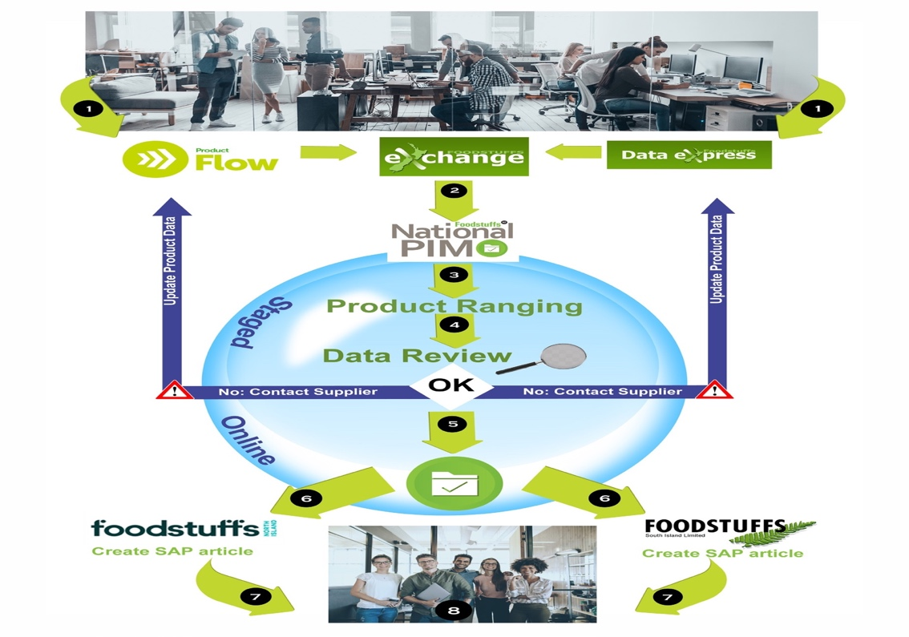

***Foodstuffs product data, n,d***

The above diagram shows how the three software’s work together.

**Step 1** - the product data is loaded into to the GS1 Product-Flow and then it is submitted to Foodstuffs by the vendor.

**Step 2** - the data is received and send to the Foodstuffs National PIM database through eXchange.

**Step 3** – in this step the category analysts decide in which range is the product data, either upper or lower, and if it is needed to improve the product data quality.

**Step 4** - in this step the product data will be reviewed by the National PIM team to make sure if the product data is completed or not.

**Step 5** – accepting or rejecting the product data. If the product data information is completed than the Foodstuffs North and South Island can use it in their systems and if it is not completed than the National PIM team will commutate with the vendor who supplied the product data in the first place for more correct product data.

**Step 6** – the local team of the Foodstuffs respond if they want the data in their system and the product data is transferred from the National PIM system into the Local system.

**Step 7** – the local team uses the SAP system to create an article for the product so that the product can be displayed and be ready for buying by the customer.

**Step 8** – Foodstuffs Ltd offers some suggestion/feedback regarding the product data process for a better commutation and experiences in the future.

* 1. Current ICT Organisational Structure



The current ICT organization structure shows only 2 level report line under CIO. The dot line report relationship is because of 3rd party contract. Dot line is used to distinguish the 3rd party contract with internal direct report line.

* 1. Summary

Foodstuffs has lots of different types of software’s that help them to run their day to day activities smoothly. This is helpful for both the customers and the staff members. Foodstuffs is continually adding new ways to improve the service they provide to their customers as they want to give their customers the best shopping experiences and the best quality products.

# Strategic Plan Analysis

* 1. Introduction

*“Sound strategy starts with having the right goal”.*

*Michael Porter*

In terms of a harsh competitive environment and rapidly evolving situation, commercial organizations should properly concentrate not solely on the internal state of affairs but also to produce long-term strategies which allow being in harmony with constant surrounding changes.

Many organizations could successfully work in the past paying attention only to everyday routine and inside problems related to increasing effectiveness of resource usage in current activities. Although the task of rational resources usage in current company activities is not canceling in nowadays, it has become a prominent model to manage in the way of timely manner adaptation to fast-changing circumstances in the business sphere.

In other words, it is vital to pay attention not only to internal factors but also to external ones.

Life pace acceleration, customers recent demands, competition tightening, new unexpected business fields emerging following the current scientific achievements, swift ICT development, and, as a consequence, rapid information delivery, change of the role of human resources, and other various reasons have made the strategic management extremely important.

The word “strategy” has a Greek origin. Literally, it means the art of deploying troops in a battlefield or, in other words, skills of a supreme commander. This military expression is widely employed in theoretical and practical spheres of a management today. In management strategy is considered as a long-term direction of a company’s development. It is a set of rules and techniques providing a basis for decision making to implement goals achieving.

“Strategy is the bridge between policy and high-order goals on one hand and tactics or concrete actions on the other... In short, the strategy is a term that refers to a complex web of thoughts, ideas, insights, experiences, goals, expertise, memories, perceptions, and expectations that provides general guidance for specific actions in pursuit of particular ends” (Hiriyappa, 2013, p.7)

However, a single common strategy for all companies does not exist, as a single universal strategic management does not exist either. Every company is unique in some way and that is why the process of building a strategy is unique for every company. It depends on the place on a market, development process, potential, competitors’ behavior, production characteristics, state of the economy, political situation and many other factors. So, that is why it is so significant to conduct a comprehensive analysis of internal and external influencing factors in various ways to produce a strategy for a particular enterprise.

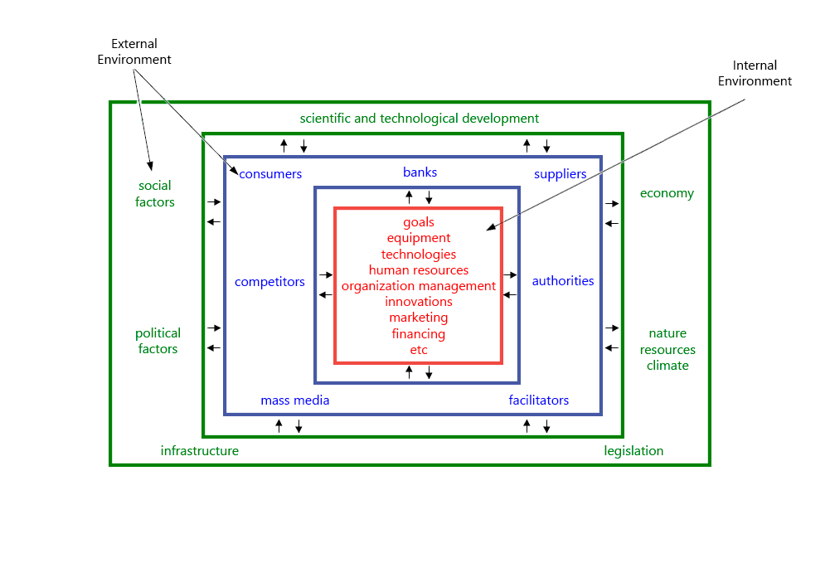

“Strategy has to be based on information about markets, customers, and noncustomers; about technology in one’s own industry and others; about worldwide finance, and about the changing world economy.” (Drucker, 2007, p.106)

As a part of the company’s ICT management team, the aim of this work is to concentrate on an ICT sector. Various analysis techniques will be used. Such as SWOT analysis, PEST analysis, Balance Scorecard, Gartner Quadrant, and Enterprise Architecture.

* 1. ICT SWOT Analysis

SWOT analysis (or SWOT matrix) is one of the strategic planning analysis techniques which includes two main categories – Internal & external factors.

Internal – **Strengths** and **Weaknesses** internal to the organisation

External – **Opportunities** and **Threats** external to the organisation

Generally, we use the diagram as below to present these factors.

**Strengths:**

* **IT Technical & Business Knowledge combination**
* **Full access to manage ICT**
* **Data Integration**
* **ICT Vender Management**

**Weaknesses**:

* Inadequate business knowledge
* Lack of customer facing experience
* Complicated processes
* Capacity and resource restriction

Opportunities:

* Improve customer satisfaction
* Obtain all the business data
* Implement cutting edge technology
* Cooperate with vendors to deliver better solution

**Threats**:

* Competition from external IT companies
* Security challenges
* Rapid technology renew speed
  + 1. Strengths Analysis – Internal
* Staff from IT department understand both IT technical knowledge and company retail business. They can transfer business requirement into IT solution or design document, then get back to business department for further review and discussion.
* As the only department in company who has full access to all the systems, IT department can extract data from multiple functions, build integration structure, and provide data analyse to support business improvement.
* Via building data integration, reducing cost and keeping data accuracy. For example, keep item master data aligned between ERP, supply chain and sales systems, build data warehouse with multiple dimensions for data analytics.
* Manage 3rd party ICT venders. Review their solutions, estimate and quality to find the best partner to work with. Outsource daily services like IT service desk to help company maintain cost and improve flexibility.
  + 1. Weaknesses Analysis – Internal
* Inadequate business knowledge. ICT department understands high- level business but doesn’t have deep knowledge of business departments’ business and requirement.
* Normally, ICT department is a service unit of other departments, it doesn’t have much experience on end customer communication, which can cause an issue that ICT department doesn’t share the same pressure as business departments. Potentially it can cause misunderstanding and delay.
* As a large company, normally ICT has complicated and long processes. Once a project or requirement raised by business departments, ICT department will trigger a process, needing to follow certain forms or templates, getting multiple level approval, estimate the impact and security policies etc. Sometimes business units choose not to request ICT because of the complexity. For example, the business department wants to add one column to display in system. ICT needs to consider more than that, like interfaces, data transformation, data security etc, so this leads to more checks and costs. As a result, the business department would like to cancel it.
* Since an internal department, ICT doesn’t have enough resource to involve all the IT related tasks. Also, the lack of resource who can work on certain technical software/tools. In this scenario, ICT department needs to either recruit the right resource or find external venders to do the tasks and prioritize the tasks.
  + 1. Opportunities – External
* IT could design new applications to improve customer satisfaction. E.g. application for online shopping, mobile app, deliver omni-channel shopping experience. Also, IT can participate in company’s optimization projects, use its advantages to analyse trend, revenue, costs and propose for improvements.
* By accessing data of multiple systems, ERP, loyal card records, check out records and supply chain system etc. IT department analyses data, using data warehouse, BI to show the trends, which helps company to improve daily business.
* Implementing the latest cutting-edge technology, which can improve efficiency, reduce cost and improve competitiveness. For example, by applying cloud solution, company can reduce cost of maintaining IT infrastructure and security.
* There are many ways IT can choose to optimize business and reduce cost. As an ICT department in Foodstuffs, it cannot perform every direction due to resource and technical restrictions. This is where the 3rd part vender step in. Selecting, evaluating venders, and cooperating with them to deliver solution is a good approach for ICT department to achieve their goals.
  + 1. Threats – External
* As a retail company, ICT department provides IT service and security management. However, business departments still can contract with 3rd party vender to deliver IT solutions. This is a challenge for IT department that sometimes have to compete with external vendors, or at least guide and manager them to meet the company’s policies.
* Along with the technology development, IT security is a critical part for ICT department. How to make sure no data leaked to external, protect data stored on servers, laptops and tablets safe is a challenge.
* Normally ICT department has limited resources, their advantage is familiar with company business but not catching up latest technologies. However, in order to keep company on track and compete with competitors, learning latest technology is important. This is a task for ICT department.
  1. ICT PEST Analysis

“PEST Analysis… considers external factors. PEST is an acronym for Political, Economic, Social, and Technological issues that may affect a business... PEST Analysis measures a market”. (Applegate, Johnsen, 2007, p.28)

Sorting out all factors into the four main groups and stressing them as the most important related to:

* The politic reflects auctions of authorities which are shaping in a significant way an organization’s environment.
* The economy determines available resources distribution within a state.
* The social sphere in this analysis researches consumers behavior and reasons for its differences.
* The technology effects on a rising market changings.

PEST analysis framework represents a table divided into columns. All that issues are brought each into its own column so as possible actions of a company directed to avoidance or mitigation of negative influence.

It can happen the name of the analysis will have different variations (STEP, PEST). The reason for that is that for one enterprise prominent could be a social sphere and political for another.

**Factor Groups**

Political could include:

* legislation acts changes
* elections of different levels
* ecological problems
* international influences, etc

Economic issues could include:

* inflation rate
* interest rate
* climate influence
* taxation policy
* standard of living, employment rate
* currencies exchange rate, etc

Social factors could include:

* demographic
* ways of life
* education level
* mass media
* popular trends, etc

Technological could include:

* scientific and technological progress and discovers.
* available technologies, Level of availability
* legislation in sphere
* science funding, etc

**Issues and Limitations of PEST analysis**

Before starting to analyze factors, which are influencing the company’s actions, it will be a good idea to establish those in every group because the set is not a universal one. It will be a good idea to pick it up individually for each company. This is the main problem of the PEST analysis – it is not a universal tool for every company. And if to apply only some factors from every group without proper consideration, the conclusion could be misleading, and the whole analysis is a waste of time.

The factors in the PEST analysis cannot consider everything that influences exact enterprise activities and decisions.

If the company is producing different kinds of products or working in different markets it is good practice to perform the analysis for every single product or marketplace.

|  |  |  |  |
| --- | --- | --- | --- |
| EST Analysis - *Foodstuffs* | | | |
| P  Political | E  Economic | S  Social | T  Technological |
| Protectionist measures from government can influence on ICT equipment prices  Legislative initiatives can significantly increase software development spending.  Legislative initiatives in personal data processing can create additional spending in software and hardware (protection, storing, processing of personal data) | Interest rate change can significantly influence IT infrastructure budgets (both positive and negative)  National currency value increase will enable to buy more innovative ICT infrastructure overseas  National currency value increase will enable to hire overseas coders cheaper  Competitors new features implementing will require additional spending in order to avoid falling behind and the customers lose | Changing patterns in social behavior. People change the way of grocery and household chemicals shopping: automatic orders from appliances.  Demographic changes can severely influence the ICT labor market  (both positive and negative) | Changing the ways of delivery: drones automatic deliveries  Artificial Intelligence can replace cashiers, consultants. Also, can impact on various business operations  Internet of Everything can give new crucial data (customers behavior, habits, preferences) for more personalized approach |
|
|
|
|
|
|
|
|
|
|
|
|
|
|

* 1. ICT Balanced Scorecard
     1. Introduction

As one of New Zealand’s largest food supplier companies, Foodstuffs runs a huge and complete ICT department. Therefore, they have invested a lot of money into their technology improvement and staff professional training to achieve annual revenue and net profit. In order to evaluate their ICT performance and manage how does their strategic action plan go, we use Balanced Scorecard (BSC) which is often used in the company’s business performance assessment to analyze and determine the long-term strategy and analysis.

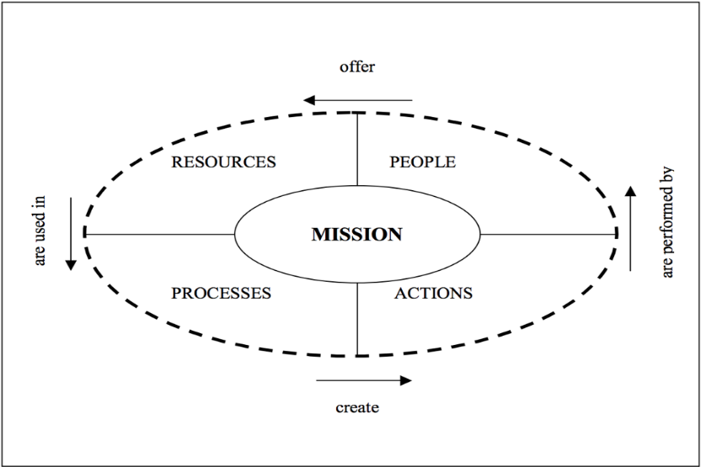

Fig.1 Process of BSC analysis

In Fig.1 we can clearly figure out how a company runs the strategic plan under standard progress. In the center of this diagram is the company’s mission or goal which is the primacy of BSC analysis. To achieve the goals, there is a relationship between people, action, processed and resources. People offer the financial resources, resources are used into processes, processes create actions and actions are performed by people. Depends on the relationships, the ICT Balanced Scorecard’s relational loop is defined like Fig.1. Each part has its own perspective, they are financial, Customer, Learning&Growth and internal processes perspectives.

* + 1. ICT Balanced Scorecard Analysis

Fig.2 Goals and objectives of each perspective

Fig.3 KPIs and Targets

Fig.4 Targets and programs

Fig5. Description

In this section, we are going to present the strategic action plan along with ICT Balanced Scorecard we have made for Foodstuffs based on the four perspectives.

The pictures above are the ICT Balanced Scorecard for Foodstuffs.

* Financial perspective

For the financial perspectives, there are two goals and several objectives in each goal. The first goal is to increase net profit. Under this goal, there are three objectives to achieve it.

1. Increasing revenue by using world-leading techniques (KPI—Number of gross profit)

For a company who wants to keep competitive in the modern market, the capability of ICT is a crucial factor. Thus, the company should keep its technologies up to date, then, the revenue would grow every year since the production efficiency. We made a three-year target depend on Foodsutffs’ annual report. The first year, because of the investment, the gross profit might less than 2018, but must keep it in a positive number, the second year they need try to maintain the same gross profit as 2018($475,796）, as for the third year, they have the ability to earn money more efficient, so the mission of the third year is to achieve 4% growth than the second year(when they invested money into some small changes in 2017, they went through a 2% decrease).

1. Increasing store sales (KPI—Store sales’ increasing percentage)

In this part, we plan to use the Customer Analysis system to achieve the goal. In the modern society, customers have a variety of needs, so the company should access the database of shopping records and analyse the data about the hobbits of each customer then produce the goods and send promotion information to each customer base on their needs.

The second goal is to win a new market. Exploring new markets is the eternal way to help a company standing firm in the competition. As the recent customer shopping tendency analysis. People in New Zealand are more willing to buy foods which are beneficial to their health. So our objective for this goal is to produce healthier foods to win new market (KPI—sales from healthy food). By using customer data analytics techniques to predict the trend of the market to develop new market one step ahead competitors. To evaluate the performance of the data analytics technology, we have to check the sales come from healthy food and compare them with other companies.

* Customer perspective

In this perspective, we focus on making customers feel worthy for what they have bought.

There are four objectives within this goal. Analysing shopping data to meet customers’ need (KPI—Customers’ satisfaction), improving Customer relation (KPI—ration of customer inflows and outflows) and Provide more information about products which customers are interested in (KPI—Customers’ feedback on the information). These three objectives are all using customer analytics to achieve the goal. Nowadays, understanding what customers need do is the first priority that a company should consider if they want to improve rate of returns. So we decide applying the shopper tracker system to understand the relationships between items which customers buy together. Therefore, shelf managers can rearrange the products in a more reasonable way to make the shopping process more comfortable and humanize. To find out customers’ satisfaction, we planned to ask customers to fill the online questionnaire. After getting the feedback, we can calculate the ration of customer inflows and outflows. Furthermore, we can use customer analytics technologies to gather information about what the customers want to know about our products and print them on the label (such as the story of the origin of the product). Then we can make a survey once a month to get more information from our customers to provide more attractive information to improve our customer inflow. The last objective in customer perspective is about the I Shop online shopping APP (Extending the number of I Shop App, KPI—Number of I Shop users). The limit of covering range is a tricky problem which prevents the company from attracting more potential customers. Thence, the company should solve this problem instantly. Adopting a new transportation management system can be an ideal way, this may provide real-time data communication between drivers and support center. To monitor how effective the system is, we will count the number of users. The target for the first year is to get 50,000 users, the second year we want to have 60,000 users and the third year the number should expend to more than 80,000.

* Learning & Growth perspective

For this part, our goal is cultivating employees’ professional knowledge and update techniques. First of all, our objective is to improve our people’s skills by operating online courses about the contract and lectures about each position (KPI—Online test average score). To evaluate the level, the online test will be launched monthly, and the average score would be the main indicator of staffs’ learning outcome. The following one is improving communication between two warehouses (KPI—Products distribution efficiency). Because we have two warehouses to store products, to achieve a more efficient good supply, we need to update the warehouse management system which can help two separate centers work like one team. The third objective is to achieve high punctuality of product supplying (KPI—Time of arrival). By applying a new transportation management system, we can monitor how is the supply-chain strategy going. The time margin is one hour for the first year, the second would be 45 minutes, then 30 minutes.

* Internal Processes

Moving on the correct direction is the first goal and the objective of it is making decisions more efficient and effective (KPI—Ratio of effective decisions and useless decisions). To make sure we are moving toward the right direction, we need to make sure our decisions are effective. Therefore, we apply SAP software into stores to help us make decisions more efficient and correct.

The second goal is improving performance. We plan through giving specific feedback to help staffs and managers understanding their team’s performance. After that they can run a weekly or monthly meeting to speak out their opinions. For this objective, we conduct the new 360˚ feedback tool to help us checking the performance.

* 1. Gartner Quadrant Analysis

Gartner Magic Quadrant (MQ) is a market research report and visualization by IT consulting firm Garner. This tool is for monitoring and evaluating the progress and position of companies in the technology-based market. This would help the company understanding market trends and compare their position with the other competitors. By showing ranking companies in quadrants, which are based on two factors, completeness of vision and ability to execute it. The Gartner Magical Quadrant separates into four categories.

**Niche Players**: Scoring low in both completeness of vision and ability to execute, these companies may narrowly focus on the specific market but cannot outperform larger vendors. Usually focused on a specific region or local business.

**Visionaries**: Have awareness of how the market will evolve and understand market trend but not be able to execute their visions. Normally in the start-up business try to escape from the mature markets.

**Challengers**: Be able to execute or well enough to be a threat to vendors in Leaders quadrant. They may have a strong product in mature markets and well known in the market but lack of strong vision or they don’t want to change their current plan however if they got their vision, they would have potential to become leaders.

**Leaders**: The vendors in the Leader quadrant have the high scores in both completeness of vision and ability to execute. A vendor in the leader quadrant has market share, understand the market trend and capability to create an invention which could affect the market’s overall direction.

* **Scope of this analysis**

In this analysis, we focus on two major suppliers’ supermarkets only in New Zealand which are Foodstuffs and closeness competitor in New Zealand, Woolworths. In this topic we want to compare Analytics and Business Intelligence Platforms between Foodstuffs and Woolworths which base on Gartner Information. Two large companies are using a different platform to analysis their business. Woolworths is using IBM to operate its system (1) and Foodstuffs is running the operating system on SAP. AS you can see in this figure 1 SAP operation is in the Visionaries quadrant, but IBM is in Niche player, one of the reasons is, SAP operation system is allowed to accumulate and transform large amounts of data to have an integral and more complete vision of the Company. It also allowed revealing hidden trends and finding answers in order to help make decisions based on objective data and transmit their results. An efficient tool that allows the fast manipulation of data with attractive visualizations that make it possible to combine and analyse data from different sources. (2) If compare with IBM It lacks though better-integrated visualization tools and native integration with other IBM products. (3).

Gartner Magical Quadrant for Analytics and Business Intelligence Platforms base on Gartner Data

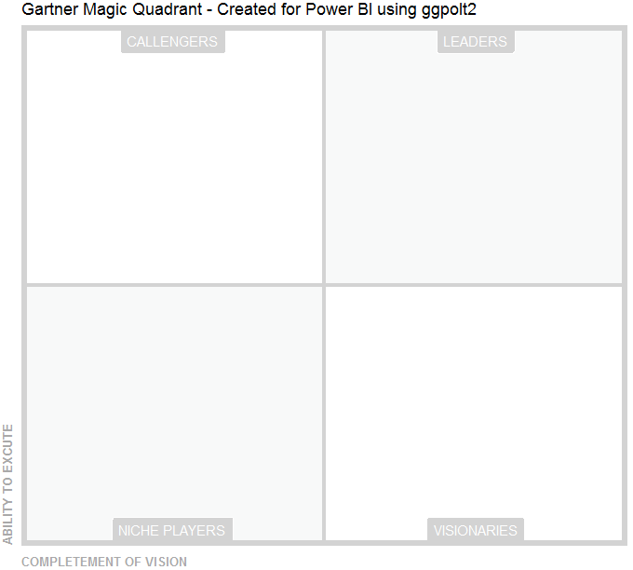

Foodstuffs (SAP)

Woolworths (IBM)

Gartner Magical Quadrant – FoodStuffs

These figures are used to show the position of these companies within the Gartner Magic Quadrant diagram. These scores rely entirely on user reviews that are collated from various categories as showing in figure 2.

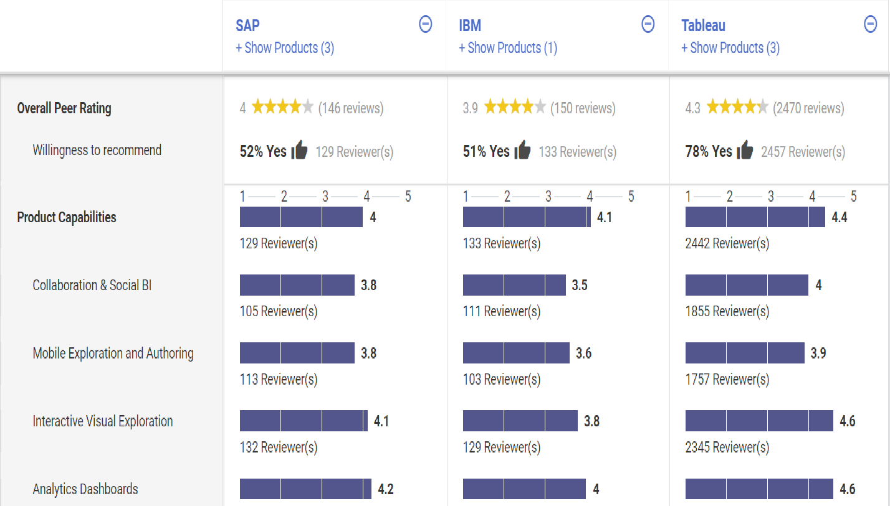

Figure 2.1 Comparing Analytics and Business Intelligent Platform between SAP, IBM and Tableau

Figure 2.2 Comparing Analytics and Business Intelligent Platform between SAP, IBM and Tableau

In conclusion, if foodstuff wanted to head more in a leadership direction it would be advisable to use the Tableau platform, which is in the Leaders position. The most common positive feedback received about Tableau is its ease to use that its make your life easier to drill down the granularity of data and you can see the different metrics and KPI in the same chart, attractive visualisation and how easy it is for new users to pick it up

* 1. Enterprise Architecture – Zachman

|  |  |  |  |  |  |  |
| --- | --- | --- | --- | --- | --- | --- |
|  | What - Data | How - Function | Where - Network | Who - People | When - Time | Why - Motivation |
| Scope  (Contextual)  Role: Planner | Description of the functions of the I-shop online shopping website such as: Allow customers to choose and purchase products.  Chose the delivery type either in store pick-up or home delivery | Selling,  Advertising,  Delivery | Locations where the enterprise operate the Programs/Applications  (User, Store, WMS&TMS)  I-Shop website operates from all location in North Island  Delivery option is limited to some locations | People or departments  Customers  Staffs | Identification of delivery events | Receive customer orders,  Online shopping option for customers  More profit and  market share |
| Enterprise Model  (Conceptual)  Role: Owner | Using an Entity-Relationship Model to outline the relationship between each function. | High-level business process to coordinate between the departments above | Logistics business level network | Work Flow Model  Relationship between different positions, roles | Delivery working business schedule | Business plan to achieve the set of goals and strategies |
| System Model  (Logical)  Role: Designer | Normalized Data Model for I-shop online shopping website information | Essential Data flow diagram application architecture with functions and user view. | Design distributed system architecture for I-shop online shopping | Design different user interfaces for different roles | Design system for delivery process and reminder | Functional requirements |
| Technology Model  (Physical)  Role: Builder | Data architecture (tables and columns) for I-shop online shopping website information. | System design – structure chart, Program functions and operation | Design the architecture  -Hardware  -Software  -Middleware  -Network etc. | Design the user interface architecture (system level) | Design the delivery process system architecture | Operational requirements |
| Detailed Representation  (Out of context)  Role: programmer | Code a Data design (denormalized)  physical storage design for I-shop online shopping website | Operation implementation including program design and DBMS stored procedures | Code  Communication,  Protocols,  Hardware,  Components,  software | Code the user interface | Delivery  System  implementation | Technical requirements |
| Functioning Enterprise  Role: User | Functioning database | Operation are developed for I-shop online shopping website | Functional distributed system | Functional user interface | Functioning delivery system | Order products online |

The Zachman above show the online shopping website that Foodstuffs launch for New World. There are six viewpoints of six different person of how they do their job ,the planner will outline the important things relating to the I-shop online shopping website such as what the website does, the website allows its customers to choose their products online and add to their cart and checkout also the customers can use the option either if they want to pick their product from their nearby New World store or want a home delivery, the owner’s viewpoint will be to identify all entities such as customers, stores and arrange them in an Entity-Relationship Model to show how each of the entities connect to each other, the designer will than break the information into smaller tables for easy understanding, the builder will actually put the broken information that was done by the designer into tables and columns to create a better understanding about the data, the programmers will code the actual database for the I-Shop online shopping website so all the orders and all the product information are saved in the database, the user who are the staff members of Foodstuffs can use the database containing all the data and also the customers who can now buy products from the website, can use the I-shop online shopping website.

For the how column, the planner will outline how will the I-shop online shopping website be used by Foodstuffs, it will be used for selling products online, it will also be used for advertising new arrival of products and it will provide delivery options for the customers, the owner will use a high-level business process to create coordination between different operations (Selling, Advertising, Delivery) into an efficient relationship, the designer will arrange the operations (Selling, Advertising, Delivery) in to an data flow diagram to show how the data will flow from one department to the other, the builder will use an structure chart to breakdown the operations into small components, the programmer will code the operations (Selling, Advertising, Delivery), the user who are the staff members can use the operations (Selling, Advertising, Delivery) to satisfy the needs of their customers.

For the where column, the planner will outline the places from where the I-shop online shopping website can be used from and delivery can be made to which, locations, the owner will use an Logistics business level network to show the all the places where Foodstuffs warehouse, stores, distribution centers are located, the I-shop website can be operated from all parts of the North Island but the delivery service is not yet available in all parts of New Zealand, it is only limited to the north Island, the designer will design the a system to allow connection between different location like for example if someone purchases a product from I-shop from one location and the product is not available in that particular location than this system will sent an request for that product from another location, the builder will design the required components for the distributed system, the programmer will code the required components for the distributed system, the user who are the staff members will use the distributed system.

For the who column, the planner will outline the people who will be using the online shopping website I-shop, the customers and staff members will use the I-shop, the owner will use a work flow model to outline the relationships between each roles,, the designer will design different user interface for different roles like customers will see the shopping website(I-Shop) in a different way and the staff members will see the website in a different way, the builder will design the required components for the user interface and the programmer will code the required components for the user interface, the user who are both the staff and the customers will use the user interface.

For the when column, the planner will outline the events that will take place for I-shop which is delivery it can happened any time of the day, week, month, year, the owner will use a delivery working schedule system to have a better understating of when and how the delivery will take place, the designer will design a system for entering and setting reminder for delivery dates and times, the builder will design the required components for the delivery system and the programmer will code the required components for the delivery system, the user who are the delivery people will use the delivery system.

For the why column, the planner will outline the reason for creating the online shopping website (I-Shop) which is to receive orders made by the customer, giving option to customers to shop online and more profit and market share, the owner’s reason is to achieve the business goals and strategies, the designer’s reason is to make the website function properly like when a new customer signs up the system should sent an confirmation email informing the customer they have successfully signed up, and the builder’s reason is to have I-shop operation such as adding a new product to the shopping work, the programmer’s reason is to have a website that is reliable, the user’s reason is to order products online using the I-shop online shopping website. First requirement for any manager to understand is the reason to create the website, so therefore this part should come first.

* 1. Summary

Different analysis methods analyse ICT department from different angle. SWOT analysis is focusing on ICT department’s advantages and cons, opportunities and challenges based on its feature. PEST analysis works on the impact from external environment (political, economic, social and techno logical features). Balanced scorecard is driven by ICT strategies, targets and actions, it analyses form strategy and management perspective. Gartner Quadrant analysis classifies companies into 4 quadrants: leaders, challengers, niche players and visionaries. It is focusing on the competitive strength of the company in the whole business environment. It helped company to release its position in the market, rise market share and improve the influence.

# ICT Strategy – *Foodstuffs*

Refer to ***ICT Strategic Plan 2018-2023 for Foodstuffs***

# ICT Infrastructure

* 1. Introduction

ICT infrastructure of a company is about the hardware, software, networks, firmware etc. of the company, they are the information and communication technologies that help the business in dealing with the day-to-day activities. Fujitsu, an IT company got the contract to supply Foodstuffs with IT equipment’s to Foodstuffs brands such as touchscreens for self-service. Foodstuffs wants to make use of technology in ways it can help them keep their operation at a rate in which it reduces the impact on environment.

To have a strong ICT Infrastructure, Foodstuffs organizational structure should be including highly skilled and well-organized people who would go to any extend to complete their work. The identified organizational structure listed below is a good and strong support to implement the ICT strategies for Foodstuffs.

* 1. Proposed ICT Organisational Structure

As the new ICT organization structure below, the main changes are:

* Moved IT project managers’ report line to IT portfolio manager.

From project management prospective, portfolio manager should manage multiple projects at the same time and manage/balance resources from these projects.

* Moved development members (software engineer, developers) to IT service manager’s team. By doing this, IT service manager can control both development and testing team. It’s efficient for them to report to same manager as the cooperation between development and testing team are a lot.
* Added “IT Delivery Manager” under “IT maintenance manager”.

IT delivery manager will consolidate and optimize IT processes, make sure projects can be delivered on time without quality issue. IT delivery manager directly reports to maintenance manager who can simplify the process by investigating with change manager.

* Added “IT DevOps Manager” to report to Core System manager. As IT team is not customer facing role, they don’t feel the urgency and pressure from customers. DevOps manager can use azure methodology to implement delivered “dev” outcome to “ops” team, shorten the development period, pushing the project to “live” world quickly, also gets feedback from business departments.



* 1. Roles of Key ICT Managers
* **Core System Manger**

Reporting to the CIO in our ICT organization structure, the Core System Manager must be able to demonstrate comprehensive knowledge of information and communication technology (ICT) and must be able to demonstrate strong leadership in managing both business and operational ICT functions.

* IT DevOps Manager

As I mentioned above, in our ICT structure I added “IT DevOps Manager” who can minimize the gap between business department and ICT department to report to Core System manager.

Like other ICT organization, our IT team is not customer facing role, they don’t feel the urgency and pressure from customers. DevOps manager can use azure methodology to implement delivered “dev” outcome to “ops” team, shorten the development period, pushing the project to “live” world quickly, also gets feedback from business departments.

* **IT Portfolio Manager**

A portfolio is a group of related initiatives, projects and/or programs that attain wide reaching benefits and impact. IT Portfolio Manager is responsible for influencing the organization to make decisions on which projects to undertake. Additionally, the IT Portfolio Manager typically tracks in-progress projects to elevate risks and issues, sometimes stopping projects mid-way if they are not forecasted to achieve the value they originally promised.

In Foodstuffs NI, the IT portfolio management role is limited to reporting; they are the weather tower of the IT organization. IT portfolio manager is typically responsible for gathering and reporting metrics that describe the state of the IT portfolio.

Finally, the IT portfolio manager usually is involved in making the technology decisions on which enabling tools will be used to manage the project portfolio.

* IT Project Manager

A project manager's role has a strong focus on delivering IT project results.

Project manager could manage multiple projects as well as manage teams of business analysts, testers and developers and have a focus on end-to-end delivery based on internal business requirements.

* **Digitalization Manager**

Digitalization Manager is a key role who are applying digital solutions for our business departments. Such as BI reports, data warehouse, OS/Office etc are the responsibilities.

* **Maintenance Manager**

Maintenance Manager’s responsibilities are as below,

* Develop maintenance procedures and ensure implementation.
* Carry out inspections of the facilities to identify and resolve issues
* Plan and oversee all repair and installation activities
* Monitor expenses and control the budget for maintenance
* Manage relationships with contractors and service providers
* Keep maintenance logs and report on daily activities
* Ensure health and safety policies are complied with
* Etc
* IT Change Manager

IT Change Manager reports to IT Maintenance Manager, to ensure change requests are well organized, recorded and implemented in terms of ICT policy.

* Accepts, prioritizes, and categorizes change requests.
* Rejects outright any change request that is completely out of scope or out of policy for Change Management.
* Has the ability to review all planned changes.
* Obtains authorization for submitted change requests from the Change Authority.
* Utilizes the Change Management reporting system to monitor and track changes.
* Negotiates end-user down time for change implementation.
* Creates consolidated change schedule and resolves any scheduling conflicts.
* Reviews all implemented changes to ensure that they have been carried out.
* Etc.
* IT Delivery Manager

IT delivery manager works with IT change manager and IT project manager to make sure changes and projects solutions can be delivered on time with good quality. This role also needs to cooperate with IT consultant, analyst and business department users to understand both IT and business expectation, and protect the timeline for the IT solution delivery.

* **IT Service Manager**

This role manages in-house software and IT tools’ development and testing teams. Also controls IT contractors from 3rd party. Sometimes, ICT permanent employees don’t have enough capacity. The responsibly of this role including and not limited to:

* Managing resource of In-house system, database, tools’ development
* Managing testing team for unit testing, SIT and UAT
* Cooperate with IT project manager to make sure projects delivered on time. Especially cooperate with IT portfolio manager.
* 3rd party contractor management (developers, testers etc.)
* IT Test Manager

This role manages testing team. IT test manager needs to balance resources from multiple projects, urgent projects have priority. If not enough testing staff for projects, this role will report to IT service manager for 3rd party resource.

* IT Development Manager

This role manages development team. . IT test manager needs to balance resources from multiple projects, urgent projects have priority. If not enough testing staff for projects, this role will report to IT service manager for 3rd party resource.

* **IT Infrastructure Manager**

This role is responsible for all company’s infrastructure maintenance, purchasing and security. The infrastructure maintenance is managing by IT infra analyst. Security is managing by IT security manager. Both of these 2 roles are reporting to IT infrastructure manager.

* IT Security Manager

This role manages IT security team and external resources. Security includes both software and hardware security. All the systems, databases, cloud platforms, and physical servers, networks and disaster recovery.

Some security is managed by 3rd party venders, this role needs to regularly catch up with these venders and make sure no security issue.

# Description of Individual Roles in the Team

* ***PartA***

|  |  |  |
| --- | --- | --- |
| **TeamF** | **Role** | **Description** |
| Sergei | Member | Hardware, Strategic Plan Analysis Introduction and PEST Analysis |
| Qixiang | Member | Execute Summary and BSC Analysis |
| Tanapol | Member | Gartner Analysis and ICT Strategic Plan |
| Melvina | Member | Software, Company overall introduction,ICT infrastructure introduction and EA(Zachman) Analysis |
| Yun | Leader | Focus on SWOT Analysis and other left parts |

***More details refer to our schedule.***

In the past few weeks, Sergei, Qixiang, Tanapol, Melvina and I worked together on our group Portfolio – Foodstuffs North Island. In this group work, we have investigated in many related analysis technologies including SWOT, PEST, Balanced ScoreCard, Zachman and Gartner Magical Quadrant.

We made our schedule using Gantt chart which was agreed by all team members. We set our individual goals and project milestones to ensure our portfolio is finished on time.

I am very lucky to cooperate with Sergei, Qixiang, Tanapol, Melvina in our team. All of the tasks in our portfolio were challenging but beneficial for us. I think this is a good experience in my academic student life.

In the end, I represent the whole team to thank our lecturer Chirs to give us the precious opportunity to participate in this portfolio project and give my own respect to all the team members for your hard-working.

**ICT Strategic Plan 2018-2023 for Foodstuffs North Island**

* **Introduction**

ICT strategy (information technology strategy) is a comprehensive plan that outlines how technology should be used to meet ICT and business goals. An ICT strategy, also called a technology strategy or ICT technology strategic plan, is a written document that details the multiple factors that affect the organization's investment in and use of technology. *(Margaret Rouse, n, d)* Foodstuffs mission, goals, objectives, vision will play a big role in outline the ICT strategy for the company.

* **ICT Vision Statement**

To underpin the delivery of service to subsidiaries and assist the Foodstuffs Ltd to achieve its vision an ICT visioning statement has been developed on the principle that “Driving business ICT product and services that are effective, robust, scalable and delivering customer satisfaction”

* **ICT Mission Statement**

To optimize data analysis of business by using cutting edge technology, support and cooperate with vender to deliver better solution.

* **ICT Overall Strategic Goals**

To improve any ICT infrastructure by reducing resources consumption and increase analysis capability that helping us to understand customer needs.

* **ICT Strategic Objectives**
* Lifecycle management of ICT infrastructure.
* Skill and Capable ICT workforce.
* Deliver business system s customer satisfaction.
* **Background and Rationale**

As we analyse above, Foodstuffs as a supermarket, ICT techniques are widely used in our company. Supermarkets service-oriented IT needs and use IT techniques in our day-to-day operations. As a leading supermarket company in New Zealand, we are adopting complex computer systems that allow us to regulate the practices, providing business managers with more information to make decisions with and making some processes automatic, saving both time and money. Appling more IT techniques could help us make the process even more personalized and streamlined.

As we all know, almost everything has been influenced by technology. In the current era of rapid development, technology facilitates peoples’ lives and creates more comfort. It has remarkably improved the quality of life. Due to this advancement, Supermarkets are getting to adjust to find the easiest and most convenient way to service customers.

This portfolio group work sought to propose a more organized and efficient ICT structure. As Foodstuffs is 100% New Zealand owned and operated organization, we must ensure that our ICT structure is well-organized and ready to cope with influence of globalization. In this organization, ICT played an important role, our proposed ICT structure can provide the other business departments in more efficient and effective way.

|  |  |  |  |  |  |
| --- | --- | --- | --- | --- | --- |
| **Strategic Plan 2018-2023** | | | | | |
| Strategic Objective 1: Lifecycle management of ICT infrastructure | | | | | |
| Specific Goals | Action Plan | Key Performance | Person Responsible | Budget | Timeframe |
| Develop ICT sustainability strategy | -Reduce print impact and paper use and west  -Analysis of energy consumption  -Updating new hardware | -Power Bills  -Financial statement | -IT Infrastructure Manger  -CFO  -Budgeting manger | 500K | 2018-2020 |
| Strategic Objective 2: Skill and Capable ICT workforce | | | | | |
| Specific Goals | Action Plan | Key Performance | Person Responsible | Budget | Timeframe |
| Develop staff training for digital disruption. | -Providing an online course for employees  -Hire HR outsource company to train our staff.  -Create a Boost camp program | -Online test score etc. | -Training & Development manager  -HR manger  -HR GM | 210K | 2018-2019 |

|  |  |  |  |  |  |
| --- | --- | --- | --- | --- | --- |
| Strategic Objective 3: Deliver business system s customer satisfaction | | | | | |
| Specific Goals | Action Plan | Key Performance | Person Responsible | Budget | Timeframe |
| Improve business analysis capability | -consolidate Business Intelligence tools  -Implement alternate electronic document and records management system | -ration of customer inflows and outflows  -Business Profit | -Business Analyst Team  -CFO  -Budget manager | 50k | 2018-2021 |

**Reference:**

Foodstuffs.co.nz. (2019). *About Foodstuffs | Foodstuffs*.

Retrieved from: <https://www.foodstuffs.co.nz/about-foodstuffs>

Suppliers.foodstuffs.co.nz. (2019).

Retrieved from: <http://suppliers.foodstuffs.co.nz/media/558964/2014.04_go-live_2-_5_supplier_briefing.pdf>

Suppliers.foodstuffs.co.nz. (2019).

Retrieved from: <http://suppliers.foodstuffs.co.nz/media/558964/2014.04_go-live_2-_5_supplier_briefing.pdf>

Foodstuffs.co.nz. (2019).   
Retrieved from: <https://www.foodstuffs.co.nz/media/151366/foodstuffs-north-island-limited-annual-report-2016.pdf>

Foodstuffs.co.nz. (2019). Retrieved from: <https://foodstuffs.co.nz/media/136794/8560_fni_annual_report_lr-_10_8_15.pdf>

Foodstuffs.co.nz. (2019). Retrieved from: <https://www.foodstuffs.co.nz/media/151366/foodstuffs-north-island-limited-annual-report-2016.pdf>

Suppliers.foodstuffs.co.nz. (2019). *Supplier Information for Foodstuffs*. Retrieved from: <http://suppliers.foodstuffs.co.nz/national-guidelines/b2b-ecommerce.aspx>

Foodstuffs.co.nz. (2019). Retrieved from: <https://www.foodstuffs.co.nz/media/132335/fsni_annual_report_web_2014>.

Suppliers.foodstuffs.co.nz. (2019). Retrieved from: <http://suppliers.foodstuffs.co.nz/media/558964/2014.04_go-live_2-_5_supplier_briefing.pdf>

Gs1nz.org. (2019). *ProductFlow | GS1NZ*. Retrieved from: <https://www.gs1nz.org/services/productflow>

Sapinsider.wispubs.com. (2019). *Foodstuffs Turns the Art of Grocery into a Science*. Retrieved from: <https://sapinsider.wispubs.com/Assets/Case-Studies/2016/April/IP-Foodstuffs-Turns-the-Art-of-Grocery-into-a-Science>

Foodstuffs-si.co.nz. (2019). Retrieved from: <https://www.foodstuffs-si.co.nz/media/107098/32307895_fs107546_-_one_data_new_product_-_pamphlet-v4.pdf>

NZ Herald. (2019). *Supermarket opts for SAP sales system*. Retrieved from: <https://www.nzherald.co.nz/technology/news/article.cfm?c_id=5&objectid=6775>

Fujitsu.com. (2019). *Fujitsu Wins Foodstuffs North Island ICT Contract - Fujitsu New Zealand*. Retrieved from: <https://www.fujitsu.com/nz/about/resources/news/press-releases/2013/20131118-01.html>

<https://en.wikipedia.org/wiki/Magic_Quadrant>

<https://whatis.techtarget.com/definition/Gartner-Magic-Quadrants>

<https://www.gartner.com/reviews/market/data-science-machine-learning-platforms/compare/ibm-vs-sap>

<https://www.gartner.com/reviews/market/analytics-business-intelligence-platforms/compare/sap-vs-ibm>

<https://www.gartner.com/reviews/review/view/571639>

Woolworths: <https://en.wikipedia.org/wiki/Woolworths_Group_(Australia)>