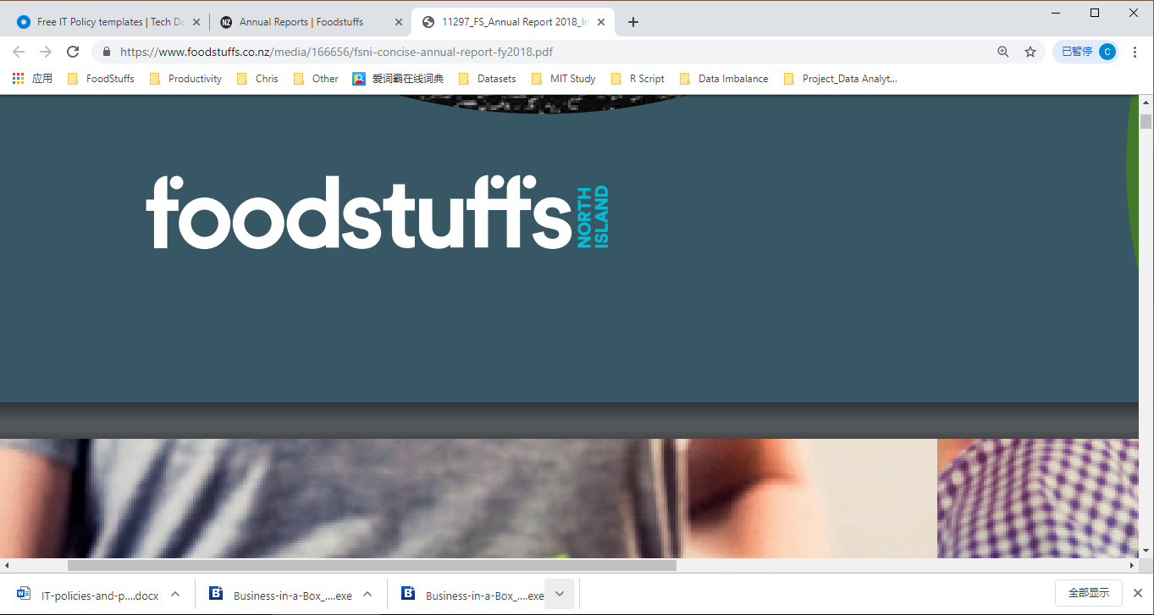

*ICT Policy and Procedure*

Foodstuffs-North Island

*Effective date:1/10/2019*

*Revision date:28/6/2019*

## Introduction & Background - Brief description of any reasons, history, and intent that led to the creation of the policy, which may be listed as motivating factors.

## Purpose statement - Outlining the policy goal, desired effect or outcome

## Policy statements

* **Access Management**
* Purpose of the Policy
* Procedures
* **Security Management**
* Purpose of the Policy
* Procedures
* **Social Media**
* Purpose of the Policy
* Procedures
* **BYOD and Private Usage of Company Devices**
* Purpose of the Policy
* Procedures
* **Communication**
* Purpose of the Policy
* Procedures
* **Privacy and Ethical**
* Purpose of the Policy
* Procedures
* **Data Management**
* Purpose of the Policy
* Procedures
* **Knowledge Management**
* Purpose of the Policy
* Procedures
* **Hardware and Software Acquisition, Update and Maintenance**
* Purpose of the Policy
* Procedures
* **ICT Project Management**
* Purpose of the Policy
* Procedures

## ICT Risk management plan

## Policy Implementation guidelines - Outline how each policy statement will be enforced.

## Overall responsibility - Responsible for overseeing the policy.

**Reference:**