**Introduction**

“Sound strategy starts with having the right goal”.

Michael Porter

In terms of a harsh competitive environment and rapidly evolving situation, commercial organizations should properly concentrate not solely on the internal state of affairs but also to produce long-term strategies which allow being in harmony with constant surrounding changes.

Many organizations could successfully work in the past paying attention only to everyday routine and inside problems related to increasing effectiveness of resource usage in current activities. Although the task of rational resources usage in current company activities is not canceling in nowadays, it has become a prominent model to manage in the way of timely manner adaptation to fast-changing circumstances in the business sphere.

In other words, it is vital to pay attention not only to internal factors but also to external ones.

Life pace acceleration, customers recent demands, competition tightening, new unexpected business fields emerging following the current scientific achievements, swift ICT development, and, as a consequence, rapid information delivery, change of the role of human resources, and other various reasons have made the strategic management extremely important.

The word “strategy” has a Greek origin. Literally, it means the art of deploying troops in a battlefield or, in other words, skills of a supreme commander. This military expression is widely employed in theoretical and practical spheres of a management today. In management strategy is considered as a long-term direction of a company’s development. It is a set of rules and techniques providing a basis for decision making to implement goals achieving.

“Strategy is the bridge between policy and high-order goals on one hand and tactics or concrete actions on the other... In short, the strategy is a term that refers to a complex web of thoughts, ideas, insights, experiences, goals, expertise, memories, perceptions, and expectations that provides general guidance for specific actions in pursuit of particular ends” (Hiriyappa, 2013, p.7)

However, a single common strategy for all companies does not exist, as a single universal strategic management does not exist either. Every company is unique in some way and that is why the process of building a strategy is unique for every company. It depends on the place on a market, development process, potential, competitors behavior, production characteristics, state of the economy, political situation and many other factors. So, that is why it is so significant to conduct a comprehensive analysis of internal and external influencing factors in various ways to produce a strategy for a particular enterprise.

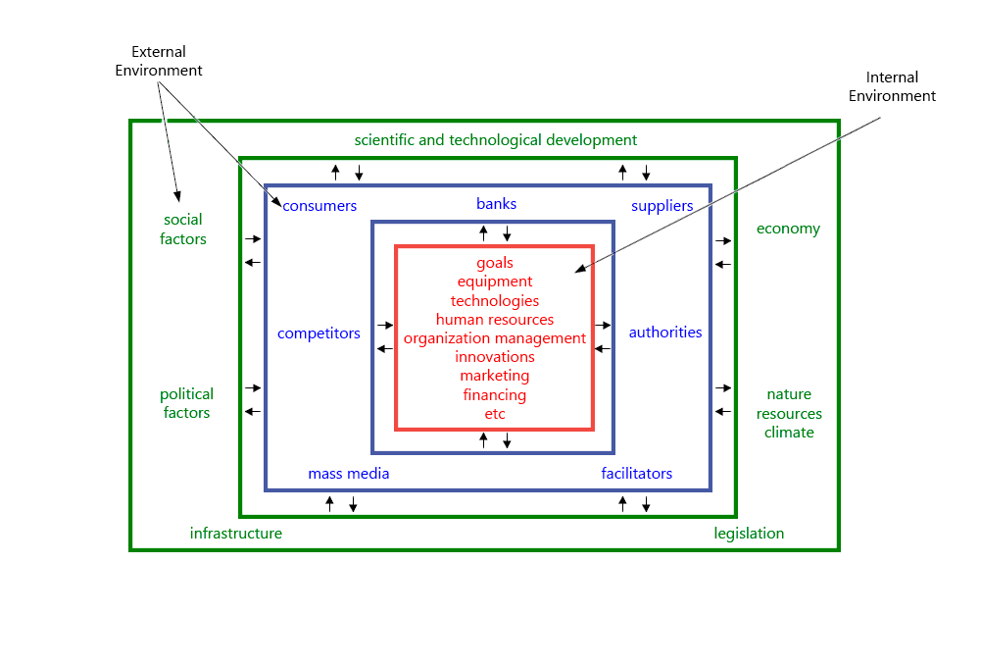

“Strategy has to be based on information about markets, customers, and noncustomers; about technology in one’s own industry and others; about worldwide finance, and about the changing world economy.” (Drucker, 2007, p.106)

As a part of the company’s ICT management team, the aim of this work is to concentrate on an ICT sector. Various analysis techniques will be used. Such as SWOT analysis, PEST analysis, Balance Scorecard, Gartner Quadrant, and Enterprise Architecture.

**PEST Analysis**

“PEST Analysis… considers external factors. PEST is an acronym for Political, Economic, Social, and Technological issues that may affect a business... PEST Analysis measures a market”. (Applegate, Johnsen, 2007, p.28)

Sorting out all factors into the four main groups and stressing them as the most important related to:

1. The politic reflects auctions of authorities which are shaping in a significant way an organization’s environment.
2. The economy determines available resources distribution within a state.
3. The social sphere in this analysis researches consumers behavior and reasons for its differences.
4. The technology affects on arising market changings.

PEST analysis framework represents a table divided into columns. All that issues are brought each into its own column so as possible actions of a company directed to avoidance or mitigation of negative influence.

It can happen the name of the analysis will have different variations (STEP, PEST). The reason for that is that for one enterprise prominent could be a social sphere and political for another.

Factor Groups

Political could include:

* legislation acts changes
* elections of different levels
* ecological problems
* international influences, etc

Economic issues could include:

* inflation rate
* interest rate
* climate influence
* taxation policy
* standard of living, employment rate
* currencies exchange rate, etc

Social factors could include:

* demographic
* ways of life
* education level
* mass media
* popular trends, etc

Technological could include:

* scientific and technological progress and discovers.
* available technologies, Level of availability
* legislation in sphere
* science funding, etc

Issues and Limitations of PEST analysis

Before starting analyzing factors which are influencing the company’s actions, it will be a good idea to establish those in every group because the set is not a universal one. It will be a good idea to pick it up individually for each company. This is the main problem of the PEST analysis – it is not a universal tool for every company. And if to apply only some factors from every group without proper consideration, the conclusion could be misleading, and the whole analysis is a waste of time.

The factors in the PEST analysis cannot consider everything that influences exact enterprise activities and decisions.

If the company is producing different kinds of products or working in different markets it is good practice to perform the analysis for every single product or marketplace.

**Foodstuffs PEST Analysis**

|  |  |  |  |
| --- | --- | --- | --- |
| PEST Analysis | | | |
| P | E | S | T |
|
|
|
|
| Political | Economic | Social | Technological |
| Protectionist measures from government can influence on ICT equipment prices  Legislative initiatives can significantly increase software development spendings.  Legislative initiatives in personal data processing can create additional spendings in software and hardware(protection, storing, processing of personal data) | Interest rate change can significantly influence IT infrastructure budgets (both positive and negative)  National currency value increase will enable to buy more innovative ICT infrastructure overseas  National currency value increase will enable to hire overseas coders cheaper  Competitors new features implementing will require additional spendings in order to avoid falling behind and the customers lose | Changing patterns in social behavior. People change the way of grocery and household chemicals shopping: automatic orders from appliances.  Demographic changes can severely influence the ICT labor market  (both positive and negative) | Changing the ways of delivery: drones automatic deliveries  Artificial Intelligence can replace cashiers, consultants. Also, can impact on various business operations  Internet of Everything can give new crucial data(customers behavior, habits, prefrences) for more personalized approach |
|
|
|
|
|
|
|
|
|
|
|
|
|
|

**Refrences**

B. Hiriyappa. 2013. “Corporate Strategy. Managing the business”. Bloomington, IN: AuthorHouse LLC

E. Applegate, A.Johnsen. 2007. “Cases in Advertising & Marketing. Real Situations for Tommorow’s Managers”. Plymouth, PL: Rowman & Littlefield Publishers inc.

P. F. Drucker. 2007 “Management Challenges for the 21st Century”. Oxford: Elsevier Butterworth-Heinemann