Game Design Document

Fill up the Following document

1. Write the title of your project.

Fish Racing Game

1. What is the goal of the game?

Goal of the game is to shoot various pots hanging on a tree.

1. Write a brief story of your game?

The story is that gopis of the Vrindavan village had made a plan to stop Lord Krishna from stealing their butter. So they had hung the pots full of butter on the branches of the tall tree. Now Lord Krishna is trying to steal the butter by shooting the pots with catapult.

1. Which are the playing characters of this game?

* Playing characters are the ones which respond to the user based on the input from the user
* Cars, monkeys, dinos, wizards etc, are the playing characters in the game.

|  |  |  |
| --- | --- | --- |
| Number | Character Name | What can this character do? |
| 1 | Lord Krishna | This character will shoot the pots with the help of the catapult. |
| 2 |  |  |
| 3 |  |  |
| 4 |  |  |
| 5 |  |  |
| 6 |  |  |
| 7 |  |  |
| 8 |  |  |

1. Which are the Non Playing Characters of this game?

* Non Playing characters are the ones which don't have an action or a behaviour when the user interacts with the game.
* Hurdles, stones, bananas, coins, etc are non playing characters in the game.

|  |  |  |
| --- | --- | --- |
| Number | Character Name | What can this character do? |
| 1 | Pots | This character will fall from the tree. |
| 2 | Stone | This character will be used to hit the pots. |
| 3 |  |  |
| 4 |  |  |
| 5 |  |  |
| 6 |  |  |
| 7 |  |  |
| 8 |  |  |

Draw your imagination of this game. What does this game look like?

* Draw the game either on your computer or on paper,
* Add images of scenes of the game to show each of the playing and non-playing characters at least once.

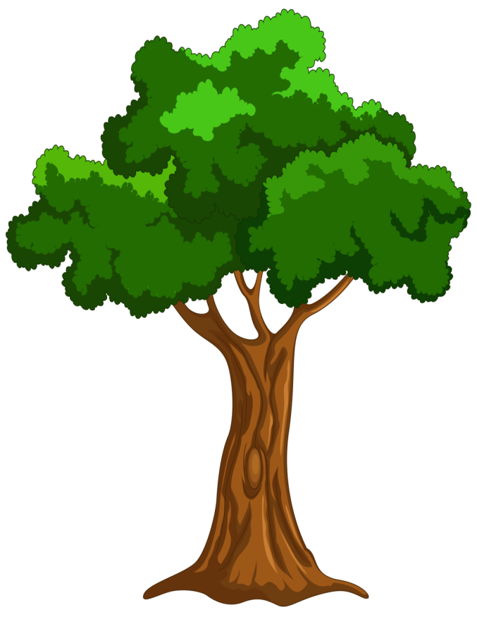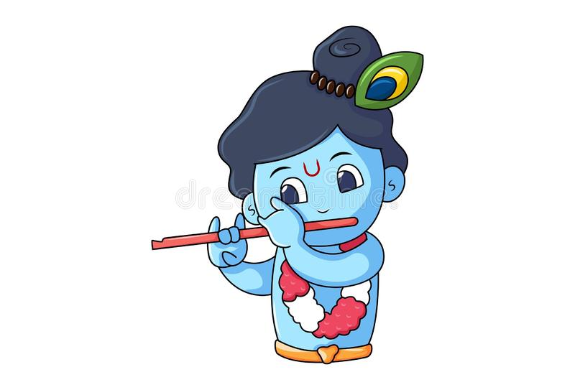

How do you plan to make your game engaging?

Pots will be of different size and they will be positioned on different and difficult position. So the player will try to give more attention towards the game to shoot all of those pots.