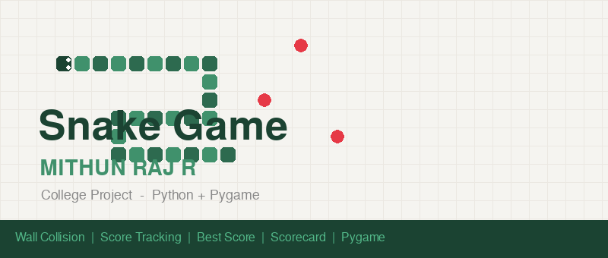
Snake Game
Mini Project — Computer Science

Student Name | MITHUN RAJ R
Project Title | Snake Game
Technology | Python 3 | Pygame 2
Subject | Python Programming / Mini Project Lab
Date | 20 May 2024
Description | A fully playable Snake game built with Python and Pygame. Features wall collision, self-collision, live score, best score, pause, and a detailed game-over scorecard.

1. Introduction
This project is a Python implementation of the classic Snake game using the Pygame library. Pygame provides a graphical window, sprite rendering, keyboard input handling, and a game clock everything needed to build a complete game without any external game engine.
The snake grows longer each time it eats food. The game ends immediately if the snake hits the wall or runs into its own body. A score of 10 is awarded per food item eaten.

2. Features
- Wall collision — touching any edge of the board ends the game instantly.
- Self collision — snake running into its own body ends the game.
- Live score — updates in real time, shown in the HUD (+10 per food).
- Best score — tracks the highest score across rounds in the same session.
- Game-over scorecard — shows Score, Best, Length, Food Eaten, Cause.
- Pause — press P at any time to pause; press P again to resume.
- Colourful sprites — rounded head with eyes (facing direction), two-shade alternating body.
- Start screen and Game Over screen with overlays.
- PNG asset files generated and saved to the assets/ folder automatically.

3. Technologies Used
Python 3 | Core programming language
Pygame 2 | Game window, rendering, input events, clock
pygame.Surface | Off-screen drawing surfaces for sprites
pygame.draw | Drawing rectangles, circles, lines, ellipses
pygame.font | Rendering HUD text, overlay text, scorecard
pygame.transform | Rotating the snake head to face movement direction
pygame.image | Saving sprite surfaces as PNG files
random module | Random food placement on free grid cells
sys module | Clean program exit with sys.exit()

4. Code Explanation — Line by Line
4.1 Constants and Colour Palette
At the top of the file, all game settings are defined as named constants. Changing CELL, COLS, ROWS, or FPS changes the whole game behaviour.
CELL = 24 # pixels per grid cell
COLS = 25 # 25 columns → board width = 600 px
ROWS = 22 # 22 rows → board height = 528 px
FPS = 10 # 10 ticks per second = game speed
Colours are stored as RGB tuples. Using named constants (HEAD_COL, FOOD_COL, etc.) makes the code readable and easy to change.
HEAD_COL = ( 27, 67, 50) # dark green — snake head
FOOD_COL = (230, 57, 70) # red — food
4.2 Sprite Surfaces
Sprites are drawn programmatically using pygame.draw functions onto small pygame.Surface objects with alpha (transparency) support. These are created once at startup and reused every frame.
def make_food_surface():
s = pygame.Surface((CELL, CELL), pygame.SRCALPHA)
pygame.draw.ellipse(s, FOOD_COL, (2, 2, CELL-4, CELL-4))
return s
pygame.SRCALPHA enables per-pixel transparency so the circular food has a transparent background instead of a solid square.
4.3 SnakeGame Class
All game state is encapsulated in a SnakeGame class. This makes it easy to reset the game by simply calling reset(), and keeps all state variables in one place.
self.snake | List of (col, row) tuples. Index 0 = head. Last index = tail tip.
self.direction | Tuple (dx, dy) applied this tick, e.g. (1,0) = right.
self.next_dir | Queued direction from last keypress — applied at tick start.
self.food | Tuple (col, row) of the current food position.
self.score | Integer, starts at 0, +10 per food eaten.
self.best | Highest score this session. Survives reset() calls.
self.food_eaten | Count of food items consumed.
self.game_over | Boolean — True when the game has ended.
self.cause | String reason for game over: "Hit the Wall" or "Hit Itself".
4.4 place_food() — Safe Food Spawning
def place_food(self):
while True:
pos = (random.randint(0, COLS-1), random.randint(0, ROWS-1))
if pos not in self.snake:
self.food = pos
break
We use a while loop to keep generating random positions until one is found that is not occupied by any snake segment. "pos not in self.snake" does a linear O(n) scan of the list.
4.5 handle_key() — Input Handling
dir_map = {
pygame.K_UP: ( 0,-1), pygame.K_w: ( 0,-1),
pygame.K_DOWN: ( 0, 1), pygame.K_s: ( 0, 1),
pygame.K_LEFT: (-1, 0), pygame.K_a: (-1, 0),
pygame.K_RIGHT: ( 1, 0), pygame.K_d: ( 1, 0),
}
A dictionary maps Pygame key constants to direction vectors. We then check the anti-reversal condition before updating next_dir:
if nd[0] + self.direction[0] != 0 or nd[1] + self.direction[1] != 0:
self.next_dir = nd
Opposite direction vectors always sum to (0, 0). For example, RIGHT (1,0) + LEFT (-1,0) = (0,0). If the sum is zero, we ignore the input to prevent the snake reversing into itself.

4.6 tick() — Core Game Logic
tick() is called once per frame (10 times per second). It performs every game update in a fixed sequence.
Step 1 — Apply direction
self.direction = self.next_dir
Copy the queued direction into the active direction. This ensures only one direction change per frame regardless of how fast the player presses keys.
Step 2 — Calculate new head position
hx, hy = self.snake[0]
dx, dy = self.direction
nx, ny = hx + dx, hy + dy
Unpack the current head coordinates and the direction vector. Add them to get the new head position.
Step 3 — Wall collision
if nx < 0 or nx >= COLS or ny < 0 or ny >= ROWS:
self._end("Hit the Wall")
return
If the new head goes outside the grid boundary (any of the four edges), the game ends with cause "Hit the Wall".
Step 4 — Self collision
if (nx, ny) in self.snake:
self._end("Hit Itself")
return
If the new head position matches any segment already in the snake list, the game ends. This is an O(n) check — Python's "in" operator scans the list from the start.
Step 5 — Move the snake
self.snake.insert(0, (nx, ny))
insert(0, ...) adds the new head at the front (index 0) of the list. At this point the snake is one cell longer than it should be — we fix this in step 6.
Step 6 — Eat food or move forward
if (nx, ny) == self.food:
self.score += 10
self.food_eaten += 1
self.place_food()
else:
self.snake.pop()
If the new head landed on food: score increases, new food is placed, and we do NOT pop the tail — so the snake grows by 1. Otherwise we pop the last element — this makes the snake appear to move forward without growing.

5. draw_board() — Rendering
5.1 Clear and Grid
pygame.draw.rect(screen, SURFACE, board_rect)
Fill the board area with white every frame to erase the previous frame.
for x in range(0, WIDTH, CELL):
pygame.draw.line(screen, GRID_COL, (x,100), (x,HEIGHT), 1)
Draw vertical lines every CELL pixels to create the grid. Same for horizontal lines.
5.2 Food
screen.blit(FOOD_IMG, (fx * CELL, 100 + fy * CELL))
blit() draws the pre-rendered food surface onto the screen at the food cell's pixel coordinates. 100 is the HUD height offset.
5.3 Snake
for i, (sx, sy) in enumerate(game.snake):
if i == 0:
head = rotate_head(game.direction)
screen.blit(head, (sx*CELL, 100+sy*CELL))
else:
img = BODY_IMG if i%2==0 else BODY_AIMG
screen.blit(img, (sx*CELL, 100+sy*CELL))
For index 0 (the head), we rotate the head sprite based on the current direction. For body segments, we alternate between BODY_IMG and BODY_AIMG using i%2 to create a two-tone pattern.
5.4 rotate_head()
angles = { RIGHT:0, LEFT:180, UP:90, DOWN:270 }
return pygame.transform.rotate(HEAD_IMG, angles[direction])
The base head sprite faces RIGHT. pygame.transform.rotate() rotates it by the specified angle to face any direction. This is why the eyes always look in the direction of travel.

6. Game Loop
The main() function contains the Pygame game loop — an infinite while loop that runs until the user quits.
while True:
for event in pygame.event.get(): # 1. Handle events
...
game.tick() # 2. Update state
screen.fill(BG) # 3. Draw background
draw_hud(game) # 4. Draw HUD
draw_board(game) # 5. Draw board
# overlays if needed ...
pygame.display.flip() # 6. Push to screen
clock.tick(FPS) # 7. Cap at 10 FPS
pygame.display.flip() swaps the back buffer to the screen (double buffering). clock.tick(FPS) sleeps for however long is needed to cap the loop at exactly FPS frames per second.

Q8: How is the self-collision check implemented?
Answer: if (nx, ny) in self.snake — Python's "in" operator does a linear O(n) scan. For larger snakes, this could be optimised to O(1) using a set of occupied positions, updated each frame.

8. Screenshots
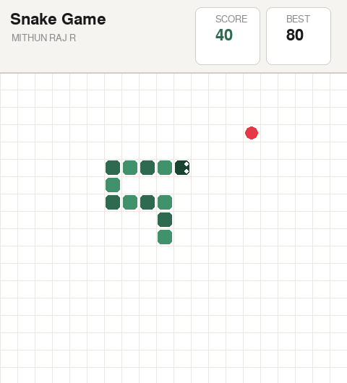
Figure 1 — Gameplay and Game-Over Scorecard

9. How to Run
- Make sure Python 3 is installed: python --version
- Install pygame: pip install pygame
- Run the game: python src/snake_game.py
- Press Enter on the start screen to begin.
- Press Q or ESC at any time to quit.

MITHUN RAJ R
Snake Game Project | Python + Pygame

