AWS-3
- Create a S3 bucket, with no public access and upload files to the bucket & view the logs using cloudwatch for the uploaded files.
Created a S3 Bucket with the name demo-private-bucket-123 and added few dummy files into it
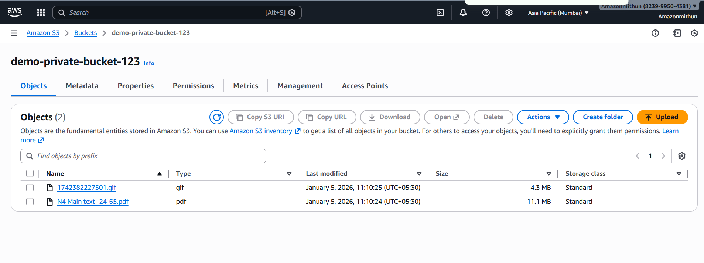
And there was already one more Bucket available in the same region hence used that S3 bucket to save the logs using the cloud watch
And configured the other bucket naming metricstreams-quickfull-ucjxvh-pjp16wzk opened the properties > server access logging and enabled the logging and provide the target bucket to save the logs

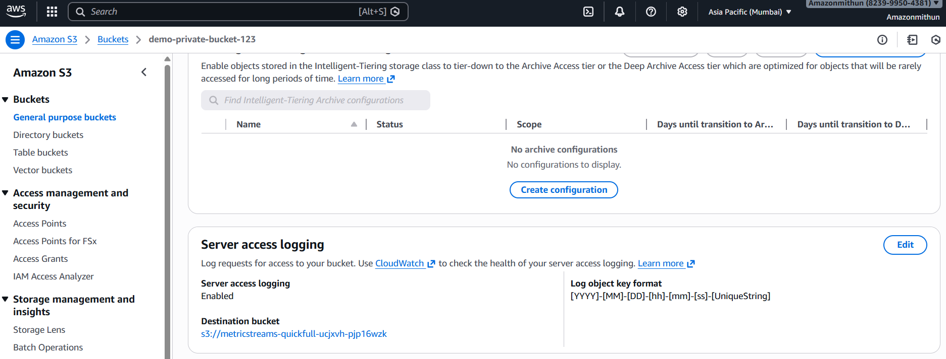
After making changes tried to add one more files and to capture the logs in the bucket it took some time
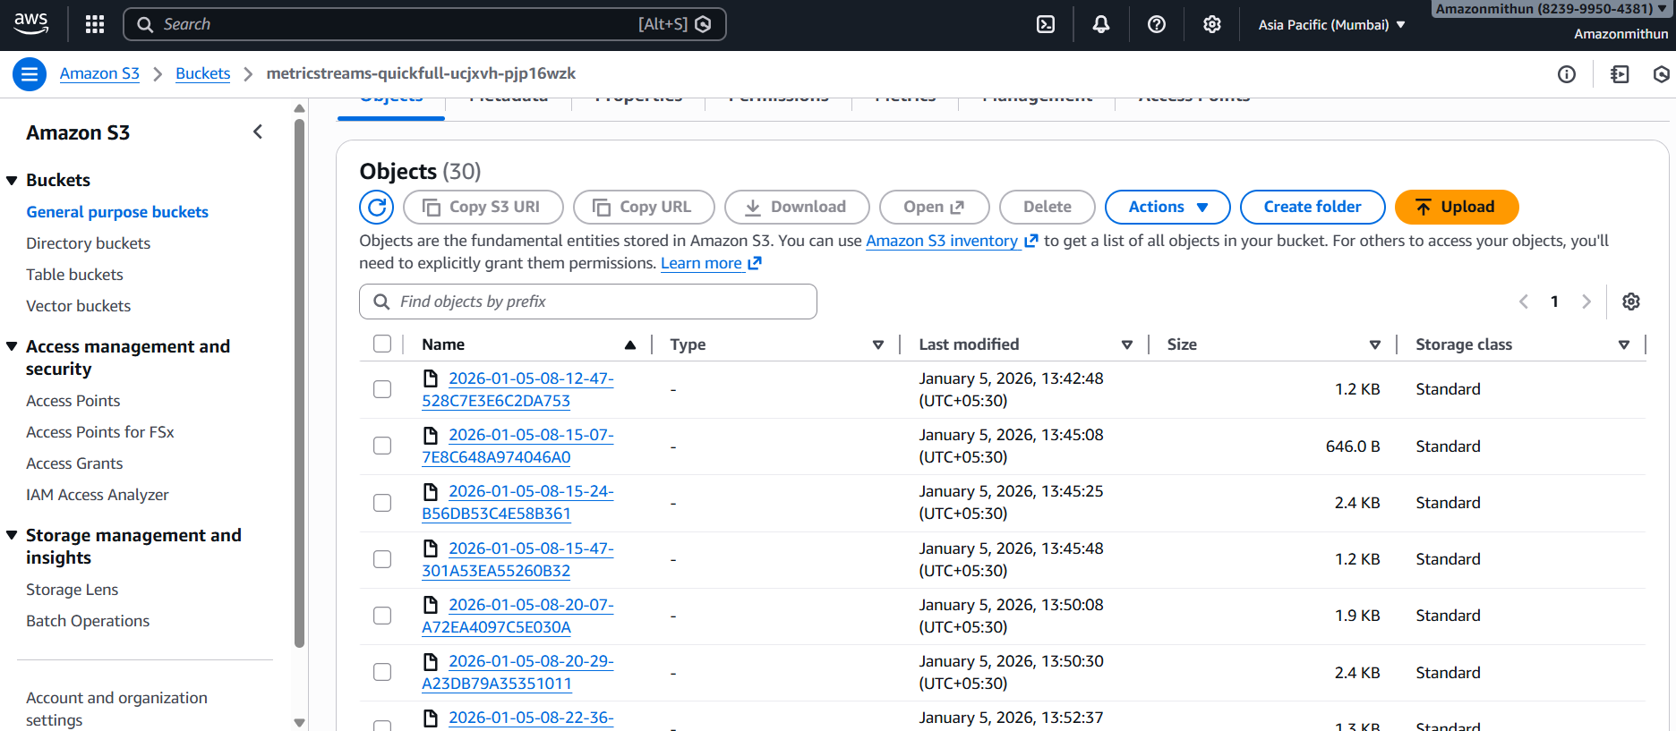
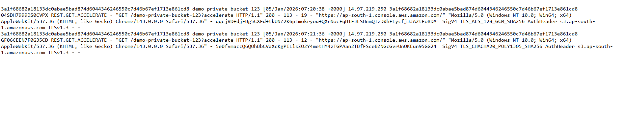
Task 2
Launch two EC2 instances and connect them to an Application Load Balancer
- Created a new 2 EC2 instance win Ubuntu AMI T2 Micro and renamed both the Host name of the EC2 instance called Webser1 and webserver2
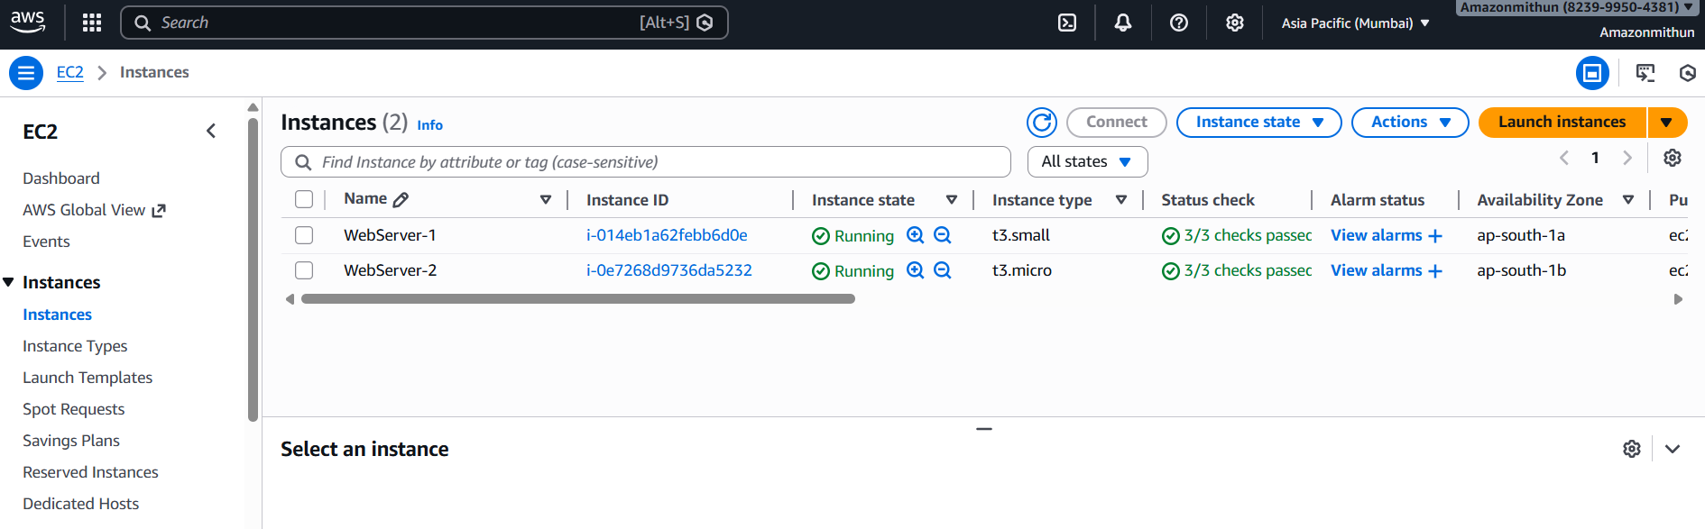
- Also installed Apache2 on both the instance
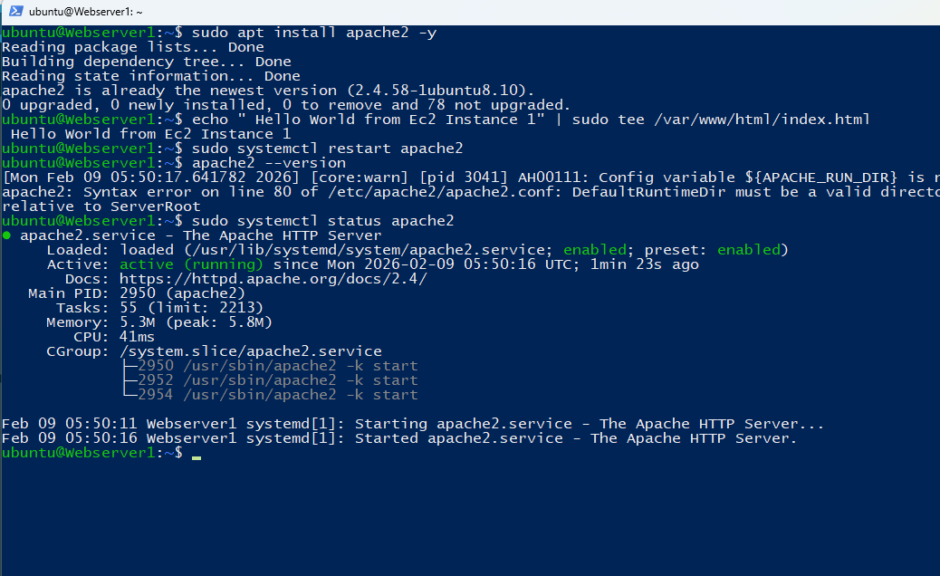
*was able to see the message from the Public IP for the Webserver 1
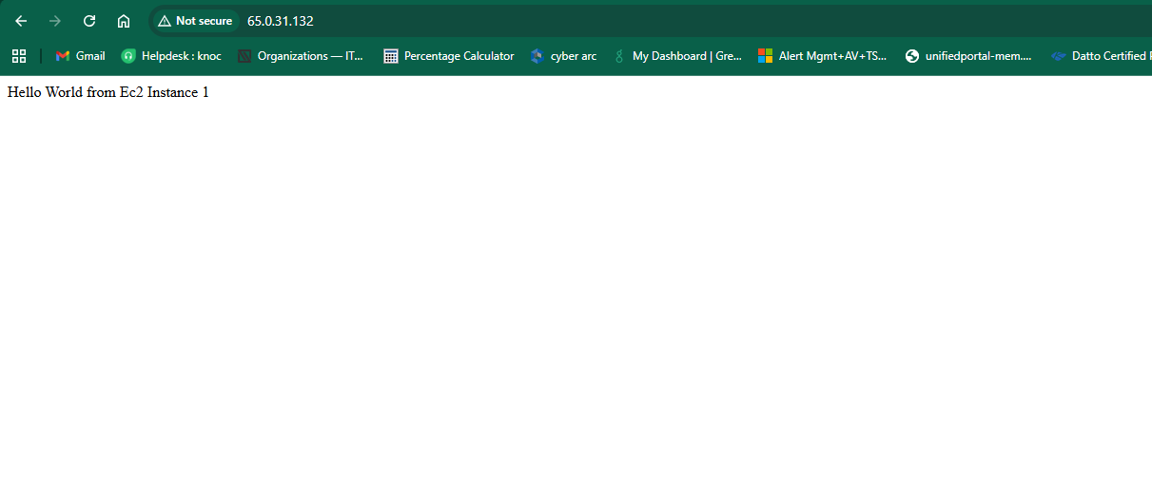
- Apache2 is installed in the Webserver 2 and added the message to index.html and able to see the message when accessed from the public IP
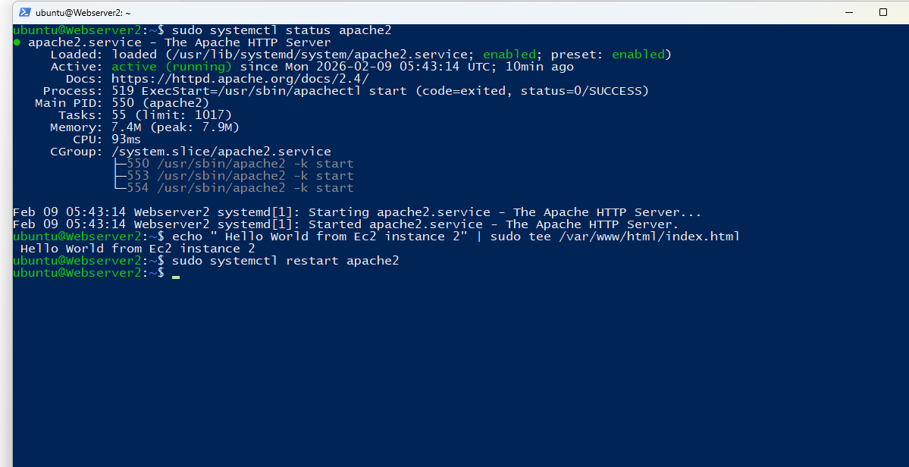
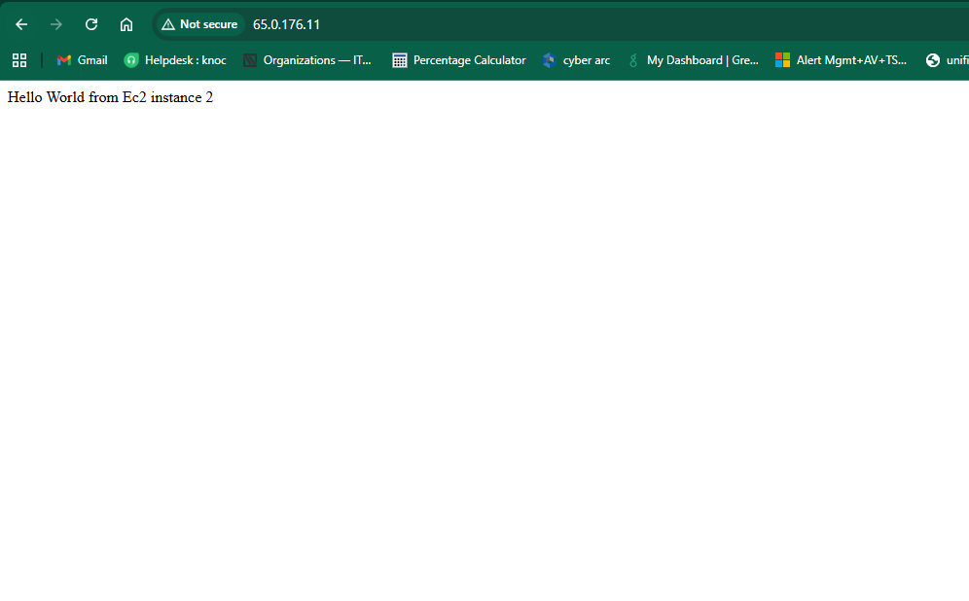
Step 3: created a new Target Group naming Applicationload01
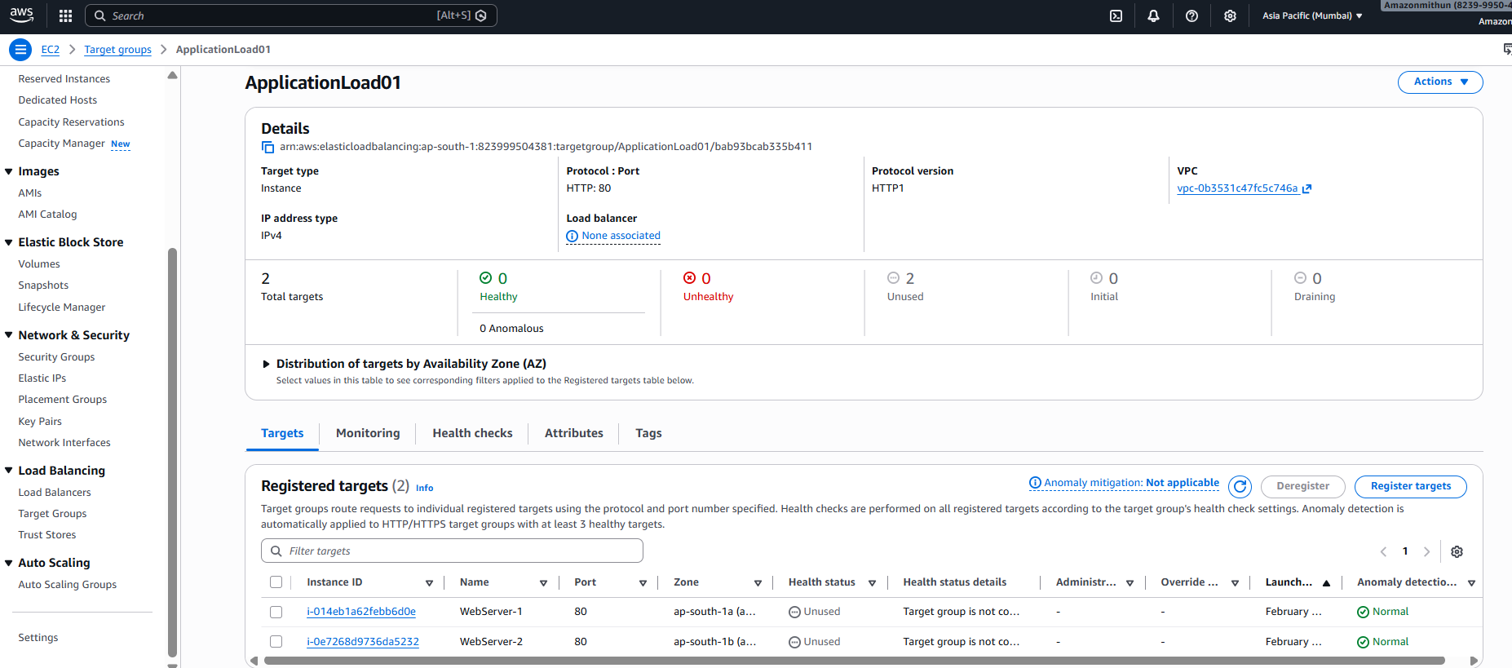
Accessed a load balancer which was created and tried to copy the DNS name and pasted in the browser. And got the message and traffic Is switching between the Webserver 1 and webserver 2.
