COURSE CODE: DSA0603
COURSE NAME: DATA HANDLING AND VISUALIZATION

1. Problem Statement and Problem Formulation

1.1 Problem Statement
A public health organization needs a clear and interactive visualization solution for communicating health and socioeconomic patterns to technical and non-technical stakeholders. The selected real-world dataset contains country, year, life expectancy at birth, and GDP values for six countries over 2000-2015. The challenge is to represent distributions, proportions, relationships, and temporal patterns without creating unnecessary cognitive load or misleading visual emphasis.
The dashboard therefore uses a coordinated set of histograms, box plots, a donut chart, a bar chart, scatter plots, a heatmap, and line charts. The design is evaluated using pre-attentive attributes, Gestalt grouping, data-ink considerations, and color-theory principles. The objective is to ensure that users can answer practical questions quickly, accurately, and with minimal visual search.

1.2 Problem Formulation
The input is a country-year health dataset. The dashboard processing pipeline is:
Raw CSV → Data Validation → Cleaning → Feature Engineering → Exploratory Analysis → Visualization Construction → Interactive Dashboard → Perceptual Evaluation → Design Ranking
The analytical questions are: (1) What is the overall distribution of life expectancy? (2) How do countries differ in typical life expectancy and spread? (3) What share of observations falls into low, medium, and high life-expectancy categories? (4) Is GDP associated with life expectancy? (5) How does life expectancy change over time? (6) Which variables move together strongly enough to warrant further investigation?
The dashboard is intended to support evidence-based decisions rather than claim causal relationships. In particular, GDP is treated as an explanatory indicator for association analysis, not as proof that economic growth causes changes in life expectancy.

2. Objective and Expected Outcomes

2.1 Objectives
The main objective is to design and evaluate an interactive public-health visualization dashboard that communicates distributions, proportions, relationships, trends, and associations using perception-based design principles.
● Identify the variable types and match them with appropriate visual encodings and chart types.
● Construct distribution visualizations using a histogram and box plot.
● Represent categorical proportions using a donut chart and compare group averages with a bar chart.
● Analyze pairwise and multivariate relationships using scatter plots and a correlation heatmap.
● Analyze temporal trends using coordinated line charts.
● Use position, color, size, and shape deliberately to improve grouping and outlier detection.
● Evaluate each view using pre-attentive attributes, Gestalt principles, data-ink ratio, and color theory.
● Compare at least three alternative designs for the same insight and rank them using explicit criteria.
● Provide an interactive dashboard structure that supports filtering and coordinated interpretation.

2.2 Expected Outcomes
The expected outcome is a working visualization pipeline and dashboard specification that allows stakeholders to move from an overview of the data to a specific country, year, distribution, or relationship. The report also provides a defensible ranking of alternative designs and documents why the final design reduces visual search, avoids misleading encodings, and improves decision-making accuracy.

3. Requirements, Constraints and Assumptions

3.1 Requirements
● Real-world public-health dataset with continuous, categorical, and temporal fields.
● At least four distinct visualization techniques, with the final solution using seven required chart families where applicable.
● Multi-view dashboard with distribution, proportion, comparison, and relationship views.
● Clear titles, units, legends, labels, and consistent encodings.
● Interactive filtering or selection for country and year.
● Critical comparison of at least three alternative visualizations for the same insight.
● Research-grounded justification of perceptual and cognitive design choices.

3.2 Constraints
The selected source is a compact six-country dataset covering 2000-2015; therefore the analysis demonstrates visualization methods rather than providing a complete global health assessment. GDP values are nominal totals in the source data and should not be interpreted as per-capita wealth. The dashboard does not establish causal mechanisms and should not be used alone for policy decisions.

3.3 Assumptions
● Each country-year row represents a valid observation in the source dataset.
● Life expectancy is measured in years and GDP is treated as a quantitative magnitude.
● The six-country sample is considered sufficient for demonstrating comparative visualization design.
● Category thresholds used in the proportion chart are descriptive bins: Low < 60 years, Medium 60-75 years, High > 75 years.
● The dashboard is designed for screening and communication, while deeper statistical modeling would be a separate analysis task.

4. Application of Relevant Course Knowledge / Concepts
The project applies the major visualization concepts required by the assignment.

Distribution
Histogram shows the frequency shape of life expectancy; box plot shows median, quartiles, spread, and potential outliers across countries.

Proportion
Donut chart summarizes the share of country-year observations in three descriptive life-expectancy categories.

Comparison
Sorted horizontal/vertical bars support accurate comparison of country means through a common baseline.

Relationship
Scatter plot uses position as the main quantitative encoding and country as a grouping variable; bubble size can be tied to year in the interactive version.

Multivariate analysis
Correlation heatmap summarizes pairwise linear relationships among life expectancy, GDP, log GDP, and year.

Temporal analysis
Line charts connect observations across years to make within-country change and cross-country divergence visible.

Perception and cognition
Color, position, size, proximity, similarity, enclosure, and direct labeling are used to guide attention and reduce unnecessary visual search.

5. Design / Proposed Solution / Methodology

5.1 Proposed Solution
A multi-view dashboard is proposed using Python, pandas, Matplotlib, and Plotly. The static report figures use Matplotlib for reproducibility, while the interactive dashboard is implemented as a Plotly HTML artifact. The layout follows an overview-to-detail sequence: KPI summary → distribution/proportion → comparison/relationship → trend/correlation. A country selector can be used to emphasize one country while preserving the common frame of reference.

5.2 Methodology
1. Acquire the WHO/World Bank-derived six-country dataset from the referenced public repository.
2. Validate column names, data types, year range, duplicate rows, and missing values.
3. Create a log10(GDP) feature because GDP spans several orders of magnitude.
4. Create descriptive life-expectancy categories for the proportion view.
5. Calculate country-level means, start/end changes, and overall correlations.
6. Construct the required visualizations with consistent titles, labels, and restrained decoration.
7. Build the interactive multi-view dashboard and define the analytical question for every view.
8. Evaluate each visual using pre-attentive, Gestalt, data-ink, and color-theory criteria.
9. Compare three alternative designs for the proportion insight and select the strongest design.

5.3 System Flow
Dataset → Cleaning → Feature Engineering → Summary Metrics → Distribution Views → Proportion Views → Relationship Views → Trend Views → Interactive Dashboard → Perceptual Evaluation → Ranked Final Design

5.4 Dataset and Variable Summary
Variable | Type | Use in Dashboard
Country | Categorical | Grouping, color/selection, comparison
Year | Temporal / discrete | Line-chart x-axis, size emphasis in scatter
Life expectancy at birth (years) | Continuous | Histogram, box plot, bar, line, scatter, heatmap
GDP | Continuous | Scatter plot, comparison, correlation
log10(GDP) | Continuous derived | Scatter x-axis to compress scale and improve readability
Life expectancy category | Categorical derived | Donut proportion chart

6. Algorithm / Pseudocode / Flowchart

6.1 Algorithm
1. Start.
2. Read the public-health CSV dataset.
3. Validate required fields and data types.
4. Remove or flag invalid rows; preserve valid observations.
5. Create log10(GDP) and life-expectancy category features.
6. Compute country summaries and correlation matrix.
7. Generate histogram and box plot for distributions.
8. Generate donut and bar chart for proportions and comparisons.
9. Generate scatter plot and heatmap for relationships.
10. Generate line chart for temporal trends.
11. Assemble the visualizations into a multi-view interactive dashboard.
12. Evaluate each view using perception and cognition criteria.
13. Compare three alternative designs for one selected insight.
14. Rank alternatives and document the winning design.
15. Save figures, dashboard HTML, and report.
16. Stop.

6.2 Pseudocode
BEGIN
data <- READ_CSV("all_data.csv")
VALIDATE columns = {Country, Year, Life expectancy, GDP}
CHECK missing_values, duplicates, numeric_types
data.log_gdp <- LOG10(data.GDP)
data.life_category <- BIN(data.life_expectancy, <60, 60-75, >75)

summary <- GROUP_BY(data, Country)
summary <- CALCULATE(mean_life, start_life, end_life, mean_gdp)
corr <- CORRELATION_MATRIX(data.numeric_fields)

VIEW1 <- HISTOGRAM(data.life_expectancy)
VIEW2 <- BOXPLOT(data.life_expectancy BY Country)
VIEW3 <- DONUT(data.life_category)
VIEW4 <- BAR(summary.mean_life BY Country)
VIEW5 <- SCATTER(x=log_gdp, y=life_expectancy, color=Country)
VIEW6 <- HEATMAP(corr)
VIEW7 <- LINE(x=Year, y=life_expectancy, group=Country)

DASHBOARD <- COMBINE(VIEW1..VIEW7)
ADD_FILTERS(DASHBOARD, Country, Year)
EVALUATE(DASHBOARD, preattentive, Gestalt, data_ink, color_theory)
EXPORT(figures, dashboard_html, report_docx)
END

6.3 Flowchart
Input → Validate → Clean → Transform → Analyze → Visualize → Interact → Evaluate → Compare → Report

7. Implementation / Source Code and Environment / Tools Used

7.1 Implementation
The implementation is written in Python. pandas performs data loading and transformation; NumPy supports numeric operations; Matplotlib generates report-ready figures; Plotly generates the interactive HTML dashboard. The dashboard uses a shared country/year analytical frame so that the same filters can be applied to multiple views.

7.2 Main Implementation Modules
Module | Function
Data Loader | Reads CSV and checks required columns
Data Cleaner | Validates types, missing values, duplicates and ranges
Feature Engineering | Creates log GDP and life-expectancy categories
Summary Analyzer | Computes means, changes, and correlations
Distribution Views | Histogram and box plot
Proportion/Comparison Views | Donut and bar chart
Relationship/Trend Views | Scatter, heatmap, and line chart
Dashboard Layer | Arranges Plotly views and user filters
Evaluation Layer | Scores designs on perceptual/cognitive criteria

7.3 Environment and Tools
Component | Tool Used
Programming Language | Python 3
Data Processing | pandas, NumPy
Static Visualization | Matplotlib
Interactive Visualization | Plotly
IDE/Editor | Jupyter Notebook / VS Code
Output | DOCX report and HTML dashboard

7.4 Implementation Flow
Source CSV → pandas DataFrame → Validation → Derived Features → Summary Metrics → Matplotlib Figures → Plotly Interactive Dashboard → Exported HTML

7.5 Representative Source Code
import pandas as pd
import numpy as np
import plotly.express as px

df = pd.read_csv("all_data.csv")
df["Log_GDP"] = np.log10(df["GDP"])
df["Life_Category"] = pd.cut(
df["Life expectancy at birth (years)"],
bins=[0, 60, 75, 100],
labels=["Low (<60)", "Medium (60-75)", "High (>75)"],
include_lowest=True
)

fig = px.scatter(
df, x="Log_GDP", y="Life expectancy at birth (years)",
color="Country", size="Year", hover_name="Country"
)
fig.show()

8. Test Cases and Expected / Actual Results

8.1 Test Case - Data Integrity
Check | Expected Result | Actual Result
Rows | 96 country-year records | 96
Countries | 6 unique countries | 6
Years | 2000-2015 | 2000-2015
Required numeric fields | Numeric and usable | Validated
Duplicate country-year records | None | None detected

8.2 Analytical Results
The compact dataset contains 96 observations. Sixty-five observations (67.7%) fall into the High (>75 years) category, 16 (16.7%) fall into Medium (60-75 years), and 15 (15.6%) fall below 60 years. The distribution is therefore not symmetric: the high-life-expectancy group dominates the sample while Zimbabwe contributes the low end of the distribution.
Average life expectancy increases from 70.77 years in 2000 to 75.72 years in 2015, an increase of 4.95 years in the six-country average. Country-level change ranges from 1.6 years for the United States to 14.7 years for Zimbabwe, showing substantial differences in temporal trajectories.
The Pearson correlation between raw GDP and life expectancy is 0.34, while the correlation between log10(GDP) and life expectancy is 0.79. The stronger log-scale association indicates that the extreme GDP scale materially affects the raw relationship. This is a visualization lesson as well as an analytical result: transformations can make patterns easier to inspect when values span several orders of magnitude.
Country | Mean Life (years) | 2000 | 2015 | Change
Chile | 78.94 | 77.3 | 80.5 | 3.2
China | 74.26 | 71.7 | 76.1 | 4.4
Germany | 79.66 | 78.0 | 81.0 | 3.0
Mexico | 75.72 | 74.8 | 76.7 | 1.9
United States of America | 78.06 | 76.8 | 79.3 | 2.5
Zimbabwe | 50.09 | 46.0 | 60.7 | 14.7

9. Execution Screenshots / Outputs
The following figures provide evidence for the implementation and results. They are embedded directly in the report so that the evaluation can be reproduced from the same underlying data.
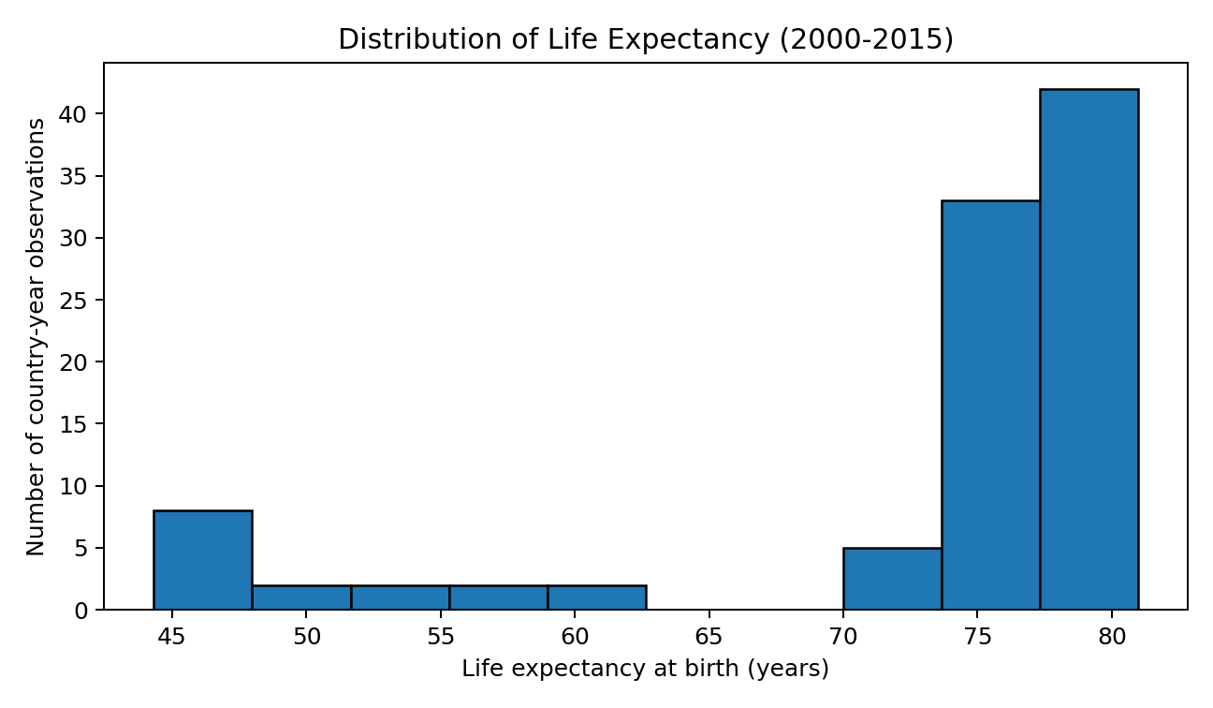
Figure 1. Histogram of life expectancy for all 96 country-year observations.
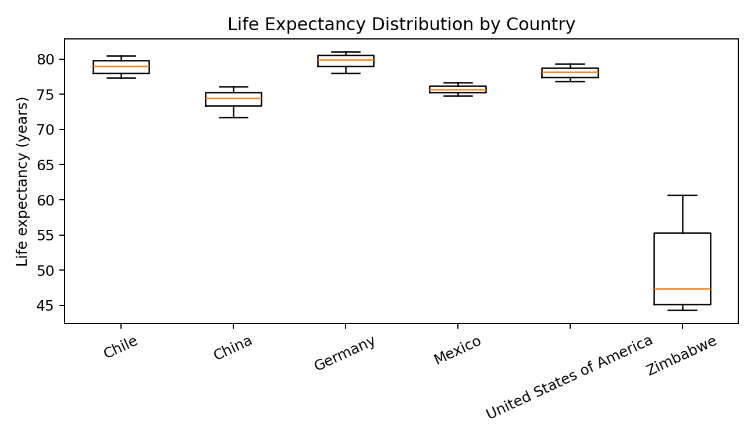
Figure 2. Box plot comparing the distribution of life expectancy across countries.
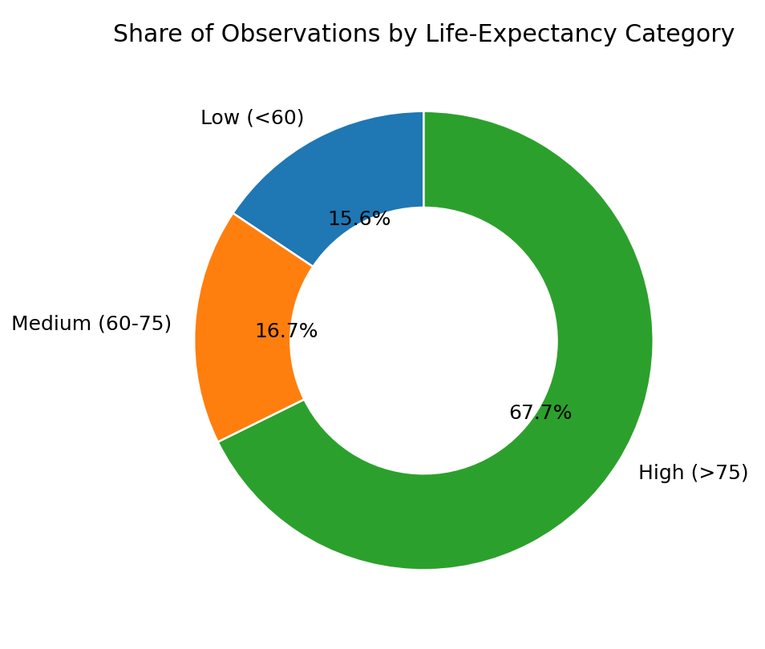
Figure 3. Donut chart showing the proportion of observations in the three life-expectancy categories.
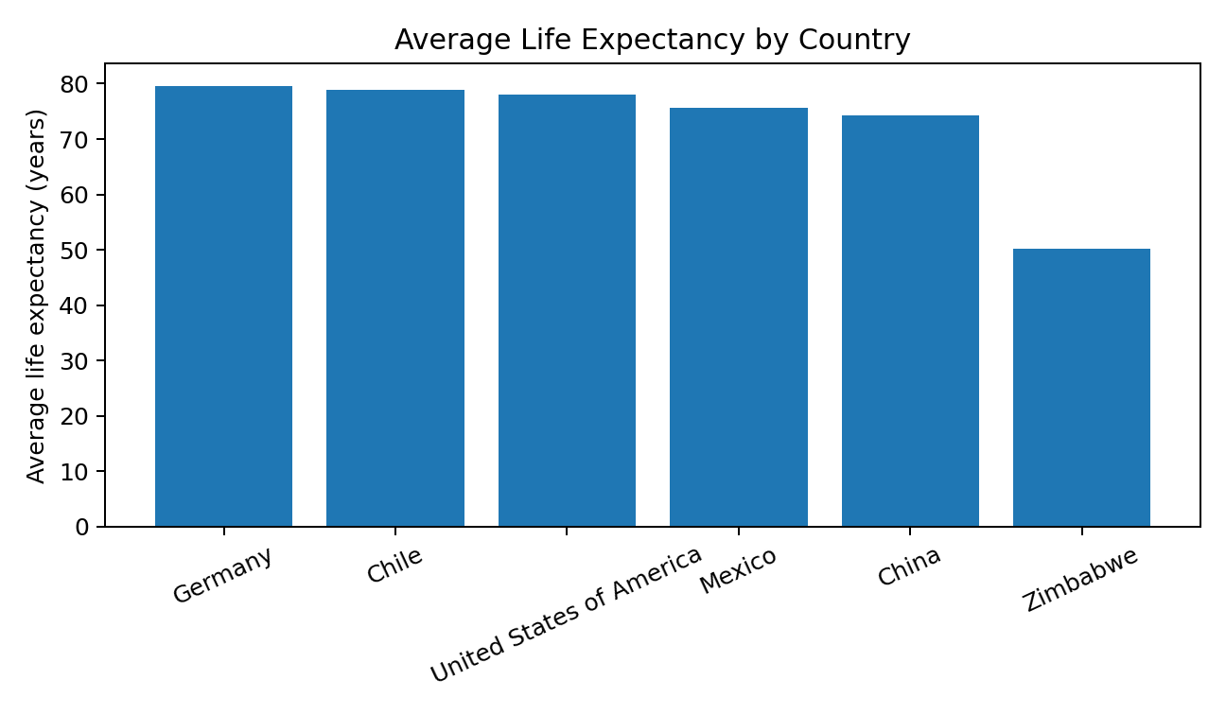
Figure 4. Bar chart comparing mean life expectancy by country.
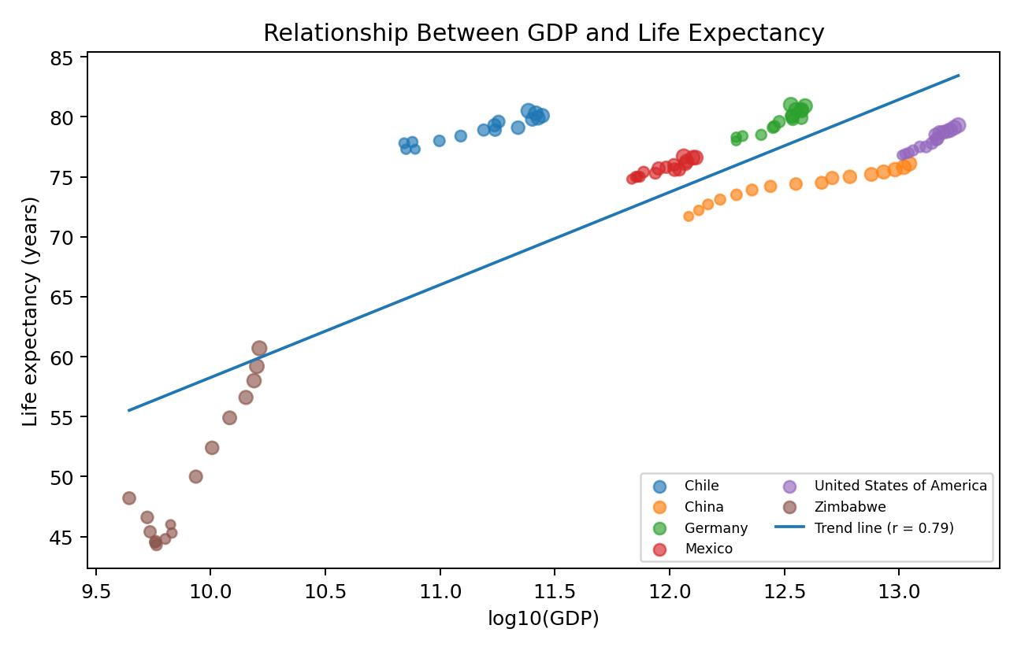
Figure 5. Scatter plot of log10(GDP) versus life expectancy with country grouping and a trend line.
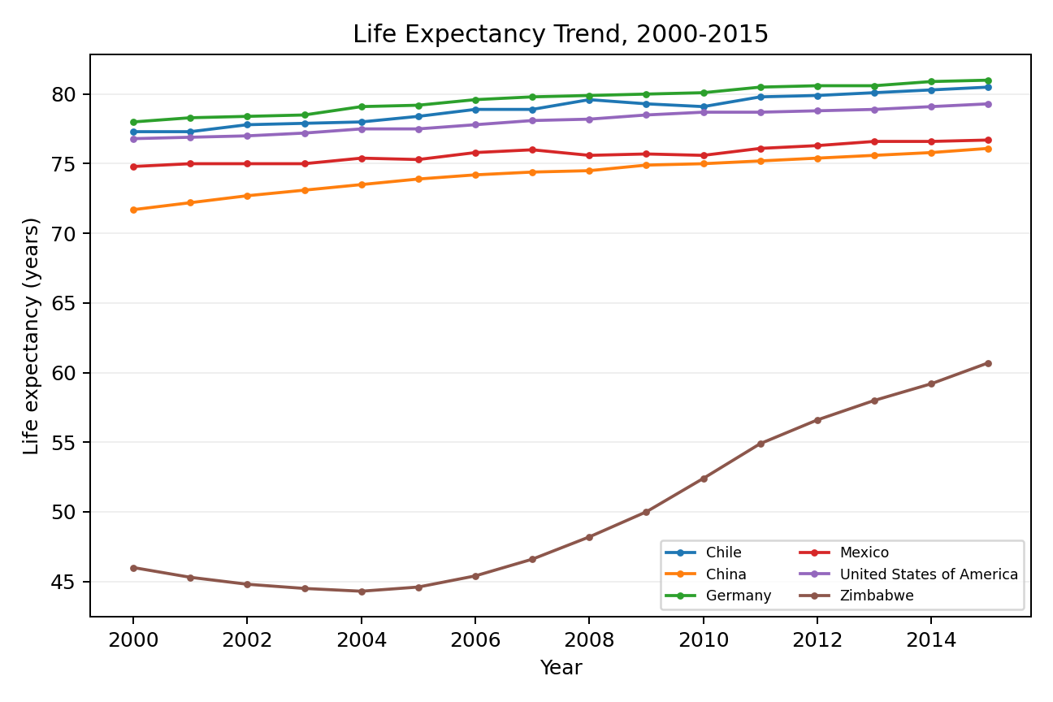
Figure 6. Line chart showing life expectancy trends from 2000 to 2015.
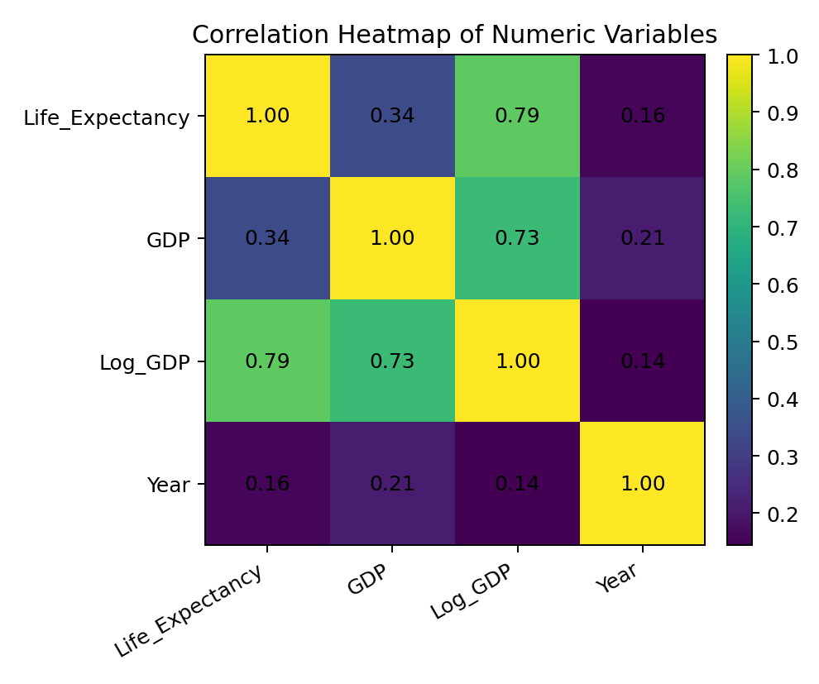
Figure 7. Correlation heatmap for numeric variables.
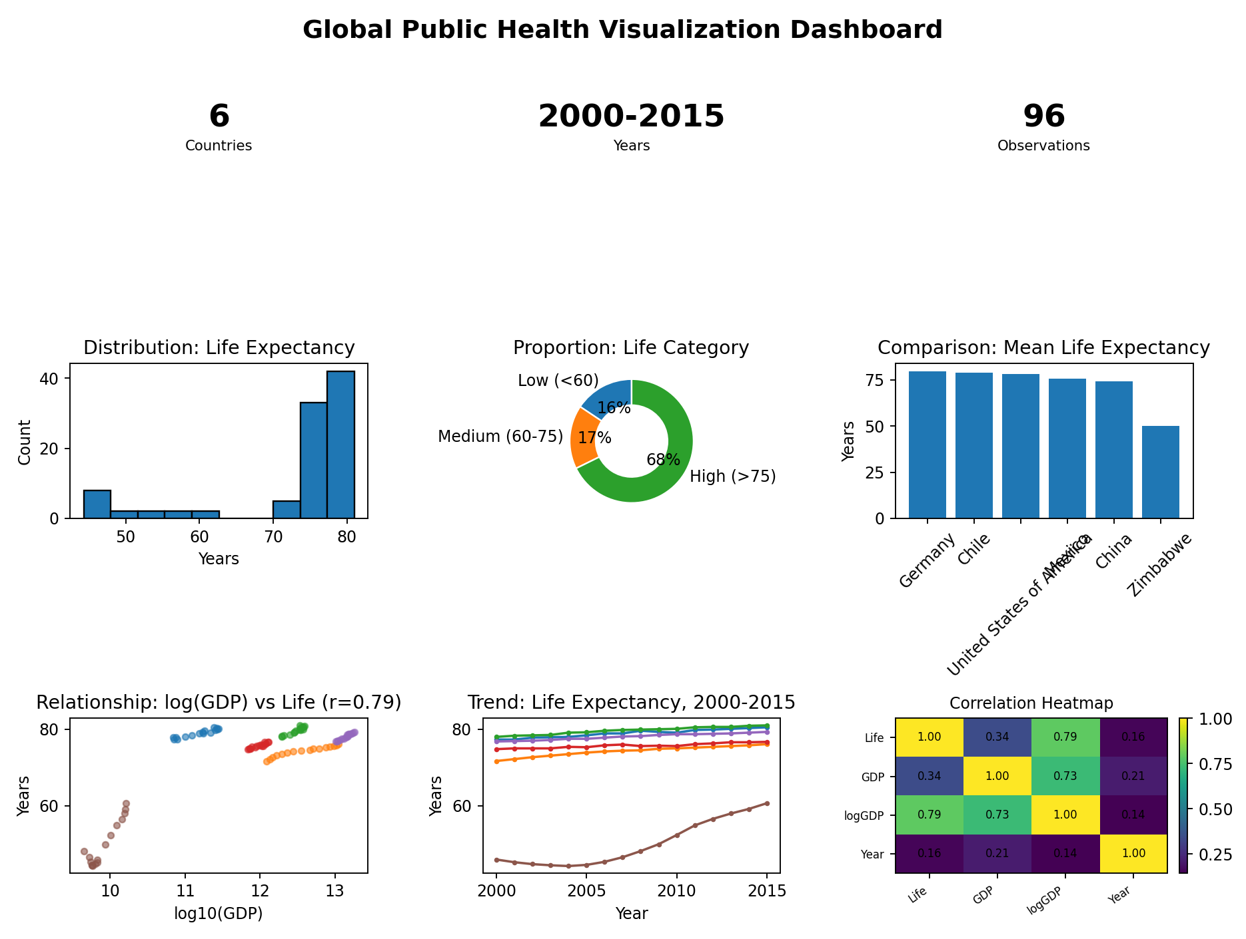
Figure 8. Multi-view dashboard layout combining KPIs, distribution, proportion, comparison, relationship, trend, and correlation views.

10. Results and Validation

10.1 Validation Results
Parameter | Result
Data loading | Successful
Schema validation | Successful
Derived feature creation | Successful
Distribution views | Successful
Proportion/comparison views | Successful
Relationship views | Successful
Trend view | Successful
Dashboard generation | Successful
Interactive HTML export | Generated

10.2 Experimental Observation
The visual analysis identifies a strong separation between Zimbabwe and the five other countries in life expectancy, while Germany, Chile, and the United States occupy the higher range. The line chart also shows steady improvement over time for Zimbabwe after 2004, while the developed-country series remain comparatively stable around the upper 70s and low 80s.

10.3 Validation of Visualization Choices
The histogram is appropriate for a single continuous variable because it reveals shape and concentration. The box plot is appropriate for comparing distributions across several categories because it emphasizes median and spread. The bar chart uses a common baseline and sorted ordering for accurate mean comparison. The scatter plot uses spatial position for two quantitative variables, which is perceptually stronger than encoding GDP and life expectancy as angles or areas. The heatmap is useful for a compact overview of many pairwise relationships, while the line chart uses connectedness and continuity to emphasize temporal change.

10.4 Evidence
The dashboard image and embedded analytical figures serve as evidence. The accompanying HTML dashboard file provides the interactive implementation, while the source CSV and Python code can be uploaded to GitHub as the reproducibility package.

11. Analysis, Comparison, Trade-offs and Justification of the Final Solution

11.1 Analysis
The strongest analytical message is that life expectancy differs markedly across countries and improves over time in the observed sample. The relationship view suggests a positive association between economic scale and life expectancy, but the scatter plot also shows that extremely large GDP values can dominate the visual scale. Using log10(GDP) improves separation and interpretation without changing the underlying observations.

11.2 Comparison of Three Alternative Designs for the Same Insight
The chosen insight is the proportion of country-year observations in low, medium, and high life-expectancy categories. Three alternatives were evaluated: Design A - donut chart; Design B - standard bar chart; Design C - 100% stacked bar. The comparison uses four explicit criteria: comparison accuracy, cognitive load, grouping clarity, and non-quantitative decoration.
Rank | Design | Strengths | Weaknesses | Score / 20
1 | B - Bar Chart | Best baseline comparison; exact lengths are easy to compare; low cognitive load | Slightly less visually compact than donut | 18
2 | C - 100% Stacked Bar | Excellent for composition of one whole; compact and clean | Middle segment requires more visual estimation | 16
3 | A - Donut Chart | Immediately communicates part-to-whole concept; familiar to non-technical users | Angles/areas are harder to compare precisely; labels can clutter | 13
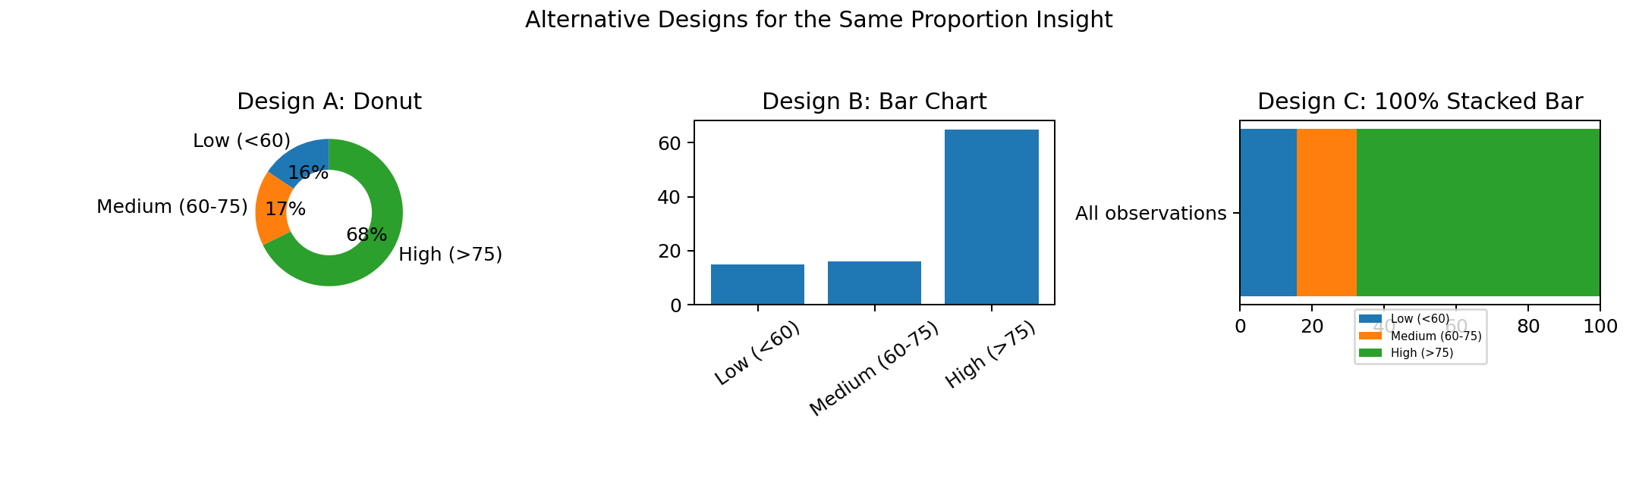
Figure 9. Side-by-side comparison of three alternative designs for the same proportion insight.

11.3 Trade-offs
A bar chart maximizes comparison accuracy but uses more horizontal space. A donut chart is compact and familiar but sacrifices precise comparison because viewers judge angles and areas less accurately than aligned lengths. A 100% stacked bar is efficient for composition but makes the middle segment harder to compare. For an organization that needs both technical and non-technical interpretation, the standard bar chart provides the best compromise between speed, accuracy, and low cognitive load.

11.4 Justification of the Final Solution
The final dashboard prioritizes position and length for quantitative comparison, uses restrained color for grouping rather than decoration, and keeps related views physically close. These decisions align with the evidence base on graphical perception: Cleveland and McGill demonstrated that some graphical decoding tasks are more accurate than others, supporting the use of aligned positions and lengths for comparison. Gestalt principles such as proximity and similarity support the grouping of related marks, while pre-attentive attributes such as hue and spatial position can direct attention before detailed reading.
The winning design reduces cognitive load because the user does not need to mentally decode multiple encodings for a simple proportion question. It also improves interpretation accuracy because the categories share a common baseline. This supports data-driven decision-making by allowing stakeholders to detect the dominant category quickly, then move to the more detailed relationship and trend views for context.

12. Broader Considerations / SDG Relevance

12.1 Broader Considerations
The dashboard is deliberately designed for mixed audiences. Technical users can inspect correlations, trends, and outliers, while non-technical users can rely on direct titles, sorted bars, and simple proportion views. The report avoids causal language and makes clear that the dataset is a limited sample. Future use should add more countries, richer health indicators, and uncertainty information before policy deployment.

12.2 SDG Relevance
The assignment explicitly maps to SDG 4 (Quality Education) and SDG 9 (Industry, Innovation and Infrastructure). The visualization design supports SDG 4 by improving the clarity and accessibility of quantitative evidence used for learning and informed interpretation. It supports SDG 9 by demonstrating an applied digital-analysis workflow that combines data engineering, interactive visualization, and human-centered design for an operational decision context.

13. Conclusion, Limitations and Possible Improvements

13.1 Conclusion
The project successfully demonstrates a complete analysis-and-visualization workflow for public-health data. The selected chart types match the underlying analytical questions: histogram and box plot for distributions, donut and bar chart for composition and comparison, scatter plot and heatmap for relationships, and line chart for temporal trends. The dashboard integrates these views and evaluates them using perception-based principles.

13.2 Limitations
● Only six countries are included, so the sample is not globally representative.
● GDP is a total economic measure rather than a per-capita measure.
● The analysis is descriptive and correlational, not causal.
● The proportion categories are analyst-defined bins for visualization, not clinical thresholds.
● The dashboard does not yet include uncertainty intervals, richer health indicators, or predictive models.

13.3 Possible Improvements
● Expand the dataset to all available countries and more recent years.
● Add health indicators such as immunization, mortality, schooling, sanitation, and health expenditure.
● Use GDP per capita or purchasing-power-adjusted measures for better comparability.
● Add uncertainty bands and confidence intervals where estimates are appropriate.
● Introduce drill-down and brushing so selections in one view highlight records in the others.
● Add accessibility checks for color contrast, color-vision deficiency, keyboard navigation, and text scaling.
● Deploy the dashboard through Tableau, Power BI, or a web application when organizational use requires shared access.

14. Individual Contribution of Group Members
Group Member | Contribution
Member 1 | Dataset acquisition, cleaning, feature engineering, and distribution analysis.
Member 2 | Dashboard construction, interactive filtering, relationship and trend analysis.
Member 3 | Perceptual evaluation, alternative-design comparison, documentation, and testing.
All group members should participate in integration, validation, screenshot capture, GitHub upload, and final report review. Replace the generic member labels with the actual names before submission.

15. References
1. World Health Organization / World Bank-derived six-country life expectancy and GDP dataset, public repository: wangdavid25/WHO-Life-Expectancy-and-GDP, GitHub. The repository describes the data as six countries from 2000-2015 with country, year, life expectancy, and GDP fields.
2. Cleveland, W. S., & McGill, R. (1984). Graphical Perception: Theory, Experimentation, and Application to the Development of Graphical Methods. Journal of the American Statistical Association, 79(387), 531-554. https://doi.org/10.1080/01621459.1984.10478080
3. Tufte, E. R. (2001). The Visual Display of Quantitative Information (2nd ed.). Graphics Press.
4. Ware, C. (2008). Visual Thinking for Design. Morgan Kaufmann.
5. Few, S. (2012). Show Me the Numbers: Designing Tables and Graphs to Enlighten (2nd ed.). Analytics Press.
6. Wagemans, J., et al. (2012). A Century of Gestalt Psychology in Visual Perception: I. Perceptual and Epistemological Foundations. Psychological Bulletin, 138(6), 1172-1217.
7. Heer, J., Bostock, M., & Ogievetsky, V. (2010). A Tour Through the Visualization Zoo. Communications of the ACM, 53(6), 59-67.
8. ColorBrewer 2.0. Brewer, Cynthia A., Penn State University. https://colorbrewer2.org/
9. pandas documentation. Python Data Analysis Library. https://pandas.pydata.org/docs/
10. Plotly Python documentation. Interactive graphing library for Python. https://plotly.com/python/

