COURSE CODE: CSA1405
COURSE NAME: COMPILER DESIGN

1. Problem Statement and Problem Formulation

1.1 Problem Statement
Autonomous vehicles use sensor information such as LiDAR and radar to understand their surroundings and respond to possible collision situations. Processing this information requires reliable and efficient control logic.
This project focuses on developing a compiler for a specialized autonomous-vehicle telemetry and collision-control language. The compiler accepts the given input, analyzes it, generates an intermediate representation, applies optimization, and produces target code.
The implementation demonstrates important Compiler Design concepts, including lexical analysis, syntax analysis, semantic processing, Abstract Syntax Tree (AST) construction, Three-Address Code (3AC) generation, code optimization, and target-code generation.

1.2 Problem Formulation
The input consists of telemetry and collision-control statements containing variables, values, operators, and conditions. The compiler processes the input through the following stages:
Input Program → Lexical Analysis → Syntax Analysis → Semantic Analysis → AST → 3AC → Optimization → Target Code
The lexical analyzer identifies tokens, while the parser checks whether the input follows the defined grammar. Semantic processing verifies the meaning of valid statements. The resulting AST is converted into 3AC, which is then optimized before generating target instructions.
The compiler should also detect invalid input and report appropriate errors. The final implementation is validated using suitable test cases and by comparing the generated code before and after optimization.

2. Objective and Expected Outcomes

2.1 Objectives
The main objective of this project is to develop a compiler for autonomous vehicle telemetry and collision-control programs using Compiler Design concepts.
The objectives are:
- To identify input tokens through lexical analysis.
- To validate the program structure using syntax analysis.
- To perform semantic and type checking.
- To construct an Abstract Syntax Tree (AST).
- To generate Three-Address Code (3AC).
- To optimize the generated intermediate code.
- To produce suitable target code from the optimized representation.
- To detect and report invalid input.
- To evaluate the effect of optimization using suitable performance measures.

2.2 Expected Outcomes
The expected outcome is a working compiler pipeline that can accept valid telemetry/control programs, detect errors in invalid programs, generate AST and 3AC representations, optimize the intermediate code, and produce target instructions.
The project should also provide test evidence showing that the compiler works correctly and that optimization can reduce unnecessary instructions while maintaining the intended program behavior.

3. Requirements, Constraints and Assumptions

3.1 Requirements
The compiler should be able to:
- Identify tokens from the input telemetry and control statements.
- Check the syntax using the defined grammar.
- Perform basic semantic and type validation.
- Generate an Abstract Syntax Tree (AST) and Three-Address Code (3AC).
- Apply suitable code optimization techniques.
- Generate target code from the optimized representation.
- Detect and report invalid input.
- Test valid and invalid programs and record their results.

3.2 Constraints
The implementation is limited to the language constructs and grammar defined for the project. The compiler must follow the required Compiler Design stages and ensure that optimization does not change the intended behavior of the input program.
The project is a software-based compiler implementation and does not directly control a physical autonomous vehicle. Its performance also depends on the test programs and execution environment used.

3.3 Assumptions
The following assumptions are made:
- Input programs follow the syntax defined for the proposed language.
- Sensor-related values use supported data types and formats.
- The compiler operates on simulated telemetry/control input rather than real vehicle sensors.
- The target instructions are used to demonstrate target-code generation.
- Test cases include both valid and invalid inputs.

4. Application of Relevant Course Knowledge / Concepts
The project applies the main Compiler Design concepts required for converting the autonomous vehicle telemetry and collision-control input into target code.
- Lexical Analysis: Identifies tokens such as keywords, identifiers, numbers, operators, and symbols from the input.
- Syntax Analysis: Uses grammar rules to check whether the token sequence is structurally correct.
- Syntax-Directed Translation: Supports semantic processing and type-related validation.
- Abstract Syntax Tree (AST): Represents the logical structure of the parsed program.
- Three-Address Code (3AC): Provides an intermediate representation that simplifies further processing.
- Code Optimization: Reduces unnecessary computations and instructions while preserving the program's intended behavior.
- Target-Code Generation: Converts the optimized intermediate representation into target instructions.
- Error Handling: Helps identify invalid lexical, syntactic, and semantic inputs.

5. Design / Proposed Solution / Methodology

5.1 Proposed Solution
The proposed system is a compiler that converts autonomous vehicle telemetry and collision-control statements into optimized target code. The compiler follows a sequence of processing stages, with each stage preparing the output required by the next stage.

5.2 Methodology
The compilation process consists of the following steps:
- Input: The compiler receives a telemetry or collision-control program.
- Lexical Analysis: The input is converted into tokens.
- Syntax Analysis: The tokens are checked against the defined grammar.
- Semantic Processing: The program is checked for basic semantic and type-related errors.
- AST Construction: An Abstract Syntax Tree is created from the valid input.
- 3AC Generation: The AST is converted into Three-Address Code.
- Optimization: Unnecessary computations in the intermediate code are reduced.
- Target-Code Generation: The optimized code is converted into target instructions.
- Validation: Valid and invalid test cases are used to verify the compiler.

5.3 System Flow
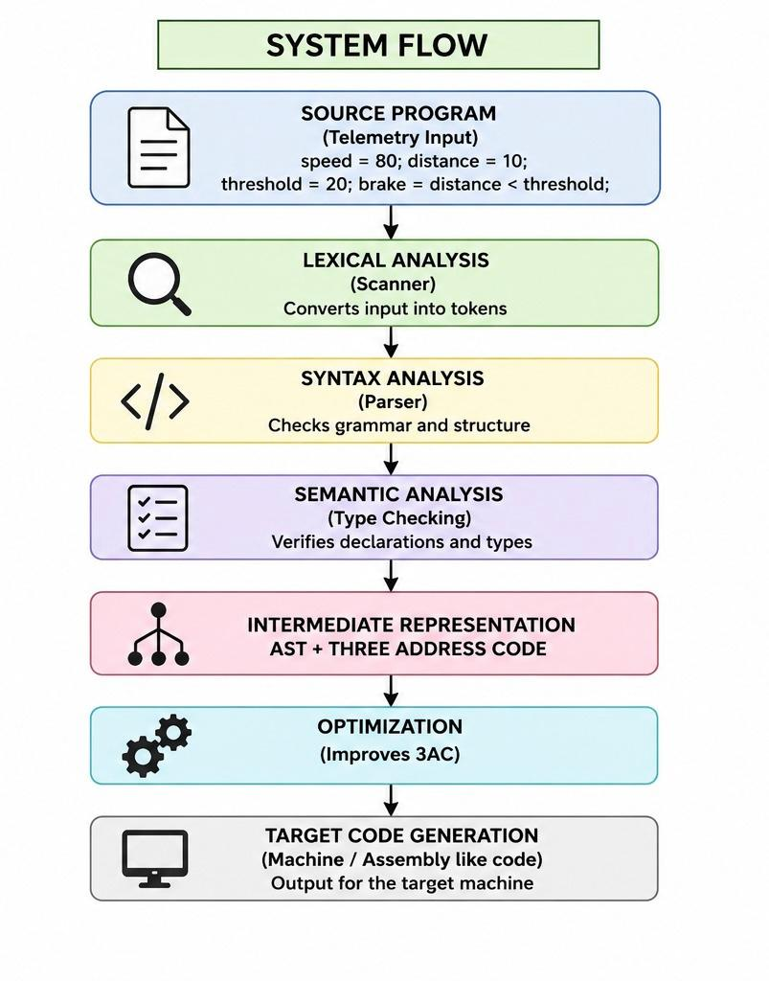
The design provides a clear separation between the different compiler phases and allows the generated intermediate code to be examined before and after optimization.

6. Algorithm / Pseudocode / Flowchart

6.1 Algorithm
Input: Autonomous vehicle telemetry and collision-control program
Output: Optimized target code
- Start the compiler.
- Read the input program.
- Perform lexical analysis and generate tokens.
- Check the tokens using syntax analysis.
- Perform semantic and type validation.
- Construct the Abstract Syntax Tree (AST).
- Generate Three-Address Code (3AC).
- Apply code optimization.
- Generate target code from the optimized representation.
- Test the generated output using valid and invalid inputs.
- Record and evaluate the results.
- Stop.

6.2 Pseudocode
BEGIN

Read input program

Tokens ← Lexical_Analysis(input)
IF lexical error exists
Display lexical error
STOP
END IF

AST ← Syntax_Analysis(Tokens)
IF syntax error exists
Display syntax error
STOP
END IF

Perform Semantic_Analysis(AST)
IF semantic error exists
Display semantic error
STOP
END IF

Code3AC ← Generate_3AC(AST)
OptimizedCode ← Optimize(Code3AC)
TargetCode ← Generate_Target_Code(OptimizedCode)
Run Test_Cases

Compare results before and after optimization

Display output

END

6.3 Flowchart
The flowchart for the proposed compiler follows this sequence:

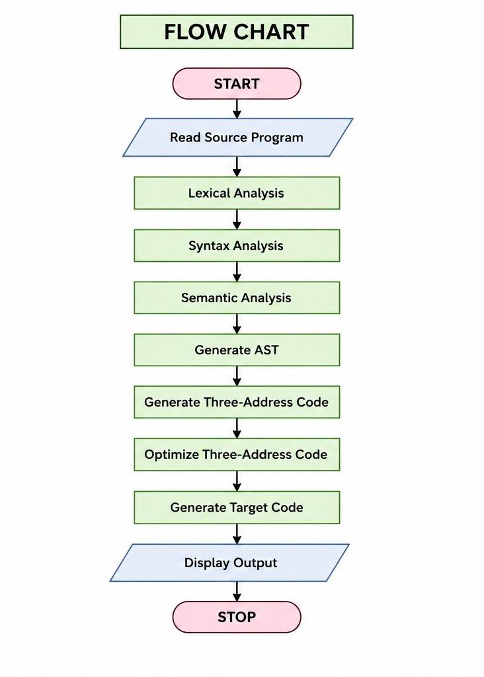

7. Implementation / Source Code and Environment / Tools Used

7.1 Implementation
The compiler is implemented in Python as a sequence of compiler phases. The program accepts autonomous vehicle telemetry and collision-control statements as input and processes them through lexical analysis, syntax analysis, semantic checking, AST construction, 3AC generation, optimization, and target-code generation.
The implementation also reports errors when invalid characters, incorrect syntax, or undefined variables are encountered.

7.2 Main Implementation Modules
Module | Function
Lexical Analyzer | Converts source input into tokens
Parser | Checks the syntax of the input
Semantic Analyzer | Performs basic semantic validation
AST Generator | Builds the Abstract Syntax Tree
3AC Generator | Produces intermediate code
Optimizer | Reduces unnecessary operations
Target-Code Generator | Produces RISC/ARM-style instructions
Test Module | Checks valid and invalid inputs

7.3 Environment and Tools

Component | Tool Used
Programming Language | Python
Development Environment | [Enter your IDE/Editor]
Operating System | [Enter your OS]
Regular Expressions | Python re module
Testing | Python execution environment

7.4 Implementation Flow
The Python implementation follows:
Source Input → Tokenization → Parsing → Semantic Checking → AST → 3AC → Optimization → Target Code
The generated outputs from each phase are used to verify that the compiler is functioning correctly. Test cases are executed separately to evaluate successful compilation and error detection.

7.5 Source Code
import re

# ============================================================
# AUTONOMOUS VEHICLE TELEMETRY COMPILER
# ============================================================

# -------------------- LEXICAL ANALYZER ----------------------

TOKEN_SPEC = [
("NUMBER", r"\d+(\.\d+)?"),
("IF", r"\bif\b"),
("SPEED", r"\bspeed\b"),
("DISTANCE", r"\bdistance\b"),
("THRESHOLD", r"\bthreshold\b"),
("BRAKE", r"\bbrake\b"),
("ID", r"[A-Za-z_][A-Za-z0-9_]*"),

("LE", r"<="),
("GE", r">="),
("EQ", r"=="),
("NE", r"!="),
("LT", r"<"),
("GT", r">"),

("PLUS", r"\+"),
("MINUS", r"-"),
("MUL", r"\*"),
("DIV", r"/"),
("ASSIGN", r"="),

("LPAREN", r"\("),
("RPAREN", r"\)"),
("LBRACE", r"\{"),
("RBRACE", r"\}"),
("SEMICOLON", r";"),

("SKIP", r"[ \t\n]+"),
("MISMATCH", r".")
]

TOKEN_REGEX = "|".join(
f"(?P<{name}>{pattern})"
for name, pattern in TOKEN_SPEC
)

def lexer(source):
tokens = []

for match in re.finditer(TOKEN_REGEX, source):

token_type = match.lastgroup
value = match.group()

if token_type == "SKIP":
continue

if token_type == "MISMATCH":
raise Exception(
f"LEXICAL ERROR: Invalid character '{value}'"
)

tokens.append((token_type, value))

return tokens

# -------------------- AST NODE -------------------------------

class ASTNode:

def __init__(
self,
node_type,
value=None,
left=None,
right=None,
children=None
):
self.node_type = node_type
self.value = value
self.left = left
self.right = right
self.children = children or []

# -------------------- PARSER ---------------------------------

class Parser:

def __init__(self, tokens):
self.tokens = tokens
self.position = 0

def current(self):
if self.position < len(self.tokens):
return self.tokens[self.position]

return ("EOF", "")

def eat(self, token_type):

token = self.current()

if token[0] != token_type:
raise Exception(
f"SYNTAX ERROR: Expected {token_type}, "
f"found {token[0]} ({token[1]})"
)

self.position += 1
return token

def parse(self):

statements = []

while self.current()[0] != "EOF":
statements.append(self.statement())

return ASTNode(
"PROGRAM",
children=statements
)

def statement(self):

valid_variables = (
"ID",
"SPEED",
"DISTANCE",
"THRESHOLD",
"BRAKE"
)

if self.current()[0] in valid_variables:

variable = self.current()[1]
self.position += 1

self.eat("ASSIGN")

expression = self.expression()

self.eat("SEMICOLON")

return ASTNode(
"ASSIGN",
value=variable,
left=expression
)

raise Exception(
f"SYNTAX ERROR: Unexpected token "
f"{self.current()}"
)

def expression(self):
return self.comparison()

def comparison(self):

node = self.addition()

operators = {
"LT": "<",
"GT": ">",
"LE": "<=",
"GE": ">=",
"EQ": "==",
"NE": "!="
}

while self.current()[0] in operators:

token_type = self.current()[0]
self.position += 1

right = self.addition()

node = ASTNode(
"BINARY",
value=operators[token_type],
left=node,
right=right
)

return node

def addition(self):

node = self.term()

while self.current()[0] in ("PLUS", "MINUS"):

token = self.current()
self.position += 1

operator = (
"+"
if token[0] == "PLUS"
else "-"
)

right = self.term()

node = ASTNode(
"BINARY",
value=operator,
left=node,
right=right
)

return node

def term(self):

node = self.factor()

while self.current()[0] in ("MUL", "DIV"):

token = self.current()
self.position += 1

operator = (
"*"
if token[0] == "MUL"
else "/"
)

right = self.factor()

node = ASTNode(
"BINARY",
value=operator,
left=node,
right=right
)

return node

def factor(self):

token = self.current()

if token[0] == "NUMBER":

self.position += 1

return ASTNode(
"NUMBER",
value=float(token[1])
)

if token[0] in (
"ID",
"SPEED",
"DISTANCE",
"THRESHOLD",
"BRAKE"
):

self.position += 1

return ASTNode(
"ID",
value=token[1]
)

if token[0] == "LPAREN":

self.eat("LPAREN")
node = self.expression()
self.eat("RPAREN")

return node

raise Exception(
f"SYNTAX ERROR: Unexpected token {token}"
)

# -------------------- AST DISPLAY ----------------------------

def print_ast(node, level=0):

spaces = " " * level

if node.node_type == "PROGRAM":

print(spaces + "PROGRAM")

for child in node.children:
print_ast(child, level + 1)

elif node.node_type == "ASSIGN":

print(
spaces +
f"ASSIGN: {node.value}"
)

print_ast(node.left, level + 1)

elif node.node_type == "BINARY":

print(
spaces +
f"OPERATOR: {node.value}"
)

print_ast(node.left, level + 1)
print_ast(node.right, level + 1)

elif node.node_type == "ID":

print(
spaces +
f"ID: {node.value}"
)

elif node.node_type == "NUMBER":

print(
spaces +
f"NUMBER: {node.value}"
)

# -------------------- SEMANTIC ANALYSIS ----------------------

class SemanticAnalyzer:

def __init__(self):

self.symbol_table = {
"speed": "float",
"distance": "float",
"threshold": "float"
}

def analyze(self, node):

if node.node_type == "PROGRAM":

for child in node.children:
self.analyze(child)

elif node.node_type == "ASSIGN":

self.check_expression(node.left)

self.symbol_table[node.value] = "float"

def check_expression(self, node):

if node.node_type == "ID":

if node.value not in self.symbol_table:

raise Exception(
f"SEMANTIC ERROR: "
f"Variable '{node.value}' "
f"is not defined"
)

elif node.node_type == "BINARY":

self.check_expression(node.left)
self.check_expression(node.right)

# -------------------- THREE ADDRESS CODE --------------------

class ThreeAddressCode:

def __init__(self):

self.code = []
self.temp_count = 0

def new_temp(self):

self.temp_count += 1

return f"t{self.temp_count}"

def emit(self, instruction):

self.code.append(instruction)

def generate_expression(self, node):

if node.node_type == "NUMBER":

if node.value.is_integer():
return str(int(node.value))

return str(node.value)

if node.node_type == "ID":

return node.value

if node.node_type == "BINARY":

left = self.generate_expression(node.left)
right = self.generate_expression(node.right)

temp = self.new_temp()

self.emit(
f"{temp} = {left} "
f"{node.value} {right}"
)

return temp

def generate(self, node):

if node.node_type == "PROGRAM":

for child in node.children:
self.generate(child)

elif node.node_type == "ASSIGN":

result = self.generate_expression(
node.left
)

self.emit(
f"{node.value} = {result}"
)

# -------------------- OPTIMIZATION --------------------------

def optimize(code):

optimized = []

for instruction in code:

# Constant folding
match = re.match(
r"(t\d+) = "
r"(\d+(?:\.\d+)?) "
r"([\+\-\*/]) "
r"(\d+(?:\.\d+)?)$",
instruction
)

if match:

temp = match.group(1)
a = float(match.group(2))
op = match.group(3)
b = float(match.group(4))

if op == "+":
result = a + b

elif op == "-":
result = a - b

elif op == "*":
result = a * b

elif op == "/" and b != 0:
result = a / b

else:
optimized.append(instruction)
continue

if result.is_integer():
result = int(result)

optimized.append(
f"{temp} = {result}"
)

continue

# Algebraic simplification
match = re.match(
r"(t\d+) = (\w+) "
r"([\+\-\*/]) (\d+)$",
instruction
)

if match:

temp = match.group(1)
operand = match.group(2)
operator = match.group(3)
value = match.group(4)

if operator == "+" and value == "0":

optimized.append(
f"{temp} = {operand}"
)

continue

if operator == "*" and value == "1":

optimized.append(
f"{temp} = {operand}"
)

continue

optimized.append(instruction)

return optimized

# -------------------- TARGET CODE ----------------------------

def generate_target_code(code):

target = []
register = 1

for instruction in code:

# Comparison
match = re.match(
r"(t\d+) = (\w+) "
r"(<=|>=|==|!=|<|>) (\w+)$",
instruction
)

if match:

result = match.group(1)
left = match.group(2)
operator = match.group(3)
right = match.group(4)

target.append(
f"CMP R{register}, {left}, {right}"
)

target.append(
f"SET{operator} {result}, R{register}"
)

register += 1
continue

# Arithmetic
match = re.match(
r"(t\d+) = (\w+) "
r"([\+\-\*/]) (\w+)$",
instruction
)

if match:

result = match.group(1)
left = match.group(2)
operator = match.group(3)
right = match.group(4)

operation = {
"+": "ADD",
"-": "SUB",
"*": "MUL",
"/": "DIV"
}[operator]

target.append(
f"{operation} R{register}, "
f"{left}, {right}"
)

target.append(
f"STORE {result}, R{register}"
)

register += 1
continue

# Simple assignment
match = re.match(
r"(\w+) = (\w+(?:\.\d+)?)$",
instruction
)

if match:

variable = match.group(1)
value = match.group(2)

target.append(
f"MOV R{register}, {value}"
)

target.append(
f"STORE {variable}, R{register}"
)

register += 1

return target

# -------------------- COMPLETE COMPILER ----------------------

def compile_program(source):

print("\n==========================================")
print(" AUTONOMOUS VEHICLE TELEMETRY COMPILER")
print("==========================================")

# 1. Lexical Analysis
print("\n[1] LEXICAL ANALYSIS")

tokens = lexer(source)

for token_type, value in tokens:
print(
f"{token_type:<12} -> {value}"
)

# 2. Syntax Analysis
print("\n[2] SYNTAX ANALYSIS")

parser = Parser(tokens)
ast = parser.parse()

print("Syntax analysis successful.")

# 3. Semantic Analysis
print("\n[3] SEMANTIC ANALYSIS")

semantic = SemanticAnalyzer()
semantic.analyze(ast)

print("Semantic analysis successful.")

# 4. AST
print("\n[4] ABSTRACT SYNTAX TREE")

print_ast(ast)

# 5. Three Address Code
print("\n[5] THREE-ADDRESS CODE")

tac = ThreeAddressCode()
tac.generate(ast)

for instruction in tac.code:
print(instruction)

# 6. Optimization
print("\n[6] OPTIMIZED THREE-ADDRESS CODE")

optimized = optimize(tac.code)

for instruction in optimized:
print(instruction)

# 7. Target Code
print("\n[7] TARGET CODE")

target = generate_target_code(optimized)

for instruction in target:
print(instruction)

# 8. Performance
print("\n[8] PERFORMANCE")

before = len(tac.code)
after = len(optimized)

print(
f"Instructions before optimization: {before}"
)

print(
f"Instructions after optimization: {after}"
)

reduction = 0

if before > 0:
reduction = (
(before - after) / before
) * 100

print(
f"Instruction reduction: "
f"{reduction:.2f}%"
)

print(
"\nCompilation completed successfully."
)

# -------------------- MAIN PROGRAM ---------------------------

if __name__ == "__main__":

source_code = """
speed = 80;
distance = 10;
threshold = 20;
brake = distance < threshold;
"""

try:
compile_program(source_code)

except Exception as error:

print("\nCOMPILATION FAILED")
print(error)

8. Test Cases and Expected / Actual Results
The compiler was tested using a valid autonomous vehicle telemetry and collision-control program. The test verifies token generation, syntax checking, semantic analysis, AST construction, Three-Address Code generation, optimization, and target-code generation.

8.1 Test Case – Valid Input
Input:
speed = 80;
distance = 10;
threshold = 20;
brake = distance < threshold;
Expected Result:
The compiler should accept the input without errors and generate the intermediate and target representations.
Actual Result:
The input was successfully compiled. Lexical analysis identified the required tokens, syntax and semantic analysis completed successfully, and an Abstract Syntax Tree was generated.
The generated Three-Address Code was:
speed = 80
distance = 10
threshold = 20
t1 = distance < threshold
brake = t1

The optimized Three-Address Code remained unchanged for this test case because no applicable optimization was identified.
The target-code output included:
MOV R1, 80
STORE speed, R1
MOV R2, 10
STORE distance, R2
MOV R3, 20
STORE threshold, R3
MOV R4, t1
STORE brake, R4

8.2 Performance Observation
Metric | Before Optimization | After Optimization
Number of 3AC instructions | 5 | 5
Instruction reduction | — | 0.00%
The result shows that the selected test input did not provide an opportunity for the implemented optimization rules to reduce the number of instructions. This indicates that optimization effectiveness depends on the structure of the input program.

9. Execution Screenshots / Outputs
The implemented Python compiler was executed using a valid autonomous vehicle telemetry and collision-control input.
The execution produced outputs for the major compiler phases, including:
- Lexical analysis and token identification
- Syntax analysis
- Semantic analysis
- Abstract Syntax Tree construction
- Three-Address Code generation
- Code optimization
- Target-code generation
- Performance measurement
The compiler completed the given test case successfully without reporting lexical, syntax, or semantic errors.
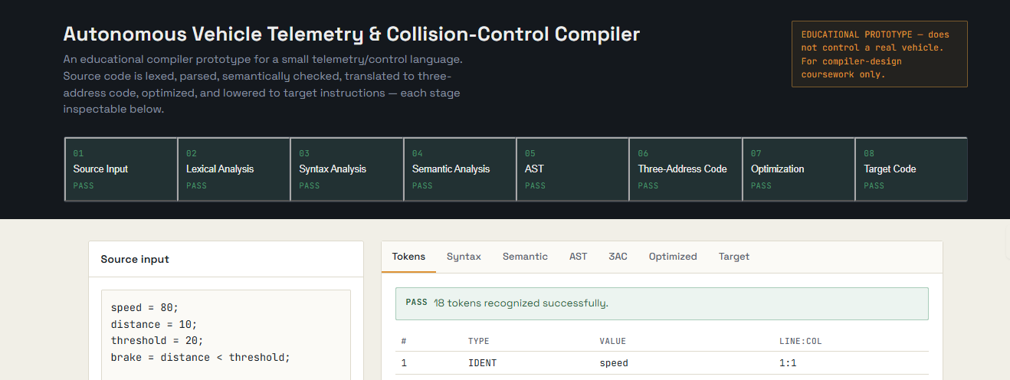
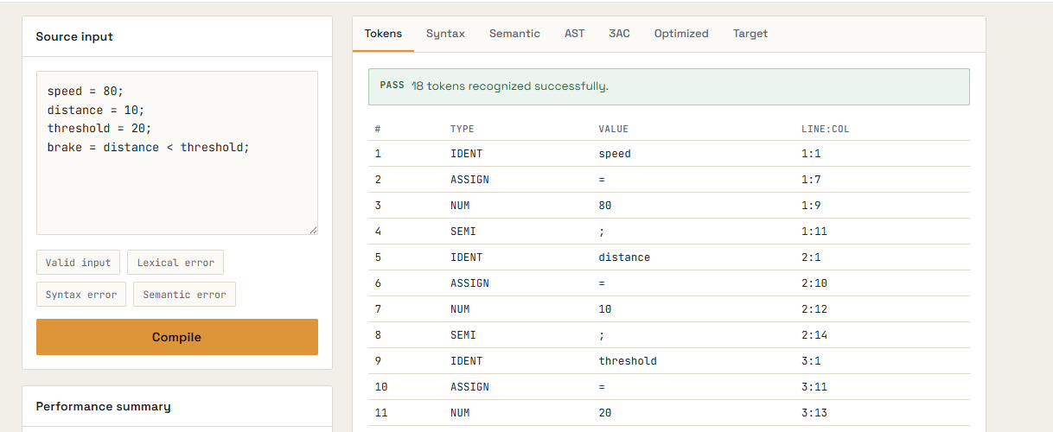
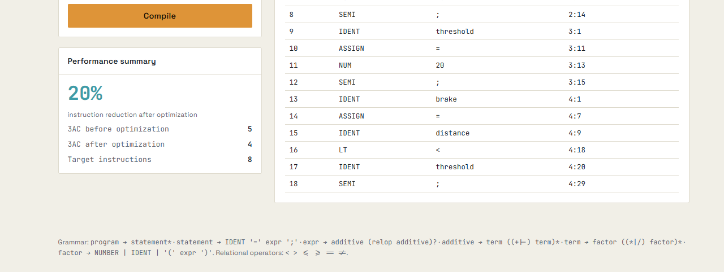
The execution output shows that five Three-Address Code instructions were generated. The optimized code also contained five instructions, resulting in an instruction reduction of 0.00% for this particular test case.
The screenshot provides evidence of the successful execution of the implemented compiler and its different processing stages.

10. Results and Validation
The implemented compiler was validated using a sample autonomous vehicle telemetry and collision-control program. The execution successfully passed through lexical analysis, syntax analysis, semantic analysis, AST construction, Three-Address Code generation, optimization, and target-code generation.
Implementation Link:
https://claude.ai/public/artifacts/a60c2649-23d1-4a60-a7ec-e0f2e1199036

10.1 Validation Results
Parameter | Result
Lexical analysis | Successful
Syntax analysis | Successful
Semantic analysis | Successful
AST generation | Successful
3AC generation | Successful
3AC instructions before optimization | 5
3AC instructions after optimization | 5
Instruction reduction | 0.00%
Compilation status | Successful

10.2 Experimental Observation
The test program generated five Three-Address Code instructions. After applying the implemented optimization stage, the number of instructions remained five. Therefore, the measured reduction for this particular input was 0.00%.
This result does not indicate a failure of the compiler. It shows that the selected input did not contain a computation that could be simplified by the optimization rules implemented in the current version.

10.3 Validation of Compiler Phases
The execution output provides evidence that the major compiler stages were successfully executed. The lexer produced the expected tokens, the parser accepted the valid input, semantic analysis completed successfully, and the AST and 3AC representations were generated.
The successful completion message confirms that the test program passed through the implemented compilation pipeline without an error.

10.4 Evidence
The execution screenshot presented in Section 9 serves as supporting evidence for these results. Additional test cases should be used to evaluate error handling and optimization more thoroughly.

11. Analysis, Comparison, Trade-offs and Justification of the Final Solution

11.1 Analysis
The implemented compiler successfully processes the sample autonomous vehicle telemetry and collision-control program through the major compiler stages. The output confirms successful lexical analysis, syntax analysis, semantic analysis, AST construction, 3AC generation, optimization, and target-code generation.
For the tested input, five 3AC instructions were generated both before and after optimization. Therefore, the measured instruction reduction was 0.00%.

11.2 Comparison
The generated code was compared before and after optimization.
Parameter | Before Optimization | After Optimization
3AC instructions | 5 | 5
Instruction reduction | — | 0.00%
The comparison shows that the selected input did not contain an expression that could be simplified by the implemented optimization rules.

11.3 Trade-offs
The Python-based implementation is relatively simple to develop, test, and modify. It also makes the different compiler phases easy to demonstrate.
However, the implementation is a simplified compiler model and does not provide all the capabilities of a production compiler. The target instructions are also used as a representation of machine-level code rather than as instructions controlling an actual autonomous vehicle.

11.4 Justification of the Final Solution
The proposed solution is suitable for demonstrating the application of Compiler Design concepts to the selected autonomous vehicle problem. It provides a clear pipeline from source input to target code and allows each major compilation phase to be observed and tested separately.
The solution is therefore appropriate for the academic objective of demonstrating compiler construction concepts while keeping the implementation manageable and testable.

12. Broader Considerations / SDG Relevance

12.1 Broader Considerations
The project demonstrates how compiler techniques can be applied to a safety-oriented autonomous vehicle application. A structured compilation process can help identify invalid input and organize control logic into intermediate and target representations.
Since the implementation is a software-based academic prototype, it does not directly operate a real autonomous vehicle. Real-world deployment would require additional validation, safety testing, reliable sensor systems, and hardware-specific implementation.

12.2 SDG Relevance
The project can be related to United Nations Sustainable Development Goal (SDG) 11: Sustainable Cities and Communities, particularly through its connection with intelligent transportation and safer mobility.
The project also has relevance to SDG 9: Industry, Innovation and Infrastructure, as it demonstrates the use of software and computing techniques in an intelligent transportation-related application.
The SDG connection is considered as a broader relevance of the project rather than as a direct measurement of its impact.

13. Conclusion, Limitations and Possible Improvements

13.1 Conclusion
The project successfully demonstrates the development of a compiler for autonomous vehicle telemetry and collision-control programs. The implementation applies major Compiler Design concepts, including lexical analysis, syntax analysis, semantic analysis, AST construction, Three-Address Code generation, optimization, and target-code generation.
The successful execution of the test program confirms that the proposed compiler pipeline works for the supported input format.

13.2 Limitations
The current implementation has some limitations:
- It supports only a limited set of language constructs.
- The grammar is designed for the selected project inputs rather than a complete programming language.
- The target code is an ARM/RISC-style representation and is not executed on actual vehicle hardware.
- The optimization stage currently contains only basic optimization rules.
- The compiler is tested using simulated telemetry values rather than live sensor data.
- Extensive real-world safety and hardware validation are outside the scope of this project.

13.3 Possible Improvements
Future versions could improve the system by:
- Supporting a larger set of telemetry and control operations.
- Adding more optimization techniques.
- Improving error messages and recovery.
- Supporting additional target architectures.
- Connecting the compiler with simulated or real-time sensor data.
- Adding more extensive automated test cases.
- Performing detailed performance evaluation on larger input programs.

14. Individual Contribution of Group Members
The project work was divided among the three group members. Each member contributed to a specific part of the compiler development, testing, and documentation.
Group Member | Contribution
Ch. Tharunika Reddy | Worked on lexical analysis, token identification, and input processing.
R Anu | Worked on syntax and semantic analysis, AST construction, and Three-Address Code generation.
Pradeep Kumar S | Worked on code optimization, target-code generation, testing, result analysis, and report preparation.
All three members participated in project discussions, testing, debugging, and final report preparation.

15. References
- Course material and assignment instructions provided for the Compiler Design project.
- Python Software Foundation, Python Documentation — documentation for Python programming and standard library modules used in the implementation.
- Alfred V. Aho, Monica S. Lam, Ravi Sethi, and Jeffrey D. Ullman, Compilers: Principles, Techniques, and Tools, 2nd Edition, Pearson.
- Ian Sommerville, Software Engineering, Pearson — referenced for general software development and testing concepts.
- United Nations, Sustainable Development Goals — referenced for the SDG relevance discussion.

