Unit – III

VISUALIZING ASSOCIATIONS & TIME SERIES
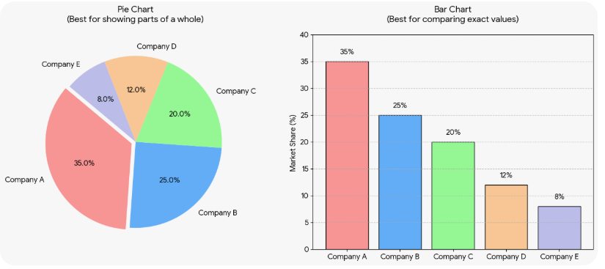

Pie charts and side-by-side bar charts serve different visual purposes when displaying proportions. Choosing the right one depends entirely on whether you want to show parts of a whole or compare individual categories.
Here is how they differ, explained through a single data example.
The Data Example: Smartphone Market Share
Imagine a market research firm tracks smartphone sales across five companies:
- Company A: 40%
- Company B: 25%
- Company C: 15%
- Company D: 12%
- Company E: 8%

A Case for Pie Charts: Seeing the Whole Picture
Use a pie chart when you want the audience to instantly grasp how much a single category contributes to the absolute total (100%).
- The Visual Strength: The human brain recognizes a circle as a complete unit.
- The Example Scenario: You want to highlight that Company A controls nearly half of the entire market all by itself.
- Why it Works: In a pie chart, Company A’s 40% slice looks like a massive chunk of a pizza. The viewer does not need to look at numbers to realize that Company A dominates the industry.
- Best For: Simple datasets (2 to 5 categories) where one or two categories make up the vast majority of the total.

A Case for Side-by-Side Bars: Spotting the Differences
Use a side-by-side bar chart when you want the audience to compare the specific sizes of different categories against each other.
- The Visual Strength: Humans are much better at judging differences in linear length (the height of a bar) than angles or areas (the slices of a pie).
- The Example Scenario: You want to show how close Company C (15%) and Company D (12%) are in competition.
- Why it Works: In a pie chart, a 3% difference in slice angles is almost impossible to detect with the naked eye. In a bar chart, placing the bars directly next to each other makes it immediately obvious that Company C's bar is slightly taller than Company D's.
- Best For: Datasets with more than 5 categories, categories with very similar values, or tracking data changes over time.

