Question 1 – Line Chart (Monthly Sales)
R
# Monthly Sales Data
month <- c("January", "February", "March", "April", "May")
sales <- c(15000, 18000, 22000, 20000, 23000)

# Line Chart
plot(sales,
type = "o",
pch = 19,
xaxt = "n",
col = "blue",
xlab = "Month",
ylab = "Sales ($)",
main = "Monthly Sales")

axis(1, at = 1:5, labels = month)

grid()

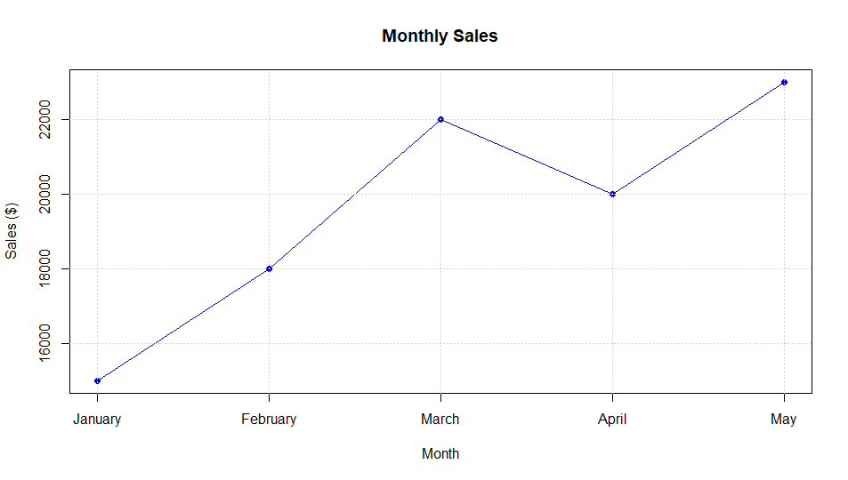

Question 2 – Bar Chart (Top-Selling Products)
(Since product data is not provided, sample values are used.)
R
# Product Sales
product <- c("Laptop", "Mobile", "Tablet", "Headphones", "Smart Watch")
product_sales <- c(42000, 35000, 28000, 22000, 18000)

# Bar Chart
barplot(product_sales,
names.arg = product,
col = "skyblue",
main = "Top-Selling Products",
xlab = "Products",
ylab = "Sales ($)")
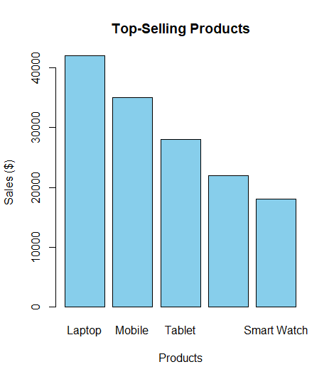

Question 3 – Scatter Plot (Advertising Budget vs Monthly Sales)
R
# Advertising Budget
advertising <- c(3000, 4000, 5000, 4500, 5500)

# Scatter Plot
plot(advertising,
sales,
pch = 19,
col = "red",
xlab = "Advertising Budget ($)",
ylab = "Monthly Sales ($)",
main = "Advertising Budget vs Monthly Sales")

# Regression Line
abline(lm(sales ~ advertising), col = "blue", lwd = 2)

# Correlation
cor(advertising, sales)
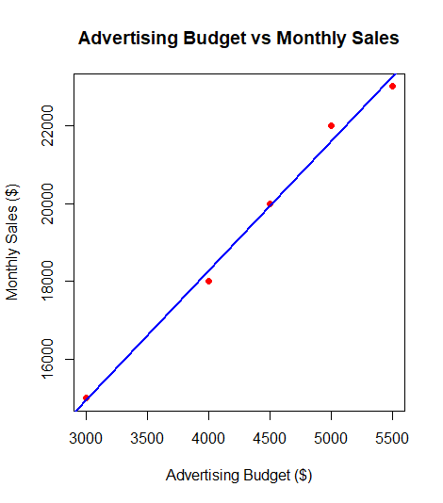

Question 4 – Interactive Dashboard
Install the required packages:
R
install.packages("flexdashboard")
install.packages("plotly")
R
library(plotly)

# Interactive Line Chart
line_chart <- plot_ly(
x = month,
y = sales,
type = "scatter",
mode = "lines+markers"
)

# Product Data
product <- c("Laptop", "Mobile", "Tablet", "Headphones", "Smart Watch")
product_sales <- c(42000, 35000, 28000, 22000, 18000)

# Interactive Bar Chart
bar_chart <- plot_ly(
x = product,
y = product_sales,
type = "bar"
)

# Display Charts
line_chart
bar_chart

