Data Interpretation Exercise-CO1-AT1

Question 1: Mapping Data onto Aesthetics
Dataset
R
library(ggplot2)

data <- data.frame(
Product = c("P1","P2","P3","P4","P5","P6"),
Sales = c(120,90,150,80,135,100),
Profit = c(18,12,25,8,22,16),
Category = c("Electronics","Clothing","Electronics","Furniture","Furniture","Clothing")
)
1. R Program (Scatter Plot)
R
library(ggplot2)

ggplot(data, aes(x = Sales,
y = Profit,
color = Category,
size = Sales)) +
geom_point(alpha = 0.8) +
labs(title = "Sales vs Profit",
x = "Sales (₹ Lakhs)",
y = "Profit (%)") +
theme_minimal()
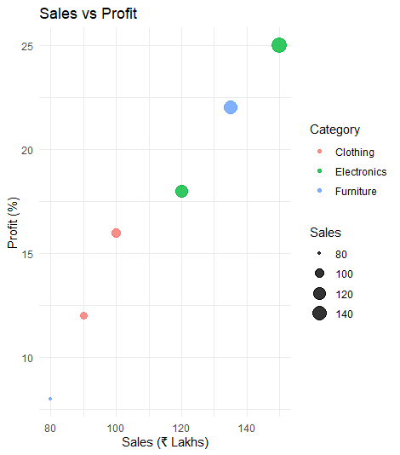

2. Aesthetic Mapping
X-axis → Sales
Y-axis → Profit
Color → Category
Size → Sales
3. Interpretation
Higher sales generally correspond to higher profit.
Electronics products have the highest sales and profit.
Furniture and Clothing have comparatively lower values.

4. Type of Scale
Variable | Scale Type
Sales | Continuous
Profit | Continuous
Category | Categorical (Discrete)
5. Alternative Visualization
Bubble Chart (or grouped bar chart) because it can display sales, profit, and category simultaneously.

Question 2: Coordinate Systems
Dataset
R
library(ggplot2)

direction <- data.frame(
Direction = c("N","NE","E","SE","S","SW","W","NW"),
Frequency = c(18,12,20,15,22,11,16,14)
)

1. Cartesian Coordinate System
R
ggplot(direction,
aes(x = Direction,
y = Frequency)) +
geom_bar(stat = "identity",
fill = "steelblue") +
labs(title = "Direction Frequency (Cartesian)",
x = "Direction",
y = "Frequency") +
theme_minimal()

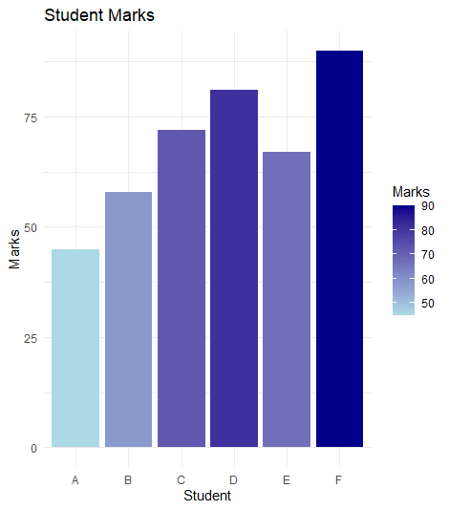

2. Polar Coordinate System
R
ggplot(direction,
aes(x = Direction,
y = Frequency,
fill = Direction)) +
geom_bar(stat = "identity") +
coord_polar() +
labs(title = "Direction Frequency (Polar)") +
theme_minimal()
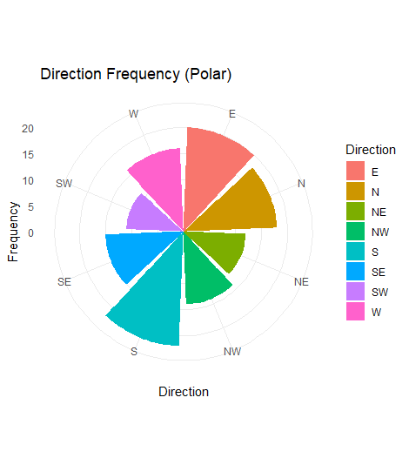

3. Comparison
Cartesian
Easier to compare frequencies.
More accurate for reading values.
Polar
Better represents directional data.
Attractive and intuitive.

4. More Appropriate Coordinate System
Polar Coordinate System

5. Justification
Directional data naturally represents angles (N, NE, E...), making the polar coordinate system more meaningful.

Question 3: Color Scales
Dataset
R
library(ggplot2)

marks <- data.frame(
Student = c("A","B","C","D","E","F"),
Marks = c(45,58,72,81,67,90)
)

1. R Program
R
ggplot(marks,
aes(x = Student,
y = Marks,
fill = Marks)) +
geom_bar(stat = "identity") +
scale_fill_gradient(low = "lightblue",
high = "darkblue") +
labs(title = "Student Marks",
x = "Student",
y = "Marks") +
theme_minimal()


2. Highest and Lowest Marks
Highest → F (90)
Lowest → A (45)

3. Why Sequential Color Scale?
Marks are continuous numerical values, so gradual color intensity effectively represents increasing values.
4. Color-blind Friendly Palette
Use the Viridis palette.
R
scale_fill_viridis_c()

5. Sequential vs Categorical Color Scale
Sequential | Categorical
Used for continuous data | Used for discrete groups
Color intensity changes gradually | Different colors represent categories
Example: Marks | Example: Region

Question 4: Highlighting with Color
Dataset
R
library(ggplot2)

revenue <- data.frame(
Region = c("North","South","East","West","Central"),
Revenue = c(820,760,790,1010,770)
)

revenue$Highlight <- ifelse(revenue$Revenue ==
max(revenue$Revenue),
"Highest",
"Others")

1. R Program
R
ggplot(revenue,
aes(x = Region,
y = Revenue,
fill = Highlight)) +
geom_bar(stat = "identity") +
scale_fill_manual(values =
c("Highest"="red",
"Others"="gray")) +
labs(title = "Regional Revenue") +
theme_minimal()
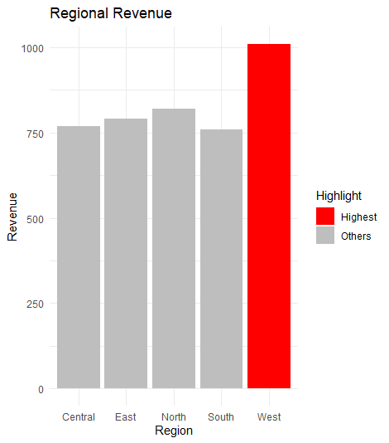

2. How Highlighting Helps
Highlighting immediately draws attention to the most important data point.

3. Highest Performing Region
West (₹1010 Crores)

4. Effect of Excessive Colors
Makes charts confusing.
Reduces readability.
Distracts viewers.

5. Alternative Highlighting Technique
Add labels/annotations to the highest bar.
Increase bar border thickness.
Use different bar patterns.

Question 5: Integrated Visualization
Dataset
R
library(ggplot2)

city <- data.frame(
City = c("A","B","C","D","E"),
Population = c(8.2,5.6,9.4,6.8,4.9),
AQI = c(110,180,90,240,150),
Rainfall = c(850,430,1200,520,680),
Region = c("North","South","North","East","West")
)

1. R Program (Bubble Chart)
R
ggplot(city,
aes(x = Population,
y = AQI,
size = Rainfall,
color = Region)) +
geom_point(alpha = 0.7) +
labs(title = "Population vs AQI",
x = "Population (Million)",
y = "AQI") +
theme_minimal()
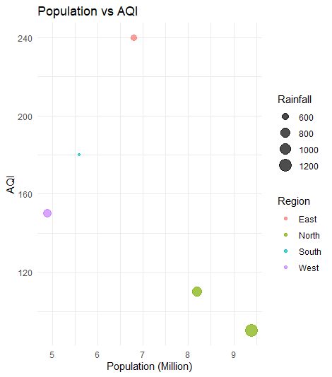

2. Aesthetic Mapping
Variable | Aesthetic
Population | X-axis
AQI | Y-axis
Rainfall | Bubble Size
Region | Color

3. Interpretation
There is no strong linear relationship between Population and AQI.
City D has the highest AQI despite having only a moderate population.
City C has the largest population but a relatively low AQI.

4. Continuous and Categorical Variables
Continuous Variables
Population
AQI
Rainfall
Categorical Variable
Region

5. Improvement
Add city labels to each bubble for easier identification.
R
geom_text(aes(label = City), vjust = -1)
This makes the chart easier to interpret without referring back to the dataset.

