Question 1 – Household Budget (Pie Chart)
# Household Budget
category <- c("Housing", "Transportation", "Food", "Entertainment")
percent <- c(40, 20, 30, 10)

# Pie Chart
pie(percent,
labels = paste(category, percent, "%"),
col = rainbow(4),
main = "Household Budget Distribution")

# Weighted Average
weighted_avg <- sum(percent * (1:4)) / sum(percent)

cat("Weighted Average Category Value =", weighted_avg)
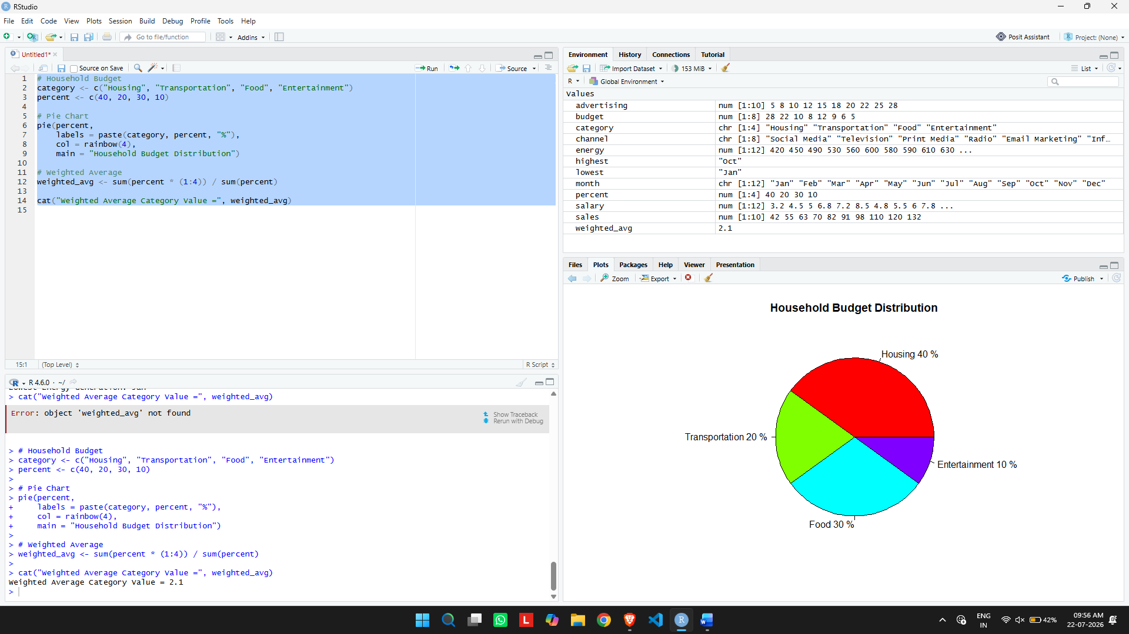

Question 2 – Student Grades (Bar Chart)
# Grade Distribution
grades <- c("A", "B", "C", "D", "E")
students <- c(6, 8, 9, 5, 2)

# Bar Chart
barplot(students,
names.arg = grades,
col = "lightblue",
main = "Student Grade Distribution",
xlab = "Grades",
ylab = "Number of Students")

# Midpoint Scores
score <- c(95, 85, 75, 65, 50)

# Average Score
average <- sum(score * students) / sum(students)

cat("Average Score =", average)
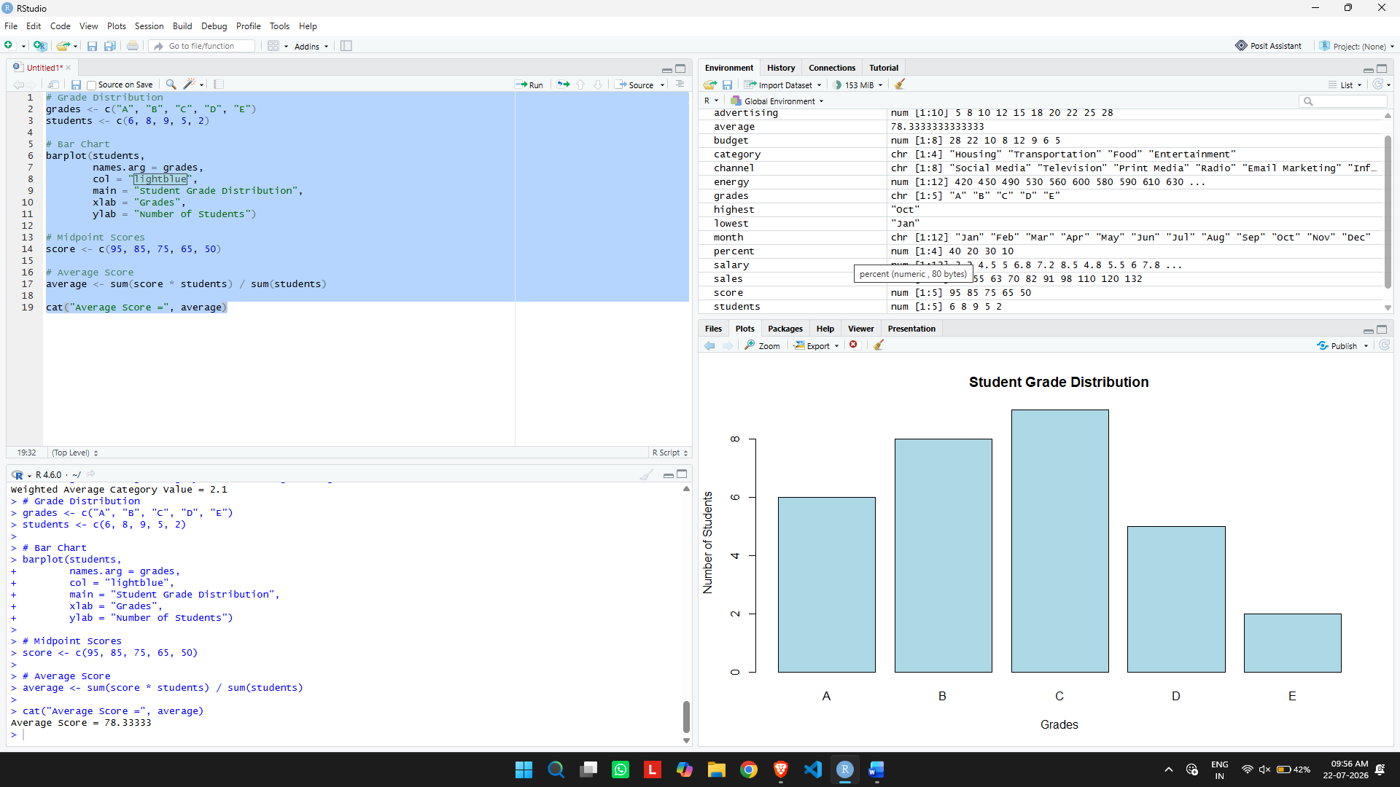

Question 3 – Favourite Fruit (Bar Chart)
# Favourite Fruits
fruit <- c("Apple", "Banana", "Mango", "Orange", "Grapes")
votes <- c(40, 35, 60, 25, 20)

# Bar Chart
barplot(votes,
names.arg = fruit,
col = "orange",
main = "Favourite Fruit Survey",
xlab = "Fruit",
ylab = "Number of Votes")

cat("Most Preferred Fruit:", fruit[which.max(votes)], "\n")
cat("Least Preferred Fruit:", fruit[which.min(votes)], "\n")
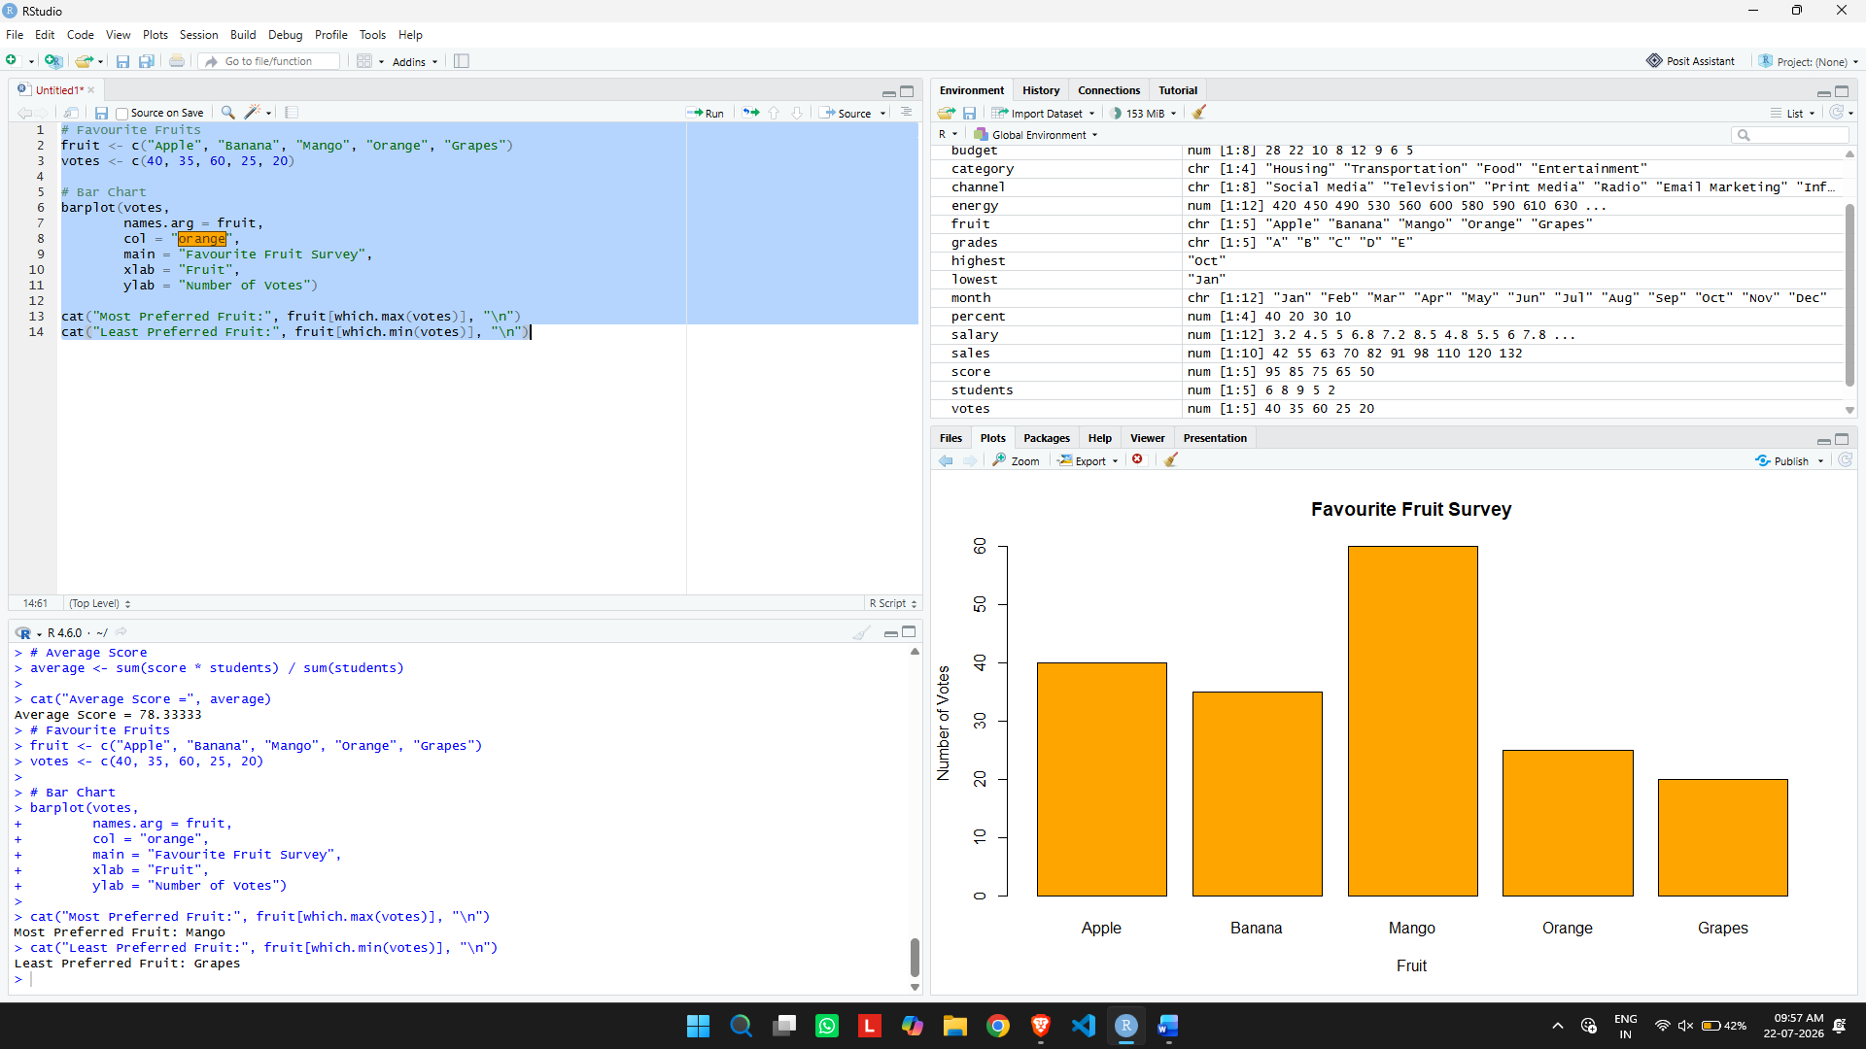

Question 4 – Employees by Department (Pie Chart)
# Department Distribution
department <- c("Marketing", "HR", "Finance", "IT", "Operations")
percent <- c(25, 15, 20, 25, 15)

# Pie Chart
pie(percent,
labels = paste(department, percent, "%"),
col = rainbow(5),
main = "Employee Department Distribution")

# Employees in Marketing
total_employees <- 200
marketing <- total_employees * 25 / 100

cat("Employees in Marketing =", marketing)
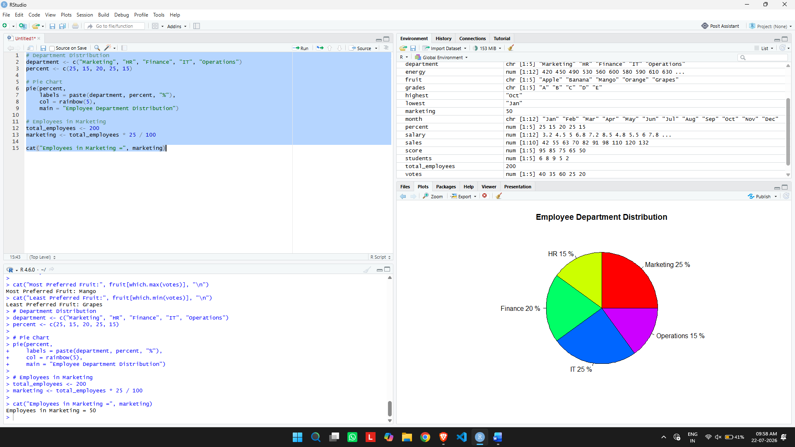

Question 5 – Weekend Activities (Pie Chart)
# Weekend Activities
activity <- c("Video Games",
"Reading",
"Cooking",
"Painting",
"Music")

percent <- c(20, 35, 20, 10, 25)

# Pie Chart
pie(percent,
labels = paste(activity, percent, "%"),
col = rainbow(5),
main = "Weekend Activities of Employees")

cat("Most Common Activity:",
activity[which.max(percent)])

