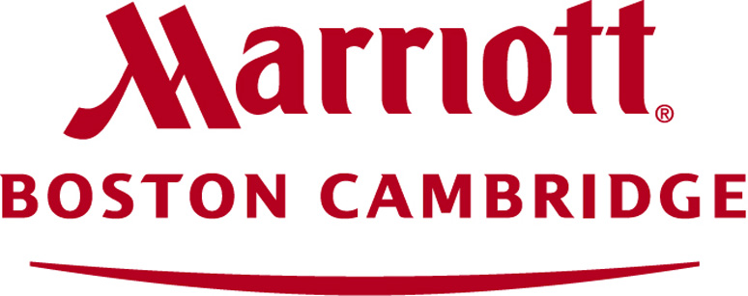

School Reservation Form | Model UN 2020| Boston Marriott Cambridge
School Name:
Complete Address:
School Phone #:
School Fax #:

Contact/Coach Name:
Phone: | Mobile:
Email:
Chaperone name (staying in hotel): | Mobile:
Email:
**Please note: Rooms booked within the block are not eligible to receive Marriott Rewards Points.**
2020 Model UN Room Rate:
$159.00 per night + 14.45% Hotel Tax (Single, Double, Triple or Quad Occupancy)

Please Note: Due to the large number of double rooms that are requested for Model UN,
we cannot guarantee double rooms for any school.
Your room-type preferences will be noted and every attempt will be made to accommodate your requests. Our king rooms do have pullout double sofas, so all of our rooms can sleep up to four guests.

Night | Thursday | Friday | Saturday
Date | 2/7/19 | 2/8/19 | 2/9/19
Number of Rooms Needed

Room and Tax for all reservations MUST be paid for in full in advance.
Please note your method of payment:
Check | Must be received Ten (10) business days prior to arrival date
Credit Card | Will be charged Three (3) business days prior to arrival date

Please email TYPED completed form to:
Myrtle.Agoncillo@marriott.com
or
Michaela.Bates@marriott.com

